**Effects of climate change and landscape-scale   
forest management on avian communities, abundance, and nest success in the Appalachian Mountains**

**Hannah L. Clipp**

Dissertation submitted  
to the Davis College of Agriculture, Natural Resources, and Design  
at West Virginia University

in partial fulfillment of the requirements for the degree of

**Doctor of Philosophy** in  
**Natural Resources Science**

Petra B. Wood, Ph.D., Co-Chair  
Christopher T. Rota, Ph.D., Co-Chair  
Catherine Johnson, Ph.D.  
Michael P. Strager, Ph.D.

Division of Forestry and Natural Resources,  
Wildlife and Fisheries Resources Program

Morgantown, West Virginia  
2023

Keywords: *Appalachian Mountains, birds, climate change, elevation, forest management,  
game birds, land cover change, latitude, Monongahela National Forest, wildlife openings*

Copyright 2023 Hannah L. Clipp

# ABSTRACT

**Effects of climate change and landscape-scale forest management on   
avian communities, abundance, and nest success in the Appalachian Mountains**

Hannah L. Clipp

Birds are integral components of ecosystems and account for billions of dollars in tangible benefits to humans. As such, recent continental declines of bird species have ecological and economic consequences, providing the impetus for my dissertation research. I identified knowledge gaps and proposed novel questions about how birds in the Appalachian Mountains are influenced by changing environmental conditions due to climate change and forest management. The Appalachian Mountains encompass an important biogeographical region with high conservation value due to its myriad habitats and corresponding bird species diversity. Thus, there is a critical need to evaluate the effects of shifting climate factors and land management decisions on long-term trends in bird populations in this region. I designed my dissertation research to fulfill that need, developing 4 chapters that investigate the effects of temperature, precipitation, land cover, and management actions on Appalachian forest bird communities.

The first 2 chapters of my dissertation emphasize the role of climate in the Appalachian Mountains. In Chapter 1, I determined the potential effects of both climate and land cover change on forest songbirds breeding in the Appalachian Mountains region by conducting a comprehensive review of published literature and presenting a novel case study. The literature review focused on synthesizing documented and predicted changes in bird species distributions, populations, and communities in response to changes in climate and land cover across the Appalachian Mountains. I concluded by noting the dearth of studies from the Appalachian Mountains that track long-term avian responses, particularly population dynamics, to changing climate and land cover. For my case study, I used 20 years of North American Breeding Bird Survey data from 322 survey routes within the Appalachian Mountains Bird Conservation Region to model the regionwide abundance and distributions of 14 songbird species, disentangle the influences of climate versus land cover change, and predict the consequences of future shifts in climate and land cover patterns. I found that both climate and land cover variables were important in shaping forest songbird distributions. However, the proportions of land cover types tended to be more influential and had higher effect sizes than temperature or precipitation variables. When predicting future distributions of the 14 focal forest songbird species within the Appalachian Mountains, the future climate and land cover combination scenarios had varying but limited impacts on projected relative abundance, regional occupancy, and shifts in the distribution of relative abundance, with the strongest consistent effects on cold-associated species and the 2 warmest scenarios resulting in the greatest differences between contemporary and future projections. Overall, the net projected impact of climate change on breeding forest songbirds within the Appalachian Mountains was modest at a broad spatiotemporal scale, but there may be cause for conservation concern for cold-associated species if greenhouse gas emissions remain high. Furthermore, based on the importance and effect sizes of land cover variables in my case study, land use changes that result in reduced forest cover and increased urban cover may pose a more immediate threat than climate change to forest songbirds in this region.

The second chapter of my dissertation takes a finer-scale approach compared to Chapter 1 and investigates whether the influence of climate change on forest songbirds in the Appalachian Mountains is mediated by latitude and elevation. In Chapter 2, I quantified differences in how forest songbird communities are affected by climate factors and additionally explored concurrent temporal trends across latitudinal and elevational gradients within the Appalachian Mountains. My specific objectives were to apply interactions with both latitude and elevation in quantifying how temperature, precipitation, and other temporal factors influence climate-related guild richness and the abundance of specific focal species during the breeding season. I used nearly 30 years of bird survey data from 1,733 sites at various elevations in National Forests located within the Northern, Central, and Southern Appalachians to model responses in guild richness and focal species abundance to climate factors and long-term temporal trends. I found that guild-specific relationships varied among latitudinal regions and along elevational gradients within the Appalachian Mountains. The results of this study are valuable for understanding historical effects of changing climate factors and improving predictions of future climate change impacts on forest songbirds in the Appalachian Mountains by verifying and delineating the dynamic nature of the relationships with temperature and precipitation across latitudinal and elevational gradients. My findings will also help to inform forest songbird conservation efforts in the Appalachian Mountains because they quantify the regional effects of temperature and precipitation on climate-related guilds and forest songbird species, and identify specific latitudes and elevations at which they are at the highest risk from climate change and other temporal factors. Based on my models, climate mitigation strategies for forest songbirds in the Appalachian Mountains are most needed for cold-associated species and for low elevations in the Southern Appalachians.

My final 2 chapters focus on the role of land management decisions within the Central Appalachian region. In Chapter 3, I used 17 years of historical bird survey data to fill a knowledge gap about long-term bird responses to landscape-scale forest management by investigating how avian diversity, abundance, and population dynamics changed over time in 2 Central Appalachian forested landscapes with varying levels of timber harvest intensity. My specific objectives were to examine the influence and effect of interactions between time and landscape-scale timber harvest intensity on breeding season songbird guild richness, focal species abundance, and focal species nest success. I found that guild richness and focal species abundance tended to be consistently higher in the actively harvested landscape, and trends in guild richness and species abundance over time were consistently positive in the actively harvested landscape and negative in the minimally harvested landscape. In particular, early-successional / edge-associated species and forest-gap species were found in higher numbers and exhibited positive temporal trends in the actively harvested landscape. However, a holistic assessment that included trends in reproductive success highlighted long-term declines in nest success for a forest-interior species of regional conservation concern within the actively harvested landscape but not the minimally harvested landscape. Thus, there are important trade-offs to consider when using landscape-scale forest management to promote songbird communities and populations in forested landscapes.

The fourth chapter of my dissertation addresses specific management efforts to promote target game birds and a diversity of breeding and post-breeding songbirds in heavily forested landscapes. In Chapter 4, I collected extensive data from 335 wildlife openings within the Monongahela National Forest, and then quantified how a suite of site-level and landscape-level wildlife opening attributes relate to multi-species occupancy of 3 game birds (wild turkey, ruffed grouse, and American woodcock) during the game bird courtship season and songbird guild richness during the breeding and post-breeding seasons. I found that game bird species occupancy in wildlife openings may be best explained by management actions and local habitat attributes. My findings further indicated that it is feasible to manage wildlife openings for the mutual benefit of different species groups across seasons. I presented a set of management recommendations to maximize occurrence of wild turkey, ruffed grouse, and American woodcock in concordance with breeding and post-breeding songbird occurrence within wildlife openings, with considerations for minimizing negative impacts to breeding songbirds in adjacent forests. These actions can be applied by private landowners, non-governmental organizations, and government agencies to simultaneously meet management goals and promote avian diversity in forest ecosystems.

Combining all 4 chapters, my dissertation research generates critical knowledge needed to manage and conserve important natural resources that are ecologically and economically valuable, particularly in the Appalachian Mountains region. My first 2 research studies advance understanding of climate change effects and underscore the significance of the Appalachian Mountains to regional bird communities, especially cold-associated bird species, with important implications for mitigating large-scale threats to biodiversity. The final 2 research studies provide specific management considerations and recommendations for Central Appalachian forests that will holistically benefit and sustain many forest bird species, including target game birds and species of regional conservation concern.

# ACKNOWLEDGMENTS

**First and foremost**

I have many, many people to thank for their myriad roles in my PhD journey, but all the acknowledgments have to first go to my 2 co-advisors, Dr. Petra Wood and Dr. Christopher Rota. Advisors are so critical in whether graduate students merely survive or truly thrive in graduate school, and I was incredibly fortunate to have co-advisors that fostered an excellent experience. They went above and beyond in their duties as my co-advisors and were truly mentors that listened to and accommodated my research ideas, dissertation concerns, proposed timeline changes, and career goals.

***Petra*** --- The entire reason that I considered returning to West Virginia University for my doctoral degree was to work with Petra. I benefitted immensely from her expertise, experience, and insight. Half of my dissertation chapters were only possible due to her willingness to share long-term datasets that she has accumulated over nearly 30 years. Petra played a fundamental role in both shaping and funding my dissertation research.

***Chris*** --- Although I reached out to only Petra initially, I am so glad that she looped in Chris as a co-advisor. Chris is an expert quantitative ecologist, and I was so lucky to receive statistical training from him. It’s no exaggeration to say that I owe all of my understanding of Bayesian approaches and my ability to construct and implement Bayesian models to him. Chris had great influence in shaping my dissertation research and was certainly responsible for its quantitative rigor.

I could keep going on for ages and pages about how much I valued having Petra and Chris as co-advisors, both individually and together, but I’ll wrap up with a few concluding thoughts. First, I’m thankful that they were really good at collaborating in a unified manner and not contradicting each other, despite this being their first time co-advising a graduate student together. In addition, although sometimes it was inexplicable to me, they both had so much faith and trust in me. It seems like a simple thing, but it was so valuable whenever I felt that I was progressing too slowly or not achieving enough. At the same time, I also thank them for reining me in when I was tempted to take on too many additional projects. There were definitely times when I needed that gentle reminder to just focus on completing my dissertation. Overall, I really felt supported and respected, and I am deeply grateful to Petra and Chris for their guidance, patience, and mentorship throughout the past 5 years.

**Dissertation committee**

My doctoral journey and dissertation research have also benefited greatly from my additional 2 dissertation committee members, Dr. Cathy Johnson and Dr. Mike Strager. I sincerely thank them for agreeing to serve on my dissertation committee. Both Cathy and Mike have been so supportive and patient, and I truly appreciate their willingness to consider and accept changes to my dissertation and timeline. Cathy was the source of crucial knowledge of the Monongahela National Forest and provided the immensely valuable perspective of a professional wildlife biologist and land manager. She reminded me to think about management applications and conservation implications, and she was the inspiration and motivation for my fourth dissertation chapter. Meanwhile, Mike was my go-to expert for questions about the GIS components of my dissertation research, particularly pertaining to land cover and remote sensing data. I appreciated his constructive comments about my map-based figures and his overall insights as the primary non-wildlife-focused member of my dissertation committee. Lastly, I thank both Cathy and Mike for providing thoughtful and thorough feedback on drafts of my dissertation chapters.

**Funding**

During my doctoral program, I was primarily supported by the following graduate fellowships (in chronological order): West Virginia University (WVU) Ruby Distinguished Doctoral Fellowship, National Science Foundation (NSF) Graduate Research Fellowship (Grant No. DGE-1102689), PEO Scholar Award, Honor Society of Phi Kappa Phi Dissertation Fellowship, and WVU Outstanding Merit Fellowship for Continuing Doctoral Students. I also received financial support through the following scholarships: Mensa Foundation J. F. Schirmer Scholarship, Honor Society of Phi Kappa Phi Love of Learning Award, Mortar Board National Foundation Fellowship, WVU HOME Scholarship, Mensa Foundation STEM Scholarship for Women, and WVU Foundation Distinguished Doctoral Scholarship.

My dissertation research and fieldwork were funded by the following sources: West Virginia Cooperative Fish and Wildlife Research Unit, NSF Graduate Research Fellowship (Grant No. DGE-1102689), McIntire-Stennis Project WVA00818, USDA Forest Service Monongahela National Forest (Agreement 19-IA-11092100-025), Explorers Club Washington Group Exploration and Field Research Grant, WVU Stitzel Graduate Student Support Fund Award, American Wildlife Conservation Foundation Research Grant, Association for Environmental Health and Sciences Foundation’s Dr. David F. Ludwig Memorial Student Travel Scholarship, American Ornithological Society Research Award, and WVU Farm Credit of the Virginias Student Value-Added Opportunity Fund Award.

I would like to thank everyone who provided recommendation letters, feedback on my application materials, or other assistance with securing the aforementioned funding. My co-advisors, Petra and Chris, contributed funds directly to my research and wrote so many letters of reference, while Dr. Derek Courtney provided feedback for almost every rendition of my fellowship and scholarship application materials. In addition, Dr. Robert Burns assisted with submitting my application for the WVU Ruby Distinguished Doctoral Fellowship; Dr. Cathy Johnson facilitated funding from the USDA Forest Service, along with Kyle Crafts, and wrote a letter of reference for the PEO Scholar Award; Jill Krabitz and PEO Chapter H nominated me for the PEO Scholar Award; Cate Johnson provided feedback on my PEO Scholar Award application materials; and Jane Hamblin offered advice for my Mortar Board National Foundation Fellowship application. Finally, many people were collectively responsible for helping me to receive the NSF Graduate Research Fellowship by providing advice or feedback on application materials, including Dr. Jeff Buler, Dr. Jim Anderson, Dr. Brett Sandercock, Dr. Peter Kiffney, Sarah Winnicki, numerous Udall Scholar alumni (particularly Anna Normand, Arden Wells, Ari Fischer, Austin Evans, Gretchen Stokes, and Jeremy Caves), Dr. Amy Cyphert, Cate Johnson, Dr. Derek Courtney, Dr. Doug Tallamy, Dr. Emily Cohen, Jaclyn Smolinsky, Matt Kaylor, Shan Kothari, Stephen Ma, Dr. Ted Morgan, and Dr. T.J. Zenzal.

**Primary collaborators**

In addition to my co-advisors and dissertation committee members, I collaborated with Dr. Steve Matthews for my first dissertation chapter, and with Dr. Scott Sillett, Dr. Mike Hallworth, Dr. Matthew Ayres, Dr. Richard Chandler, Dr. Bob Cooper, and Sheryl Bryan for my second dissertation chapter. I thank them for their data contributions and research ideas.

**Field data collection**

During 3 years of field data collection, I supervised 7 awesome field technicians, who made invaluable data contributions to my second and fourth dissertation chapters. I thank them all so much for their efforts and perseverance through the challenges of fieldwork in the Monongahela National Forest. Spencer Crawford joined me for my first field season and endured my first attempt at being a field crew leader. I appreciated his patience, enthusiasm for avian field work, and willingness to do the tasks assigned to him. Marco Messina and Davey Walters joined me for my second field season and faced the many challenges introduced by the global coronavirus pandemic. Some of Marco’s top strengths as a field technician are his dependability, trustworthiness, amiability, and ability to handle stressful situations. Davey is a keen birder, and I appreciated his determination and spirit in the face of the difficult terrain and occasionally formidable vegetation conditions associated with the historic transects that he was responsible for surveying. For my final field season, I managed to assemble the dream team of Kyle Klotz, Larissa Babicz, Isabella Plummer, and Emie McGee. Kyle is a brilliant birder and naturalist who deserves all the praise. He was the ideal field technician for my dissertation research. Larissa is passionate about birds, birding, and conservation, and I appreciated her enthusiasm, motivation, and thoughtfulness. Although I only worked with Isabella and Emie for a month, I was impressed by their competence, initiative, reliability, and work ethic.

I also want to give a special acknowledgment to Jeremy Castle, who volunteered to conduct fieldwork for my dissertation research for an entire month during my third field season. He handled the challenging field conditions of the Monongahela National Forest with unflagging cheer, and his performance was equal to that of the other field technicians, despite his non-traditional background. I immensely appreciated his generosity in volunteering so much time to conducting game bird surveys, and I valued his life experience and ability to merge seamlessly with the other field technicians.

Several additional volunteers helped to collect field data during the 3 field seasons. I thank Cassidy Attanasio, Mark McKnight, and Jacob Lam for conducting multiple game birds surveys and/or assisting with multiple days of deploying and retrieving game cameras and acoustic recording units. I also thank Blayne Ott, Dayla Woller, and Andi Blaski for joining my field technicians and myself for a limited time in the field.

The Monongahela National Forest was a wonderful study area in terms of its exciting wildlife species, overall biological diversity, gorgeous scenery, and outdoor recreational opportunities. However, it also had its nightmarish qualities. In terms of anti-acknowledgments, I certainly did not appreciate these aspects of the Monongahela National Forest: roads that appear on Google Maps but do not actually exist or are not drivable; gates that do not open; white-tailed deer that leap into the road directly in front of you while you are driving; no cell service when you develop a flat tire and cannot find a lug wrench; treacherous terrain; and unpredictable rain showers and thunderstorms. Despite all that, I do offer the Monongahela National Forest my sincere gratitude for having mercy on me when I made questionable decisions in the midst of maddening battles with dreadfully endless rhododendron thickets.

**Field season assistance**

I would like to thank everyone who provided assistance with field housing, field site access, and field equipment during my 3 field seasons in the Monongahela National Forest. From the USDA Forest Service, I am grateful to Dr. Cathy Johnson, Kyle Crafts, Gregory Brooks, Andy Moore, Shane Jones, Dr. Melissa Thomas-Van Gundy, Jon Morgan, Jack Tribble, Joe Foster, Rachel Arrick, and Bonnie Shawyer; and from the West Virginia Division of Natural Resources, I am grateful to Keith Krantz, Rich Rogers, Brian Kain, and Danny Bennett. I also want to express my sincere gratitude to Dr. Jim Anderson, Donna Hartman, and Gregory Brooks for lending me acoustic recording units and facilitating the exchange prior to and following the game bird sampling season. In particular, Dr. Anderson’s generous contribution of acoustic recording units more than doubled my sample sizes.

Furthermore, all of my field vehicles, gasoline for the field vehicles, and the majority of my field equipment were provided by the West Virginia Cooperative Fish and Wildlife Research Unit. My fieldwork in the Monongahela National Forest would not have been possible without that support. The steadfast Ford Explorer served me well for all 3 field seasons, despite a white-tailed deer collision and too many flat tires; the Silver Patriot was mostly reliable when needed; the Gold Patriot was an absolute terror during my first 2 field seasons, and I was relieved when it was retired from the fleet; and the new Silver Latitude was excellent. I am also grateful to Colonial Court Service Station in Elkins for fixing many of the field vehicle issues.

**Data provisioning and data processing**

I received data directly from multiple sources that I want to acknowledge: future climate scenarios data were provided by the USDA Forest Service Northern Research Station, facilitated by Dr. Steve Matthews and Matthew Peters; avian point count survey data were provided by the USDA Forest Service National Forest System, facilitated by Dr. Cathy Johnson, Sheryl Bryan, and Donna Ray; and wildlife openings data were provided by the West Virginia Division of Natural Resources, facilitated by Jeremy Rowan.

For 2 of my dissertation chapters, I used historical avian point count survey data that were collected by former WVU graduate students (mostly in the West Virginia Cooperative Fish and Wildlife Research Unit), including Jeffrey Nichols, Jeffrey Duguay, Tom DeMeo, Gary Williams, Cathy Weakland, Rachel Dellinger, Tim Dellinger, Molly McDermott, Douglas Becker, Kyle Aldinger, and Gordon Dimmig. I definitely appreciate all of their hard work in collecting and compiling that data!

Although much of the field data were entered and proofed by myself and my field technicians, I was aided in data entry and data proofing by several undergraduate student interns and workers, including Blayne Ott, Cassidy Rausch, and Aly Scheibe. In addition, Daniel Rubianto and Marleigh Kuhn entered historical data from datasheets into electronic databases.

Processing the game camera data and especially the acoustic recording unit data was a mammoth and marathon effort involving many people. For game camera data processing, I heartily thank Annie Simpson (who processed 58 wildlife openings), Seth Blackwell (who processed 38 wildlife openings), Jacob Lam (who processed 37 wildlife openings), and Larissa Babicz (who processed 11 wildlife openings). Aly Scheibe, Kayley Toothman, Megan Tenney, Connor Tracey, Maria Tallman, and Leah Bittinger also helped with processing game camera data. For the acoustic recording unit data processing, I give all the kudos and appreciation to Marleigh Kuhn (who processed >57 wildlife openings), Daniel Rubianto (who processed >50 wildlife openings), Jeremy Castle (who processed >24 wildlife openings), Domonique Ennis (who processed >15 wildlife openings), Kyle Klotz and Larissa Babicz (who each processed 9 wildlife openings), and Audrey Longenecker (who processed 5 wildlife openings).

**Computing resources**

Some of my Bayesian models took days to weeks to run successfully, and I was often running up to 10 models at a time. I would have constantly crashed my poor personal computer if I had attempted to run those models, so I am deeply thankful for the computing resources provided by Chris and the West Virginia Cooperative Fish and Wildlife Research Unit.

**West Virginia Cooperative Fish and Wildlife Research Unit**

I have acknowledged the West Virginia Cooperative Fish and Wildlife Research Unit for providing fieldwork funding, field vehicles, gasoline, field equipment, and computing resources, but I also want to highlight the people facilitating those contributions. Of course, Petra was my main connection, but I want to express appreciation for Dr. Pat Mazik, who ensured that I had continued access to resources after Petra retired, and Becky Nestor, who managed all the official forms, paperwork, and numerous gas receipts.

**Miscellaneous support from West Virginia University staff**

Aside from all the support and assistance that I received for my dissertation research activities, I want to thank Dr. Jessica Queener and Christopher Symes for their help in administering the NSF Graduate Research Fellowship cost-of-education funds, Mark Aronhalt and Joshua Ayres for their help with various IT matters, Dr. Kim Barnes and Wendy Daly for their help with Davis College paperwork and administrative forms, Clay Lohan for his help with Division of Forestry and Natural Resources communications and Percival Hall room reservations, and John Howell for his help with access to Percival Hall.

**Miscellaneous support from fellow graduate students**

One of the best aspects of the WVU Division of Forestry and Natural Resources is its graduate student community. I received valuable advice from more experienced and former PhD candidates, including Dr. Laura Farwell, Dr. Eric Margenau, and Dr. Lucas Price. I also really appreciated the support and fellowship with graduate students from other labs (Amber Evans, Brin Kessinger, Dan Roche, Darien Lozon, Joel Mota, Lauren Schumacher, Sindupa De Silva) and especially my labmates (Gordon Dimmig, Reina Tyl, Sara Crayton, Dr. Eric Margenau, Lincoln Oliver, Stephanie Augustine, Erin Morrison, Brett Skelly, Sarah Pesi).

**Inspiration and mentorship**

My professional journey to this point originated when I was an undergraduate student, and I am so grateful for the mentorship, inspiration, advice, and support that I have experienced since then. I want to particularly highlight Dr. Jim Anderson, whose mentorship played an integral role in paving the path to my career in wildlife biology. In addition, throughout my time as an undergraduate and then graduate student, I have been inspired by and received excellent advice from former PhD candidates, including Dr. Bram Verheijen, Dr. Laura Farwell, Dr. Andrew Dennhardt, Dr. Desiree Narango, Dr. Sergio Cabrera-Cruz, and Dr. Kyle Horton. Finally, I am grateful for the career advice and assistance that I have received over the years from USDA Forest Service scientists, including Dr. Susannah Lerman, Dr. Donald Brown, Dr. Melissa Thomas-Van Gundy, and Dr. Scott Stoleson.

**Family support**

Last but certainly not hindmost, I want to thank my parents, Bob and Katherine Clipp, and sister, Emily Clipp, for their constant support as I completed my doctoral degree and wrestled with the massive undertaking that is this dissertation. Despite occasional bafflement and consternation when I attempted to explain the inner workings of graduate school, the professional dynamics of my field of study, and the details of my research projects, they were always cheering me onward and upward. Special acknowledgment also goes to Derek Courtney, who has had a front-row seat to the stage of my entire PhD journey. He witnessed or was regaled with every single challenge, setback, and success, and he has patiently endured the associated rants, tears, and celebrations. I would not have thrived so well in this arduous endeavor without Derek.

**Final context and perspective**

At various points over the past 5 years, I have felt like I was not progressing quickly enough or not being productive enough, so here’s a reminder and acknowledgment of what I was able to accomplish while pursuing my doctoral degree, due to the support of everyone listed above: I enrolled in 11 classes (including 4 statistics courses and 3 GIS courses) across 5 semesters and maintained a 4.0 GPA; I developed a 111-page dissertation proposal with 5 chapters; I earned $183,000 from 5 graduate fellowships and $20,000 from 6 scholarships; I prepared and submitted 14 grant proposals, including to the National Science Foundation, and was ultimately awarded $8,180 in funding from 6 research grants; I conducted 4 months of fieldwork (from April to August) for 3 years; I hired, trained, and supervised 7 field technicians and coordinated 7 fieldwork volunteers; I mentored, trained, and/or supervised 13 undergraduate students; I completed 7 different research projects, from initiation to manuscript preparation; I was first author (N = 4) or co-author (N = 5) for 9 peer-reviewed journal articles; I delivered 12 oral and 7 poster presentations at 9 international / national conferences, 4 regional conferences / meetings, and 6 local events; I was invited to speak at 13 events hosted by 8 organizations; and I persisted through a disruptive global pandemic.

Table of Contents

ABSTRACT ii

ACKNOWLEDGMENTS v

LIST OF TABLES xv

LIST OF FIGURES xviii

CHAPTER 1 1

Introduction 1

Global climate change effects on birds 1

Landscape change as an additional factor 2

Significance of the Appalachian Mountains 4

Purpose and objectives 4

Literature review: Climate and land cover change in the Appalachian Mountains and associated forest songbird responses 5

Historical and contemporary changes in climate and land cover 5

Projected future changes in climate and land cover 8

Documented and predicted forest songbird responses to changing climate and land cover 10

Conclusions 13

Case study: Influence of climate and land cover change on 14 forest songbird distributions in the Appalachian Mountains 13

Methods 14

Results 19

Discussion 25

Acknowledgments 34

Literature Cited 34

Tables 55

Figures 67

CHAPTER 2 111

Introduction 111

Purpose, objectives, and hypotheses 113

Methods 114

Study area 114

Guild designations 115

Focal species 116

Bird count data 116

Environmental data 117

Data analysis 118

Results 122

Variation in effects of temperature across latitudinal and elevational gradients 122

Variation in effects of precipitation across latitudinal and elevational gradients 123

Variation in temporal trends across latitudinal and elevational gradients 124

Discussion 124

Conclusions 128

Acknowledgments 128

Literature Cited 129

Tables 135

Figures 145

CHAPTER 3 160

Introduction 160

Long-term changes in bird populations 160

Timber harvest as a forest management tool for bird conservation 161

Knowledge gap 162

Purpose, objectives, and hypotheses 163

Methods 164

Study area 164

Harvest history 165

Guild designations 165

Focal species 166

Bird count data 166

Nest success data 167

Environmental data 168

Data analysis 169

Results 174

Effects of harvest intensity over time on overall species and guild richness 174

Effects of harvest intensity over time on focal species abundance 174

Effects of harvest intensity over time on focal species nest success 175

Discussion 176

Conclusions 179

Acknowledgments 180

Literature Cited 180

Tables 189

Figures 199

CHAPTER 4 222

Introduction 222

Wildlife use of forest openings 222

Knowledge gap 225

Purpose, objectives, and hypotheses 226

Methods 226

Study area 226

Sampling design 227

Focal game bird species and songbird guild designations 227

Field data collection 228

Data compilation and processing 230

Data analysis 233

Results 238

Detection of game bird species during surveys 238

Comparison of multi-species game bird occupancy models 239

Effects of important predictor variables and co-occurrence on game bird occupancy 239

Detection of breeding and post-breeding songbird species during surveys 240

Effects of important predictor variables on breeding and post-breeding songbird guild richness 240

Discussion 241

Management recommendations for individual game bird species and breeding songbird guilds within wildlife openings 242

Management recommendations for holistic avian communities within wildlife openings 244

Additional considerations for breeding songbirds in the adjacent forest 244

Future research directions 245

Conclusions 245

Acknowledgments 245

Literature Cited 246

Tables 255

Figures 269

APPENDIX A 278

Appendix A1: JAGS model code 278

APPENDIX B 281

Appendix B1: Table of forest songbird species 281

Appendix B2: JAGS model code 284

Appendix B3: Model information 292

APPENDIX C 293

Appendix C1: Table of songbird species 293

Appendix C2: JAGS model code 297

Appendix C3: Model information 304

APPENDIX D 305

Appendix D1: Table of songbird species 305

Appendix D2: JAGS model code 309

Appendix D3: Model information 317

# LIST OF TABLES

CHAPTER 1

Table 1. List of the 14 focal forest songbird species used in the case study 55

Table 2. List of variables used in the case study 56

Table 3. Measures of prevalence based on North American Breeding Bird Survey data from routes surveyed in 1997–2017, model type and model fit, the number of iterations in the posterior distribution, and statistical significance of predictor variables for the 14 focal forest songbird species 58

Table 4. Minimum and maximum of the mean expected species counts across all values of each predictor variable and the corresponding absolute difference and percent proportional difference for the 14 focal forest songbird species 59

Table 5. Mean and standard deviation of growing season and breeding season temperatures and precipitation in 2100 predicted by the 6 combinations of 3 general circulation models and 2 representative concentration pathways (RCPs) that correspond to lower and higher levels of greenhouse gas emissions, as well as the averages of the 3 general circulation models for each RCP 62

Table 6. Range in values of mean March–April and May–June temperatures, mean total March–April and May–June precipitation, and proportions of deciduous and mixed forest, conifer forest, and developed land across the AMBCR in 2000 and 2100, using the 4 future climate and land cover combination scenarios, as well as the mean and maximum differences in values 63

Table 7. Total projected count of individuals for each species across the entire study region in 2000 and 2100, based on the 4 future climate and land cover combination scenarios 64

Table 8. Total number of occupied hexagonal grid cells for each species across the entire study region in 2000 and 2100, based on the 4 future climate and land cover combination scenarios 65

Table 9. Distance and angle of the shift in count-weighted mean-center of the projected distribution for each species from 2000 to 2100, based on the 4 future climate and land cover combination scenarios 66

**CHAPTER 2**

Table 1. List of the 16 forest songbird species used in the focal species analyses 135

Table 2. List of temporal, spatial, climate, topographical, and habitat variables 136

Table 3. Statistical significance of slope coefficients for the 10 linear predictor variables corresponding to overall species richness, the 4 guild designations, and the 16 focal forest songbird species 138

Table 4. Statistical significance of slope coefficients for the two-way interactions between latitude or elevation and year, mean temperature, SD temperature, current precipitation, and previous precipitation corresponding to overall species richness, the 4 guild designations, and the 16 focal forest songbird species 139

Table 5. Statistical significance of slope coefficients for the three-way interactions among latitude and elevation and year, mean temperature, SD temperature, current precipitation, and previous precipitation corresponding to overall species richness, the 4 guild designations, and the 16 focal forest songbird species 140

Table 6. Statistical significance of effective slope coefficients for the 2 temperature variables, mean temperature and SD temperature, on overall species richness, the 4 guild designations, and the 16 focal forest songbird species at low, mid, and high elevations in northern, central, and southern latitudes within the Appalachian Mountains 141

Table 7. Statistical significance of effective slope coefficients for the 2 precipitation variables, current precipitation and previous precipitation, and the temporal variable, year, on overall species richness, the 4 guild designations, and the 16 focal forest songbird species at low, mid, and high elevations in northern, central, and southern latitudes within the Appalachian Mountains 143

CHAPTER 3

Table 1. List of the 15 songbird species used in the focal species analyses 189

Table 2. List of the 17 site covariates used in the guild richness and focal species abundance analyses 190

Table 3. Statistical significance of slope coefficients for the predictor variables corresponding to overall species richness, guild richness, and focal songbird species abundance 192

Table 4. Statistical significance of slope coefficients for the predictor variables corresponding to the probability of nest success during the incubation and brooding periods 194

Table 5. Statistical significance of the annual effective slope coefficients for landscape-scale harvest intensity on overall species richness, guild richness, focal songbird species abundance, and focal songbird species nest success corresponding to each year in the study period 195

Table 6. Statistical significance of the effective slope coefficients for year on overall species richness, guild richness, focal songbird species abundance, and focal songbird species nest success in an actively harvested landscape and minimally harvested landscape 197

Table 7. Statistical significance of the effective slope coefficients for year on overall nest success of focal songbird species in an actively harvested landscape and minimally harvested landscape during the years in the study period 198

CHAPTER 4

Table 1. List of site covariates corresponding to the wildlife openings 255

Table 2. List of 8 candidate models with corresponding predictor variables and deviance information criterion value 258

Table 3. List of the various data sources for game bird and breeding / post-breeding songbird occurrence 259

Table 4. List of detection covariates corresponding to each survey type 260

Table 5. List of the 3 hierarchical community models organized by sampling season and sampling point location, along with their corresponding number of species and site / detection covariates 261

Table 6. List of the 3 sets of guild richness models, organized by sampling season and sampling point location, along with the corresponding number of guilds and site covariates 262

Table 7. Slope coefficient values and significance associated with the full set of predictor variables from the top 4 candidate multi-species game bird occupancy models 263

Table 8. Slope coefficient values and significance associated with the full set of predictor variables from the bottom 4 candidate multi-species game bird occupancy models 265

Table 9. Overall summary of the significance, direction, and magnitude of effects of predictor variables on game bird occupancy and guild richness 267

Table 10. Slope coefficient values and significance associated with the full set of predictor variables from the 14 guild richness models 268

LIST OF FIGURES

CHAPTER 1

Figure 1. Map of the 8 ecoregions located within the Appalachian Mountains in the eastern United States, and graphs of land cover change corresponding to each ecoregion 68

Figure 2. Mean June temperatures and total June precipitation across the eastern United States in 2000 and projected to 2100 under lower and higher greenhouse gas emissions scenarios 69

Figure 3. Mean June temperature and mean total June precipitation within the Appalachian Mountains Bird Conservation Region in 2000 and projections of changes in those climate metrics in 2100 under low and high greenhouse gas emissions scenarios 70

Figure 4. Land cover of the eastern United States in 2000 and projected to 2100 under lower and higher greenhouse gas emissions scenarios 71

Figure 5. Proportion of developed land and proportion of deciduous and mixed forest within the Appalachian Mountains Bird Conservation Region in 2000 and projections of changes in those proportions in 2100 under low and high greenhouse gas emissions scenarios 72

Figure 6. Location and extent of the Appalachian Mountains Bird Conservation Region in the eastern United States, along with the starting point associated with 322 North American Breeding Bird Survey routes within the study region 73

Figure 7. Sampling hexagons corresponding to the 322 North American Breeding Survey routes and hexagonal grid covering the Appalachian Mountains Bird Conservation Region 74

Figure 8. Whisker plots for each of the 14 focal forest songbird species, displaying the slope coefficients of the predictor environmental variables, with a point at the mean values for the posterior distributions and whiskers encompassing the 95% credible intervals 78

Figure 9. Plots of the relationships between the predictor variables and the mean expected count for each of the 14 focal forest songbird species, with 95% credible intervals 92

Figure 10. Maps of the projected contemporary (2000) distribution of each focal species across the study region, overlaid with white circles representing the 322 North American Breeding Bird Survey routes 96

Figure 11. Maps of the projected contemporary (2000) and future (2100) distributions of each focal species across the study region 103

Figure 12. Maps of the percent differences in projected contemporary (2000) and future (2100) distributions of each focal species across the study region 110

CHAPTER 2

Figure 1. Location and extent of the 3 study regions in the Appalachian Mountains 145

Figure 2. Locations and elevations of the 373 sampling points in the Hubbard Brook Experimental Forest; 1,149 sampling points in the Monongahela National Forest; and 211 sampling points in the Pisgah and Nantahala National Forests 146

Figure 3. Whisker plots for overall species richness and guild richness, displaying the slope coefficients of the predictor variables 149

Figure 4. Whisker plots for each focal species, displaying the slope coefficients of the predictor variables 156

Figure 5. Relationships between mean temperature / SD temperature and mean expected number of species belonging to the north guild, trailing guild, and south guild, with 95% credible intervals, at low, mid, and high elevations in the Northern, Central, and Southern Appalachians 158

CHAPTER 3

Figure 1. Locations of sampling points for point count surveys and nest search plots for nest monitoring surveys from 2 study areas in West Virginia 199

Figure 2. Locations of the sampling points and nest search plots within the MeadWestvaco Wildlife and Ecosystem Research Forest 200

Figure 3. Locations of the sampling points and nest search plots within the Monongahela National Forest 201

Figure 4. Timber harvest history of the actively harvested MeadWestvaco Wildlife and Ecosystem Research Forest during 1996–1998, 2001–2003, and 2007–2009 203

Figure 5. Land cover change in the MeadWestvaco Wildlife and Ecosystem Research Forest and the Monongahela National Forest from 2001 to 2009, based on 2001 / 2004 / 2006 / 2008 National Land Cover Database data 205

Figure 6. Whisker plots for overall species richness and guild richness, displaying the slope coefficients of the predictor variables 207

Figure 7. Whisker plots for each focal species in the abundance analyses, displaying the slope coefficients of the predictor variables 210

Figure 8. Whisker plots for each focal species in the nest success analyses, displaying the slope coefficients of the predictor variables 212

Figure 9. Plots of the change over time in overall species richness and guild richness within an actively harvested landscape and minimally harvested landscape 214

Figure 10. Plots of the change over time in focal songbird species abundance within an actively harvested landscape and minimally harvested landscape 218

Figure 11. Plots of the change over time in focal songbird species nest success during the incubation period, brooding period, and overall nesting period within an actively harvested landscape and minimally harvested landscape 221

CHAPTER 4

Figure 1. Map and location of the Monongahela National Forest, West Virginia 269

Figure 2. Locations of all recorded wildlife openings and the 335 sampling sites within the Monongahela National Forest, West Virginia 270

Figure 3. Diagram of a small (<1 ha) wildlife opening, a midsize (1–5 ha) wildlife opening, and 2 large (>5 ha) wildlife openings within the Monongahela National Forest, with their central survey points, game camera and acoustic recording unit survey points, adjacent forest survey points, and transect survey points and segments 271

Figure 4. Effects of the 6 predictor variables in the MANAGEMENT candidate model of multi-species game bird occupancy 272

Figure 5. Effects of the significant predictor variables in the HABITAT, CONDITION, and SIZE candidate models of multi-species game bird occupancy 273

Figure 6. Effects of wildlife opening size on mean expected overall species richness, early-successional / edge-associated guild richness, forest-interior guild richness, forest-gap guild richness, and forest generalist guild richness during the breeding season within the wildlife opening and in the adjacent forest, as well as during the post-breeding season within the wildlife opening 275

Figure 7. Optimal wildlife opening sizes for game bird occupancy and songbird guild richness during the breeding and post-breeding seasons 276

# CHAPTER 1

**Effects of climate and land cover change on forest songbirds of the   
Appalachian Mountains: A literature review and case study**

## Introduction

### Global climate change effects on birds

Global climate change is implicated as a factor in declines of avian populations. Defined as the unprecedented rate of increase in Earth’s surface temperature during the 20th and 21st centuries, due primarily to human activity (Karl and Trenberth 2003), global climate change can elicit a myriad of avian responses, including shifts in phenology, distributions, and communities; population responses to altered weather; and evolutionary changes (Oliver and Morecroft 2014). Impacts to birds can occur either directly or indirectly (Trautmann 2018). Direct mortality of migrating birds can occur when encountering storms, which are increasing in frequency and intensity under global climate change (Zumeta and Holmes 1978, Newton 2007). Temperature can interact with landscape factors to lower songbird productivity (Cox et al. 2013*a*), and increasing temperatures may elevate rates of nest failure caused by snakes and avian predators (Cox et al. 2013*b*). In terms of indirect effects, there is strong evidence that rising temperatures cause phenological mismatches between birds, vegetation budding dates, and emergence or peak abundances of insect prey (Visser et al. 2006, Waite and Strickland 2006). In North America, the interval between spring green-up and arrival of migratory passerine species has increased, with certain species unable to keep pace (Mayor et al. 2017). Changes in phenology of migration and breeding are particularly prevalent in response to climate change (Both et al. 2004, 2006, Crick 2004, Møller et al. 2008). For instance, arrival dates of Australian and European migratory birds at their breeding grounds are advancing, and departure dates from their breeding grounds for some species are delayed (Beaumont et al. 2006, Jonzén et al. 2006). Meanwhile, the clutch initiation dates of a multitude of migratory bird species, including tree swallows (*Tachycineta bicolor*) and pied flycatchers (*Ficedula hypoleuca*), are similarly advancing (Winkler et al. 2002, Both and Visser 2005). These phenological changes can have fitness consequences (Møller et al. 2008); species that advance their migration or breeding phenology to track changes in climate may benefit from a longer breeding period and possibly increased recruitment, but species with limited phenological plasticity may be facing an increasing mismatch between timing of food requirements and food availability (Both et al. 2009), lowering reproductive success. For instance, species that advance their egg-laying dates the least in response to increasing spring temperatures over time exhibit the most negative population trends (Franks et al. 2018). In addition to direct and indirect impacts to populations and phenology, global climate change is affecting avian biogeographical patterns.

There is evidence linking global climate change to long-term changes in avian distributions and geographical ranges (Chen et al. 2011). Many bird species in North America and Europe have expanded or contracted their wintering and/or breeding ranges northward (Thomas and Lennon 1999, Hitch and Leberg 2007, La Sorte and Thompson 2007, Virkkala et al. 2008), but both latitudinal and altitudinal shifts have been documented and projected (Pounds et al. 1999, Rodenhouse et al. 2008, Maggini et al. 2011, Flousek et al. 2015). High-elevation species are particularly vulnerable to climate change (Siegel et al. 2014, Flousek et al. 2015, Freeman et al. 2018). As little as 1 °C warming could reduce suitable habitat for certain high-elevation bird species by more than 50% (Rodenhouse et al. 2008). Meanwhile, low-elevation species are expanding upslope (DeLuca and King 2017, Freeman et al. 2018). However, along elevational gradients, climate change can cause potentially heterogeneous range shifts, as rising temperatures push species upslope while increased precipitation pulls them downslope (Tingley et al. 2012). Global climate change can further affect avian distributions indirectly by altering tree species distributions (Iverson et al. 2008), as well as the frequency, intensity, duration, and timing of forest disturbances, which can alter habitat quality during both breeding and non-breeding seasons (Dale et al. 2001). Looking into the future, both latitudinal and altitudinal shifts in North American bird distribution are predicted to continue, in conjunction with tree species responses to climate change (Matthews et al. 2011).

It is likely that climate change plays a role in declining forest songbird populations through direct, indirect, and synergistic effects (Jenouvrier 2013, Oliver and Morecroft 2014, Northrup et al. 2019), with consequences potentially greatest for long-distance migrants in seasonal habitats (Lemoine and Böhning-Gaese 2003, Both et al. 2010, Flousek et al. 2015, Zurell et al. 2018). In fact, migrant passerine species are projected to encounter novel climates throughout most of their annual cycle in the future (Zurell et al. 2018), which may adversely affect their survival rates (La Sorte et al. 2018). As the climate continues to warm, certain birds may even face extirpation and extinction (Schwartz et al. 2006, Sekercioglu et al. 2008, Tayleur et al. 2016, Freeman et al. 2018). Alternatively, some species are predicted to expand their distributions (Tayleur et al. 2016), and resident species may benefit from warmer winters (Rodenhouse et al. 2008). Ultimately, changes in bird communities are likely to result from climate change (Rodenhouse et al. 2008, Stralberg et al. 2009, Davey et al. 2012, Lindström et al. 2013), in part due to expanded ranges and increased relative abundance of habitat generalists (Davey et al. 2013); specifically, habitat specialists and cold-associated species tend to decline in numbers and are more negatively affected by higher temperatures than southerly distributed species associated with warm temperatures (La Sorte and Jetz 2010, Davey et al. 2012, Pearce-Higgins et al. 2015, Tayleur et al. 2016, Freeman et al. 2018).

### Landscape change as an additional factor

Many studies addressing global change are focused on anthropogenic climate change, but it is important to also consider that landscapes have been altered significantly in the last century. Broad-scale trends are spatially and temporally variable, with some regions within the United States (e.g., West Virginia) experiencing no change or increases in forest area within the past 5 decades (Childs 2005, Morin et al. 2016). However, cumulative historical changes in land cover and land use, landscape composition, and landscape configuration over hundreds of years have tended to result in forest habitat loss, fragmentation, and decreased connectivity, which affect forest songbird populations and distributions (Villard et al. 1999). Certain forest songbirds require large tracts of relatively mature forest, which makes them sensitive to landscape change (Moenkkoenen and Welsh 1994). Losses in suitable forest habitat directly lead to subsequent declines or absences of associated forest bird populations (Pimm and Askins 1995, Trzcinski et al. 1999). Conversion of preferred habitat to less suitable habitat can also lead to population declines and reductions in species richness (Gaston et al. 2003, Aratrakorn et al. 2006, Zurita et al. 2006). For instance, urbanization and energy development tend to negatively impact native forest bird populations and communities (Nilon et al. 1995, Rottenborn 1999, Er et al. 2005, Farwell et al. 2016).

Forest habitat fragmentation is a landscape-scale process involving the simultaneous loss of forest, reduction in forest patch size, increase in the number of forest patches, and increased isolation of forest patches (Fahrig 2003). Previous studies using land cover datasets with moderate resolution (e.g., 30 m cell size) indicate that fragmentation generally has non-significant or positive relationships with overall species abundance and richness (Fahrig 2017, Fahrig et al. 2019). However, forest habitat fragmentation may also have negative effects on forest-interior species, such as ovenbirds (*Seiurus aurocapillus*) (Bayne et al. 2005) and red-eyed vireos (*Vireo olivaceus*) (Keller and Yahner 2007), and forest gap species, such as cerulean warblers (*Setophaga cerulea*) (Weakland and Wood 2005). For instance, forest-interior and forest gap guild abundances decreased after specific thresholds in area of timber harvested within a heavily forested landscape in the central Appalachian Mountains (Becker et al. 2011). Similarly, forest-interior species abundance responded negatively to core forest (i.e., >100 m from a non-forest edge) loss, forest loss, and increased edge density after alteration of landscape structure by mountaintop removal activities (Becker et al. 2015). In fragmented forest habitat patches, forest-interior songbirds and long-distance migratory birds are subject to increased risk of nest predation and parasitism (Wilcove 1985, Robinson et al. 1995, Hobson and Bayne 2000, Donovan et al. 2012). Distance to edge, edge type, and type of timber harvest also influence nestling growth rates (Duguay et al. 2000, Kaiser and Lindell 2007). Ultimately, forest-interior songbird populations in severely fragmented landscapes can become extirpated (Temple and Cary 1988). However, the overall effects of forest fragmentation vary by species, with some (e.g., edge-associated species) increasing in abundance and others showing no response (Uezu et al. 2005, Becker et al. 2015).

Because landscape change (encompassing changes in land cover and land use) can have significant impacts on bird populations, communities, and distributions (Rittenhouse et al. 2012), it is worth considering as an additional factor when evaluating avian responses to global climate change. In general, climate change may have greater influence on bird distributions than land cover change, as it likely affects range limits while land cover affects where species occur within those ranges. For instance, Sohl (2014) found that climate variables (i.e., mean annual temperature and precipitation) contributed more than land cover variables to models of 50 North American bird distributions in 2001, and that projected climate change resulted in larger overall range changes than projected land cover change. However, Sohl (2014) concluded that both climate and land cover variables are important for modeling contemporary and potential future species ranges, and other studies emphasize the importance of land cover change in driving bird population trends (Eglington and Pearce-Higgins 2012). At regional scales, adding vegetation cover / land cover / land use in species distribution models can create more refined projections (Seoane et al. 2004). For example, including tree species has been demonstrated to improve models for breeding bird species in the eastern United States (Matthews et al. 2011). Furthermore, the importance of including land cover change in projections of future avian ranges on a global scale was highlighted by models that coupled climate and land use change together (Jetz et al. 2007); they projected range reductions in many bird species, with land use change in the tropics responsible for range contractions of species currently not recognized as imperiled. Therefore, it is important to incorporate changing land cover and land use in conjunction with global climate change, especially given that an altered climate regime itself can precipitate changes in vegetation communities and land cover types.

### Significance of the Appalachian Mountains

Changes in climate and land cover patterns are occurring within the Appalachian Mountains region, with likely consequences for its bird communities. The Appalachian Mountains, which first formed ~480 million years ago during the Ordovician Period, are a dominant land feature of the eastern United States. They contain a range of elevations and primarily forested habitats, from temperate deciduous forests at lower elevations / latitudes to boreal coniferous forests at higher elevations / latitudes. The biota in this extensive region reflects that habitat diversity, with forest songbird communities comprising species from a plethora of families. The Appalachian Mountains are a key component influencing contemporary species’ ranges, and they serve as the southern-most limit for many breeding songbird species, such as black-throated blue warblers (*Setophaga caerulescens*) and Canada warblers (*Cardellina canadensis*). Looking forward, the Appalachian Mountains will likely play an important role in shaping future distributions of birds, particularly those whose regional distributions seem to be influenced heavily by elevation and concomitant climatic conditions. As the climate warms over time, the elevational gradient of the Appalachian Mountains may enable them to serve as refugia for bird species (Keppel et al. 2012) or as a dispersal corridor that enables the northward migration of southerly species (Lawler et al. 2013, Zhu et al. 2021). However, the Appalachian Mountains region is also experiencing and projected to undergo rapid land cover change in some areas (Ordonez et al. 2014, Leonard et al. 2017), in part due to energy extraction (e.g., coal mines, wells and pipelines for natural gas) or production (e.g., wind turbines) and urban development (Lawler et al. 2014). Given the significance of the Appalachian Mountains and the potential impact on high-elevation species, there is a clear need to focus on this specific region and assess bird responses to the relative and cumulative effects of global climate change and land cover change. Greater understanding of how avian populations, communities, and species distributions in the Appalachian Mountains have been changing and will change over time will inform conservation and management efforts in this region.

### Purpose and objectives

To determine the potential effects of both climate and land cover change on forest songbirds of the Appalachian Mountains, I conducted a comprehensive review of published literature and investigated a novel case study. The specific objectives of the review and case study were to: (1) provide a synthesis of documented and predicted changes in forest songbird species distributions, population dynamics, and communities in the Appalachian Mountains in response to climate and land cover change; (2) determine the relative influence of climate change and land cover change on 14 forest songbird distributions in the Appalachian Mountains over a 20-year period (1997–2017); and (3) project future distribution changes based on expected scenarios of climate change and land cover change.

## Literature review: Climate and land cover change in the Appalachian Mountains and associated forest songbird responses

### Historical and contemporary changes in climate and land cover

The impacts of global climate change are already being experienced in the Appalachian Mountains. Over the last several decades, this region has become warmer and wetter (Hayhoe et al. 2007, IPCC 2007, Huntington et al. 2009), although there is spatial variation in how precipitation has changed over time. Evidence of climate change in the northeastern USA, which encompasses the northern Appalachian Mountains (hereafter, Northern Appalachians), is extensive (Hayhoe et al. 2007, Huntington et al. 2009). Temperatures in the Northern Appalachians have risen over the last several decades (Rogers et al. 2016). This region has experienced an average increase in annual temperatures of ~0.08 °C per decade over the last century, with the rate increasing to ~0.25 °C per decade since 1970 (Hayhoe et al. 2007). Average annual temperatures in the 1990s were 0.6 °C warmer than the 1900–1999 long-term mean, with higher disparities in winter than summer (Hayhoe et al. 2007). In addition to warming temperatures, the Northern Appalachian region has seen accompanying increases in the number of extremely high temperature days (i.e., exceed the 95th percentile threshold for daily maximum temperature) and in warm minimum temperature extremes, as well as decreases in extremely cold temperature days (DeGaetano and Allen 2002) and in the ratio of snow to total precipitation (Huntington et al. 2004). However, broadly observed changes in precipitation in the northeast USA over the last century are speculated to be primarily driven by natural variability rather than a long-term climate trend (Hayhoe et al. 2007). Specific points within the Northern Appalachians echo broader regional trends; weather stations in the mountains of New Hampshire and Vermont have also reported increases in average annual temperatures and increases in precipitation since the 1960s (Beckage et al. 2008, Seidel et al. 2009, DeLuca and King 2017).

In the central Appalachian Mountains region (hereafter, Central Appalachians), annual temperatures are rising, and annual precipitation may be increasing. One study found non-significant but warming trends in maximum temperatures and significant increases in minimum temperatures, which averaged a difference of +0.2 °C over 31 years, as well as non-significant increases in precipitation by an average of 34 mm (Gaertner et al. 2019). A report from the USDA Forest Service on observed climate change in the Central Appalachians also reported increases in annual and seasonal mean temperature and particularly minimum temperatures, with non-significant increases in annual mean precipitation and spatial variation in precipitation patterns (Butler et al. 2015). Another study looking at a specific site within the Central Appalachians yielded the same general trends: average and minimum annual air temperatures increased significantly since the 1950s, and mean annual precipitation increased non-significantly (Young et al. 2019). A fourth study also found that mean annual temperatures in the Central Appalachians have increased significantly, but there were no significant changes in mean annual precipitation (Mathias and Thomas 2018). In particular, Mathias and Thomas (2018) noted that mean April temperatures increased by 0.06 °C per year from 1989 to 2014 and were 0.72 °C warmer during 1989–2014 than during 1940–1989. Within the Central Appalachians, the mid-Atlantic highlands (comprising most of Pennsylvania and West Virginia and the western portions of Maryland and Virginia) experienced relatively stable mean temperatures over the past century, while changes in precipitation have been spatially variable, with an increase in high-intensity precipitation events (Pitchford et al. 2011). Specifically within West Virginia, changes from 1900 to 2016 show that both minimum temperatures in the summer and annual precipitation are increasing, with an accelerated rate in the increase of precipitation since 1959 (Kutta and Hubbart 2019).

In the southern Appalachian Mountains region (hereafter, Southern Appalachians), temperatures have increased by 0.6 °C and precipitation has increased by 10% during the last century (IPCC 2007). One study that assessed temperature and precipitation metrics from 1931 to 2004 in the Southern Appalachian region of North Carolina found that temperatures during both the cool and warm seasons increased slightly between the 1960s and 2004, but there were no long-term changes in precipitation (Warren and Bradford 2010). Another study found that, since the late 1970s, air temperatures have increased significantly, drought severity and frequency have increased, and the distribution of precipitation has become more extreme (Laseter et al. 2012). Burt et al. (2018) also note major periods of drought and a tendency for increased variability in annual rainfall totals over time at a site in the Southern Appalachians. More recently, minimum and maximum temperatures in the Southern Appalachians both significantly increased in the winter and minimum temperatures additionally increased in the summer from 1980–2008 (Hawkins and Smith 2011). Changes in precipitation likely reflect regional variation, ranging from no significant changes (Warren and Bradford 2010) to decreases in certain seasons (Hawkins and Smith 2011) to general increases across most seasons (Sayemuzzaman and Jha 2014).

Land cover and land use in the Appalachian Mountains have also changed over the past 50 years, encompassing a history of timber harvest across the region; reforestation leading to increases in forest cover, particularly in the Northern Appalachians; conversion from forest to mining in the Central Appalachians; and increases in developed areas, especially in the Southern Appalachians (Brown et al. 2005, Sleeter et al. 2012, Sayler et al. 2016). All ecoregions within the Appalachian Mountains experienced net declines of up to 5% in forest and agricultural cover and net increases of up to 60% in developed land cover between 1973 and 2000 (Sleeter et al. 2013). Conversions from upland forest to developed land cover between 1973 and 2011 also occurred in all ecoregions (Auch et al. 2016). In addition, exurban development (i.e., rural sprawl or rural residential development) increased between 1970 and 2000 throughout the Appalachian Mountains region, accompanied by reductions in cropland (Brown et al. 2005).

The U.S. Geological Survey prepared a comprehensive report on the status and trends of land cover and land use change from 1973 to 2000 in the eastern United States, detailing changes in land cover and land use classes during 4 time periods (1973–1980, 1980–1986, 1986–1992, and 1992–2000) in individual ecoregions (Figure 1) (Sayler et al. 2016). In the Northeastern Highlands Ecoregion, declines in forest cover was the greatest land cover change between 1973 and 2000, whereas the Northern Appalachian Plateau and Uplands Ecoregion experienced initial declines in forest cover, followed by a slight increase for no net gain, and declines in agricultural land (Figure 1) (Sayler et al. 2016). In both ecoregions, timber harvest, grassland / shrubland, and developed land increased. The 3 ecoregions that lie primarily within the Central Appalachians (North Central Appalachians Ecoregion, Western Allegheny Plateau Ecoregion, and Western Allegheny Plateau Ecoregion) and the Ridge and Valley Ecoregion, which extends through both the Central and Southern Appalachians, all experienced declines in forest cover and agricultural land between 1973 and 2000, as well as increases in timber harvest and developed land (Figure 1) (Sayler et al. 2016). During this time period, mining land decreased in the Western Allegheny Plateau Ecoregion but increased in the North Central Appalachians Ecoregion and especially in the Central Appalachians Ecoregion, and grassland / shrubland increased in the Western Allegheny Plateau Ecoregion and Central Appalachians Ecoregion. In the 2 primary ecoregions of the Southern Appalachians (Southwestern Appalachians Ecoregion and Blue Ridge Mountains Ecoregion), forest cover and agricultural land declined, whereas timber harvest and developed land increased between 1973 and 2000 (Figure 1) (Sayler et al. 2016). In addition, the proportion of mining land declined, while the proportion of grassland / shrubland increased in the Southwestern Appalachians Ecoregion, perhaps because reclaimed mines may be re-classed to grassland over time.

Data from other sources and time periods agree with and build on these land cover trends, although there is scarce literature pertaining to land cover change within the past decade (2013–2023). In the Northern Appalachians, some forested land has been converted to open land, which consists of non-forested areas such as fields, highways, clear-cuts, and developed areas (Miller et al. 2010). Net increases in developed land cover ranged from 10–40% between 1973 and 2000 (Sleeter et al. 2013). Meanwhile, the Central Appalachians are characterized by surface mining and reclamation as the dominant driver of land cover change (Townsend et al. 2009), with additional forest cover decline in favor of urbanization in recent years (Rosenberger et al. 2018). Net increases in developed land cover ranged from 10–20% between 1973 and 2000 (Sleeter et al. 2013). Within the north-central Appalachian region specifically, the primary change has been conversion of forests to mining, shale gas development, and urban lands (Napton et al. 2003). However, Gallant et al. (2004) modeled little overall change in relative abundance of land cover types in the North Central Appalachians Ecoregion from 1973 to 2000, with a gain of only 5 ha per year of urban development. In the Southern Appalachians, forest cover increased and forest fragmentation declined overall between 1950 and 1990, but areas at lower elevations and on more gentle terrain tended to remain in non-forest cover and experience recent losses of forest cover (Wear and Bolstad 1998, Turner et al. 2003). Meanwhile, the abundance of agricultural cover and developed areas in the Southern Appalachians has changed over time with shifting patterns of land use, with decreases in percent agriculture and increases in percent urban cover (Wear and Bolstad 1998, Gragson and Bolstad 2006). Specifically, the main change in land cover in recent decades has been an increase in urban development, particularly at higher elevations and in rural residential areas (Wear and Bolstad 1998, Turner et al. 2003, Gragson and Bolstad 2006). Net increases in developed land cover ranged from 10–60% between 1973 and 2000 (Sleeter et al. 2013). Correspondingly, the number and density of buildings in forested areas has increased, while forest cover in rapidly developing areas has declined (Turner et al. 2003). Often, urban development results in forest loss and fragmentation in the Southern Appalachians (Lumpkin and Pearson 2013).

Multiple studies focused on land cover change in the Blue Ridge Mountains Ecoregion in the Southern Appalachians. Napton et al. (2010) found only 2% of the ecoregion changed land cover from 1973 to 2000, with forest cover slowly declining, net agricultural land remaining stable, and developed land increasing at an annual rate of 0.35% until the 1990s when it increased to 0.54% annual change. Griffith et al. (2003) also looked at landscape patterns in the Blue Ridge Mountains from 1973 to 2000, with percent forest cover declining by ~1.3%, forest fragmentation increasing, percent agricultural land declining by ~0.8%, and percent urban cover increasing by ~0.8%. In a single county within the southern Blue Ridge province, development trends have increased in housing density from rural to exurban to suburban from 1906 to 2009, and the rate of development in forested areas increased between 1990 and 2009 (Kirk et al. 2012).

### Projected future changes in climate and land cover

Relative to 1986–2005, global surface temperature changes are predicted to increase by an average of ~4 °C by 2081–2100 under a high greenhouse gas emissions scenario, with even higher predictions (ranging ~4–7 °C) for the United States (IPCC 2014). Across the entire Appalachian Mountains range, projections tend towards warmer temperatures by the end of the century (IPCC 2014); for instance, Rogers et al. (2016) reported that temperatures in the Appalachian Mountains are projected to increase by 2.2–3.0 °C by 2055 and 2.7–4.6 °C by 2080. Higher greenhouse gas emissions scenarios result in greater temperature increases (Iverson et al. 2008, Zhu et al. 2021). It is worth noting that these temperature increases exceed long-term global targets of staying under 1.5 °C of warming (IPCC 2018). In terms of precipitation, projected changes in precipitation patterns across the Appalachian Mountains include increased frequency of moderate to heavy (>12.5 mm) and widespread, heavy (>25 mm) precipitation events by 2050 (Rastogi et al. 2020). However, different projections vary in their predictions of whether average annual precipitation will increase or decrease. Some indicate drier conditions in the future (Elguindi and Grundstein 2013); however, most predict variable but generally higher precipitation amounts (IPCC 2014, Rogers et al. 2016). Furthermore, projections across the entire Appalachian Mountains range show varying regional trends in precipitation amounts and seasonality, with some scenarios predicting the highest increases in annual precipitation in the northeast region (Fernandez and Zegre 2019).

Overall trends (e.g., increasing temperatures, variable precipitation) are consistent across the entire range of the Appalachian Mountains, but there is regional variation in specific predictions. The Northern Appalachians are predicted to experience a warmer, wetter climate, with increased variability in weather and increased likelihood of extreme weather events (Hayhoe et al. 2007, Huntington et al. 2009). Under higher greenhouse gas emissions scenarios, projected increases in annual regional surface temperature average 5.3 °C by 2070–2099, relative to 1961–1990 (Hayhoe et al. 2007). Additionally, precipitation and drought events will increase in variability and magnitude (IPCC 2014). Meanwhile, the Central Appalachians will experience substantial warming, with projections of mean, minimum, and maximum annual temperatures increasing by 7.7–7.8 °C from 2000 to 2100 under a high greenhouse gas emissions scenario (Butler et al. 2015). Annual precipitation overall is only projected to increase by 5–51 mm, depending on the emissions scenario, but there is both temporal and spatial variation in precipitation patterns (Butler et al. 2015); in addition, the Central Appalachians may experience 2–4 more days of heavy (>76 mm) precipitation annually by the end of the century (Diffenbaugh et al. 2005). Consistent with the other 2 regions, climate in the Southern Appalachians is also projected to become warmer; for example, mid- to high-elevation areas may experience increases of 3.5 °C in the next 100 years (Schultheis et al. 2010). Although there is consensus that temperatures will increase regionwide within the Southern Appalachians (Mearns et al. 2003, Ingram et al. 2013, McDonnell et al. 2013, Wu et al. 2014), there is uncertainty regarding whether long-term annual precipitation will increase or decrease (Karl et al. 2009, Ingram et al. 2013). Some estimates indicate increased precipitation (IPCC 2007, Wu et al. 2014) and higher frequencies of extreme precipitation events (Ingram et al. 2013), whereas others predict less precipitation overall, including large decreases in summer precipitation but also increases in spring precipitation (Mearns et al. 2003).

Looking specifically at long-term (30-yr average from 2070–2099), downscaled, monthly projections (Iverson et al. 2019) for the avian breeding season in the Appalachian Mountains, mean temperatures and total precipitation in June are predicted to generally increase from 2000 to 2100, with varying regional trends depending on the emissions scenario (i.e., representative concentration pathway 4.5 vs. 8.5) (Figures 2–3). Under a low greenhouse gas emissions scenario for 2100, increases in June temperature range from ~2.0–2.6 °C, with the highest differences concentrated in the Central Appalachians (Figure 3). In the same scenario, there is less precipitation in the northern and southwestern Appalachian Mountains and increased precipitation in the southeastern region (i.e., western Virginia and western North Carolina). In contrast, a high greenhouse gas emissions scenario for 2100 predicts increases in June temperature ranging from ~5.5–7.0 °C, with the difference from 2000 increasing with latitude, such that the greatest increases in temperature are in the Northern Appalachians (Figure 3). Precipitation in the 2100 high greenhouse gas emissions scenario increases across most of the Appalachian Mountains, with the highest increases in the Southern Appalachians.

Although most studies that project future land cover in the Appalachian Mountains region have focused on the Southern Appalachians, estimates of the rates of climate and land cover change across the United States until 2050 indicate that the entire Appalachian Mountains region will experience relatively high rates of land cover change (Ordonez et al. 2014). Specifically, a study of projected land cover across the United States shows increases in cropland (particularly under a future scenario with high crop demand) and urban areas, decreases in pastureland, and a mix of increases and decreases in forest cover by 2051 (Lawler et al. 2014). The highest increases in developed and agricultural land and decreases in forest cover within the Appalachian Mountains from 2000 to 2100 are predicted under the highest emissions or most extreme climate change scenarios (Sleeter et al. 2012); in contrast, the lowest greenhouse gas emissions scenarios predict reduced or no change in developed land, decreased agricultural land, and reduced change or gains in forest cover.

In addition, forest cover patterns and structure in the southeastern USA are projected to experience dramatic changes during the next 50 years due to population growth and demand for wood products (Wear and Greis 2002). In the Southern Appalachians, reforestation is likely in less populated regions, but building density in forest habitats is projected to increase in the region in the future (Kirk et al. 2012), with declining forest cover in rapidly developing areas (Turner et al. 2003). In addition, conifer forests in the southernmost region are projected to be disturbed due to timber cuts or converted to another land cover class by 2050 (Sohl and Sayler 2008). Rapid urbanization is projected to occur in the Southern Appalachians, with the highest urbanization probability in the next 50 years in parts of western North Carolina (e.g., around Asheville), eastern Tennessee (e.g., around Knoxville), northwest South Carolina (e.g., around Greenville), northern Georgia (e.g., around Atlanta), and north-central Alabama (e.g., around Birmingham and Huntsville), resulting in corresponding losses in agricultural and forested areas (Terando et al. 2014).

Looking at future land cover data from projections produced by the U.S. Geological Survey Earth Resources Observation and Science Center (Sohl et al. 2007), the Appalachian Mountains region will remain heavily forested, but will experience notable increases in urban development by 2100, particularly under a higher greenhouse gas emissions scenario (Figures 4–5). Areas of urban expansion include around cities and/or major highways in southern New York, northern New Jersey, southeastern Pennsylvania, southwestern Pennsylvania, western Virginia, western North Carolina, and northern Alabama (Figure 5). Forest loss is relatively limited in the low greenhouse gas emissions scenario but more widespread and severe in the high greenhouse gas emissions scenario (Figure 5).

### Documented and predicted forest songbird responses to changing climate and land cover

***Species distributions, occupancy, and abundance***

It is well-established that both climate and land cover factors affect the occupancy and abundance of forest songbirds, even when focusing solely on species and study sites occurring in the Appalachian Mountains. However, there is limited literature from the Appalachian Mountains that incorporates both climate and land cover variables in models of forest songbird responses. One of the few examples of this found that both climate and forest habitat influence bird abundance in the Northern Appalachians, with evidence for direct and indirect climate effects (Duclos et al. 2019). Temperature had a positive direct effect on 2 of the 13 focal species, a negative direct effect on 1 species, a positive indirect effect on 5 species, and a negative indirect effect on 5 species, whereas precipitation had a positive direct effect on 5 of the 13 focal species, a negative direct effect on 4 species, a positive indirect effect on 7 species, and a negative indirect effect on 2 species (Duclos et al. 2019). In another study, both urban development and temperature were important predictors of bird species occupancy in the Southern Appalachians; Lumpkin and Pearson (2013) reported that both building density and mean temperature were included in the top occupancy models for 19 of 36 focal species and an interaction between the 2 factors was included in models for 8 bird species. In their study, forest-interior species and Neotropical migrants responded more strongly and negatively to urban development compared to forest canopy cover or mean temperature, whereas habitat generalists and resident species responded positively to temperature (Lumpkin and Pearson 2013).

Even fewer studies actually track forest songbird species responses to changes in climate or land cover at sites in the Appalachian Mountains over time, rather than measure the responses at sites that cover a gradient of those factors. For example, DeLuca and King (2017) studied forest songbirds in the Northern Appalachians from 1993 to 2009 and concluded that shifting ranges and changing abundances of low- and high-elevation species along an elevational gradient was likely due to increasing temperatures and changing precipitation regimes. One-third of the 9 low-elevation species in their study significantly expanded their upper elevational boundary higher and a single species expanded lower; the majority (N = 7) of the species also significantly shifted their center of occurrence higher, while the same single species shifted lower (DeLuca and King 2017). Of the 11 high-elevation species, a minority (N = 3) significantly shifted their upper elevational boundary lower and only 1 species shifted higher; 6 species also shifted their lower elevational boundary downslope, perhaps in response to the regrowth of spruce-fir forests following historic logging (DeLuca and King 2017). Similarly, Kirchman and Van Keuren (2017) also documented shifting boundaries of altitudinal breeding ranges for 42 species in the Northern Appalachians over a period of 40 years (1974 to 2015), although they found a preponderance of uphill shifts which could be correlated with a regional trend toward warmer summers; specifically, the shift of abundance-weighted mean altitudes across their focal species was 82.8 m upslope. At a third study area in the Northern Appalachians, Glennon et al. (2019*a*) examined changes in occupancy patterns for 8 species of boreal birds over a decade (2007–2016) and assessed the relative contribution of climate and non-climate drivers in determining colonization and extinction rates. Six of the species showed patterns of declining occupancy, and occupancy patterns were best described by climate drivers; their focal species appeared most likely to colonize sites with lower levels of precipitation, and they tended to persist in sites that were warmer in the breeding season and had low and less variable precipitation in the winter (Glennon et al. 2019*a*). In the Central Appalachians, the probability of occurrence and mean abundance of 2 forest songbird species (ovenbird and cerulean warbler) declined in response to expanding unconventional shale gas development from 2008 to 2017 (Farwell et al. 2019), and the relative abundance of forest-interior and forest gap guild species declined over 3 time periods (1996–1998, 2001–2003, and 2007–2009) due to forest cover loss from timber harvest (Becker et al. 2011).

Predicted changes in temperature, precipitation, and land cover in the next several decades will likely result in further shifts in species’ ranges and occupancy or abundance patterns. As such, several attempts have been made to project bird distributions in the future, especially under various scenarios of climate change. Although none of the efforts have focused primarily on the Appalachian Mountains (and instead encompass the entire eastern USA or contain parts of the Appalachian Mountains), observations can still be made from relative abundance maps for certain species or groups of species. For instance, Rodenhouse et al. (2008) projected the relative abundance of bird species in the northeastern USA, which includes the Northern Appalachians. In terms of range, they predicted that more bird species will maintain or increase their ranges than experience contractions, but the projected relative abundance of individual species of Nearctic-Neotropical migrants varied, with 24–47% of the 63 species projected to decline, 13–43% of the species projected to remain stable, and 33–40% of the species projected to increase as a result of climate change (Rodenhouse et al. 2008). Looking at associations with various habitat types, 36–54% of the 50 focal forest species are expected to decline in relative abundance, depending on the future climate scenario; in contrast, 8–38% of the species are expected to remain stable and 26–38% of the species expected to increase in relative abundance (Rodenhouse et al. 2008). More recently, Ralston and Kirchman (2013) used GIS-based climate niche models to project geographic distributions of 15 boreal forest bird species for the year 2080 under 2 emissions scenarios to predict the extent to which ranges will shift. They found that climate suitability for all species was predicted to shift northward by 772–934 km, with 12 of the 15 species expected to become extirpated (99–100% decrease in suitable area) in New York, Vermont, and New Hampshire by 2080 (Ralston and Kirchman 2013).

At a larger scale, the USDA Forest Service Climate Change Bird Atlas made projections across the eastern USA, encompassing the entirety of the Appalachian Mountains range. Within those projections, higher latitude and higher elevation (i.e., cold-associated) species, such as black-throated blue warbler, black-throated green warbler (*Setophaga virens*), Blackburnian warbler (*Setophaga fusca*), Canada warbler, Nashville warbler (*Leiothlypis ruficapilla*), least flycatcher (*Empidonax minimus*), purple finch (*Haemorhous purpureus*), red-breasted nuthatch (*Sitta canadensis*), veery (*Catharus fuscescens*), and winter wren (*Troglodytes hiemalis*), were predicted to decline in both occurrence and relative abundance due to climate change (Landscape Change Research Group 2014). A more extreme case was the projection for Swainson’s thrush (*Catharus ustulatus*), which was virtually extirpated from the Appalachian Mountains under the highest emissions scenario (Landscape Change Research Group 2014). Cerulean warblers, which are a mid-elevation and mid-latitude species, also experienced projected declines in relative abundance, but more southern latitude and low elevation (i.e., warm-associated) species like Kentucky warbler (*Geothlypis formosa*) and summer tanager (*Piranga rubra*) were projected to increase significantly in range (Landscape Change Research Group 2014). Meanwhile, some common and/or widespread (i.e., climate generalist) species such as wood thrush (*Hylocichla mustelina*) and red-eyed vireo declined in relative abundance, while others like eastern wood-pewee (*Contopus virens*) and worm-eating warbler (*Helmitheros vermivorum*) shifted in their distribution of relative abundance (Landscape Change Research Group 2014). Overall, projected shifts in the distribution of relative abundance for 147 bird species averaged a distance of ~100–200 km in the north-northeast direction (Matthews et al. 2011).

There were few studies that explicitly projected the distributions or occupancy / abundance patterns of forest songbirds in the Appalachian Mountains in relation to changing land cover in the future. Landscape capability models have been specifically developed for the northeastern United States and were designed to apply in modeled future landscapes and climate scenarios as part of conservation planning (Loman et al. 2018), but such applications are still in progress and have yet to be published. Preliminary results from McGarigal et al. (2018) indicate a projected decline in landscape capability for Blackburnian warblers and blackpoll warblers (*Setophaga striata*) across the northeastern United States by 2080 in response to a change in climate only. In addition, Lumpkin and Pearson (2013) speculate that the abundance of forest-interior species and Neotropical migrants is likely to decline as urban development expands in the Southern Appalachians and throughout the entire region. However, the severity of those declines probably depends upon the pattern of future urban development (e.g., expansion of already developed areas vs. establishment of new developed areas in forested landscapes). Ultimately, there is a clear need for research that focuses on or incorporates land cover changes into future projections of bird distributions and abundance in the Appalachian Mountains.

***Population dynamics***

A limited number of studies have examined population dynamics of forest songbird species in the Appalachian Mountains in relation to ongoing or future climate and land cover change (i.e., studies that track survival and reproduction at sites undergoing changes in both climate and land cover over time), and they tend to be speculative rather than quantitative. For instance, Rodenhouse et al. (2008) predicted that mid-elevation species in the Northern Appalachians may experience declines in habitat quality due to climate change, which could affect demography. Although global climate change and land cover change have been shown to impact distributions and abundances of forest songbirds, the underlying mechanisms are not well understood and clearly need more investigation, especially focusing on effects on survival and reproduction.

***Communities and species composition***

As avian species shift in distribution due to climate and land cover change, avian communities may shift in composition. Global climate change has been implicated in changes in community-level indices, such as species richness (Davey et al. 2012, McDonald et al. 2012, Lindström et al. 2013). Species richness in the Appalachian Mountains varies along an elevational gradient, in part due to land cover, temperature, and precipitation, with the strongest association with land cover heterogeneity (Dillon and Conway 2021). At a broad scale, McDonald et al. (2012) documented an increase and northward shift in bird diversity in eastern North America between 1966 and 2010, which was best explained by an increase in regional pre-breeding season temperature. At a single study area in the Northern Appalachians, there have been temporal changes in avian community composition from 2007 to 2016, with boreal species exhibiting the largest changes in occupancy compared to the larger avian community (Glennon et al. 2019*b*). Looking into the future, Rodenhouse et al. (2008) predicted large changes in bird communities of the Northern Appalachians resulting from climate change, with areas simultaneously gaining and losing bird species and changes most dramatic under a high emissions scenario. In particular, Ralston and Kirchman (2013) predict a severe loss of diversity in boreal forest bird species across the Northern Appalachians by 2080.

### Conclusions

Here, I present a literature review focused on the effects of climate change and land cover change on forest bird distributions in the Appalachian Mountains. This region is characterized by high bird diversity and corresponding high conservation value, but it is relatively understudied in terms of focusing on forest bird responses to changes in both climate and land cover across its range. My literature review covers documented and predicted changes in bird species distributions, population dynamics, and communities, and I find that climate and land cover have significant impacts. However, I also highlight the dearth of studies that track avian responses over long periods of time (>2–3 years) and incorporate elements of population dynamics (e.g., survival, recruitment). Identifying areas within the Appalachian Mountains that are associated with stable or increasing long-term trends in forest songbirds and determining climate and land cover factors that may be driving those trends would be valuable for conservation practitioners. Furthermore, the extent to which climate vs. land cover limits forest songbird species in the Appalachian Mountains has major implications for the conservation and management of those species, such as determining whether wildlife managers should focus on climate refugia preservation or management of particular landscape-level characteristics relating to land cover and land use (Stralberg et al. 2019, Ralston and Deluca 2020).

## Case study: Influence of climate and land cover change on 14 forest songbird distributions in the Appalachian Mountains

As a case study, I used North American Breeding Bird Survey (BBS) data from the Appalachian Mountains Bird Conservation Region (AMBCR; Figure 6) to evaluate how climate and land cover influence contemporary and future distributions of forest songbirds in the Appalachian Mountains. Specifically, I determined the relative importance and effects of 4 climate and 3 land cover variables on the current distributions and relative abundance of 14 forest songbirds, and then explored potential future changes in those metrics based on expected scenarios of changing climate and land cover patterns.

### Methods

***Study area***

My study area was the AMBCR, which includes portions of 13 states in the eastern United States (Figure 6), extending from the Allegheny Plateau in New York to the Talladega Mountains in Alabama and Blue Ridge Mountains in Georgia. The AMBCR encompasses most of the Appalachian Mountains range, covering nearly 42 million ha and stretching across a latitudinal range of 1,260 km. It comprises 4 main physiographic provinces (Appalachian Plateau, Ridge and Valley, Blue Ridge, and Piedmont), contains 8 ecoregions (Figure 1) (Omernik 1987), and broadly forms the Appalachian Highlands physiographic division (Fenneman 1917). Elevation within the AMBCR ranges from below sea level to ~2,025 m above sea level. Mean breeding season precipitation and temperature vary widely across latitudes and elevations.

The dominant land cover type within the AMBCR is mature forest (Figure 4). Tree diversity reflects local and regional geology, latitude, elevation, and moisture availability. Coniferous forests with pines (*Pinus* spp.), eastern hemlock (*Tsuga canadensis*), red spruce (*Picea rubens*), and firs (*Abies* spp.) tend to dominate the northern latitudes and high elevations. At middle and lower latitudes and elevations, deciduous tree communities include mixed mesophytic, northern hardwood, oak (*Quercus* spp.)-hickory (*Carya* spp.), and oak-pine forests (Turner et al. 2003). In the southernmost reaches of the AMBCR, there are also pockets of pine stands in the lowlands (Ruefenacht et al. 2008). The diversity in forest types at varying elevations supports a high diversity of forest bird species and allows for trailing-edge populations of species that usually breed at higher latitudes (e.g., boreal forests of Canada).

***Focal species***

I focused on 14 forest songbird species that are considered passerines (i.e., Order Passeriformes), use mature forest as primary breeding habitat, and are readily detectable via roadside surveys; in total, they span 5 families and 11 genera, and comprise 12 species of regional conservation concern (Table 1). Mature forest as breeding habitat was kept consistent in part because between-habitat differences (e.g., forest vs. grassland) in species sensitivity to climate factors can confound the detectability of broad-scale climate change vs. land cover change impacts (Clavero et al. 2011). For each species, I assigned 1 of the following 3 climate classifications based on its occurrence and general range patterns within just the study region: cold-associated (i.e., primarily found at higher elevations or higher latitudes within the AMBCR; N = 5), warm-associated (i.e., primarily found at lower elevations or lower latitudes within the AMBCR; N = 4), or climate generalist (i.e., found throughout the AMBCR; N = 5).

***Bird count data***

I obtained 1997–2017 count data for the 14 individual bird species from BBS routes located within the AMBCR (Figure 6). The BBS is a long-term, large-scale, international avian monitoring program initiated in 1966 to track the status and trends of North American bird populations (Sauer et al. 2013); it is coordinated by the U.S. Geological Survey's Patuxent Wildlife Research Center and Environment Canada's Canadian Wildlife Service. Following a rigorous protocol, BBS data are collected by thousands of participants along randomly established roadside survey routes. Each survey route is approximately 40 km long, with 50 stops separated by ~800 m. At each stop, a 3-minute point count survey is conducted. During the survey, a single observer records every bird seen or heard within a 400-m radius. Surveys start 30 minutes before local sunrise and continue for 5 hours.

For this case study, all statistical analyses were conducted at the route-level, as point-level location data were only available for the first stop along a route (representing 2% of the points). I downloaded data from all BBS routes within the AMBCR with at least 1 year of data during the 20-year period, for a total of 322 routes. I then calculated the summed count for each of the 14 focal species from each BBS route in each year to obtain 20 years of route-level annual total species counts, which served as the response variable in my analyses.

***Environmental data compilation***

I summarized all environmental data within regular hexagons with vertices at 0°, 60°, 120°, 180°, 240°, and 300° that were spaced approximately 24 km from the centerpoint of the hexagon (Figure 7). Hexagons were used to keep shape consistency between the first and second objectives of the case study and because hexagonal grids have advantages over square grids when applied to ecological networks or systems at this broad scale (Birch et al. 2007, Nhancale and Smith 2011), such as reduced edge effects and better fit to curved surfaces. As part of the first study objective, I generated 322 individual sampling hexagons that were centered on the first stop of each BBS route (the only points along the BBS route for which there were location data; Figure 7) and then compiled the corresponding environmental data from 1997–2017, using spatial analysis approaches in Program R (R Core Team 2022). I determined the dimensions of the sampling hexagon to ensure that the entire BBS route was fully encompassed within the hexagon (i.e., every route was completely contained within its corresponding hexagon). As part of the second study objective, I created 346 individual hexagons that formed a non-overlapping grid that encompassed the AMBCR (Figure 7), within which I summarized contemporary (2000) and future (2100) environmental data. The hexagonal grid cells used for prediction matched the dimensions of the sampling hexagons used for model building (Figure 7); thus, contemporary and future environmental data were compiled and projected at the same resolution across the entire study.

***Contemporary environmental data***

I considered 9 environmental covariates as contemporary predictor variables (Table 2): latitude, median elevation, mean breeding season (May–June) temperature, mean temperature difference between the growing (March–April) and breeding seasons, mean total growing season precipitation, mean total breeding season precipitation, and proportions of deciduous and mixed forest, conifer forest, and developed land. Latitude and elevation were included to account for their known effects on bird occupancy and abundance. Mean breeding season temperature and mean total breeding season precipitation were meant to assess direct climate effects on birds, while mean temperature difference between the growing and breeding seasons (i.e., temperature variability) and mean total growing season precipitation may have indirect effects via vegetation growing conditions. Proportions of the 2 forest types represent habitat cover, whereas proportion of developed land represents non-habitat cover. Correlations among the 9 environmental covariates ranged from -0.55 to 0.51, which is below the threshold of concern for collinearity (Dormann et al. 2013).

I used land cover data from the National Land Cover Database (NLCD), which had a resolution of 30 m and were available for the years 2001, 2004, 2006, 2008, 2011, 2013, and 2016. For the 3 land cover classes, I used various combinations of 8 NLCD land cover categories, such that: (1) deciduous and mixed forest was comprised of 3 NLCD land cover categories: deciduous forest, mixed forest, and woody wetlands; (2) conifer forest corresponded directly with the NLCD land cover category of evergreen forest; and (3) developed land was comprised of 4 NLCD land cover categories: developed – open space, developed – low intensity, developed – medium intensity, and developed – high intensity. Developed land was unlikely to be used as breeding habitat and served as a proxy of urban development (Soifer et al. 2021).

To determine the relative importance and effects of climate and land cover variables on the current distributions and relative abundance of 14 forest songbirds (i.e., first study objective), I calculated latitude of the hexagon centerpoint and median elevation, means of the climate variables, and proportions of the land cover variables within each sampling hexagon. Central latitude and median elevation (derived from Shuttle Radar Topography Mission digital elevation data; Table 2) were static across the sampling period, but climate variables were calculated from PRISM Climate Group monthly temperature and precipitation data (Daly et al. 2008) corresponding to each year and land cover variables were derived from NLCD data (Jin et al. 2019), using the closest year available (i.e., 2001 land cover data was associated with 1997–2002 BBS data, 2004 land cover data was associated with 2003–2004 BBS data, 2006 land cover data was associated with 2005–2007 BBS data, 2008 land cover data was associated with 2008–2009 BBS data, 2011 land cover data was associated with 2010–2012 BBS data, 2013 land cover data was associated with 2013–2014 BBS data, and 2016 land cover data was associated with 2015–2017 BBS data). Note that the years 2005, 2007, and 2012 were equally close to 2004 vs. 2006, 2006 vs. 2008, and 2011 vs. 2013, respectively; I chose to use the 2006 NLCD data for both 2005 and 2007, and I chose to use the 2011 data for 2012 because those were when on-the-ground conditions were originally measured and ensured the most overall consistency.

To evaluate potential future changes in bird distributions and relative abundance across the AMBCR (i.e., second study objective), I used the year 2000 as the baseline (i.e., contemporary projection). Thus, I compiled data for each hexagonal grid cell using environmental metrics corresponding to just the year 2000. I calculated latitude of the centerpoint, median elevation, means of the climate variables from 2000 PRISM data, and proportions of the land cover variables from 2001 NLCD data.

***Future environmental data***

To project future distributions of counts across the AMBCR, I used the same 9 environmental covariates that I considered when estimating contemporary distributions (Table 2) and summarized projected conditions in the same manner as previously described.

For calculations of mean climate conditions in 2100, I used long-term (30-yr average from 2070–2099), downscaled, monthly data from 3 general circulation model outputs (Iverson et al. 2019): the Community Earth System Model 4.0 (CCSM; Gent et al. 2011) from the National Center for Atmospheric Research, the Geophysical Fluid Dynamics Laboratory model 3.0 (GFDL; Donner et al. 2011) from the National Aeronautics and Space Administration, and Hadley GEM2-ES (HAD; Collins et al. 2011) from the UK Hadley Centre. I further considered 2 representative concentration pathways (RCPs), 4.5 and 8.5, that reflect lower and higher levels of greenhouse gas emissions, respectively. These data were compiled into a 10-km2 grid (Iverson et al. 2019), from which I extracted area-weighted means for each hexagonal cell. For analysis purposes, I averaged the 3 circulation models for each RCP to yield an average low (ALE: average 4.5 RCP) and average high (AHE: average 8.5 RCP) emissions set of climate predictors. In addition to the 2 averages, I modeled the coolest scenario (COOL: CCSM-4.5 RCP) and warmest scenario (WARM: GFDL-8.5 RCP) to represent the 2 extreme possible outcomes from the climate analysis. These 4 scenarios all project a warmer, generally wetter eastern United States, with the higher greenhouse gas emissions scenarios resulting in greater increases in temperature by 2100 (Iverson et al. 2008).

To calculate future proportions of land cover, I used projections produced by the U.S. Geological Survey Earth Resources Observation and Science Center (Sohl et al. 2007). The Earth Resources Observation and Science Center used a modeling framework that forecasts scenarios of land cover change out to 2100 based on 3 greenhouse gas emissions scenarios: A1b, which assumes that current emission trends continue for several decades without modification and incorporates a balanced emphasis on all energy sources; A2, which assumes that current emission trends continue without modification and with regionally oriented economic development; and B1, which assumes that emissions will be reduced. Corresponding to the 2 RCPs of the future climate change scenarios, I used the higher (A1b) and lower (B1) emissions scenarios for projecting land cover change.

Combining the projected climate and land cover data together, I focus on 4 future scenarios: (1) the coolest (COOL) scenario combines the CCSM general circulation model with a 4.5 RCP and land cover change based on B1 emissions; (2) the average low emissions (ALE) scenario incorporates the averaged outputs of the 3 general circulation models with a 4.5 RCP and land cover change based on B1 emissions; (3) the average high emissions (AHE) scenario incorporates the averaged outputs of the 3 general circulation models with a 8.5 RCP and land cover change based on A1b emissions; and (4) the warmest (WARM) scenario combines the GFDL general circulation model with an 8.5 RCP and land cover change based on A1b emissions.

***Data analysis***

I modeled each of the 14 focal species individually, with the route-level annual total counts assumed to be a negative binomial random variable and the predictor variables consisting of the 9 environmental covariates described previously. Based on species-specific *a priori* predictions of relationships, latitude was specified as an orthogonal polynomial with either 1 degree (i.e., linear) or 2 degrees (i.e., quadratic) to allow for nonlinear relationships, and elevation was specified as an orthogonal polynomial with either 1 degree or 4 degrees to allow for multimodal relationships (Table 3). For 6 species (BTBW, BHVI, CAWA, LEFL, SUTA, VEER; 4-letter codes correspond to species in Table 1) whose relationship with elevation may vary with latitude (e.g., species with trailing-edge populations in the southern Appalachian Mountains), I modeled the route-level annual total counts as a function of latitude + elevation + latitude × elevation, plus the climate and land cover variables (Table 3). For the remaining 8 species (CERW, EAWP, KEWA, REVI, SCTA, SWWA, WEWA, WOTH), which generally had a widespread distribution or whose relationship with elevation was generally constant across latitudes, I modeled the route-level annual total counts as a function of latitude2 + elevation4, plus the climate and land cover variables (Table 3). For all models, the 4 climate variables were specified as orthogonal polynomials with 2 degrees to allow for nonlinear relationships and the 3 land cover variables were specified as orthogonal polynomials with 1 degree, based on an expectation for linear relationships with habitat vs. non-habitat cover types. Because my data included repeated observations at each route over time, all models also included a random site effect for log expected count.

It was important to ensure that these models based on contemporary data had good fit before I used them to project distributions in the future. To improve goodness-of-fit of the initial models, I incrementally added structural elements. First, I decided to account for spatial autocorrelation in species count distributions by building models with spatial dependence. Ten of the focal species exhibited spatial structure in their distribution (e.g., concentrated in the northern, central, or southern latitudes) and required spatial models to ensure that predictions followed the regional clustering patterns. To incorporate spatial relatedness among route-level annual total counts into these models, I included spatial random effects and assumed that the spatial process followed an exponential covariance structure (Banerjee et al. 2003, Royle and Wikle 2005). Adding spatial structure resolved model fit issues for 10 species; however, 4 of the focal species were abundant and widespread across the study region, with over-dispersed counts and non-constant variance across space, so spatial models for them still yielded a poor fit. For these species, I next constructed models without spatial dependence but incorporated site-level random effects for the negative binomial dispersion parameter because they exhibited substantial regional variation in counts, and this allowed for site-level changes in count variance. With these 2 final sets of models, all 14 focal species achieved adequate model fit.

I used a Bayesian framework for inference and prediction, implemented with Markov chain Monte Carlo methods. For all parameters in each model, I used prior distributions which were meant to provide little information; all gamma prior distributions, such as for the dispersion parameter, had a shape parameter of 0.01 and rate parameter of 0.01, and all Gaussian prior distributions, such as for slope coefficients for each site covariate, had a mean of 0 and precision of 0.01 (Appendix A1). I fit the models in JAGS (Plummer 2003) using the “jagsUI” package (Kellner and Meredith 2021) in Program R (R Core Team 2022). I used the “autojags” function to run 3 chains for each model with a burn-in of 25,000 iterations, thinning rate of 50 iterations, and iteration increment of 50,000; models iteratively ran until reasonable convergence (R̂ ≤ 1.1) was achieved (Gelman et al. 2014), resulting in a range of 3,000 to 21,000 posterior draws (Table 3).

Model goodness-of-fit was assessed with posterior predictive checks that compared parameter sets derived from the original data with those derived for a replicate (simulated data set); significant differences between the observed and simulated data would indicate that model assumptions were not being met (Conn et al. 2018). To compare the 2 data sets, I used the sum of squared Pearson residuals as a test statistic; if the Bayesian p-value was between 0.05 and 0.95, I considered the model fit to be good (Gelman et al. 2014).

To determine the relative influence of climate change and land cover change on the 14 focal species, I compared variable importance and the marginal effects on expected count among the climate and land cover variables. Variable importance was determined by looking at whether credible intervals of the beta coefficient values overlapped 0; if the credible intervals did not overlap 0, the variable was considered important. To compare the marginal effects of each climate and land cover variable overall and for each species, I calculated the absolute difference between the maximum mean expected count and minimum mean expected count across all values of each covariate (while holding all other variables at their mean value), and then plotted the change in expected count from the minimum value to the maximum value of the covariate. Because some of the focal species had higher expected counts than others, which would lead to higher absolute differences, I also calculated a proportional difference for each covariate (Table 4), which is the absolute difference between the maximum and minimum mean expected species counts across all values of the individual predictor variable, divided by the maximum mean expected species count across all predictor variables. Thus, if the absolute difference is equal to the maximum mean expected count for a species, then that covariate would have a proportional difference of 1.

Once I ascertained that all the negative binomial models exhibited good fit, I used them to predict contemporary species counts (based on climate and land cover data associated with the year 2000) and future (2100) species counts (based on the 4 different future climate and land cover combination scenarios: COOL, ALE, AHE, and WARM) to the hexagonal grid covering the study area. I then quantified 3 indices of changes: (1) differences in the total projected count of individuals across the entire study region; (2) differences in the total number of occupied hexagonal grid cells (i.e., for which the expected count was >0) across the entire study region; and (3) shifts (measured by distance and angle) in the spatial mean-center of count distributions between 2000 and 2100 for each species, which was determined by calculating the count-weighted mean latitude and longitude values. All predicted counts were assumed to be an index of abundance.

Statistical significance of the changes in total projected counts and total number of occupied hexagonal grid cells were determined by whether the 95% credible interval of the distribution of differences between expected counts in 2000 and 2100 overlapped 0. Statistical significance of the shifts in count-weighted mean-center of the projected distributions was determined by whether the count-weighted mean-center in 2000 fell within a 95% isopleth around the projected 2100 count-weighted mean-centers from the posterior iterations.

### Results

I ran a total of 14 models (Table 3), with model fit ranging from 0.211 to 0.839 (indicating good model fit for all species). The total number of important (i.e., 95% credible interval for any of the associated beta coefficients did not overlap 0) environmental predictor variables for each species ranged from 1 for Swainson’s warbler (*Limnothlypis swainsonii*) to 8 for wood thrush (Table 3; Figure 8). Latitude and elevation were included to account for their known effects and were important for all species except Swainson’s warbler (for which neither were important) and cerulean warbler (for which only elevation was important).

***Relative influence of climate vs. land cover variables based on variable importance***

To determine the relative influence of climate change and land cover change on the 14 focal species, I first compared variable importance on expected count among the climate and land cover variables. Based on the model results, all predictor variables of interest (i.e., climate or land cover variables) were important for at least 1 of the focal forest songbird species. Across all species, the most frequently important predictor variables were proportion of deciduous and mixed forest (N = 10 species), followed by temperature difference (N = 8 species). The least frequently important predictor variable was the proportion of conifer forest (N = 3 species). Among the 5 cold-associated species, all predictor variables were important for 1–2 species except for mean May–June temperature, which was unimportant for those species (i.e., 95% credible interval for the associated beta coefficients overlapped 0). For the warm-associated species, the proportion of deciduous and mixed forest was important for all 4 species, and the 2 temperature variables were important for 3 of the 4 species, whereas both mean March–April precipitation and proportion of developed land were unimportant for all 4 species. Among the 5 climate generalist species, the proportion of deciduous and mixed forest and the proportion of developed land were important for most species (N = 4), but the proportion of conifer forest was not important for any species.

Land cover variables were more frequently important for the focal species overall and specifically for cold-associated species compared to climate variables. Across all 14 species, at least 1 climate variable was important for 11 species, and at least 1 land cover variable was important for 13 species (Table 3). In terms of the climate classifications, at least 1 climate variable was important for 3 of the 5 cold-associated species, 3 of the 4 warm-associated species, and all 5 climate generalist species, while at least 1 land cover variable was significant for 4 of the 5 cold-associated species, all 4 warm-associated species, and all 5 climate generalist species. Across the 3 climate classifications, climate variables were important for a higher percentage of climate generalist species (100%) than warm-associated species (75%) or cold-associated species (60%). Similarly, land cover variables were important for a higher percentage of climate generalist species (100%) and warm-associated species (100%) compared to cold-associated species (80%). Within each climate classification, I calculated the average percentage of species for which the individual predictor variables were important (e.g., May–June temperature was important for 60% of the climate generalist species) and found that the 3 land cover variables had higher average influence than the 4 climate variables for cold-associated species but equal average influence for the warm-associated and climate generalist species.

Focusing on variable importance for individual species, all 4 climate variables were important for wood thrush (climate generalist) and 3 of the 4 climate variables were important for 3 species: Kentucky warbler (warm-associated), summer tanager (warm-associated), and eastern wood-pewee (climate generalist). There was no species for which all 3 land cover variables were important, but 2 of the 3 land cover variables were important for 6 species: black-throated blue warbler (cold-associated), cerulean warbler (warm-associated), summer tanager (warm-associated), red-eyed vireo (climate generalist), scarlet tanager (climate generalist), and wood thrush (climate generalist).

***Relative influence of climate vs. land cover variables based on marginal effects***

To aid in determining the relative influence of climate change and land cover change on the 14 focal species, I also compared the marginal effect sizes of the climate and land cover variables on expected count. For each species, I calculated the absolute and proportional differences between the maximum and minimum mean expected counts corresponding to each covariate (Table 4). Across all species, changes in the proportion of conifer forest resulted in the greatest average absolute difference in mean expected count (primarily driven by its high modeled effect size on Swainson’s warbler and blue-headed vireo [*Vireo solitarius*]), followed by changes in the proportion of developed land and the proportion of deciduous and mixed forest. Changes in the proportions of conifer forest, deciduous and mixed forest, and developed land also resulted in the 3 highest average proportional differences, respectively. The proportion of conifer forest had a significant negative effect on 2 warm-associated species and a positive effect on 1 cold-associated species. The proportion of deciduous and mixed forest had a significant positive effect on 10 focal species, whereas the proportion of developed land had a significant negative effect on 5 of the 6 species for which it was an important predictor variable. Meanwhile, the lowest average absolute and proportional differences were associated with changes in mean total May–June precipitation, the mean temperature difference between March–April and May–June, and the mean total March–April precipitation.

Among the 5 cold-associated species, changes in the proportion of conifer forest had the greatest average effect (with generally positive relationships), followed by changes in the proportion of developed land (with generally negative relationships), and changes in mean total May–June precipitation had the least average effect. For the warm-associated species, changes in the proportion of conifer forest also had the highest magnitude effects (with generally negative relationships), whereas changes in mean total March-April precipitation and the mean temperature difference between March–April and May–June had little impact. However, the model for Swainson’s warbler produced a relatively high estimate for maximum mean expected count across the gradient of proportion of conifer forest, which drove the influence patterns for the warm-associated species group; excluding Swainson’s warbler, the highest average absolute and proportional changes in mean expected counts for the remaining 3 warm-associated species were associated with changes in the proportion of deciduous and mixed forest (with positive relationships). Among the 5 climate generalist species, changes in the proportion of deciduous and mixed forest resulted in the highest average difference in mean expected counts (with positive relationships), and changes in mean total May–June precipitation corresponded to the smallest average difference.

When comparing the mean marginal effect sizes across the 4 climate variables vs. the mean marginal effect sizes across the 3 land cover variables, the average effects of land cover changes on the mean expected count had higher magnitude overall (i.e., across all species), across the 3 climate classifications, and for all individual species (Table 4). Across all 14 species, the average absolute differences resulting from changes in land cover proportions were 7 (excluding Swainson’s warbler) to 62 (including Swainson’s warbler) times higher than the average absolute differences resulting from changes in the 4 climate variables. The average proportional differences varied by a magnitude of 4.6–5.2 times. Cold-associated, warm-associated, and climate generalist species all showed a similar pattern of higher average impacts from the land cover variables. Furthermore, across the 3 climate classifications, changes in both climate and land cover variables tended to have a higher average effect on climate generalist species than warm-associated species or cold-associated species, perhaps because climate generalist species were the most abundant of the focal species (Table 4).

Looking at individual species and predictor variables, the largest absolute differences in expected mean counts were for Swainson’s warbler and blue-headed vireo across the gradient of proportion of conifer forest and for Swainson’s warbler and veery across the gradient of proportion of developed land (Table 4, Figure 9). However, more species were impacted the most by changes in the proportion of deciduous and mixed forest (N = 8) compared to the proportions of conifer forest (N = 4) and developed land (N = 2). Specifically, changes in the proportion of deciduous and mixed forest corresponded to the highest proportional differences across the full set of climate and land cover variables for black-throated blue warbler (cold-associated), Canada warbler (cold-associated), cerulean warbler (warm-associated), Kentucky warbler (warm-associated), summer tanager (warm-associated), red-eyed vireo (climate generalist), scarlet tanager (climate generalist), and wood thrush (climate generalist). All relationships with proportion of deciduous and mixed forest were positive. Although the 4 climate variables as a group had lower magnitude effects for all species, breeding season temperature tended to be the most impactful (Table 4); among just the climate variables, changes in mean May–June temperature produced the highest absolute differences in mean expected counts for 7 of the focal species and resulted in 1.7–2.3 times the proportional difference in mean expected counts compared to the next most impactful climate variable for 3 species: cerulean warbler (warm-associated), eastern wood-pewee (climate generalist), and scarlet tanager (climate generalist).

***Projected climate and land cover differences in 2100***

The 4 future climate and land cover combination scenarios varied slightly in predicted mean growing and breeding season temperatures and precipitation amounts in 2100 (Table 5). The COOL scenario combined the CCSM global circulation model with a 4.5 RCP and was among the driest of the future scenarios, whereas the WARM scenario combined the GFDL global circulation model with an 8.5 RCP and was among the wettest scenarios. The difference in mean temperatures between the COOL and WARM scenarios was 3.72 °C in the growing season and 3.09 °C in the breeding season, while the difference in mean precipitation amounts was 26.79 mm and 21.79 mm in the growing and breeding seasons, respectively. The differences between the ALE and AHE scenarios were less pronounced. In all 4 future climate and land cover combination scenarios, mean temperatures increased, mean total precipitation amounts stayed the same or increased, and the proportion of developed land increased from 2000 to 2100 (Table 6).

***Projected contemporary (2000) distribution***

Projections of each species’ distribution in 2000 using contemporary environmental data were largely consistent with the raw results from the BBS data (Figure 10). Spatial patterns were captured well for the 5 cold-associated species with trailing-edge populations in the central and southern Appalachian Mountains and the 4 most populous climate generalist species, but the model for the least common species, Swainson’s warbler, uniformly predicted low counts across the study region (although the model fit was good). In general, the modeled results for species with more significant predictor variables appeared to better visually match the raw BBS data.

***Projected differences in total species counts from 2000 to 2100***

There were statistically significant differences in the total counts across the entire study region between 2000 and 2100 for 7 species (Table 7), which consisted of at least 2 species from each of the 3 climate classifications. Of the 2 cold-associated species, blue-headed vireo was projected to increase by 7.17% in total species count in the AHE scenario, and least flycatcher was projected to increase by 7.47–12.36% in all 4 future scenarios, with the lowest percent increase in the COOL scenario and the highest percent increase in the WARM scenario. Of the 2 warm-associated species, all 4 future scenarios resulted in a slight percent decrease in Kentucky warbler total count and relatively large percent decrease in summer tanager total count. Of the 3 climate generalist species, worm-eating warbler and scarlet tanager were both projected to slightly decrease in the WARM scenario, and wood thrush was projected to slightly decrease in the ALE, AHE, and WARM scenarios. Of the 4 species projected to undergo a >5% decline (black-throated blue warbler, Canada warbler, summer tanager, and veery), changes in land cover, such as increased proportions of developed land and decreased proportions of deciduous and mixed forests, may have had a stronger influence than changes in climate on corresponding changes in relative abundance.

Across all species and all projections, there was an average change in total counts of -2.2% from 2000 to 2100, and the average change decreased in magnitude from the coolest (-2.5%) to the warmest (-1.9%) future climate and land cover combination scenario (Table 7). Among the climate classifications, warm-associated species experienced the greatest average declines (-3.7%) across the 4 future scenarios and in each future scenario. However, the decline in warm-associated species was largely driven by summer tanager, which was projected to significantly decline by an average of 12.5% across future climate and land cover combination scenarios from 2000 to 2100. The total counts for the other 3 warm-associated species remained relatively stable over time. Cold-associated species declined an average of 3.1% across the 4 future scenarios, but there was a high amount of variation in trends among the 5 species. Least flycatcher was the only species projected to consistently and significantly increase in total count from 2000 to 2100. In contrast, black-throated blue warbler and veery were projected to decline by an average of 12.4% and 10.4%, respectively, across the 4 future scenarios (although their changes in expected total count were not statistically significant). Meanwhile, the trends for blue-headed vireo and Canada warbler depended on the future scenario; for instance, Canada warbler total counts were projected to remain relatively stable in the COOL and ALE scenarios but decline by an average of 8.5% in the AHE and WARM scenarios. For both of the warmest scenarios, 3 of the 5 cold-associated species were projected to decrease in total count from 2000 to 2100. Projections for climate generalist species, both as a group and individually, were relatively stable across all 4 future scenarios, with an average change of <0.12% across all 5 species and 4 future scenarios.

Among the cold-associated species, 3 of the 5 species showed a similar regional pattern of changes in expected species counts across the study region (Figures 11–12). For black-throated blue warbler, blue-headed vireo, and least flycatcher, the steepest declines were concentrated in the southern portion of their range and the highest increases were concentrated in the northern portion of their range. There did not appear to be a consistent regional trend for the warm-associated species, but 3 of the 5 climate generalist species (scarlet tanager, red-eyed vireo, and wood thrush) exhibited a distinct pattern of declines along the edges of the southern half of their ranges, particularly the southeastern edge.

***Projected differences in species occurrence from 2000 to 2100***

There were no statistically significant differences for any species regarding the total number of occupied hexagonal grid cells across the entire study region between time periods (Table 8). In addition, no consistent trends in this metric emerged among the 3 climate classifications. The largest expansion (an average 5.0% gain across the 4 future scenarios) was projected for black-throated blue warbler, but the other 4 cold-associated species showed either no net change in range or a net gain / loss of only 1 hexagonal grid cell. The most contraction (an average of -2.8% across the 4 future scenarios) was projected for summer tanager. For the remaining warm-associated species and 4 of the 5 climate generalist species, the total number of occupied hexagonal grid cells did not change at all.

In terms of regional changes in occurrence, there were certain spatial patterns among the climate classifications. Four of the 5 cold-associated species expanded their range either exclusively or predominantly in the northern half of their range (Figures 11–12). For 3 of the 4 warm-associated species, contractions in range tended to be due to loss of occurrence in hexagonal grid cells that bordered unoccupied hexagonal grid cells (e.g., those on the edges or outskirts of the range). Three of the 5 climate generalist species neither expanded nor contracted their range anywhere within the study region, and the remaining 2 showed no consistency in regional trends concerning changes in occupancy.

***Projected shifts in spatial distributions from 2000 to 2100***

There were no statistically significant shifts in the count-weighted mean-center of the projected species distributions from 2000 to 2100 (Table 9). However, the furthest projected shift was for veery and exceeded 1,000 km in a generally southwestern direction. In terms of the climate classifications, cold-associated species had the highest average shift distances (470 km across the 4 future scenarios), with consistent movement in the northeastern direction for 4 of the 5 species. In addition, for 4 of the 5 cold-associated species, the shift distances projected for the COOL and ALE scenarios tended to be less than those for the AHE and WARM scenarios. Warm-associated species had an average shift distance of 81 km across the 4 future scenarios, always in the northeastern or eastern direction. Climate generalist species had the lowest average shift distances (21 km across the 4 future scenarios), which was less than half the width of a single hexagonal grid cell.

***Synthesis of overall results***

Based on variable importance and their marginal effects on expected species counts, both climate and land cover covariates were important in shaping forest songbird distributions. However, the proportions of land cover types tended to be more influential and had higher effect sizes than temperature or precipitation amount across all species and across the 3 climate classifications. Furthermore, there was minimal deviance from this overall pattern when comparing among the cold-associated, warm-associated, and climate generalist species; as a group, species from each of the 3 climate classifications responded more strongly to the 3 land cover variables than the 4 climate variables. The magnitude and direction of differences between species distributions projected in 2000 vs. 2100 varied by species, but there were some consistent trends within the climate classifications. Cold-associated species were projected to experience slight declines in relative abundance, with the steepest declines concentrated in the southern portion of their ranges within the AMBCR, but there was little projected change in their overall ranges, with any expansions occurring predominantly in the northern half of their ranges. Correspondingly, the mean-center of projected distributions for cold-associated species shifted the greatest average distance, with consistent movement in the northeastern direction. Under the warmest future climate and land cover combination scenarios, the declines in relative abundance and shifts in distributions were more pronounced. Meanwhile, the relative abundance and ranges for warm-associated species either declined or remained similar in the future, with range contractions tending to be on the edges and modest distribution shifts in the northeastern or eastern direction. Climate generalist species appeared to be least affected by future climate and land cover changes; there was little to no change in overall projected relative abundance or range, and very little to no shifts in their distribution; however, there was a distinct regional pattern of declining relative abundance along the edges of the southern half of their ranges within the AMBCR. In general, the 4 future climate and land cover combination scenarios had varying but limited impacts on projected relative abundance, regional occupancy, and shifts in the distribution of relative abundance corresponding to the 14 focal forest songbird species, with the strongest consistent effects on cold-associated species and the 2 warmest scenarios resulting in the greatest differences between contemporary and future projections.

### Discussion

This novel case study furthers our understanding of the potential effects of both climate and land cover change on forest songbirds of the Appalachian Mountains. Here, I quantified the relative influence of climate change and land cover change on 14 forest songbird distributions during the breeding season and explored differences between their contemporary and future distributions, using 4 projections of climate and land cover conditions in 2100. At a broad spatiotemporal scale, the net projected impact of climate change on breeding forest songbirds within the Appalachian Mountains was modest. Based on the importance and effect sizes of land cover variables in this case study, I suspect that land use changes that result in reduced forest cover and increased urban cover may pose a more immediate threat than climate change to forest songbirds in this region. Conservation efforts might be better focused on landscape-scale strategies to maintain and manage mature forest habitat rather than implementing climate change strategies for individual species.

***Effects of global climate change and land cover change on forest songbirds in the Appalachian Mountains***

This case study reinforces how critical it is to conservation efforts to investigate the long-term potential effects of global climate change and land cover change simultaneously on bird distributions and communities. Mountain ranges in particular are globally important areas for biodiversity (La Sorte and Jetz 2010, Rodríguez-Rodríguez et al. 2011, Lehikoinen et al. 2019), and the Appalachian Mountains are no exception, with diverse wooded habitats that arise in part from steep elevational gradients and support populations of more than 100 forest-breeding bird species. A handful of previous studies have focused on the effects of changing climate and land cover regimes on birds occupying mountain ranges in other parts of the world (e.g., Chamberlain et al. 2013, Harris et al. 2014, Scridel et al. 2018, Lehikoinen et al. 2019) and in other regions of the United States (e.g., Siegel et al. 2014). However, results from other mountainous regions may not be applicable to the Appalachian Mountains, which are dominated by temperate forest. In addition, rather than hosting elevation-restricted or purely montane bird species, the Appalachian Mountains serves as the southern-most limit of many boreal forest bird species’ breeding ranges by supporting trailing-edge populations at higher elevations (Merker and Chandler 2020). To my knowledge, no previous study had investigated the impacts of both climate and land cover change across the majority of the Appalachian Mountains range; therefore, this case study takes an important step in filling some of that knowledge gap and adding to the literature on this subject. My data were able to address a series of questions pertaining to the potential effects of both climate and land cover change on forest songbirds of the Appalachian Mountains, and my findings are largely congruent with other studies.

***Are both climate and land cover important in determining forest songbird distributions, and is one more influential than the other?***

I confirmed that both climate and land cover were important for the 14 focal forest songbird species within the AMBCR, which is consistent with expectations. Within the past decade, studies have increasingly acknowledged and integrated the effects of both climate and land cover on bird distributions and abundance (Chamberlain et al. 2013, Mantyka-Pringle et al. 2015, Jarzyna et al. 2016, Betts et al. 2019, Northrup et al. 2019, Fumy and Fartmann 2021). Factors such as the amount and availability of suitable land cover can mediate species responses to climate change (Virkkala et al. 2005, Jarzyna et al. 2015, 2016, Bateman et al. 2016); alternatively, climate change can mediate or exacerbate the effects of land cover change (Chamberlain et al. 2013, Mantyka-Pringle et al. 2015, Northrup et al. 2019).

By comparing the relative influence of climate vs. land cover variables based on variable importance and marginal effects, I further distinguished that land cover change tended to be more influential, due to the importance of the proportion of deciduous and mixed forest to most of the focal forest songbird species. Land cover variables may have been more important than climate variables in this case study due to the study region and selection of focal forest songbird species. When modeling bird species responses to climate variables, it is usually better to consider as much of their range as possible (Chamberlain et al. 2013, Barbet-Massin and Jetz 2015). All 14 focal species have ranges that extend outside of the AMBCR, some quite significantly so (e.g., Canada warbler, summer tanager, red-eyed vireo). Within this portion of their range, it is reasonable that the relationships between these forest songbirds and the proportion of deciduous and mixed forest were truly stronger than their relationships with the temperature and precipitation variables used in this case study. This finding indicates the importance of maintaining mature forest cover in the landscape. Furthermore, there is evidence for strong effects of land cover change on avian species richness, abundance, and population trends (Eglington and Pearce-Higgins 2012, Rittenhouse et al. 2012). Other studies that also used North American Breeding Bird Survey data have consistently found that land cover variables influence distributions and impact population dynamics of forest songbird species (Venier et al. 2004, LeBrun et al. 2017, Betts et al. 2019, Northrup et al. 2019).

Although the 3 land cover variables in my case study were more frequently important and had higher effect sizes, the 4 climate variables were still important for many of the focal species. Climate can exert direct influences on bird abundance (Duclos et al. 2019, Ceresa et al. 2021), and there is plentiful evidence that climate plays a key role in shaping distributions and populations of bird species (Luoto et al. 2007, Zurell et al. 2018, Howard et al. 2020, Ramesh et al. 2022), particularly in North America (Jiménez-Valverde et al. 2011). Previous studies have found that climate has more influence than land cover on occupancy and abundance patterns (Venier et al. 2004, Sohl 2014, Stralberg et al. 2015, Glennon et al. 2019*a*). Accordingly, climate change is thought to have greater influence on bird species distributions than land cover change. However, many of these studies tend to incorporate even larger spatial scales than this case study; for instance, Jetz et al. (2007) found that climate change was the principal driver of bird species range contractions at higher latitudes across the world. Indeed, the relative importance of climate and land cover variables may be a simple matter of scale. Trends in the differential influence of climate vs. land cover likely arise because climatic conditions often determine overall range limits, whereas land cover patterns dictate where species occur within those ranges. For example, Luoto et al. (2007) suggest that the determinants of bird species distributions are hierarchically structured such that climate variables operate at a large-scale (>40 km) and then land cover variables secondarily operate at finer resolutions (<20 km); this scale-dependent hierarchy is supported by findings from other studies, such as Sohl (2014) and Brambilla et al. (2019). Although scientific understanding of the relative importance of climate vs. land cover is still incomplete (Heikkinen et al. 2006), there is ultimately a consensus that bird distribution models perform better and produce more accurate results when both climate and land cover variables (or other measures of habitat) are included (Luoto et al. 2007, Sohl 2014, Chamberlain et al. 2016, Betts et al. 2019, Duclos et al. 2019, Ceresa et al. 2021).

***Will forest songbird species experience changes in relative abundance, range, and distribution in the future due to changes in climate and land cover patterns?***

By comparing the projected relative abundance, overall range, and distribution of relative abundance of the 14 focal forest songbird species in 2000 vs. 2100, I noted that responses tended to vary by species and future scenario, but most species experienced little to no changes within the Appalachian Mountains region. For those species that did show differences between the 2 time periods, more species were projected to undergo a >5% decline (N = 4) than a >5% increase (N = 2), there was less change in range than in relative abundance, and the majority of >50 km distribution shifts were in the northeastern or eastern direction.

Many of these findings are in agreement with previous research. For example, other studies have emphasized that avian responses to climate and land cover change are usually species-specific (Jetz et al. 2007, Lindström et al. 2013, Sohl 2014, Stralberg et al. 2015, Bateman et al. 2016, Lehikoinen and Virkkala 2016, Tayleur et al. 2016, Northrup et al. 2019, Ralston and Deluca 2020, Bradter et al. 2022). In addition, previous research has found bird species distributions remaining stable in response to climate change (Chamberlain et al. 2013), with forest birds in particular responding weakly to changes in temperature and precipitation (Jarzyna et al. 2016, LeBrun et al. 2017). LeBrun et al. (2017) point out that time frames greater than 100 years may be required for climate-related effects to be seen for some species. However, declines in populations and abundance in conjunction with warming temperatures are common in studies that look at montane bird species (e.g., Lehikoinen et al. 2014, Harris et al. 2014); for example, 9 of 14 montane bird species in northern Europe declined significantly in numbers as summer temperatures increased (Lehikoinen et al. 2014). Additionally, greater changes in relative abundance compared to overall range is consistent with previous studies (e.g., Rodenhouse et al. 2008, Harris et al. 2014). Although few studies examined the changes in the mean center of weighted species abundance or densities in response to climate change, their results were notably consistent with my findings. A study that used count data on a 1000 km south–north gradient in Finland found that between 1970–1989 and 2000–2012, 128 bird species shifted their densities an average of 37 km towards the north-northeast, with forest birds in particular shifting towards a north-eastern direction and declining montane species moving in the same direction as the highest and coldest montane areas (Lehikoinen and Virkkala 2016). Although my case study cannot be compared directly to the Finland study, the similar pattern is interesting to note and has been documented in eastern North America, where projected shifts in the distribution of relative abundance for 147 bird species averaged a distance of ~100–200 km in the north-northeast direction (Matthews et al. 2011).

I speculate that the temperate conditions and/or trailing-edge bird populations of the Appalachian Mountains may have contributed to the limited response to climate and land cover change in my study. Other investigations from across the world have noted more pronounced effects from climate and land cover change, but they are usually at more northern latitudes, within mountain ranges that are oriented east to west, and focused on northern or strictly montane bird species. For example, a study from Sweden found that both range contractions of cold-associated species and range expansions of warm-associated species have occurred over a 15-year period of increasing temperatures (Tayleur et al. 2016). Looking into the future, climate change is expected to cause range declines of 74–84% for boreal and arctic species in northern Europe (Virkkala et al. 2008), as well as up to 47% decreases in range area and 61% decreases in population size for mid-elevation and high-elevation bird species in Indonesia (Harris et al. 2014). Indeed, it makes sense that climate change will have profound effects on species that are adapted to the coldest environments or to the highest elevations and lesser effects on more temperate species that are not as range-restricted. In addition to a disparity in study regions and focal species, differences in effect size of changes compared to my case study may be due to varying spatiotemporal scales, climate models, and future emissions scenarios. There is strong spatial and species variability in the impacts of climate change (Northrup et al. 2019). At increasingly larger spatial scales, Langham et al. (2015) warned that 314 North American bird species are projected to lose more than half of their current geographic range by 2099, Zurell et al. (2018) projected strong summer range contractions in 83% of 715 long-distance migratory birds of the Holarctic, and Jetz et al. (2007) projected that over 900 species across the world will undergo >50% range reductions by 2100.

***Are forest songbird species belonging to certain climate classifications more strongly or negatively affected than others?***

There were several key differences in climate vs. land cover influence and 2000 vs. 2100 projections among the 3 climate classifications. Compared to warm-associated species and climate generalist species, cold-associated species tended to: be more influenced by land cover variables; be more likely to decline overall in relative abundance in the future, particularly in the southern portion of their range; experience the highest increases in relative abundance and expansions in occupancy within the northern half of their range; and shift both in the northeastern direction and the greatest distances in their mean-center of relative abundance distribution. In contrast, climate variables were more likely to be important for a higher percentage of climate generalist species, perhaps because they had higher abundances and reduced uncertainty compared to cold- or warm-associated species. Projections for climate generalist species showed little to no change in relative abundance and overall range, with the lowest average shift distances.

It is important to note that the species that I classified as cold-associated are primarily associated with higher latitudes and elevations specifically within the AMBCR, not range-wide; thus, it may be more accurate to say that their trailing-edge populations at the southern limits of their range are cold-associated, but not the species overall. That distinction may explain the trends for the cold-associated species despite their limited response to climate variables. Outside of my study region, the vulnerability of cold-associated species (encompassing species that are primarily found at high latitudes or high elevations) to climate change is well-documented and frequently considered, with examples from across the world. Northern (i.e., high latitude) species are experiencing or projected to experience range shifts and losses. A study looking at changes in the mean weighted latitude of density of 94 bird species in Finland found that northern species shifted northward more than southern species (Virkkala and Lehikoinen 2014). In northern Europe, boreal and arctic species are expected to experience large-scale range reductions due to climate change (Virkkala et al. 2008). For long-distance migratory birds of the Holarctic, summer range loss was predicted to be higher for migrants that breed further north, and species with small environmental niches were at a higher risk from summer range loss (Zurell et al. 2018). Montane (i.e., high elevation) species are particularly at risk. A prevalence of studies agree that high-elevation specialist and montane bird species are likely to be more vulnerable to climate change (Rodenhouse et al. 2008, La Sorte and Jetz 2010, Freeman et al. 2018, Sierra-Morales et al. 2021). A meta-analysis focusing on future distribution shifts suggested that montane bird species, particularly those whose breeding distributions are largely restricted to mountains, are more likely to be negatively impacted than other species (Scridel et al. 2018). Indeed, climate change has greater negative effects on high-elevation endemics in Indonesia, compared to mid-elevation bird species (Harris et al. 2014), and montane bird species populations across Europe are declining (Lehikoinen et al. 2014, 2019), perhaps due to higher summer temperatures, with species breeding at higher elevations having more negative trends than species breeding at lower elevations (Flousek et al. 2015). Ultimately, climate change is thought to have a larger impact on montane birds due their shrinking climatic niche (Lehikoinen et al. 2019), which is limited by elevation (Sekercioglu et al. 2008), but that does not appear to be the case for cold-associated, trailing-edge forest songbird populations in the Appalachian Mountains.

***Do higher emission scenarios result in stronger or more negative effects on forest songbird species?***

Among the 4 future climate and land cover combination scenarios, there were differences in the effect size between the 2 low greenhouse gas emissions scenarios (COOL and ALE) compared to the 2 high greenhouse gas emissions scenarios (AHE and WARM). For most species, regardless of climate classification, changes in relative abundance and overall range from 2000 to 2100 tended to have higher magnitude under the high emissions scenarios, and the shift distances projected for the high emissions scenarios tended to be greater than those for the low emissions scenarios. This is consistent with other studies, where higher greenhouse gas emissions scenarios generally have more negative or severe consequences for bird species. More extreme climate scenarios (i.e., warmer temperatures, higher emissions) have been forecasted to result in greater range declines of boreal and arctic species in northern Europe (Virkkala et al. 2008), higher percentages of population declines and range losses for mid-elevation and high elevation bird species in Indonesia (Harris et al. 2014), greater losses in bird species richness and increases in the number of species with declining ranges and declining incidence across the northeastern United States (Rodenhouse et al. 2008), more severe range shifts of bird species in the United States (Sohl 2014), and higher vulnerability of bird species to habitat loss across the world (Mantyka-Pringle et al. 2015). Additionally, an assessment of risk to North American birds from future climate change found that the global warming scenario of 3.0 °C was associated with more widespread and intense climate-related threats compared to 1.5 °C (Bateman et al. 2020).

***What are possible explanations for the effect sizes of climate and land cover change on forest songbirds in the Appalachian Mountains?***

At a broad scale, the findings from this case study indicate that climate and land cover change will result in subtle net differences in the distribution and relative abundance of breeding forest songbirds within the AMBCR over the next 80 years. There are several possible explanations for the lack of dramatic changes, including the range of expected climate and land cover changes, the role of forests in moderating the impacts of climate warming, and the possibility that the Appalachian Mountains are acting as a climate refuge.

The minimal to modest responses of the 14 focal bird species to future changes in climate and land cover may be explained by the contemporary comparative range of conditions experienced across the entire study region relative to the projected differences in those conditions in the future. Across the AMBCR, mean breeding season temperatures ranged 12.7 °C, from 13.6 °C to 23.4 °C in 2000, with the lowest temperatures in the north or at high elevations and the highest temperatures in the south at low elevations (Figure 3). Meanwhile, under the warmest scenario, the maximum mean breeding season temperature in 2100 was 28.5 °C and the maximum increase in mean breeding season temperatures in any given area within the AMBCR from 2000 to 2100 was 6.7 °C (Table 6). Thus, there was a definite rise in absolute temperature, but for many locations within the AMBCR, any increase was likely well within the contemporary temperature range of most of the species, particularly those with larger latitudinal gradients. In fact, for all temperature, precipitation, and land cover metrics considered in this case study, the maximum absolute value in 2100 may have increased from 2000, but the maximum difference in that value in 2000 vs. 2100 in any given area within the AMBCR was always less than the regionwide range of values (Table 6). It seems probable that most changes in these metrics in 2100 across the study region were still within a tolerable range for the focal forest songbird species, whose relatively large geographic distributions suggest correspondingly wide climatic niches (Barnagaud et al. 2012, Jarzyna et al. 2015, 2016) and high tolerances for thermal stress (Jiguet et al. 2006).

In addition, forests and montane regions may have the capacity to buffer the impacts of climate warming compared to open habitat or lowlands. Multiple studies have found that forest bird species are affected less by climate change than open habitat species (e.g., Chamberlain et al. 2013, Jarzyna et al. 2016), and there is some evidence that old growth forests have the capacity to buffer the negative effects of climate change for bird species that are sensitive to temperature increases (Frey et al. 2016, Betts et al. 2018, De Frenne et al. 2019). Trees intercept solar radiation and reduce direct sunlight below the canopy (De Frenne et al. 2021); therefore, thermal conditions beneath forest canopies are typically less extreme than those in open habitats (Suggitt et al. 2011, Betts et al. 2018), and canopy cover is associated with warmer minimum and cooler maximum temperatures (Gilbert et al. 2022). Dense forest canopies may moderate the impact of macroclimate warming by facilitating cooler microclimatic conditions during the summer (Suggitt et al. 2011, De Frenne et al. 2013, 2019, 2021). In fact, surface temperatures in the spring and summer decline as the proportion of forest increases, especially in landscapes with spatially extensive forests (Wickham et al. 2013). Specifically, old growth forests in montane regions appear to have a strong, thermally insulating (i.e., cooling) effect on under-canopy air temperatures during the avian breeding season (Frey et al. 2016). Thus, the expansive mature forests of the Appalachian Mountains may provide microclimates that are uncoupled from regional thermal regimes and thus exert a modulating effect from changing climatic conditions in the future (Frey et al. 2016, Jarzyna et al. 2016, Betts et al. 2018, De Frenne et al. 2019). In addition, the forest habitats in the Appalachian Mountains are comprised of tree species with relatively long average life spans; with this inherent inertia, or lag in how quickly they will respond to changing climatic conditions, the long-lived nature of these forests may additionally enable them to serve as a buffer for species under rapid climate changes in the future (Duclos et al. 2019).

A further element to consider is the elevational gradient of the Appalachian Mountains, since cooler temperatures at higher elevations may allow species to track their climatic niches by moving upslope (Tingley et al. 2012, Freeman et al. 2018). Although temperature warming can be especially pronounced at higher elevations (Pepin et al. 2015), certain regions within mountain ranges can still provide climate refugia for cold-associated bird species in the future (Stralberg et al. 2015, Brambilla et al. 2022). Sites identified as climate refugia are likely to preserve suitable ecological conditions and thus allow the persistence of species and habitats at risk from climate change (Morelli et al. 2020). Indeed, regions within the Appalachian Mountains have been identified by Stralberg et al. (2018) as prime locations for microrefugia for songbirds in the eastern United States.

***Scope and context***

*Case study limitations*

I want to acknowledge certain limitations to this case study that contextualize my findings. Like many previous and concurrent studies that cover such a large geographic region within the United States, I used count data from the North American Breeding Bird Survey, which has known biases due to its roadside methods (Keller and Scallan 1999, Betts et al. 2007, Harris and Haskell 2007) and serves as an index of abundance rather than true abundance. My models incorporated the effects of changes in climate and land cover on bird relative abundance but assumed otherwise stable populations in the interval between 2000 and 2100. It is also important to note that my model projections make the same assumptions as any other species distribution model (Heikkinen et al. 2006): (1) historical predictor-response relationships remain constant through time; (2) the predictors used are comprehensive and ecologically relevant to birds; (3) the models of bird-habitat associations are able to capture the distribution of a species rather than spurious spatial associations; (4) biotic interactions with other species do not change the outcomes; and (5) there are no major changes in forest dynamics. As with all species distribution models, violations of any of these assumptions could lead to model deficiencies. In addition, although I was using some of the best available data and models for contemporary and future climate and land cover, they are imperfect and have associated levels of intrinsic error. Finally, none of the focal forest songbird species have breeding ranges that were fully encompassed by the study region; for many of the species, such as Canada warblers, I only captured a small portion of their breeding habitat proportional to their entire range. A broader scale evaluation of these species would have likely involved larger temperature and precipitation gradients and may have predicted greater shifts in abundance or distribution. My results were limited in spatial scope to the Appalachian Mountains Bird Conservation Region. Given the inherent constraints of the data and models, this case study nonetheless represents a robust analytical approach. Data were aggregated and modeled at a broad scale, with an intentional matching of spatiotemporal scales for both the data and analyses, and my models incorporated an honest assessment of uncertainty that is not often achieved by other similar modeling attempts. At least some of the non-significance of variables, relationships, and trends was due to high uncertainty in the predictions; despite this, there were a few consistent patterns among the species and climate classifications. Therefore, this case study is meant to provide a general, broad-scale perspective of relationships with climate or land cover and potential changes in the future due to changing conditions, and the model results should not be examined or interpreted at fine scales or beyond the boundaries of the study region.

*Additional ecological context*

There are several key components that support the limited magnitude of climate effects but could also significantly affect the ecological implications of this case study. It is likely that several of the focal forest songbird species are more strongly influenced by fine-scale habitat factors than by the broad-scale climate variables used in this investigation. I draw this conclusion based in part on the observation that climate variables were more important for a higher percentage of climate generalist species compared to more specialist species, and changes in both climate and land cover variables tended to have a higher average effect on climate generalist species than warm-associated species or cold-associated species. It seems that alternate factors, such as fine-scale habitat characteristics, have greater influence on species that were not climate generalists. In support of this notion, other studies have found that local habitat exceeded climate in better explaining model variation (Chamberlain et al. 2016) or trends in range shifts or abundance along elevation gradients (DeLuca and King 2017, Ceresa et al. 2021). Five of the focal forest songbird species in this case study (black-throated blue warbler, Canada warbler, Swainson’s warbler, veery, and worm-eating warbler) had significant relationships with 2 or fewer climate or land cover variables. Each of these species has known preferences for local habitat factors that were not accounted for within my models. For example, all 5 species prefer breeding habitat with well-developed understory vegetation, relatively thick undergrowth, and/or dense patches of shrubs (Anich et al. 2020, Heckscher et al. 2020, Holmes et al. 2020, Reitsma et al. 2020, Vitz et al. 2020). Canada warblers additionally tend to occupy areas near water and with a developed layer of moss and uneven forest floor (Reitsma et al. 2020), while Swainson’s warblers are typically found in sites with abundant leaf litter and little herbaceous ground cover (Anich et al. 2020). Veeries further have a strong preference for moist or riparian habitat (Heckscher et al. 2020), and worm-eating warblers occur regularly on forested hillsides with moderate to steep slopes (Vitz et al. 2020). The presence of understory vegetation and other species-specific factors likely better explains the distribution of these 5 species when the climate and land cover variables are within tolerable levels.

Compounding the importance of fine-scale habitat factors, climate may have indirect effects on birds through its effects on vegetation (e.g., forest) composition, structure, and processes (Iverson et al. 2008, Matthews et al. 2011, Duclos et al. 2019, Ceresa et al. 2021). Multiple studies in montane regions have found that bird species experience both direct and indirect effects of climate (Duclos et al. 2019, Ceresa et al. 2021); for many of those species, the primary mechanism by which climate influenced their abundance across an elevational gradient was via an indirect pathway, mediated by vegetation or forest habitat. Climate change could further affect other biotic components that influence bird distributions, such as interspecific interactions, invasive species, and disease. As a final consideration, it is important to remember that all organisms have limits in their tolerance of habitat conditions, including climate and land cover. In this case study, I focused on average seasonal conditions and assumed that the focal forest songbird species can persist when breeding season temperatures increase to 28.5 °C, precipitation amounts increase to 178 mm, and proportions of developed land rise to 0.771. However, avian responses to extreme weather events associated with climate change and/or unknown thresholds in tolerance could alter my results. It is possible that future temperature, precipitation, or land cover conditions may surpass biological thresholds and cause avian responses to change dramatically.

***Future directions***

It is important to consider scale when incorporating scientific knowledge into conservation and management plans. An interesting exercise would be to conduct similar analyses as this study at multiple spatial scales, from focal landscapes to the range-wide scale for the focal species, and then compare how results may vary. New insights could also result from finer resolution datasets. For my study, fine-scale changes may be just as important in determining spatial distributions of forest songbirds in the Appalachian Mountains. In the future, our understanding of climate and land cover change effects on bird species would be improved by finer-scale analyses that explicitly consider changes along the extensive latitudinal and elevational gradients of this region. Indeed, other studies of climate change, elevational range shifts, and bird extinctions have noted the urgent need for high-resolution measurements of shifting elevational ranges of bird species, particularly to improve the precision of climate-induced extinction estimates (Sekercioglu et al. 2008). Furthermore, several of the focal species in my case study (e.g., black-throated blue warbler, Canada warbler, Swainson’s warbler, veery, worm-eating warbler) were likely responding more strongly to habitat-level factors, such as vegetative structure, ground cover, or moisture regimes. Therefore, it would be beneficial when possible to construct models at finer spatiotemporal scales that can incorporate interactions between species (Heikkinen et al. 2006, 2007, Ralston and Deluca 2020) and interactions between climate change and habitat (Duclos et al. 2019), as climate warming could change habitat composition (Beckage et al. 2008, Stralberg et al. 2015), suitability (Matthews et al. 2011), and/or quality (Rodenhouse et al. 2008). For example, warmer growing seasons could elevate mountain ecotones and confine high-elevation wildlife communities to higher, small, and more isolated patches (Rodenhouse et al. 2008). It is also critical to investigate both broad-scale and fine-scale trends in survival and recruitment of cold-associated, warm-associated, and climate generalist species in relation to changing climate and land cover patterns, as populations may be in decline but persist on the landscape. Any knowledge gained about avian biogeography and population dynamics in the Appalachian Mountains must be applied to identify areas of habitat that should be prioritized for protection and inform regional conservation efforts.

***Conclusions***

Developing effective conservation plans and planning management actions requires knowledge of predicted climate and land cover changes, the role of additive and interacting factors, and how those changes will affect species in the region at multiple spatiotemporal scales. This case study serves as an example of a broad-scale analysis addressing these research needs. The impact of projected climate change may be mediated in the Appalachian Mountains by their mature forests and elevational gradient, which potentially buffer the impacts of climate warming for forest songbird species. Combined with the greater relative importance and higher effect sizes of land cover change on the focal forest songbird species, it seems evident that conservation efforts in the Appalachian Mountains should incorporate prioritizing, preserving, and promoting mature forest habitat.

## Acknowledgments

This research was supported by the National Science Foundation Graduate Research Fellowship under Grant No. DGE-1102689. In addition, I thank Dr. Steve Matthews and Matthew Peters from the USDA Forest Service Northern Research Station and Northern Institute of Applied Climate Science for providing future climate data.

## Literature Cited

Anich, N. M., T. J. Benson, J. D. Brown, C. Roa, J. C. Bednarz, R. E. Brown, and J. G. Dickson. 2020. Swainson's Warbler (*Limnothlypis swainsonii*), version 1.0. In Birds of the World (P. G. Rodewald, ed.). Cornell Lab of Ornithology, Ithaca, New York, USA.

Aratrakorn, S., S. Thunhikorn, and P. F. Donald. 2006. Changes in bird communities following conversion of lowland forest to oil palm and rubber plantations in southern Thailand. Bird Conservation International 16:71–82.

Auch, R. F., M. A. Drummond, G. Xian, K. L. Sayler, W. Acevedo, and J. L. Taylor. 2016. Regional differences in upland forest to developed (urban) land cover conversions in the conterminous U.S., 1973–2011. Forests 7:132.

Banerjee, S., B. P. Carlin, A. E. Gelfand, and S. Banerjee. 2003. Hierarchical modeling and analysis for spatial data. Chapman and Hall/CRC.

Barbet-Massin, M., and W. Jetz. 2015. The effect of range changes on the functional turnover, structure and diversity of bird assemblages under future climate scenarios. Global Change Biology 21:2917–2928.

Barnagaud, J. Y., V. Devictor, F. Jiguet, M. Barbet-Massin, I. Viol, and F. Archaux. 2012. Relating habitat and climatic niches in birds. PLOS ONE 7:e32819.

Bateman, B. L., A. M. Pidgeon, V. C. Radeloff, J. Vanderwal, W. E. Thogmartin, S. J. Vavrus, and P. J. Heglund. 2016. The pace of past climate change vs. potential bird distributions and land use in the United States. Global Change Biology 22:1130–1144.

Bateman, B. L., L. Taylor, C. Wilsey, J. Wu, G. S. LeBaron, and G. Langham. 2020. Risk to North American birds from climate change-related threats. Conservation Science and Practice 2:e243.

Bayne, E. M., S. L. Van Wilgenburg, S. Boutin, and K. A. Hobson. 2005. Modeling and field-testing of Ovenbird (*Seiurus aurocapillus*) responses to boreal forest dissection by energy sector development at multiple spatial scales. Landscape Ecology 20:203–216.

Beaumont, L. J., I. A. W. McAllan, and L. Hughes. 2006. A matter of timing: Changes in the first date of arrival and last date of departure of Australian migratory birds. Global Change Biology 12:1339–1354.

Beckage, B., B. Osborne, D. G. Gavin, C. Pucko, T. Siccama, and T. Perkins. 2008. A rapid upward shift of a forest ecotone during 40 years of warming in the Green Mountains of Vermont. Proceedings of the National Academy of Sciences 105:4197–4202.

Becker, D. A., P. B. Wood, M. P. Strager, and C. Mazzarella. 2015. Impacts of mountaintop mining on terrestrial ecosystem integrity: Identifying landscape thresholds for avian species in the central Appalachians, United States. Landscape Ecology 30:339–356.

Becker, D. A., P. B. Wood, P. D. Keyser, T. B. Wigley, R. Dellinger, and C. A. Weakland. 2011. Threshold responses of songbirds to long-term timber management on an active industrial forest. Forest Ecology and Management 262:449–460.

Betts, M. G., B. Phalan, S. J. K. Frey, J. S. Rousseau, and Z. Yang. 2018. Old-growth forests buffer climate-sensitive bird populations from warming. Diversity and Distributions 24:439–447.

Betts, M. G., D. Mitchell, A. W. Diamond, and J. Bety. 2007. Uneven rates of landscape change as a source of bias in roadside wildlife surveys. Journal of Wildlife Management 71:2266.

Betts, M. G., J. Gutiérrez Illán, Z. Yang, S. M. Shirley, and C. D. Thomas. 2019. Synergistic effects of climate and land-cover change on long-term bird population trends of the western USA: A test of modeled predictions. Frontiers in Ecology and Evolution 7:186.

Birch, C. P. D., S. P. Oom, and J. A. Beecham. 2007. Rectangular and hexagonal grids used for observation, experiment, and simulation in ecology. Ecological Modelling 206:347–359.

Both, C., A. V. Artemyev, B. Blaauw, R. J. Cowie, A. J. Dekhuijzen, T. Eeva, A. Enemar, L. Gustafsson, E. V. Ivankina, A. Järvinen, N. B. Metcalfe, N. E. I. Nyholm, J. Potti, P.-A. Ravussin, J. J. Sanz, B. Silverin, F. M. Slater, L. V. Sokolov, J. Török, W. Winkel, J. Wright, H. Zang, and M. E. Visser. 2004. Large–scale geographical variation confirms that climate change causes birds to lay earlier. Proceedings of the Royal Society of London B: Biological Sciences 271:1657–1662.

Both, C., and M. E. Visser. 2005. The effect of climate change on the correlation between avian life-history traits. Global Change Biology 11:1606–1613.

Both, C., C. A. M. Van Turnhout, R. G. Bijlsma, H. Siepel, A. J. Van Strien, and R. P. B. Foppen. 2010. Avian population consequences of climate change are most severe for long-distance migrants in seasonal habitats. Proceedings of the Royal Society B: Biological Sciences 277:1259–1266.

Both, C., M. van Asch, R. G. Bijlsma, A. B. van den Burg, and M. E. Visser. 2009. Climate change and unequal phenological changes across four trophic levels: Constraints or adaptations? Journal of Animal Ecology 78:73–83.

Both, C., S. Bouwhuis, C. M. Lessells, and M. E. Visser. 2006. Climate change and population declines in a long-distance migratory bird. Nature 441:81–83.

Bradter, U., A. Johnston, W. M. Hochachka, A. Soultan, J. E. Brommer, E. Gaget, J. A. Kålås, A. Lehikoinen, Å. Lindström, S. Piirainen, D. Pavón-Jordán, T. Pärt, I. J. Øien, and B. K. Sandercock. 2022. Decomposing the spatial and temporal effects of climate on bird populations in northern European mountains. Global Change Biology 28:6209–6227.

Brambilla, M., D. Rubolini, O. Appukuttan, G. Calvi, D. N. Karger, P. Kmecl, T. Mihelič, T. Sattler, B. Seaman, N. Teufelbauer, J. Wahl, and C. Celada. 2022. Identifying climate refugia for high-elevation alpine birds under current climate warming predictions. Global Change Biology 28:4276–4291.

Brambilla, M., M. Gustin, M. Cento, L. Ilahiane, and C. Celada. 2019. Predicted effects of climate factors on mountain species are not uniform over different spatial scales. Journal of Avian Biology 50:e02162.

Brown, D. G., K. M. Johnson, T. R. Loveland, and D. M. Theobald. 2005. Rural land‐use trends in the conterminous United States, 1950–2000. Ecological Applications 15:1851–1863.

Burt, T. P., C. Ford Miniat, S. H. Laseter, and W. T. Swank. 2018. Changing patterns of daily precipitation totals at the Coweeta Hydrologic Laboratory, North Carolina, USA. International Journal of Climatology 38:94–104.

Butler, P. R., L. Iverson, F. R. Thompson, L. Brandt, S. Handler, M. Janowiak, P. D. Shannon, C. Swanston, K. Karriker, J. Bartig, S. Connolly, W. Dijak, S. Bearer, S. Blatt, A. Brandon, E. Byers, C. Coon, T. Culbreth, J. Daly, W. Dorsey, D. Ede, C. Euler, N. Gillies, D. M. Hix, C. Johnson, L. Lyte, S. Matthews, D. McCarthy, D. Minney, D. Murphy, C. O’Dea, R. Orwan, M. Peters, A. Prasad, C. Randall, J. Reed, C. Sandeno, T. Schuler, L. Sneddon, B. Stanley, A. Steele, S. Stout, R. Swaty, J. Teets, T. Tomon, J. Vanderhorst, J. Whatley, and N. Zegre. 2015. Central Appalachians forest ecosystem vulnerability assessment and synthesis: A report from the Central Appalachians Climate Change Response Framework project. Gen. Tech. Rep. NRS-146. Newtown Square, PA: U.S. Department of Agriculture, Forest Service, Northern Research Station.

Ceresa, F., P. Kranebitter, J. S. Monrós, F. Rizzolli, and M. Brambilla. 2021. Disentangling direct and indirect effects of local temperature on abundance of mountain birds and implications for understanding global change impacts. PeerJ 9:e12560.

Chamberlain, D. E., M. Negro, E. Caprio, and A. Rolando. 2013. Assessing the sensitivity of alpine birds to potential future changes in habitat and climate to inform management strategies. Biological Conservation 167:127–135.

Chamberlain, D., M. Brambilla, E. Caprio, P. Pedrini, and A. Rolando. 2016. Alpine bird distributions along elevation gradients: The consistency of climate and habitat effects across geographic regions. Oecologia 181:1139–1150.

Chen, I. C., J. K. Hill, R. Ohlemüller, D. B. Roy, and C. D. Thomas. 2011. Rapid range shifts of species associated with high levels of climate warming. Science 333:1024–1026.

Childs, R. A. 2005. West Virginia’s forests: Growing West Virginia’s future. <http://www.wvforestry.com/Economic Impact Study.pdf>.

Clavero, M., D. Villero, and L. Brotons. 2011. Climate change or land use dynamics: Do we know what climate change indicators indicate? PLOS ONE 6:e18581.

Collins, W. J., N. Bellouin, M. Doutriaux-Boucher, N. Gedney, P. Halloran, T. Hinton, J. Hughes, C. D. Jones, M. Joshi, S. Liddicoat, G. Martin, F. O’Connor, J. Rae, C. Senior, S. Sitch, I. Totterdell, A. Wiltshire, and S. Woodward. 2011. Development and evaluation of an Earth-System model - HadGEM2. Geoscientific Model Development 4:1051–1075.

Conn, P. B., D. S. Johnson, P. J. Williams, S. R. Melin, and M. B. Hooten. 2018. A guide to Bayesian model checking for ecologists. Ecological Monographs 88:526–542.

Cox, W. A., F. R. Thompson III, J. L. Reidy, and J. Faaborg. 2013a. Temperature can interact with landscape factors to affect songbird productivity. Global Change Biology 19:1064–1074.

Cox, W. A., F. R. Thompson III, and J. L. Reidy. 2013b. The effects of temperature on nest predation by mammals, birds, and snakes. The Auk 130:784–790.

Crick, H. Q. P. 2004. The impact of climate change on birds. Ibis 146:48–56.

Dale, V. H., L. A. Joyce, S. McNulty, R. P. Neilson, M. P. Ayres, M. D. Flannigan, P. J. Hanson, L. C. Irland, A. E. Lugo, C. J. Peterson, D. Simberloff, F. J. Swanson, B. J. Stocks, and B. M. Wotton. 2001. Climate change and forest disturbances. Bioscience 51:723–734.

Daly, C., M. Halbleib, J. I. Smith, W. P. Gibson, M. K. Doggett, G. H. Taylor, J. Curtis, and P. P. Pasteris. 2008. Physiographically sensitive mapping of climatological temperature and precipitation across the conterminous United States. International Journal of Climatology 28:2031–2064.

Davey, C. M., D. E. Chamberlain, S. E. Newson, D. G. Noble, and A. Johnston. 2012. Rise of the generalists: Evidence for climate driven homogenization in avian communities. Global Ecology and Biogeography 21:568–578.

Davey, C. M., V. Devictor, N. Jonzén, Å. Lindström, and H. G. Smith. 2013. Impact of climate change on communities: Revealing species’ contribution. Journal of Animal Ecology 82:551–561.

De Frenne, P., F. Rodríguez-Sánchez, D. A. Coomes, L. Baeten, G. Verstraeten, M. Vellen, M. Bernhardt-Römermann, C. D. Brown, J. Brunet, J. Cornelis, G. M. Decocq, H. Dierschke, O. Eriksson, F. S. Gilliam, R. Hédl, T. Heinken, M. Hermy, P. Hommel, M. A. Jenkins, D. L. Kelly, K. J. Kirby, F. J. G. Mitchell, T. Naaf, M. Newman, G. Peterken, P. Petřík, J. Schultz, G. Sonnier, H. Van Calster, D. M. Waller, G. R. Walther, P. S. White, K. D. Woods, M. Wulf, B. J. Graae, and K. Verheyen. 2013. Microclimate moderates plant responses to macroclimate warming. Proceedings of the National Academy of Sciences of the United States of America 110:18561–18565.

De Frenne, P., F. Zellweger, F. Rodríguez-Sánchez, B. R. Scheffers, K. Hylander, M. Luoto, M. Vellend, K. Verheyen, and J. Lenoir. 2019. Global buffering of temperatures under forest canopies. Nature Ecology & Evolution 2019 3:5 3:744–749.

De Frenne, P., J. Lenoir, M. Luoto, B. R. Scheffers, F. Zellweger, J. Aalto, M. B. Ashcroft, D. M. Christiansen, G. Decocq, K. De Pauw, S. Govaert, C. Greiser, E. Gril, A. Hampe, T. Jucker, D. H. Klinges, I. A. Koelemeijer, J. J. Lembrechts, R. Marrec, C. Meeussen, J. Ogée, V. Tyystjärvi, P. Vangansbeke, and K. Hylander. 2021. Forest microclimates and climate change: Importance, drivers, and future research agenda. Global Change Biology 27:2279–2297.

DeGaetano, A. T., and R. J. Allen. 2002. Trends in twentieth-century temperature extremes across the United States. Journal of Climate 15:3188–3205.

DeLuca, W. V., and D. I. King. 2017. Montane birds shift downslope despite recent warming in the northern Appalachian Mountains. Journal of Ornithology 158:493–505.

Diffenbaugh, N. S., J. S. Pal, R. J. Trapp, and F. Giorgi. 2005. Fine-scale processes regulate the response of extreme events to global climate change. Proceedings of the National Academy of Sciences of the United States of America 102:15774–15778.

Dillon, K. G., and C. J. Conway. 2021. Habitat heterogeneity, temperature, and primary productivity drive elevational gradients in avian species diversity. Ecology and Evolution 11:5985–5997.

Donner, L. J., B. L. Wyman, R. S. Hemler, L. W. Horowitz, Y. Ming, M. Zhao, J.-C. Golaz, P. Ginoux, S.-J. Lin, M. D. Schwarzkopf, J. Austin, G. Alaka, W. F. Cooke, T. L. Delworth, S. M. Freidenreich, C. T. Gordon, S. M. Griffies, I. M. Held, W. J. Hurlin, S. A. Klein, T. R. Knutson, A. R. Langenhorst, H.-C. Lee, Y. Lin, B. I. Magi, S. L. Malyshev, P. C. D. Milly, V. Naik, M. J. Nath, R. Pincus, J. J. Ploshay, V. Ramaswamy, C. J. Seman, E. Shevliakova, J. J. Sirutis, W. F. Stern, R. J. Stouffer, R. J. Wilson, M. Winton, A. T. Wittenberg, and F. Zeng. 2011. The dynamical core, physical parameterizations, and basic simulation characteristics of the atmospheric component AM3 of the GFDL Global Coupled Model CM3. Journal of Climate 24:3484–3519.

Donovan, T. M., P. W. Jones, E. M. Annand, and F. R. Thompson. 2012. Variation in local-scale edge effects: Mechanisms and landscape context. Ecology 78:2064–2075.

Dormann, C. F., J. Elith, S. Bacher, C. Buchmann, G. Carl, G. Carré, J. R. G. Marquéz, B. Gruber, B. Lafourcade, P. J. Leitão, T. Münkemüller, C. Mcclean, P. E. Osborne, B. Reineking, B. Schröder, A. K. Skidmore, D. Zurell, and S. Lautenbach. 2013. Collinearity: A review of methods to deal with it and a simulation study evaluating their performance. Ecography 36:27–46.

Duclos, T. R., W. V. DeLuca, and D. I. King. 2019. Direct and indirect effects of climate on bird abundance along elevation gradients in the northern Appalachian Mountains. Diversity and Distributions 25:1670–1683.

Duguay, J. P., P. B. Wood, and G. W. Miller. 2000. Effects of timber harvests on invertebrate biomass and avian nest success. Wildlife Society Bulletin 28:1123–1131.

Eglington, S. M., and J. W. Pearce-Higgins. 2012. Disentangling the relative importance of changes in climate and land-use intensity in driving recent bird population trends. PLOS ONE 7:e30407.

Elguindi, N., and A. Grundstein. 2013. An integrated approach to assessing 21st century climate change over the contiguous U.S. using the NARCCAP RCM output. Climatic Change 117:809–827.

Er, K. B. H., J. L. Innes, K. Martin, and B. Klinkenberg. 2005. Forest loss with urbanization predicts bird extirpations in Vancouver. Biological Conservation 126:410–419.

Fahrig, L. 2003. Effects of habitat fragmentation on biodiversity. Annual Review of Ecology, Evolution, and Systematics 34:487–515.

Fahrig, L. 2017. Ecological responses to habitat fragmentation per se. Annual Review of Ecology, Evolution, and Systematics 2017 48:1–23.

Fahrig, L., V. Arroyo-Rodríguez, J. R. Bennett, V. Boucher-Lalonde, E. Cazetta, D. J. Currie, F. Eigenbrod, A. T. Ford, S. P. Harrison, J. A. G. Jaeger, N. Koper, A. E. Martin, J.-L. Martin, J. P. Metzger, P. Morrison, J. R. Rhodes, D. A. Saunders, D. Simberloff, A. C. Smith, L. Tischendorf, M. Vellend, and J. I. Watling. 2019. Is habitat fragmentation bad for biodiversity? Biological Conservation 230:179–186.

Farwell, L. S., P. B. Wood, D. J. Brown, and J. Sheehan. 2019. Proximity to unconventional shale gas infrastructure alters breeding bird abundance and distribution. The Condor 121:1–20.

Farwell, L. S., P. B. Wood, J. Sheehan, and G. A. George. 2016. Shale gas development effects on the songbird community in a central Appalachian forest. Biological Conservation 201:78–91.

Fenneman, N. M. 1917. Physiographic subdivision of the United States. Proceedings of the National Academy of Sciences 3:17–22.

Fernandez, R., and N. Zegre. 2019. Seasonal changes in water and energy balances over the Appalachian region and beyond throughout the twenty-first century. Journal of Applied Meteorology and Climatology 58:1079–1102.

Flousek, J., T. Telenský, J. Hanzelka, and J. Reif. 2015. Population trends of central European montane birds provide evidence for adverse impacts of climate change on high-altitude species. PLOS ONE 10:e0139465.

Franks, S. E., J. W. Pearce‐Higgins, S. Atkinson, J. R. Bell, M. S. Botham, T. M. Brereton, R. Harrington, and D. I. Leech. 2018. The sensitivity of breeding songbirds to changes in seasonal timing is linked to population change but cannot be directly attributed to the effects of trophic asynchrony on productivity. Global Change Biology 24:957–971.

Freeman, B. G., M. N. Scholer, V. Ruiz-Gutierrez, and J. W. Fitzpatrick. 2018. Climate change causes upslope shifts and mountaintop extirpations in a tropical bird community. Proceedings of the National Academy of Sciences of the United States of America 115:11982–11987.

Frey, S. J. K., A. S. Hadley, S. L. Johnson, M. Schulze, J. A. Jones, and M. G. Betts. 2016. Spatial models reveal the microclimatic buffering capacity of old-growth forests. Science Advances 2:e1501392.

Fumy, F., and T. Fartmann. 2021. Climate and land-use change drive habitat loss in a mountain bird species. Ibis 163:1189–1206.

Gaertner, B. A., N. Zegre, T. Warner, R. Fernandez, Y. He, and E. R. Merriam. 2019. Climate, forest growing season, and evapotranspiration changes in the central Appalachian Mountains, USA. Science of The Total Environment 650:1371–1381.

Gallant, A. L., T. R. Loveland, T. L. Sohl, and D. E. Napton. 2004. Using an ecoregion framework to analyze land-cover and land-use dynamics. Environmental Management 34:S89–S110.

Gaston, K. J., T. M. Blackburn, and K. K. Goldewijk. 2003. Habitat conversion and global avian biodiversity loss. Proceedings of the Royal Society B: Biological Sciences 270:1293–1300.

Gelman, A., J. B. Carlin, H. S. Stern, and D. B. Rubin. 2014. Bayesian data analysis. Third edition. CRC Press, Boca Raton, Florida, USA.

Gent, P. R., G. Danabasoglu, L. J. Donner, M. M. Holland, E. C. Hunke, S. R. Jayne, D. M. Lawrence, R. B. Neale, P. J. Rasch, M. Vertenstein, P. H. Worley, Z.-L. Yang, and M. Zhang. 2011. The Community Climate System Model Version 4. Journal of Climate 24:4973–4991.

Gilbert, N. A., N. M. Anich, M. Worland, and B. Zuckerberg. 2022. Microclimate complexities at the trailing edge of the boreal forest. Forest Ecology and Management 524:120533.

Glennon, M. J., S. F. Langdon, M. A. Rubenstein, and M. S. Cross. 2019a. Relative contribution of climate and non-climate drivers in determining dynamic rates of boreal birds at the edge of their range. PLOS ONE 14:e0224308.

Glennon, M. J., S. F. Langdon, M. A. Rubenstein, and M. S. Cross. 2019b. Temporal changes in avian community composition in lowland conifer habitats at the southern edge of the boreal zone in the Adirondack Park, NY. PLOS ONE 14:e0220927.

Gragson, T. L., and P. V. Bolstad. 2006. Land use legacies and the future of Southern Appalachia. Society and Natural Resources 19:175–190.

Griffith, J. A., S. V. Stehman, and T. R. Loveland. 2003. Landscape trends in mid-Atlantic and southeastern United States ecoregions. Environmental Management 32:572–588.

Harris, J. B. C., and D. G. Haskell. 2007. Land cover sampling biases associated with roadside bird surveys. Avian Conservation and Ecology 2:12.

Harris, J. B. C., D. Dwi Putra, S. D. Gregory, B. W. Brook, D. M. Prawiradilaga, N. S. Sodhi, D. Wei, and D. A. Fordham. 2014. Rapid deforestation threatens mid-elevational endemic birds but climate change is most important at higher elevations. Diversity and Distributions 20:773–785.

Hawkins, T. W., and K. L. Smith. 2011. Historical and projected climate trends along the Appalachian Trail, USA, and the implications for trail usage. Physical Geography 32:22–51.

Hayhoe, K., C. P. Wake, T. G. Huntington, L. Luo, M. D. Schwartz, J. Sheffield, E. Wood, B. Anderson, J. Bradbury, A. DeGaetano, T. J. Troy, and D. Wolfe. 2007. Past and future changes in climate and hydrological indicators in the US Northeast. Climate Dynamics 28:381–407.

Heckscher, C. M., L. R. Bevier, A. F. Poole, W. Moskoff, P. Pyle, and M. A. Patten. 2020. Veery (*Catharus fuscescens*), version 1.0. In Birds of the World (P. G. Rodewald, ed.). Cornell Lab of Ornithology, Ithaca, New York, USA.

Heikkinen, R. K., M. Luoto, M. B. Araújo, R. Virkkala, W. Thuiller, and M. T. Sykes. 2006. Methods and uncertainties in bioclimatic envelope modelling under climate change. Progress in Physical Geography 30:751–777.

Heikkinen, R. K., M. Luoto, R. Virkkala, R. G. Pearson, and J. H. Körber. 2007. Biotic interactions improve prediction of boreal bird distributions at macro-scales. Global Ecology and Biogeography 16:754–763.

Hitch, A. T., and P. L. Leberg. 2007. Breeding distributions of North American bird species moving north as a result of climate change. Conservation Biology 21:534–539.

Hobson, K. A., and E. Bayne. 2000. Effects of forest fragmentation by agriculture on avian communities in the southern boreal mixedwoods of western Canada. Wilson Bulletin 112:373–387.

Holmes, R. T., S. A. Kaiser, N. L. Rodenhouse, T. S. Sillett, M. S. Webster, P. Pyle, and M. A. Patten. 2020. Black-throated Blue Warbler (*Setophaga caerulescens*), version 1.0. In Birds of the World (P. G. Rodewald, ed.). Cornell Lab of Ornithology, Ithaca, New York, USA.

Howard, C., P. A. Stephens, J. W. Pearce-Higgins, R. D. Gregory, S. H. M. Butchart, and S. G. Willis. 2020. Disentangling the relative roles of climate and land cover change in driving the long-term population trends of European migratory birds. Diversity and Distributions 26:1442–1455.

Huntington, T. G. H. G., A. D. R. D. Richardson, K. J. M. J. McGuire, and K. H. Hayhoe. 2009. Climate and hydrological changes in the northeastern United States: Recent trends and implications for forested and aquatic ecosystems. Canadian Journal of Forest Research 39: 199–212.

Huntington, T. G., G. A. Hodgkins, B. D. Keim, and R. W. Dudley. 2004. Changes in the proportion of precipitation occurring as snow in New England (1949–2000). Journal of Climate 17:2626–2636.

Ingram, K., K. Dow, L. Carter, J. Anderson. 2013. Climate change of the southeast United States: Variability, change, impacts, and vulnerability. Island Press, Washington, D.C., USA.

Intergovernmental Panel on Climate Change [IPCC]. 2007. Climate change 2007: The physical science basis. S. Solomon, D. Qin, M. Manning, M. Marquis, K. Averyt, M.M.B. Tignor, H.L. Miller Jr., and Z. Chen (eds.). Contribution of Working Group I to the Fourth Assessment Report of the Intergovernmental Panel on Climate Change. Cambridge University Press, New York, USA.

Intergovernmental Panel on Climate Change [IPCC]. 2014. Climate change 2014: Synthesis Report. R.K. Pachauri and L.A. Meyer (eds.). Contribution of Working Groups I, II and III to the Fifth Assessment Report of the Intergovernmental Panel on Climate Change. Intergovernmental Panel on Climate Change, Geneva, Switzerland.

Intergovernmental Panel on Climate Change [IPCC]. 2018. Summary for Policymakers. In: Global Warming of 1.5 °C. An IPCC Special Report on the impacts of global warming of 1.5 °C above pre-industrial levels and related global greenhouse gas emission pathways, in the context of strengthening the global response to the threat of climate change, sustainable development, and efforts to eradicate poverty. Masson-Delmotte, V., P. Zhai, H.-O. Pörtner, D. Roberts, J. Skea, P.R. Shukla, A. Pirani, W. Moufouma-Okia, C. Péan, R. Pidcock, S. Connors, J.B.R. Matthews, Y. Chen, X. Zhou, M.I. Gomis, E. Lonnoy, T. Maycock, M. Tignor, and T. Waterfield (eds.). Cambridge University Press, Cambridge, UK and New York, USA.

Iverson, L. R., A. M. Prasad, S. N. Matthews, and M. Peters. 2008. Estimating potential habitat for 134 eastern US tree species under six climate scenarios. Forest Ecology and Management 254:390–406.

Iverson, L., M. Peters, A. Prasad, and S. Matthews. 2019. Analysis of climate change impacts on tree species of the eastern US: Results of DISTRIB-II modeling. Forests 10:302.

Jarzyna, M. A., B. Zuckerberg, A. O. Finley, and W. F. Porter. 2016. Synergistic effects of climate and land cover: grassland birds are more vulnerable to climate change. Landscape Ecology 31:2275–2290.

Jarzyna, M. A., W. F. Porter, B. A. Maurer, B. Zuckerberg, and A. O. Finley. 2015. Landscape fragmentation affects responses of avian communities to climate change. Global Change Biology 21:2942–2953.

Jenouvrier, S. 2013. Impacts of climate change on avian populations. Global Change Biology 19:2036–2057.

Jetz, W., D. S. Wilcove, and A. P. Dobson. 2007. Projected impacts of climate and land-use change on the global diversity of birds. PLoS Biology 5:1211–1219.

Jiguet, F., R. Julliard, C. D. Thomas, O. Dehorter, S. E. Newson, and D. Couvet. 2006. Thermal range predicts bird population resilience to extreme high temperatures. Ecology Letters 9:1321–1330.

Jiménez-Valverde, A., N. Barve, A. Lira-Noriega, S. P. Maher, Y. Nakazawa, M. Papeş, J. Soberón, J. Sukumaran, and A. T. Peterson. 2011. Dominant climate influences on North American bird distributions. Global Ecology and Biogeography 20:114–118.

Jin, S., C. Homer, L. Yang, P. Danielson, J. Dewitz, C. Li, Z. Zhu, G. Xian, and D. Howard. 2019. Overall methodology design for the United States National Land Cover Database 2016 products. Remote Sensing 11:2971.

Jonzén, N., A. Lindén, T. Ergon, E. Knudsen, J. O. Vik, D. Rubolini, D. Piacentini, C. Brinch, F. Spina, L. Karlsson, M. Stervander, A. Andersson, J. Waldenström, A. Lehikoinen, E. Edvardsen, R. Solvang, and N. C. Stenseth. 2006. Rapid advance of spring arrival dates in long-distance migratory birds. Science 312:1959–1961.

Kaiser, S. A., and C. A. Lindell. 2007. Effects of distance to edge and edge type on nestling growth and nest survival in the wood thrush. The Condor 109:288–303.

Karl, T. R., and K. E. Trenberth. 2003. Modern global climate change. Science 302:1719–1723.

Karl, T. R., J. M. Melillo, and T. C. Peterson. 2009. Global climate change impacts in the United States. Cambridge University Press, New York, USA.

Keller, C. M. E., and J. T. Scallan. 1999. Potential roadside biases due to habitat changes along Breeding Bird Survey routes. The Condor 101:50–57.

Keller, G. S., and R. H. Yahner. 2007. Seasonal forest-patch use by birds in fragmented landscapes of south-central Pennsylvania. The Wilson Journal of Ornithology 119:410–418.

Kellner, K., and M. Meredith. 2021. Package “jagsUI.” <http://mcmc-jags.sourceforge.net>.

Keppel, G., K. P. Van Niel, G. W. Wardell-Johnson, C. J. Yates, M. Byrne, L. Mucina, A. G. T. Schut, S. D. Hopper, and S. E. Franklin. 2012. Refugia: Identifying and understanding safe havens for biodiversity under climate change. Global Ecology and Biogeography 21:393–404.

Kirchman, J. J., and A. E. Van Keuren. 2017. Altitudinal range shifts of birds at the southern periphery of the boreal forest: 40 years of change in the Adirondack mountains. The Wilson Journal of Ornithology 129:742–753.

Kirk, R. W., P. V. Bolstad, and S. M. Manson. 2012. Spatio-temporal trend analysis of long-term development patterns (1900–2030) in a Southern Appalachian County. Landscape and Urban Planning 104:47–58.

Kutta, E., and J. Hubbart. 2019. Climatic trends of West Virginia: A representative Appalachian microcosm. Water 11:1117.

La Sorte, F. A., and F. R. Thompson III. 2007. Poleward shifts in winter ranges of North American birds. Ecology 88:1803–1812.

La Sorte, F. A., and W. Jetz. 2010. Projected range contractions of montane biodiversity under global warming. Proceedings of the Royal Society B: Biological Sciences 277:3401–3410.

La Sorte, F. A., D. Fink, and A. Johnston. 2018. Seasonal associations with novel climates for North American migratory bird populations. Ecology Letters 21:845–856.

Landscape Change Research Group. 2014. Climate change atlas. Northern Research Station, USDA Forest Service, Delaware, Ohio, USA. <https://www.nrs.fs.fed.us/atlas>.

Laseter, S. H., C. R. Ford, J. M. Vose, and L. W. Swift. 2012. Long-term temperature and precipitation trends at the Coweeta Hydrologic Laboratory, Otto, North Carolina, USA. Hydrology Research 43:890–901.

Lawler, J. J., A. S. Ruesch, J. D. Olden, and B. H. McRae. 2013. Projected climate-driven faunal movement routes. Ecology Letters 16:1014–1022.

Lawler, J. J., D. J. Lewis, E. Nelson, A. J. Plantinga, S. Polasky, J. C. Withey, D. P. Helmers, S. Martinuzzi, D. Penningtonh, and V. C. Radeloff. 2014. Projected land-use change impacts on ecosystem services in the United States. Proceedings of the National Academy of Sciences of the United States of America 111:7492–7497.

LeBrun, J. J., J. E. Schneiderman, F. R. Thompson, W. D. Dijak, J. S. Fraser, H. S. He, and J. J. Millspaugh. 2017. Bird response to future climate and forest management focused on mitigating climate change. Landscape Ecology 32:1433–1446.

Lehikoinen, A., and R. Virkkala. 2016. North by north-west: climate change and directions of density shifts in birds. Global Change Biology 22:1121–1129.

Lehikoinen, A., L. Brotons, J. Calladine, T. Campedelli, V. Escandell, J. Flousek, C. Grueneberg, F. Haas, S. Harris, S. Herrando, M. Husby, F. Jiguet, J. A. Kålås, Å. Lindström, R. Lorrillière, B. Molina, C. Pladevall, G. Calvi, T. Sattler, H. Schmid, P. M. Sirkiä, N. Teufelbauer, and S. Trautmann. 2019. Declining population trends of European mountain birds. Global Change Biology 25:577–588.

Lehikoinen, A., M. Green, M. Husby, J. A. Kålås, and Å. Lindström. 2014. Common montane birds are declining in northern Europe. Journal of Avian Biology 45:3–14.

Lemoine, N., and K. Böhning-Gaese. 2003. Potential impact of global climate change on species richness of long-distance migrants. Conservation Biology 17:577–586.

Leonard, P. B., R. F. Baldwin, and R. D. Hanks. 2017. Landscape-scale conservation design across biotic realms: Sequential integration of aquatic and terrestrial landscapes. Scientific Reports 7: 14556.

Lindström, Å., M. Green, G. Paulson, H. G. Smith, and V. Devictor. 2013. Rapid changes in bird community composition at multiple temporal and spatial scales in response to recent climate change. Ecography 36:313–322.

Loman, Z. G., W. V. Deluca, D. J. Harrison, C. S. Loftin, B. W. Rolek, and P. B. Wood. 2018. Landscape capability models as a tool to predict fine-scale forest bird occupancy and abundance. Landscape Ecology 33:77–91.

Lumpkin, H. A., and S. M. Pearson. 2013. Effects of exurban development and temperature on bird species in the southern Appalachians. Conservation Biology 27:1069–1078.

Lumpkin, H. A., S. M. Pearson, and M. G. Turner. 2012. Effects of climate and exurban development on nest predation and predator presence in the southern Appalachian Mountains (U.S.A.). Conservation Biology 26:679–688.

Luoto, M., R. Virkkala, and R. K. Heikkinen. 2007. The role of land cover in bioclimatic models depends on spatial resolution. Global Ecology and Biogeography 16:34–42.

Maggini, R., A. Lehmann, M. Kéry, H. Schmid, M. Beniston, L. Jenni, and N. Zbinden. 2011. Are Swiss birds tracking climate change?: Detecting elevational shifts using response curve shapes. Ecological Modelling 222:21–32.

Mantyka-Pringle, C. S., P. Visconti, M. Di Marco, T. G. Martin, C. Rondinini, and J. R. Rhodes. 2015. Climate change modifies risk of global biodiversity loss due to land-cover change. Biological Conservation 187:103–111.

Mathias, J. M., and R. B. Thomas. 2018. Disentangling the effects of acidic air pollution, atmospheric CO2, and climate change on recent growth of red spruce trees in the Central Appalachian Mountains. Global Change Biology 24:3938–3953.

Matthews, S. N., L. R. Iverson, A. M. Prasad, and M. P. Peters. 2011. Changes in potential habitat of 147 North American breeding bird species in response to redistribution of trees and climate following predicted climate change. Ecography 34:933–945.

Mayor, S. J., R. P. Guralnick, M. W. Tingley, J. Otegui, J. C. Withey, S. C. Elmendorf, M. E. Andrew, S. Leyk, I. S. Pearse, and D. C. Schneider. 2017. Increasing phenological asynchrony between spring green-up and arrival of migratory birds. Scientific Reports 7:1902.

McDonald, K. W., C. J. W. McClure, B. W. Rolek, and G. E. Hill. 2012. Diversity of birds in eastern North America shifts north with global warming. Ecology and Evolution 2:3052–3060.

McDonnell, T. C., T. J. Sullivan, B. J. Cosby, W. A. Jackson, and K. J. Elliott. 2013. Effects of climate, land management, and sulfur deposition on soil base cation supply in national forests of the southern Appalachian Mountains. Water, Air, and Soil Pollution 224:1–18.

McGarigal, K., W.V. DeLuca, B.W. Compton, E. B. Plunkett, and J. Grand. 2017. Designing sustainable landscapes: Modeling focal species. Report to the North Atlantic Conservation Cooperative, US Fish and Wildlife Service, Northeast Region.

Mearns, L. O., F. Giorgi, L. McDaniel, and C. Shields. 2003. Climate scenarios for the southeastern U.S. based on GCM and regional model simulations. Pages 7–35 in Issues in the Impacts of Climate Variability and Change on Agriculture. Springer, Dordrecht.

Merker, S. A., and R. B. Chandler. 2020. Identifying global hotspots of avian trailing-edge population diversity. Global Ecology and Conservation 22:e00915

Miller, A. B., E. S. Bryant, and R. W. Birnie. 2010. An analysis of land cover changes in the Northern Forest of New England using multitemporal Landsat MSS data. International Journal of Remote Sensing 19: 245–265.

Moenkkoenen, M., and D. A. Welsh. 1994. A biogeographical hypothesis on the effects of human caused landscape changes on the forest bird communities of Europe and North America. Annales Zoologici Fennici 31:61–70.

Møller, A. P., D. Rubolini, and E. Lehikoinen. 2008. Populations of migratory bird species that did not show a phenological response to climate change are declining. Proceedings of the National Academy of Sciences of the United States of America 105:16195–16200.

Morelli, T. L., C. W. Barrows, A. R. Ramirez, J. M. Cartwright, D. D. Ackerly, T. D. Eaves, J. L. Ebersole, M. A. Krawchuk, B. H. Letcher, M. F. Mahalovich, G. W. Meigs, J. L. Michalak, C. I. Millar, R. M. Quiñones, D. Stralberg, and J. H. Thorne. 2020. Climate-change refugia: Biodiversity in the slow lane. Frontiers in Ecology and the Environment 18:228–234.

Morin, R. S., G. W. Cook, C. J. Barnett, B. J. Butler, S. J. Crocker, M. A. Hatfield, C. M. Kurtz, T. W. Lister, W. G. Luppold, W. H. McWilliams, P. D. Miles, M. D. Nelson, C. H. Perry, R. J. Piva, J. E. Smith, J. A. Westfall, R. H. Widmann, and C. W. Woodall. 2016. West Virginia Forests 2013. Resources Bulletin NRS-105. Department of Agriculture, Forest Service, Northern Research Station. Newtown Square, Pennsylvania, USA.

Napton, D. E., R. F. Auch, R. Headley, and J. L. Taylor. 2010. Land changes and their driving forces in the Southeastern United States. Regional Environmental Change 10:37–53.

Napton, D. E., T. L. Sohl, R. F. Auch, and T. R. Loveland. 2003. Land use and land cover change in the North Central Appalachians ecoregion. Pennsylvania Geographer 41:46–66.

Newton, I. 2007. Weather-related mass-mortality events in migrants. Ibis 149:453–467.

Nhancale, B. A., and R. J. Smith. 2011. The influence of planning unit characteristics on the efficiency and spatial pattern of systematic conservation planning assessments. Biodiversity and Conservation 2011 20:8 20:1821–1835.

Nilon, C. H., C. N. Long, and W. C. Zipperer. 1995. Effects of wildland development on forest bird communities. Landscape and Urban Planning 32:81–92.

Northrup, J. M., J. W. Rivers, Z. Yang, and M. G. Betts. 2019. Synergistic effects of climate and land-use change influence broad-scale avian population declines. Global Change Biology 25:1561–1575.

Oliver, T. H., and M. D. Morecroft. 2014. Interactions between climate change and land use change on biodiversity: attribution problems, risks, and opportunities. Wiley Interdisciplinary Reviews: Climate Change 5:317–335.

Omernik, J. M. 1987. Ecoregions of the conterminous United States. Annals of the Association of American Geographers 77:118–125.

Ordonez, A., S. Martinuzzi, V. C. Radeloff, and J. W. Williams. 2014. Combined speeds of climate and land-use change of the conterminous US until 2050. Nature Climate Change 2014 4:9 4:811–816.

Pearce-Higgins, J. W., S. M. Eglington, B. Martay, and D. E. Chamberlain. 2015. Drivers of climate change impacts on bird communities. Journal of Animal Ecology 84:943–954.

Pepin, N., R. S. Bradley, H. F. Diaz, M. Baraer, E. B. Caceres, N. Forsythe, H. Fowler, G. Greenwood, M. Z. Hashmi, X. D. Liu, J. R. Miller, L. Ning, A. Ohmura, E. Palazzi, I. Rangwala, W. Schöner, I. Severskiy, M. Shahgedanova, M. B. Wang, S. N. Williamson, and D. Q. Yang. 2015. Elevation-dependent warming in mountain regions of the world. Nature Climate Change 2015 5:5 5:424–430.

Pimm, S. L., and R. A. Askins. 1995. Forest losses predict bird extinctions in eastern North America. Proceedings of the National Academy of Sciences 92:9343–9347.

Pitchford, J. L., C. Wu, L. Lin, J. T. Petty, R. Thomas, W. E. Veselka, D. Welsch, N. Zegre, and J. T. Anderson. 2011. Climate change effects on hydrology and ecology of wetlands in the Mid-Atlantic Highlands. Wetlands 2011 32:1 32:21–33.

Plummer, M. 2003. JAGS: A program for analysis of Bayesian graphical models using Gibbs sampling. In K. Hornik, F. Leisch, and A. Zeileis (eds.). Proceedings of the 3rd International Workshop on Distributed Statistical Computing. Vienna, Austria.

Pounds, J. A., M. P. L. Fogden, and J. H. Campbell. 1999. Biological response to climate change on a tropical mountain. Nature 398:611–615.

R Core Team. 2022. R: A language and environment for statistical computing. R Foundation for Statistical Computing, Vienna, Austria. https://www.R-project.org/.

Ralston, J., and J. J. Kirchman. 2013. Predicted range shifts in North American boreal forest birds and the effect of climate change on genetic diversity in blackpoll warblers (*Setophaga striata*). Conservation Genetics 14:543–555.

Ralston, J., and W. V. Deluca. 2020. Conservation lessons from the study of North American boreal birds at their southern periphery. Diversity 12:257.

Ramesh, V., P. R. Gupte, M. W. Tingley, V. V. Robin, and R. DeFries. 2022. Using citizen science to parse climatic and land cover influences on bird occupancy in a tropical biodiversity hotspot. Ecography 2022:e06075.

Rastogi, D., D. Touma, K. J. Evans, and M. Ashfaq. 2020. Shift toward intense and widespread precipitation events over the United States by mid-21st century. Geophysical Research Letters 47:e2020GL089899.

Reitsma, L. R., M. T. Hallworth, M. McMahon, and C. J. Conway. 2020. Canada Warbler (*Cardellina canadensis*), version 2.0. In Birds of the World (P. G. Rodewald and B. K. Keeney, eds.). Cornell Lab of Ornithology, Ithaca, New York, USA.

Robinson, S. K., F. R. Thompson, T. M. Donovan, D. R. Whitehead, and J. Faaborg. 1995. Regional forest fragmentation and the nesting success of migratory birds. Science 267:1987–1990.

Rodenhouse, N. L., S. N. Matthews, K. P. McFarland, J. D. Lambert, L. R. Iverson, A. Prasad, T. S. Sillett, and R. T. Holmes. 2008. Potential effects of climate change on birds of the Northeast. Mitigation and Adaptation Strategies for Global Change 13:517–540.

Rodríguez-Rodríguez, D., B. Bomhard, S. H. M. Butchart, and M. N. Foster. 2011. Progress towards international targets for protected area coverage in mountains: A multi-scale assessment. Biological Conservation 144:2978–2983.

Rogers, B. M., P. Jantz, S. J. Goetz, and D. M. Theobald. 2016. Vulnerability of tree species to climate change in the Appalachian Landscape Conservation Cooperative. Pages 212–233 in Climate Change in Wildlands: Pioneering Approaches to Science and Management. Island Press, Washington, DC.

Rosenberger, J., J. Chester, and C. Jantz. 2018. Spatiotemporal analysis of long-term and short-term land cover trends along the Kittatinny Ridge corridor in Pennsylvania’s Appalachian landscape. Middle States Geographer 51:33–45.

Rottenborn, S. C. 1999. Predicting the impacts of urbanization on riparian bird communities. Biological Conservation 88:289–299.

Royle, J. A., and C. K. Wikle. 2005. Efficient statistical mapping of avian count data. Environmental and Ecological Statistics 12:225–243.

Ruefenacht, B., M. V. Finco, M. D. Nelson, R. Czaplewski, E. H. Helmer, J. A. Blackard, G. R. Holden, A. J. Lister, D. Salajanu, D. Weyermann, and K. Winterberger. 2008. Conterminous U.S. and Alaska forest type mapping using forest inventory and analysis data. Photogrammetric Engineering and Remote Sensing 74:1379–1388.

Sauer, J. R., W. A. Link, J. E. Fallon, K. L. Pardieck, and D. J. Ziolkowski. 2013. The North American Breeding Bird Survey 1966–2011: Summary analysis and species accounts. North American Fauna 79:1–32.

Sayemuzzaman, M., and M. K. Jha. 2014. Seasonal and annual precipitation time series trend analysis in North Carolina, United States. Atmospheric Research 137:183–194.

Sayler, K. L., W. Acevedo, and J. L. Taylor. 2016. Status and trends of land change in the Eastern United States—1973 to 2000. U.S. Geological Survey Professional Paper 1794-D.

Schultheis, E. H., K. N. Hopfensperger, and J. C. Brenner. 2010. Potential impacts of climate change on sphagnum bogs of the southern Appalachian Mountains. Natural Areas Journal 30:417–424.

Schwartz, M. W., L. R. Iverson, A. M. Prasad, S. N. Matthews, and R. J. O’Connor. 2006. Predicting extinctions as a result of climate change. Ecology 87:1611–1615.

Scridel, D., M. Brambilla, K. Martin, A. Lehikoinen, A. Iemma, A. Matteo, S. Jähnig, E. Caprio, G. Bogliani, P. Pedrini, A. Rolando, R. Arlettaz, and D. Chamberlain. 2018. A review and meta-analysis of the effects of climate change on Holarctic mountain and upland bird populations. Ibis 160:489–515.

Seidel, T., D. Weihrauch, K. Kimball, A. Pszenny, R. Soboleski, E. Crete, and G. Murray. 2009. Evidence of climate change declines with elevation based on temperature and snow records from 1930s to 2006 on Mount Washington, New Hampshire, U.S.A. Arctic, Antarctic, and Alpine Research 41:362–372.

Sekercioglu, C. H., S. H. Schneider, J. P. Fay, and S. R. Loarie. 2008. Climate change, elevational range shifts, and bird extinctions. Conservation Biology 22:140–150.

Seoane, J., J. Bustamante, and R. Díaz-Delgado. 2004. Competing roles for landscape, vegetation, topography, and climate in predictive models of bird distribution. Ecological Modelling 171:209–222.

Siegel, R. B., P. Pyle, J. H. Thorne, A. J. Holguin, C. A. Howell, S. Stock, and M. W. Tingley. 2014. Vulnerability of birds to climate change in California’s Sierra Nevada. Avian Conservation & Ecology 9:7.

Sierra-Morales, P., O. Rojas-Soto, C. A. Ríos-Muñoz, L. M. Ochoa-Ochoa, P. Flores-Rodríguez, and R. C. Almazán-Núñez. 2021. Climate change projections suggest severe decreases in the geographic ranges of bird species restricted to Mexican humid mountain forests. Global Ecology and Conservation 30:e01794.

Sleeter, B. M., T. L. Sohl, M. A. Bouchard, R. R. Reker, C. E. Soulard, W. Acevedo, G. E. Griffith, R. R. Sleeter, R. F. Auch, K. L. Sayler, S. Prisley, and Z. Zhu. 2012. Scenarios of land use and land cover change in the conterminous United States: Utilizing the special report on emission scenarios at ecoregional scales. Global Environmental Change 22:896–914.

Sleeter, B. M., T. L. Sohl, T. R. Loveland, R. F. Auch, W. Acevedo, M. A. Drummond, K. L. Sayler, and S. V. Stehman. 2013. Land-cover change in the conterminous United States from 1973 to 2000. Global Environmental Change 23:733–748.

Sohl, T. L. 2014. The relative impacts of climate and land-use change on conterminous United States bird species from 2001 to 2075. PLOS ONE 9:e112251.

Sohl, T. L., K. L. Sayler, M. A. Drummond, and T. R. Loveland. 2007. The FORE-SCE model: A practical approach for projecting land cover change using scenario-based modeling. Journal of Land Use Science 2:103–126.

Sohl, T. L., and K. Sayler. 2008. Using the FORE-SCE model to project land-cover change in the southeastern United States. Ecological Modelling 219:49–65.

Soifer, L. G., S. K. Donovan, E. T. Brentjens, and A. R. Bratt. 2021. Piecing together cities to support bird diversity: Development and forest edge density affect bird richness in urban environments. Landscape and Urban Planning 213:104122.

Stralberg, D., C. Carroll, J. H. Pedlar, C. B. Wilsey, D. W. McKenney, and S. E. Nielsen. 2018. Macrorefugia for North American trees and songbirds: Climatic limiting factors and multi-scale topographic influences. Global Ecology and Biogeography 27:690–703.

Stralberg, D., D. Berteaux, C. R. Drever, M. Drever, I. N. Lewis, F. K. A. Schmiegelow, and J. A. Tremblay. 2019. Conservation planning for boreal birds in a changing climate: A framework for action. Avian Conservation and Ecology 14:13.

Stralberg, D., D. Jongsomjit, C. A. Howell, M. A. Snyder, J. D. Alexander, J. A. Wiens, and T. L. Root. 2009. Re-shuffling of species with climate disruption: A no-analog future for California birds? PLOS ONE 4:e6825.

Stralberg, D., S. M. Matsuoka, A. Hamann, E. M. Bayne, P. Sólymos, F. K. A. Schmiegelow, X. Wang, S. G. Cumming, and S. J. Song. 2015. Projecting boreal bird responses to climate change: The signal exceeds the noise. Ecological Applications 25:52–69.

Stralberg, D., E. M. Bayne, S. G. Cumming, P. Sólymos, S. J. Song, and F. K. A. Schmiegelow. 2015. Conservation of future boreal forest bird communities considering lags in vegetation response to climate change: a modified refugia approach. Diversity and Distributions 21:1112–1128.

Suggitt, A. J., P. K. Gillingham, J. K. Hill, B. Huntley, W. E. Kunin, D. B. Roy, and C. D. Thomas. 2011. Habitat microclimates drive fine-scale variation in extreme temperatures. Oikos 120:1–8.

Tayleur, C. M., V. Devictor, P. Gaüzère, N. Jonzén, H. G. Smith, and Å. Lindström. 2016. Regional variation in climate change winners and losers highlights the rapid loss of cold-dwelling species. Diversity and Distributions 22:468–480.

Temple, S. A., and J. R. Cary. 1988. Modeling dynamics of habitat‐interior bird populations in fragmented landscapes. Conservation Biology 2:340–347.

Terando, A. J., J. Costanza, C. Belyea, R. R. Dunn, A. McKerrow, and J. A. Collazo. 2014. The southern megalopolis: Using the past to predict the future of urban sprawl in the Southeast U.S. PLOS ONE 9:e102261.

Thomas, C. D., and J. J. Lennon. 1999. Birds extend their ranges northwards. Nature 399:213.

Tingley, M. W., M. S. Koo, C. Moritz, A. C. Rush, and S. R. Beissinger. 2012. The push and pull of climate change causes heterogeneous shifts in avian elevational ranges. Global Change Biology 18:3279–3290.

Townsend, P. A., D. P. Helmers, C. C. Kingdon, B. E. McNeil, K. M. de Beurs, and K. N. Eshleman. 2009. Changes in the extent of surface mining and reclamation in the Central Appalachians detected using a 1976–2006 Landsat time series. Remote Sensing of Environment 113:62–72.

Trautmann, S. 2018. Climate change impacts on bird species. Pages 217–234 in Bird Species. Springer, Cham.

Trzcinski, M. K., L. Fahrig, and G. Merriam. 1999. Independent effects of forest cover and fragmentation on the distribution of forest breeding birds. Ecological Applications 9:586–593.

Turner, M. G., S. M. Pearson, P. Bolstad, and D. N. Wear. 2003. Effects of land-cover change on spatial pattern of forest communities in the Southern Appalachian Mountains (USA). Landscape Ecology 18:449–464.

Uezu, A., J. P. Metzger, and J. M. E. Vielliard. 2005. Effects of structural and functional connectivity and patch size on the abundance of seven Atlantic Forest bird species. Biological Conservation 123:507–519.

Venier, L. A., J. Pearce, J. E. McKee, D. W. McKenney, and G. J. Niemi. 2004. Climate and satellite-derived land cover for predicting breeding bird distribution in the Great Lakes Basin. Journal of Biogeography 31:315–331.

Villard, M. A., M. K. Trzcinski, and G. Merriam. 1999. Fragmentation effects on forest birds: relative influence of woodland cover and configuration on landscape occupancy. Conservation Biology 13:774–783.

Virkkala, R., and A. Lehikoinen. 2014. Patterns of climate-induced density shifts of species: poleward shifts faster in northern boreal birds than in southern birds. Global Change Biology 20:2995–3003.

Virkkala, R., M. Luoto, R. K. Heikkinen, and N. Leikola. 2005. Distribution patterns of boreal marshland birds: modelling the relationships to land cover and climate. Journal of Biogeography 32:1957–1970.

Virkkala, R., R. K. Heikkinen, N. Leikola, and M. Luoto. 2008. Projected large-scale range reductions of northern-boreal land bird species due to climate change. Biological Conservation 141:1343–1353.

Visser, M. E., L. J. M. Holleman, and P. Gienapp. 2006. Shifts in caterpillar biomass phenology due to climate change and its impact on the breeding biology of an insectivorous bird. Oecologia 147:164–172.

Vitz, A. C., L. A. Hanners, and S. R. Patton. 2020. Worm-eating Warbler (*Helmitheros vermivorum*), version 1.0. In Birds of the World (A. F. Poole, ed.). Cornell Lab of Ornithology, Ithaca, New York, USA.

Waite, T. A., and D. Strickland. 2006. Climate change and the demographic demise of a hoarding bird living on the edge. Proceedings of the Royal Society B: Biological Sciences 273:2809–2813.

Warren, R. J., and M. A. Bradford. 2010. Seasonal climate trends, the North Atlantic Oscillation, and salamander abundance in the Southern Appalachian Mountain Region. Journal of Applied Meteorology and Climatology 49:1597–1603.

Weakland, C. A., and P. B. Wood. 2005. Cerulean warbler (*Dendroica cerulea*) microhabitat and landscape-level habitat characteristics in southern West Virginia. The Auk 122:497.

Wear, D. N., and J. G. Greis. 2002. Southern forest resource assessment: Summary of findings. Journal of Forestry 100:6–14.

Wear, D. N., and P. Bolstad. 1998. Land-use changes in Southern Appalachian landscapes: Spatial analysis and forecast evaluation. Ecosystems 1:575–594.

Wickham, J. D., T. G. Wade, and K. H. Riitters. 2013. Empirical analysis of the influence of forest extent on annual and seasonal surface temperatures for the continental United States. Global Ecology and Biogeography 22:620–629.

Wilcove, D. S. 1985. Nest predation in forest tracks and the decline of migratory songbirds. Ecology 66:1211–1214.

Winkler, D. W., P. O. Dunn, and C. E. McCulloch. 2002. Predicting the effects of climate change on avian life-history traits. Proceedings of the National Academy of Sciences of the United States of America 99:13595–13599.

Wu, W., J. S. Clark, and J. M. Vose. 2014. Response of hydrology to climate change in the southern Appalachian Mountains using Bayesian inference. Hydrological Processes 28:1616–1626.

Young, D., N. Zégre, P. Edwards, and R. Fernandez. 2019. Assessing streamflow sensitivity of forested headwater catchments to disturbance and climate change in the central Appalachian Mountains region, USA. Science of The Total Environment 694:133382.

Zhu, G., M. Papeş, X. Giam, S. H. Cho, and P. R. Armsworth. 2021. Are protected areas well-sited to support species in the future in a major climate refuge and corridor in the United States? Biological Conservation 255:108982.

Zhu, G., M. Papeş, X. Giam, S.-H. Cho, and P. R. Armsworth. 2021. Are protected areas well-sited to support species in the future in a major climate refuge and corridor in the United States? Biological Conservation 255:108982.

Zumeta, D. C., and R. T. Holmes. 1978. Habitat shift and roadside mortality of scarlet tanagers during a cold wet New England spring. Wilson Bulletin 90:575–586.

Zurell, D., C. H. Graham, L. Gallien, W. Thuiller, and N. E. Zimmermann. 2018. Long-distance migratory birds threatened by multiple independent risks from global change. Nature Climate Change 2018 8:11 8:992–996.

Zurita, G. A., N. Rey, D. M. Varela, M. Villagra, and M. I. Bellocq. 2006. Conversion of the Atlantic Forest into native and exotic tree plantations: Effects on bird communities from the local and regional perspectives. Forest Ecology and Management 235:164–173.

## Tables

Table 1. List of the 14 focal forest songbird species used in the case study, including climate classification, common and scientific names, 4-letter species code, and taxonomic family. Climate classifications were assigned based on the species’ occurrence and general range patterns within just the Appalachian Mountains Bird Conservation Region: cold-associated (i.e., primarily found at higher elevations or higher latitudes; N = 5), warm-associated (i.e., primarily found at lower elevations or lower latitudes; N = 4), or climate generalist (i.e., found throughout the study region; N = 5). An asterisk (*) following the common name indicates a species of regional conservation concern (i.e., listed as an Appalachian Mountains Joint Venture Priority Species or North American Bird Conservation Initiative’s Watch List species).

|  |  |  |  |
| --- | --- | --- | --- |
| **Climate Classification** | **Common Name  (*Scientific Name*)** | **Code** | **Family** |
| Cold-associated | Black-throated blue warbler  (*Setophaga caerulescens*) | BTBW | Parulidae |
|  | Blue-headed vireo  (*Vireo solitarius*) | BHVI | Vireonidae |
|  | Canada warbler*  (*Cardellina canadensis*) | CAWA | Parulidae |
|  | Least flycatcher  (*Empidonax minimus*) | LEFL | Tyrannidae |
|  | Veery  (*Catharus fuscescens*) | VEER | Turdidae |
| Warm-associated | Cerulean warbler*  (*Setophaga cerulea*) | CERW | Parulidae |
|  | Kentucky warbler*  (*Geothlypis formosa*) | KEWA | Parulidae |
|  | Summer tanager*  (*Piranga rubra*) | SUTA | Cardinalidae |
|  | Swainson’s warbler*  (*Limnothlypis swainsonii*) | SWWA | Parulidae |
| Climate generalist | Eastern wood-pewee*  (*Contopus virens*) | EAWP | Tyrannidae |
|  | Scarlet tanager*  (*Piranga olivacea*) | SCTA | Cardinalidae |
|  | Red-eyed vireo  (*Vireo olivaceus*) | REVI | Vireonidae |
|  | Worm-eating warbler*  (*Helmitheros vermivorum*) | WEWA | Parulidae |
|  | Wood thrush*  (*Hylocichla mustelina*) | WOTH | Turdidae |

Table 2. List of variables used in the case study, with detailed descriptions including units and identification of data sources including the spatial resolution of the dataset. Variables are organized by time period (1997–2017 vs. 2100).

|  |  |  |
| --- | --- | --- |
| **Variable** | **Description (Unit)** | **Data Source (Resolution)** |
| Latitude | Latitude (decimal degrees) of the starting point of the Breeding Bird Survey route (also the center of the sampling hexagon) or of the central point of a hexagonal grid cell | North American Breeding Bird Survey route data, U.S. Geological Survey |
| Elevation | Median elevation (m) within sampling hexagon or within hexagonal grid cell | Shuttle Radar Topography Mission digital elevation data (~20–25 m), Consultative Group on International Agricultural Research – Consortium for Spatial Information |
| *Time Period: 1997–2017* | | |
| Mean May–June temperature | Mean (°C) of mean monthly temperatures in May within sampling hexagon and mean monthly temperatures in June within sampling hexagon | PRISM Climate Group monthly temperatures (4 km) |
| Temperature difference | Difference (°C) between mean March–April temperature (calculated as described above but for March and April) and mean May–June temperature |
| March–April precipitation | Mean (mm) of total monthly precipitation in March within sampling hexagon and total monthly precipitation in April within sampling hexagon | PRISM Climate Group monthly precipitation (4 km) |
| May–June precipitation | Mean (mm) of total monthly precipitation in May within sampling hexagon and total monthly precipitation in June within sampling hexagon |
| Deciduous and mixed forest | Proportion of each land cover class within the sampling hexagon | National Land Cover Database (30 m; 1:60,000 scale), U.S. Geological Survey |
| Conifer forest |
| Developed land |

Table 2. Continued.

|  |  |  |
| --- | --- | --- |
| **Variable** | **Description (Unit)** | **Data Source (Resolution)** |
| *Time Period: Future (2100)* | | |
| Mean May–June temperature | Mean (°C) of area-weighted mean monthly temperatures in May within hexagonal grid cell and area-weighted mean monthly temperatures in June within hexagonal grid cell | Long-term (30-yr average), downscaled, monthly temperature data from 3 general circulation model outputs and 2 representative concentration pathways (10 km), USDA Forest Service Northern Research Station |
| Temperature difference | Difference (°C) between mean March–April temperature (calculated as described above but for March and April) and mean May–June temperature |
| March–April precipitation | Mean (mm) of area-weighted mean total precipitation in March within hexagonal grid cell and area-weighted mean monthly precipitation in April within hexagonal grid cell | Long-term (30-yr average), downscaled, monthly precipitation data from 3 general circulation model outputs and 2 representative concentration pathways (10 km), USDA Forest Service Northern Research Station |
| May–June precipitation | Mean (mm) of area-weighted mean total precipitation in May within hexagonal grid cell and area-weighted mean monthly precipitation in June within hexagonal grid cell |
| Deciduous and mixed forest | Proportion of each land cover class within the hexagonal grid cell | Projections from the Forecasting Scenarios (FORE-SCE) of Land Use model (250 m), U.S. Geological Survey |
| Conifer forest |
| Developed land |

Table 3. Measures of prevalence based on North American Breeding Bird Survey data from routes surveyed in 1997–2017, model type and model fit, the number of iterations in the posterior distribution, and statistical significance of predictor variables for the 14 focal forest songbird species (see Table 1 for species codes). “Routes” is the total number of routes across years where at least 1 individual was detected, and “Count” is the total count across years (i.e., the total number of individuals detected across all routes and years). Model type refers to whether the negative binomial model included spatial dependence (1) or not (0). Model fit was assessed with posterior predictive checks. Predictor variables (latitude [LAT], elevation [ELEV], interaction between latitude and elevation [L**×**E], mean May–June temperature [MJT], difference between mean March–April temperature and mean May–June temperature [TD], mean total March–April precipitation [MAP], mean total May–June precipitation [MJP], and proportions of deciduous and mixed forest [DF], conifer forest [CF], and developed land [DL]) are marked with an X if the credible interval of their beta coefficient(s) did not overlap 0 (which indicates statistical significance) and with a 0 if their beta coefficient(s) did overlap 0. Horizontal lines delineate the cold-associated species (N = 5), warm-associated species (N = 4), and climate generalists (N = 5).

|  |  |  |  |  |  |  |  |  |  |  |  |  |  |  |  |
| --- | --- | --- | --- | --- | --- | --- | --- | --- | --- | --- | --- | --- | --- | --- | --- |
| **Species** | **Routes** | **Count** | **Model Type** | **Model Fit** | **Iterations** | **LAT** | **ELEV** | **L×E** | **MJT** | **TD** | **MAP** | **MJP** | **DF** | **CF** | **DL** |
| BTBW | 857 | 3,016 | 1 | 0.725 | 18,000 | X | X | X | 0 | 0 | 0 | 0 | X | 0 | X |
| BHVI | 1,768 | 6,995 | 1 | 0.313 | 15,000 | X | X | 0 | 0 | X | X | 0 | 0 | X | 0 |
| CAWA | 411 | 1,041 | 1 | 0.41 | 15,000 | X | X | X | 0 | 0 | 0 | 0 | 0 | 0 | 0 |
| LEFL | 1,352 | 5,299 | 1 | 0.452 | 21,000 | X | X | X | 0 | X | X | 0 | X | 0 | 0 |
| VEER | 1,590 | 11,441 | 1 | 0.679 | 6,000 | X | X | X | 0 | 0 | 0 | X | 0 | 0 | X |
| CERW | 904 | 2,761 | 1 | 0.448 | 3,000 | 0 | X | --- | X | X | 0 | 0 | X | X | 0 |
| KEWA | 1,317 | 3,575 | 1 | 0.647 | 3,000 | X | X | --- | X | X | 0 | X | X | 0 | 0 |
| SUTA | 826 | 3,078 | 1 | 0.839 | 15,000 | X | X | 0 | X | X | 0 | X | X | X | 0 |
| SWWA | 114 | 183 | 1 | 0.616 | 18,000 | 0 | 0 | --- | 0 | 0 | 0 | 0 | X | 0 | 0 |
| EAWP | 3,933 | 20,348 | 0 | 0.459 | 3,000 | X | X | --- | X | X | 0 | X | 0 | 0 | X |
| REVI | 4,481 | 140,488 | 0 | 0.317 | 3,000 | X | X | --- | 0 | X | X | 0 | X | 0 | X |
| SCTA | 4,034 | 34,152 | 0 | 0.413 | 3,000 | X | X | --- | X | 0 | 0 | 0 | X | 0 | X |
| WOTH | 4,412 | 56,553 | 0 | 0.211 | 3,000 | X | X | --- | X | X | X | X | X | 0 | X |
| WEWA | 1,274 | 3,648 | 0 | 0.519 | 6,000 | X | X | --- | 0 | 0 | X | 0 | X | 0 | 0 |

Table 4. Minimum and maximum of the mean expected species counts (see Table 1 for species codes) across all values of each predictor variable (latitude [LAT], elevation [ELEV], mean May–June temperature [MJT], difference between mean March–April and mean May–June temperature [TD], mean total March–April precipitation [MAP], mean total May–June precipitation [MJP], and proportions of deciduous and mixed forest [DF], conifer forest [CF], and developed land [DL]) and the corresponding absolute difference and percent proportional difference (i.e., the difference between the maximum and minimum mean expected species counts across all values of the individual predictor variable divided by the maximum mean expected species count across all predictor variables, then multiplied by 100%) for the 14 focal forest songbird species. Horizontal lines delineate the cold-associated species (N = 5), warm-associated species (N = 4), and climate generalists (N = 5).

|  |  |  |  |  |  |  |  |  |  |  |
| --- | --- | --- | --- | --- | --- | --- | --- | --- | --- | --- |
| **Species** | **Count Metric** | **LAT** | **ELEV** | **MJT** | **TD** | **MAP** | **MJP** | **DF** | **CF** | **DL** |
| BTBW | *minimum* | 0.000 | 0.000 | 0.006 | 0.007 | 0.007 | 0.007 | 0.002 | 0.007 | 0.001 |
|  | *maximum* | 0.077 | 5.011 | 0.008 | 0.011 | 0.008 | 0.008 | 0.021 | 0.014 | 0.016 |
|  | *difference* | 0.077 | 5.011 | 0.001 | 0.004 | 0.001 | 0.001 | 0.019 | 0.007 | 0.015 |
|  | *% difference* | 1.5 | 100.0 | 0.0 | 0.1 | 0.0 | 0.0 | 0.4 | 0.1 | 0.3 |
| BHVI | *minimum* | 0.083 | 0.042 | 0.182 | 0.182 | 0.166 | 0.242 | 0.150 | 0.166 | 0.244 |
|  | *maximum* | 0.524 | 10.560 | 0.369 | 0.352 | 0.266 | 0.323 | 0.368 | 8.522 | 0.461 |
|  | *difference* | 0.441 | 10.518 | 0.187 | 0.170 | 0.099 | 0.081 | 0.218 | 8.355 | 0.217 |
|  | *% difference* | 4.2 | 99.6 | 1.8 | 1.6 | 0.9 | 0.8 | 2.1 | 79.1 | 2.1 |
| CAWA | *minimum* | 0.000 | 0.000 | 0.001 | 0.001 | 0.001 | 0.001 | 0.000 | 0.001 | 0.000 |
|  | *maximum* | 0.036 | 1.731 | 0.001 | 0.001 | 0.001 | 0.001 | 0.005 | 0.003 | 0.001 |
|  | *difference* | 0.036 | 1.731 | 0.000 | 0.000 | 0.000 | 0.001 | 0.005 | 0.003 | 0.001 |
|  | *% difference* | 2.1 | 100.0 | 0.0 | 0.0 | 0.0 | 0.0 | 0.3 | 0.1 | 0.1 |
| LEFL | *minimum* | 0.000 | 0.006 | 0.030 | 0.031 | 0.024 | 0.043 | 0.016 | 0.041 | 0.016 |
|  | *maximum* | 2.686 | 2.725 | 0.060 | 0.047 | 0.046 | 0.051 | 0.090 | 0.144 | 0.058 |
|  | *difference* | 2.685 | 2.719 | 0.030 | 0.016 | 0.022 | 0.008 | 0.073 | 0.103 | 0.042 |
|  | *% difference* | 98.5 | 99.8 | 1.1 | 0.6 | 0.8 | 0.3 | 2.7 | 3.8 | 1.6 |
| VEER | *minimum* | 0.000 | 0.002 | 0.021 | 0.024 | 0.025 | 0.023 | 0.024 | 0.022 | 0.014 |
|  | *maximum* | 2.692 | 8.590 | 0.026 | 0.031 | 0.031 | 0.030 | 0.030 | 0.244 | 2.782 |
|  | *difference* | 2.692 | 8.588 | 0.005 | 0.007 | 0.006 | 0.006 | 0.006 | 0.222 | 2.768 |
|  | *% difference* | 31.3 | 100.0 | 0.1 | 0.1 | 0.1 | 0.1 | 0.1 | 2.6 | 32.2 |

Table 4. Continued.

|  |  |  |  |  |  |  |  |  |  |  |
| --- | --- | --- | --- | --- | --- | --- | --- | --- | --- | --- |
| **Species** | **Metric** | **LAT** | **ELEV** | **MJT** | **TD** | **MAP** | **MJP** | **DF** | **CF** | **DL** |
| CERW | *minimum* | 0.018 | 0.010 | 0.030 | 0.015 | 0.021 | 0.035 | 0.001 | 0.001 | 0.010 |
|  | *maximum* | 0.052 | 0.056 | 0.092 | 0.039 | 0.039 | 0.072 | 0.350 | 0.067 | 0.054 |
|  | *difference* | 0.034 | 0.046 | 0.063 | 0.024 | 0.018 | 0.036 | 0.349 | 0.067 | 0.044 |
|  | *% difference* | 9.8 | 13.0 | 17.8 | 6.9 | 5.1 | 10.4 | 99.7 | 19.1 | 12.6 |
| KEWA | *minimum* | 0.051 | 0.029 | 0.113 | 0.037 | 0.126 | 0.129 | 0.031 | 0.132 | 0.097 |
|  | *maximum* | 1.283 | 0.210 | 0.258 | 0.155 | 0.144 | 0.259 | 0.357 | 0.255 | 0.155 |
|  | *difference* | 1.233 | 0.181 | 0.145 | 0.118 | 0.018 | 0.130 | 0.326 | 0.123 | 0.058 |
|  | *% difference* | 96.0 | 14.1 | 11.3 | 9.2 | 1.4 | 10.2 | 25.4 | 9.6 | 4.5 |
| SUTA | *minimum* | 0.000 | 0.000 | 0.008 | 0.004 | 0.009 | 0.009 | 0.001 | 0.000 | 0.002 |
|  | *maximum* | 11.450 | 0.341 | 0.018 | 0.011 | 0.009 | 0.016 | 0.046 | 0.014 | 0.013 |
|  | *difference* | 11.449 | 0.341 | 0.010 | 0.006 | 0.001 | 0.008 | 0.046 | 0.014 | 0.011 |
|  | *% difference* | 100.0 | 3.0 | 0.1 | 0.1 | 0.0 | 0.1 | 0.4 | 0.1 | 0.1 |
| SWWA | *minimum* | 0.059 | 0.065 | 0.057 | 0.063 | 0.056 | 0.059 | 0.001 | 0.034 | 0.058 |
|  | *maximum* | 0.117 | 0.154 | 0.188 | 0.095 | 0.199 | 0.249 | 3.288 | 160.543 | 47.534 |
|  | *difference* | 0.058 | 0.089 | 0.131 | 0.033 | 0.143 | 0.190 | 3.287 | 160.509 | 47.477 |
|  | *% difference* | 0.0 | 0.1 | 0.1 | 0.0 | 0.1 | 0.1 | 2.0 | 100.0 | 29.6 |
| EAWP | *minimum* | 0.555 | 0.490 | 0.681 | 0.855 | 0.998 | 0.951 | 0.870 | 0.485 | 0.296 |
|  | *maximum* | 1.333 | 1.471 | 1.176 | 1.110 | 1.014 | 1.093 | 1.297 | 1.110 | 1.237 |
|  | *difference* | 0.778 | 0.980 | 0.495 | 0.255 | 0.016 | 0.141 | 0.427 | 0.625 | 0.941 |
|  | *% difference* | 52.9 | 66.7 | 33.7 | 17.3 | 1.1 | 9.6 | 29.0 | 42.5 | 64.0 |
| REVI | *minimum* | 0.600 | 0.503 | 0.951 | 0.974 | 0.984 | 0.917 | 0.457 | 0.974 | 0.430 |
|  | *maximum* | 1.102 | 1.232 | 1.056 | 1.157 | 1.172 | 1.005 | 1.611 | 1.327 | 1.160 |
|  | *difference* | 0.502 | 0.729 | 0.105 | 0.183 | 0.188 | 0.088 | 1.154 | 0.353 | 0.730 |
|  | *% difference* | 31.1 | 45.3 | 6.5 | 11.3 | 11.7 | 5.5 | 71.6 | 21.9 | 45.3 |

Table 4. Continued.

|  |  |  |  |  |  |  |  |  |  |  |
| --- | --- | --- | --- | --- | --- | --- | --- | --- | --- | --- |
| **Species** | **Metric** | **LAT** | **ELEV** | **MJT** | **TD** | **MAP** | **MJP** | **DF** | **CF** | **DL** |
| SCTA | *minimum* | 0.309 | 0.487 | 0.763 | 0.996 | 0.888 | 0.964 | 0.326 | 0.964 | 0.489 |
|  | *maximum* | 1.311 | 1.222 | 1.048 | 1.039 | 1.012 | 1.037 | 1.976 | 1.496 | 1.142 |
|  | *difference* | 1.003 | 0.735 | 0.285 | 0.043 | 0.125 | 0.073 | 1.650 | 0.532 | 0.652 |
|  | *% difference* | 50.7 | 37.2 | 14.4 | 2.2 | 6.3 | 3.7 | 83.5 | 26.9 | 33.0 |
| WEWA | *minimum* | 0.061 | 0.050 | 0.117 | 0.129 | 0.114 | 0.128 | 0.019 | 0.108 | 0.113 |
|  | *maximum* | 0.228 | 0.329 | 0.138 | 0.166 | 0.148 | 0.140 | 0.465 | 1.064 | 0.657 |
|  | *difference* | 0.167 | 0.279 | 0.021 | 0.037 | 0.034 | 0.011 | 0.446 | 0.956 | 0.544 |
|  | *% difference* | 15.7 | 26.2 | 1.9 | 3.5 | 3.2 | 1.1 | 41.9 | 89.8 | 51.2 |
| WOTH | *minimum* | 0.584 | 0.428 | 0.722 | 0.846 | 0.521 | 0.845 | 0.571 | 0.731 | 0.530 |
|  | *maximum* | 1.288 | 1.494 | 1.034 | 1.019 | 1.033 | 1.078 | 1.411 | 1.051 | 1.121 |
|  | *difference* | 0.704 | 1.066 | 0.312 | 0.173 | 0.511 | 0.232 | 0.840 | 0.320 | 0.592 |
|  | *% difference* | 47.1 | 71.4 | 20.9 | 11.6 | 34.2 | 15.6 | 56.2 | 21.4 | 39.6 |

Table 5. Mean and standard deviation (SD) of growing season (March–April) and breeding season (May–June) temperatures (°C) and precipitation (mm) in 2100 predicted by the 6 combinations of 3 general circulation models (Community Climate System Model [CCSM], Geophysical Fluid Dynamics Laboratory model [GFDL], and Hadley GEM2-ES [HAD] model) and 2 representative concentration pathways (RCP) that correspond to lower (4.5) and higher (8.5) levels of greenhouse gas emissions, as well as the averages of the 3 general circulation models for each RCP (ALE: average 4.5 RCP, AHE: average 8.5 RCP).

|  |  |  |  |  |  |  |  |  |
| --- | --- | --- | --- | --- | --- | --- | --- | --- |
| **Climate scenario** | **March–April Temperature** | | **May–June Temperature** | | **March–April Precipitation** | | **May–June Precipitation** | |
| *Mean* | *SD* | *Mean* | *SD* | *Mean* | *SD* | *Mean* | *SD* |
| CCSM-4.5 RCP | 9.90 | 3.09 | 20.75 | 2.14 | 102.42 | 17.65 | 112.10 | 8.86 |
| CCSM-8.5 RCP | 11.87 | 3.07 | 22.86 | 2.18 | 114.95 | 22.41 | 111.30 | 13.65 |
| GFDL-4.5 RCP | 11.02 | 2.86 | 22.05 | 1.92 | 122.34 | 21.90 | 130.67 | 14.81 |
| GFDL-8.5 RCP | 13.62 | 2.68 | 23.84 | 1.91 | 129.21 | 17.32 | 133.89 | 14.19 |
| HAD-4.5 RCP | 11.87 | 2.91 | 21.71 | 2.08 | 117.11 | 23.28 | 113.44 | 10.90 |
| HAD-8.5 RCP | 13.43 | 2.85 | 23.81 | 2.44 | 124.18 | 17.97 | 117.94 | 10.95 |
| ALE | 10.93 | 2.95 | 21.50 | 2.05 | 113.96 | 20.73 | 118.73 | 10.83 |
| AHE | 12.97 | 2.87 | 23.50 | 2.17 | 122.78 | 18.63 | 121.04 | 10.50 |

Table 6. Range in values of mean March–April (MAT) and May–June (MJT) temperatures (°C), mean total March–April (MAP) and May–June (MJP) precipitation (mm), and proportions of deciduous and mixed forest (DF), conifer forest (CF), and developed land (DL) across the AMBCR in 2000 and 2100, using the 4 future climate and land cover combination scenarios (COOL: CCSM-4.5 RCP, ALE: average of lower emissions, AHE: average of higher emissions, and WARM: GFDL-8.5 RCP), as well as the mean and maximum differences in values.

|  |  |  |  |  |  |  |
| --- | --- | --- | --- | --- | --- | --- |
| **Variable** | **Metric** | **2000** | **COOL** | **ALE** | **AHE** | **WARM** |
| MAT | Minimum | 2.1 | 3.9 | 5.1 | 7.3 | 8.3 |
|  | Maximum | 14.8 | 16.5 | 17.3 | 19.1 | 19.5 |
|  | Range | 12.7 | 12.6 | 12.2 | 11.8 | 11.2 |
|  | Mean difference from 2000 | --- | 1.6 | 2.7 | 4.7 | 5.4 |
|  | Max difference from 2000 | --- | 2.0 | 3.2 | 5.5 | 6.7 |
| MJT | Minimum | 13.6 | 16.0 | 16.9 | 18.8 | 19.5 |
|  | Maximum | 23.4 | 25.6 | 26.3 | 28.5 | 28.5 |
|  | Range | 9.8 | 9.6 | 9.4 | 9.8 | 9.0 |
|  | Mean difference from 2000 | --- | 2.4 | 3.2 | 5.2 | 5.5 |
|  | Max difference from 2000 | --- | 2.6 | 3.7 | 5.9 | 6.7 |
| MAP | Minimum | 67.4 | 66.6 | 75.6 | 86.4 | 99.8 |
|  | Maximum | 143.5 | 150.0 | 166.1 | 171.9 | 173.9 |
|  | Range | 76.1 | 83.4 | 90.5 | 85.5 | 74.1 |
|  | Mean difference from 2000 | --- | 2.8 | 14.3 | 23.2 | 29.6 |
|  | Max difference from 2000 | --- | 13.0 | 33.5 | 40.3 | 45.9 |
| MJP | Minimum | 81.9 | 79.5 | 83.3 | 84.1 | 87.9 |
|  | Maximum | 143.2 | 144.9 | 157.8 | 164.8 | 178.0 |
|  | Range | 61.3 | 65.4 | 74.5 | 80.7 | 90.1 |
|  | Mean difference from 2000 | --- | 0.0 | 6.6 | 8.9 | 21.8 |
|  | Max difference from 2000 | --- | 12.9 | 20.9 | 29.9 | 37.1 |
| DF | Minimum | 0.199 | 0.202 | 0.202 | 0.153 | 0.153 |
|  | Maximum | 0.968 | 0.976 | 0.976 | 0.943 | 0.943 |
|  | Range | 0.769 | 0.774 | 0.774 | 0.790 | 0.790 |
|  | Mean difference from 2000 | --- | -0.010 | -0.010 | -0.084 | -0.084 |
|  | Max difference from 2000 | --- | 0.075 | 0.075 | 0.035 | 0.035 |
| CF | Minimum | 0.002 | 0.002 | 0.002 | 0.002 | 0.002 |
|  | Maximum | 0.297 | 0.302 | 0.302 | 0.277 | 0.277 |
|  | Range | 0.295 | 0.301 | 0.301 | 0.275 | 0.275 |
|  | Mean difference from 2000 | --- | -0.002 | -0.002 | -0.011 | -0.011 |
|  | Max difference from 2000 | --- | 0.024 | 0.024 | 0.004 | 0.004 |
| DL | Minimum | 0.001 | 0.001 | 0.001 | 0.001 | 0.001 |
|  | Maximum | 0.493 | 0.627 | 0.627 | 0.771 | 0.771 |
|  | Range | 0.493 | 0.626 | 0.626 | 0.771 | 0.771 |
|  | Mean difference from 2000 | --- | 0.028 | 0.028 | 0.050 | 0.050 |
|  | Max difference from 2000 | --- | 0.358 | 0.358 | 0.489 | 0.489 |

Table 7. Total projected count of individuals for each species (see Table 1 for species codes) across the entire study region (“Count”) in 2000 and 2100, based on the 4 future climate and land cover combination scenarios (COOL: CCSM-4.5 RCP, ALE: average of lower emissions, AHE: average of higher emissions, and WARM: GFDL-8.5 RCP), as well as the percent change from 2000 to 2100 (“%”). Bolded text indicates a statistically significant difference between years. Horizontal lines delineate the cold-associated species (N = 5), warm-associated species (N = 4), and climate generalists (N = 5).

|  |  |  |  |  |  |  |  |  |  |
| --- | --- | --- | --- | --- | --- | --- | --- | --- | --- |
| **Species** | **2000** | **COOL** | | **ALE** | | **AHE** | | **WARM** | |
| *Count* | *Count* | *%* | *Count* | *%* | *Count* | *%* | *Count* | *%* |
| BTBW | 471 | 416 | -11.68 | 417 | -11.46 | 410 | -12.95 | 408 | -13.38 |
| BHVI | 711 | 696 | -2.11 | 695 | -2.25 | 762 | **+7.17** | 736 | +3.52 |
| CAWA | 2,048 | 2071 | +1.12 | 2,072 | +1.17 | 1,855 | -9.42 | 1,891 | -7.67 |
| LEFL | 348 | 374 | **+7.47** | 375 | **+7.76** | 379 | **+8.91** | 391 | **+12.36** |
| VEER | 1,179 | 1,015 | -13.91 | 1,014 | -13.99 | 1,098 | -6.87 | 1,100 | -6.7 |
| CERW | 72 | 71 | -1.39 | 71 | -1.39 | 71 | -1.39 | 72 | 0.00 |
| KEWA | 110 | 108 | **-1.82** | 108 | **-1.82** | 109 | **-0.91** | 109 | **-0.91** |
| SUTA | 1,393 | 1,206 | **-13.42** | 1,244 | **-10.70** | 1,189 | **-14.64** | 1,236 | **-11.27** |
| SWWA | 1 | 1 | 0.00 | 1 | 0.00 | 1 | 0.00 | 1 | 0.00 |
| EAWP | 1,194 | 1,195 | +0.08 | 1,194 | 0.00 | 1,194 | 0.00 | 1,192 | -0.17 |
| REVI | 8,057 | 8,057 | 0.00 | 8,057 | 0.00 | 8,057 | 0.00 | 8,059 | +0.02 |
| SCTA | 1,839 | 1,838 | -0.05 | 1,837 | -0.11 | 1,837 | -0.11 | 1,833 | **-0.33** |
| WEWA | 197 | 198 | +0.51 | 197 | 0.00 | 197 | 0.00 | 195 | **-1.02** |
| WOTH | 3,550 | 3,551 | +0.03 | 3,541 | **-0.25** | 3,544 | **-0.17** | 3,525 | **-0.70** |

Table 8. Total number of occupied hexagonal grid cells (i.e., where projected species count >0; “Cells”) for each species (see Table 1 for species codes) across the entire study region in 2000 and 2100, based on the 4 future climate and land cover combination scenarios (COOL: CCSM-4.5 RCP, ALE: average of lower emissions, AHE: average of higher emissions, and WARM: GFDL-8.5 RCP), as well as the percent change from 2000 to 2100 (“%”). There were no statistically significant differences between years. Horizontal lines delineate the cold-associated species (N = 5), warm-associated species (N = 4), and climate generalists (N = 5).

|  |  |  |  |  |  |  |  |  |  |
| --- | --- | --- | --- | --- | --- | --- | --- | --- | --- |
| **Species** | **2000** | **COOL** | | **ALE** | | **AHE** | | **WARM** | |
| *Cells* | *Cells* | *%* | *Cells* | *%* | *Cells* | *%* | *Cells* | *%* |
| BTBW | 55 | 57 | +3.64 | 58 | +5.45 | 58 | +5.45 | 58 | +5.45 |
| BHVI | 142 | 142 | 0.00 | 142 | 0.00 | 143 | 0.70 | 143 | 0.70 |
| CAWA | 75 | 76 | +1.33 | 76 | +1.33 | 74 | -1.33 | 74 | -1.33 |
| LEFL | 108 | 108 | 0.00 | 108 | 0.00 | 108 | 0.00 | 108 | 0.00 |
| VEER | 135 | 134 | -0.74 | 134 | -0.74 | 134 | -0.74 | 134 | -0.74 |
| CERW | 2 | 2 | 0.00 | 2 | 0.00 | 2 | 0.00 | 2 | 0.00 |
| KEWA | 63 | 63 | 0.00 | 63 | 0.00 | 63 | 0.00 | 63 | 0.00 |
| SUTA | 80 | 78 | -2.5 | 78 | -2.5 | 77 | -3.75 | 78 | -2.5 |
| SWWA | 0 | 0 | 0.00 | 0 | 0.00 | 0 | 0.00 | 0 | 0.00 |
| EAWP | 346 | 346 | 0.00 | 346 | 0.00 | 346 | 0.00 | 346 | 0.00 |
| REVI | 346 | 346 | 0.00 | 346 | 0.00 | 346 | 0.00 | 346 | 0.00 |
| SCTA | 346 | 346 | 0.00 | 346 | 0.00 | 346 | 0.00 | 346 | 0.00 |
| WEWA | 154 | 153 | -0.65 | 153 | -0.65 | 153 | -0.65 | 151 | -1.95 |
| WOTH | 346 | 346 | 0.00 | 346 | 0.00 | 346 | 0.00 | 346 | 0.00 |

Table 9. Distance (km) and angle (consisting of the degree, where 0 is directly east and 90 is directly north, and corresponding cardinal direction) of the shift in count-weighted mean-center of the projected distribution for each species (see Table 1 for species codes) from 2000 to 2100, based on the 4 future climate and land cover combination scenarios (COOL: CCSM-4.5 RCP, ALE: average of lower emissions, AHE: average of higher emissions, and WARM: GFDL-8.5 RCP). There were no statistically significant differences between years. Horizontal lines delineate the cold-associated species (N = 5), warm-associated species (N = 4), and climate generalists (N = 5).

|  |  |  |  |  |  |  |  |  |
| --- | --- | --- | --- | --- | --- | --- | --- | --- |
| **Species** | **COOL** | | **ALE** | | **AHE** | | **WARM** | |
| *Distance* | *Angle* | *Distance* | *Angle* | *Distance* | *Angle* | *Distance* | *Angle* |
| BTBW | 407 | 45  (NE) | 416 | 45  (NE) | 513 | 46  (NE) | 528 | 46  (NE) |
| BHVI | 71 | 53  (NE) | 89 | 50  (NE) | 46 | 61  (NNE) | 84 | 52  (NE) |
| CAWA | 32 | 254  (SSW) | 66 | 238  (SSW) | 74 | 47  (NE) | 20 | 34  (ENE) |
| LEFL | 250 | 41  (NE) | 233 | 42  (NE) | 283 | 39  (NE) | 313 | 35  (NE) |
| VEER | 1,111 | 211  (WSW) | 1,114 | 211  (WSW) | 1,921 | 215  (SW) | 1,828 | 215  (SW) |
| CERW | 154 | 29  (ENE) | 59 | 24  (ENE) | 75 | 28  (ENE) | 57 | 10  (E) |
| KEWA | 71 | 46  (NE) | 71 | 40  (NE) | 24 | 67  (NNE) | 37 | 17  (ENE) |
| SUTA | 72 | 19  (ENE) | 62 | 21  (ENE) | 82 | 10  (E) | 67 | 9  (E) |
| SWWA | 70 | 33  (ENE) | 61 | 43  (NE) | 82 | 59  (NNE) | 257 | 48  (NE) |
| EAWP | 32 | 200  (WSW) | 6 | 79  (NNE) | 17 | 181  (W) | 9 | 21  (ENE) |
| REVI | 15 | 208  (WSW) | 10 | 216  (SW) | 11 | 219  (SW) | 28 | 220  (SW) |
| SCTA | 16 | 206  (WSW) | 9 | 61  (NNE) | 8 | 130  (NW) | 31 | 53  (NE) |
| WEWA | 44 | 219  (SW) | 9 | 203  (WSW) | 12 | 157  (WNW) | 38 | 55  (NE) |
| WOTH | 31 | 197  (WSW) | 34 | 45  (NE) | 13 | 130  (NW) | 51 | 35  (NE) |

## Figures

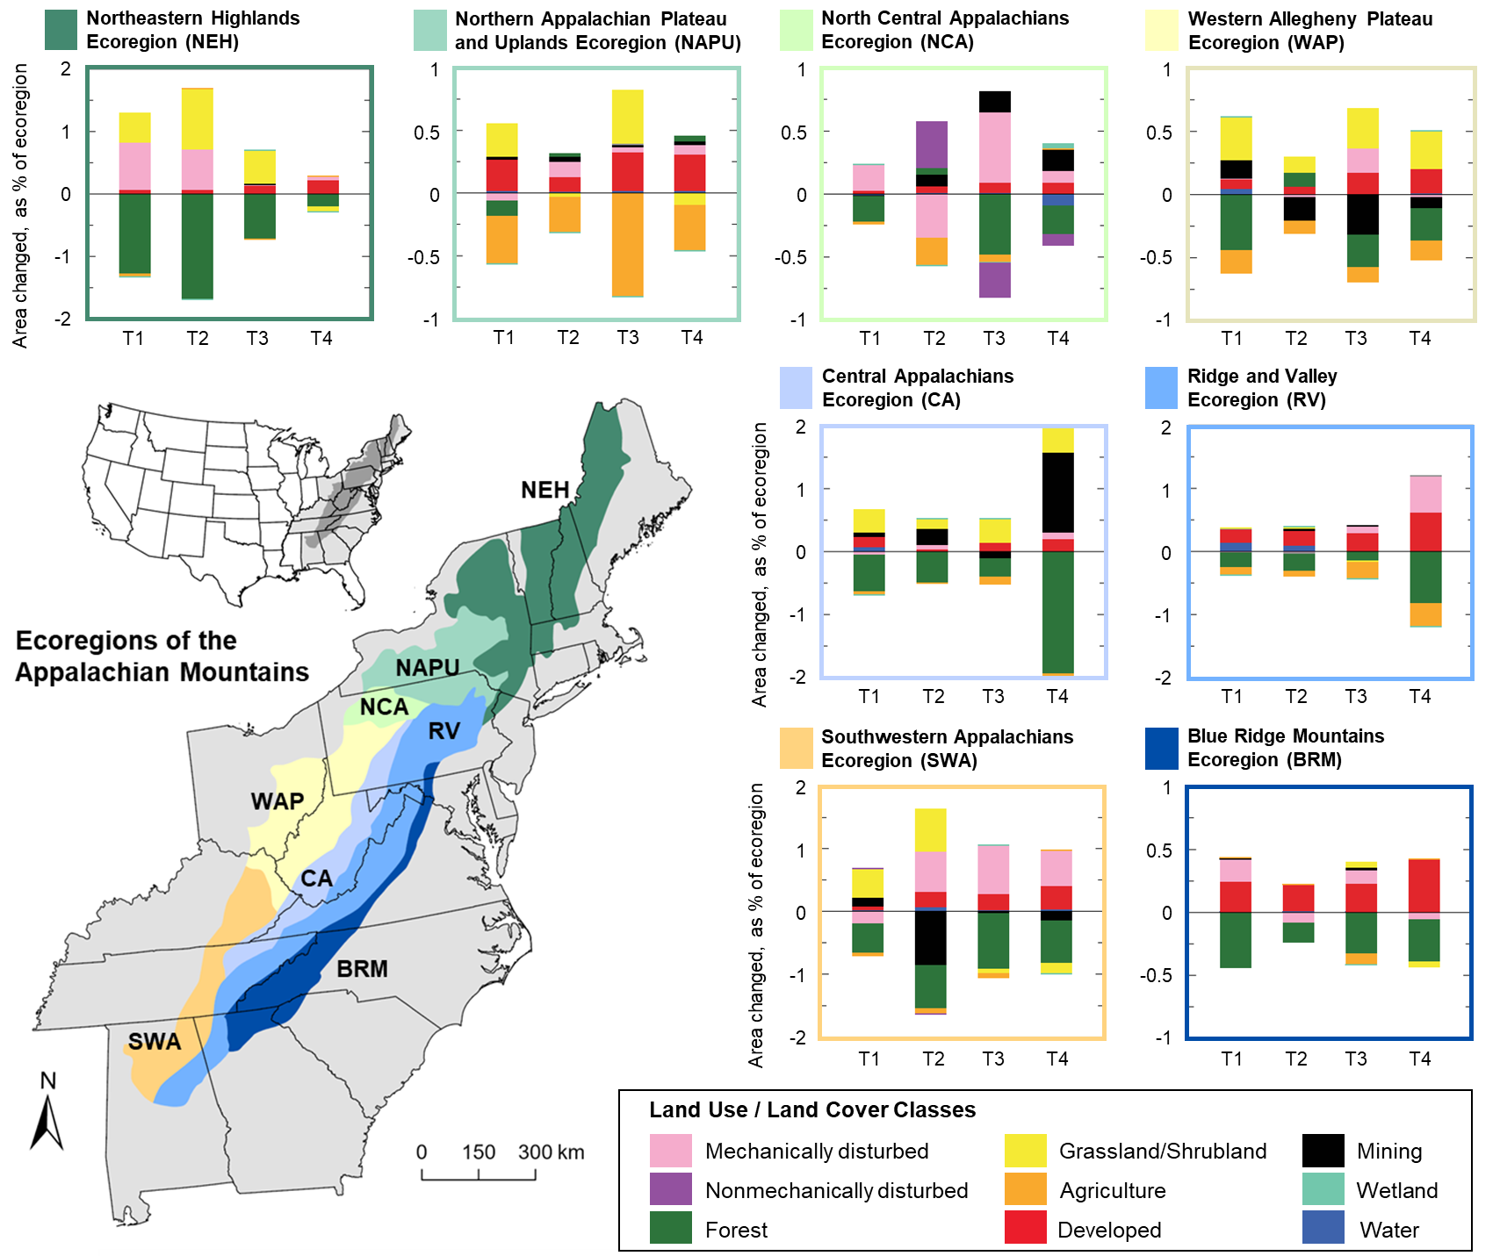

Figure 1. Map of the 8 ecoregions (color-coded and labeled) located within the Appalachian Mountains in the eastern United States, and graphs of land cover change corresponding to each ecoregion. The bar graphs were created by Sayler et al. (2016) as part of a U.S. Geological Survey report on the status and trends of land change from 1973 to 2000 in the eastern United States, detailing changes in land cover classes during 4 time periods (1973–1980, 1980–1986, 1986–1992, and 1992–2000). The graphs indicate changes in the area (measured as the percent of the ecoregion; y-axis) of 9 land cover classes (see legend for categories and color designations) within each ecoregion during the 4 time periods covered by the report (x-axis): T1 = 1973–1980, T2 = 1980–1986, T3 = 1986–1992, and T4 = 1992–2000.

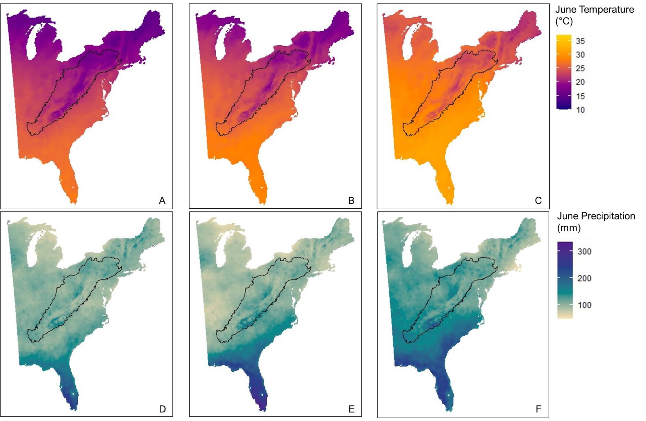

Figure 2. Mean June temperature in degrees Celsius (first row: A, B, C) and total June precipitation in mm (second row: D, E, F) across the eastern United States in 2000 (first column: A, D) and projected to 2100 under lower (second column: B, E) and higher (third column: C, F) greenhouse gas emissions scenarios, with the Appalachian Mountains Bird Conservation Region outlined in black. Contemporary and future monthly climate projections were calculated and compiled by Iverson et al. (2019).

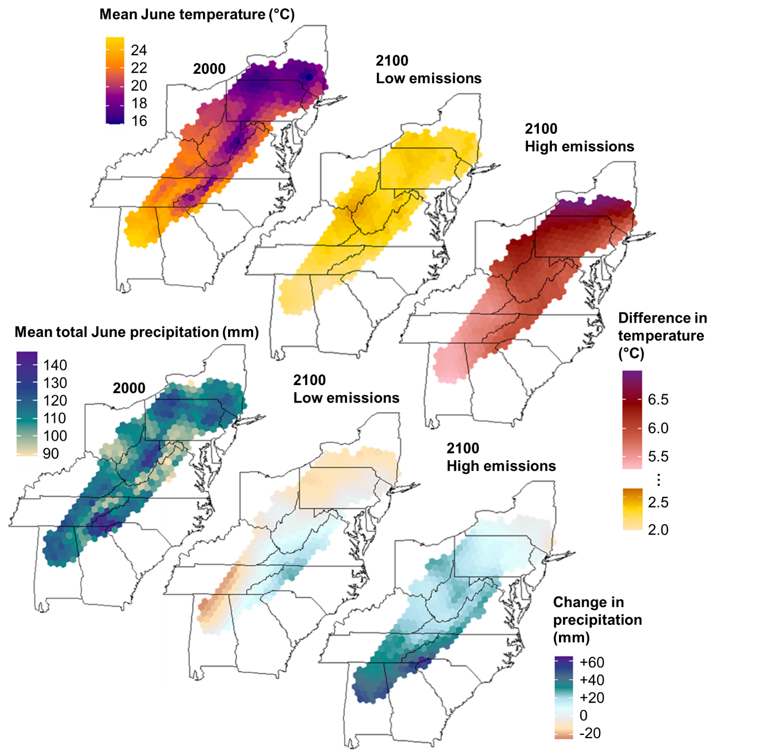

Figure 3. Mean June temperature in degrees Celsius and mean total June precipitation in mm within the Appalachian Mountains Bird Conservation Region (hexagonal grid extent) in 2000 and projections of changes in those climate metrics in 2100 under low and high greenhouse gas emissions scenarios. Contemporary and future monthly climate projections were calculated and compiled by Iverson et al. (2019).



Figure 4. Land cover of the eastern United States in (A) 2000 and projected to 2100 under (B) lower and (C) higher greenhouse gas emissions scenarios. Within the Appalachian Mountains Bird Conservation Region (black outline), shades of green represent different types of forest (deciduous, mixed, and conifer), red represents developed land, and shades of yellow or orange represent agriculture (cropland and hay / pasture land). Future land cover projections were produced by the U.S. Geological Survey Earth Resources Observation and Science Center (Sohl et al. 2007).



Figure 5. Proportion of developed land and proportion of deciduous and mixed forest within the Appalachian Mountains Bird Conservation Region (hexagonal grid extent) in 2000 and projections of changes in those proportions in 2100 under low and high greenhouse gas emissions scenarios. Future land cover projections were produced by the U.S. Geological Survey Earth Resources Observation and Science Center (Sohl et al. 2007).

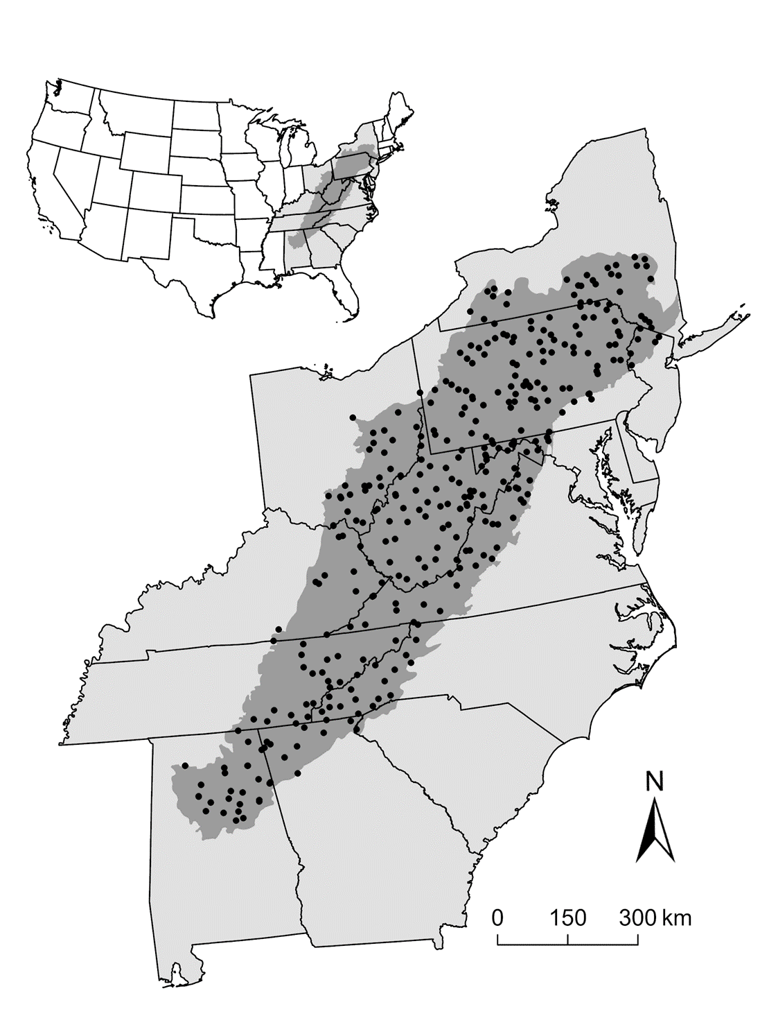

Figure 6. Location and extent of the Appalachian Mountains Bird Conservation Region (shaded in dark gray) in the eastern United States, along with the starting point associated with 322 North American Breeding Bird Survey routes (black points; Sauer et al. 2013) within the study region.

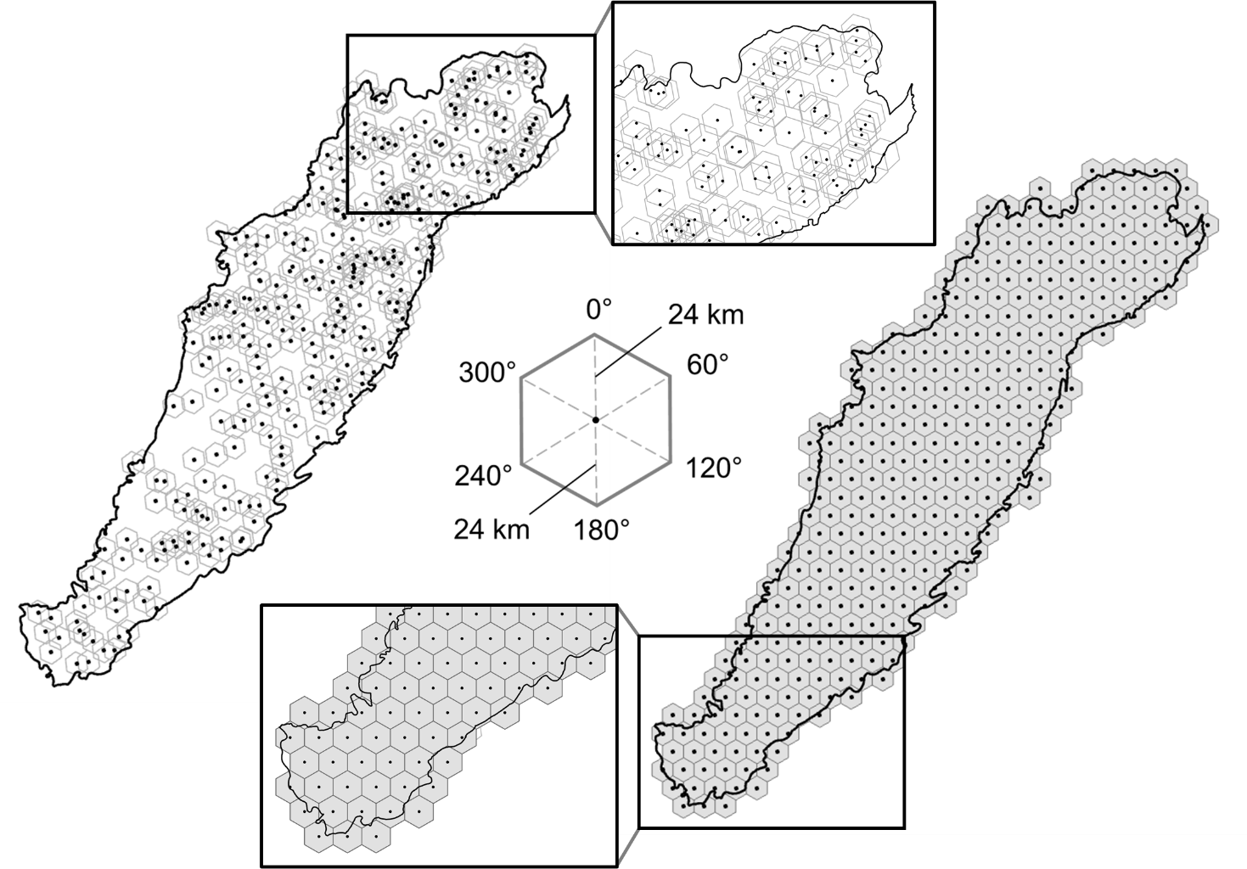

Figure 7. Sampling hexagons (left) corresponding to the 322 North American Breeding Survey routes (black points; Sauer et al. 2013) and hexagonal grid (right) covering the Appalachian Mountains Bird Conservation Region (outlined in black). All hexagons, whether sampling hexagons or hexagonal grid cells, were regular shapes with vertices at 0°, 60°, 120°, 180°, 240°, and 300° that were spaced approximately 24 km from the centerpoint of the hexagon (see center diagram); thus, the hexagonal grid cells (right) used for prediction matched the dimensions of the sampling hexagons (left) used for model building.

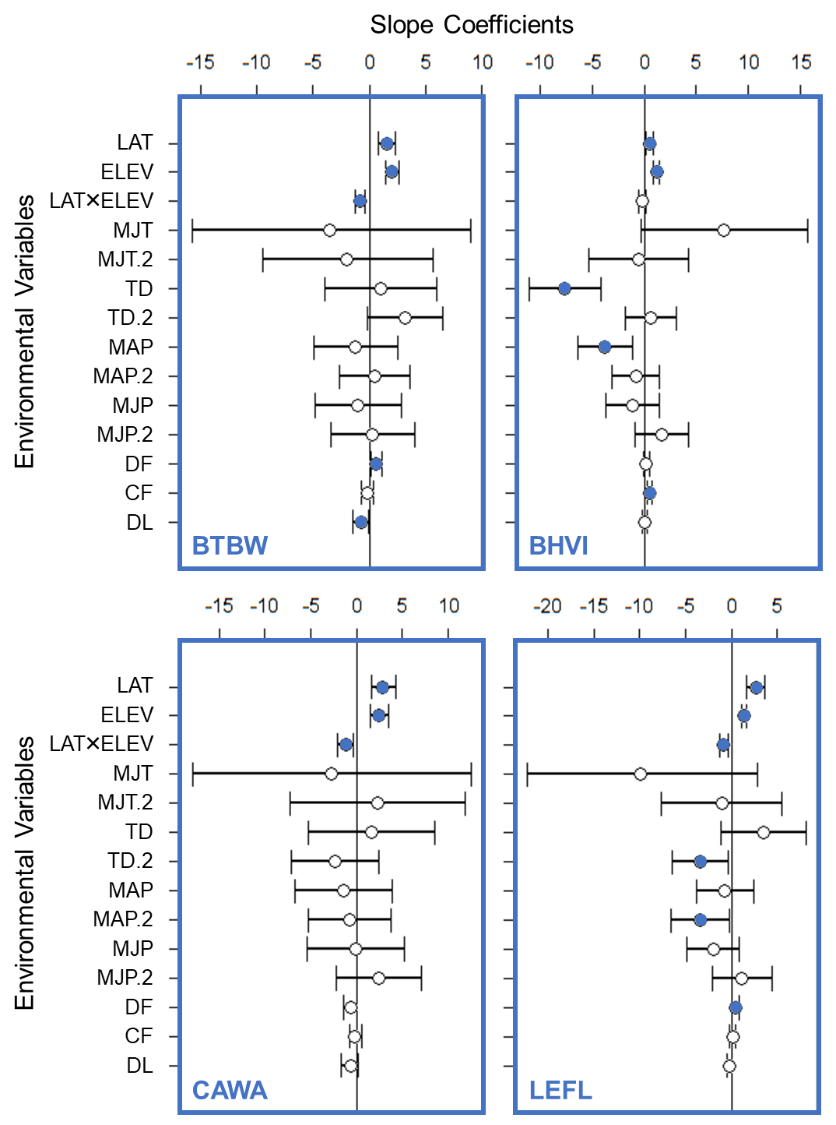

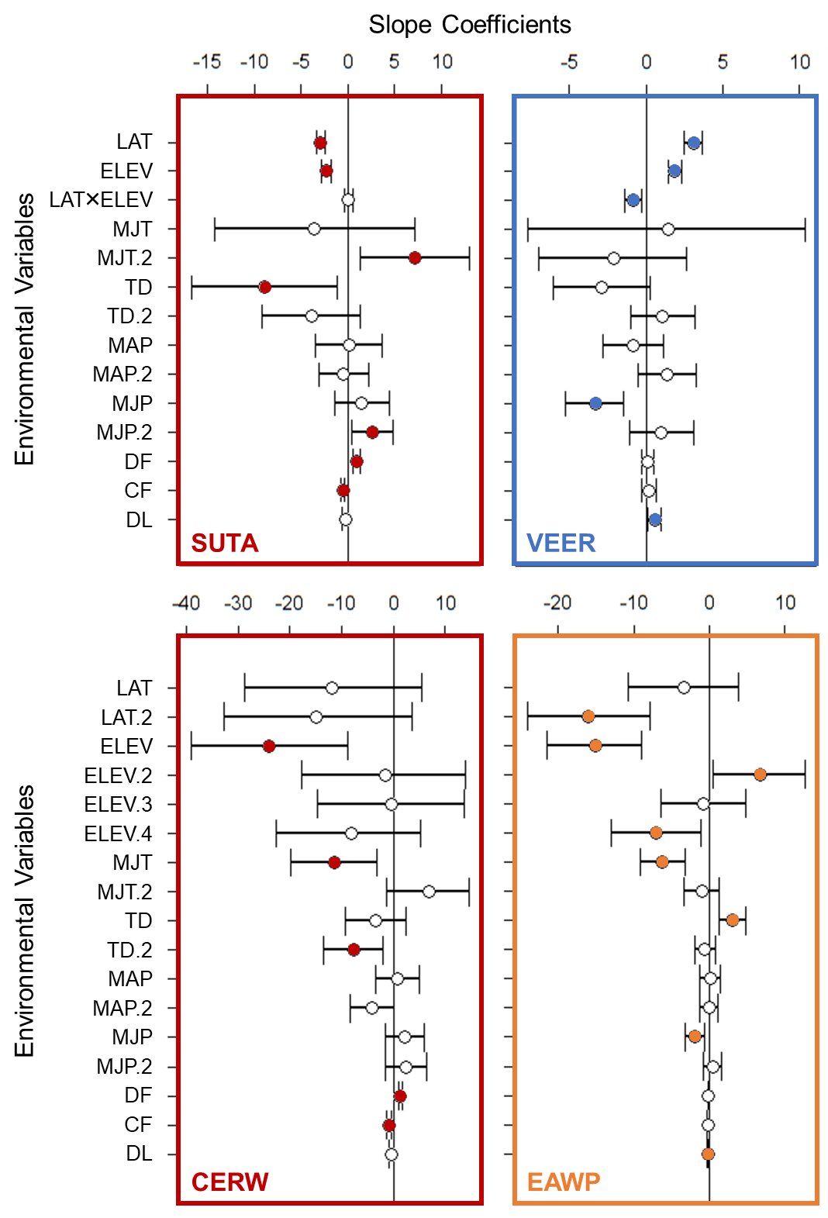

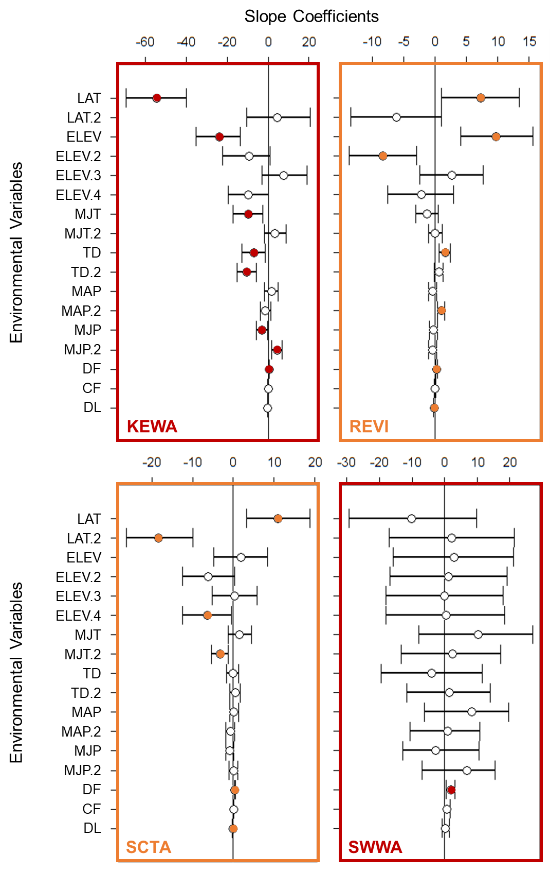

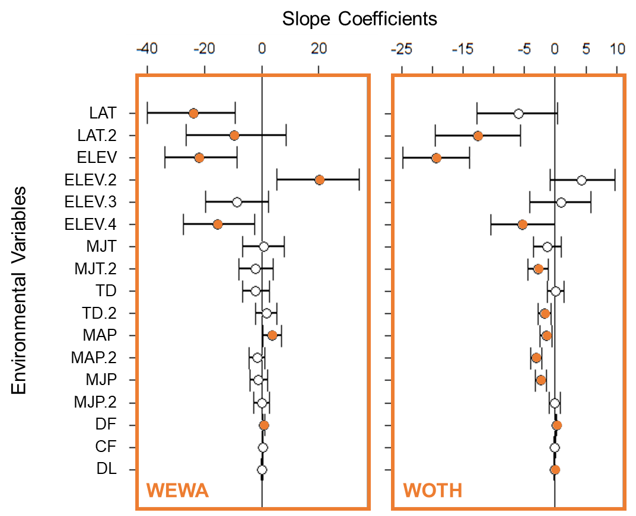

Figure 8. Whisker plots for each species (Table 1), displaying the slope coefficients of the predictor environmental variables (LAT = latitude [1 or 2 parameters], ELEV = elevation [1 or 4 parameters], LAT×ELEV = latitude × elevation interaction [1 parameter], MJT = mean May–June temperature [2 parameters], TD = temperature difference [2 parameters], MAP = mean March–April precipitation [2 parameters], MJP = mean May–June precipitation [2 parameters], DF = deciduous and mixed forest [1 parameter], CF = conifer forest [1 parameter], DL = developed land [1 parameter]), with a point at the mean values for the posterior distributions and whiskers encompassing the 95% credible intervals. For the first 6 species (BTBW, BHVI, CAWA, LEFL, SUTA, VEER), latitude and elevation were both specified as linear and a simple interaction between latitude and elevation was included. For the latter 8 species (CERW, EAWP, KEWA, REVI, SCTA, SWWA, WEWA, WOTH), latitude was specified as an orthogonal polynomial with 2 degrees (i.e., quadratic), elevation was specified as an orthogonal polynomial with 4 degrees, and there was no interaction between latitude and elevation. Points with filled circles indicate statistical significance (i.e., credible intervals do not overlap 0). The color of the 4-letter species code and plot elements indicates the climate classification of that species (blue = cold-associated, red = warm-associated, orange = climate generalist).

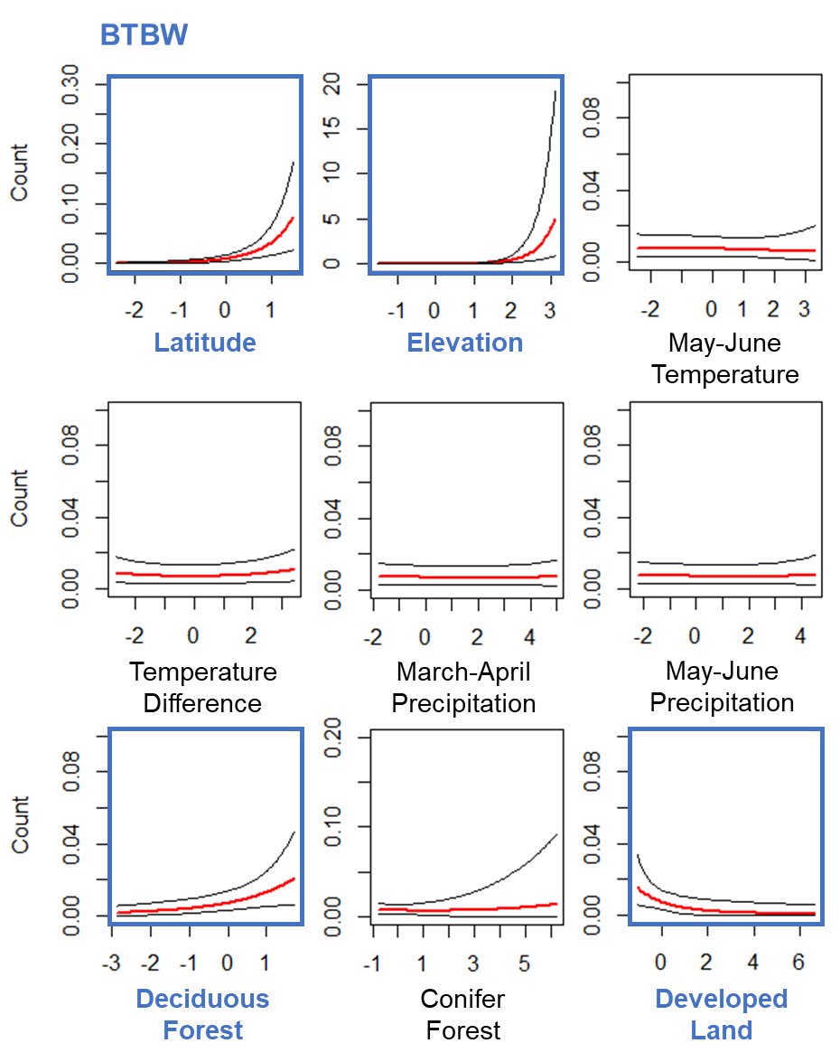

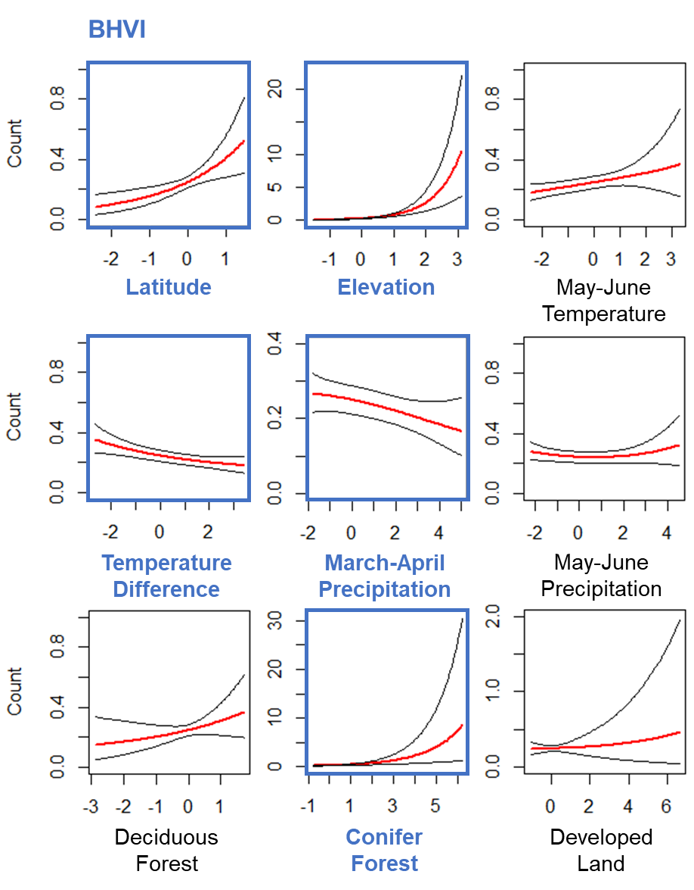

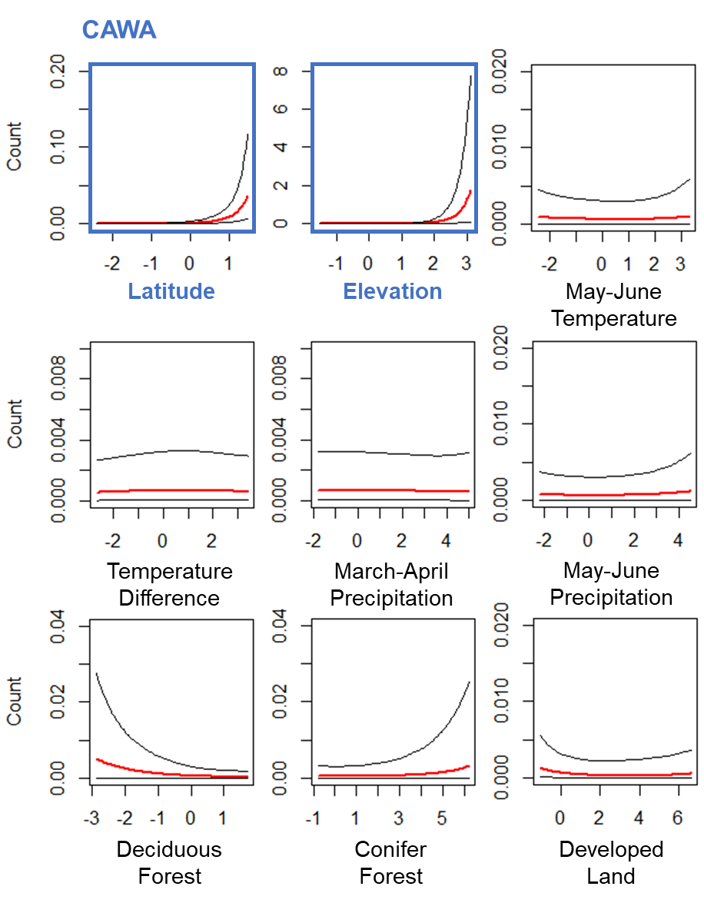

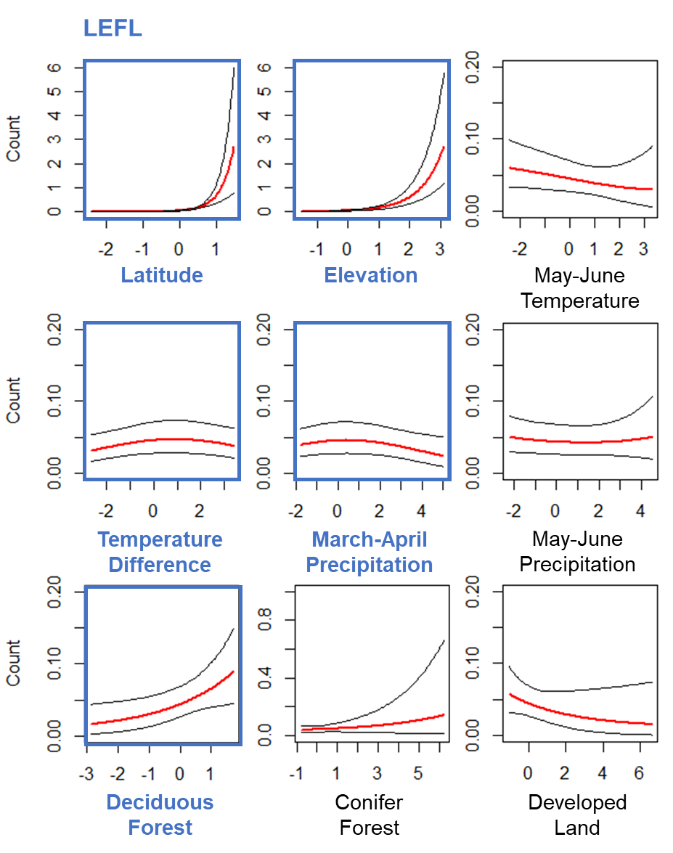

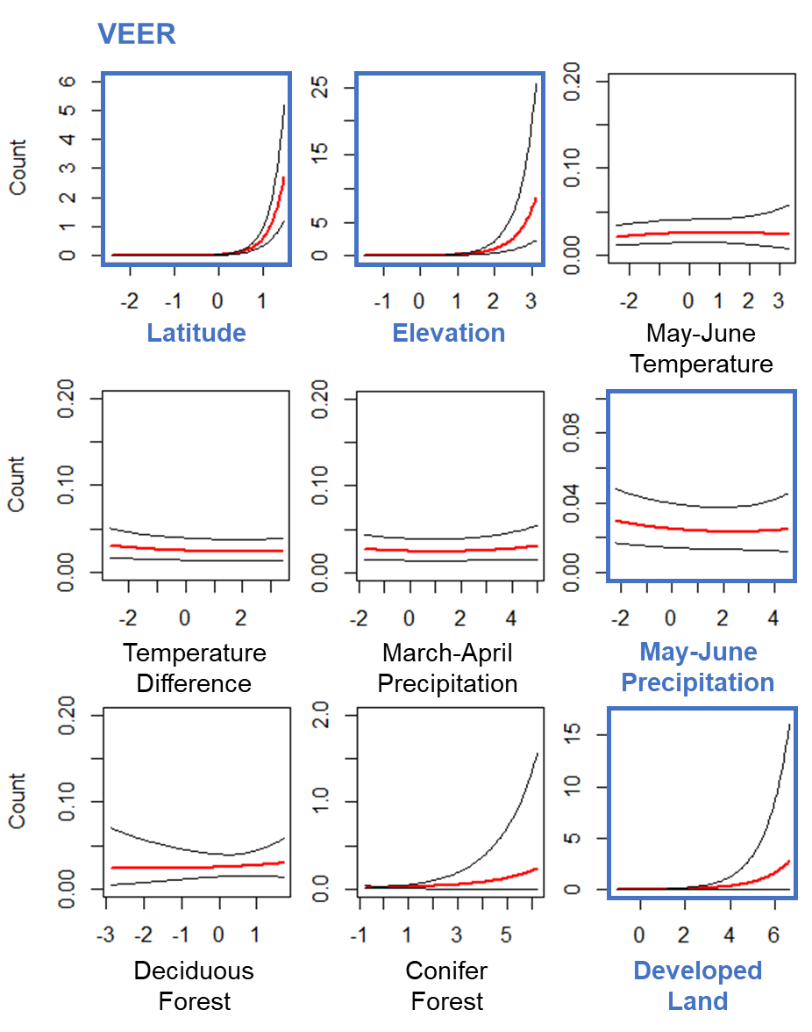

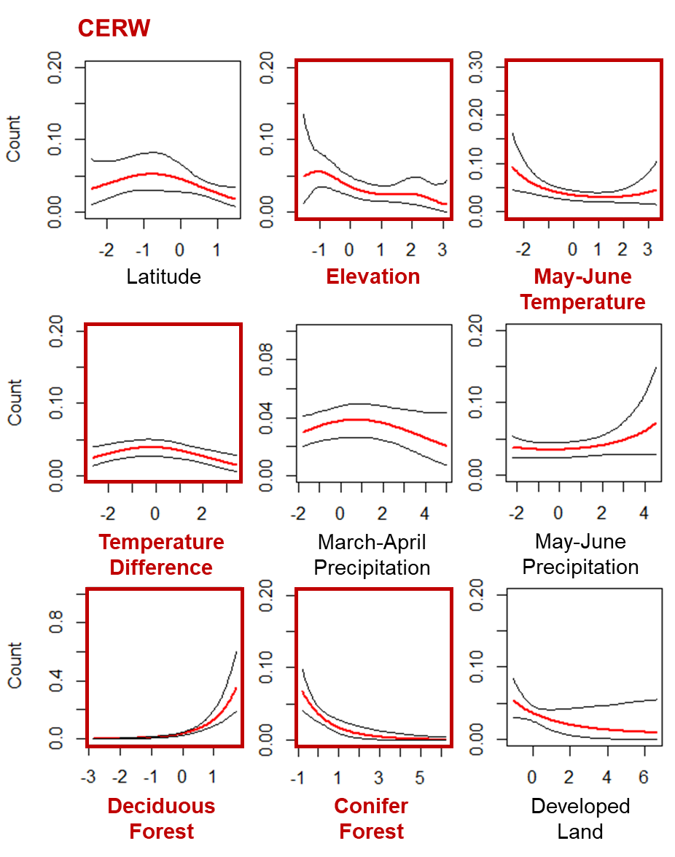

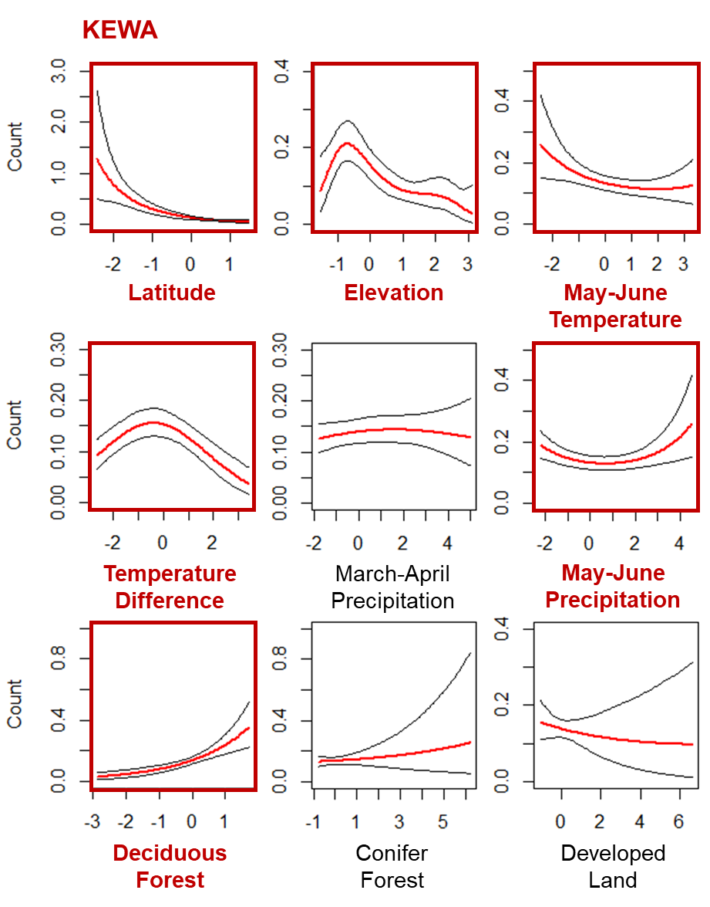

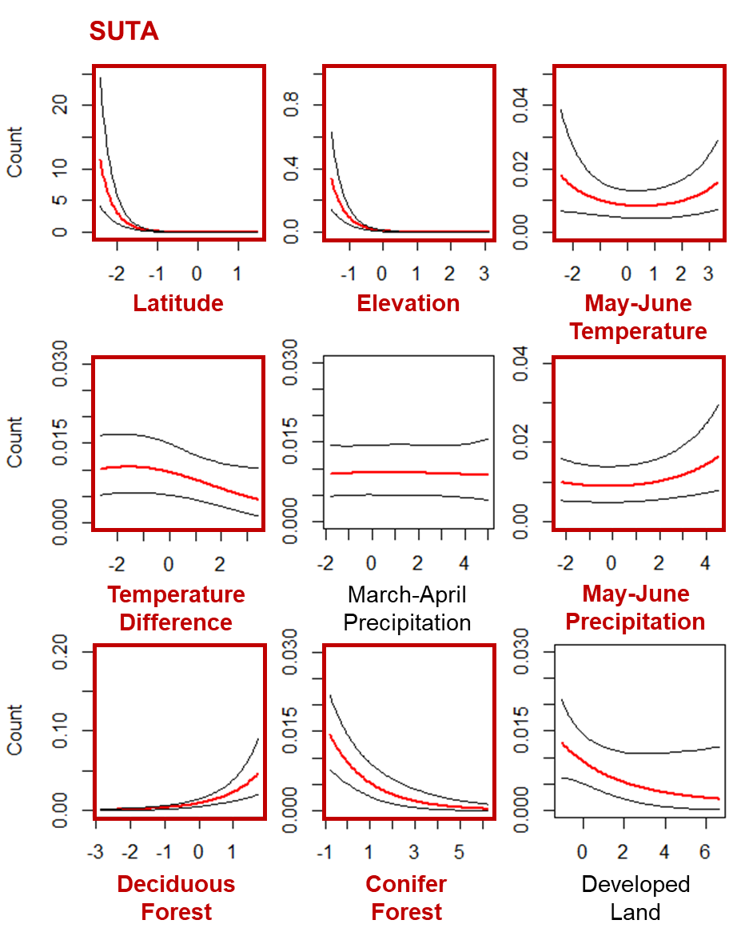

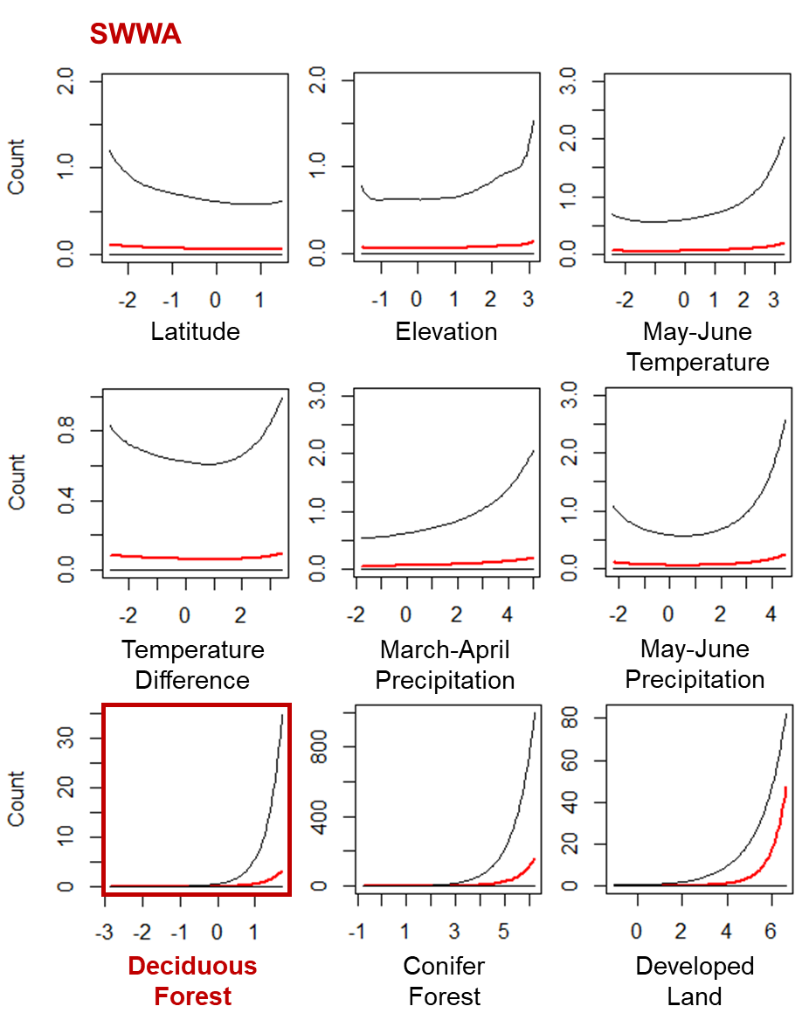

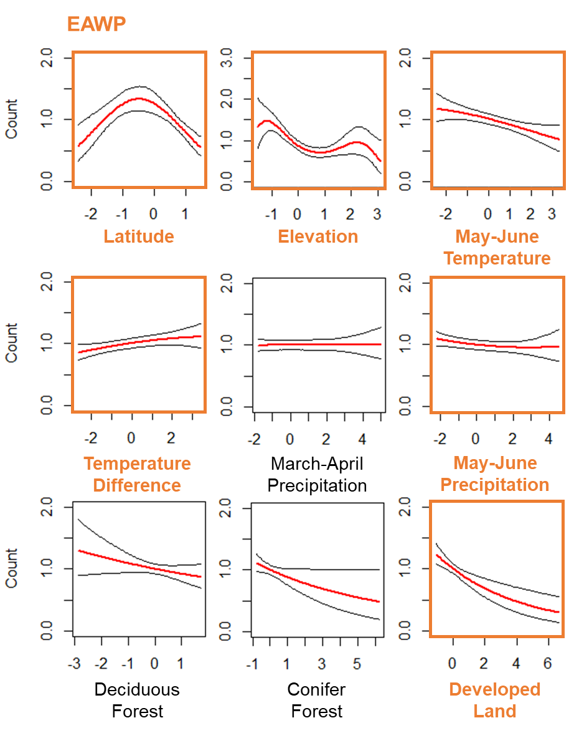

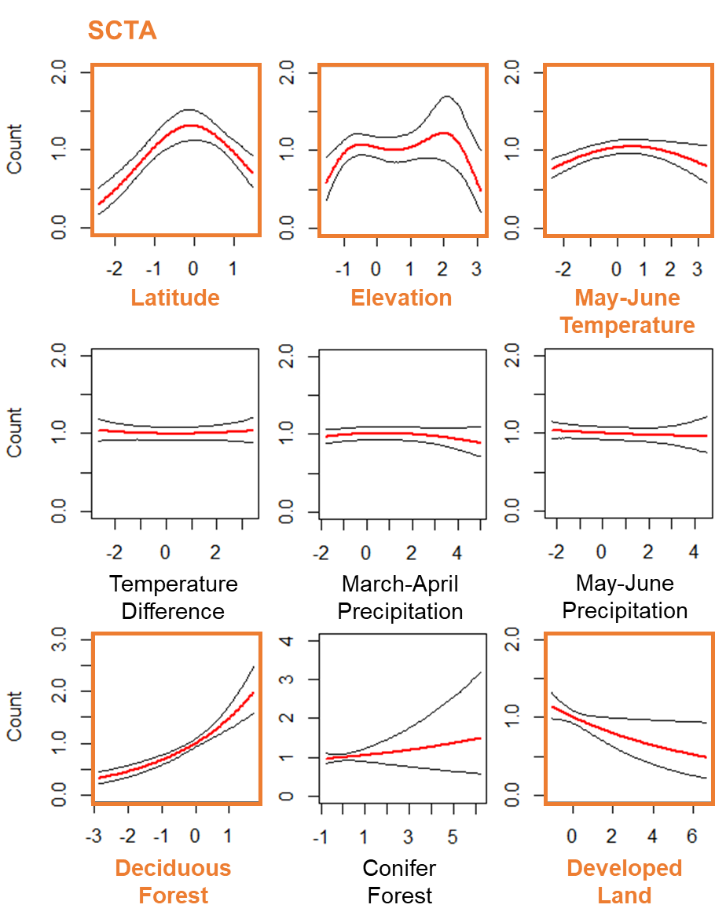

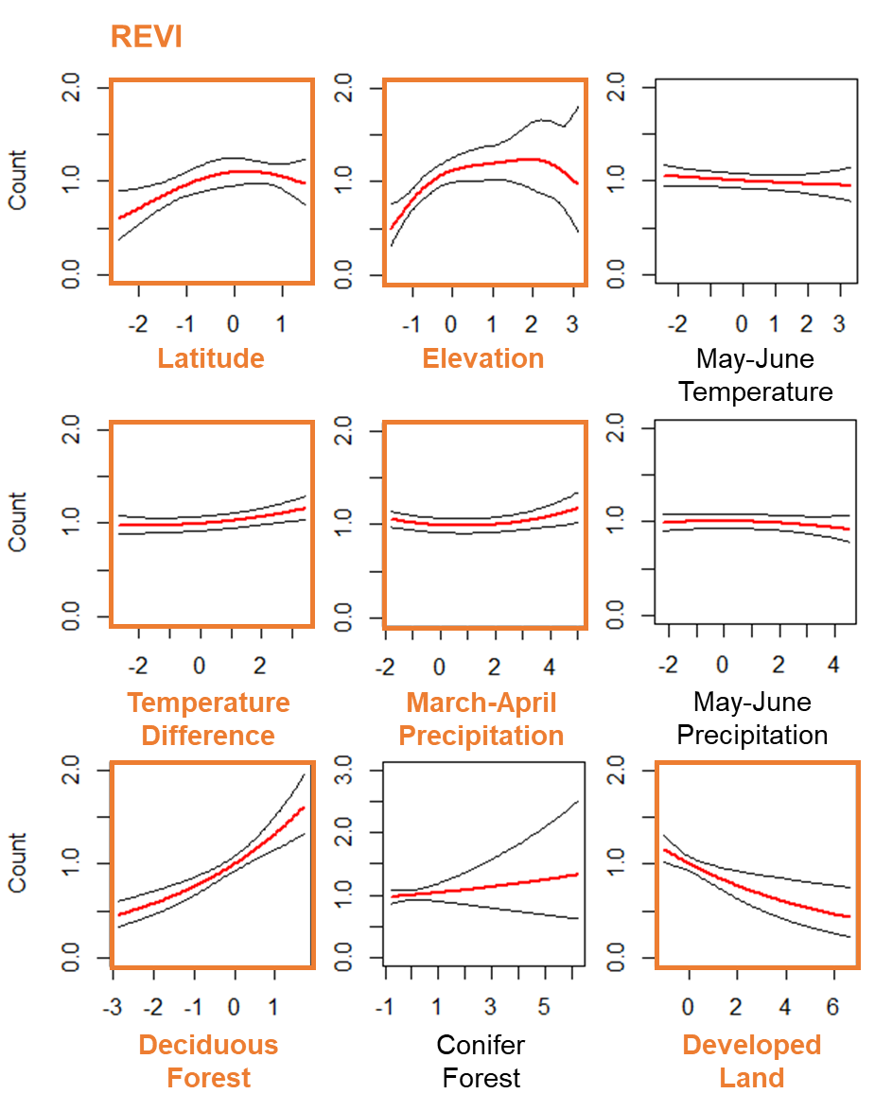

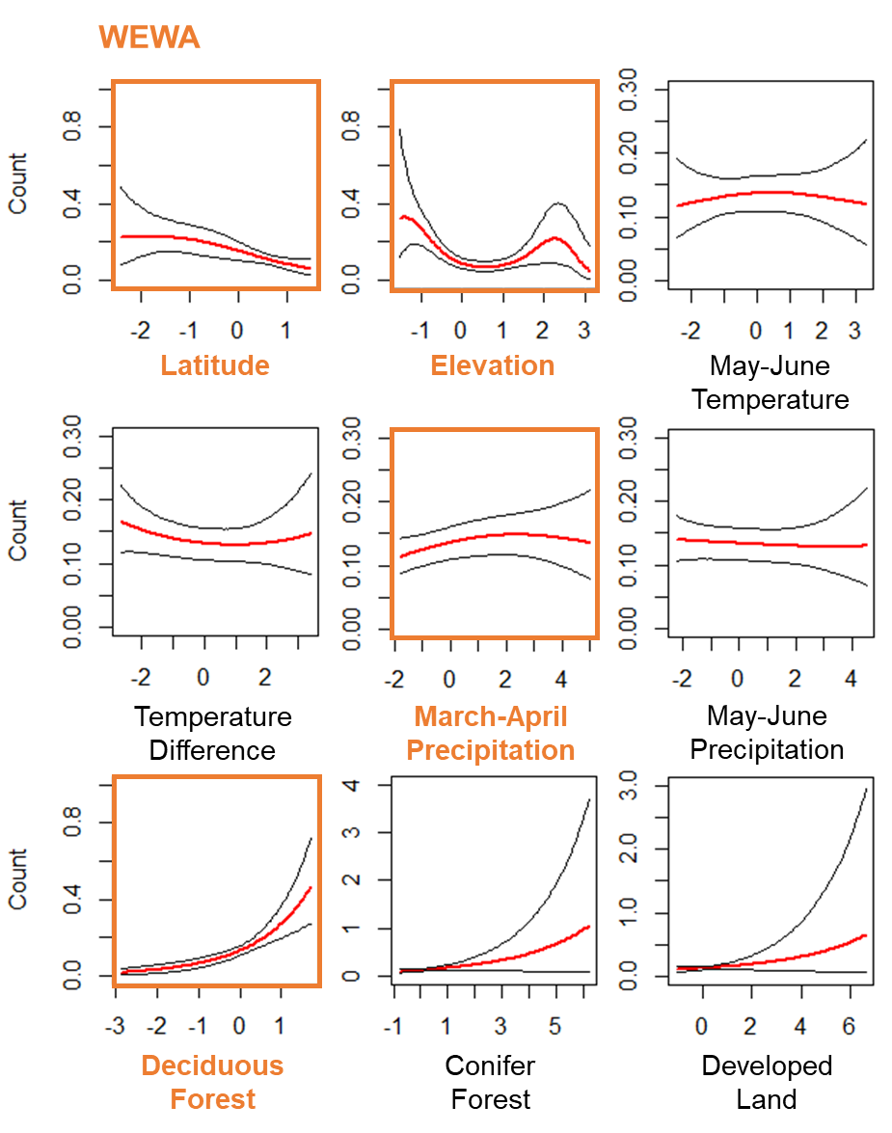

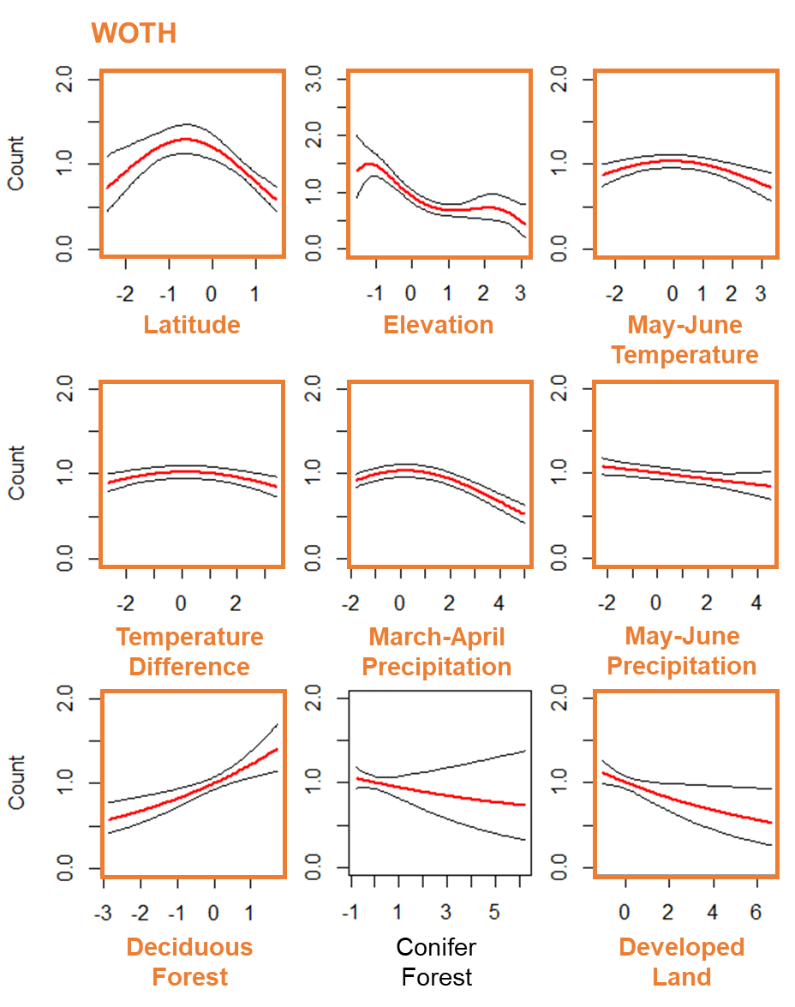

Figure 9. Plots of the relationships between the predictor variables (Table 2) and the mean expected count (red line) for each of the 14 focal forest songbird species (Table 1), with 95% credible intervals (black lines). The predictor variables are scaled, such that 0 is the mean value, and reflect the range of the data. Predictor variables with bolded and colorful font have statistically significant beta coefficients (i.e., credible intervals do not overlap 0). The color of the 4-letter species code and plot elements indicates the climate classification of that species (blue = cold-associated, red = warm-associated, orange = climate generalist).

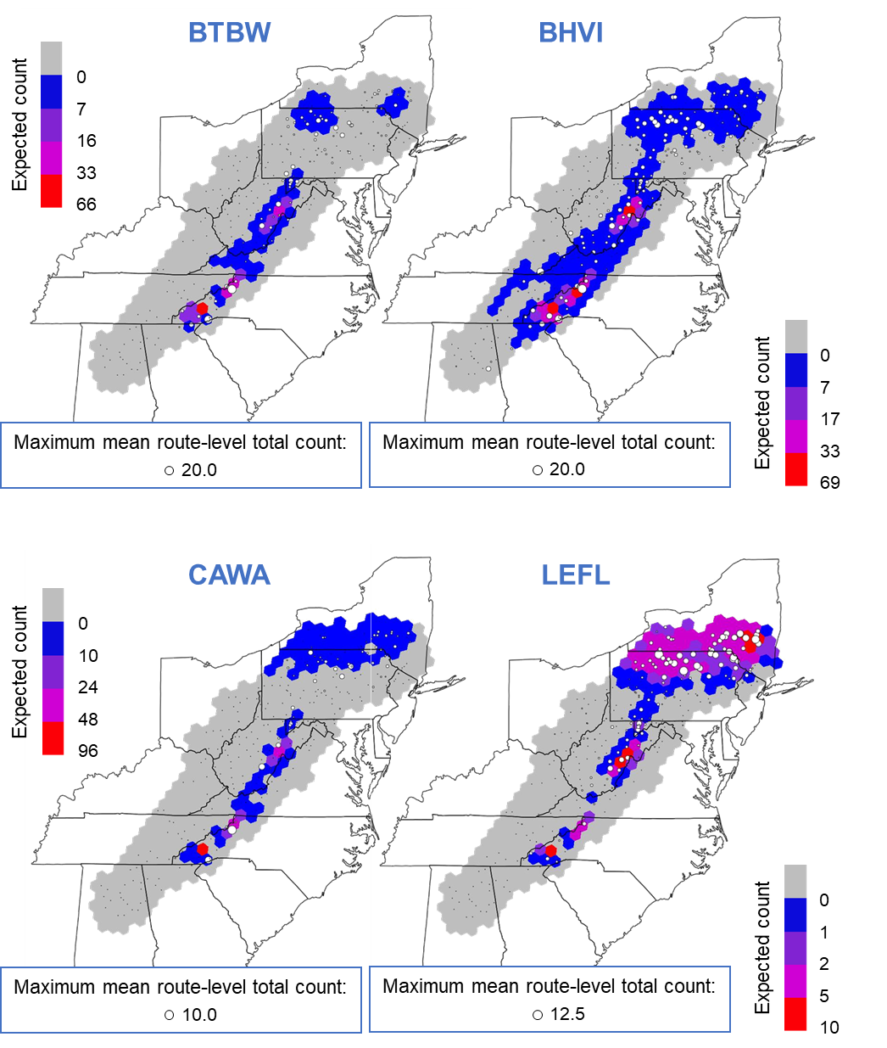

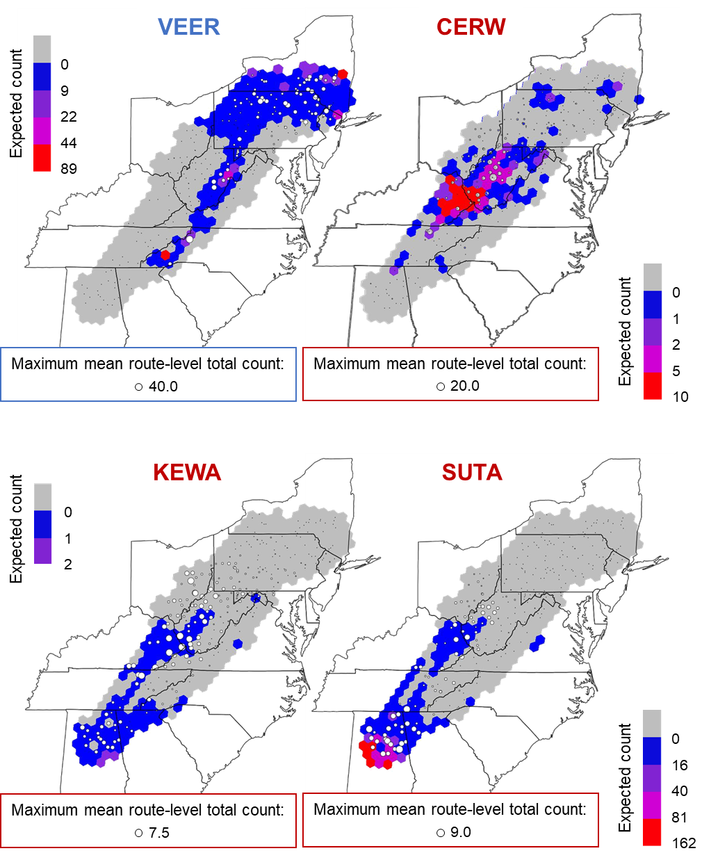

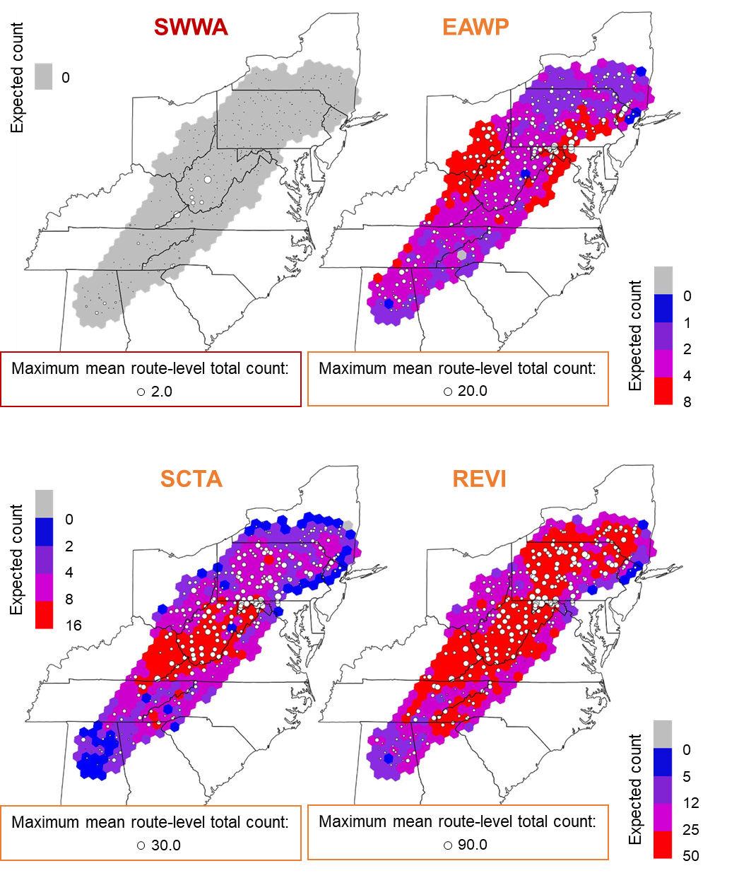

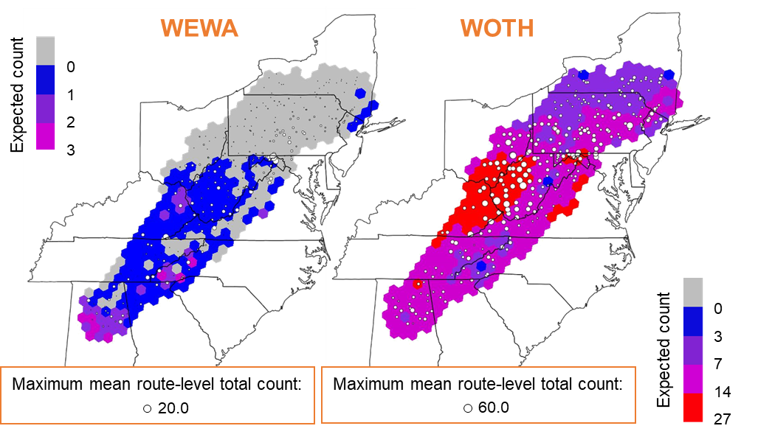

Figure 10. Maps of the projected contemporary (2000) distribution of each focal species (Table 1) across the study region, overlaid with white circles representing the 322 North American Breeding Bird Survey routes. The color of each hexagonal grid cell reflects the expected count from the model corresponding to each species (see Table 3 for model details), and the size of the white circles reflect the mean route-level total counts across years, with the maximum value presented for each species. The color of the 4-letter species code and figure elements indicates the climate classification of that species (blue = cold-associated, red = warm-associated, orange = climate generalist).

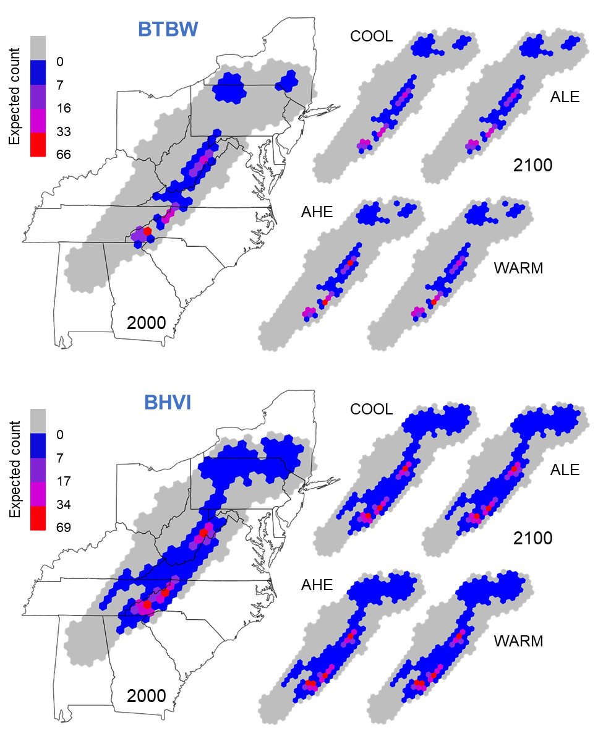

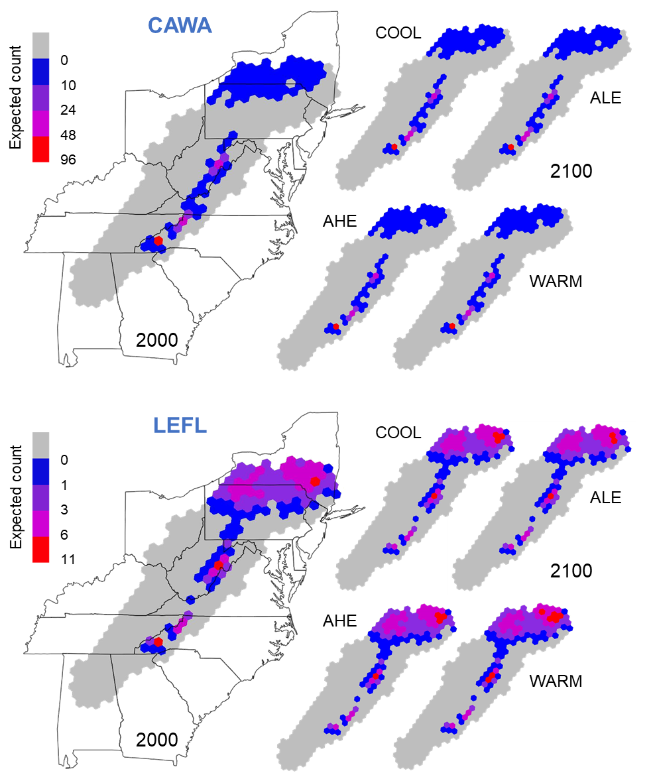

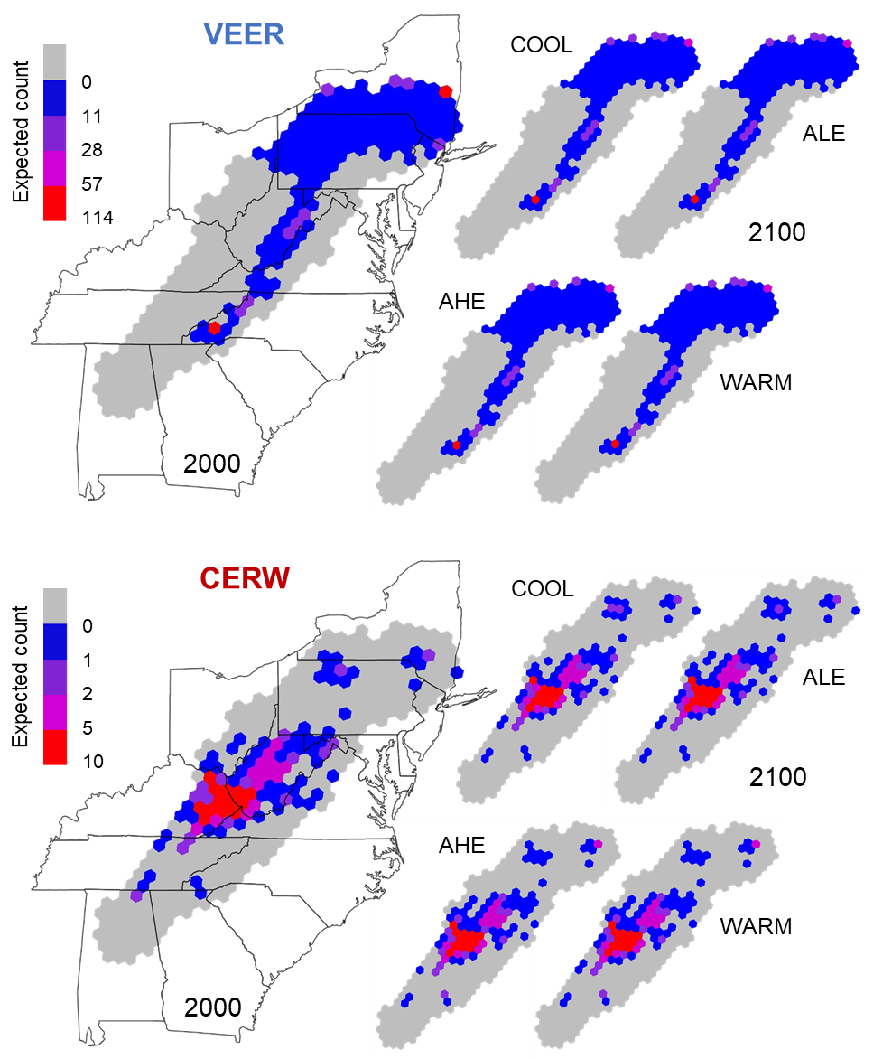

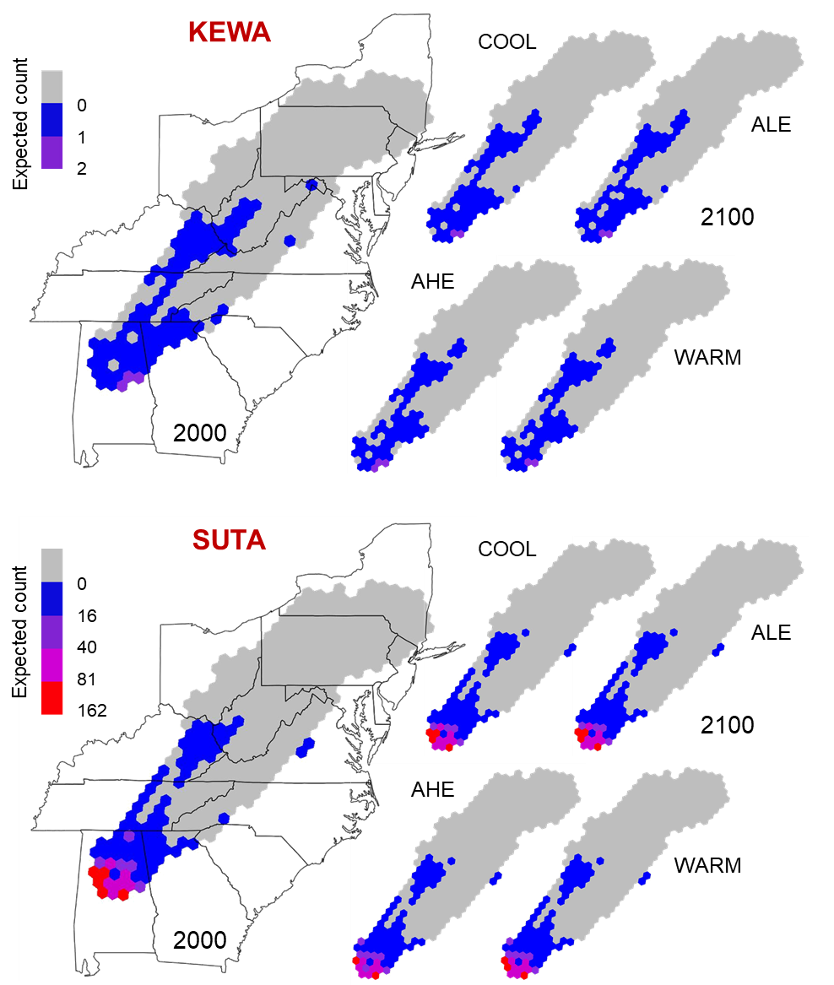

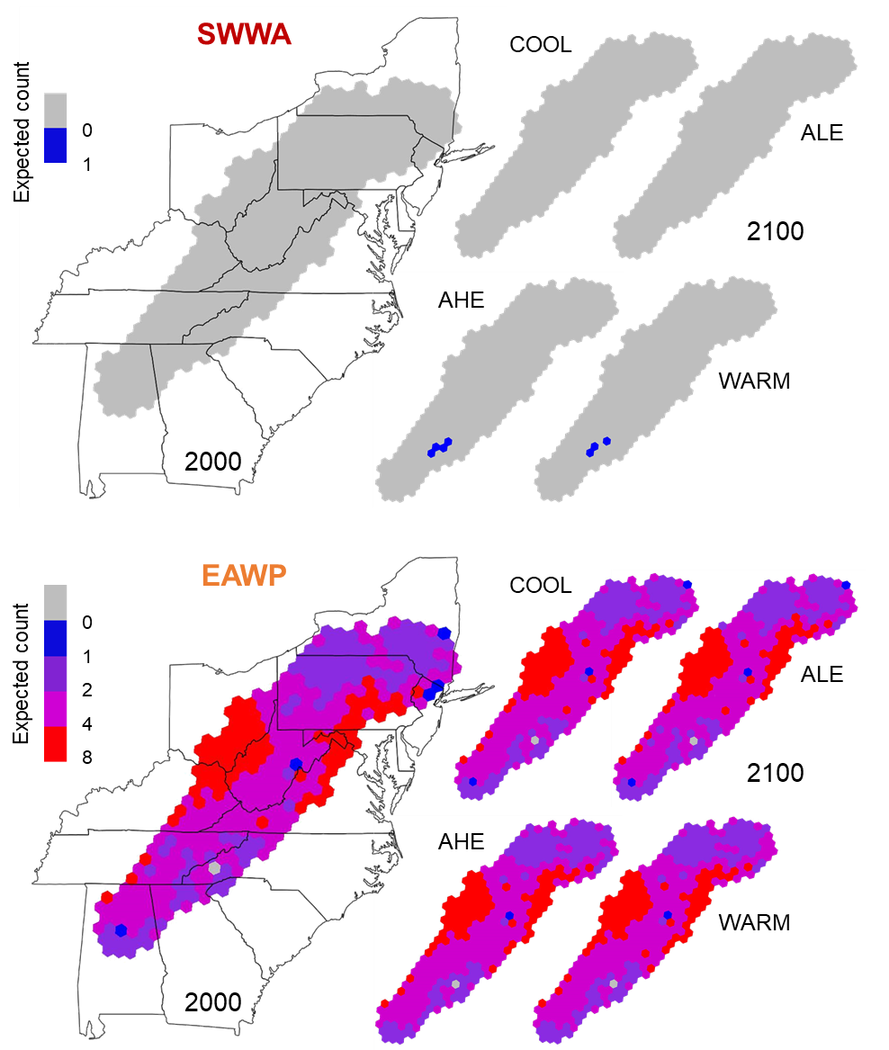

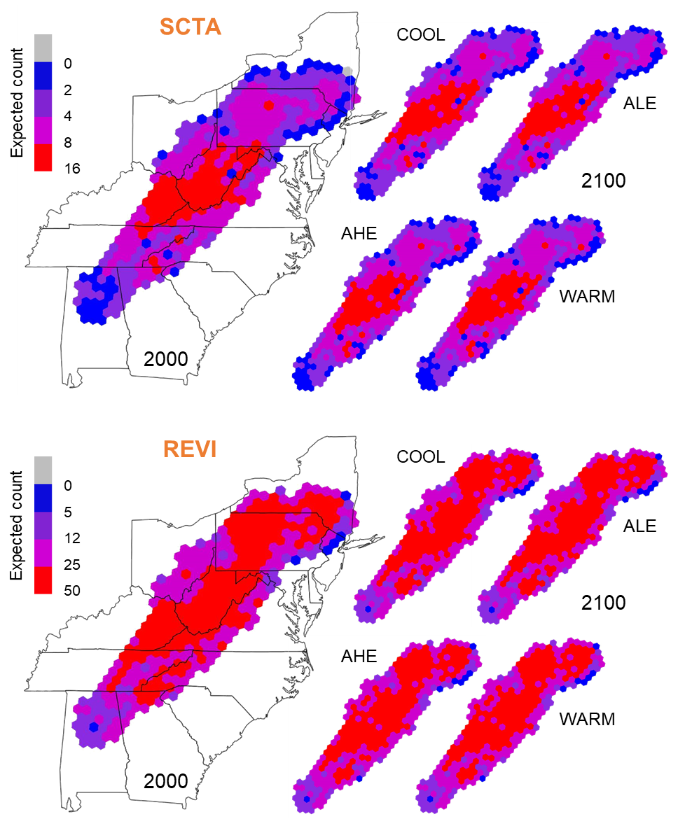

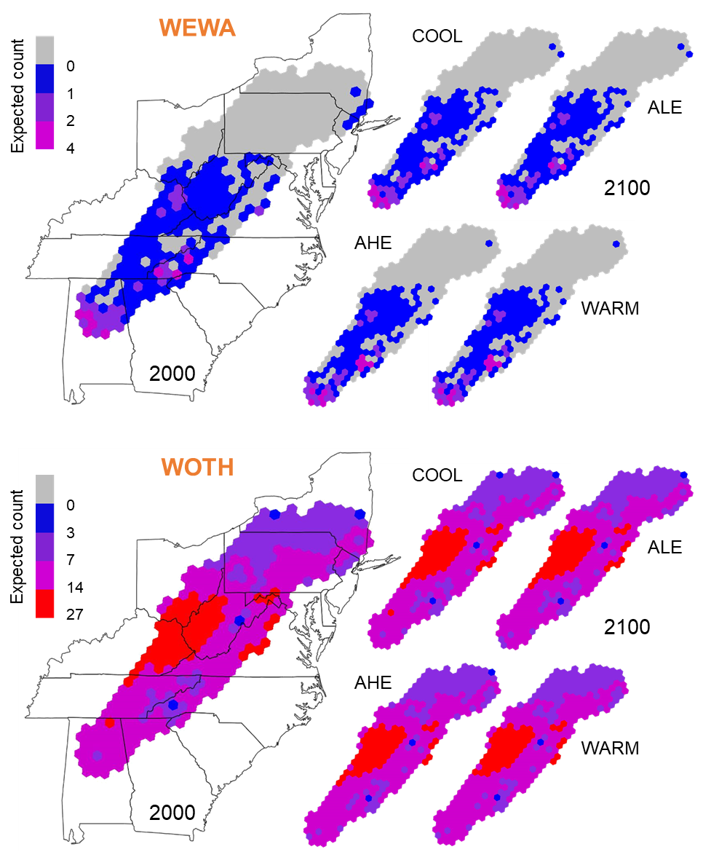

Figure 11. Maps of the projected contemporary (2000) and future (2100) distributions of each focal species (Table 1) across the study region. Future distributions were modeled based on 4 future climate and land cover combination scenarios, the coolest (COOL) and warmest (WARM) scenarios and the average low (ALE) and average high (AHE) emission scenarios. The color of each hexagonal grid cell reflects the expected count from the model corresponding to each species. The color of the 4-letter species code indicates the climate classification of that species (blue = cold-associated, red = warm-associated, orange = climate generalist).

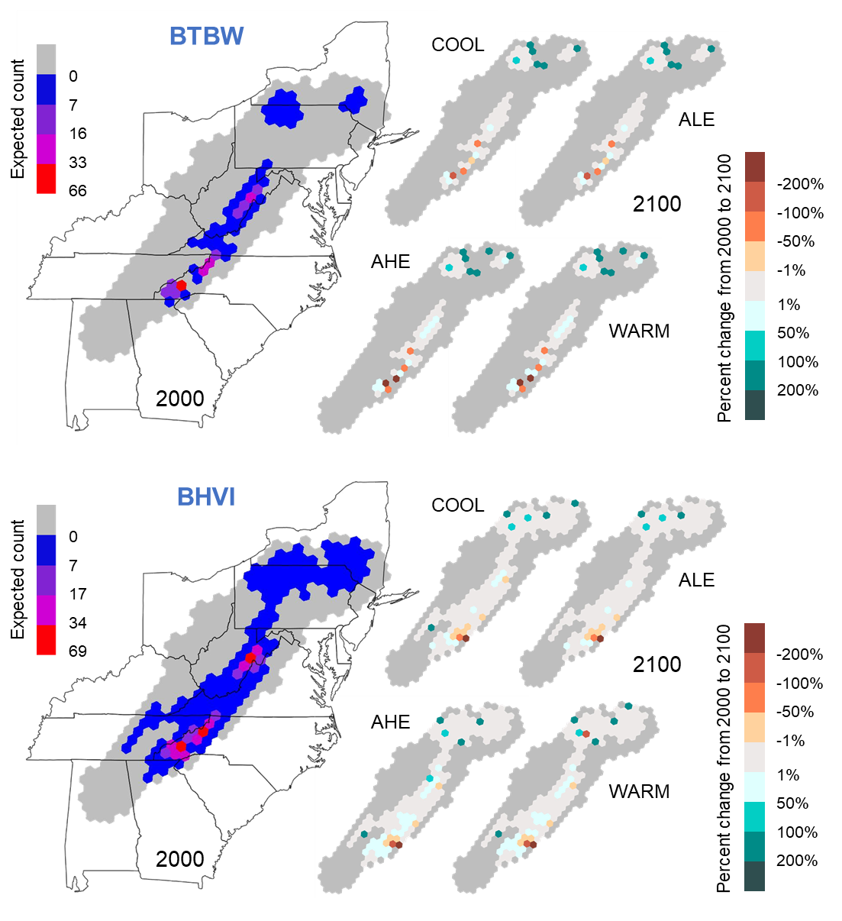

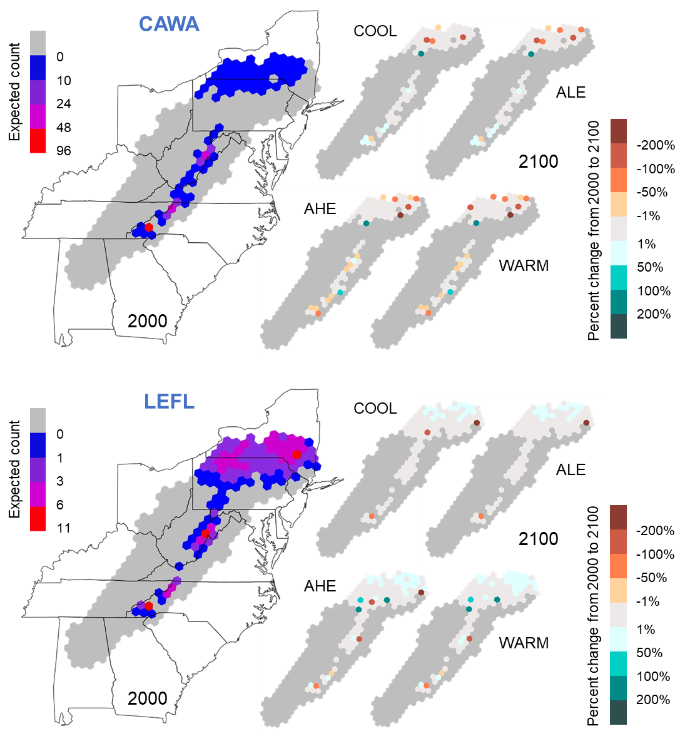

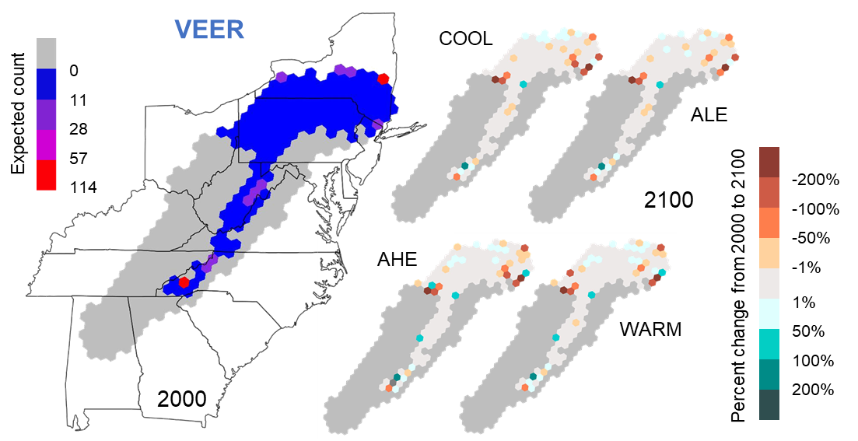

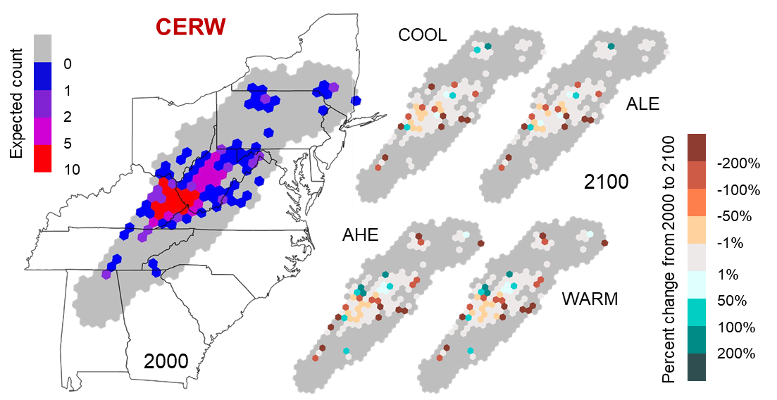

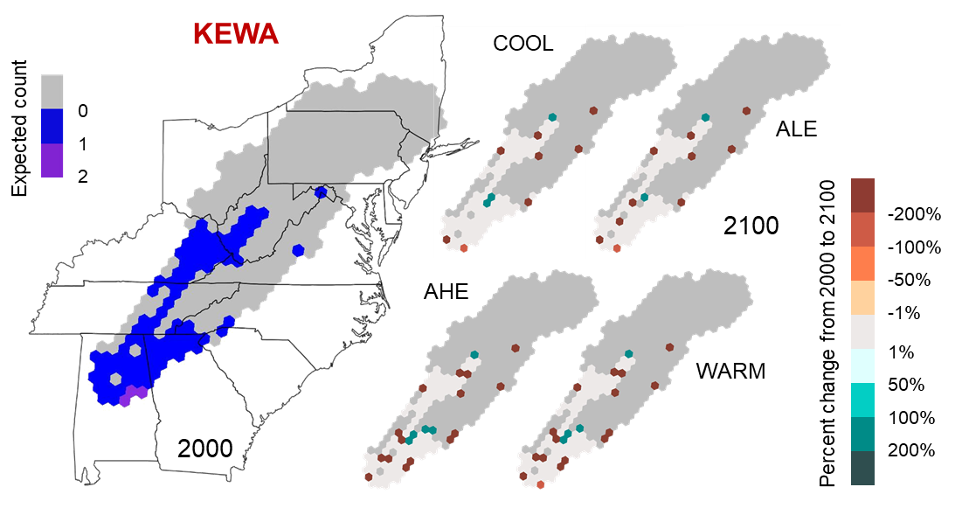

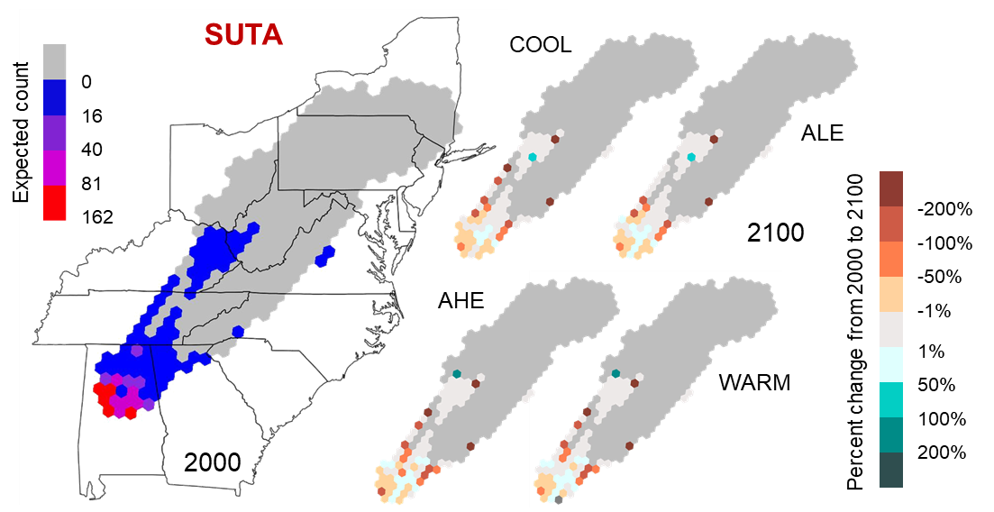

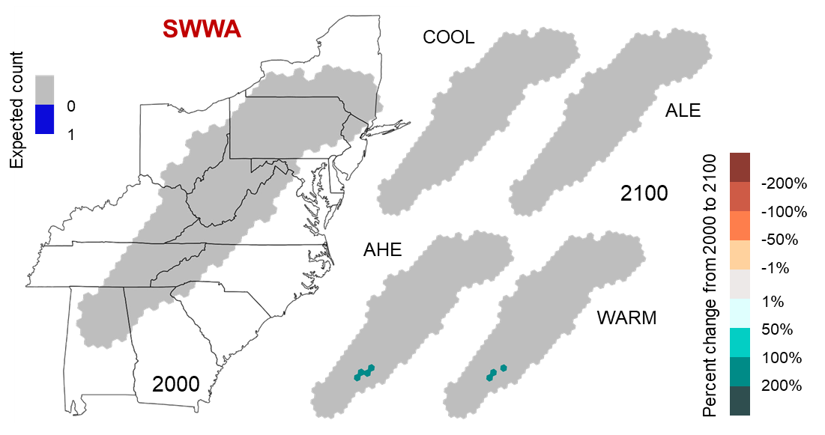

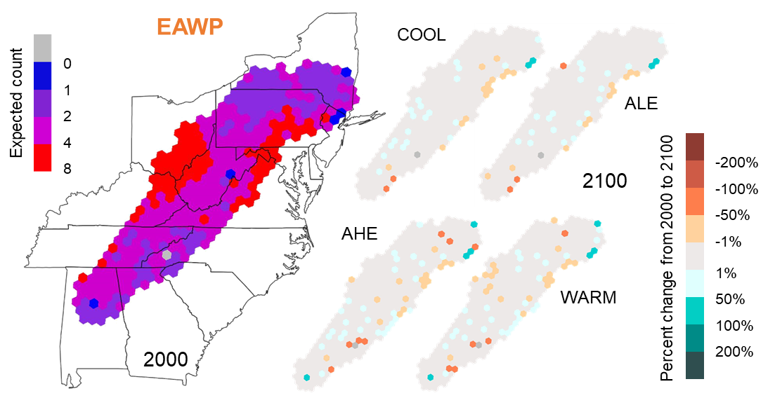

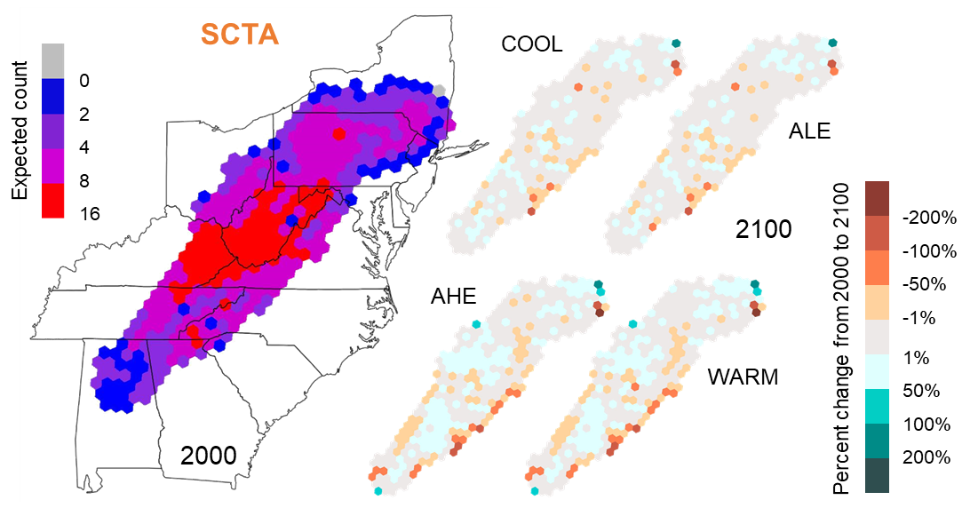

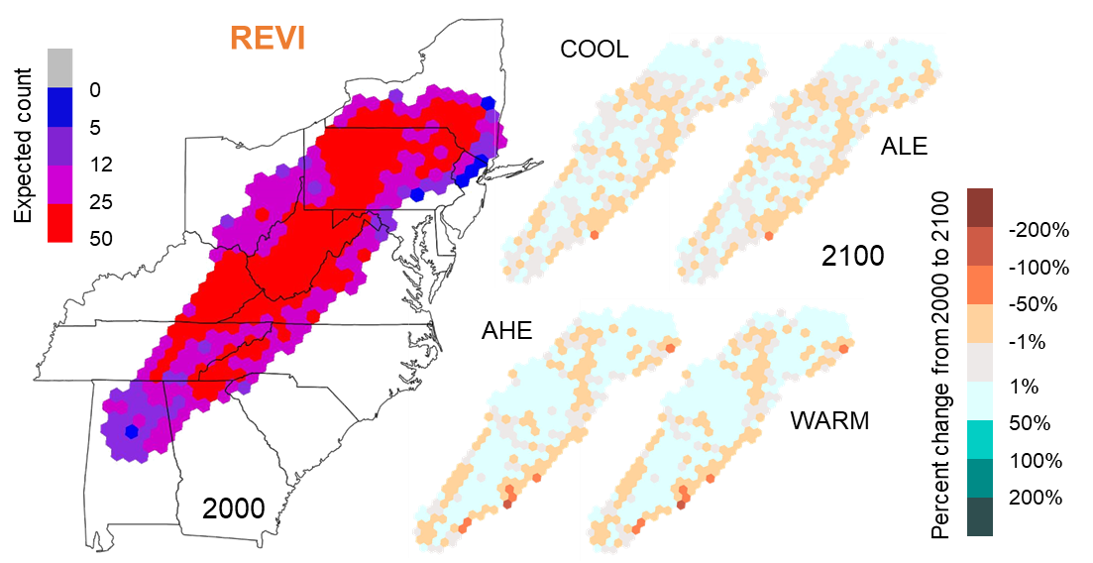

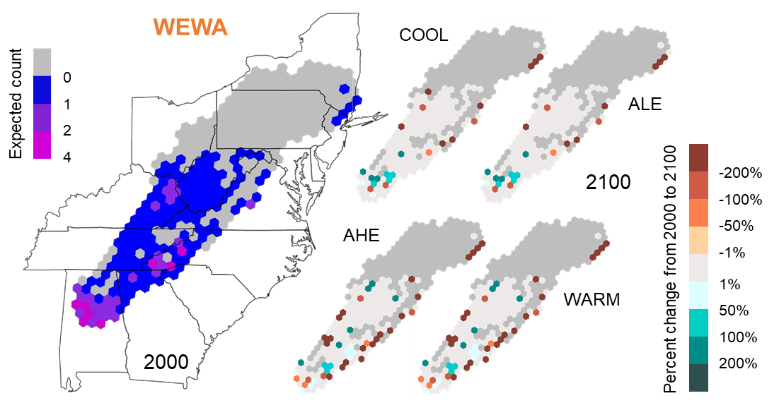

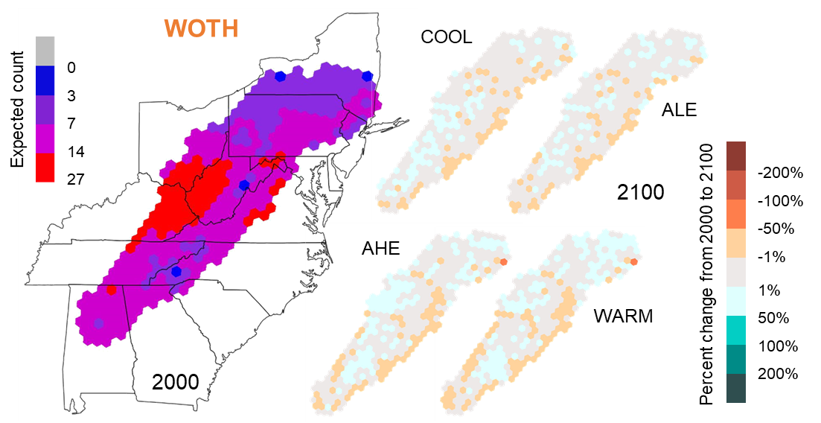

Figure 12. Maps of the percent differences in projected contemporary (2000) and future (2100) distributions of each focal species (Table 1) across the study region. Future distributions were modeled based on 4 future climate and land cover combination scenarios, the coolest (COOL) and warmest (WARM) scenarios and the average low (ALE) and average high (AHE) emission scenarios. The color of each hexagonal grid cell reflects the expected count in 2000 on the left and the percent changes in the expected counts from 2000 and 2100 on the right. The color of the 4-letter species code indicates the climate classification of that species (blue = cold-associated, red = warm-associated, orange = climate generalist).

# CHAPTER 2

**Effects of climate and temporal trends in forest songbird communities and abundance along latitudinal and elevational gradients in the Appalachian Mountains**

## Introduction

Wildlife populations naturally fluctuate over time from local to regional scales. However, consistent and widespread changes in abundance over long time periods are likely connected to a particular set of environmental or anthropogenic drivers, as may be the case for bird species breeding in the forests of eastern North America. Prevailing evidence suggests that forest songbird populations have been decreasing in abundance during the past century. These are passerine and near-passerine species that primarily breed in mature forest habitat, often nesting in trees and feeding on tree-associated insects (e.g., Lepidopteran larvae). Past qualitative investigations note that numbers of certain forest songbird species breeding in eastern deciduous forests declined from the mid-1930s to the 1970s (Temple and Temple 1976, Ambuel and Temple 1982). Long-term data from annual, nationwide breeding bird surveys indicate that numerous bird species, many of which breed in forests (Robbins et al. 1989), have experienced decreases in their populations throughout the eastern United States from 1966 to 2019 (Sauer et al. 2020). Additionally, a recent quantitative study using data from multiple and independent monitoring networks demonstrated bird population losses across much of North America since 1970, including a negative change within the range of -15.6% to -19.2% in birds breeding in eastern forests, with 63.5% of those species in decline (Rosenberg et al. 2019). The U.S. Fish & Wildlife Service considers a statistically significant (*p* ≤ 0.1) population trend of -15% to -50% during this time period to be a “possible large decrease” and has identified 12 songbird species that breed in forests of eastern North America as “birds of conservation concern” (U.S. Fish & Wildlife Service 2021). Without targeted conservation action, there is concern that consistent declines in these and other bird populations will continue, with the potential for species to become endangered or even become extirpated (i.e., locally or regionally extinct) (Rosenberg et al. 2019).

In addition to multiple other factors, global climate change may contribute to declining populations of forest songbirds in eastern North America (Stephens et al. 2016, Rosenberg et al. 2019). Rising temperatures associated with climate change can negatively impact birds through direct and indirect interactions (Trautmann 2018). Warmer temperatures directly affect behavior (e.g., activity levels), thermoregulation, and incubation (Robbins 1981, Crick 2004), and temperature variability can affect energy expenditure, with consequences for reproductive output (Pendlebury et al. 2004). Temperature can also interact with landscape factors to lower songbird reproductive success (Cox et al. 2013*a*), and increasing temperatures may elevate rates of nest predation (Cox et al. 2013*b*). Furthermore, there is strong evidence that rising temperatures cause phenological mismatches between birds, vegetation budding dates, and emergence of / peaks in their insect prey (Visser et al. 2006, Waite and Strickland 2006). In North America, the interval between spring green-up and arrival of migratory passerine species has increased, with certain species unable to keep pace (Mayor et al. 2017). These phenological changes can have fitness consequences; species populations may begin to decline if they fail to advance their egg-laying dates in response to increasing spring temperatures over time (Pearce-Higgins et al. 2015, Franks et al. 2018, Koleček et al. 2020). Changing precipitation patterns associated with climate change may also have direct and indirect negative effects on bird populations. Precipitation directly affects thermoregulation (Leech and Crick 2007), nest site selection (Martin 2001), and nest success and juvenile survival (Sherry et al. 2015). In the northeastern United States, precipitation was determined to influence bird species abundance (Duclos et al. 2019). Previous studies have also found lagged correlations between bird population trends and precipitation from the prior year (Pearce-Higgins et al. 2015). Overall, climate change appears to play a role in declining forest songbird populations in eastern North America through synergistic effects of changing temperatures and precipitation patterns.

However, climate change is unlikely to affect all forest songbird species in the same way. Negative impacts from warming temperatures may be most pronounced for cold-associated species (i.e., those that breed primarily in regions with colder temperatures, such as northern latitudes or high elevations), whereas climate generalist species (i.e., those that breed in regions with wide-ranging temperatures, without a strong association with particular latitudes or certain elevations) and warm-associated species (i.e., those that breed primarily in regions with warmer temperatures, such as southern latitudes or low elevations) may have a neutral or positive relationship with temperatures. For instance, studies often indicate that cold-associated species that occur at high elevations are particularly vulnerable to climate change (Rodenhouse et al. 2008, Siegel et al. 2014). In contrast, there is evidence of the distributions of warm-associated, low-elevation species expanding in regions where mean temperatures are rising (DeLuca and King 2017). Overall, climate change is expected to result in changes in the numbers of cold-associated species vs. climate generalist species vs. warm-associated species (i.e., climate-related guild richness) (Rodenhouse et al. 2008, Stralberg et al. 2009), with climate specialists and cold-associated species likely to be more negatively affected by higher temperatures than climate generalists or warm-associated species (Pearce-Higgins et al. 2015). In extreme circumstances (e.g., crossing unknown thresholds in tolerable climate conditions), certain cold-associated species could be at risk of extirpation from sites or regions within their current range as temperatures continue to warm (Schwartz et al. 2006, Sekercioglu et al. 2008, Tayleur et al. 2016, Freeman et al. 2018).

Although it may be possible to broadly predict the effects of rising temperatures on forest songbird species based on their climate guild, there is less certainty concerning the additional effects of precipitation, particularly across latitudinal and elevational gradients. The importance of considering latitude and elevation in combination with climate change has been highlighted by multiple studies that track shifts in bird species distributions over time. Previous evidence suggests that species distributions are shifting northward in response to climate change (Thomas and Lennon 1999, Hitch and Leberg 2007, La Sorte and Thompson 2007), and simultaneous latitudinal and elevational shifts have been documented and projected for the future (Pounds et al. 1999, Rodenhouse et al. 2008). For instance, populations of cold-associated, high-elevation species are likely to decline and warm-associated, low-elevation species may begin to expand into higher elevations in response to increasing temperatures (Forero-Medina et al. 2011, Tingley et al. 2012). However, elevational shifts are not always upward; along elevational gradients, climate change has caused heterogeneous range shifts, as rising temperature pushes species upslope while increased precipitation pulls them downslope (Tingley et al. 2012). A common assumption in these studies is that relationships with temperature and precipitation are static across latitudinal and elevational gradients. However, to accurately predict how climate change will affect forest songbirds in the future and to better inform conservation efforts, it is imperative to verify whether the influence of changing temperatures and precipitation amounts is mediated by latitude and elevation.

Looking forward, there is a critical need to address this research question, as climate change is affecting and will continue to affect the forest songbirds of eastern North America. Over the last several decades, this region has become warmer and wetter (Hayhoe et al. 2007, Huntington et al. 2009), though there is spatial variation in precipitation patterns. These trends of increasing temperatures and precipitation amounts are projected to continue in the future (Trenberth 2011, Rogers et al. 2016, Fernandez and Zegre 2019). To understand the role that temperature and precipitation have played in the ongoing declines in forest songbird populations in eastern North America and to predict the effects of future climate change, we need to evaluate historic temporal changes in abundance of individual species and in diversity of avian communities (Magurran et al. 2010, Rittenhouse et al. 2010) across both latitudinal and elevational gradients, such as provided by the Appalachian Mountains.

The Appalachian Mountains, which first formed ~480 million years ago during the Ordovician Period, are a dominant land feature of the eastern United States. They span ~2,000 km from Maine in the north (latitude: ~47.3° N) to Alabama in the south (latitude: ~34.4° N), include a broad range of elevations (38–2,037 m), and contain primarily forested habitats, from temperate deciduous forests at lower latitudes/elevations to boreal coniferous forests at higher latitudes/elevations. The biota in this extensive region reflects that habitat diversity, with forest songbird communities comprising species from a plethora of families. With their elevational variability and latitudinal range, the Appalachian Mountains provide a twofold gradient over which to study avian communities and allow for the opportunity to simultaneously study multiple climate-related guilds. Within the Appalachian Mountains, there are cold-associated species that can be divided into 2 sub-categories: (1) northern species, which occur only in the northern and central latitudinal gradient of the mountain range (hereafter, Northern and Central Appalachians), and (2) trailing species, which have core populations in the northern latitudes and trailing-edge populations at higher elevations in the central and southern latitudes (i.e., Central and Southern Appalachians). Warm-associated species in the Appalachian Mountains comprise southern species which occur only in the Central and Southern Appalachians, and climate generalist species can be found throughout the entire mountain range.

### Purpose, objectives, and hypotheses

The purpose of this collaborative study was to quantify potential differences in how forest songbird communities are affected by climate factors and to additionally explore concurrent temporal trends across latitudinal and elevational gradients within the Appalachian Mountains. My specific objectives were to apply interactions with both latitude and elevation in quantifying how temperature, precipitation, and other temporal factors influence climate-related guild richness and the abundance of specific focal species during the breeding season. To better capture the potential effects of climate factors and limit habitat variability, I focused exclusively on sampling points located in mature, primarily deciduous or mixed forests that had not been harvested in >60 years (similar to Duclos et al. [2019] but incorporating multiple study regions that spanned the Appalachian Mountains).

In this study, I tested the hypothesis that the effects of climate change on forest songbird communities during the breeding season are mediated by latitude and elevation. I predicted that relationships with climate factors and long-term temporal trends would vary by guild designation, latitude, and elevation. For example, I expected increasing temperatures to negatively affect northern and trailing species but positively affect southern species, and I expected increasing temperature variability (i.e., temperature extremes) and precipitation amounts to negatively affect all guilds. Furthermore, I conjectured that the magnitude of effect would increase near range limits, such that northern species would respond most strongly at lower elevations in the Central Appalachians, trailing species would respond most strongly at lower elevations in the Southern Appalachians, and southern species would respond most strongly at higher elevations in the Central Appalachians. Taking a holistic approach, I assessed statistical significance and effect sizes of interactions with both latitude and elevation for overall species richness, 4 guild designations, and 16 focal forest songbird species (Table 1).

## Methods

### Study area

Sampling points for this study were located throughout 3 study regions within the northern, central, and southern Appalachian Mountains (Figure 1). I used data from a total of 1733 sampling points (Figure 2), consisting of 373 sampling points in the Hubbard Brook Experimental Forest (HBEF) in the White Mountains of New Hampshire (~43.9° latitude), 1,149 sampling points in the Monongahela National Forest (MNF) in the Allegheny Mountains of West Virginia (~38.5° latitude), and 211 sampling points in the Pisgah and Nantahala National Forests (PNF / NNF; collectively referred to as NCNF hereafter) in the Blue Ridge Mountains of North Carolina (~35.2° latitude). All sampling points used in this study were located in forest stands that had not been harvested during the 60 years prior to sampling, and distances between sampling points were at least 200 m.

Located in north-central New Hampshire, the HBEF was the source of data for the Northern Appalachians study region. The experimental forest was established in 1955 by the USDA Forest Service and consists of a 3,160-ha bowl-shaped valley within the White Mountains National Forest. The HBEF lies in the New England physiographic province, specifically the Northern Appalachian and Atlantic Maritime Highlands ecoregion, and is characterized by sloping and steep terrain, ranging from 222–1,015 m in elevation. The majority of the HBEF consists of second-growth, uneven-aged, and unmanaged northern hardwoods that grade into boreal forests at higher elevations (Holmes 2011). The forest has remained uncut since the early 1900s, but periodic severe weather events, such as ice storms, contribute to heterogeneity in forest structure (Rhoads et al. 2011). Average annual precipitation is ~140 cm, of which 25–33% is snow. Vegetation consists primarily of sugar maple (*Acer saccharum*), American beech (*Fagus grandifolia*), and yellow birch (*Betula alleghaniensis*), with white ash (*Fraxinus americana*) on lower and middle slopes and eastern hemlock (*Tsuga canadensis*) near stream drainages. At high elevations, red spruce (*Picea rubens*), balsam fir (*Abies balsamea*), and white birch (*Betula papyrifera* var. *cordifolia*) are common. The understory contains seedlings and saplings of the major tree species, as well as hobblebush (*Viburnum alnifolium*), striped (*Acer pensylvanicum*) and mountain maple (*A. spicatum*), and various ferns and forbs (Holmes 2011).

Located in east-central West Virginia, the MNF was the source of data for the Central Appalachians study region. The national forest was established in 1920 and encompasses 371,906 ha of public, federally owned land. It stretches across a latitudinal range of nearly 200 km and lies within 2 ecoregions / physiographic provinces, the Central Appalachians (Allegheny Mountains) and the Ridge and Valley. The eastern section, which overlaps the Ridge and Valley physiographic province, lies in the rain shadow of the Allegheny Mountains, so it receives significantly less precipitation (~75 cm per year) compared to the rest of the forest, which experiences 115–150 cm per year (Clarkson 1966). Elevation ranges 275–1480 m. The MNF hosts high regional tree diversity, with 4 major forest zones (mixed mesophytic, northern hardwoods, red spruce, and dry oaks) (McCay et al. 1997, DeMeo 1999). Mixed mesophytic forests are present at low elevations (<900 m), with northern red oak (*Quercus rubra*), sugar maple, hickory (*Carya* spp.), and tulip-poplar (*Liriodendron tulipifera*) as the dominant species (Madarish et al. 2002). Northern hardwoods, including sugar maple, American beech, and black cherry (*Prunus serotina*), dominate mid-elevations (Stephenson 1993). At the highest elevations (>1150 m), remnant boreal forest ecosystems consist of red spruce. Dry oaks are common in the Ridge and Valley area, consisting of white (*Quercus alba*), chestnut (*Q. prinus*), scarlet (*Q. coccinea*), and black (*Q. velutina*) oaks, as well as pines (*Pinus* spp.). Forest stands in the MNF were generally 70–100 years old at the start of the study period.

Located in western North Carolina, the NCNF (i.e., combined PNF and NNF) were the sources of data for the Southern Appalachians study region. The USDA Forest Service established the PNF in 1911, and it comprises >20,200 ha of primarily hardwood forest, whereas the NNF was established in 1920 and covers ~214,950 ha in area. Both national forests have elevations ranging 360–1770 m and lie within the Blue Ridge ecoregion and physiographic province, with a mean annual precipitation of 152 cm. Vegetation in the NCNF consists of mature (i.e., >75 years since last logging) southern Appalachian hardwood forest dominated by oaks and other hardwood species, including yellow birch, black birch (*Betula lenta*), sugar maple, and American beech.

### Guild designations

To assess climate relationships and temporal trends for overall species richness and guild richness, I used a specific subset of forest songbird species. Although a total of 153 bird species were detected across all surveys in all years from all 3 study regions, I limited the richness analyses to 40 species (see Appendix B1 for full list) in Order Passeriformes that were mature forest obligates with breeding ranges that overlapped at least 1 of the 3 study regions. I enacted these species restrictions for several reasons: (1) the bird count data were from avian point count surveys, which are primarily designed to detect passerines (i.e., songbirds); (2) this study focused on breeding birds rather than migrants; and (3) by concentrating on bird species with similar breeding habitat requirements or preferences, I sought to minimize differences in species responses due to forest habitat change, since the primary variables of interest were climate factors.

Climate-related guild designations for the 40 forest songbird species were assigned based on their ranges within the Appalachian Mountains and comprised 4 mutually exclusive categories (Appendix B1): north, south, trailing, and general. Species in the north guild were only found in the Northern or Central Appalachians study regions, whereas species in the south guild were only found in the Southern or Central Appalachians study regions. Species in the trailing guild could be found in all 3 study regions in the Appalachian Mountains but had trailing-edge populations that were most abundant in the Northern Appalachians and at higher elevations in the Central or Southern Appalachians study regions. In contrast, species in the general guild were found throughout all 3 study regions in the Appalachian Mountains.

### Focal species

To assess climate relationships and temporal trends for focal species belonging to each guild designation, I selected 16 forest songbird species commonly found within the Appalachian Mountains (Table 1). In addition to limiting the focal species by taxonomic order, breeding range, and primary breeding habitat as described above for the richness analyses, I considered only long-distance migrants to keep migration status consistent and selected at least 3 relatively abundant (i.e., >250 detections; Appendix B1) species from the 3 taxonomic families (Parulidae, Turdidae, and Tyrannidae) with the most species meeting all the criteria. These selection decisions were made to ensure that models would run efficiently and to compare any potential differences between the 4 guilds within taxonomic families.

### Bird count data

Avian point count survey data for the 3 study regions were collected in 1999–2002 and 2005–2019 at 373 HBEF sampling points, in 1993–2013 and 2017–2020 at 1,149 MNF sampling points, and in 1997–2018 and 2020 at 211 NCNF sampling points. Avian point count surveys were not completed every year at every sampling point. The number of years of data associated with each sampling point ranged 1–19 years (mean = 17.5 ± 1.6 years) in the HBEF, 1–17 years (mean = 4.6 ± 3.9 years) in the MNF, and 8–23 years (mean = 17.6 ± 3.3 years) in the NCNF. Within a year that avian point count survey data were collected, the number of repeated visits (i.e., replicate surveys) ranged from 1–5 visits (mean = 3.0 ± 0.8 visits) in the HBEF and 1–4 visits (mean = 1.2 ± 0.4 visits) in the MNF; in the NCNF, only 1 avian point count survey was completed per year. I included all replicate surveys per sampling point per year in my data analyses, for a total of 29,610 replicate surveys across 15,494 site × year combinations.

Avian point count surveys were conducted from mid-May to early July (i.e., during the bird breeding season) and consisted of 10-minute stationary counts, during which a single observer recorded the species and number of all birds heard or seen. Up to 4 detection covariates were recorded for each survey: date, start time, wind code or wind speed, and sky code. For data standardization, any recorded wind speed measurements were converted to wind codes using the Beaufort wind scale. While date was recorded for all surveys, a subset of surveys was missing start times (55% of MNF data, 4% of NCNF data), wind codes or wind speeds (59% of MNF data, 7% of NCNF data), or sky codes (<1% of HBEF data, 60% of MNF data, 7% of NCNF data). However, all surveys began within 30 minutes of sunrise and continued until approximately 4 hours after sunrise, and no surveys were conducted on days with rain, heavy fog, or high wind speed, following the guidelines of Ralph et al. (1993).

The 10-minute point count survey was divided into 3 time intervals (i.e., within-survey replicates): 0:00–3:20, 3:21–6:40, and 6:41–10:00 minutes (HBEF); 0:00–3:00, 3:01–5:00, and 5:01–10:00 minutes (MNF); or 0:00–3:59, 4:00–5:59, and 6:00–10:00 minutes (NCNF). For each individual bird that was detected, observers recorded the corresponding time interval and distance band (≤50 m or >50 m). During point count surveys within the HBEF, each 3:20-minute interval was treated as a new sampling period (i.e., the presence of an individual bird would be recorded 3 separate times if the bird sang in all 3 time intervals), but observers indicated if a bird appeared for the first time or not during a time interval. Thus, I was able to convert all HBEF data to a removal sampling format prior to data analyses. During point count surveys within the MNF and NCNF, individual birds were only recorded the first time they were observed, following removal sampling methods. To limit detection variability due to distance, I restricted all data analyses to birds detected within 50 m.

### Environmental data

The full set of site covariates included year of data collection, latitude, elevation, 4 focal climate variables, and 4 environmental variables that were included to control for their known effects (Table 2). Latitude corresponded to the location of the sampling point. Mean elevation within 50 m of each sampling point was calculated using Shuttle Radar Topography Mission digital elevation data, which had a resolution of ~20–25 m (Table 2). The focal climate variables consisted of mean breeding season (i.e., 15 May to 30 June) temperature during the year of data collection (hereafter mean temperature), standard deviation of mean breeding season temperature (hereafter SD temperature), and mean total breeding season precipitation during the year of data collection and during the previous year (hereafter current precipitation and previous precipitation, respectively). All climate data were calculated from PRISM Climate Group daily temperature and precipitation data (Daly et al. 2008) corresponding to 15 May through 30 June of each survey year. The 4 environmental variables consisted of aspect, topographic position index (TPI), dominant (i.e., occupying the greatest proportion of area within 50 m of the sampling point) forest type (deciduous, mixed, or coniferous), and proportion of any type of mature forest cover within 1 km of the sampling point. Mode aspect and mode TPI within 50 m of each sampling point were derived from Shuttle Radar Topography Mission digital elevation data. To determine the dominant forest type and proportion of forest cover, I used land cover data from the National Land Cover Database (NLCD), which has a resolution of 30 m and is available for the years 2001, 2004, 2006, 2008, 2011, 2013, 2016, and 2019. All calculations were made using land cover data from the closest year available (i.e., I used the 2001 NLCD data for surveys conducted in 2002 or earlier, 2004 NLCD data for surveys conducted in 2003 or 2004, 2006 NLCD data for surveys conducted in 2005–2007, 2008 NLCD data for surveys conducted in 2008 or 2009, 2011 NLCD data for surveys conducted in 2010–2012, 2013 NLCD data for surveys conducted in 2013 or 2014, 2016 NLCD data for surveys conducted in 2015–2017, and 2019 NLCD data for surveys conducted in 2018 or later). Note that the years 2005, 2007, and 2012 were equally close to 2004 vs. 2006, 2006 vs. 2008, and 2011 vs. 2013, respectively; I chose to use the 2006 NLCD data for both 2005 and 2007, and I chose to use the 2011 data for 2012 because those were when on-the-ground conditions were originally measured and ensured the most overall consistency.

### Data analysis

***Determining overall species and guild richness from a hierarchical community model***

To calculate overall species richness and guild richness at each sampling point in each year sampled, I estimated the individual species occupancy of the 40 forest songbird species simultaneously in a hierarchical community model (see Appendix B2 for JAGS code) and then derived the corresponding sums for all species and each guild designation (Zipkin et al. 2010). The hierarchical community model facilitated a multi-species approach to estimating individual species occurrence probabilities (Dorazio and Royle 2005, Dorazio et al. 2006). Following the modeling framework of Zipkin et al. (2010), species-specific occurrence and detection processes within the hierarchical community model were related through a community-level hierarchical component, which assumed that each of the species parameters were random effects, governed by “hyper-parameters” (i.e., drawn from a community-level distribution). Linking individual species occurrence probabilities through this community-level hierarchical component leads to improved precision of species-specific estimates (Kéry and Royle 2008, Zipkin et al. 2009).

Occurrence *Zs,y,sp* was defined as a binary variable in which *Zs,y,sp* = 1 if species *sp* occurred within 50 m of sampling point *s* in year *y*. The occurrence state was assumed to be the outcome of a Bernoulli random variable, denoted by:

*Zs,y,sp* ~ *Bernoulli*(*Ψs,y,sp*)

where *Ψs,y,sp*is the probability that species *sp* occurred at sampling point *s* in year *y*. I further used a logit link to model linear relationships between occurrence probability (*Ψs,y,sp*) and 6 site covariates, which consisted of latitude, elevation, aspect, TPI, dominant forest type, and proportion of forest. All continuous site covariates were centered and scaled prior to analysis.

Due to missing detection data and inconsistencies in time intervals of avian point count survey periods among the 3 study regions, I had to customize the species-specific detection model within the hierarchical community model. Given the observed data *Ys,y,r,sp*, where *r* is a within-survey replicate (i.e., time interval during the point count survey period) across all survey replicates (i.e., repeated visits to the sampling point during the sampling year), I defined the detection model for species *sp* at sampling point *s* in year *y* during replicate *r* as:

*Ys,y,r,sp* ~ *Bernoulli*(*ps,y,r,sp* × *Zs,y,sp*)

where *ps,y,r,sp* is the probability of detecting species *sp* at least once during the *r*th within-survey replicate at sampling point *s* in year *y*, given that species *sp* is present at sampling point *s* in year *y*. Note that the detection probability (*p*) was calculated in such a way as to handle uneven timing (ranging 2–5 minutes) among the within-survey replicates, which corresponded to the 3 time intervals during the avian point count survey period; I initially modeled detection probability of species *sp* at sampling point *s* in year *y* during replicate *r* for 1 minute (*p1*) and then I used an approach similar to the logistic exposure model (Shaffer 2004) to calculate the probability that an individual is detected at least once during the entire time interval *t* of the within-survey replicate *r* (e.g., 2, 3, or 5 minutes), using the following equation:

*ps,y,r,sp* = 1 – (1 – *p1s,y,r,sp*)*t*

I further used a logit link to model linear relationships between detection probability (*ps,y,r,sp*) and 4 detection covariates, which consisted of ordinal day (centered and scaled prior to analysis), time since sunrise (measured as decimal hours, and centered and scaled prior to analysis), a dummy variable for wind (0 = wind codes of 0, 1, or 2; 1 = wind codes >2), and a dummy variable for sky (0 = sky codes of 0, 1, or 2; 1 = sky codes >2). I imputed study region-specific detection covariates for avian point count surveys that were lacking data on time, wind code, or sky code. I assumed that time since sunrise was a Gaussian random variable with region-specific prior mean and variance, and that the wind and sky dummy variables were Bernoulli random variables with region-specific probabilities of success. Imputation was informed by the observed data and accounted for uncertainty, with values drawn from a posterior distribution of each detection variable (Gelman et al. 2014).

The hierarchical community model yielded species-specific estimates of latent occupancy (*Zs,y,sp*) for species *sp* at each sampling point *s* in each year *y* based on observed data from replicate surveys. I then derived the overall species richness for each sampling point in each year sampled by summing the occupancy of the 40 forest songbird species, as in the following equation:

$$\sum_{sp=1}^{40}{Z_{s,y,sp}}$$

Similarly, I derived guild-specific richness by summing the occupancy of the subset of forest songbird species that belonged to each guild designation.

I was able to integrate distinct detection processes and explicitly account for the effects of different sampling methods in each study region within the hierarchical community model by using a Bayesian framework, implemented with Markov chain Monte Carlo methods. For all community-level and species-specific parameters, I used prior distributions which were meant to provide little information; all gamma prior distributions, often used for variance parameters, had a shape parameter of 1 and rate parameter of 1, and all Gaussian prior distributions, such as for the community-level slope coefficients for each site covariate, had a mean of 0 and precision of either 0.1 or 1 (Appendix B2). I fit the models in JAGS (Plummer 2003) using the “jagsUI” package (Kellner and Meredith 2021) in Program R (R Core Team 2022). I used the “jags” function to run 3 chains for the hierarchical community model with a burn-in of 2,500 iterations, thinning rate of 1 iteration, and iteration increment of 1,000, which resulted in 3,000 posterior draws and reasonable convergence (R̂ ≤ 1.1) (Gelman et al. 2014).

***Determining relationships with climate factors and temporal trends for overall species and guild richness***

After I derived detection-corrected overall species and guild richness from the hierarchical community model, I then incorporated those estimates into corresponding generalized linear mixed effects models, with overall species or guild richness as the response variable and incorporating the 4 climate variables as predictor variables. To propagate uncertainty from the original hierarchical community model results, I ran 3,000 iterations of the generalized linear mixed effects models for overall species richness and for each guild designation, cycling through the values from each of the 3,000 posterior draws. The models yielded a posterior distribution of 3,000 for each slope coefficient, from which I derived the mean and 95% credible intervals. Thus, the estimated effects on overall species and guild richness were calculated as derived quantities (Kery and Royle 2016).

For each generalized linear mixed effects model, I assumed the number of species at each site in each year (i.e., overall species richness or guild richness) to be a Poisson random variable and used a log link to model relationships with controlling habitat factors and interactions between year, latitude, and elevation. All continuous predictor variables were centered and scaled prior to analysis. The total number of slope coefficients was 25 (resulting in a ratio of ~620 sites to 1 slope coefficient; Bolker et al. 2008), corresponding to 9 single site covariates (year, latitude, elevation, mean temperature, SD temperature, current precipitation, previous precipitation, dominant forest type, and proportion of forest), 11 two-way interactions (latitude × year, latitude × elevation, latitude × mean temperature, latitude × SD temperature, latitude × current precipitation, latitude × previous precipitation, elevation × year, elevation × mean temperature, elevation × SD temperature, elevation × current precipitation, and elevation × previous precipitation), and 5 three-way interactions (latitude × elevation × year, latitude × elevation × mean temperature, latitude × elevation × SD temperature, latitude × elevation × current precipitation, and latitude × elevation × previous precipitation). All of the generalized linear mixed effects models also incorporated a random site effect for log expected richness to account for repeated observations at each sampling point over the course of multiple years.

I fit all generalized linear mixed effects models using the “lme4” package (Bates et al. 2015) in Program R (R Core Team 2022). Specifically, I used the “glmer” function with family = “poisson”, optimizer = “bobyqa” (i.e., a specific optimizing function used by the model), and nAGQ = 0. The nAGQ is the number of points per axis for evaluating the adaptive Gauss-Hermite approximation to the log-likelihood. A value of 0 uses a form of parameter estimation for generalized linear mixed effects models by optimizing the random effects and the fixed-effects coefficients in the penalized iteratively reweighted least squares step.

***Determining relationships with climate factors and temporal trends for individual focal species***

To quantify and compare how temperature, precipitation, and other temporal factors influenced specific focal species during the breeding season across latitudes and elevations, I estimated the abundance of 16 forest songbird species (Table 1) independently in stacked N-mixture models (Royle 2004) (see Appendix B2 for JAGS code). For the abundance model within the hierarchical stacked N-mixture model, I assumed that species count was a Poisson random variable and used a log link to model relationships with controlling habitat and topographical factors and interactions between year, elevation, and latitude. All continuous predictor variables were centered and scaled prior to analysis. The total number of slope coefficients was 27, corresponding to 11 single site covariates (year, latitude, elevation, mean temperature, SD temperature, current precipitation, previous precipitation, aspect, TPI, dominant forest type, and proportion of forest) and the same 11 two-way interactions and 5 three-way interactions as in the generalized linear mixed effects models. The stacked N-mixture models also incorporated a random site effect for log expected count to account for repeated observations at each sampling point over the course of multiple years.

Due to missing detection data and inconsistencies in time intervals of avian point count survey periods among the 3 study regions, I had to customize the detection model within the hierarchical stacked N-mixture model. I assumed that the observed count was a binomial random variable and modeled the adjusted probability of detection for the entire time interval of each within-survey replicate, using the same methods and equation as for the hierarchical community model. I further used a logit link to model linear relationships between detection probability and 4 detection covariates, which consisted of ordinal day (centered and scaled prior to analysis), time since sunrise (measured as decimal hours and centered and scaled prior to analysis), a dummy variable for wind (0 = wind codes of 0, 1, or 2; 1 = wind codes >2), and a dummy variable for sky (0 = sky codes of 0, 1, or 2; 1 = sky codes >2). I used the same methods as for the hierarchical community model to impute study region-specific detection covariates for avian point count surveys that were lacking data on time, wind code, or sky code.

The stacked N-mixture models were constructed in a Bayesian framework, implemented with Markov chain Monte Carlo methods. For all model parameters, I initially used prior distributions which were meant to provide little information; gamma prior distributions had shape and rate parameters of 0.01 or 0.1, and Gaussian prior distributions had a mean of 0 and precision of 0.01 or 0.1 (Appendix B2). For 2 species (blackpoll warbler [*Setophaga striata*] and yellow-bellied flycatcher [*Empidonax flaviventris*]) with relatively low abundance and restricted ranges, I used Gaussian prior distributions with precision values of 1. I fit the models in JAGS (Plummer 2003) using the “jagsUI” package (Kellner and Meredith 2021) in Program R (R Core Team 2022). I used the “autojags” function to run 3 chains for each model with a burn-in of 2,000–137,000 iterations (Appendix B3), thinning rate of 3 iterations, and iteration increment of 3,000–30,000; models iteratively ran until reasonable convergence (R̂ ≤ 1.1) was achieved (Gelman et al. 2014), resulting in 3,000–30,000 posterior draws.

***Determining significance of interactions***

For all of the guild richness models and focal species abundance models, relationships with individual variables were considered significant when the 95% credible intervals of their slope coefficient values did not overlap 0 (Table 3, Figures 3–4). Similarly, interactions with latitude and elevation (Tables 4–5, Figures 3–4) were considered significant when the 95% credible intervals of their effective slope coefficient values did not overlap 0 (Tables 6–7). I defined an effective slope coefficient as the effect of a 1-unit change in 1 predictor variable given specific levels of the 2 interacting variables (i.e., northern vs. central vs. southern latitudes and low vs. mid vs. high elevations). Given the varying elevational gradients of the 3 study regions, I used 3 sets of low vs. mid vs. high elevation values, corresponding to the 15th, 50th, and 85th percentiles of the elevation data across all sampling points within the HBEF (Northern Appalachians; low = 461.4 m, mid = 609.1 m, high = 773.1 m), the MNF (Central Appalachians; low = 706.7 m, mid = 927.3 m, high = 1226.4 m), and the NCNF (Southern Appalachians; low = 546.4 m, mid = 977.4 m, high = 1566.3 m).

## Results

### Variation in effects of temperature across latitudinal and elevational gradients

Overall species richness, north guild richness, south guild richness, trailing guild richness, general guild richness, and each of the 16 focal forest songbird species had an average of ~4.9 effective slope coefficient values (range: 1–9) that were significant for mean temperature at various levels of latitude and elevation, with the direction and/or magnitude of the effects of mean temperature depending on latitude and elevation (Table 6, Figure 5). As predicted, 1 of the 3 northern species (Swainson’s thrush [*Catharus ustulatus*]), trailing guild richness, and 3 of the 6 trailing species (Blackburnian warbler [*Setophaga fusca*], black-throated green warbler [*S. virens*], and black-throated blue warbler [*S. caerulescens*]) responded negatively to increasing mean temperature across most of the Appalachian Mountains, and south guild richness and 2 of the 3 southern species (hooded warbler [*Setophaga citrina*] and worm-eating warbler [*Helmitheros vermivorum*]) tended to respond positively, particularly in the Central Appalachians. General guild richness also had an overall positive relationship with mean temperature. However, contrary to expectations, I found a positive effect of mean temperature on north guild richness at low to mid elevations and on 2 of the 3 northern species (blackpoll warbler and yellow-bellied flycatcher), and I found a negative effect of mean temperature on south guild richness and 2 of the 3 southern species (hooded warbler and Acadian flycatcher [*Empidonax virescens*]) at low elevations in the Southern Appalachians. After determining the regions with the highest magnitude effects for each guild and focal forest songbird species, I was mostly correct in my original predictions regarding range limits. North guild richness and 1 of the 3 northern species (Swainson’s thrush) responded most strongly at low elevations in the Central Appalachians; trailing guild richness and 5 of the 6 trailing species (Blackburnian warbler, black-throated green warbler, black-throated blue warbler, Canada warbler [*Cardellina canadensis*], and least flycatcher [*Empidonax minimus*]) responded most strongly at either low or high elevations in the Southern Appalachians; and south guild richness responded most strongly at high elevations in the Central Appalachians. Interestingly, all 3 southern species (hooded warbler, worm-eating warbler, and Acadian flycatcher), general guild richness, and 3 of the 4 climate generalist species (American redstart [*Setophaga ruticilla*], ovenbird [*Seiurus aurocapilla*], and wood thrush [*Hylocichla mustelina*]) had the highest magnitude responses at either low or high elevations in the Southern Appalachians, similar to trailing guild richness and most of the trailing species. Furthermore, the steepest negative effects for south guild richness, 2 of the 3 southern species (hooded warbler and Acadian flycatcher), trailing guild richness, 3 of the 6 trailing species (Blackburnian warbler, black-throated blue warbler, and least flycatcher), general guild richness, and all 4 climate generalist species (American redstart, northern parula [*Setophaga americana*], ovenbird, and wood thrush) occurred at low elevations in the Southern Appalachians.

Overall species richness, north guild richness, south guild richness, trailing guild richness, general guild richness, and 13 of the 16 focal forest songbird species had an average of ~4.3 effective slope coefficient values (range: 1–8) that were significant for SD temperature at various levels of latitude and elevation, with the direction and/or magnitude of the effects of SD temperature depending on latitude and elevation (Table 6, Figure 5). As predicted, SD temperature had a negative effect on north guild richness, all 3 northern species (blackpoll warbler, Swainson’s thrush, and yellow-bellied flycatcher), 1 of the 3 southern species (Acadian flycatcher), trailing guild richness, and 4 of the 6 trailing species (Blackburnian warbler, black-throated green warbler, black-throated blue warbler, and Canada warbler). Contrary to expectations, south guild richness and 1 of the 3 southern species (worm-eating warbler) had positive relationships with SD temperature in the Central Appalachians, and general guild richness and 1 of the 4 climate generalist species (ovenbird) responded positively to SD temperature across most of the Appalachian Mountains. After determining the regions with the highest magnitude effects for each guild and focal forest songbird species, I was again mostly correct in my original predictions regarding range limits. North guild richness and 1 of the 3 northern species (Swainson’s thrush) responded most strongly at low elevations in the Central Appalachians; trailing guild richness and 2 of the 6 trailing species (Blackburnian warbler and black-throated blue warbler) responded most strongly at low elevations in the Southern Appalachians; and south guild richness responded most strongly at high elevations in the Central Appalachians. Furthermore, the steepest negative effects for overall species richness, 3 of the climate-related guilds, and 7 of the focal forest songbird species (all 3 northern species: blackpoll warbler, Swainson’s thrush, and yellow-bellied flycatcher; 3 of the 6 trailing species: Blackburnian warbler, black-throated blue warbler, and Canada warbler; and 1 of the 4 climate generalist species: American redstart) occurred at low elevations.

### Variation in effects of precipitation across latitudinal and elevational gradients

Overall species richness, north guild richness, south guild richness, trailing guild richness, general guild richness, and 13 the 16 focal forest songbird species had an average of ~3.7 effective slope coefficient values (range: 0–8) that were significant for current precipitation at various levels of latitude and elevation, with the direction and/or magnitude of the effects of current precipitation depending on latitude and elevation (Table 7). As predicted, north guild richness, 1 of the 3 northern species (Swainson’s thrush), south guild richness, all 3 southern species (hooded warbler, worm-eating warbler, and Acadian flycatcher), and 2 of the 4 climate generalist species (ovenbird and wood thrush) had negative relationships with current precipitation. However, contrary to expectations, current precipitation positively affected trailing guild richness and 4 of the 6 trailing species (Blackburnian warbler, black-throated green warbler, black-throated blue warbler, and Canada warbler). After determining the regions with the highest magnitude effects for each guild and focal forest songbird species, I was partially correct in my original predictions regarding range limits. North guild richness and 1 of the 3 northern species (Swainson’s thrush) responded most strongly at low elevations in the Central Appalachians, and south guild richness and 1 of the 3 southern species (hooded warbler) responded most strongly at high elevations in the Central Appalachians. In contrast, trailing guild richness responded most strongly in the Northern Appalachians, and trailing species tended to respond most strongly at high elevations. Specifically, current precipitation exhibited the highest magnitude effects on black-throated blue warbler abundance at high elevations in the Northern Appalachians, on Blackburnian warbler and veery [*Catharus fuscescens*] abundance at high elevations in the Central Appalachians, and on black-throated green warbler abundance at high elevations in the Southern Appalachians. The steepest negative effects for overall species richness, 3 of the 4 climate-related guilds, and 5 of the focal forest songbird species (Swainson’s thrush, hooded warbler, worm-eating warbler, veery, and ovenbird) occurred in the Central Appalachians.

Overall species richness, north guild richness, south guild richness, trailing guild richness, general guild richness, and 15 of the 16 focal forest songbird species had an average of ~4.0 effective slope coefficient values (range: 0–8) that were significant for previous precipitation at various levels of latitude and elevation, with the direction and/or magnitude of the effects of previous precipitation depending on latitude and elevation (Table 7). Unlike my original prediction, previous precipitation had a mixed effect on overall species richness and guild richness, although all 3 southern species (hooded warbler, worm-eating warbler, and Acadian flycatcher), 2 of the 6 trailing species (black-throated green warbler and veery), and 2 of the 4 climate generalist species (ovenbird and wood thrush) tended to respond negatively as predicted. North guild richness had a positive relationship with previous precipitation at high elevations, south guild richness had a negative relationship at high elevations and a positive relationship at low to mid elevations in the Southern Appalachians, and trailing guild richness had a positive relationship in the Northern and Central Appalachians. After determining the regions with the highest magnitude effects for each guild and focal forest songbird species, the results did not generally support my original predictions regarding range limits. Although 4 of the 6 trailing species (Blackburnian warbler, black-throated blue warbler, veery, and least flycatcher) did respond most strongly to previous precipitation at low elevations in the Southern Appalachians, the strongest response for both north and trailing guild richness was at high elevations in the Northern Appalachians and for south guild richness was at low elevations in the Southern Appalachians. Furthermore, the steepest negative effects for overall species richness, 2 of the 4 climate-related guilds, and 4 of the focal forest songbird species (hooded warbler, black-throated green warbler, ovenbird, and wood thrush) occurred at high elevations in the Southern Appalachians.

### Variation in temporal trends across latitudinal and elevational gradients

Temporal trends in overall species richness, north guild richness, south guild richness, trailing guild richness, general guild richness, and 15 the 16 focal forest songbird species varied among latitudes and elevations, with differences among the 4 guild designations (Table 7). Across most of the Appalachian Mountains, trailing guild richness, 4 of the 6 trailing species (Blackburnian warbler, black-throated green warbler, black-throated blue warbler, and veery), and 1 of the 4 climate generalist species (ovenbird) increased over time. For both north and south guild richness, temporal trends tended to be negative in the northern portion of their ranges (Northern and Central Appalachians, respectively) and positive in the southern portion of the ranges (Central and Southern Appalachians, respectively). Trailing guild richness and 4 of the 6 trailing species (Blackburnian warbler, black-throated green warbler, black-throated blue warbler, and veery) had the strongest temporal trends at low elevations in the Southern Appalachians, and all 3 southern species (hooded warbler, worm-eating warbler, and Acadian flycatcher) decreased the most in abundance over time at high elevations in the Central Appalachians. Otherwise, the regions with the strongest and most negative temporal trends varied among and within guilds, with low consistency in patterns.

## Discussion

This study quantified the effects of climate factors on forest songbird communities and species abundance during the breeding season across latitudinal and elevational gradients within the Appalachian Mountains. I also investigated concurrent long-term temporal trends beyond climate change and determined how they varied at different latitudes and elevations. Model results supported the hypothesis that climate effects on forest songbird communities during the breeding season are mediated by latitude and elevation. My prediction that relationships with climate factors and long-term temporal trends would vary by climate-related guild designation, latitude, and elevation was supported. The 4 guilds showed distinct trends that varied among latitudinal regions and along elevational gradients within the Appalachian Mountains (Figure 5). Because temperatures are expected to rise and precipitation patterns will be altered in the future due to climate change (Trenberth 2011, Rogers et al. 2016, Fernandez and Zegre 2019), it is critical to incorporate this new understanding of dynamic relationships with climate factors across latitudinal and elevational gradients to improve region-specific predictions of how climate change will affect cold-associated, warm-associated, and climate generalist species. In addition, variation in temporal trends among guild designations, latitudes, and elevations indicates the potential need for additional research and conservation efforts for certain climate-related guilds in specific regions.

I had originally predicted that warming temperatures would negatively affect northern and trailing species but positively affect southern species, but my results only partially support that prediction. Broadly, temperature influenced guild richness and focal forest songbird species as expected, but there were notable exceptions. Of the 3 northern species, blackpoll warbler and yellow-bellied flycatcher responded positively rather than negatively to increasing temperatures. The breeding occurrence of both species is essentially restricted to the Northern Appalachians within the entire study area, with the vast majority of their ranges comprising the boreal forests of Canada (and Alaska in the case of blackpoll warblers). It is possible that the deviance from the expected response to temperature may be due to a quadratic rather than linear relationship within the Northern Appalachians or a correlation between temperature and a local habitat variable that was not accounted for in my models. Other cases where my prediction was not supported were due to changes in the relationship with temperature along latitudinal and elevational gradients. For example, the effect of mean temperature was positive for north guild richness at low elevations, positive for trailing guild richness and 4 of the 6 trailing species (Blackburnian warbler, black-throated blue warbler, Canada warbler, and least flycatcher) at high elevations in the Southern Appalachians, and negative for south guild richness and 2 of the 3 southern species (hooded warbler and Acadian flycatcher) at low elevations in the Southern Appalachians. These relationships are perhaps indicative of trailing and southern species shifting from lower elevations in more southerly latitudes to higher elevations or higher latitudes, due to warming temperatures (Hitch and Leberg 2007, Ralston and Kirchman 2013, Rushing et al. 2020). Another possibility is that temperature is correlated with particular tree species or vegetative communities at those latitudes and elevations (e.g., McKenney et al. 2007).

I had also predicted that the highest magnitude effects would be experienced near range limits, such as low elevations in the Central Appalachians for northern species, low elevations in the Southern Appalachians for trailing species, and high elevations in the Central Appalachians for southern species. This prediction was consistently supported by the guild richness results and many of the focal species results, particularly for temperature effects. In addition, general guild richness tended to have the strongest responses at high elevations in the Central and Southern Appalachians, which could be considered the peripheries of their range along an elevational gradient.

The findings from my study build upon the previous literature focused on climate change and forest songbirds in various portions of the Appalachian Mountains. Duclos et al. (2019) explored direct and indirect effects of climate on bird abundance along elevational gradients in the Northern Appalachians, with an overlap in 7 of the focal forest songbird species from my study. They found that climate exerts direct influences on bird abundance, as well as indirect influences mediated by vegetation composition and structure (Duclos et al. 2019). Although there were differences in methodology and metrics, climate relationships with abundance of 4 focal species were consistent with my results (e.g., positive direct effect of precipitation on yellow-bellied flycatcher and black-throated green warbler, negative indirect effect of temperature on Swainson’s thrush, positive indirect effect of temperature and negative direct effect of precipitation on ovenbird). DeLuca and King (2017) also focused on forest songbirds in the Northern Appalachians, noting both upslope and downslope shifts in elevational boundaries. In agreement with my study results that show decreasing abundance in certain focal forest songbird species at lower elevations in the Northern Appalachians in response to warming temperatures, DeLuca and King (2017) documented upward movement of the upper elevational boundary of black-throated blue warblers over time and overall upslope shifts in occurrence for Blackburnian warblers, black-throated blue warblers, and ovenbirds. Their study corroborated the importance of elevational gradients when considering the impacts of climate change, as did a climate mitigation review article focusing on the Southern Appalachians (Conroy et al. 2011). The authors of the latter paper predicted that both latitudinal and elevational gradients might mediate the influence of climate, such that birds at lower elevations near the edge of their southern range would be especially sensitive to climate drivers, which is what my study showed for both northern and trailing species.

Overall species richness exhibited a strong positive response to rising temperatures at low elevations throughout the Appalachian Mountains and within the Southern Appalachians, with mixed responses to increases in temperature variability and precipitation. Therefore, at a broad scale, climate change that involves increased mean temperatures, temperature variability, and precipitation amounts could potentially result in a slight increase in net overall species richness at sites across the Appalachian Mountains. However, results from this study underscore the importance of climate-related guild designation, with models indicating that the 4 guilds in the Appalachian Mountains would respond differently to climate change across the entire region (Figure 5). When applying the guild-level results in considerations of the potential effects of climate change, northern species and trailing species seem to be most at risk. Based on the modeled responses to temperature, trailing guild richness should decline in much of the Appalachian Mountains as temperatures warm, and both north and trailing guild richness and northern species abundance is likely to decline as temperatures become more variable. Increasing precipitation amounts may lead to further declines in north guild richness, but it may benefit trailing guild richness and trailing species, as precipitation generally had a positive effect on them. Other studies have also concluded that northern and high-elevation species are most at risk from warming temperatures (Rodenhouse et al. 2008). In contrast, general guild richness is most likely to respond positively to climate change. Increasing mean temperature and temperature variability both had a positive effect on general guild richness across most of the Appalachian Mountains, whereas increasing precipitation had mixed impacts.

In addition, the strength of this study is being able to determine specific regions (based on latitude and elevation) within the Appalachian Mountains where declines in overall species and guild richness and focal species abundance are mostly likely to occur in response to climate change (Figure 5). Assuming relationships with climate factors remain stationary through time and that future climate conditions do not surpass unknown biological thresholds in tolerance, I would expect the cumulative effects of warming temperatures and increasing temperature variability to result in the steepest decreases in southern species, trailing species, and climate generalist species at low elevations in the Southern Appalachians. Species occurring at low elevations in the Northern and Central Appalachians may also be vulnerable to increasing temperature variability. The effects of increasing precipitation were more variable and therefore less predictable. As a note, my study estimates and compares the relative magnitude of temperature and precipitation effects on guild richness and focal species abundance at varying levels of latitude and elevation; thus, it focuses on modeling relationships rather than measuring absolute changes based on site-specific conditions. To make precise predictions and identify regions where changes in guild richness or focal species abundance may pass specific thresholds, my results should be integrated with fine-scale, spatially explicit maps of contemporary and future temperature and precipitation patterns.

Just as with relationships with climate factors, temporal trends in guild richness and focal species abundance were mediated by latitude and elevation, although the direction of changes over time seemed primarily correlated with latitude (Table 7). For example, overall species richness decreased over time in the Southern Appalachians, northern species decreased over time in the Northern Appalachians, and southern species decreased over time in the Central Appalachians. Although there did not appear to be any other discernible prevailing regional patterns in decreasing or increasing richness over time, other studies and datasets suggest similar temporal trends in the abundance of the 16 focal forest songbird species and have documented regional variation in those trends along latitudinal gradients. For example, my results regarding temporal trends in the 3 northern species align with those of a study that used data from 1993–2003 from the White Mountains of New Hampshire (King et al. 2008). As another example, Wilson et al. (2011) used North American Breeding Bird Survey data from 1982–2007 and detected a difference in percent change in mean abundance per year in the Atlantic Northern Forest Bird Conservation Region (which contains the HBEF study region) vs. the Northern Appalachian Mountains Bird Conservation Region (which contains the MNF study region) vs. the Southern Appalachian Mountains Bird Conservation Region (which contains the NCNF study region). In those regions, mean abundance of American redstarts tended to be declining, which was also reflected in my study results. When compared to regional temporal trends in the abundance of the 16 focal forest songbird species from 1993–2019 North American Breeding Bird Survey data (Ziolkowski et al. 2022) and 2007–2021 eBird trends data (Fink et al. 2022), which both aggregated their data across larger spatial regions, my results were in general agreement. Disparities in individual species trends over time were likely due to differences in spatial scales, since North American Breeding Bird Survey data were summarized by bird conservation regions and states, whereas my data reflected patterns in focal forest songbird species abundance at my 3 specific study regions within the Appalachian Mountains.

Indeed, it is important to note that my findings were extrapolated from protected, federally owned forests that have a history of minimal timber harvest within the past 60 years. Although I accounted for topographical factors, forest type, and proportion of mature forest in the surrounding landscape in my models, the results regarding temporal trends may not accurately represent the status of forest songbirds breeding on privately owned properties that involve large-scale or high-intensity timber harvest operations. Future research could investigate whether long-term trends in guild richness and species abundance along latitudinal and elevational gradients in the Appalachian Mountains vary across ownership types (i.e., private vs. public), disturbance regimes (e.g., timber harvest, prescribed fire), and/or forest habitat quality metrics. In contrast to temporal trends, the ecological relationships with climate factors at the various latitudes and elevations examined in my study are more likely to be broadly applicable to the mature forested landscapes that dominate the Appalachian Mountains region.

### Conclusions

Here, I establish that the influence of temperature and precipitation on guild richness and abundance of forest songbirds breeding in the Appalachian Mountains is mediated by latitude and elevation. The results of this study are valuable for understanding historical effects of changing climate factors and improving predictions of future climate change impacts on forest songbirds in the Appalachian Mountains by verifying and delineating the dynamic nature of the relationships with temperature and precipitation across latitudinal and elevational gradients. They will also help to inform forest songbird conservation efforts in the Appalachian Mountains because they quantify the regional effects of temperature and precipitation on climate-related guilds and forest songbird species and identify specific latitudes and elevations at which they are at the highest risk from climate change and other temporal factors. Based on my models, climate mitigation strategies for forest songbirds in the Appalachian Mountains are most needed for cold-associated species and for low elevations in the Southern Appalachians.

## Acknowledgments

This research was supported by the National Science Foundation Graduate Research Fellowship under Grant No. DGE-1102689, as well as by funding from the West Virginia Cooperative Fish and Wildlife Research Unit, USDA Forest Service Monongahela National Forest (Agreement 19-IA-11092100-025), West Virginia University (WVU) through McIntire-Stennis Project WVA00818, WVU Ruby Distinguished Doctoral Fellowship, WVU Outstanding Merit Fellowship for Continuing Doctoral Students, and the following research grants: Explorers Club Washington Group Exploration and Field Research Grant, WVU Stitzel Graduate Student Support Fund Award, and Association for Environmental Health and Sciences Foundation’s Dr. David F. Ludwig Memorial Student Travel Scholarship. I thank Spencer Crawford, Davey Walters, and Marco Messina for their hard work as field technicians collecting the 2019–2020 Monongahela National Forest data; Blayne Ott and Cassidy Rausch for assisting with data entry; and Dr. Cathy Johnson, Kyle Crafts, Andy Moore, Shane Jones, Joe Foster, Dr. Melissa Thomas-Van Gundy, Keith Krantz, Rich Rogers, Danny Bennett, and Brian Kain for facilitating access to Monongahela National Forest sampling points and providing field housing. I thank my project collaborators --- Dr. Scott Sillett, Dr. Matthew Ayres, Dr. Mike Hallworth, Dr. Cathy Johnson, Dr. Richard Chandler, Dr. Bob Cooper, and Sheryl Bryan --- for offering input during the project development stage and for facilitating access to or directly providing much of the bird survey data. Additional thanks to Donna Ray for helping to track down the data from the Pisgah and Nantahala National Forests. Finally, I appreciate the valuable contributions of all the field technicians who collected data from the Hubbard Brook Experimental Forest, Pisgah National Forest, and Nantahala National Forest.

## Literature Cited

Ambuel, B., and S. A. Temple. 1982. Songbird populations in southern Wisconsin forests: 1954 and 1979. Journal of Field Ornithology 53:149–158.

Bates, D., M. Mächler, B. M. Bolker, and S. C. Walker. 2015. Fitting linear mixed-effects models using lme4. Journal of Statistical Software 67:1–48.

Bolker, B. M., M. E. Brooks, C. J. Clark, S. W. Geange, J. R. Poulsen, M. H. H. Stevens, and J. S. S. White. 2009. Generalized linear mixed models: A practical guide for ecology and evolution. Trends in Ecology and Evolution 24:127–135.

Clarkson, R. 1966. The vascular flora of the Monongahela national forest, West Virginia. Castanea 31:1–119.

Conroy, M. J., M. C. Runge, J. D. Nichols, K. W. Stodola, and R. J. Cooper. 2011. Conservation in the face of climate change: The roles of alternative models, monitoring, and adaptation in confronting and reducing uncertainty. Biological Conservation 144:1204–1213.

Cox, W. A., F. R. Thompson III, J. L. Reidy, and J. Faaborg. 2013a. Temperature can interact with landscape factors to affect songbird productivity. Global Change Biology 19:1064–1074.

Cox, W. A., F. R. Thompson III, and J. L. Reidy. 2013b. The effects of temperature on nest predation by mammals, birds, and snakes. The Auk 130:784–790.

Crick, H. Q. P. 2004. The impact of climate change on birds. Ibis 146:48–56.

Daly, C., M. Halbleib, J. I. Smith, W. P. Gibson, M. K. Doggett, G. H. Taylor, J. Curtis, and P. P. Pasteris. 2008. Physiographically sensitive mapping of climatological temperature and precipitation across the conterminous United States. International Journal of Climatology 28:2031–2064.

DeLuca, W. V., and D. I. King. 2017. Montane birds shift downslope despite recent warming in the northern Appalachian Mountains. Journal of Ornithology 158:493–505.

DeMeo, T. E. 1999. Forest songbird abundance and viability at multiple scales on the Monongahela National Forest, West Virginia. Ph.D. Dissertation, West Virginia University, Morgantown, West Virginia, USA.

Dorazio, R. M., and J. A. Royle. 2005. Estimating size and composition of biological communities by modeling the occurrence of species. Journal of the American Statistical Association 100:389–398.

Dorazio, R. M., J. A. Royle, B. Söderström, and A. Glimskär. 2006. Estimating species richness and accumulation by modeling species occurrence and detectability. Ecology 9658:12–15.

Duclos, T. R., W. V. DeLuca, and D. I. King. 2019. Direct and indirect effects of climate on bird abundance along elevation gradients in the northern Appalachian Mountains. Diversity and Distributions 25:1670–1683.

Fernandez, R., and N. Zegre. 2019. Seasonal changes in water and energy balances over the Appalachian region and beyond throughout the twenty-first century. Journal of Applied Meteorology and Climatology 58:1079–1102.

Fink, D., T. Auer, A. Johnston, M. Strimas-Mackey, S. Ligocki, O. Robinson, W. Hochachka, L. Jaromczyk, A. Rodewald, C. Wood, I. Davies, and A. Spencer. 2022. eBird Status and Trends, Data Version: 2021. Cornell Lab of Ornithology, Ithaca, New York, USA.

Forero-Medina, G., J. Terborgh, S. J. Socolar, and S. L. Pimm. 2011. Elevational ranges of birds on a tropical montane gradient lag behind warming temperatures. PLOS ONE 6:e28535.

Franks, S. E., J. W. Pearce‐Higgins, S. Atkinson, J. R. Bell, M. S. Botham, T. M. Brereton, R. Harrington, and D. I. Leech. 2018. The sensitivity of breeding songbirds to changes in seasonal timing is linked to population change but cannot be directly attributed to the effects of trophic asynchrony on productivity. Global Change Biology 24:957–971.

Freeman, B. G., M. N. Scholer, V. Ruiz-Gutierrez, and J. W. Fitzpatrick. 2018. Climate change causes upslope shifts and mountaintop extirpations in a tropical bird community. Proceedings of the National Academy of Sciences of the United States of America 115:11982–11987.

Gelman, A., J. B. Carlin, H. S. Stern, and D. B. Rubin. 2014. Bayesian data analysis. Third edition. CRC Press, Boca Raton, Florida, USA.

Hayhoe, K., C. P. Wake, T. G. Huntington, L. Luo, M. D. Schwartz, J. Sheffield, E. Wood, B. Anderson, J. Bradbury, A. DeGaetano, T. J. Troy, and D. Wolfe. 2007. Past and future changes in climate and hydrological indicators in the US Northeast. Climate Dynamics 28:381–407.

Hitch, A. T., and P. L. Leberg. 2007. Breeding distributions of North American bird species moving north as a result of climate change. Conservation Biology 21:534–539.

Holmes, R. T. 2011. Avian population and community processes in forest ecosystems: Long-term research in the Hubbard Brook Experimental Forest. Forest Ecology and Management 262:20–32.

Huntington, T. G. H. G., A. D. R. D. Richardson, K. J. M. J. McGuire, and K. H. Hayhoe. 2009. Climate and hydrological changes in the northeastern United States: Recent trends and implications for forested and aquatic ecosystems. Canadian Journal of Forest Research 39: 199–212.

Jin, S., C. Homer, L. Yang, P. Danielson, J. Dewitz, C. Li, Z. Zhu, G. Xian, and D. Howard. 2019. Overall methodology design for the United States National Land Cover Database 2016 products. Remote Sensing 11:2971.

Kellner, K., and M. Meredith. 2021. Package “jagsUI.” <http://mcmc-jags.sourceforge.net>.

Kéry, M., and J. A. Royle. 2008. Hierarchical Bayes estimation of species richness and occupancy in spatially replicated surveys. Journal of Applied Ecology 45:589–598.

Kéry, M., and J. A. Royle. 2016. Applied hierarchical modeling in ecology. Academic Press, Boston, Massachusetts, USA.

King, D. I., J. D. Lambert, J. P. Buonaccorsi, and L. S. Prout. 2008. Avian population trends in the vulnerable montane forests of the Northern Appalachians, USA. Biodiversity and Conservation 17:2691–2700.

Koleček, J., P. Adamík, and J. Reif. 2020. Shifts in migration phenology under climate change: temperature vs. abundance effects in birds. Climatic Change 159:177–194.

La Sorte, F. A., and F. R. Thompson III. 2007. Poleward shifts in winter ranges of North American birds. Ecology 88:1803–1812.

Leech, D. I., and H. Q. P. Crick. 2007. Influence of climate change on the abundance, distribution, and phenology of woodland bird species in temperate regions. Ibis 149:128–145.

Madarish, D. M., Rodrigue, J. L., and M. B. Adams. 2002. Vascular flora and macroscopic fauna on the Fernow Experimental Forest. General Technical Report NE-291. USDA Forest Service Northeast Research Station, Newtown Square, Pennsylvania, USA.

Magurran, A. E., S. R. Baillie, S. T. Buckland, J. M. Dick, D. A. Elston, E. M. Scott, R. I. Smith, P. J. Somerfield, and A. D. Watt. 2010. Long-term datasets in biodiversity research and monitoring: Assessing change in ecological communities through time. Trends in Ecology & Evolution 25:574–582.

Martin, T. E. 2001. Abiotic vs. biotic influences on habitat selection of coexisting species: Climate change impacts? Ecology 82:175–188.

Mayor, S. J., R. P. Guralnick, M. W. Tingley, J. Otegui, J. C. Withey, S. C. Elmendorf, M. E. Andrew, S. Leyk, I. S. Pearse, and D. C. Schneider. 2017. Increasing phenological asynchrony between spring green-up and arrival of migratory birds. Scientific Reports 7:1902.

McCay, D. H., M. D. Abrams, and T. E. DeMeo. 1997. Gradient analysis of secondary forests of eastern West Virginia. Journal of the Torrey Botanical Society 124:160–173.

McKenney, D. W., J. H. Pedlar, K. Lawrence, K. Campbell, and M. F. Hutchinson. 2007. Potential impacts of climate change on the distribution of North American trees. BioScience 57:939–948.

Pearce-Higgins, J. W., N. Ockendon, D. J. Baker, J. Carr, E. C. White, R. E. A. Almond, T. Amano, E. Bertram, R. B. Bradbury, C. Bradley, S. H. M. Butchart, N. Doswald, W. Foden, D. J. C. Gill, R. E. Green, et al. 2015. Geographical variation in species’ population responses to changes in temperature and precipitation. Proceedings of the Royal Society B: Biological Sciences 282:20151561.

Pearce-Higgins, J. W., S. M. Eglington, B. Martay, and D. E. Chamberlain. 2015. Drivers of climate change impacts on bird communities. Journal of Animal Ecology 84:943–954.

Pendlebury, C. J., M. G. MacLeod, and D. M. Bryant. 2004. Variation in temperature increases the cost of living in birds. Journal of Experimental Biology 207:2065–2070.

Plummer, M. 2003. JAGS: A program for analysis of Bayesian graphical models using Gibbs sampling. In K. Hornik, F. Leisch, and A. Zeileis (eds.). Proceedings of the 3rd International Workshop on Distributed Statistical Computing. Vienna, Austria.

Pounds, J. A., M. P. L. Fogden, and J. H. Campbell. 1999. Biological response to climate change on a tropical mountain. Nature 398:611–615.

R Core Team. 2022. R: A language and environment for statistical computing. R Foundation for Statistical Computing, Vienna, Austria. https://www.R-project.org/.

Ralph, C. J., S. Droege, J. R. Sauer. 1993. Managing and monitoring birds using point counts: Standards and applications. General Technical Report PSW-GTR-149. USDA Forest Service, Albany, California, USA.

Ralston, J., and J. J. Kirchman. 2013. Predicted range shifts in North American boreal forest birds and the effect of climate change on genetic diversity in blackpoll warblers (*Setophaga striata*). Conservation Genetics 14:543–555.

Rhoads, A. G., S. P. Hamburg, T. J. Fahey, T. G. Siccama, E. N. Hane, J. Battles, C. Cogbill, J. Randall, and G. Wilson. 2011. Effects of an intense ice storm on the structure of a northern hardwood forest. Canadian Journal of Forest Research 32:1763–1775.

Rittenhouse, C. D., A. M. Pidgeon, T. P. Albright, P. D. Culbert, M. K. Clayton, C. H. Flather, C. Huang, J. G. Masek, S. I. Stewart, and V. C. Radeloff. 2010. Conservation of forest birds: Evidence of a shifting baseline in community structure. PLOS ONE 5:e11938.

Robbins, C. 1981. Bird activity levels related to weather. Studies in Avian Biology 6:301–310.

Robbins, C. S., J. R. Sauer, R. S. Greenberg, and S. Droege. 1989. Population declines in North American birds that migrate to the neotropics. Proceedings of the National Academy of Sciences 86:7658–7662.

Rodenhouse, N. L., S. N. Matthews, K. P. McFarland, J. D. Lambert, L. R. Iverson, A. Prasad, T. S. Sillett, and R. T. Holmes. 2008. Potential effects of climate change on birds of the Northeast. Mitigation and Adaptation Strategies for Global Change 13:517–540.

Rogers, B. M., P. Jantz, S. J. Goetz, and D. M. Theobald. 2016. Vulnerability of tree species to climate change in the Appalachian Landscape Conservation Cooperative. Pages 212–233 in Climate Change in Wildlands: Pioneering Approaches to Science and Management. Island Press, Washington, D.C., USA.

Rosenberg, K. V, A. M. Dokter, P. J. Blancher, J. R. Sauer, A. C. Smith, P. A. Smith, J. C. Stanton, A. Panjabi, L. Helft, M. Parr, and P. P. Marra. 2019. Decline of the North American avifauna. Science 366:120–124.

Royle, J. A. 2004. N-mixture models for estimating population size from spatially replicated counts. Biometrics 60:108–115.

Rushing, C. S., J. A. Royle, D. J. Ziolkowski, and K. L. Pardieck. 2020. Migratory behavior and winter geography drive differential range shifts of eastern birds in response to recent climate change. Proceedings of the National Academy of Sciences 117:12897–12903.

Sauer, J. R., W. A. Link, and J. E. Hines. 2020. The North American breeding bird survey, analysis results 1966–2019. US Geological Survey data release 10:P96A7675.

Schwartz, M. W., L. R. Iverson, A. M. Prasad, S. N. Matthews, and R. J. O’Connor. 2006. Predicting extinctions as a result of climate change. Ecology 87:1611–1615.

Sekercioglu, C. H., S. H. Schneider, J. P. Fay, and S. R. Loarie. 2008. Climate change, elevational range shifts, and bird extinctions. Conservation Biology 22:140–150.

Shaffer, T. 2004. Unified approach to analyzing nest success. The Auk 121:526–540.

Sherry, T. W., S. Wilson, S. Hunter, and R. T. Holmes. 2015. Impacts of nest predators and weather on reproductive success and population limitation in a long-distance migratory songbird. Journal of Avian Biology 46:559–569.

Siegel, R. B., P. Pyle, J. H. Thorne, A. J. Holguin, C. A. Howell, S. Stock, and M. W. Tingley. 2014. Vulnerability of birds to climate change in California’s Sierra Nevada. Avian Conservation & Ecology 9:7.

Stephens, P. A., L. R. Mason, R. E. Green, R. D. Gregory, J. R. Sauer, J. Alison, A. Aunins, L. Brotons, S. H. M. Butchart, T. Campedelli, T. Chodkiewicz, P. Chylarecki, O. Crowe, J. Elts, V. Escandell, et al. 2016. Consistent response of bird populations to climate change on two continents. Science 352:84–87.

Stephenson, S. L. 1993. Upland forests of West Virginia. McClain Printing Co, Parsons, West Virginia, USA.

Stralberg, D., D. Jongsomjit, C. A. Howell, M. A. Snyder, J. D. Alexander, J. A. Wiens, and T. L. Root. 2009. Re-shuffling of species with climate disruption: A no-analog future for California birds? PLOS ONE 4:e6825.

Tayleur, C. M., V. Devictor, P. Gaüzère, N. Jonzén, H. G. Smith, and Å. Lindström. 2016. Regional variation in climate change winners and losers highlights the rapid loss of cold-dwelling species. Diversity and Distributions 22:468–480.

Temple, S. A., and B. L. Temple. 1976. Avian population trends in central New York State, 1935-1972. Bird-Banding 47:238.

Thomas, C. D., and J. J. Lennon. 1999. Birds extend their ranges northwards. Nature 399:213.

Tingley, M. W., M. S. Koo, C. Moritz, A. C. Rush, and S. R. Beissinger. 2012. The push and pull of climate change causes heterogeneous shifts in avian elevational ranges. Global Change Biology 18:3279–3290.

Trautmann, S. 2018. Climate change impacts on bird species. Pages 217–234 in Bird Species. Springer, Cham.

Trenberth, K. E. 2011. Changes in precipitation with climate change. Climate Research 47:123–138.

U.S. Fish & Wildlife Service. 2021. Birds of conservation concern 2021. United States Department of the Interior, U.S. Fish & Wildlife Service, Migratory Birds, Falls Church, Virginia, USA. <http://www.fws.gov/birds/management/managed-species/birds-of-conservation-concern.php>

Visser, M. E., L. J. M. Holleman, and P. Gienapp. 2006. Shifts in caterpillar biomass phenology due to climate change and its impact on the breeding biology of an insectivorous bird. Oecologia 147:164–172.

Waite, T. A., and D. Strickland. 2006. Climate change and the demographic demise of a hoarding bird living on the edge. Proceedings of the Royal Society B: Biological Sciences 273:2809–2813.

Wilson, S., S. L. Ladeau, A. P. Tøttrup, and P. P. Marra. 2011. Range-wide effects of breeding-and nonbreeding-season climate on the abundance of a Neotropical migrant songbird. Ecology 92:1789–1798.

Ziolkowski Jr., D. J., M. Lutmerding, V. I. Aponte, and M-A. R. Hudson. 2022. North American Breeding Bird Survey Dataset 1966 - 2021: U.S. Geological Survey data release.

Zipkin, E. F., A. Dewan, and J. A. Royle. 2009. Impacts of forest fragmentation on species richness: A hierarchical approach to community modelling. Journal of Applied Ecology 46:815–822.

Zipkin, E. F., J. A. Royle, D. K. Dawson, and S. Bates. 2010. Multi-species occurrence models to evaluate the effects of conservation and management actions. Biological Conservation 143:479–484.

## Tables

Table 1. List of the common name, scientific name, 4-letter species code, taxonomic family, and climate-related guild designation of the 16 forest songbird species used in the focal species analyses. Climate-related guild designations for the 40 forest songbird species were assigned based on their ranges within the Appalachian Mountains and comprised 4 mutually exclusive categories (Appendix B1): north (only found in the Northern or Central Appalachians study regions), south (only found in the Southern or Central Appalachians study regions), trailing (found in all 3 study regions in the Appalachian Mountains but with trailing-edge populations that are limited to higher elevations in the Central or Southern Appalachians study regions), and general (found throughout all 3 study regions in the Appalachian Mountains). An asterisk (*) following the common name indicates a species of regional conservation concern (i.e., listed as an Appalachian Mountains Joint Venture Priority Species or North American Bird Conservation Initiative’s Watch List species).

|  |  |  |  |  |  |  |
| --- | --- | --- | --- | --- | --- | --- |
| **Common Name** | **Scientific Name** | **Code** | **Family** | **Guild** | | |
| Blackpoll warbler* | *Setophaga striata* | BLPW | Parulidae | | north |
| Swainson's thrush | *Catharus ustulatus* | SWTH | Turdidae | | north |
| Yellow-bellied flycatcher* | *Empidonax flaviventris* | YBFL | Tyrannidae | | north |
| Acadian flycatcher* | *Empidonax virescens* | ACFL | Tyrannidae | | south |
| Hooded warbler* | *Setophaga citrina* | HOWA | Parulidae | | south |
| Worm-eating warbler* | *Helmitheros vermivorum* | WEWA | Parulidae | | south |
| Blackburnian warbler* | *Setophaga fusca* | BLBW | Parulidae | | trailing |
| Black-throated blue warbler | *Setophaga caerulescens* | BTBW | Parulidae | | trailing |
| Black-throated green warbler | *Setophaga virens* | BTNW | Parulidae | | trailing |
| Canada warbler* | *Cardellina canadensis* | CAWA | Parulidae | | trailing |
| Least flycatcher | *Empidonax minimus* | LEFL | Tyrannidae | | trailing |
| Veery | *Catharus fuscescens* | VEER | Turdidae | | trailing |
| American redstart | *Setophaga ruticilla* | AMRE | Parulidae | | general |
| Northern parula* | *Setophaga americana* | NOPA | Parulidae | | general |
| Ovenbird | *Seiurus aurocapilla* | OVEN | Parulidae | | general |
| Wood thrush* | *Hylocichla mustelina* | WOTH | Turdidae | | general |

Table 2. List of temporal (N = 1), spatial (N = 2), climate (N = 4), topographical (N = 2), and habitat (N = 2) variables with detailed descriptions including units, identification of data sources including the spatial resolution of the dataset, and notes on the type of variable and its corresponding range in values.

|  |  |  |
| --- | --- | --- |
| **Variable** | **Description (Unit)** | **Data Source (Resolution)** |
| Year | Year of data collection; variable type: discrete; range: 1993–2020 | Bird survey data |
| Latitude | Latitude (decimal degrees) of the sampling point; variable type: continuous; range: 35.00585–43.95997 | Bird survey data |
| Elevation | Mean elevation (m) within 50 m of each sampling point; variable type: continuous; range: 240–1881 m | Shuttle Radar Topography Mission digital elevation data (~20–25 m), Consultative Group on International Agricultural Research – Consortium for Spatial Information |
| Mean Temperature | Average of daily mean temperatures (°C) from 15 May–30 June (i.e., breeding season) corresponding to the year of bird data collection within 50 m of the sampling point; variable type: continuous; range: 12.2–24.0 °C | PRISM Climate Group daily temperatures (4 km) |
| SD Temperature | Standard deviation of daily mean temperatures (°C) from 15 May–30 June corresponding to the year of bird data collection within 50 m of the sampling point; variable type: continuous; range: 1.3–5.7 °C | PRISM Climate Group daily temperatures (4 km) |
| Current Precipitation | Sum of daily total precipitation (mm) from 15 May–30 June corresponding to the year of bird data collection within 50 m of the sampling point; variable type: continuous; range: 42–808 mm | PRISM Climate Group daily precipitation (4 km) |
| Previous Precipitation | Sum of daily total precipitation (mm) from 15 May–30 June from the year prior to the year corresponding to the bird data collection within 50 m of the sampling point; variable type: continuous; range:  42–808 mm | PRISM Climate Group daily precipitation (4 km) |

Table 2. Continued.

|  |  |  |
| --- | --- | --- |
| **Variable** | **Description (Unit)** | **Data Source (Resolution)** |
| Aspect | Mode aspect (degrees) within 50 m of each sampling point; variable type: continuous; bounded between 0 and 360 degrees | Shuttle Radar Topography Mission digital elevation data (~20–25 m), Consultative Group on International Agricultural Research – Consortium for Spatial Information |
| Topographical Position Index (TPI) | Mode TPI within 50 m of each sampling point; higher positive values indicate ridges, lower positive values indicate upper to mid slopes, values near 0 indicate flat areas, higher negative values indicate lower slopes, and lower negative values indicate valleys; variable type: continuous; range: -4.125–4.625 | Shuttle Radar Topography Mission digital elevation data (~20–25 m), Consultative Group on International Agricultural Research – Consortium for Spatial Information |
|  |  |  |
| Dominant Forest Type | Forest type (deciduous or mixed / coniferous) occupying the greatest proportion of area within 50 m of the sampling point; variable type: dummy; 1 = deciduous forest; 0 = not deciduous forest (i.e., mixed and coniferous forest) | National Land Cover Database (30 m; 1:60,000 scale), U.S. Geological Survey |
| Proportion Forest | Proportion of any type of mature forest cover (including deciduous, mixed, and coniferous) within 1 km of the sampling point; variable type: continuous; bounded between 0 and 1 | National Land Cover Database (30 m; 1:60,000 scale), U.S. Geological Survey |
|  |  |  |

Table 3. Statistical significance (indicated by bold type) of slope coefficients for the 10 linear predictor variables (YR = year, LAT = latitude, EL = elevation, ASP = aspect, TPI = topographic position index, DFT = dominant forest type, PF = proportion forest, MT = mean temperature, SDT = SD temperature, CP = current precipitation, PP = previous precipitation) corresponding to overall species richness (ALL), the 4 guild designations (NORTH, SOUTH, TRAILING, and GENERAL), and the 16 focal forest songbird species (see Table 1 for species codes), arranged by guild designation.

|  |  |  |  |  |  |  |  |  |  |  |  |  |
| --- | --- | --- | --- | --- | --- | --- | --- | --- | --- | --- | --- | --- |
| **Guild** | **Species** | **YR** | **LAT** | **EL** | **ASP** | **TPI** | **DFT** | **PF** | **MT** | **SDT** | **CP** | **PP** |
| ALL | --- | **0.028** | **-0.196** | **-0.193** | **---** | **---** | **-0.032** | **0.010** | **-0.008** | **0.006** | **-0.032** | **0.064** |
| NORTH | --- | 0.007 | **0.383** | **0.722** | **---** | **---** | **0.071** | **-0.087** | **-0.038** | 0.002 | **-0.737** | 0.002 |
|  | BLPW | 0.179 | **2.493** | **4.876** | 0.972 | 0.118 | -0.620 | **0.636** | **-0.189** | 0.165 | **-1.362** | 0.370 |
|  | SWTH | 0.083 | **0.746** | **1.685** | **-0.461** | **-0.811** | **-0.492** | 0.119 | **0.060** | -0.056 | **-0.862** | **-0.186** |
|  | YBFL | -0.110 | **2.396** | **4.262** | 0.053 | -0.368 | -0.164 | -0.536 | **-0.249** | 0.080 | **-1.339** | **0.824** |
| SOUTH | --- | **-0.158** | **-0.738** | **-1.503** | **---** | **---** | **0.561** | **0.081** | **-0.072** | **-0.025** | **0.257** | **0.084** |
|  | HOWA | **-0.330** | **-1.057** | **-2.152** | **0.534** | 0.118 | -0.139 | 0.037 | 0.005 | 0.016 | 0.095 | 0.078 |
|  | WEWA | **-0.636** | **-1.258** | **-4.645** | **0.862** | **0.614** | -0.248 | **-0.459** | 0.024 | -0.019 | 0.083 | **0.170** |
|  | ACFL | **-0.389** | **-1.617** | **-2.283** | -0.049 | 0.081 | -0.034 | **-0.174** | -0.062 | **-0.224** | **0.492** | **0.183** |
| TRAILING | --- | **0.040** | **0.268** | **0.225** | **---** | **---** | **-0.055** | **-0.028** | **0.015** | **0.014** | **-0.249** | **0.093** |
|  | BLBW | **0.141** | -0.096 | **0.303** | **-0.410** | **-0.273** | 0.035 | **0.084** | -0.038 | -0.032 | **-0.511** | 0.067 |
|  | BTNW | **0.049** | **0.107** | **0.251** | **-0.101** | -0.028 | **0.090** | -0.031 | 0.002 | 0.018 | **0.097** | **0.114** |
|  | BTBW | **0.076** | -0.068 | -0.034 | **-0.338** | **-0.139** | 0.026 | **0.102** | **-0.070** | -0.057 | -0.029 | **0.142** |
|  | CAWA | 0.056 | **0.611** | 0.071 | -0.084 | 0.065 | 0.102 | **0.172** | 0.017 | **-0.196** | **-0.750** | 0.011 |
|  | VEER | -0.051 | 0.127 | **-0.790** | 0.121 | -0.011 | 0.030 | -0.035 | -0.095 | 0.002 | **0.597** | -0.098 |
|  | LEFL | **0.332** | **1.198** | **0.707** | 0.395 | **0.628** | -0.198 | **-0.316** | **-0.242** | -0.221 | **0.669** | **-0.250** |
| GENERAL | --- | **0.012** | **-0.739** | **-0.688** | **---** | **---** | **0.112** | **0.055** | **-0.021** | **-0.012** | **0.396** | **0.102** |
|  | AMRE | **-0.264** | **-1.279** | -0.050 | -0.002 | -0.010 | -0.002 | 0.035 | -0.041 | 0.006 | **0.929** | **0.222** |
|  | NOPA | **-0.329** | **-1.193** | **-1.701** | 0.222 | 0.233 | 0.219 | -0.071 | **-0.159** | **-0.099** | -0.107 | 0.041 |
|  | OVEN | **0.153** | **-0.748** | **-0.446** | **0.283** | **0.104** | **-0.093** | **-0.077** | **0.104** | **0.073** | **0.327** | **0.113** |
|  | WOTH | **-0.492** | **-1.538** | **-1.615** | 0.004 | -0.104 | 0.008 | -0.116 | **0.125** | 0.010 | **0.476** | 0.098 |

Table 4. Statistical significance (indicated by bold type) of slope coefficients for the two-way interactions between latitude (LAT) or elevation (EL) and year (YR), mean temperature (MT), SD temperature (SDT), current precipitation (CP), and previous precipitation (PP) corresponding to overall species richness (ALL), the 4 guild designations (NORTH, SOUTH, TRAILING, and GENERAL), and the 16 focal forest songbird species (see Table 1 for species codes), arranged by guild designation.

|  |  |  |  |  |  |  |  |  |  |  |  |  |
| --- | --- | --- | --- | --- | --- | --- | --- | --- | --- | --- | --- | --- |
| **Guild** | **Species** | **LAT:YR** | **LAT:EL** | **LAT:MT** | **LAT:SDT** | **LAT:CP** | **LAT:PP** | **EL:YR** | **EL:MT** | **EL:SDT** | **EL:CP** | **EL:PP** |
| ALL | --- | **0.026** | **-0.024** | **-0.093** | **0.011** | **-0.008** | **0.022** | **0.024** | **-0.066** | **0.025** | **-0.017** | 0.000 |
| NORTH | --- | 0.022 | **-0.096** | **-0.196** | 0.011 | 0.000 | **0.036** | **0.035** | **-0.187** | **0.034** | 0.002 | **0.035** |
|  | BLPW | -0.134 | **-1.010** | **-0.741** | -0.144 | 0.367 | **-0.379** | 0.209 | 0.020 | **0.736** | 0.283 | **-0.539** |
|  | SWTH | -0.022 | -0.191 | **0.363** | **0.319** | **0.329** | -0.068 | -0.036 | 0.174 | **0.484** | **0.190** | -0.029 |
|  | YBFL | -0.107 | **-0.761** | -0.361 | 0.092 | 0.157 | 0.383 | -0.201 | 0.065 | 0.642 | 0.055 | -0.082 |
| SOUTH | --- | **-0.143** | **0.065** | **0.526** | **0.063** | **-0.034** | **-0.038** | **0.042** | 0.087 | **0.163** | **-0.079** | **-0.038** |
|  | HOWA | **-0.330** | **-0.362** | **0.330** | 0.092 | -0.077 | 0.084 | -0.078 | 0.056 | 0.148 | **-0.184** | -0.026 |
|  | WEWA | **-0.832** | **-2.311** | 0.023 | **0.391** | -0.112 | -0.183 | -0.159 | 0.209 | 0.040 | -0.015 | 0.175 |
|  | ACFL | **-0.444** | **-1.262** | 0.212 | **0.288** | 0.075 | -0.150 | -0.043 | 0.118 | **0.367** | -0.070 | -0.134 |
| TRAILING | --- | **-0.021** | **-0.097** | -0.010 | 0.003 | 0.004 | **0.014** | **-0.028** | **0.014** | **0.029** | 0.002 | 0.003 |
|  | BLBW | -0.033 | **0.101** | **0.317** | 0.015 | 0.019 | **-0.054** | **-0.133** | **0.452** | **0.160** | 0.051 | -0.044 |
|  | BTNW | **-0.088** | -0.008 | -0.008 | **-0.073** | -0.002 | **0.056** | **-0.059** | **-0.099** | 0.028 | 0.029 | 0.007 |
|  | BTBW | -0.014 | **0.343** | **0.335** | **0.087** | 0.017 | -0.016 | -0.043 | **0.574** | **0.164** | 0.007 | **-0.065** |
|  | CAWA | **0.119** | **0.289** | -0.153 | -0.014 | -0.042 | 0.023 | **0.222** | 0.106 | 0.145 | -0.008 | 0.045 |
|  | VEER | **-0.239** | 0.082 | **0.946** | 0.080 | 0.045 | **-0.149** | **-0.113** | **0.740** | **0.141** | 0.003 | **-0.106** |
|  | LEFL | **0.829** | **-0.672** | **0.622** | **0.783** | -0.069 | 0.137 | **0.626** | **0.473** | **0.601** | -0.207 | 0.041 |
| GENERAL | --- | **0.011** | **-0.020** | **0.093** | **0.035** | **-0.019** | 0.002 | -0.008 | **0.193** | **0.074** | **-0.024** | **-0.038** |
|  | AMRE | **-0.180** | **-0.823** | 0.236 | 0.019 | 0.075 | 0.073 | **-0.169** | **0.496** | **0.236** | -0.088 | -0.065 |
|  | NOPA | **-0.398** | 0.090 | **0.323** | **0.279** | **0.167** | -0.057 | **-0.366** | 0.175 | 0.165 | 0.200 | -0.170 |
|  | OVEN | **0.052** | **0.410** | **0.138** | 0.024 | **-0.042** | 0.007 | 0.019 | **0.447** | 0.055 | **-0.094** | **-0.134** |
|  | WOTH | **-0.506** | **-0.519** | -0.023 | -0.006 | 0.094 | -0.071 | **-0.385** | **0.348** | 0.084 | 0.060 | -0.115 |

Table 5. Statistical significance (indicated by bold type) of slope coefficients for the three-way interactions among latitude (LAT) and elevation (EL) and year (YR), mean temperature (MT), SD temperature (SDT), current precipitation (CP), and previous precipitation (PP) corresponding to overall species richness (ALL), the 4 guild designations (NORTH, SOUTH, TRAILING, and GENERAL), and the 16 focal forest songbird species (see Table 1 for species codes), arranged by guild designation.

|  |  |  |  |  |  |  |
| --- | --- | --- | --- | --- | --- | --- |
| **Guild** | **Species** | **LAT:EL:YR** | **LAT:EL:MT** | **LAT:EL:SDT** | **LAT:EL:CP** | **LAT:EL:PP** |
| ALL | **---** | **0.019** | **-0.074** | **0.027** | **-0.011** | **0.006** |
| NORTH | --- | **0.026** | **-0.065** | -0.007 | -0.007 | **0.011** |
|  | BLPW | 0.086 | **-0.757** | 0.051 | -0.106 | **0.571** |
|  | SWTH | 0.036 | 0.025 | **-0.337** | -0.067 | -0.022 |
|  | YBFL | 0.190 | **-0.792** | -0.002 | -0.166 | 0.114 |
| SOUTH | --- | **0.050** | **-0.085** | **0.105** | **-0.062** | 0.004 |
|  | HOWA | -0.037 | -0.209 | 0.079 | **-0.167** | 0.086 |
|  | WEWA | -0.103 | -0.223 | 0.085 | 0.054 | 0.186 |
|  | ACFL | 0.067 | 0.011 | **0.484** | 0.028 | -0.083 |
| TRAILING | --- | -0.001 | **-0.045** | **-0.011** | -0.002 | **0.004** |
|  | BLBW | **0.074** | **-0.155** | **-0.128** | -0.010 | 0.022 |
|  | BTNW | -0.006 | -0.014 | -0.020 | -0.010 | 0.013 |
|  | BTBW | 0.026 | **-0.184** | **-0.084** | -0.003 | 0.016 |
|  | CAWA | **0.106** | -0.097 | **0.157** | 0.069 | **0.084** |
|  | VEER | **-0.070** | -0.022 | 0.025 | 0.005 | -0.008 |
|  | LEFL | 0.029 | **0.389** | **0.273** | -0.152 | **-0.145** |
| GENERAL | --- | **0.012** | **-0.019** | **0.026** | **-0.025** | -0.002 |
|  | AMRE | **0.238** | -0.168 | -0.115 | 0.033 | 0.024 |
|  | NOPA | **-0.244** | -0.076 | 0.134 | **0.147** | -0.085 |
|  | OVEN | 0.012 | 0.006 | 0.013 | **-0.060** | **-0.032** |
|  | WOTH | **-0.248** | **-0.317** | 0.067 | 0.049 | 0.006 |

Table 6. Statistical significance (indicated by bold type) of effective slope coefficients for the 2 temperature variables, mean temperature (MT) and SD temperature (SDT), on overall species richness (ALL), the 4 guild designations (NORTH, SOUTH, TRAILING, and GENERAL), and the 16 focal forest songbird species (see Table 1 for species codes) at low, mid, and high elevations (EL) in northern, central, and southern latitudes (LAT) within the Appalachian Mountains.

|  |  |  |  |  |  |  |  |  |  |  |  |
| --- | --- | --- | --- | --- | --- | --- | --- | --- | --- | --- | --- |
|  | **LAT** | **EL** | **ALL** | **NORTH** | **BLPW** | **SWTH** | **YBFL** | **SOUTH** | **HOWA** | **WEWA** | **ACFL** |
| MT | North | High | **-0.115** | **-0.148** | 0.209 | 0.078 | -0.048 | --- | --- | --- | --- |
|  |  | Mid | -0.005 | 0.023 | **0.943** | -0.046 | **0.695** | --- | --- | --- | --- |
|  |  | Low | **0.095** | **0.176** | **1.603** | -0.158 | **1.364** | --- | --- | --- | --- |
|  | Central | High | **-0.054** | -0.067 | **1.497** | **-0.377** | 0.526 | **0.533** | **0.574** | **1.182** | 0.022 |
|  |  | Mid | -0.009 | **0.108** | **1.234** | **-0.550** | 0.206 | **0.415** | **0.449** | **0.893** | -0.098 |
|  |  | Low | **0.024** | **0.237** | 1.040 | **-0.678** | -0.030 | **0.327** | **0.357** | **0.679** | -0.187 |
|  | South | High | **0.213** | --- | --- | --- | --- | **0.280** | **0.912** | **2.111** | -0.125 |
|  |  | Mid | **0.122** | --- | --- | --- | --- | **-0.161** | 0.154 | **0.996** | -0.334 |
|  |  | Low | **0.055** | --- | --- | --- | --- | **-0.484** | **-0.400** | 0.180 | **-0.487** |
| SDT | North | High | 0.001 | **-0.076** | **-0.460** | **-0.221** | **-0.466** | --- | --- | --- | --- |
|  |  | Mid | **-0.039** | **-0.089** | **-0.930** | **-0.165** | **-0.830** | --- | --- | --- | --- |
|  |  | Low | **-0.076** | **-0.101** | **-1.353** | -0.115 | **-1.158** | --- | --- | --- | --- |
|  | Central | High | **0.026** | **-0.047** | **1.010** | -0.218 | 0.360 | **0.215** | 0.236 | 0.511 | 0.250 |
|  |  | Mid | **0.009** | **-0.085** | 0.260 | **-0.830** | -0.309 | **0.079** | 0.107 | **0.496** | 0.022 |
|  |  | Low | -0.004 | **-0.113** | -0.293 | **-1.281** | -0.802 | -0.021 | 0.011 | **0.486** | -0.146 |
|  | South | High | **-0.044** | --- | --- | --- | --- | -0.002 | 0.052 | -0.176 | **-1.195** |
|  |  | Mid | **-0.012** | --- | --- | --- | --- | -0.013 | -0.011 | 0.002 | **-0.462** |
|  |  | Low | **0.011** | --- | --- | --- | --- | -0.020 | -0.056 | 0.133 | 0.074 |

Table 6. Continued.

|  |  |  |  |  |  |  |  |  |  |  |  |  |  |  |
| --- | --- | --- | --- | --- | --- | --- | --- | --- | --- | --- | --- | --- | --- | --- |
|  | **LAT** | **EL** | **TRAILING** | **BLBW** | **BTNW** | **BTBW** | **CAWA** | **VEER** | **LEFL** | **GENERAL** | **AMRE** | **NOPA** | **OVEN** | **WOTH** |
| MT | North | High | **-0.047** | 0.063 | -0.065 | **0.137** | **-0.324** | **1.009** | **1.471** | **0.209** | 0.322 | **0.761** | **0.338** | 0.045 |
|  |  | Mid | -0.011 | -0.043 | 0.005 | -0.009 | -0.289 | 0.356 | **1.070** | **0.117** | 0.205 | **0.735** | 0.078 | 0.159 |
|  |  | Low | **0.022** | **-0.137** | 0.068 | **-0.140** | -0.258 | -0.232 | **0.709** | **0.035** | 0.099 | 0.712 | **-0.157** | 0.261 |
|  | Central | High | **-0.020** | 0.080 | **-0.210** | **0.301** | 0.123 | 0.620 | **0.710** | **0.319** | **0.570** | 0.357 | **0.764** | **0.535** |
|  |  | Mid | **-0.048** | **-0.440** | **-0.111** | **-0.355** | -0.019 | 0.252 | -0.068 | **0.111** | 0.000 | 0.150 | **0.301** | 0.071 |
|  |  | Low | **-0.069** | **-0.823** | -0.039 | **-0.839** | -0.123 | -0.020 | **-0.641** | **-0.042** | **-0.421** | -0.002 | -0.040 | **-0.270** |
|  | South | High | **0.151** | **0.729** | **-0.271** | **1.166** | **0.738** | **-0.795** | **0.528** | **0.498** | **1.409** | 0.420 | **1.110** | **1.981** |
|  |  | Mid | -0.015 | **-0.673** | **-0.113** | **-0.576** | 0.223 | -0.571 | **-1.057** | **0.042** | -0.124 | -0.172 | **0.212** | **0.293** |
|  |  | Low | **-0.136** | **-1.699** | 0.003 | **-1.851** | -0.153 | -0.406 | **-2.216** | **-0.292** | **-1.245** | **-0.604** | **-0.445** | **-0.942** |
| SDT | North | High | **-0.027** | **-0.223** | **-0.151** | 0.003 | -0.126 | **1.549** | 0.053 | **0.068** | 0.008 | 0.556 | **0.115** | -0.194 |
|  |  | Mid | **-0.032** | **-0.188** | **-0.146** | -0.008 | **-0.363** | **0.937** | -0.052 | 0.000 | -0.013 | 0.329 | **0.071** | -0.308 |
|  |  | Low | **-0.037** | **-0.156** | **-0.143** | -0.018 | **-0.577** | 0.386 | -0.147 | **-0.060** | -0.033 | 0.125 | 0.031 | -0.411 |
|  | Central | High | 0.009 | -0.043 | 0.035 | 0.058 | 0.182 | **0.997** | 0.121 | **0.121** | 0.303 | 0.294 | **0.156** | -0.028 |
|  |  | Mid | **-0.025** | **-0.250** | -0.001 | **-0.140** | 0.082 | **0.458** | -0.018 | **0.053** | 0.021 | 0.164 | **0.104** | -0.094 |
|  |  | Low | **-0.049** | **-0.403** | -0.027 | **-0.286** | 0.008 | 0.061 | -0.120 | **0.002** | -0.187 | 0.069 | **0.065** | -0.142 |
|  | South | High | **0.076** | **0.535** | **0.220** | **0.414** | -0.130 | -0.092 | 0.112 | **0.085** | 0.922 | -0.270 | 0.151 | -0.135 |
|  |  | Mid | -0.018 | **-0.186** | **0.100** | **-0.180** | 0.057 | -0.485 | -0.099 | **0.013** | 0.087 | **-0.197** | **0.079** | -0.101 |
|  |  | Low | **-0.087** | **-0.714** | 0.012 | **-0.614** | 0.193 | -0.773 | -0.253 | **-0.039** | **-0.524** | -0.143 | 0.026 | -0.076 |

Table 7. Statistical significance (indicated by bold type) of effective slope coefficients for the 2 precipitation variables, current precipitation (CP) and previous precipitation (PP), and the temporal variable, year (YR), on overall species richness (ALL), the 4 guild designations (NORTH, SOUTH, TRAILING, and GENERAL), and the 16 focal forest songbird species (see Table 1 for species codes) at low, mid, and high elevations (EL) in northern, central, and southern latitudes (LAT) within the Appalachian Mountains.

|  |  |  |  |  |  |  |  |  |  |  |  |
| --- | --- | --- | --- | --- | --- | --- | --- | --- | --- | --- | --- |
|  | **LAT** | **EL** | **ALL** | **NORTH** | **BLPW** | **SWTH** | **YBFL** | **SOUTH** | **HOWA** | **WEWA** | **ACFL** |
| CP | North | High | **-0.008** | **-0.034** | -0.027 | 0.045 | **0.199** | --- | --- | --- | --- |
|  |  | Mid | **0.013** | **-0.028** | -0.084 | 0.002 | **0.330** | --- | --- | --- | --- |
|  |  | Low | **0.031** | -0.023 | -0.136 | -0.036 | 0.449 | --- | --- | --- | --- |
|  | Central | High | **-0.021** | **-0.033** | -0.361 | **-0.346** | -0.087 | **-0.133** | **-0.272** | -0.250 | -0.150 |
|  |  | Mid | **-0.007** | **-0.038** | -0.690 | **-0.565** | -0.198 | **-0.070** | -0.134 | -0.218 | -0.068 |
|  |  | Low | **0.003** | **-0.041** | -0.932 | **-0.726** | -0.279 | **-0.024** | -0.032 | **-0.194** | -0.007 |
|  | South | High | 0.004 | --- | --- | --- | --- | 0.012 | 0.131 | -0.305 | **-0.413** |
|  |  | Mid | **0.005** | --- | --- | --- | --- | **-0.017** | -0.004 | -0.110 | **-0.182** |
|  |  | Low | 0.005 | --- | --- | --- | --- | **-0.039** | **-0.103** | 0.033 | -0.012 |
| PP | North | High | **0.040** | **0.043** | **-0.197** | 0.027 | 0.079 | --- | --- | --- | --- |
|  |  | Mid | **0.033** | 0.012 | **-0.451** | **0.066** | 0.013 | --- | --- | --- | --- |
|  |  | Low | **0.027** | -0.016 | **-0.681** | **0.100** | -0.045 | --- | --- | --- | --- |
|  | Central | High | -0.003 | **0.029** | -0.089 | 0.113 | **-0.791** | **-0.059** | -0.050 | -0.264 | -0.256 |
|  |  | Mid | -0.001 | -0.005 | **0.655** | 0.136 | -0.669 | -0.018 | 0.004 | **-0.387** | **-0.143** |
|  |  | Low | 0.000 | -0.029 | **1.204** | 0.154 | -0.580 | 0.012 | 0.044 | **-0.477** | -0.060 |
|  | South | High | **-0.050** | --- | --- | --- | --- | **-0.072** | **-0.453** | **-0.427** | 0.028 |
|  |  | Mid | **-0.031** | --- | --- | --- | --- | **0.019** | **-0.137** | **-0.216** | 0.047 |
|  |  | Low | **-0.017** | --- | --- | --- | --- | **0.085** | 0.094 | -0.062 | 0.061 |
| YR | North | High | **0.050** | 0.013 | **-0.196** | 0.035 | **-0.345** | --- | --- | --- | --- |
|  |  | Mid | **0.018** | **-0.033** | **-0.401** | 0.021 | **-0.418** | --- | --- | --- | --- |
|  |  | Low | **-0.011** | **-0.074** | **-0.585** | 0.008 | -0.484 | --- | --- | --- | --- |
|  | Central | High | **0.041** | **0.032** | 0.435 | 0.035 | -0.382 | **-0.084** | **-0.307** | **-0.530** | **-0.328** |
|  |  | Mid | **0.022** | 0.004 | 0.245 | 0.084 | -0.112 | **-0.111** | **-0.238** | **-0.398** | **-0.262** |
|  |  | Low | **0.008** | -0.017 | 0.104 | 0.120 | 0.086 | **-0.131** | **-0.186** | **-0.300** | **-0.213** |
|  | South | High | **-0.020** | --- | --- | --- | --- | -0.024 | 0.112 | **0.600** | -0.063 |
|  |  | Mid | **-0.012** | --- | --- | --- | --- | **0.046** | **0.158** | **0.609** | **0.231** |
|  |  | Low | -0.006 | --- | --- | --- | --- | **0.097** | **0.192** | **0.616** | **0.446** |

Table 7. Continued.

|  |  |  |  |  |  |  |  |  |  |  |  |  |  |  |
| --- | --- | --- | --- | --- | --- | --- | --- | --- | --- | --- | --- | --- | --- | --- |
|  | **LAT** | **EL** | **TRAILING** | **BLBW** | **BTNW** | **BTBW** | **CAWA** | **VEER** | **LEFL** | **GENERAL** | **AMRE** | **NOPA** | **OVEN** | **WOTH** |
| CP | North | High | **0.022** | 0.054 | **0.081** | **0.055** | -0.016 | -0.130 | 0.102 | **-0.026** | 0.139 | 0.325 | **-0.086** | 0.111 |
|  |  | Mid | **0.023** | 0.035 | **0.074** | **0.053** | -0.079 | 0.138 | 0.095 | **0.013** | **0.157** | 0.066 | 0.026 | 0.029 |
|  |  | Low | **0.023** | 0.017 | **0.068** | **0.052** | -0.137 | 0.379 | 0.088 | **0.048** | **0.174** | -0.168 | **0.128** | -0.046 |
|  | Central | High | **0.017** | **0.093** | **0.128** | 0.030 | 0.081 | **-0.367** | 0.018 | **-0.035** | -0.141 | 0.350 | **-0.169** | 0.032 |
|  |  | Mid | **0.014** | 0.037 | **0.095** | 0.022 | **0.111** | -0.199 | 0.016 | **-0.018** | -0.038 | 0.189 | **-0.090** | -0.015 |
|  |  | Low | **0.013** | -0.005 | **0.070** | 0.015 | **0.133** | -0.076 | 0.015 | -0.005 | 0.037 | 0.070 | -0.032 | -0.049 |
|  | South | High | **0.019** | 0.163 | **0.196** | 0.028 | -0.098 | -0.048 | -0.049 | **0.039** | -0.438 | -0.079 | -0.040 | -0.166 |
|  |  | Mid | **0.011** | 0.027 | **0.107** | 0.004 | **0.130** | -0.089 | -0.039 | **0.011** | -0.156 | -0.038 | -0.031 | **-0.137** |
|  |  | Low | 0.005 | -0.072 | 0.042 | -0.014 | **0.297** | -0.118 | -0.032 | **-0.009** | 0.050 | -0.007 | -0.024 | -0.116 |
| PP | North | High | **0.033** | -0.007 | **0.054** | **0.090** | **0.135** | 0.005 | **-0.245** | 0.008 | 0.171 | -0.043 | 0.012 | -0.195 |
|  |  | Mid | **0.028** | -0.003 | **0.037** | **0.112** | 0.026 | 0.124 | **-0.176** | **0.033** | **0.185** | 0.138 | **0.120** | -0.135 |
|  |  | Low | **0.022** | 0.000 | 0.022 | **0.131** | -0.072 | 0.232 | -0.115 | **0.054** | **0.197** | 0.301 | **0.218** | -0.081 |
|  | Central | High | **0.012** | 0.041 | -0.045 | 0.025 | **0.188** | -0.258 | -0.112 | **-0.056** | -0.073 | -0.224 | **-0.225** | **-0.231** |
|  |  | Mid | **0.010** | **0.093** | **-0.048** | **0.098** | **0.168** | **-0.347** | -0.004 | **-0.017** | 0.003 | -0.074 | **-0.096** | -0.110 |
|  |  | Low | 0.008 | **0.132** | **-0.050** | **0.151** | **0.153** | **-0.412** | 0.076 | **0.011** | 0.059 | 0.037 | -0.001 | -0.021 |
|  | South | High | -0.013 | -0.015 | **-0.145** | -0.083 | -0.053 | 0.089 | -0.035 | **-0.096** | -0.314 | -0.088 | **-0.290** | **-0.300** |
|  |  | Mid | -0.008 | **0.141** | **-0.119** | **0.098** | 0.113 | **-0.442** | **0.159** | **-0.025** | -0.106 | 0.001 | **-0.114** | -0.048 |
|  |  | Low | -0.004 | **0.255** | **-0.101** | **0.231** | 0.234 | **-0.830** | **0.300** | **0.027** | 0.047 | 0.065 | 0.014 | 0.136 |
| YR | North | High | **0.016** | **0.086** | **-0.074** | **0.052** | 0.099 | **1.491** | **-0.370** | **0.025** | **-0.671** | **-0.700** | **0.228** | **-1.039** |
|  |  | Mid | **0.032** | **0.089** | **-0.035** | **0.051** | **-0.131** | **1.105** | **-0.236** | **0.017** | **-0.808** | -0.251 | **0.205** | **-0.575** |
|  |  | Low | **0.048** | **0.092** | 0.001 | **0.051** | **-0.339** | **0.757** | -0.116 | 0.010 | **-0.932** | 0.154 | **0.185** | -0.158 |
|  | Central | High | **0.014** | -0.032 | 0.010 | 0.021 | **0.243** | **0.804** | -0.084 | -0.005 | **-0.493** | **-0.549** | **0.155** | **-0.700** |
|  |  | Mid | **0.043** | **0.130** | **0.069** | **0.073** | 0.045 | 0.162 | 0.011 | 0.007 | **-0.241** | **-0.246** | **0.139** | **-0.379** |
|  |  | Low | **0.065** | **0.249** | **0.112** | **0.112** | -0.100 | -0.312 | 0.081 | **0.016** | -0.056 | -0.023 | **0.127** | **-0.142** |
|  | South | High | 0.007 | **-0.384** | 0.064 | -0.095 | 0.028 | **0.464** | **0.291** | **-0.066** | **-1.232** | **0.269** | 0.078 | 0.233 |
|  |  | Mid | **0.064** | **0.115** | **0.166** | **0.071** | -0.102 | **-0.729** | **0.306** | **-0.012** | -0.156 | **0.268** | **0.075** | **0.261** |
|  |  | Low | **0.105** | **0.480** | **0.240** | **0.193** | -0.198 | **-1.602** | **0.317** | **0.028** | **0.631** | **0.267** | 0.072 | **0.282** |

## Figures



Figure 1. Location and extent of the 3 study regions in the Appalachian Mountains (shaded in gray): Hubbard Brook Experimental Forest (EF) in the White Mountains of New Hampshire (i.e., Northern Appalachians); Monongahela National Forest (NF) in the Allegheny Mountains of West Virginia (i.e., Central Appalachians); and Pisgah and Nantahala National Forests (NF) in the Blue Ridge Mountains of North Carolina (i.e., Southern Appalachians).

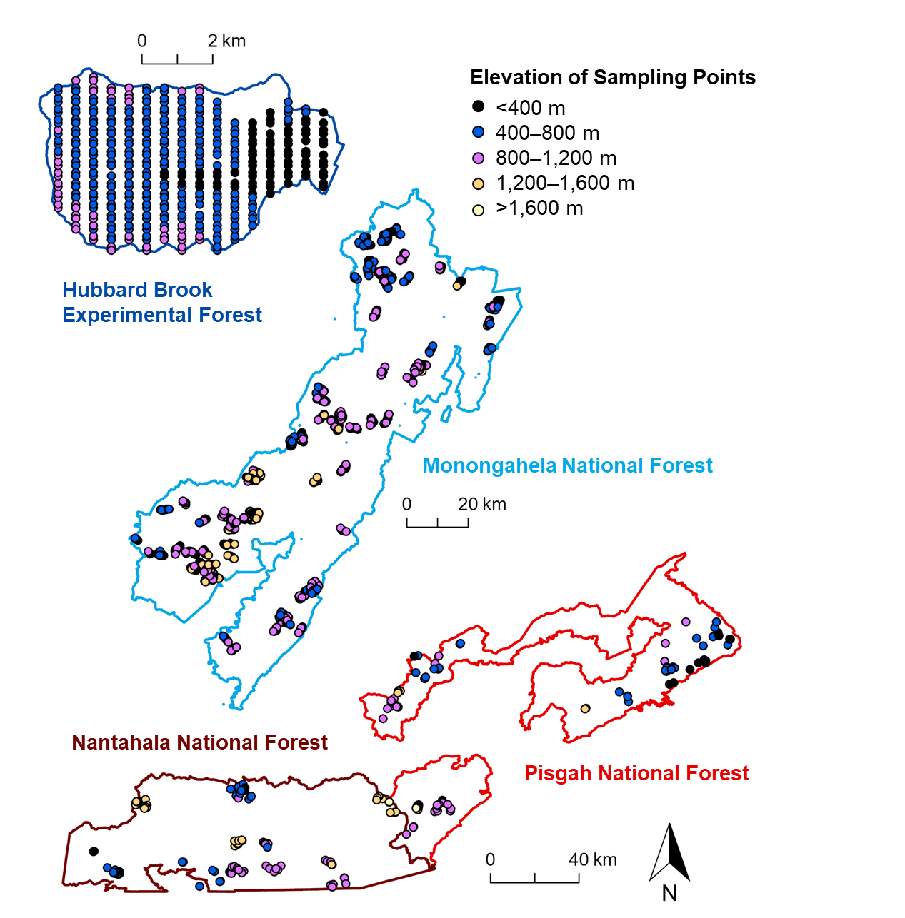

Figure 2. Locations and elevations (m) of the 373 sampling points in the Hubbard Brook Experimental Forest (i.e., Northern Appalachians study region); 1,149 sampling points in the Monongahela National Forest (i.e., Central Appalachians study region); and 211 sampling points in the Pisgah and Nantahala National Forests (i.e., Southern Appalachians study region).

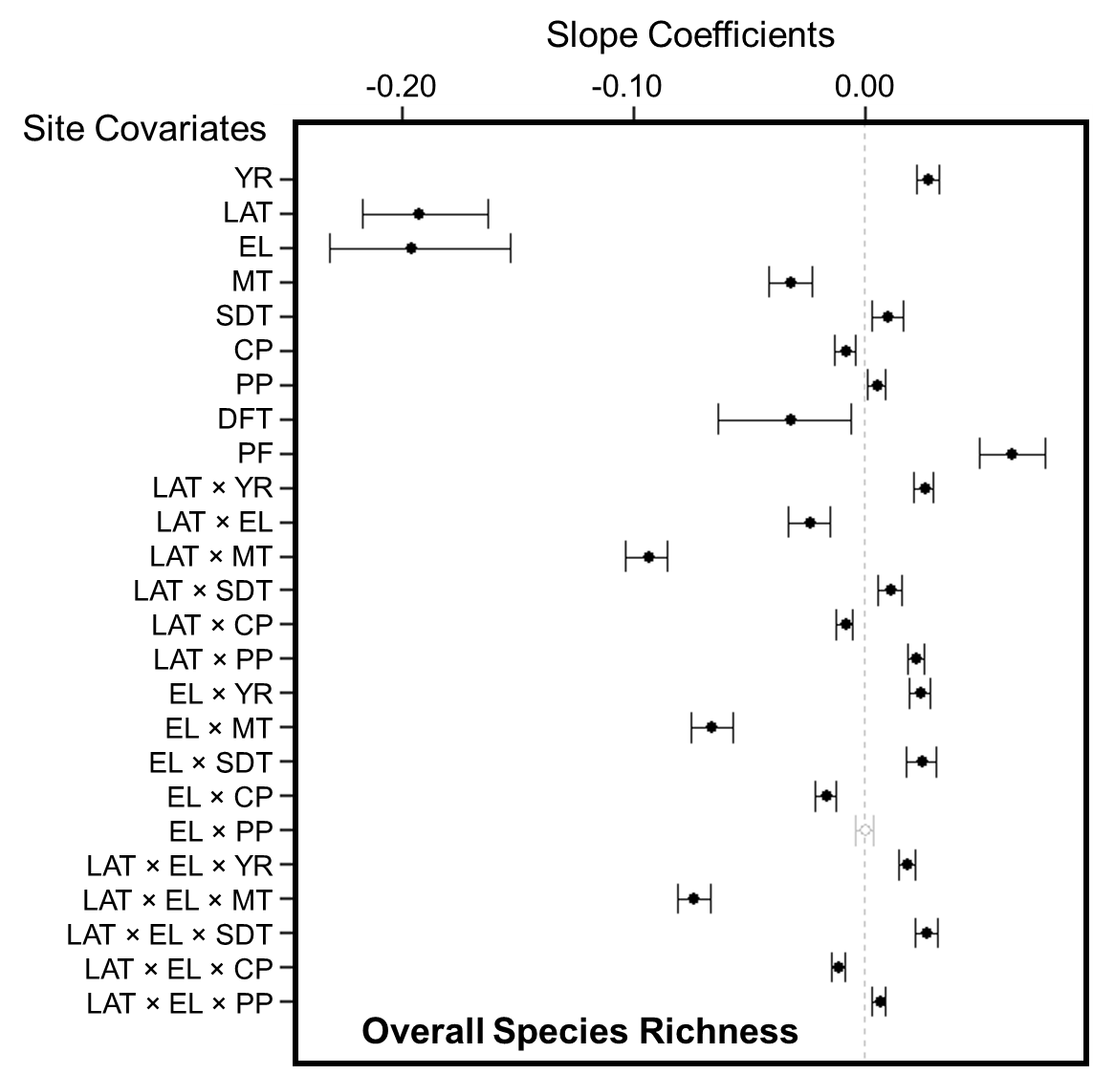

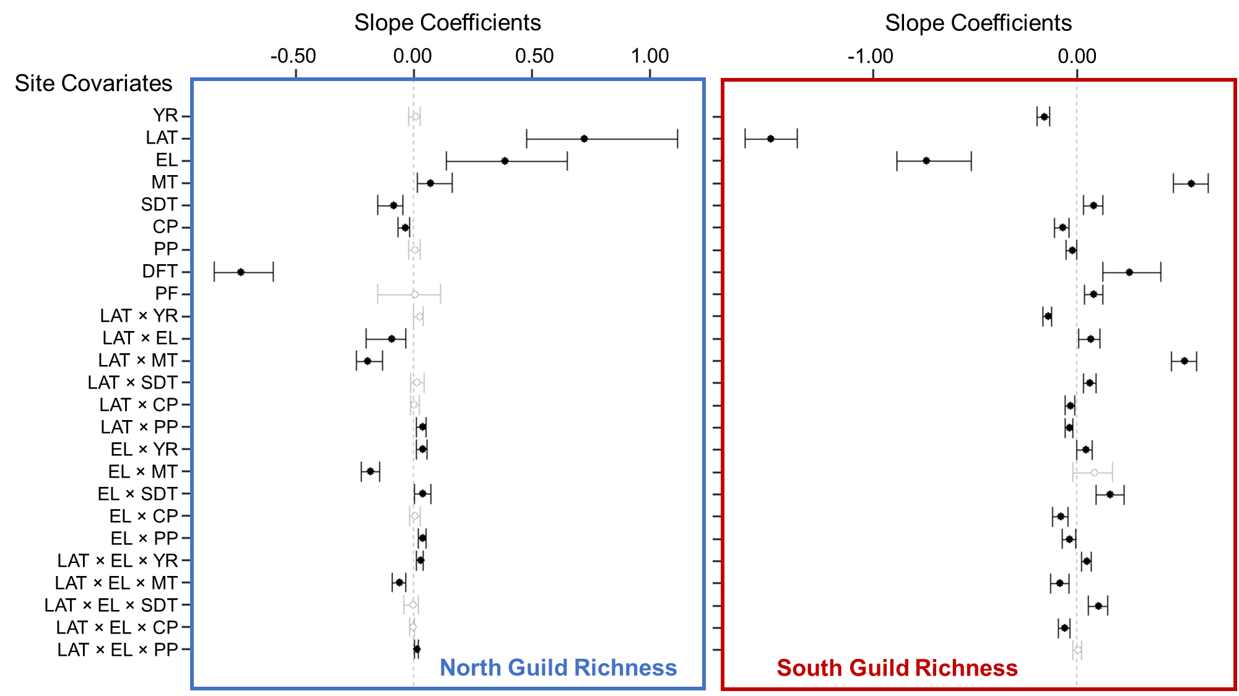

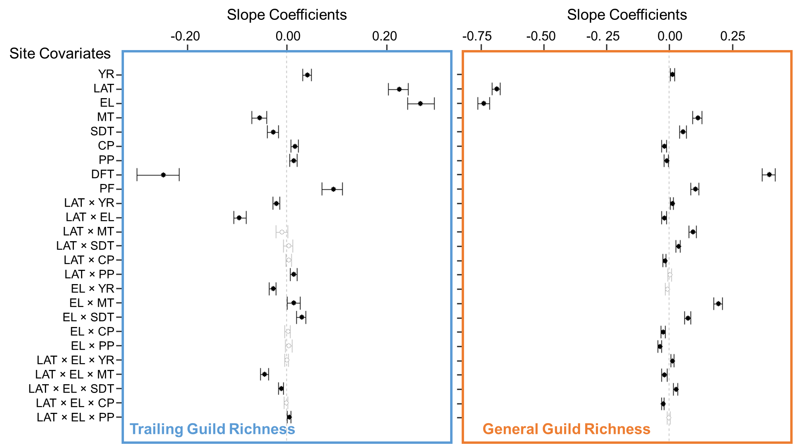

Figure 3. Whisker plots for overall species richness and guild richness (see Appendix B1 for guild designations and associated forest songbird species), displaying the slope coefficients of the predictor variables (i.e., site covariates), which consisted of year (YR), latitude (LAT), elevation (EL), mean breeding season (i.e., 15 May to 30 June) temperature during the year of data collection (MT), standard deviation of breeding season temperature (SDT), total breeding season precipitation during the year of data collection (CP), total breeding season precipitation during the previous year (PP), dominant forest type within 50 m as deciduous forest (DFT), and proportion of any type of forest cover within 1 km (PF). Points are located at the mean values for the posterior distributions and the corresponding whiskers encompass the 95% credible intervals. Black points with closed circles and black whiskers indicate statistical significance (i.e., credible intervals do not overlap 0).

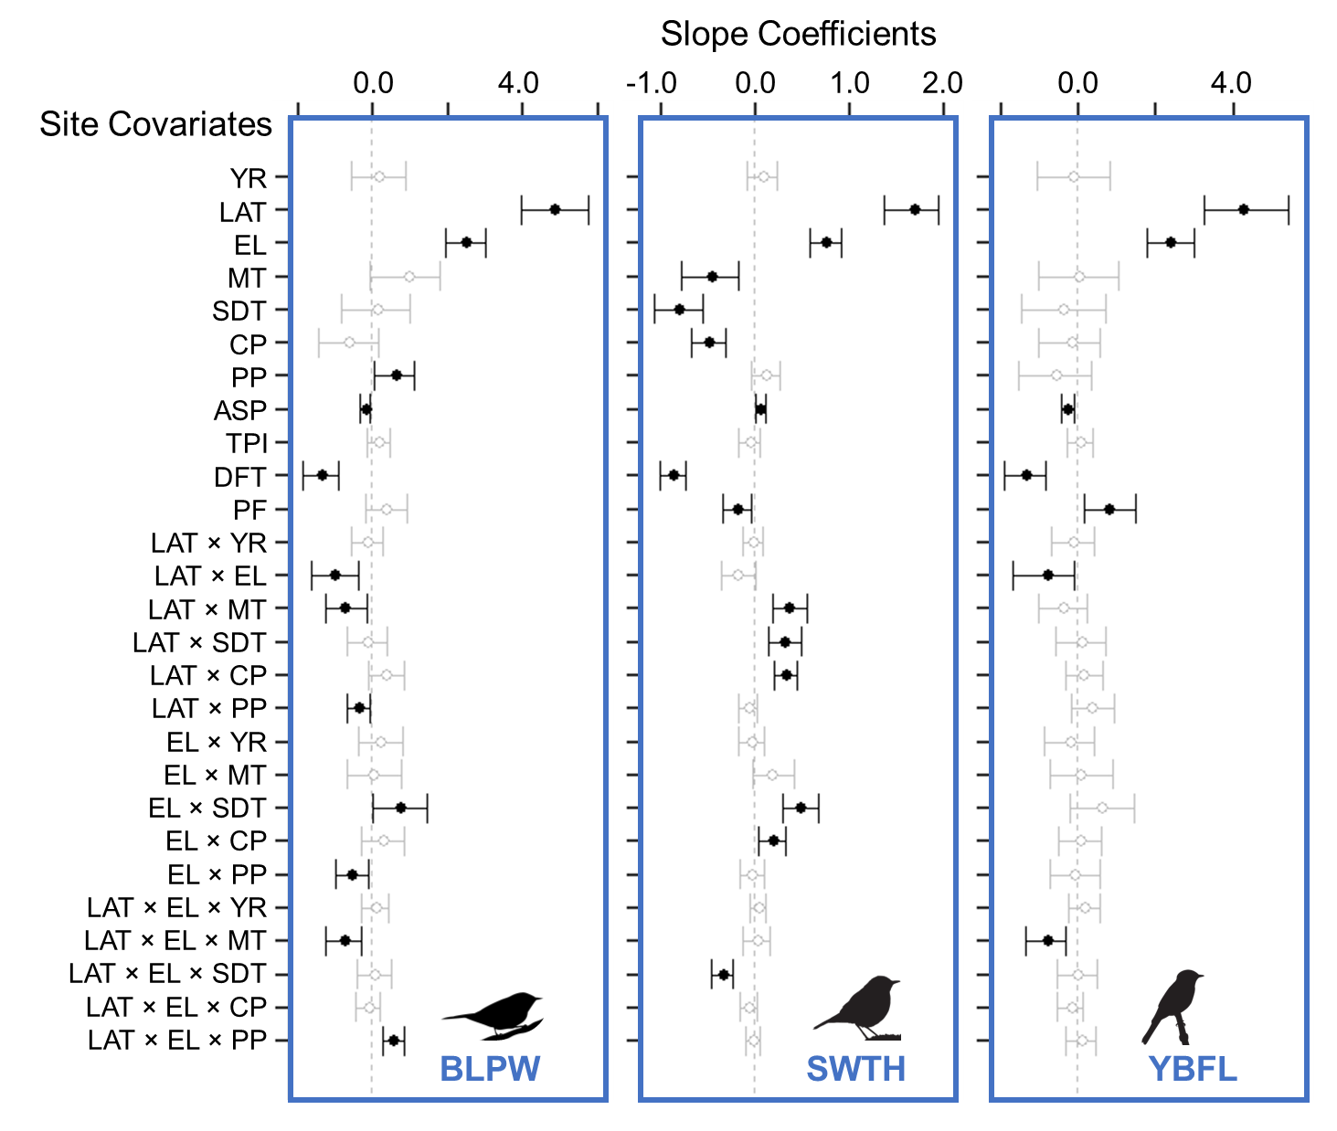

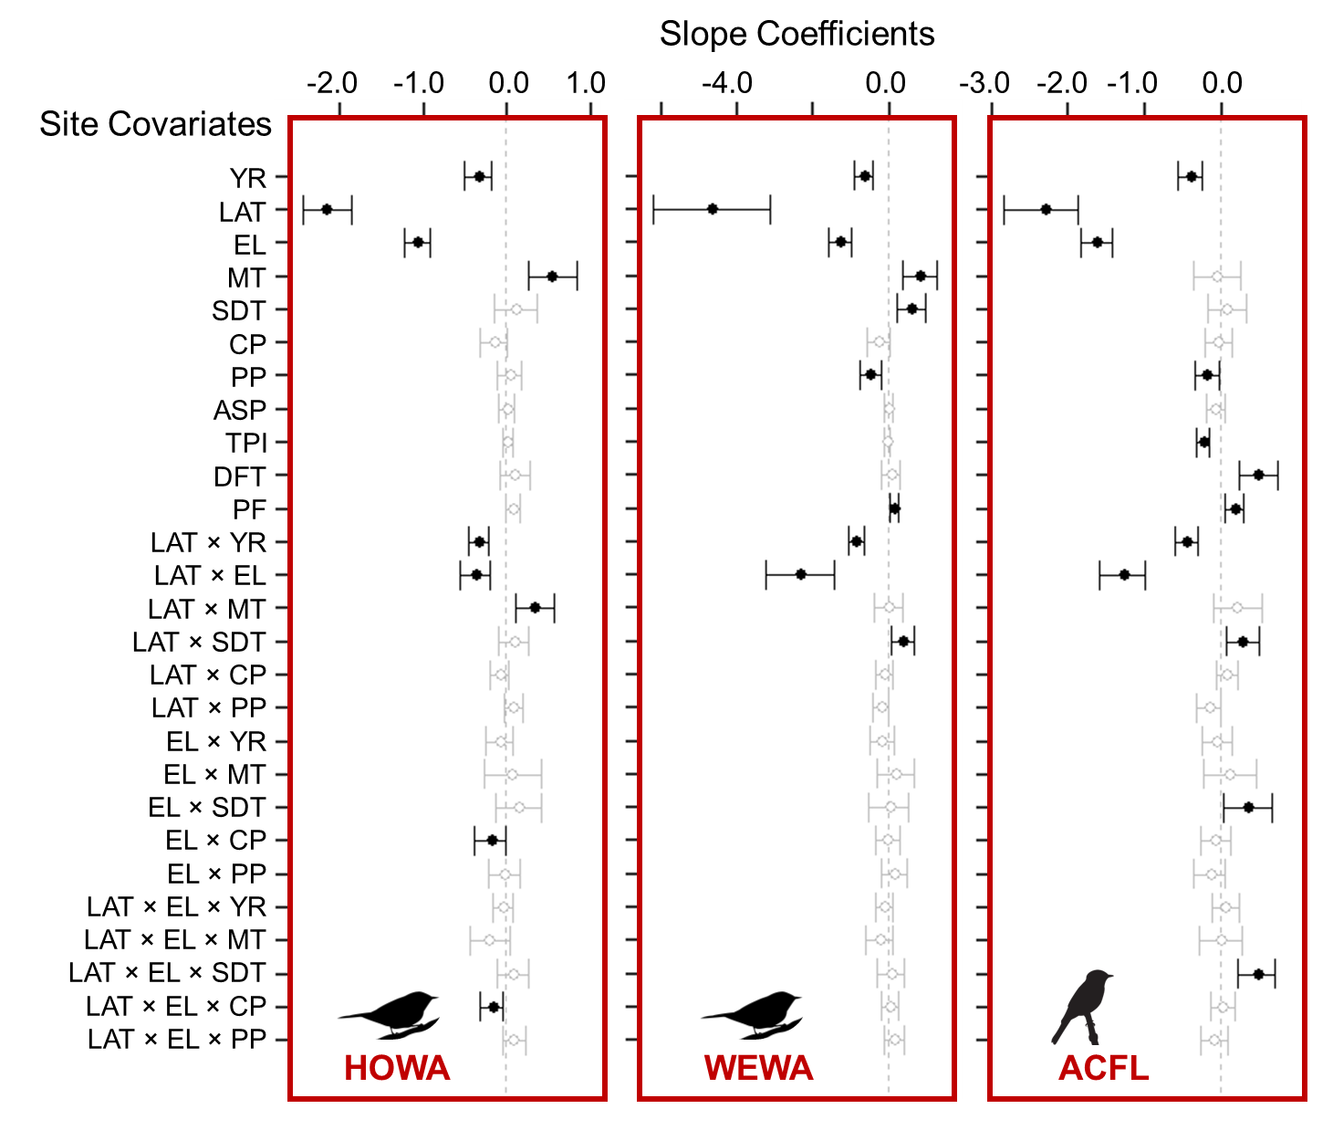

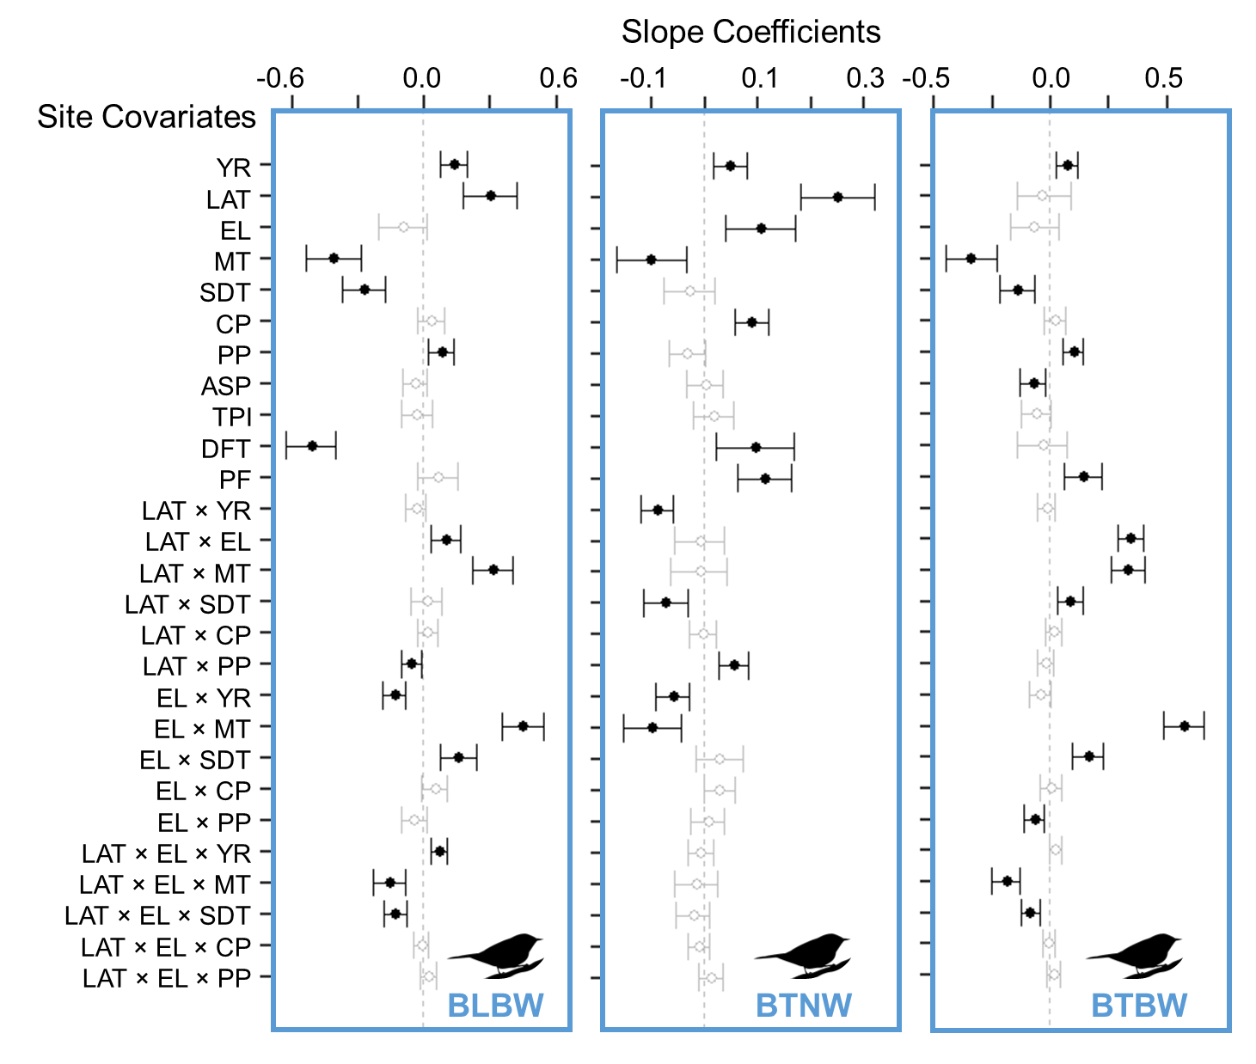

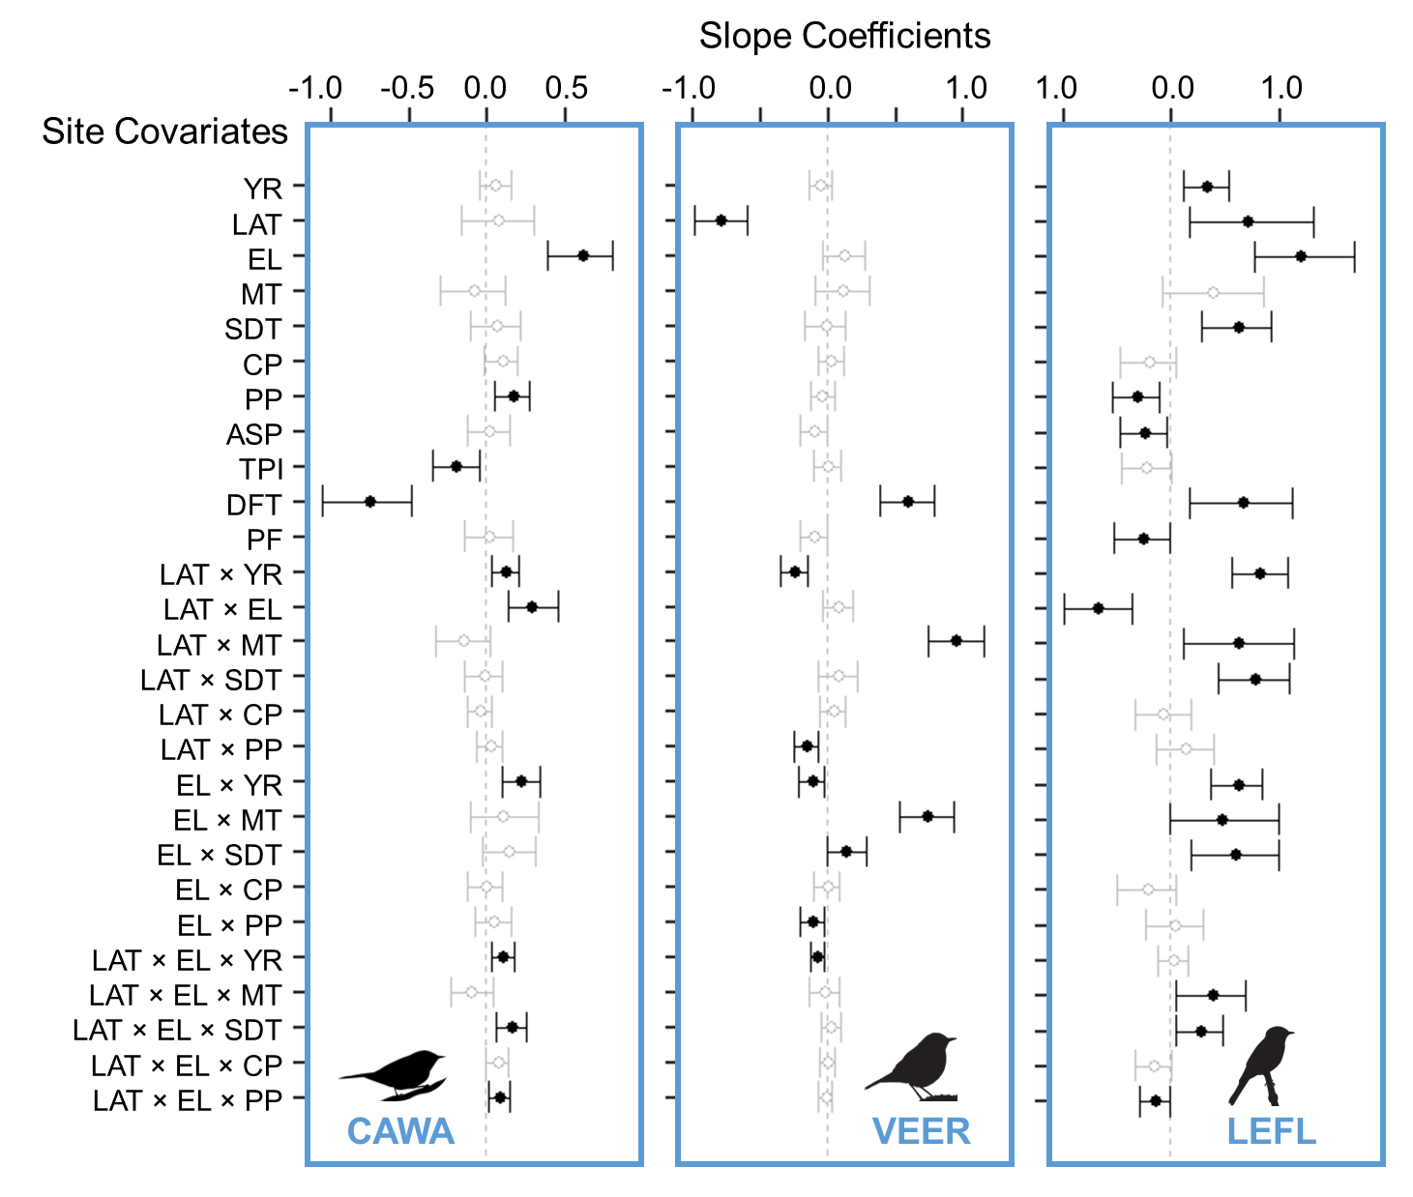

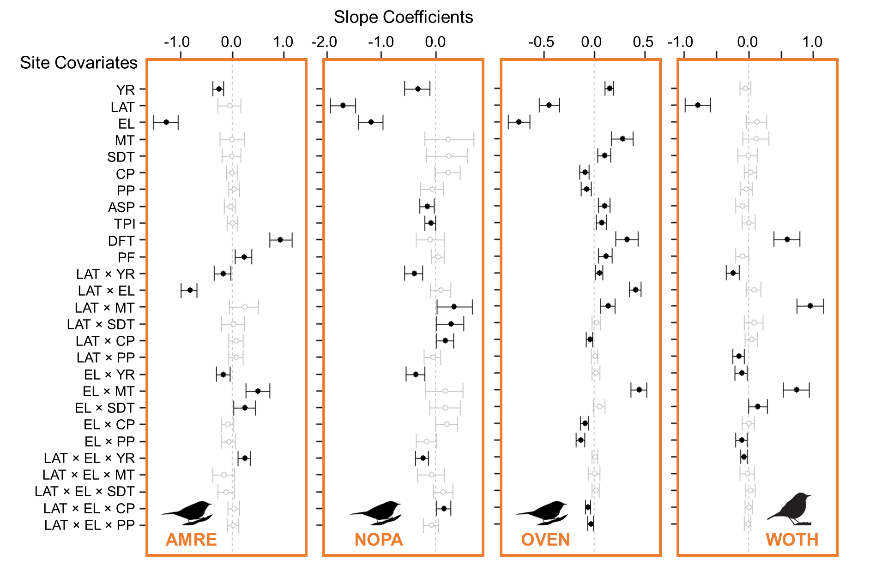

Figure 4. Whisker plots for each focal species (Table 1), displaying the slope coefficients of the predictor variables (i.e., site covariates), which consisted of year (YR), latitude (LAT), elevation (EL), mean breeding season (i.e., 15 May to 30 June) temperature during the year of data collection (MT), standard deviation of breeding season temperature (SDT), total breeding season precipitation during the year of data collection (CP), and total breeding season precipitation during the previous year (PP), aspect (ASP), topographic position index (TPI), dominant forest type within 50 m as deciduous forest (DFT), proportion of any type of forest cover within 1 km (PF),. Points are located at the mean values for the posterior distributions and the corresponding whiskers encompass the 95% credible intervals. Black points with closed circles and black whiskers indicate statistical significance (i.e., credible intervals do not overlap 0). Color of the 4-letter species code indicates its guild designation (dark blue = north guild, red = south guild, light blue = trailing guild, orange = general guild), and the bird silhouette indicates its taxonomic family (warbler, thrush, or flycatcher).

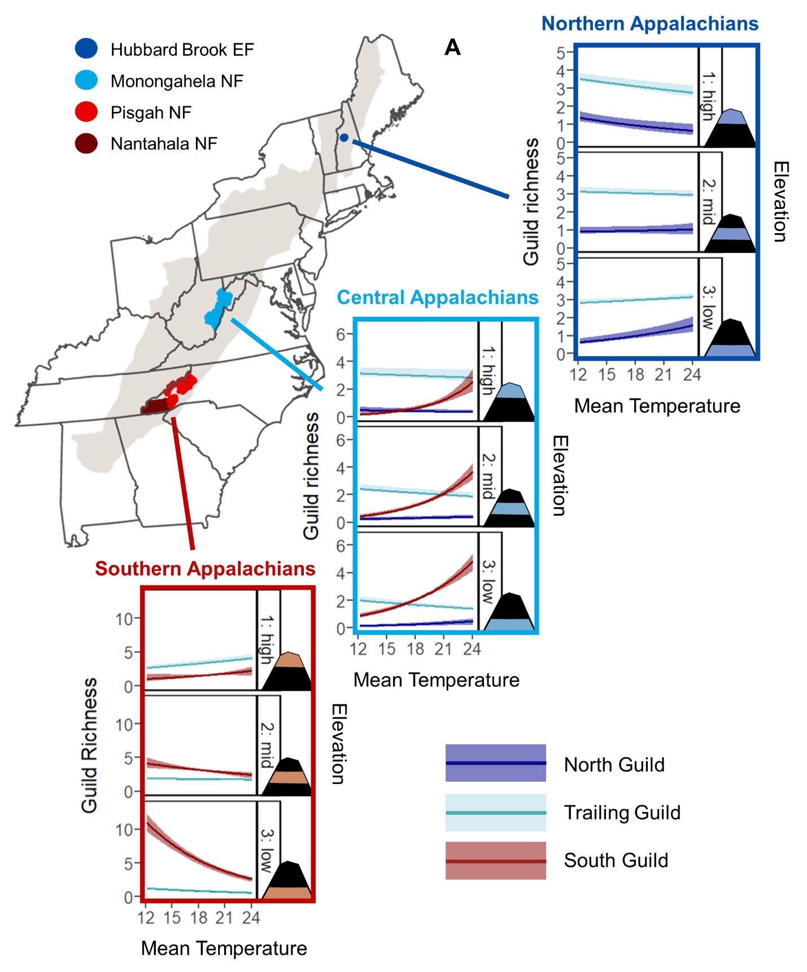

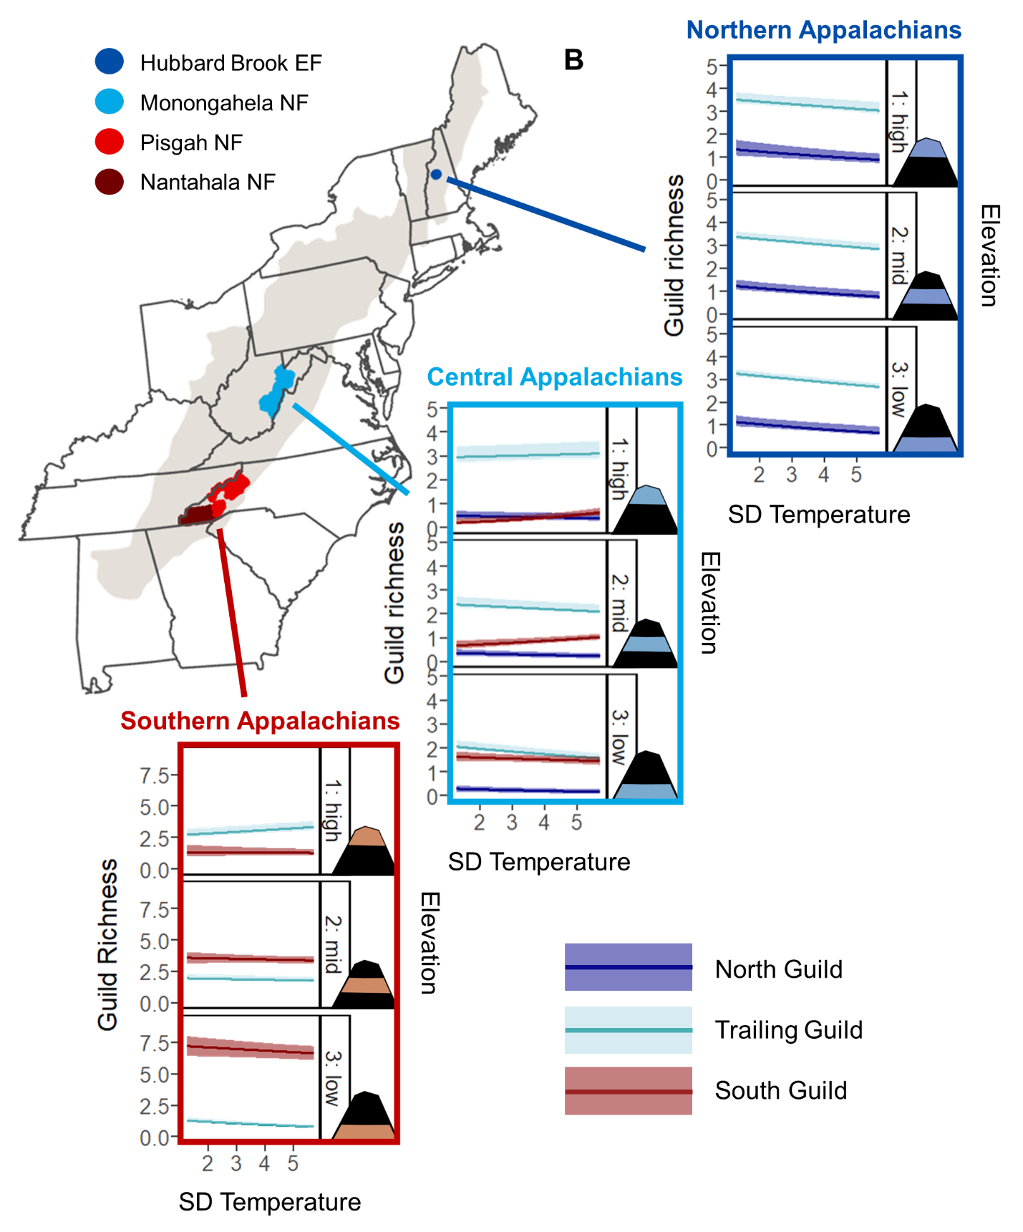

Figure 5. Relationships between (A) mean temperature (°C) or (B) SD temperature (°C) and mean expected number of species (solid line) belonging to the north guild (dark blue), trailing guild (light blue), and south guild (red), with 95% credible intervals (shading), at low, mid, and high elevations in the Northern, Central, and Southern Appalachians. The low, mid, and high elevation plots correspond respectively to the 15th, 50th, and 85th percentiles of the elevation data across all sampling points within the Hubbard Brook Experimental Forest (EF) (Northern Appalachians; low = 461.4 m, mid = 609.1 m, high = 773.1 m), Monongahela National Forest (NF) (Central Appalachians; low = 706.7 m, mid = 927.3 m, high = 1226.4 m), or the 2 North Carolina National Forests (NF) (Southern Appalachians; low = 546.4 m, mid = 977.4 m, high = 1566.3 m).

# CHAPTER 3

**Comparison of avian guild richness, species abundance, and nest success in   
actively harvested and minimally harvested forested landscapes**

## Introduction

### Long-term changes in bird populations

Prevailing evidence suggests that forest songbird populations in eastern North America have been decreasing in abundance during the past century. Long-term data from annual, nationwide breeding bird surveys indicate that numerous bird species, many of which breed in forests (Robbins et al. 1989), have experienced decreases in their populations throughout the eastern United States since 1966 (Sauer et al. 2020). Additionally, a recent quantitative study using data from multiple and independent monitoring networks demonstrated bird population losses across much of North America since 1970, including a negative change within the range of -15.6% to -19.2% in birds breeding in eastern forests, with 63.5% of those species in decline (Rosenberg et al. 2019). The U.S. Fish & Wildlife Service considers a statistically significant (*p* ≤ 0.1) population trend of -15% to -50% during this time period to be a “possible large decrease” and has identified 12 songbird species that breed in forests of eastern North America as “birds of conservation concern” (U.S. Fish & Wildlife Service 2021). Without targeted conservation action, there is concern that consistent declines in these and other bird populations will continue, with the potential for species to become endangered or even become extirpated (i.e., locally or regionally extinct) (Rosenberg et al. 2019).

In the Central Appalachian region of the eastern United States, forest management may contribute to or ameliorate these declines over time, with tradeoffs associated with different forest bird guilds. Bird species that breed in early-successional forest habitat, such as chestnut-sided warblers (*Setophaga pensylvanica*), eastern towhees (*Pipilo erythrophthalmus*), and yellow-breasted chats (*Icteria virens*), are strongly associated with herbaceous or shrubby areas in the stand initiation / stand establishment or regeneration phase, with low canopy basal area (Sheehan et al. 2014). In contrast, bird species that breed in mature forest habitat, such as blue-headed vireos (*Vireo* *solitarius*), ovenbirds (*Seiurus aurocapilla*), and wood thrushes (*Hylocichla mustelina*), are associated with late-successional stands in the canopy transition or old-growth / gap dynamics stages, with high canopy basal area (Sheehan et al. 2014). However, a subset of songbirds that breed in mature forest will shift their habitat use to early-successional areas, including regenerating clear-cuts (Vitz and Rodewald 2006, McDermott and Wood 2010, Streby et al. 2011, Major and Desrochers 2012, Stoleson 2013) during the post-breeding period (i.e., after nesting but before migration) (Pagen et al. 2000, Bowen et al. 2007, Chandler et al. 2012). Thus, there are differential benefits to early-successional vs. mature forest birds when forest management actions such as timber harvest alter the composition and configuration of forested landscapes. Here, landscape composition refers to amount of different habitat patch types without regard to spatial attributes (e.g., proportions of individual habitat types), whereas landscape configuration refers to spatial characteristics of individual habitat patches, requiring spatial information and usually aggregated across patches (e.g., mean patch size, patch density, edge density).

Historically, changes in forested landscapes of the eastern United States over hundreds of years have comprised a loss of old-growth forests followed more recently by a decrease in age-class diversity and structural complexity within second-growth forests (e.g., Schulte et al. 2007) and loss of early-successional habitats dominated by grass, shrubs, or young trees (Askins 2001, Trani et al. 2001). Concomitantly, there were severe and widespread population declines in shrubland-dependent species, some of which are currently species of conservation concern (Litvaitis 1993, Hunter et al. 2001, DeGraaf and Yamasaki 2003, Litvaitis et al. 2021), with the removal of early-successional habitat from the landscape thought to be the primary reason driving those negative trends (Kelley et al. 2008, King and Schlossberg 2014). Thus, optimizing diversity across forest-associated bird guilds during the breeding and post-breeding seasons likely calls for a landscape mosaic approach that incorporates a variety of forest age classes or successional stages (Loehle et al. 2005, Mitchell et al. 2008). Such landscapes can be produced by active forest management involving timber harvest.

### Timber harvest as a forest management tool for bird conservation

Timber harvest can be used as a landscape-level forest management tool by increasing the variation in composition and configuration of forested landscapes. For instance, harvesting forests can create smaller, distinct patches that are more fragmented and less connected (Boucher et al. 2015). These forests also contain more edge area and are subjected to more frequent and more severe uniformly sized disturbance from periodic, repeated timber harvest regimes. Within stands, even-aged silvicultural systems (e.g., clear-cuts) can create homogenous vertical and horizontal structure (Kuuluvainen et al. 1996), but at a landscape scale, timber rotation length can change the age-class distribution of forests, increasing the proportions of early-successional or young forest (Hejl et al. 1995). In contrast, non-harvested forested landscapes (i.e., no timber harvest within >80 years) are usually characterized by occasional large-scale disturbances and frequent small-scale disturbances, which allow for a finer-grained mosaic of different successional phases (Bengtsson et al. 2000). Thus, landscape-scale structural heterogeneity is generally higher in harvested forests managed in an even-aged system whereas within-stand structural heterogeneity might be higher in non-harvested landscapes (Dettki and Esseen 1998), particularly those subject to historic natural disturbance regimes (e.g., fire). However, century-long fire suppression tactics have reduced the amount of large-scale natural disturbances in forests of eastern North America, contributing to an increase in homogenous forest conditions over large scales. In the absence of natural disturbance regimes, timber harvest may be the most feasible source of anthropogenic disturbance for land managers to diversify forest structure.

Timber harvests can increase the availability of early-successional forest habitat, which leads to increased abundance and densities of early-successional and generalist bird species in those areas (King and Degraaf 2000, Duguay et al. 2001, McDermott and Wood 2009). Similarly, higher proportions of early-successional habitats in harvested landscapes can also result in significantly higher abundances of early-successional and generalist bird species in those landscapes (Drapeau et al. 2000). Timber harvests can also increase fragmentation, edge density, and canopy openings within a forest stand or landscape, which could lead to increased abundance of edge-associated species, such as indigo buntings, and gap-dependent species, such as hooded warblers (Greenberg and Lanham 2001). On the other hand, large-scale timber harvest operations may negatively affect mature forest birds that require intact forest-interior / core forest habitat or late-successional (i.e., >80 years old) forest (Lichstein et al. 2002). Forest-interior species are more abundant in mature forest than clearcuts (King and Degraaf 2000, Sheehan et al. 2014) and in landscapes with higher amounts of late-successional forest in the landscape (Lichstein et al. 2002). Thus, abundance of forest-interior and forest gap species can decrease after reaching specific thresholds in timber harvest within forested landscapes (Becker et al. 2011). Small openings may not necessarily adversely affect mature forest birds (e.g., Greenberg and Lanham 2001), but a study of the breeding bird community in a Vermont hardwood forest found that 0.4-ha clearcuts resulted in the movement of several forest-interior species away from the harvested areas and subsequently decreased abundance in and adjacent to clearcuts (Germaine et al. 1997).

In addition to species abundance, it is critical to consider long-term bird population dynamics because abundance and density metrics alone can be poor indicators of habitat quality (Van Horne 1983, Vickery et al. 1992, Hagan et al. 1996). Reproductive success of avian species in forested landscapes can be affected by timber harvest due to changes in habitat composition and configuration. For example, nest success of wood thrush in the Monongahela National Forest in West Virginia was found to be positively related to mean shape indices and mean patch fractal dimension of mature forest (both indicative of higher complexity of mature forest patch shapes) and negatively related to an interspersion-juxtaposition index (i.e., measure of the relative interspersion of mature forest patches) and proportion of open habitat (Williams 2002). Composition within forested landscapes further influences avian nesting success by altering interactions between nest predators and nesting birds (Rodewald and Yahner 2001, Rodewald et al. 2001). However, recent studies of nest success within Central Appalachian forests have found little overall effect of various harvest types on productivity (Duguay et al. 2001, Becker et al. 2011, 2012), perhaps because habitat features related to nest survival are spatially variable (Boves et al. 2013*a*, *b*).

Avian population and community processes operate across a broad scale (Bennett et al. 2004), and habitat-associated guilds are thought to respond differently to landscape-scale harvest intensity. Patterns of bird species composition and diversity are related to landscape composition, such as proportions of forest types and ages (Drapeau et al. 2000, Carrara et al. 2015), and landscape configuration, such as patch sizes and edge density. In general, greater landscape age heterogeneity produced by higher levels of timber harvest intensity is associated with greater overall species richness (Loehle et al. 2005, Mitchell et al. 2008). Furthermore, landscape changes due to timber harvest can ultimately result in shifts in avian community composition and diversity (Parody et al. 2001, Anderson and Crompton 2002), as conversion of guild-specific preferred habitat to less suitable habitat can lead to reductions in guild richness (Aratrakorn et al. 2006, Zurita et al. 2006) and increased edge habitat can result in increases in generalist richness but decreases in specialist species richness (Jones et al. 2000). In summary, landscape-scale harvest intensity may differentially affect forest bird assemblages.

### Knowledge gap

Forest managers often aim to balance or combine the economic benefits of timber harvest with the maintenance of wildlife habitat, biodiversity, and ecosystem function. Forest songbirds exhibit varying responses to timber harvest, which can alter forest composition, configuration, and connectivity on a landscape scale (e.g., Spies et al. 1994). Thus, timber harvest can be potentially used as a landscape-level management tool to promote both early-successional and mature forest songbird populations and diversity (Petit et al. 1995). However, we have an incomplete understanding of how birds respond over time to landscape-scale harvest intensity. Many studies on this topic are traditionally focused on single harvest types or single harvesting events; examine avian responses at control and harvested sites on limited spatial scales; or tend to be short-term (i.e., lasting 1–3 years) and focused on immediate impacts that may not reflect the full temporal response to the management practices under study (Sallabanks et al. 2000, Loehle et al. 2005). By quantifying long-term, landscape-level trends in avian responses to active forest management using multiple harvesting methods and harvesting events (e.g., Perry et al. 2018, Kellner et al. 2019), we can guide management decisions and make recommendations to provide lasting benefits to forest bird species. Thus, it would be valuable to investigate the response of bird communities and populations through time in forested landscapes with varying levels of timber harvest intensity, particularly within the Central Appalachian region.

### Purpose, objectives, and hypotheses

The purpose of this study was to quantify long-term avian responses to landscape-scale forest management and compare changes over time in avian diversity, abundance, and population dynamics from 2 Central Appalachian forested landscapes that varied in timber harvest intensity. My specific objectives were to examine the influence and effect of interactions between time and landscape-scale timber harvest intensity on breeding season songbird guild richness, focal species abundance, and focal species nest success. I focused on 2 landscapes with diverging forest management prescriptions: (1) an actively harvested landscape with >60% of its area experiencing diameter-limit harvest, two-age harvest, or clear-cutting, where timber harvest operations began in 1994 and continued throughout the study period, and (2) a minimally harvested landscape with <1% of its area experiencing two-age harvest or clear-cutting, where timber harvest operations were conducted approximately 10–15 years prior to the study period but not during the study period.

In this study, I tested the hypothesis that long-term temporal trends in forest songbird communities and populations during the breeding season are mediated by landscape-level forest management. I predicted that trends over time in diversity, abundance, and nest success would vary by guild designation and landscape (i.e., level of timber harvest intensity). For example, in the actively harvested landscape, I expected that early-successional / edge-associated species would respond positively over time, whereas forest-interior species and forest-gap species would respond negatively over time, due to the loss of mature forest and creation of early-successional habitat. In contrast, in the minimally harvested landscape, I expected little to no change over time for most species, with the possibility of early-successional / edge-associated species declining due to general forest maturation. Taking a holistic approach, I assessed the statistical significance and effect sizes of interactions between time and landscape-scale timber harvest intensity for overall species richness, the number of species belonging to 4 habitat guild designations, the abundance of 15 focal songbird species, and the nest success of 6 focal songbird species (Table 1).

## Methods

### Study area

Sampling points and nest search plots for this study were spread throughout 2 study areas within the Central Appalachian region (Figures 1–3). I used data from a total of 1,186 sampling points and 50 nest search plots (Figures 2–3), consisting of 166 sampling points and 20 nest search plots in the actively harvested MeadWestvaco Wildlife and Ecosystem Research Forest (WERF), which is located in Randolph County, West Virginia, and 1020 sampling points and 30 nest search plots in the minimally harvested Monongahela National Forest (MNF), which encompasses portions of 9 counties (Preston, Tucker, Grant, Randolph, Pendleton, Pocahontas, Webster, Nicholas, and Greenbrier) in eastern West Virginia. All sampling points used in this study were located in forest stands that experienced varying levels and types of recent or ongoing timber harvest (ranging from no harvest to clear-cutting), and distances between sampling points were at least 200 m.

Research in the actively harvested WERF was conducted from 1996–1998 (Weakland 2000), 2001–2003 (Dellinger 2005), and 2007–2009 (Becker 2010). The WERF encompasses 3,080 ha and was established in 1994 by the Westvaco Corporation to study the effects of industrial forest management practices on ecosystem processes and wildlife within a primarily 70–90 years-old even-aged mature forest. Located within the Central Appalachians (Allegheny Mountains) physiographic province, regional topography within the WERF consists of narrow valleys with small, high-gradient streams and broad ridges oriented south-southwest to north-northeast (Becker et al. 2011). Annual average precipitation is >160 cm per year (Strausbaugh and Core 1977), and elevation ranges 734–1,180 m. Vegetation communities in the WERF are variable across that elevational gradient. At high elevations (>1,000 m), red spruce (*Picea rubens*) and eastern hemlock (*Tsuga canadensis*) dominate. At mid-elevations (850–1,000 m), northern hardwoods such as red maple (*Acer rubrum*), American beech (*Fagus grandifolia*), and black cherry (*Prunus serotina*) are most prevalent. Meanwhile, low-elevation sites (<850 m) consist of cove hardwood and mixed mesophytic plant communities (northern red oak [*Quercus rubra*], black birch [*Betula lenta*], and tulip-poplar [*Liriodendron tulipifera*]) and xeric oak-hickory communities (black oak [*Quercus velutina*], scarlet oak [*Q. coccinea*], and hickory [*Carya* spp.]). Non-forest cover in the study area was limited to grassy cover along road edges, gas well openings, and log landings.

Research in the minimally harvested MNF was conducted from 1993–1994 (Nichols 1996), 1995–1996 (Duguay 1997), 1996–1997 (DeMeo 1999), 1998–2000 (Williams 2002), and 2001–2009. The MNF was placed under federal protection in 1920 and encompasses nearly 688,000 ha, of which 54% (371,906 ha) is owned and overseen by the USDA Forest Service. The MNF stretches across a latitudinal range of nearly 200 km and lies within 2 physiographic provinces, the Central Appalachians (Allegheny Mountains) and the Ridge and Valley. The eastern section of the Monongahela National Forest, which overlaps the Ridge and Valley physiographic province, lies in the rain shadow of the Allegheny Mountains, so it receives significantly less precipitation (~75 cm/year) compared to the rest of the forest, which experiences 115–150 cm/year (Clarkson 1966). Elevation within the MNF ranges 275–1,480 m. In terms of forest composition, the MNF was comprised primarily of 70–100 years-old stands at the start of the study period, with high regional tree diversity and 4 major forest zones (mixed mesophytic, northern hardwoods, red spruce, and dry oaks) (McCay et al. 1997, DeMeo 1999). Mixed mesophytic forests are present at low elevations (<900 m), with northern red oak, sugar maple (*Acer saccharum*), hickory, and tulip-poplar as the dominant species (Madarish et al. 2002). At increasing elevations, there is a transition in stand dominance to northern hardwoods, including American beech, sugar maple, and black cherry (*Prunus serotina*) (Stephenson 1993). At the highest elevations (>1,150 m), remnant boreal forest ecosystems consist of red spruce. In the eastern MNF, dry oaks are common in the Ridge and Valley area, consisting of white (*Q. alba*), chestnut (*Q. prinus*), scarlet, and black oaks, as well as pines (*Pinus* spp.).

### Harvest history

During its establishment in 1994, the WERF was comprised of secondary forests that were established by natural regeneration following large-scale logging from 1916–1928 (Keyser and Ford 2005). Timber had been sporadically thinned and harvested since the 1930s, resulting in numerous logging roads and skidder trails transecting the forest. Since its initial establishment, much of the WERF had been actively managed using even-aged timber harvesting through clear-cuts, shelterwood cuts, and uneven-age or partial harvesting via single-tree selection and high-grade harvests of mature sawtimber (Dellinger et al. 2007). Prior to 1997, several timber harvests had been conducted, including diameter-limit harvests, two-age harvests, and regeneration (seed-tree) harvests, but the majority of the WERF remained mature deciduous or mixed forest (Figure 4). From 1997–1998, additional forest stands were harvested using a variety of methods (e.g., diameter-limit harvests, two-age harvests, regeneration harvests, clear-cuts). More stands were harvested throughout the years, and nearly 50% of the WERF had recently experienced some type of harvest by 2003 (Figure 4). In 2007, management shifted to primarily uneven-aged techniques, and by 2009, at least 60% of the WERF had been recently harvested to some degree (Figure 4). Thus, the WERF served as an actively harvested landscape for this study.

The MNF is comprised of mature, second-growth Appalachian hardwood forests. A timber harvest rotation of 100–120 years applies to most areas of the MNF not designated as Wilderness Areas. From the 1940s to the 1960s, timber harvest on the MNF was almost exclusively uneven-aged management, but the use of clearcut harvesting increased on the MNF in the 1960s and 1970s (Miller 2014). However, the vast majority of the MNF had not been harvested nor majorly disturbed within the 50 years prior to the study period. Therefore, most of the sampling points within the MNF were located in relatively intact areas with high (>60%) core area (DeMeo 1999). A small subset of the sampling points was in forest stands in the Cheat and Greenbrier Ranger Districts of the MNF that had experienced two-age harvest or clear-cutting between 1979 and 1986 for a study on the effects of two-age harvests (Miller et al. 2006). However, the area of the harvested stands accounted for <1% of the total area of public lands in the MNF. Thus, the MNF served as a minimally harvested landscape for this study.

### Guild designations

To compare temporal trends for overall species richness and guild richness in the actively harvested landscape and the minimally harvested landscape, I considered a subset of the 114 total avian species that were detected across all surveys in all years from the 2 study areas. Specifically, I limited the richness analyses to 62 passerine and near-passerine species (see Appendix C1 for full list) with breeding ranges that encompassed the 2 study areas and that had ≥10 detections. I also excluded wetland-associated songbirds (e.g., red-winged blackbirds [*Agelaius phoeniceus*]) because they were incidental to the focal habitat types, as well as corvids (family Corvidae) and waterthrushes (*Parkesia* spp.) because they are not well-sampled with breeding songbird point count surveys.

Habitat-related guild designations for the 62 songbird species were assigned based on breeding habitat and comprised 4 categories (Appendix C1): (1) early-successional / edge-associated (i.e., primarily breed or found in grasslands, shrub/scrub, or young forest; or along forest edges, such as the interface of early-successional and mature forest); (2) forest-interior (i.e., generally breed or found in the core area of mature forest); (3) forest-gap (i.e., generally breed or found in or near small forest gaps within the core area of mature forest); and (4) forest generalist (i.e., associated with forest but no strong preference for early-successional vs. mature forest).

### Focal species

To compare temporal trends in focal species abundance in the actively harvested landscape and the minimally harvested landscape, I selected a total of 15 songbird species across the 4 guild designations (Table 1): 4 early-successional / edge-associated species, 4 forest-interior species, 4 forest-gap species, and 3 forest generalist species. Species selection was based on overall relative frequency (i.e., throughout the study period); for each guild designation, I included the 3 species with the highest relative frequency. For the early-successional / edge-associated guild, forest-interior guild, and forest-gap guild, I additionally included a species of regional conservation concern with the highest relative frequency.

To assess temporal trends in focal species nest success in the actively harvested landscape and the minimally harvested landscape, I selected 6 species from the 15 songbird species listed above as focal species for abundance analyses (Table 1): 2 early-successional / edge-associated species, 3 forest-interior species, and 1 forest-gap species. Species selection was based on total sample size from throughout the study period; these were the 6 species that had sample sizes of at least 70 total nests across the 2 study areas and a minimum of 15 nests from each study area.

### Bird count data

Avian point count survey data for the 2 study areas were collected in 1996–1998, 2001–2003, and 2007–2009 at 166 WERF sampling points and in 1996–2009 at 1,020 MNF sampling points. In the WERF, point count surveys were conducted within a 50-m fixed radius at locations selected systematically from available points on a 241 × 241 m forest inventory grid (Figure 2) established in 1995 by Westvaco Forest Resources (prior to extensive timber harvesting). An average of 110 points were surveyed each year, and locations were mostly consistent across time periods. In the MNF, point count surveys were conducted along 109 extensive linear transects (up to 2,500 m in length) with 10–12 sampling points per transect (Figure 3). Of the 109 total transects, at least 44 transects were oriented at right angles to contours to capture maximum variation in elevation and landforms.

Avian point count surveys were not completed every year at every sampling point. The number of years of data associated with each sampling point ranged 2–9 years (mean = 5.9 ± 2.5 years) in the WERF and 1–12 years (mean = 4.0 ± 2.8 years) in the MNF. Within a year that avian point count survey data were collected, the number of repeated visits (i.e., replicate surveys) ranged from 1–3 visits (mean = 2.0 ± 0.2 visits) in the WERF and 1–4 visits (mean = 1.3 ± 0.5 visits) in MNF. I included all replicate surveys per sampling point per year in my data analyses, for a total of 14,504 replicate surveys across 4,999 site × year combinations.

At both study areas, avian point count surveys were conducted from mid-May to early July (i.e., during the bird breeding season) and consisted of 10-minute stationary counts, during which a single observer recorded all individuals heard or seen. Up to 4 detection covariates were recorded for each survey: date, start time, wind code, and sky code. While date was recorded for all surveys, a subset of surveys was missing start times (68% of MNF data), wind codes (73% of MNF data), or sky codes (73% of MNF data). However, all surveys began within 30 minutes of sunrise and continued until approximately 4 hours after sunrise, and no surveys were conducted on days with rain, heavy fog, or high wind speed, following the guidelines of Ralph et al. (1993).

The 10-minute point count survey was divided into 2 time intervals (i.e., within-survey replicates): 0–5 minutes and >5–10 minutes. Individual birds were only recorded the first time they were observed, following removal sampling methods. For each record, observers indicated the corresponding time interval and distance band (≤50 m or >50 m). To limit detection variability due to distance, I restricted all data analyses to birds detected within 50 m.

### Nest success data

Avian nest monitoring survey data were collected at the 2 study areas from 1996–1998, 2001–2003, and 2007–2009 from 20 WERF nest search plots and from 1993–1999 at 30 MNF nest search plots (Figures 2–3). Throughout the breeding season, field technicians looked for active nests within the nest search plots. Nests that were located through both systematic searching efforts and opportunistic observations were then monitored from mid-May until mid-July. During the monitoring period, field technicians checked each nest a minimum of every 3–4 days until the nesting attempt was complete and identified as either successful or failed. From the nest monitoring records, I used the following data for each nest location: bird species, success or failure during the incubation period, and success or failure during the brooding period.

Nest search plots varied in size and location among sampling years and between study areas (Figures 2–3). In the WERF, there were 8 45-ha nest search plots during 1996–1998 and 12 20-ha nest search plots during 2001–2003 and 2007–2009. The nest search plots were distributed randomly throughout 3 elevational blocks and encompassed either non-harvested areas with intact, predominantly mature hardwood forest, lightly harvested areas that retained closed canopy conditions, or heavily harvested areas with early-successional vegetation. Due to harvest activity, 4 nest search plots had to be shifted slightly for the 2007–2009 nest monitoring seasons (Figure 2). In the MNF, 31 stands were intensively searched for nests during 1993–1998 (Duguay et al. 2001), with search effort distributed relatively evenly between stands. From 1996 to 1999, nest searches occurred within 40-ha (200-m wide × 2,000-m long, oriented perpendicular to prevailing slopes) plots that were established along 2 transects in each of 5 2,500-ha study areas that were randomly located within the mixed mesophytic vegetation zone of the MNF; the study areas ranged from 42–81% in core forest area (DeMeo 1999). Nest searching protocols followed the methodology of the national BBird program of nest search plot monitoring (Conway and Martin 2000). In 1998 and 1999, additional nests (outside the established nest search plots) in the northwestern region of the MNF (within Tucker and Randolph counties) were located through behavioral cues and systematic searches of likely nesting habitat (Williams 2002).

My objective was to compare temporal trends in nest success between the actively harvested landscape and the minimally harvested landscape, but the time periods of nest monitoring at the 2 study areas did not fully overlap (WERF: 1996–1998, 2001–2003, and 2007–2009 vs. MNF: 1993–1999). Therefore, I made the following assumptions: (1) trends from MNF data collected from 1993 to 1999 were representative of long-term trends; and (2) there were no outside, unconsidered systemic confounding factors (e.g., stochastic weather extremes, climate change, invasive species introduction) influencing trends from WERF data collected after 1999.

### Environmental data

The full set of site covariates for the guild richness analyses and focal species abundance analyses included year of data collection, landscape-scale harvest intensity, an interaction between year and landscape-scale harvest intensity, and 15 environmental variables that were included to account for their known effects (Table 2). Landscape-scale harvest intensity was a dummy variable where 1 = actively harvested landscape (i.e., WERF) and 0 = minimally harvested landscape (i.e., MNF). The first 3 controlling environmental variables were topographical factors: elevation, aspect, and topographical position index (TPI). Mean elevation, mode aspect, and mode TPI within 50 m of each sampling point were calculated or derived using Shuttle Radar Topography Mission digital elevation data, which had a resolution of ~20–25 m. The next controlling environmental variable was stand age. To calculate mode stand age within 50 m of each sampling point, I used GIS datasets from the WERF and from the MNF that mapped forest stands in each study area and provided stand-scale attribute information.

The 11 remaining controlling environmental variables involved land cover classifications and were determined using the National Land Cover Database (NLCD) (Jin et al. 2019), which had a resolution of 30 m and was available for the years 2001, 2004, 2006, and 2008. All calculations were made using land cover data from the closest year available (i.e., I used the 2001 NLCD data for surveys conducted in 2002 or earlier, 2004 NLCD data for surveys conducted in 2003 or 2004, 2006 NLCD data for surveys conducted in 2005–2007, and 2008 NLCD data for surveys conducted in 2008 or 2009). Note that the years 2005 and 2007 were equally close to 2004 vs. 2006 and 2006 vs. 2008, respectively; I chose to use the 2006 NLCD data for both 2005 and 2007 because that was when on-the-ground conditions were originally measured. To account for breeding songbird habitat type, I calculated the proportions of all forest (i.e., any type of mature forest) and of shrub cover within 50 of each sampling point. Mature forest cover was defined as areas dominated by trees generally >5 m tall and >20% of total vegetation cover, and shrub cover was defined as areas dominated by shrubs (i.e., <5 m tall with shrub canopy typically >20% of total vegetation) and included true shrubs and young trees in an early successional stage. To account for forest type, I calculated the proportions of deciduous forest and of conifer forest within 50 m of each sampling point. The proportion of mixed forest was strongly correlated (*r* > 0.7) with the proportion of deciduous forest, so it was not used in the data analyses. To account for landscape composition, I included the proportion of all forest and of shrub cover within 1 km of the sampling point, and to account for landscape configuration, I included landscape patch richness (i.e., number of patch types), mean number of core forest patches, forest patch density (i.e., number of forest patches per 100 ha), open habitat patch density (i.e., number of open habitat patches per 100 ha), and total forest edge (sum of all edges of forest patches) within 1 km of the sampling point. I calculated the 5 landscape configuration metrics with the “landscapemetrics” package (Hesselbarth 2023) in Program R (R Core Team 2022), using 4 patch types (Figure 5): mature forest (comprising deciduous, mixed, and coniferous forest), open habitat (representing early-successional habitat and comprising shrubs, grasslands, and hay / pasture), water, and other non-habitat cover (comprising developed land, barren land, and cropland).

### Data analysis

***Determining overall species and guild richness from a hierarchical community model***

To calculate overall species richness and guild richness at each sampling point in each year sampled, I estimated the individual species occupancy of the 62 passerine and near-passerine species (Appendix C1) simultaneously in a hierarchical community model (see Appendix C2 for JAGS code) and then derived the corresponding sums for all species and each guild designation (Zipkin et al. 2010). The hierarchical community model facilitated a multi-species approach to estimating individual species occurrence probabilities (Dorazio and Royle 2005, Dorazio et al. 2006). Following the modeling framework of Zipkin et al. (2010), species-specific occurrence processes within the hierarchical community model were related to one another through a community-level hierarchical component, which assumed that each of the species parameters were random effects, governed by “hyper-parameters” (i.e., drawn from a community-level distribution). Linking individual species occurrence probabilities through this community-level hierarchical component leads to improved precision of species-specific estimates (Kéry and Royle 2008, Zipkin et al. 2009).

Occurrence *Zs,y,sp* was defined as a binary variable in which *Zs,y,sp* = 1 if species *sp* occurred within 50 m of sampling point *s* in year *y*. The occurrence state was assumed to be the outcome of a Bernoulli random variable, denoted by:

*Zs,y,sp* ~ *Bernoulli*(*Ψs,y,sp*)

where *Ψs,y,sp*is the probability that species *sp* occurs at sampling point *s* in year *y*. I further used a logit link to model relationships between occurrence probability (*Ψs,y,sp*) and 15 site covariates, which consisted of elevation, aspect, TPI, stand age, proportion of all forest / shrub / deciduous forest / conifer forest within 50 m, proportion of all forest / shrub cover within 1 km, landscape patch richness within 1 km, mean number of core forest patches within 1 km, forest / open habitat patch density within 1 km, and total forest edge within 1 km (Table 2). All continuous site covariates were centered and scaled prior to analysis. In addition, the hierarchical community model incorporated a random site effect to account for repeated observations at each sampling point over the course of multiple years.

Given the observed data *Ys,y,r,sp*, where *r* is a within-survey replicate (i.e., 5-minute time interval during the 10-minute point count survey period) across all survey replicates (i.e., repeated visits to the sampling point during the sampling year), I defined the detection model for species *sp* at sampling point *s* in year *y* during replicate *r* as:

*Ys,y,r,sp* ~ *Bernoulli*(*ps,y,r,sp* × *Zs,y,sp*)

where *ps,y,r,sp* is the detection probability of species *sp* for the *r*th replicate at sampling point *s* in year *y*, given that species *sp* is present at sampling point *s* in year *y*. I further used a logit link to model linear relationships between detection probability (*ps,y,r,sp*) and 4 detection covariates, which consisted of ordinal day (centered and scaled prior to analysis), time since sunrise (measured as decimal hours, and centered and scaled prior to analysis), a dummy variable for wind (0 = wind codes of 0, 1, or 2; 1 = wind codes >2), and a dummy variable for sky (0 = sky codes of 0, 1, or 2; 1 = sky codes >2).

Because a subset of avian point count surveys conducted in the MNF lacked data pertaining to time, wind code, or sky code, I imputed those detection covariate values. I assumed that time since sunrise was a Gaussian random variable, and that the wind and sky dummy variables were Bernoulli random variables. Imputation was informed by the observed data and accounted for uncertainty, with values drawn from a posterior distribution of each detection variable (Gelman et al. 2014).

Ultimately, the hierarchical community model yielded species-specific estimates of latent occupancy (*Zs,y,sp*) for species *sp* at each sampling point *s* in each year *y* based on observed data from replicate surveys. I then derived the overall species richness for each sampling point in each year by summing the occupancy of the 62 passerine and near-passerine species, as in the following equation:

$$\sum_{sp=1}^{62}{Z_{s,y,sp}}$$

Similarly, I derived guild-specific richness by summing the occupancy of the subset of songbird species that belonged to each habitat guild designation (Appendix C1).

Due to the need to construct a customized hierarchical community model, I used a Bayesian framework, implemented with Markov chain Monte Carlo methods. For all community-level and species-specific parameters, I used prior distributions which were meant to provide little information; all gamma prior distributions, often used for variance parameters, had a shape parameter of 0.1 and rate parameter of 0.1, and all Gaussian prior distributions, such as for the community-level slope coefficients for each site covariate, had a mean of 0 and precision of 0.1 (Appendix C2). I fit the models in JAGS (Plummer 2003) using the “jagsUI” package (Kellner and Meredith 2021) in Program R (R Core Team 2022). I used the “jags” function to run 3 chains of 18,000 iterations for the hierarchical community model, with a burn-in of 15,000 iterations and thinning rate of 1 iteration, which resulted in 9,000 posterior draws and reasonable convergence (R̂ ≤ 1.1) (Gelman et al. 2014).

***Determining relationships with harvest intensity over time for overall species and guild richness***

After I derived detection-corrected overall species and guild richness from the hierarchical community model, I then incorporated those estimates into corresponding generalized linear mixed effects models, with overall species or guild richness as the response variable and incorporating an interaction between time and landscape-scale harvest intensity as a predictor variable. To propagate uncertainty from the original hierarchical community model results, I ran 9,000 iterations of the generalized linear mixed effects models for overall species richness and for each guild designation, cycling through the values from each of the 9,000 posterior draws. The models yielded a posterior distribution of 9,000 for each slope coefficient, from which I derived the mean and 95% credible intervals. Thus, the estimated effects on overall species and guild richness were calculated as derived quantities (Kery and Royle 2016).

For each generalized linear mixed effects model, I assumed the number of species at each site in each year (i.e., overall species richness or guild richness) to be a Poisson random variable and used a log link to model relationships with controlling topographical / habitat / landscape factors and an interaction between year and landscape-scale harvest intensity. All continuous predictor variables were centered and scaled prior to analysis. The total number of slope coefficients was 20 (resulting in a ratio of ~250 site × year combinations to 1 slope coefficient; Bolker et al. 2008), corresponding to year, landscape-scale harvest intensity, year × landscape-scale harvest intensity, elevation, aspect, aspect squared, TPI, stand age, stand age squared, proportion of all forest within 50 m, proportion of shrub within 50 m, proportion of deciduous forest within 50 m, proportion of conifer forest within 50 m, proportion of all forest within 1 km, proportion of shrub within 1 km, landscape patch richness within 1 km, mean number of core forest patches within 1 km, forest patch density within 1 km, open habitat patch density within 1 km, and total forest edge within 1 km. All of the generalized linear mixed effects models also incorporated a random site effect for log expected richness to account for repeated observations at each sampling point over the course of multiple years.

I fit all generalized linear mixed effects models using the “lme4” package (Bates et al. 2015) in Program R (R Core Team 2022). Specifically, I used the “glmer” function with family = “poisson”, optimizer = “bobyqa” (i.e., a specific optimizing function used by the model), and nAGQ = 0. The nAGQ is the number of points per axis for evaluating the adaptive Gauss-Hermite approximation to the log-likelihood. A value of 0 uses a form of parameter estimation for generalized linear mixed effects models by optimizing the random effects and the fixed-effects coefficients in the penalized iteratively reweighted least squares step.

***Determining relationships with landscape-scale harvest intensity over time for abundance of individual focal species***

To quantify and compare temporal trends in the abundance of specific focal species during the breeding season, I estimated the abundance of 15 songbird species (Table 1) independently in stacked N-mixture models (Royle 2004) (see Appendix C2 for JAGS code). For the abundance model within the hierarchical stacked N-mixture model, I assumed that species count was a Poisson random variable and used a log link to model relationships with controlling topographical and habitat factors and an interaction between year and landscape-scale harvest intensity. All continuous predictor variables were centered and scaled prior to analysis. The total number of slope coefficients was 20 (resulting in a ratio of ~250 site × year combinations to 1 slope coefficient), corresponding to same site covariates as for the generalized linear mixed effects models. The stacked N-mixture models also incorporated a random site effect for log expected count to account for repeated observations at each sampling point over the course of multiple years.

For the detection model within the hierarchical stacked N-mixture model, I assumed that the observed count was a binomial random variable and modeled the probability of detection for each within-survey replicate, using the same methods as for the hierarchical community model. I further used a logit link to model linear relationships between detection probability and 4 detection covariates, which consisted of ordinal day (centered and scaled prior to analysis), time since sunrise (measured as decimal hours, and centered and scaled prior to analysis), a dummy variable for wind (0 = wind codes of 0, 1, or 2; 1 = wind codes >2), and a dummy variable for sky (0 = sky codes of 0, 1, or 2; 1 = sky codes >2). I used the same methods as for the hierarchical community model to impute study region-specific detection covariates for avian point count surveys from the MNF that were lacking data on time, wind code, or sky code.

The stacked N-mixture models were constructed in a Bayesian framework, implemented with Markov chain Monte Carlo methods. For all model parameters, I used prior distributions which were meant to provide little information; gamma prior distributions had shape and rate parameters of 0.01 or 0.1, and Gaussian prior distributions had a mean of 0 and precision of 0.01 (Appendix C2). I fit the models in JAGS (Plummer 2003) using the “jagsUI” package (Kellner and Meredith 2021) in Program R (R Core Team 2022). I used the “autojags” function to run 3 chains for each model with a burn-in of 9,000–54,000 iterations (Appendix C3), thinning rate of 3 iterations, and iteration increment of 3,000; models iteratively ran until reasonable convergence (R̂ ≤ 1.1) was achieved (Gelman et al. 2014), resulting in 3,000–9,000 posterior draws.

***Determining relationships with harvest intensity over time for nest success of individual focal species***

To quantify and compare temporal trends in nest success of specific focal species during the breeding season, I estimated the overall probability of nest success of 6 songbird species (Table 1) independently in conditional binomial models (see Appendix C2 for JAGS code). I assumed that observed nest success was a Bernoulli random variable and modeled both the probability of nest success during the incubation period and the probability of nest success during the brooding period, which was conditional upon nest success during the incubation period. Thus, given the observed nest success data *Ys,sp,1:2*, where *Ys,sp,1* = 1 if the nest of species *sp* at nest location *s* survived the incubation period (and *Ys,sp,1* = 0 if not) and *Ys,sp,2* = 1 if the nest of species *sp* at nest location *s* survived the brooding period and successfully fledged at least 1 offspring (and *Ys,sp,2* = 0 if not), I defined the nest success model as:

*Ys,sp,1* ~ *Bernoulli*(*p.incubations,sp*)  
*Ys,sp,2* ~ *Bernoulli*(*p.broodings,sp* × *Ys,sp,1*)

where *p.incubations,sp* is the probability of nest success during the incubation period and *p.incubations,sp* is the probability of nest success during the brooding period, dependent upon the nest fate during the incubation period. The probability of overall nest success (*p.overalls,sp*) for species *sp* at nest location *s* was then calculated as the product of the probabilities of nest success during the incubation and brooding periods, as in the following equation:

*p.overalls,sp = p.incubations,sp* × *p.broodings,sp*

For both the probabilities of nest success during the incubation and brooding periods, I further used a logit link to model their relationships with 4 site covariates, which consisted of year, landscape-scale harvest intensity, a dummy variable for harvest history within the nest search plot (0 = no timber harvest within the past 20 years; 1 = any type of timber harvest within the past 20 years), and a dummy variable for whether the nest search plot was dominated (i.e., >50%) by mature forest (0 = no; 1 = yes). The total number of slope coefficients was 5 (resulting in a ratio of 14–50 nest locations to 1 slope coefficient), corresponding to year, landscape-scale harvest intensity, year × landscape-scale harvest intensity, harvest history, and mature forest. I also incorporated a species-specific and period-specific random nest search plot effect in the conditional binomial model.

The conditional binomial models were constructed in a Bayesian framework, implemented with Markov chain Monte Carlo methods. For all model parameters, I used prior distributions which were meant to provide little information; gamma prior distributions had shape and rate parameters of 0.01, and Gaussian prior distributions had a mean of 0 and precision of 0.01 (Appendix C2). I fit the models in JAGS (Plummer 2003) using the “jagsUI” package (Kellner and Meredith 2021) in Program R (R Core Team 2022). I used the “autojags” function to run 3 chains for each model with a burn-in of 9,000–30,000 iterations (Appendix C3), thinning rate of 3 iterations, and iteration increment of 3,000; models iteratively ran until reasonable convergence (R̂ ≤ 1.1) was achieved (Gelman et al. 2014), resulting in 6,000 or 9,000 posterior draws.

***Determining significance of interactions***

For all of the guild richness models, focal species abundance models, and focal species nest success models, relationships with individual linear variables were considered significant when the 95% credible intervals of their slope coefficient values did not overlap 0 (Tables 3–4, Figures 5–7). Similarly, interactions between year and landscape-scale harvest intensity were considered significant when the 95% credible intervals of their effective slope coefficient values did not overlap 0 (Tables 5–6, Figures 8–10). I defined an annual effective slope coefficient for landscape-scale harvest intensity as the effect of a 1-unit change in the dummy variable (representing the difference between the actively harvested landscape [1] and the minimally harvested landscape [0]) corresponding to each year in the study period. For year, I defined an effective slope coefficient as the effect of a 1-unit change in time given specific levels of landscape-scale harvest intensity (i.e., actively harvested landscape vs. minimally harvested landscape). Given the following equation:

*Y* = *β0* + *β1* × *X1* + *β2* × *X2* + *β3* × *X1* × *X2*

where *X1* is year (scaled and centered), *X2* is landscape-scale harvest intensity (either 0 or 1), and all the other variables are held constant at their mean values, then the annual effective slope coefficient (*βeff*) for landscape-scale harvest intensity can be calculated as *βeff* = *β2* + *β3* × *X1* and the effective slope coefficient (*βeff*) for year can be calculated as *βeff* = *β1* + *β3* × *X2*.

## Results

### Effects of harvest intensity over time on overall species and guild richness

Guild richness model results indicated a significant interaction between year and landscape-scale harvest intensity for overall species richness and early-successional / edge-associated guild richness, forest-gap guild richness, and forest generalist guild richness (Table 3). Looking at the annual effective slope coefficients for landscape-scale harvest intensity, mean expected richness was generally higher in the actively harvested landscape (Figure 9), but the guilds exhibited distinct temporal trends (Table 5). Overall species richness and forest-interior guild richness were significantly higher in the actively harvested landscape for the entire study period, but early-successional / edge-associated richness and forest-gap guild richness were significantly higher in the actively harvested landscape following a lag of 1–2 years after the start of sampling. Meanwhile, forest generalist guild richness was significantly higher in the minimally harvested landscape during the first year but significantly higher in the actively harvested landscape during the final 5 years of the study period (2005–2009).

Looking at the effective slope coefficients for year, trends in overall species richness and guild richness over time seemed to be mostly increasing in the actively harvested landscape and mostly decreasing in the minimally harvested landscape (Table 6, Figure 9). Overall species richness and all of the habitat-related guilds except the early-successional / edge-associated guild showed significant changes in both landscapes. For overall species richness and forest-gap guild richness, the effective slope coefficients for year indicated significant increases over time in the actively harvested landscape and significant decreases over time in the minimally harvested landscape. Early-successional / edge-associated guild richness significantly increased over time in the actively harvested landscape. Interestingly, at both levels of landscape-scale harvest intensity, forest-interior guild richness was significantly decreasing and forest generalist guild richness was significantly increasing.

### Effects of harvest intensity over time on focal species abundance

Focal species abundance model results indicated a significant interaction between year and landscape-scale harvest intensity for 7 of the 15 total focal songbird species, including 1 of the 4 early-successional / edge-associated species, 3 of the 4 forest-interior species, 2 of the 4 forest-gap species, and 1 of the 3 forest generalist species (Table 3). Looking at the annual effective slope coefficients for landscape-scale harvest intensity, mean expected abundance was generally higher in the actively harvested landscape (Figure 10), but there was temporal variation in significance (Table 5). The expected abundance of 4 species (chestnut-sided warbler, eastern towhee, dark-eyed junco [*Junco hyemalis*], and veery [*Catharus fuscescens*]) was significantly higher in the actively harvested landscape for the entire study period (1996 –2009), while the abundance of 6 species (indigo bunting [*Passerina cyanea*], black-throated green warbler [*Setophaga virens*], red-eyed vireo [*Vireo olivaceus*], hooded warbler [*S. citrina*], American robin [*Turdus migratorius*], and black-capped chickadee [*Poecile atricapillus*]) was significantly higher in the actively harvested landscape following a lag of 2-4 years after the start of the study. American redstart [*Setophaga ruticilla*] and cerulean warbler [*S. cerulea*] were the only 2 focal species to have significantly higher mean expected abundance in the minimally harvested landscape for a portion of the study period. Finally, 3 focal species had effective slope coefficients for landscape-scale harvest intensity that were never statistically significant.

Looking at the effective slope coefficients for year, trends in focal species abundance over time seemed to be increasing in the actively harvested landscape and decreasing in the minimally harvested landscape (Table 6, Figure 10). Of the 4 early-successional / edge-associated species, brown-headed cowbird (*Molothrus ater*) and chestnut-sided warbler abundance were significantly decreasing over time in the minimally harvested landscape, while indigo bunting abundance was significantly increasing over time in the actively harvested landscape, and eastern towhee showed increasing abundance over time in both landscapes, with a higher rate of increase in the actively harvested landscape. Of the 4 forest-interior species and 4 forest-gap species, dark-eyed junco abundance was significantly increasing in the actively harvested landscape and significantly decreasing in the minimally harvested landscape, while black-throated green warbler, red-eyed vireo, American redstart, and veery abundance significantly decreased over time in the minimally harvested landscape and hooded warbler abundance significantly increased over time in the actively harvested landscape. Of the 3 forest generalist species, American robin abundance significantly increased over time in the actively harvested landscape, and black-capped chickadee abundance significantly decreased over time in the minimally harvested landscape. Only 3 focal species (wood thrush, cerulean warbler, and white-breasted nuthatch [*Sitta carolinensis*]) did not exhibit a significant change in abundance over time in either landscape.

### Effects of harvest intensity over time on focal species nest success

Focal species nest success model results indicated a significant interaction between year and landscape-scale harvest intensity for only 1 of the 6 focal songbird species, with a difference in indigo bunting nest success during the incubation period over time between the actively harvested landscape and minimally harvested landscape (Table 3). Looking at the annual effective slope coefficients for landscape-scale harvest intensity, the probability of incubation success of indigo buntings was significantly higher in the actively harvested landscape in just the first year of the study, and the probability of incubation success of wood thrushes was significantly higher in the minimally harvested landscape in the middle to later years (1998–2005) of the study period. Looking at the effective slope coefficients for year, the probability of red-eyed vireo nest success during the incubation period decreased over time in the minimally harvested landscape, while the probability of wood thrush nest success during the incubation period decreased over time in the actively harvested landscape. Furthermore, for wood thrush nest success during the overall nesting period, effective slope coefficients for year were significantly negative during the later years of the study period, such that the probability of overall nest success for wood thrushes declined over time during 2004–2007 in the actively harvested landscape (Table 7, Figure 11). Eastern towhees, dark-eyed juncos, and veeries did not exhibit a significant change in nest success during any nesting period over time in either landscape.

## Discussion

This study quantified the effects of landscape-scale forest management on changes in avian diversity, abundance, and nest success over time, using 2 Central Appalachian forested landscapes that varied greatly in timber harvest intensity as focal study areas. My results supported the hypothesis that long-term temporal trends in forest songbird communities and populations during the breeding season are mediated by landscape-level forest management. Guild richness and focal species abundance tended to be consistently higher in the actively harvested landscape, and trends in guild richness and species abundance over time were consistently positive in the actively harvested landscape and negative in the minimally harvested landscape. In particular, early-successional / edge-associated species and forest-gap species were found in higher numbers and exhibited positive temporal trends in the actively harvested landscape. However, a holistic assessment that included trends in reproductive success highlighted long-term declines in nest success for a forest-interior species of regional conservation concern (wood thrush) within the actively harvested landscape but not the minimally harvested landscape. Thus, there are important trade-offs to consider when using landscape-scale forest management to promote songbird communities and populations in forested landscapes.

Landscape-scale harvest intensity influenced changes over time in overall species richness and guild richness. As predicted, early-successional / edge-associated guild richness increased over time in the actively harvested landscape. Overall species richness and forest-gap guild richness also increased over time in the actively harvested landscape. Within the actively harvested landscape, a combination of clear-cut harvests, heavy partial harvests, and light partial harvests were applied, which created early-successional habitat and canopy gaps, so it makes sense that the number of early-successional / edge-associated species and forest-gap species increased over time. These results are also consistent with previous studies that document higher species diversity and species richness in harvested forest stands compared to non-harvested mature forest (Hagan et al. 1997, King and Degraaf 2000). In addition, partial harvesting in the actively harvested landscape included single-tree selection, which other studies have found can benefit forest-gap species (Doyon et al. 2005, Holmes et al. 2012, Perry et al. 2018). Unexpectedly, forest-interior guild richness was higher in the actively harvested landscape but declined over time in both landscapes and at a steeper rate in the minimally harvested landscape. Also contrary to my original predictions, forest-gap guild richness decreased over time in the minimally harvested landscape. Overall declines of forest-interior guild richness in both landscapes may reflect negative regional population trends of forest-interior species, which are also documented by North American Breeding Bird Survey data (Ziolkowski et al. 2022) for species such as red-eyed vireo in West Virginia. However, decreasing forest-gap guild richness and the steeper declines of forest-interior guild richness in the minimally harvested landscape may be due to increasing homogenization of forest stand structure over time and a need for some amount of early-successional habitat within the landscape during the post-breeding season (Stoleson 2013). It is also important to note that although changes in the number of species were statistically significant, the differences in modeled responses across the entire study period were generally ≤1 species, with a maximum 45% increase in early-successional / edge-associated guild richness and forest generalist guild richness in the actively harvested landscape and a maximum 28% decrease in forest-gap guild richness in the minimally harvested landscape. Thus, differences between the 2 levels of landscape-scale harvest intensity may not have had much biological significance.

Focal species exhibited consistent diverging trends in abundance over time corresponding to landscape-scale harvest intensity, and changes in abundance followed overall similar patterns as changes in guild richness. As predicted, 2 of the 4 early-successional / edge-associated species increased over time in the actively harvested landscape and 2 decreased over time in the minimally harvested landscape. One of the focal forest-gap species also increased in abundance over time in the actively harvested landscape. Just as with the corresponding guild richness results, these findings are consistent with the habitats being transformed or modified by clear-cut harvests, heavy partial harvests, and light partial harvests in the actively harvested landscape. A multitude of previous studies found similar results in how the abundance of early-successional / edge-associated species and forest-gap species responds to timber harvest (e.g., Hagan et al. 1997, Becker et al. 2011). In contrast, trends in forest-interior species and forest-gap species defied my initial expectations. Of the 4 forest-interior species, 3 decreased in abundance over time in the minimally harvested landscape, and 1 of the species increased in abundance over time in the actively harvested landscape. Similarly, 2 of the 4 forest-gap species decreased in abundance over time in the minimally harvested landscape. It is possible that those declining trends could be explained by homogenized forest structure associated with mid-successional, second-growth stands and suppression of certain natural sources of disturbance (e.g., fire), or perhaps the lack of nearby appropriate post-breeding habitat (Stoleson 2013). DeMeo (1999) characterized certain mature forest stands within the Monongahela National Forest where bird surveys were conducted as having a relatively depauperate understory. As with the guild richness results, statistically significant differences may have limited biological impact, as the differences in modeled responses in abundance across the entire study period were ≤1 individual for all but 1 focal species. However, the highest percent changes in focal species abundance included increases of 115–185% for 5 species (eastern towhee, indigo bunting, dark-eyed junco, hooded warbler, and American robin) in the actively harvested landscape and decreases of 81–104% for 5 species (brown-headed cowbird, chestnut-sided warbler, dark-eyed junco, red-eyed vireo, and veery) in the minimally harvested landscape. Thus, landscape-scale harvest intensity tended to have a higher proportional effect size on individual focal species than on guild richness.

In addition to species diversity and abundance, it is critical to consider landscape-scale harvest intensity impacts on long-term bird population dynamics, such as changes in reproductive success, because abundance and density metrics alone can be poor indicators of habitat quality (Van Horne 1983, Vickery et al. 1992, Hagan et al. 1996). Looking at focal species nest success, there was substantial uncertainty in trends over time, as indicated by wide credible intervals and lack of statistical significance. Wood thrushes had the highest sample size of the 6 focal songbird species, and there were notable significant declines in nest success during both the incubation and overall nesting periods within the actively harvested landscape. This result echoed the findings of Becker (2010), who tracked nest success in the WERF and used a similar dataset spanning 1996–1998, 2001–2003, and 2007–2009. Becker (2010) found few differences in nest success among harvest types within the WERF, but wood thrush nest success significantly declined from 1996–1998 to 2007–2009. Another study also measured nest success of wood thrushes in the MNF and found that nest success was positively associated with mature forest patches and negatively related to open habitat occurring in the landscape (Williams 2002).

Overall, songbird diversity and abundance tended to slightly increase over time in the actively harvested landscape. The higher numbers of species and positive temporal trends in the actively harvested landscape were likely due to increased habitat diversity, both spatially and structurally. Similar to forest management practices in central hardwood forests (e.g., Missouri Ozark forests; Thompson et al. 1992, Annand and Thompson 1997), clear-cutting and heavy partial harvests can create breeding and post-breeding habitat for early-successional / edge-associated species and post-breeding habitat for forest-interior and forest-gap species. Light partial harvests (e.g., single-tree selection) can additionally create short-term breeding habitat for forest-gap species. As a notable exception, the forest-gap species of regional conservation concern (cerulean warbler) had higher mean abundance in the minimally harvested landscape, perhaps due to the higher amounts of mature forest in the landscape (Wood et al. 2013), although other studies have found that cerulean warblers can benefit from timber harvest operations in the Central Appalachians (Nareff et al. 2019).

Contrary to expectations, guild richness and focal species abundance tended to slightly decrease over time in the minimally harvested landscape. While many studies of timber harvest in central hardwood forests find that forest-interior species are more abundant in non-harvested mature forest sites (Thompson et al. 1992, Annand and Thompson 1997), my results indicated that forest-interior species were less abundant and declining over time in the minimally harvested landscape. More investigation is needed to determine the cause for these unexpected trends and ascertain why the extensive expanses of mature, non-harvested forest in the minimally harvested landscape were not sustaining forest-interior species. Looking at the predictor variables included to account for their known effects, forest-interior guild richness responded positively to increasing forest age and higher proportions of forest within 50 m but negatively to the mean number of core forest patches and forest patch density, indicating potential adverse effects from forest fragmentation. Other factors that could individually and cumulatively impact forest interior species negatively by degrading forest habitat quality include changes in tree species composition (e.g., loss of oak species and rising dominance of shade-tolerant species) of deciduous forests (Thomas-Van Gundy and Morin 2021), white-tailed deer (*Odocoileus virginianus*) herbivory (Miller et al. 2009), forest pests and invasive species (e.g., Spaulding and Rieske 2010, Williams and Wang 2021), and climate change (USDA Forest Service 2015). Further research would be required to determine the relative contributions of these varying stressors and to consider the role of non-breeding season impacts on declining populations of forest-interior songbirds. In this study, the minimally harvested landscape was largely comprised of extensive areas of homogenous, even-aged mature forest. If one of the underlying reasons for lower and decreasing abundance is reduced structural diversity and/or lack of early-successional habitat for post-breeding dispersal, as tentatively suggested by the comparison with the actively harvested landscape, then it is likely that some intermediate level of disturbance intensity is needed in forest-dominated Central Appalachian landscapes, which were historically disturbed by fire, frequent small-scale windthrow, and natural gap dynamics within old-growth forests (Meier et al. 1995, Oliver and Larson 1996).

It is also important to consider that the reproductive success of an area-sensitive forest-interior species (wood thrush) declined over time in the actively harvested landscape but not in the minimally harvest landscape. This indicates a potential conservation issue associated with higher levels of timber harvest intensity. Possible mitigating actions include matching harvest intensity to levels of natural disturbance (Drapeau et al. 2000), reducing the amount of edge from roads and timber harvests, and keeping overall area of harvested forest stands below a specified threshold within the landscape (Becker et al. 2011). Alternatively, it may be critical to allow non-harvested forests to mature into the old-growth stage with natural gap dynamics (Oliver and Larson 1996), enhancing forest structural diversity without the need for timber harvesting.

While my results are specific to my 2 study areas, they may reflect broad temporal trends for forested landscapes within the Central Appalachians, which comprise stands with an active history of logging (Fredericksen 1998) and with minimal to no timber harvest. The timber harvest techniques practiced in the WERF are also applied to other privately owned forests in West Virginia (Luppold and Alderman 2007), and forest composition trends in the MNF are reflective of the greater Central Appalachian region (Thomas-Van Gundy and Morin 2021). Thus, I believe my findings can contribute valuable insight to landscape-scale forest management that apply beyond the boundaries of the 2 study areas. Furthermore, trends in abundance over time of 7 focal species in the actively harvested landscape and of 4 focal species in the minimally harvested landscape were similar to their relative abundance trends in West Virginia from 1996–2009 North American Breeding Bird Survey data (Ziolkowski et al. 2022). It would be interesting to supplement my findings with an investigation of long-term trends in landscapes across a more extensive spectrum of timber harvest intensity levels in terms of total area harvested and harvest types. Furthermore, this study did not address finer-scale reasons for diverging temporal trends in the actively harvested landscape and minimally harvested landscape. More research is needed to understand the specific mechanisms driving varying temporal trends in species communities and populations in different landscapes.

### Conclusions

Here, I compare the influence of 2 levels of landscape-scale harvest intensity on songbird diversity, abundance, and reproductive success over time. The results of this study are valuable for understanding how to balance the management of forested landscapes for a diversity of breeding songbird species with different habitat associations, and for predicting long-term effects of landscape-scale forest management on those species. My findings indicate that there are distinct benefits and potential negative consequences associated with varying levels of landscape-scale harvest intensity. Actively harvested landscapes may promote overall species richness, as well as the number (i.e., richness) and abundance of early-successional / edge-associated species, but there may be long-term negative effects on nest success of area-sensitive forest-interior species (e.g., wood thrushes). Minimally harvested landscapes may be valuable for certain species of regional conservation concern associated with intact mature forests (e.g., cerulean warblers), but in my study, forest-interior guild richness, forest-gap guild richness, and many of the forest-interior and forest-gap species were declining in the minimally harvested landscape, indicating a potential issue in landscape-scale management for those species. An intermediate level of disturbance is likely needed to promote stand- and landscape-scale structural diversity and could be achieved by using timber harvest to mimic natural disturbance regimes or by allowing non-harvested forests to mature into old-growth conditions and develop natural gap dynamics. Ultimately, timber harvest operations can benefit a subset of songbird guilds and species without impacting much of the songbird community, but this study also emphasizes the value of maintaining minimally harvested landscapes to support species of regional conservation concern that require extensive stands of mature forest.

## Acknowledgments

This research was supported by the National Science Foundation Graduate Research Fellowship under Grant No. DGE-1102689, as well as the West Virginia University Ruby Distinguished Doctoral Fellowship and Outstanding Merit Fellowship for Continuing Doctoral Students. I thank the previous WVU graduate students (including Jeffrey V. Nichols, Jeffrey P. Duguay, Thomas E. DeMeo, Gary E. Williams Jr., Cathy A. Weakland, Rachel Dellinger, Tim Dellinger, and Douglas Becker) who were responsible for field data collection from 1993–2009 in the 2 study areas, as well as their funding sources and field technicians.

## Literature Cited

Anderson, S. H., and B. J. Crompton. 2002. The effects of shelterwood logging on bird community composition in the Black Hills, Wyoming. Forest Science 48:365–372.

Annand, E. M., and F. R. Thompson. 1997. Forest bird response to regeneration practices in central hardwood forests. The Journal of Wildlife Management 61:159–171.

Aratrakorn, S., S. Thunhikorn, and P. F. Donald. 2006. Changes in bird communities following conversion of lowland forest to oil palm and rubber plantations in southern Thailand. Bird Conservation International 16:71–82.

Askins, R. A. 2001. Sustaining biological diversity in early successional communities: The challenge of managing unpopular habitats. Wildlife Society Bulletin 29:407–412.

Bates, D., M. Mächler, B. M. Bolker, and S. C. Walker. 2015. Fitting linear mixed-effects models using lme4. Journal of Statistical Software 67:1–48.

Becker, D. 2010. Long-term effects of timber management on forest breeding songbirds in the central Appalachians. Ph.D. Dissertation, West Virginia University, Morgantown, West Virginia, USA.

Becker, D. A., P. B. Wood, P. D. Keyser, T. B. Wigley, R. Dellinger, and C. A. Weakland. 2011. Threshold responses of songbirds to long-term timber management on an active industrial forest. Forest Ecology and Management 262:449–460.

Bengtsson, J., S. G. Nilsson, A. Franc, and P. Menozzi. 2000. Biodiversity, disturbances, ecosystem function and management of European forests. Forest Ecology and Management 132:39–50.

Bennett, A. F., S. A. Hinsley, P. E. Bellamy, R. D. Swetnam, and R. Mac Nally. 2004. Do regional gradients in land-use influence richness, composition, and turnover of bird assemblages in small woods? Biological Conservation 119:191–206.

Bolker, B. M., M. E. Brooks, C. J. Clark, S. W. Geange, J. R. Poulsen, M. H. H. Stevens, and J. S. S. White. 2009. Generalized linear mixed models: A practical guide for ecology and evolution. Trends in Ecology and Evolution 24:127–135.

Boucher, D., L. De Grandpré, D. Kneeshaw, B. St-Onge, J. C. Ruel, K. Waldron, and J. M. Lussier. 2015. Effects of 80 years of forest management on landscape structure and pattern in the eastern Canadian boreal forest. Landscape Ecology 30:1913–1929.

Brittingham, M. C., and S. A. Temple. 1983. Have cowbirds caused forest songbirds to decline? BioScience 33:31–35.

Clarkson, R. 1966. The vascular flora of the Monongahela national forest, West Virginia. Castanea 31:1–119.

Conway, C. J. and T. E. Martin. 2000. The value of monitoring demographic parameters and associated habitat: The BBIRD program. In Strategies for Bird Conservation: The Partners in Flight Planning Process (R. Bonney, D. N. Pashley, R. J. Cooper, and L. Niles, eds.). US Department of Agriculture, Forest Service Research Station Proceedings RMRS-P-16.

Crawford, H. S., R. G. Hooper, and R. W. Titterington. 1981. Songbird population response to silvicultural practices in central Appalachian hardwoods. Journal of Wildlife Management 45:680–692.

DeGraaf, R. M., and M. Yamasaki. 2003. Options for managing early-successional forest and shrubland bird habitats in the northeastern United States. Forest Ecology and Management 185:179–191.

DeGraaf, R. M., J. B. Hestbeck, and M. Yamasaki. 1998. Associations between breeding bird abundance and stand structure in the White Mountains, New Hampshire and Maine, USA. Forest Ecology and Management 103:217–233.

Dellinger, R. 2005. Nesting success and nest site characteristics of four thrush species on a managed forest. Ph.D. Dissertation, West Virginia University, Morgantown, West Virginia, USA.

Dellinger, R. L., P. B. Wood, P. D. Keyser, and G. Seidel. 2007. Habitat partitioning of four sympatric thrush species at three spatial scales on a managed forest in West Virginia. The Auk 124:1425.

DeMeo, T. E. 1999. Forest songbird abundance and viability at multiple scales on the Monongahela National Forest, West Virginia. Ph.D. Dissertation, West Virginia University, Morgantown, West Virginia, USA.

Dettki, H., and P.-A. Esseen. 1998. Epiphytic macrolichens in managed and natural forest landscapes: A comparison at two spatial scales. Ecography 21:613–624.

Dorazio, R. M., and J. A. Royle. 2005. Estimating size and composition of biological communities by modeling the occurrence of species. Journal of the American Statistical Association 100:389–398.

Dorazio, R. M., J. A. Royle, B. Söderström, and A. Glimskär. 2006. Estimating species richness and accumulation by modeling species occurrence and detectability. Ecology 9658:12–15.

Doyon, F., D. Gagnon, and J.-F. Giroux. 2005. Effects of strip and single-tree selection cutting on birds and their habitat in a southwestern Quebec northern hardwood forest. Forest Ecology and Management 209:101–115.

Drapeau, P., A. Leduc, J. F. Giroux, J. P. L. Savard, Y. Bergeron, and W. L. Vickery. 2000. Landscape-scale disturbances and changes in bird communities of boreal mixed-wood forests. Ecological Monographs 70:423–444.

Drolet, B., and A. Desrochers. 1999. Effects of landscape structure on nesting songbird distribution in a harvested boreal forest. The Condor 101:699–704.

Duguay, J. P. 1997. Influence of two-age and clearcut timber management practices on songbird abundance, nest success, and invertebrate biomass in West Virginia. Ph.D. Dissertation, West Virginia University, Morgantown, West Virginia, USA.

Duguay, J. P., P. B. Wood, and J. V Nichols. 2001. Songbird abundance and avian nest survival rates in forest fragmented by different silvicultural treatments. Conservation Biology 15:1405–1415.

Faaborg, J., M. Brittingham, T. Donovan, and J. Blake. 1999. Habitat fragmentation in the temperate zone. NCASI Technical Bulletin.

Fredericksen, T. S. 1998. Impacts of logging and development on Central Appalachian forests. Natural Areas Journal 18:175–178.

Gaston, K. J., T. M. Blackburn, and K. K. Goldewijk. 2003. Habitat conversion and global avian biodiversity loss. Proceedings of the Royal Society B: Biological Sciences 270:1293–1300.

Gates, J. E., and L. W. Gysel. 1978. Avian nest dispersion and fledging success in field-forest ecotones. Ecology 59:871–883.

Gelman, A., J. B. Carlin, H. S. Stern, and D. B. Rubin. 2014. Bayesian data analysis. Third edition. CRC Press, Boca Raton, Florida, USA.

Germaine, S. S., S. H. Vessey, and D. E. Capen. 1997. Effects of small forest openings on the breeding bird community in a Vermont hardwood forest. Condor 99:708–718.

Hagan, J. M., P. S. McKinley, A. L. Meehan, and S. L. Grove. 1997. Diversity and abundance of landbirds in a northeastern industrial forest. The Journal of Wildlife Management 61:718–735.

Hagan, J. M., W. M. Vander Haegen, and P. S. McKinley. 1996. The early development of forest fragmentation effects on birds. Conservation Biology 10:188–202.

Hejl, S. J., R. L. Hutto, C. R. Preston, and D. M. Finch. 1995. Effects of silvicultural treatments in the Rocky Mountains. Pages 220–244 in E. Martin and D. M. Finch, editors. Ecology and management of Neotropical migratory birds: A synthesis and review of critical issues. Oxford University Press, New York, New York, USA.

Hesselbarth, M. H. K. 2023. Package “landscapemetrics.” < https://cran.r-project.org/web/ packages/landscapemetrics/landscapemetrics.pdf>.

Holmes, S. B., D. G. Pitt, K. A. McIlwrick, and M. K. Hoepting. 2012. Response of bird communities to single-tree selection system harvesting in northern hardwoods: 10–12 years post-harvest. Forest Ecology and Management 271:132–139.

Howell, C. A., S. C. Latta, T. M. Donovan, P. A. Porneluzi, G. R. Parks, and J. Faaborg. 2000. Landscape effects mediate breeding bird abundance in midwestern forests. Landscape Ecology 15:547–562.

Hunter, W. C., D. A. Buehler, R. A. Canterbury, J. L. Confer, and P. B. Hamel. 2001. Conservation of disturbance-dependent birds in eastern North America. Wildlife Society Bulletin 29:440–455.

Jin, S., C. Homer, L. Yang, P. Danielson, J. Dewitz, C. Li, Z. Zhu, G. Xian, and D. Howard. 2019. Overall methodology design for the United States National Land Cover Database 2016 products. Remote Sensing 11:2971.

Jones, K. B., A. C. Neale, M. S. Nash, K. H. Riitters, J. D. Wickham, R. V. O’Neill, and R. D. Van Remortel. 2000. Landscape correlates of breeding bird richness across the United States mid-Atlantic region. Environmental Monitoring and Assessment 63:159–174.

Kelley, J., S. Williamson, and T. R. Cooper. 2008. American woodcock conservation plan: a Summary of and recommendations for woodcock conservation in North America. U.S. Fish and Wildlife Publications Paper 430.

Kellner, K. F., R. B. Renken, J. J. Millspaugh, P. A. Porneluzi, A. J. Wolf, D. K. Fantz, R. A. Gitzen, J. Faaborg, S. R. Timm, S. Ehlers, M. L. Buchanan, J. M. Haslerig, A. D. George, and C. T. Rota. 2019. Effects of forest management on vertebrates: Synthesizing two decades of data from hardwood forests in Missouri, USA. Ecological Applications 29:e01993.

Kellner, K., and M. Meredith. 2021. Package “jagsUI.” <http://mcmc-jags.sourceforge.net>.

Kéry, M., and J. A. Royle. 2008. Hierarchical Bayes estimation of species richness and occupancy in spatially replicated surveys. Journal of Applied Ecology 45:589–598.

Kéry, M., and J. A. Royle. 2016. Applied hierarchical modeling in ecology. Academic Press, Boston, Massachusetts, USA.

Keyser, P. D., and W. M. Ford. 2005. Ten years of research on the MeadWestvaco Wildlife and Ecosystem Research Forest. U.S. Department of Agriculture Forest Service General Technical Report NE-330, Northeastern Research Station, Newtown Square, Pennsylvania, USA.

King, D. I., and R. M. Degraaf. 2000. Bird species diversity and nesting success in mature, clearcut and shelterwood forest in northern New Hampshire, USA. Forest Ecology and Management 129:227–235.

King, D. I., and S. Schlossberg. 2014. Synthesis of the conservation value of the early-successional stage in forests of eastern North America. Forest Ecology and Management 324:186–195.

Kuuluvainen, T., A. Pentinnen, K. Leinonen, and M. Nygren. 1996. Statistical opportunities for comparing stand structural heterogeneity in managed and primeval forests: An example from boreal spruce forest in southern Finland. Silva Fennica 30:315–3328.

Litvaitis, J. A. 1993. Response of early successional vertebrates to historic changes in land use. Conservation Biology 7:866–873.

Litvaitis, J. A., J. L. Larkin, D. J. McNeil, D. Keirstead, and B. Costanzo. 2021. Addressing the early-successional habitat needs of at-risk species on privately owned lands in the eastern United States. Land 10:1116.

Loehle, C., T. B. Wigley, S. Rutzmoser, J. A. Gerwin, P. D. Keyser, R. A. Lancia, C. J. Reynolds, R. E. Thill, R. Weih, D. White, and P. B. Wood. 2005. Managed forest landscape structure and avian species richness in the southeastern US. Forest Ecology and Management 214:279–293.

Luppold, W., and D. Alderman. 2007. Influence of species on site selection and timber removal: A case study for West Virginia. Northern Journal of Applied Forestry 24:146–148.

Madarish, D. M., Rodrigue, J. L., and M. B. Adams. 2002. Vascular flora and macroscopic fauna on the Fernow Experimental Forest. General Technical Report NE-291. USDA Forest Service Northeast Research Station, Newtown Square, Pennsylvania, USA.

McCay, D. H., M. D. Abrams, and T. E. DeMeo. 1997. Gradient analysis of secondary forests of eastern West Virginia. Journal of the Torrey Botanical Society 124:160–173.

McDermott, M. E., and P. B. Wood. 2009. Short- and long-term implications of clearcut and two-age silviculture for conservation of breeding forest birds in the central Appalachians, USA. Biological Conservation 142:212–220.

McDermott, M. E., P. B. Wood, G. W. Miller, and B. T. Simpson. 2011. Predicting breeding bird occurrence by stand- and microhabitat-scale features in even-aged stands in the Central Appalachians. Forest Ecology and Management 261:373–380.

Meier, A. J., S. P. Bratton, and D. C. Duffy. 1995. Possible ecological mechanisms for loss of vernal-herb diversity in logged eastern deciduous forests. Ecological Applications 5:935–946.

Miller, B. F., T. A. Campbell, B. R. Laseter, W. M. Ford, and K. V Miller. 2009. White-tailed deer herbivory and timber harvesting rates: Implications for regeneration success. Forest Ecology and Management 258:1067–1072.

Miller, G. W. 2014. The Monongahela clearcutting controversy: Scientists and land managers develop an alternative practice on the Fernow Experimental Forest. Pages 173–199 in USDA Forest Service Experimental Forests and Ranges. Springer, New York, New York, USA.

Miller, G. W., P. B. Wood, and J. V. Nichols. 1995. Two-age silviculture - an innovative tool for enhancing species diversity and vertical structure in Appalachian hardwoods. Pages 175- 182 In Forest Health Through Silviculture (L.G. Eskew, Comp.). Proceedings of the 1995 National Silviculture Workshop. Gen. Tech. Rep. RM-GTR-267. U.S. Department of Agriculture, Forest Service, Rocky Mountain Forest and Range Experiment Station, Fort Collins, Colorado, USA.

Mitchell, M. S., M. J. Reynolds-Hogland, M. L. Smith, P. B. Wood, J. A. Beebe, P. D. Keyser, C. Loehle, C. J. Reynolds, P. Van Deusen, and D. White. 2008. Projected long-term response of Southeastern birds to forest management. Forest Ecology and Management 256:1884–1896.

Moorman, C. E., and D. C. Guynn, Jr. 2015. Effects of group-selection opening size on breeding bird habitat use in bottomland forest. Ecological Applications 11:1680–1691.

Nareff, G. E., P. B. Wood, D. J. Brown, T. Fearer, J. L. Larkin, and W. M. Ford. 2019. Cerulean Warbler (*Setophaga cerulea*) response to operational silviculture in the central Appalachian region. Forest Ecology and Management 448:409–423.

Nichols, J. V. 1996. Effects of two-age timber management and clearcutting on songbird density and reproductive success. M.S. Thesis, West Virginia University, Morgantown, West Virginia, USA.

Oliver, C. D., and B. C. Larson. 1996. Forest stand dynamics. John Wiley and Sons, New York, USA.

Parody, J. M., F. J. Cuthbert, and E. H. Decker. 2001. The effect of 50 years of landscape change on species richness and community composition. Global Ecology and Biogeography 10:305–313.

Perry, R. W., J. M. A. Jenkins, R. E. Thill, and F. R. Thompson. 2018. Long-term effects of different forest regeneration methods on mature forest birds. Forest Ecology and Management 408:183–194.

Petit, L. J., D. R. Petit, and T. E. Martin. 1995. Landscape-level management of migratory birds: looking past the trees to see the forest. Wildlife Society Bulletin 2:420–429.

Plummer, M. 2003. JAGS: A program for analysis of Bayesian graphical models using Gibbs sampling. In K. Hornik, F. Leisch, and A. Zeileis (eds.). Proceedings of the 3rd International Workshop on Distributed Statistical Computing. Vienna, Austria.

R Core Team. 2022. R: A language and environment for statistical computing. R Foundation for Statistical Computing, Vienna, Austria. https://www.R-project.org/.

Ralph, C. J., S. Droege, J. R. Sauer. 1993. Managing and monitoring birds using point counts: Standards and applications. General Technical Report PSW-GTR-149. USDA Forest Service, Albany, California, USA.

Robbins, C. S., J. R. Sauer, R. S. Greenberg, and S. Droege. 1989. Population declines in North American birds that migrate to the neotropics. Proceedings of the National Academy of Sciences 86:7658–7662.

Robinson, S. K., F. R. Thompson, T. M. Donovan, D. R. Whitehead, and J. Faaborg. 1995. Regional forest fragmentation and the nesting success of migratory birds. Science 267:1987–1990.

Robinson, W. D., and S. K. Robinson. 1999. Effects of selective logging on forest bird populations in a fragmented landscape. Conservation Biology 13:58–66.

Rodewald, A. D., and R. H. Yahner. 2001. Influence of landscape composition on avian community structure and associated mechanisms. Ecology 82:3493–3504.

Rosenberg, K. V, A. M. Dokter, P. J. Blancher, J. R. Sauer, A. C. Smith, P. A. Smith, J. C. Stanton, A. Panjabi, L. Helft, M. Parr, and P. P. Marra. 2019. Decline of the North American avifauna. Science 366:120–124.

Royle, J. A. 2004. N-mixture models for estimating population size from spatially replicated counts. Biometrics 60:108–115.

Sallabanks, R., E. B. Arnett, and J. M. Marzluff. 2000. An evaluation of research on the effects of timber harvest on bird populations. Wildlife Society Bulletin 28:1144–1155.

Sauer, J. R., W. A. Link, and J. E. Hines. 2020. The North American breeding bird survey, analysis results 1966–2019. US Geological Survey data release 10: P96A7675.

Schulte, L. A., D. J. Mladenoff, T. R. Crow, L. C. Merrick, and D. T. Cleland. 2007. Homogenization of northern U.S. Great Lakes forests due to land use. Landscape Ecology 22:1089–1103.

Sheehan, J., P. B. Wood, D. A. Buehler, P. D. Keyser, J. L. Larkin, A. D. Rodewald, T. B. Wigley, T. J. Boves, G. A. George, M. H. Bakermans, T. A. Beachy, A. Evans, M. E. McDermott, F. L. Newell, K. A. Perkins, and M. White. 2014. Avian response to timber harvesting applied experimentally to manage Cerulean Warbler breeding populations. Forest Ecology and Management 321:5–18.

Spaulding, H. L., and L. K. Rieske. 2010. The aftermath of an invasion: Structure and composition of Central Appalachian hemlock forests following establishment of the hemlock woolly adelgid, *Adelges tsugae*. Biological Invasions 12:3135–3143.

Spies, T. A., W. J. Ripple, and G. A. Bradshaw. 1994. Dynamics and pattern of a managed coniferous forest landscape in Oregon. Ecological Applications 4:555–568.

Stephenson, S. L. 1993. Upland forests of West Virginia. McClain Printing Co, Parsons, West Virginia, USA.

Stoleson, S. H. 2013. Condition varies with habitat choice in postbreeding forest birds. The Auk 130:417–428.

Strausbaugh, P. D., and E. L. Core. 1977. Flora of West Virginia. Seneca Books, Grantsville, West Virginia, USA.

Thomas-Van Gundy, M., and R. Morin. 2021. Change in Montane Forests of East-central West Virginia over 250 years. Forest Ecology and Management 479:118604.

Thompson, F. R., W. D. Dijak, T. G. Kulowiec, and D. A. Hamilton. 1992. Breeding bird populations in Missouri Ozark forests with and without clearcutting. The Journal of Wildlife Management 56:23–30.

Trani, M. K., R. T. Brooks, T. L. Schmidt, V. A. Rudis, and C. M. Gabbard. 2001. Patterns and trends of early successional forests in the Eastern United States. Wildlife Society Bulletin 29:413–424.

U.S. Fish & Wildlife Service. 2021. Birds of conservation concern 2021. United States Department of the Interior, U.S. Fish & Wildlife Service, Migratory Birds, Falls Church, Virginia, USA. <http://www.fws.gov/birds/management/managed-species/birds-of-conservation-concern.php>

USDA Forest Service. 2015. Central Appalachians forest ecosystem vulnerability assessment and synthesis: A report from the Central Appalachians Climate Change Response Framework Project. USDA Forest Service, Northern Research Station, General Technical Report NRS-146.

Van Horne, B. 1983. Density as a misleading indicator of habitat quality. The Journal of Wildlife Management 47:893–901.

Vickery, P. D., M. L. Hunter, and J. V. Wells. 1992. Is density an indicator of breeding success? The Auk 109:706–710.

Weakland, C. A. 2000. Effects of diameter-limit and two-age timber harvesting on songbird populations on an industrial forest in central West Virginia. Ph.D. Dissertation, West Virginia University, Morgantown, West Virginia, USA.

Williams, G. E. 2002. Relations of nesting behavior, nest predators, and nesting success of wood thrushes (*Hylocichla mustelina*) to habitat characteristics at multiple scales. Ph.D. Dissertation, West Virginia University, Morgantown, West Virginia, USA.

Williams, R., and H. Wang. 2021. Effects of wildfire and the presence of the invasive paulownia tomentosa on the regeneration of native tree species in north-central Appalachia. Fire 4:60.

Wood, P. B., J. Sheehan, P. Keyser, D. Buehler, J. Larking, A. Rodewald, S. Stoleson, T. B. Wigley, J. Mizel, T. Boves, G. George, M. Bakermans, T. Beachy, A. Evans, M. McDermott, F. Newell, K. Perkins, and M. White. 2013. Cerulean warbler management guidelines for enhancing breeding habitat in Appalachian hardwood forests. American Bird Conservancy. The Plains, Virginia, USA.

Ziolkowski Jr., D. J., M. Lutmerding, V. I. Aponte, and M-A. R. Hudson. 2022. North American Breeding Bird Survey Dataset 1966 - 2021: U.S. Geological Survey data release.

Zipkin, E. F., A. Dewan, and J. A. Royle. 2009. Impacts of forest fragmentation on species richness: A hierarchical approach to community modelling. Journal of Applied Ecology 46:815–822.

Zipkin, E. F., J. A. Royle, D. K. Dawson, and S. Bates. 2010. Multi-species occurrence models to evaluate the effects of conservation and management actions. Biological Conservation 143:479–484.

Zurita, G. A., N. Rey, D. M. Varela, M. Villagra, and M. I. Bellocq. 2006. Conversion of the Atlantic Forest into native and exotic tree plantations: Effects on bird communities from the local and regional perspectives. Forest Ecology and Management 235:164–173.

## Tables

Table 1. List of the common name, scientific name, 4-letter species code, and habitat-related guild designation of the 15 songbird species used in the focal species analyses. The habitat-related guild designation indicates the primary breeding habitat of the species, such that: species in the early-successional / edge-associated (ESEA) guild breed in open habitat, shrub/scrub, or young forest, or along forest edges, such as the interface of early-successional and mature forest; species in the forest-interior (INT) guild breed in the core area of mature forest; species in the forest-gap (GAP) guild breed in or near small forest gaps within the core area of mature forest; and species in the forest generalist (GEN) guild are associated with forest but have no preference for early-successional vs. mature forest. All 15 species were focal species for assessing temporal trends in abundance, and 6 species (with bolded common names and 4-letter species codes) were focal species for assessing temporal trends in nest success. An asterisk following the common name indicates a species of regional conservation concern (i.e., listed as an Appalachian Mountains Joint Venture Priority Species or North American Bird Conservation Initiative’s Watch List species).

|  |  |  |  |
| --- | --- | --- | --- |
| **Common Name** | **Scientific Name** | **Code** | **Guild** |
| Brown-headed cowbird | *Molothrus ater* | BHCO | ESEA |
| Chestnut-sided warbler | *Setophaga pensylvanica* | CSWA | ESEA |
| **Eastern towhee\*** | *Pipilo erythrophthalmus* | **EATO** | ESEA |
| **Indigo bunting\*** | *Passerina cyanea* | **INBU** | ESEA |
| Black-throated green warbler | *Setophaga virens* | BTNW | INT |
| **Dark-eyed junco** | *Junco hyemalis* | **DEJU** | INT |
| **Red-eyed vireo** | *Vireo olivaceus* | **REVI** | INT |
| **Wood thrush**\* | *Hylocichla mustelina* | **WOTH** | INT |
| American redstart | *Setophaga ruticilla* | AMRE | GAP |
| Cerulean warbler* | *Setophaga cerulea* | CERW | GAP |
| Hooded warbler* | *Setophaga citrina* | HOWA | GAP |
| **Veery** | *Catharus fuscescens* | **VEER** | GAP |
| American robin | *Turdus migratorius* | AMRO | GEN |
| Black-capped chickadee* | *Poecile atricapillus* | BCCH | GEN |
| White-breasted nuthatch | *Sitta carolinensis* | WBNU | GEN |

Table 2. List, detailed description, and data source of the 17 site covariates used in the guild richness and focal species abundance analyses, comprising 2 focal variables and 15 environmental variables (3 topographical variables + 5 habitat variables + 2 landscape composition variables + 5 landscape configuration variables) included to account for their effects.

|  |  |  |
| --- | --- | --- |
| **Variable** | **Description** | **Data Source** |
| Year | Year of data collection; variable type: discrete; range: 1996–2009 | Bird survey data |
| Landscape-scale Harvest Intensity | Harvest intensity at the landscape level, corresponding to study area; variable type: dummy; 1 = actively harvested (i.e., WERF), 0 = minimally harvested (i.e., MNF) |
| Elevation | Mean elevation (m) within 50 m of each sampling point; variable type: continuous; range: 353–1,395 m | Shuttle Radar Topography Mission digital elevation data (20–25 m resolution), Consultative Group on International Agricultural Research – Consortium for Spatial Information |
| Aspect | Mode aspect (degrees) within 50 m of each sampling point; variable type: continuous; bounded between 0 and 360 degrees |
| Topographical Position Index (TPI) | Mode TPI within 50 m of each sampling point; higher positive values indicate ridges, lower positive values indicate upper to mid slopes, values near 0 indicate flat areas, higher negative values indicate lower slopes, and lower negative values indicate valleys; variable type: continuous; range: -3.500–2.375 |
| Stand Age | Mode stand age within 50 m of each sampling point; variable type: discrete; range: 0–180 years | GIS datasets of WERF and MNF forest stands |
| Proportion All Forest | Proportion of any type of mature forest (i.e., trees generally >5 m tall) cover (including deciduous, mixed, and coniferous) / shrub cover / deciduous forest cover / coniferous forest cover within 50 m of the sampling point; variable type: continuous; bounded between 0 and 1 | 2001 / 2004 / 2006 / 2008 National Land Cover Database (30 m resolution; 1:60,000 scale), U.S. Geological Survey |
| Proportion Shrub |
| Proportion Deciduous Forest |
| Proportion Conifer Forest |

Table 2. Continued.

|  |  |  |
| --- | --- | --- |
| **Variable** | **Description** | **Data Source** |
| Proportion All Forest within 1 km | Proportion of any type of mature (i.e., trees generally >5 m tall) forest cover (including deciduous, mixed, and coniferous) / shrub cover within 1 km of the sampling point; variable type: continuous; bounded between 0 and 1 | 2001 / 2004 / 2006 / 2008 National Land Cover Database (30 m resolution; 1:60,000 scale), U.S. Geological Survey |
| Proportion Shrub within 1 km |
| Landscape Patch Richness within 1 km | Diversity metric that reflects the number of patch types within 1 km of the sampling point; variable type: discrete; range: 0–4 |
| Mean Core Forest Patches within 1 km | Core area metric that reflects the mean number of disjunct core areas of forest within 1 km of the sampling point; variable type: continuous; range: 0.2–8.0 |
| Forest Patch Density within 1 km | Aggregation metric that reflects the number of forest patches per 100 ha within 1 km of the sampling point; variable type: continuous: range: 0.32–6.36 |
| Open Habitat Patch Density within 1 km | Aggregation metric that reflects the number of open habitat (including shrub, grassland, and hay / pasture) patches per 100 ha within 1 km of the sampling point; variable type: continuous: range: 0.00–7.32 |
| Total Forest Edge within 1 km | Edge metric that reflects the sum of all edges of forest patches within 1 km of the sampling point; variable type: continuous: range: 0–120 m |

Table 3. Statistical significance (indicated by bold type) of slope coefficients for the predictor variables (year [YR], landscape-scale harvest intensity [LSHI], their interaction [YR×LSHI], elevation [EL], aspect [ASP] squared [ASP2], topographic position index [TPI], stand age [AGE] squared [AGE2], proportion of all forest [PAF] / shrub cover [PS] / deciduous forest [PDF] / conifer forest [PCF] within 50 m, proportion of all forest [PAFkm] / shrub cover [PSkm] within 1 km, and landscape patch richness [LPR] / mean core forest patches [MCFP] / forest patch density [FPD] / open habitat patch density [OHPD] / total forest edge [TFE] within 1 km) corresponding to overall species richness (ALL), guild (early-successional / edge-associated [ESEA], forest-interior [INT], forest-gap [GAP], and forest generalist [GEN]) richness, and focal songbird species abundance (see Table 1 for species codes).

|  |  |  |  |  |  |  |  |  |  |  |  |
| --- | --- | --- | --- | --- | --- | --- | --- | --- | --- | --- | --- |
| **Response** | **YR** | **LSHI** | **YR×LSHI** | **EL** | **ASP** | **ASP2** | **TPI** | **AGE** | **AGE2** | **PAF** | **PS** |
| ALL | **-0.021** | **0.170** | **0.074** | **-0.221** | **-0.031** | **-0.020** | 0.010 | -0.004 | **0.012** | **0.046** | **0.017** |
| ESEA | -0.023 | **0.300** | **0.183** | **-0.542** | -0.023 | -0.044 | 0.003 | -0.042 | **0.031** | -0.032 | **0.024** |
| BHCO | **-0.371** | -0.266 | 0.131 | **-0.608** | -0.147 | **-0.314** | -0.076 | 0.105 | 0.072 | **-0.301** | -0.076 |
| CSWA | **-0.386** | **1.402** | **0.482** | -0.156 | 0.122 | -0.041 | -0.113 | -0.072 | 0.053 | **-0.302** | **0.091** |
| EATO | **0.409** | **1.492** | 0.236 | **-0.398** | -0.066 | -0.120 | 0.073 | **-0.200** | -0.011 | **-0.297** | 0.007 |
| INBU | 0.015 | **0.752** | 0.388 | **-0.684** | -0.080 | -0.090 | 0.054 | -0.149 | 0.080 | **-0.473** | -0.037 |
| INT | **-0.034** | **0.188** | 0.011 | **-0.092** | **-0.028** | -0.010 | 0.001 | **0.016** | 0.002 | **0.062** | -0.002 |
| BTNW | **-0.226** | **0.640** | **0.379** | **0.263** | **-0.074** | 0.020 | 0.040 | 0.002 | -0.020 | 0.037 | -0.010 |
| DEJU | **-0.286** | **2.029** | **0.782** | **0.574** | -0.016 | **0.113** | **-0.071** | **0.088** | 0.027 | 0.007 | 0.001 |
| REVI | **-0.286** | **0.381** | **0.392** | **-0.229** | 0.035 | -0.001 | 0.010 | **-0.056** | -0.020 | -0.054 | 0.012 |
| WOTH | -0.086 | -0.264 | -0.135 | **-0.876** | 0.006 | -0.069 | -0.003 | 0.026 | -0.041 | **-0.275** | **-0.215** |
| GAP | **-0.099** | **0.266** | **0.199** | **-0.499** | 0.010 | **-0.045** | 0.000 | -0.017 | **0.026** | **0.157** | **0.025** |
| AMRE | **-0.259** | -0.721 | **0.681** | **-0.623** | -0.047 | 0.045 | -0.009 | 0.004 | 0.027 | -0.114 | 0.014 |
| CERW | -0.166 | **-1.914** | -0.509 | -0.288 | -0.070 | 0.145 | 0.141 | 0.159 | -0.068 | **0.520** | -0.192 |
| HOWA | -0.170 | **0.855** | **0.788** | **-0.787** | 0.087 | -0.149 | -0.018 | 0.020 | 0.031 | 0.021 | 0.058 |
| VEER | **-0.326** | **1.974** | 0.279 | 0.060 | **0.111** | 0.062 | -0.003 | -0.058 | 0.036 | 0.059 | 0.029 |
| GEN | **0.039** | 0.016 | **0.124** | **-0.325** | **-0.068** | -0.023 | **0.052** | -0.016 | 0.012 | -0.019 | -0.010 |
| AMRO | 0.090 | **1.053** | 0.326 | -0.084 | 0.032 | 0.069 | 0.043 | -0.013 | 0.027 | **-0.303** | -0.036 |
| BCCH | **-0.244** | **0.817** | **0.559** | -0.011 | -0.065 | -0.011 | **0.102** | -0.059 | **0.053** | 0.121 | -0.040 |
| WBNU | 0.083 | 0.125 | 0.051 | **-0.337** | -0.039 | -0.089 | **0.156** | 0.071 | -0.007 | **-0.432** | -0.009 |

Table 3. Continued.

|  |  |  |  |  |  |  |  |  |  |
| --- | --- | --- | --- | --- | --- | --- | --- | --- | --- |
| **Response** | **PDF** | **PCF** | **PAFkm** | **PSkm** | **LPR** | **MCFP** | **FPD** | **OHPF** | **TFE** |
| ALL | **-0.096** | -0.011 | -0.012 | 0.016 | **0.041** | **-0.019** | -0.009 | **0.023** | **-0.050** |
| ESEA | **-0.468** | -0.041 | **-0.076** | **0.076** | **0.076** | -0.041 | -0.018 | **0.106** | **-0.168** |
| BHCO | **0.387** | **-1.066** | -0.121 | **0.384** | 0.211 | -0.024 | -0.063 | -0.093 | -0.256 |
| CSWA | **0.366** | -0.019 | 0.225 | 0.117 | -0.009 | -0.097 | -0.148 | 0.134 | 0.284 |
| EATO | 0.195 | -0.020 | **0.249** | 0.097 | 0.096 | 0.051 | 0.000 | 0.128 | 0.037 |
| INBU | **0.502** | 0.077 | -0.197 | 0.035 | **0.170** | 0.028 | -0.102 | 0.015 | -0.208 |
| INT | 0.040 | 0.008 | **0.032** | 0.014 | 0.013 | **-0.020** | **-0.038** | -0.003 | **0.029** |
| BTNW | **0.110** | **-0.128** | **0.211** | 0.052 | **-0.086** | -0.047 | -0.076 | **-0.102** | **0.236** |
| DEJU | **-0.158** | **-0.072** | 0.046 | **-0.097** | 0.012 | 0.047 | 0.045 | -0.043 | 0.065 |
| REVI | **0.264** | **-0.236** | **0.146** | 0.029 | 0.031 | 0.022 | 0.059 | **-0.065** | 0.021 |
| WOTH | **0.312** | -0.060 | 0.156 | **0.309** | 0.041 | 0.070 | 0.010 | -0.072 | 0.004 |
| GAP | **-0.398** | **-0.121** | 0.007 | **0.039** | **0.061** | -0.025 | -0.019 | -0.027 | -0.027 |
| AMRE | **0.592** | -0.026 | **0.321** | **0.378** | **0.156** | **0.176** | -0.012 | -0.093 | -0.062 |
| CERW | **0.427** | 0.168 | 0.470 | -0.010 | **0.444** | -0.019 | 0.081 | 0.181 | -0.164 |
| HOWA | 0.116 | -0.150 | 0.179 | -0.004 | -0.032 | -0.028 | -0.088 | **0.224** | 0.021 |
| VEER | **0.176** | -0.121 | 0.153 | 0.037 | -0.103 | -0.075 | 0.008 | **-0.210** | **0.332** |
| GEN | **-0.297** | **-0.087** | **-0.069** | **-0.070** | **0.103** | -0.001 | **0.055** | **0.073** | **-0.213** |
| AMRO | **0.221** | -0.028 | 0.085 | -0.119 | -0.005 | -0.060 | **0.197** | 0.092 | 0.020 |
| BCCH | **-0.284** | -0.055 | -0.145 | **-0.202** | -0.062 | 0.075 | 0.075 | 0.044 | **-0.284** |
| WBNU | **0.568** | 0.031 | 0.080 | -0.092 | 0.116 | 0.114 | **0.209** | -0.044 | **-0.270** |

Table 4. Statistical significance (indicated by bold type) of slope coefficients for the predictor variables (year [YR], landscape-scale harvest intensity [LSHI], interaction [YR×LSHI] between year and landscape-scale harvest intensity, harvest history [HH] of nest search plot, and nest search plot located in mature forest [MF]) corresponding to the probability of nest success during the incubation and brooding periods. Focal species (see Table 1 for species codes) are arranged by habitat-related guild designation (early-successional / edge-associated [ESEA], forest-interior [INT], and forest-gap [GAP]).

|  |  |  |  |  |  |  |  |  |  |  |  |
| --- | --- | --- | --- | --- | --- | --- | --- | --- | --- | --- | --- |
| **Species** | **Guild** | **Incubation Period** | | | | | **Brooding Period** | | | | |
| **YR** | **LSHI** | **YR×LSHI** | **HH** | **MF** | **YR** | **LSHI** | **YR×LSHI** | **HH** | **MF** |
| EATO | ESEA | 0.217 | -0.773 | -0.501 | 0.785 | -1.402 | 1.458 | -1.347 | -2.006 | 1.528 | 0.446 |
| INBU | ESEA | 2.211 | -0.330 | **-3.336** | 1.476 | -1.150 | -2.766 | 1.886 | 4.840 | 1.047 | 1.577 |
| DEJU | INT | -1.391 | 1.516 | 1.560 | 0.893 | 0.360 | -4.751 | 0.050 | 4.700 | 0.631 | 1.194 |
| REVI | INT | -1.150 | -0.692 | 1.888 | -0.518 | 0.043 | -0.459 | -2.115 | 1.647 | -0.266 | -0.025 |
| WOTH | INT | 0.081 | **-1.099** | -0.968 | 0.434 | -0.415 | -0.748 | 1.184 | 2.320 | **-1.427** | -0.797 |
| VEER | GAP | -0.548 | -0.100 | 0.539 | -0.664 | -0.744 | 1.022 | -0.469 | -4.535 | 4.768 | -2.662 |

Table 5. Statistical significance (indicated by bold type) of the annual effective slope coefficients for landscape-scale harvest intensity on overall species richness (ALL), guild (early-successional / edge-associated [ESEA], forest-interior [INT], forest-gap [GAP], and forest generalist [GEN]) richness, focal songbird species abundance (see Table 1 for species codes), and focal songbird species nest success corresponding to each year in the study period. Model type is denoted such that GR = guild richness, FSA = focal species abundance, FSNS-I = focal species nest success during the incubation period, and FSNS-B = focal species nest success during the brooding period.

|  |  |  |  |  |  |  |  |  |  |
| --- | --- | --- | --- | --- | --- | --- | --- | --- | --- |
| **Response** | **Model** | **1993** | **1994** | **1995** | **1996** | **1997** | **1998** | **1999** | **2000** |
| ALL | GR | --- | --- | --- | **0.079** | **0.096** | **0.112** | **0.128** | **0.144** |
| ESEA | GR | --- | --- | --- | 0.074 | **0.114** | **0.154** | **0.195** | **0.235** |
| BHCO | FSA | --- | --- | --- | -0.428 | -0.399 | -0.370 | -0.342 | -0.313 |
| CSWA | FSA | --- | --- | --- | **0.807** | **0.913** | **1.018** | **1.124** | **1.229** |
| EATO | FSA | --- | --- | --- | **1.200** | **1.252** | **1.304** | **1.356** | **1.407** |
|  | FSNS-I | -0.110 | -0.246 | -0.382 | -0.518 | -0.654 | -0.790 | -0.925 | -1.061 |
|  | FSNS-B | 1.306 | 0.763 | 0.219 | -0.324 | -0.868 | -1.411 | -1.955 | -2.499 |
| INBU | FSA | --- | --- | --- | 0.273 | 0.358 | 0.443 | 0.528 | **0.613** |
|  | FSNS-I | **4.084** | 3.180 | 2.275 | 1.371 | 0.467 | -0.437 | -1.341 | -2.245 |
|  | FSNS-B | -4.516 | -3.205 | -1.893 | -0.582 | 0.730 | 2.042 | 3.353 | 4.665 |
| INT | GR | --- | --- | --- | **0.174** | **0.177** | **0.179** | **0.182** | **0.184** |
| BTNW | FSA | --- | --- | --- | 0.172 | 0.255 | **0.338** | **0.421** | **0.504** |
| DEJU | FSA | --- | --- | --- | **1.063** | **1.234** | **1.405** | **1.577** | **1.748** |
|  | FSNS-I | -0.547 | -0.124 | 0.298 | 0.721 | 1.144 | 1.567 | 1.989 | 2.412 |
|  | FSNS-B | -6.168 | -4.894 | -3.620 | -2.346 | -1.073 | 0.201 | 1.475 | 2.749 |
| REVI | FSA | --- | --- | --- | -0.103 | -0.017 | 0.069 | 0.155 | **0.240** |
|  | FSNS-I | **-3.189** | **-2.677** | -2.166 | -1.654 | -1.143 | -0.631 | -0.119 | 0.392 |
|  | FSNS-B | -4.294 | -3.848 | -3.401 | -2.955 | -2.508 | -2.062 | -1.616 | -1.169 |
| WOTH | FSA | --- | --- | --- | -0.097 | -0.127 | -0.156 | -0.186 | -0.216 |
|  | FSNS-I | 0.181 | -0.081 | -0.343 | -0.606 | -0.868 | **-1.130** | **-1.393** | **-1.655** |
|  | FSNS-B | -1.886 | -1.257 | -0.628 | 0.001 | 0.630 | 1.259 | 1.887 | 2.516 |
| GAP | GR | --- | --- | --- | 0.021 | 0.064 | **0.108** | **0.152** | **0.195** |
| AMRE | FSA | --- | --- | --- | **-1.561** | **-1.412** | **-1.263** | **-1.114** | **-0.965** |
| CERW | FSA | --- | --- | --- | -1.285 | -1.397 | **-1.508** | **-1.620** | **-1.732** |
| HOWA | FSA | --- | --- | --- | -0.119 | 0.054 | 0.227 | 0.399 | **0.572** |
| VEER | FSA | --- | --- | --- | **1.630** | **1.691** | **1.752** | **1.813** | **1.874** |
|  | FSNS-I | -0.813 | -0.667 | -0.521 | -0.375 | -0.229 | -0.082 | 0.064 | 0.210 |
|  | FSNS-B | 5.529 | 4.300 | 3.071 | 1.842 | 0.614 | -0.615 | -1.844 | -3.073 |
| GEN | GR | --- | --- | --- | **-0.137** | -0.110 | -0.082 | -0.055 | -0.028 |
| AMRO | FSA | --- | --- | --- | 0.651 | 0.722 | **0.794** | **0.865** | **0.936** |
| BCCH | FSA | --- | --- | --- | 0.126 | 0.249 | 0.371 | **0.494** | **0.616** |
| WBNU | FSA | --- | --- | --- | 0.062 | 0.073 | 0.084 | 0.096 | 0.107 |

Table 5. Continued.

|  |  |  |  |  |  |  |  |  |  |  |
| --- | --- | --- | --- | --- | --- | --- | --- | --- | --- | --- |
| **Response** | **Model** | **2001** | **2002** | **2003** | **2004** | **2005** | **2006** | **2007** | **2008** | **2009** |
| ALL | GR | **0.160** | **0.176** | **0.193** | **0.209** | **0.225** | **0.241** | **0.257** | **0.273** | **0.290** |
| ESEA | GR | **0.275** | **0.315** | **0.355** | **0.395** | **0.436** | **0.476** | **0.516** | **0.556** | **0.596** |
| BHCO | FSA | -0.284 | -0.256 | -0.227 | -0.198 | -0.170 | -0.141 | -0.112 | -0.083 | -0.055 |
| CSWA | FSA | **1.335** | **1.440** | **1.546** | **1.651** | **1.757** | **1.862** | **1.968** | **2.073** | **2.179** |
| EATO | FSA | **1.459** | **1.511** | **1.562** | **1.614** | **1.666** | **1.717** | **1.769** | **1.821** | **1.873** |
|  | FSNS-I | -1.197 | -1.333 | -1.469 | -1.605 | -1.740 | -1.876 | -2.012 | -2.148 | --- |
|  | FSNS-B | -3.042 | -3.586 | -4.129 | -4.673 | -5.216 | -5.760 | -6.303 | -6.847 | --- |
| INBU | FSA | **0.698** | **0.783** | **0.868** | **0.953** | **1.038** | **1.123** | **1.208** | **1.293** | **1.378** |
|  | FSNS-I | -3.150 | -4.054 | -4.958 | -5.862 | -6.766 | -7.670 | -8.575 | -9.479 | --- |
|  | FSNS-B | 5.976 | 7.288 | 8.599 | 9.911 | 11.223 | 12.534 | 13.846 | 15.157 | --- |
| INT | GR | **0.187** | **0.189** | **0.192** | **0.194** | **0.197** | **0.199** | **0.202** | **0.204** | **0.207** |
| BTNW | FSA | **0.587** | **0.670** | **0.753** | **0.836** | **0.919** | **1.002** | **1.085** | **1.168** | **1.251** |
| DEJU | FSA | **1.919** | **2.091** | **2.262** | **2.433** | **2.605** | **2.776** | **2.947** | **3.119** | **3.290** |
|  | FSNS-I | 2.835 | 3.258 | 3.680 | 4.103 | 4.526 | 4.949 | 5.372 | 5.794 | --- |
|  | FSNS-B | 4.022 | 5.296 | 6.570 | 7.844 | 9.118 | 10.391 | 11.665 | 12.939 | --- |
| REVI | FSA | **0.326** | **0.412** | **0.498** | **0.584** | **0.670** | **0.755** | **0.841** | **0.927** | **1.013** |
|  | FSNS-I | 0.904 | 1.415 | 1.927 | 2.439 | 2.950 | 3.462 | 3.973 | 4.485 | --- |
|  | FSNS-B | -0.723 | -0.277 | 0.170 | 0.616 | 1.062 | 1.509 | 1.955 | 2.401 | --- |
| WOTH | FSA | -0.245 | -0.275 | -0.305 | -0.334 | -0.364 | -0.393 | -0.423 | -0.453 | -0.482 |
|  | FSNS-I | **-1.917** | **-2.180** | **-2.442** | **-2.704** | **-2.967** | -3.229 | -3.491 | -3.754 | --- |
|  | FSNS-B | 3.145 | 3.774 | 4.403 | 5.032 | 5.660 | 6.289 | 6.918 | 7.547 | --- |
| GAP | GR | **0.239** | **0.282** | **0.326** | **0.369** | **0.413** | **0.456** | **0.500** | **0.544** | **0.587** |
| AMRE | FSA | **-0.816** | -0.667 | -0.517 | -0.368 | -0.219 | -0.070 | 0.079 | 0.228 | 0.377 |
| CERW | FSA | **-1.843** | **-1.955** | **-2.066** | **-2.178** | **-2.290** | **-2.401** | -2.513 | -2.624 | -2.736 |
| HOWA | FSA | **0.745** | **0.918** | **1.090** | **1.263** | **1.436** | **1.609** | **1.781** | **1.954** | **2.127** |
| VEER | FSA | **1.935** | **1.996** | **2.058** | **2.119** | **2.180** | **2.241** | **2.302** | **2.363** | **2.424** |
|  | FSNS-I | 0.356 | 0.502 | 0.648 | 0.794 | 0.940 | 1.086 | 1.232 | 1.378 | --- |
|  | FSNS-B | -4.302 | -5.531 | -6.760 | -7.989 | -9.218 | -10.447 | -11.676 | -12.905 | --- |
| GEN | GR | -0.001 | 0.026 | 0.053 | 0.081 | **0.108** | **0.135** | **0.162** | **0.189** | **0.216** |
| AMRO | FSA | **1.008** | **1.079** | **1.151** | **1.222** | **1.293** | **1.365** | **1.436** | **1.508** | **1.579** |
| BCCH | FSA | **0.739** | **0.861** | **0.984** | **1.106** | **1.229** | **1.351** | **1.473** | **1.596** | **1.718** |
| WBNU | FSA | 0.118 | 0.129 | 0.140 | 0.152 | 0.163 | 0.174 | 0.185 | 0.196 | 0.208 |

Table 6. Statistical significance (indicated by bold type) of the effective slope coefficients for year on overall species richness (ALL), guild (early-successional / edge-associated [ESEA], forest-interior [INT], forest-gap [GAP], and forest generalist [GEN]) richness, focal songbird species abundance (see Table 1 for species codes), and focal songbird species nest success in an actively harvested landscape and minimally harvested landscape. Model type is denoted such that GR = guild richness, FSA = focal species abundance, FSNS-I = focal species nest success during the incubation period, and FSNS-B = focal species nest success during the brooding period.

|  |  |  |  |  |
| --- | --- | --- | --- | --- |
| **Guild** | **Species** | **Model** | **Actively Harvested** | **Minimally Harvested** |
| ALL |  | GR | **0.053** | **-0.021** |
| ESEA |  | GR | **0.161** | -0.023 |
|  | BHCO | FSA | -0.240 | **-0.371** |
|  | CSWA | FSA | 0.096 | **-0.386** |
|  | EATO | FSA | **0.645** | **0.409** |
|  |  | FSNS-I | -0.285 | 0.217 |
|  |  | FSNS-B | -0.548 | 1.458 |
|  | INBU | FSA | **0.403** | 0.015 |
|  |  | FSNS-I | -1.125 | 2.211 |
|  |  | FSNS-B | 2.074 | -2.766 |
| INT |  | GR | **-0.022** | **-0.034** |
|  | BTNW | FSA | 0.153 | **-0.226** |
|  | DEJU | FSA | **0.496** | **-0.286** |
|  |  | FSNS-I | 0.169 | -1.391 |
|  |  | FSNS-B | -0.051 | -4.751 |
|  | REVI | FSA | 0.106 | **-0.286** |
|  |  | FSNS-I | 0.738 | **-1.150** |
|  |  | FSNS-B | 1.188 | -0.459 |
|  | WOTH | FSA | -0.222 | -0.086 |
|  |  | FSNS-I | **-0.887** | 0.081 |
|  |  | FSNS-B | 1.572 | -0.748 |
| GAP |  | GR | **0.100** | **-0.099** |
|  | AMRE | FSA | 0.422 | **-0.259** |
|  | CERW | FSA | -0.676 | -0.166 |
|  | HOWA | FSA | **0.618** | -0.170 |
|  | VEER | FSA | -0.047 | **-0.326** |
|  |  | FSNS-I | -0.010 | -0.548 |
|  |  | FSNS-B | -3.513 | 1.022 |
| GEN |  | GR | **0.163** | **0.039** |
|  | AMRO | FSA | **0.416** | 0.090 |
|  | BCCH | FSA | 0.315 | **-0.244** |
|  | WBNU | FSA | 0.135 | 0.083 |

Table 7. Statistical significance (indicated by bold type) of the effective slope coefficients for year on overall nest success of focal songbird species (see Table 1 for species codes) in an actively harvested landscape (AHL) and minimally harvested landscape (MHL) during the years in the study period. Effective slope coefficients for overall nest success in each year and for each level of landscape-scale harvest intensity (LSHI) were determined by calculating the change in estimated probability of nest success during the entire nesting period from one year to the next. Habitat-related guild designation (early-successional / edge-associated [ESEA], forest-interior [INT], forest-gap [GAP], and forest generalist [GEN]) of each species is noted in parentheticals.

|  |  |  |  |  |  |  |  |  |  |  |  |  |  |  |  |  |
| --- | --- | --- | --- | --- | --- | --- | --- | --- | --- | --- | --- | --- | --- | --- | --- | --- |
| **Species** | **LSHI** | **1993** | **1994** | **1995** | **1996** | **1997** | **1998** | **1999** | **2000** | **2001** | **2002** | **2003** | **2004** | **2005** | **2006** | **2007** |
| EATO  (ESEA) | AHL | -0.015 | -0.017 | -0.018 | -0.018 | -0.019 | -0.019 | -0.018 | -0.017 | -0.016 | -0.014 | -0.013 | -0.011 | -0.009 | -0.008 | -0.006 |
| MHL | 0.040 | 0.047 | 0.048 | 0.041 | 0.032 | 0.022 | 0.015 | 0.010 | 0.007 | 0.005 | 0.003 | 0.002 | 0.001 | 0.000 | 0.000 |
| INBU  (ESEA) | AHL | 0.035 | 0.044 | 0.053 | 0.053 | 0.037 | 0.011 | -0.015 | -0.035 | -0.048 | -0.054 | -0.056 | -0.054 | -0.049 | -0.043 | -0.037 |
| MHL | 0.079 | 0.095 | 0.077 | 0.008 | -0.069 | -0.099 | -0.085 | -0.060 | -0.042 | -0.029 | -0.021 | -0.016 | -0.012 | -0.009 | -0.007 |
| DEJU (INT) | AHL | 0.006 | 0.005 | 0.005 | 0.004 | 0.003 | 0.002 | 0.001 | 0.000 | -0.001 | -0.002 | -0.003 | -0.003 | -0.004 | -0.004 | -0.005 |
| MHL | -0.021 | -0.042 | -0.075 | -0.118 | -0.156 | -0.113 | -0.057 | -0.027 | -0.013 | -0.007 | -0.005 | -0.003 | -0.002 | -0.002 | -0.001 |
| REVI  (INT) | AHL | 0.014 | 0.018 | 0.024 | 0.031 | 0.040 | 0.049 | 0.055 | 0.055 | 0.050 | 0.042 | 0.034 | 0.028 | 0.022 | 0.018 | 0.014 |
| MHL | -0.017 | -0.030 | -0.047 | -0.064 | -0.077 | -0.080 | -0.074 | -0.063 | -0.051 | -0.040 | -0.031 | -0.024 | -0.019 | -0.015 | -0.012 |
| WOTH  (INT) | AHL | 0.028 | 0.025 | 0.013 | -0.009 | -0.028 | -0.039 | -0.042 | -0.041 | -0.037 | -0.033 | **-0.028** | **-0.024** | **-0.020** | **-0.017** | **-0.014** |
| MHL | -0.005 | -0.009 | -0.014 | -0.019 | -0.024 | -0.029 | -0.033 | -0.035 | -0.035 | -0.033 | -0.031 | -0.028 | -0.025 | -0.022 | -0.020 |
| VEER  (GAP) | AHL | -0.011 | -0.019 | -0.031 | -0.046 | -0.063 | -0.074 | -0.076 | -0.067 | -0.049 | -0.032 | -0.019 | -0.012 | -0.008 | -0.006 | -0.004 |
| MHL | 0.030 | 0.033 | 0.030 | 0.017 | -0.002 | -0.017 | -0.024 | -0.026 | -0.025 | -0.022 | -0.020 | -0.017 | -0.015 | -0.013 | -0.011 |

## Figures

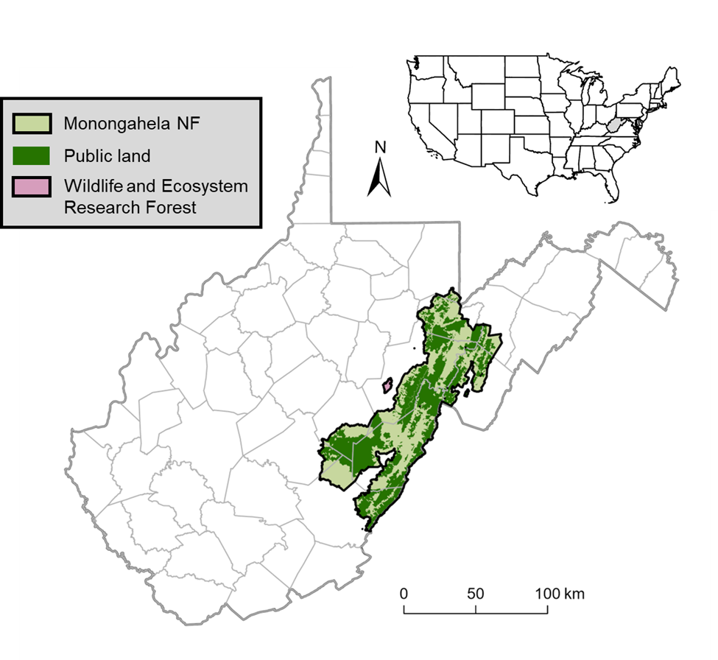

Figure 1. Sampling points and nest search plots for this study were located in 2 study areas in West Virginia: (1) the MeadWestvaco Wildlife and Ecosystem Research Forest, which was established in 1994 by the Westvaco Corporation and comprises 3,080 ha; and (2) the Monongahela National Forest (NF), which encompasses portions of 9 counties (delineated by gray lines) and comprises nearly 688,000 ha, of which 54% (371,906 ha) is public land (dark green).

Figure . Locations of the sampling points and nest search plots within the MeadWestvaco Wildlife and Ecosystem Research Forest (WERF) in 1996–1998, 2001–2003, and 2007–2009.

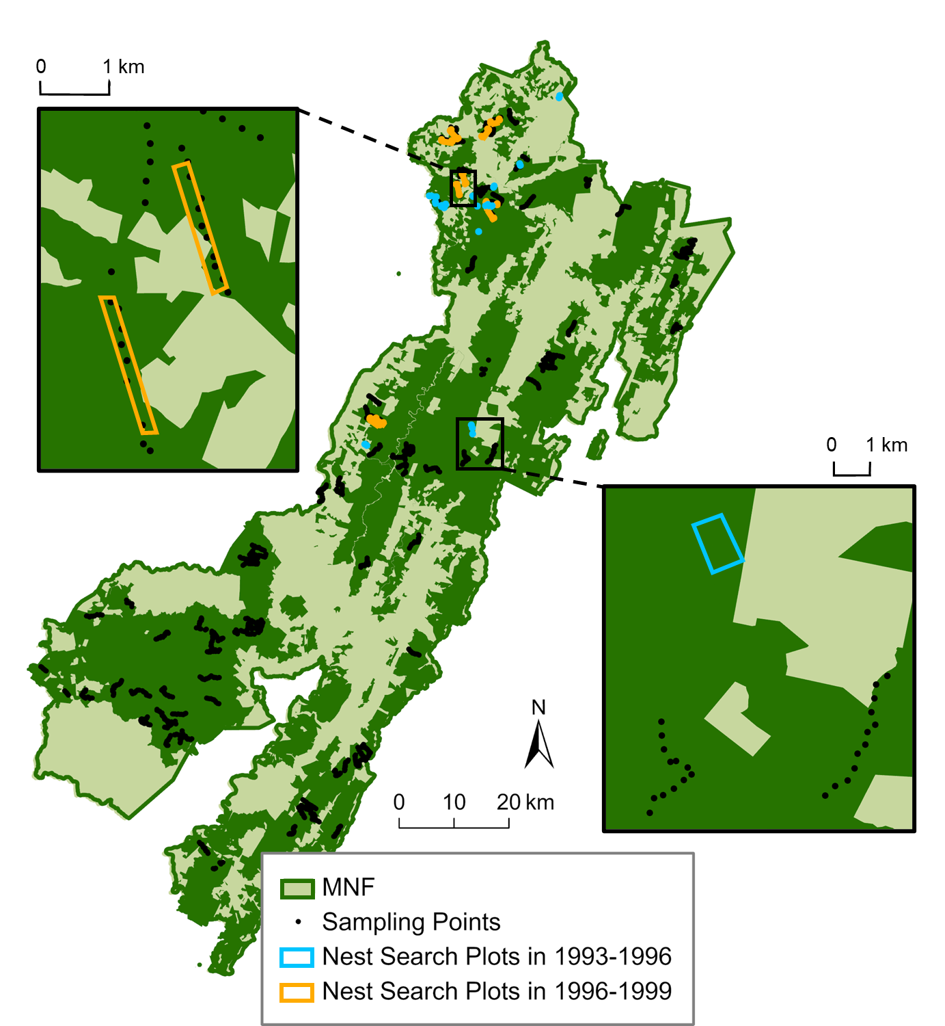

Figure . Locations of the sampling points and nest search plots within the public lands (dark green) of the Monongahela National Forest (MNF) in 1993–1996 and 1996–1999.

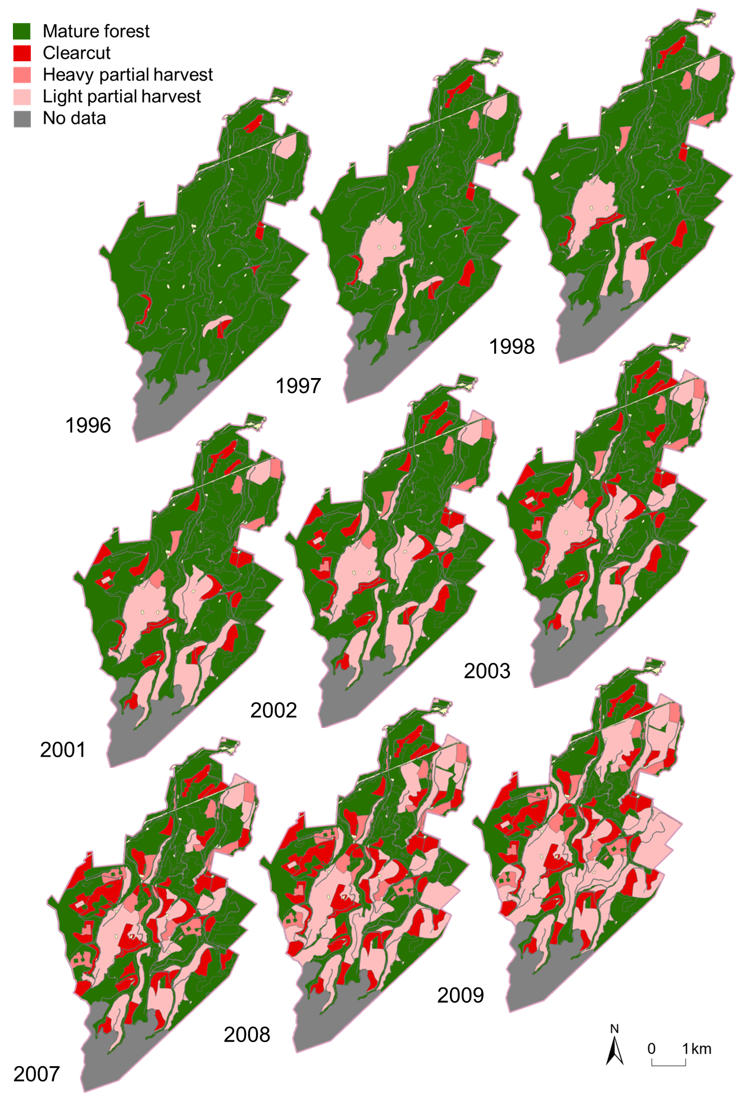

Figure 4. Timber harvest history of the actively harvested MeadWestvaco Wildlife and Ecosystem Research Forest (WERF) during 1996–1998, 2001–2003, and 2007–2009. Heavy partial harvest methods included shelterwood cuts, two-age harvests, and regeneration (seed-tree) harvests, whereas light partial harvest methods included diameter-limit harvests and single-tree selection.

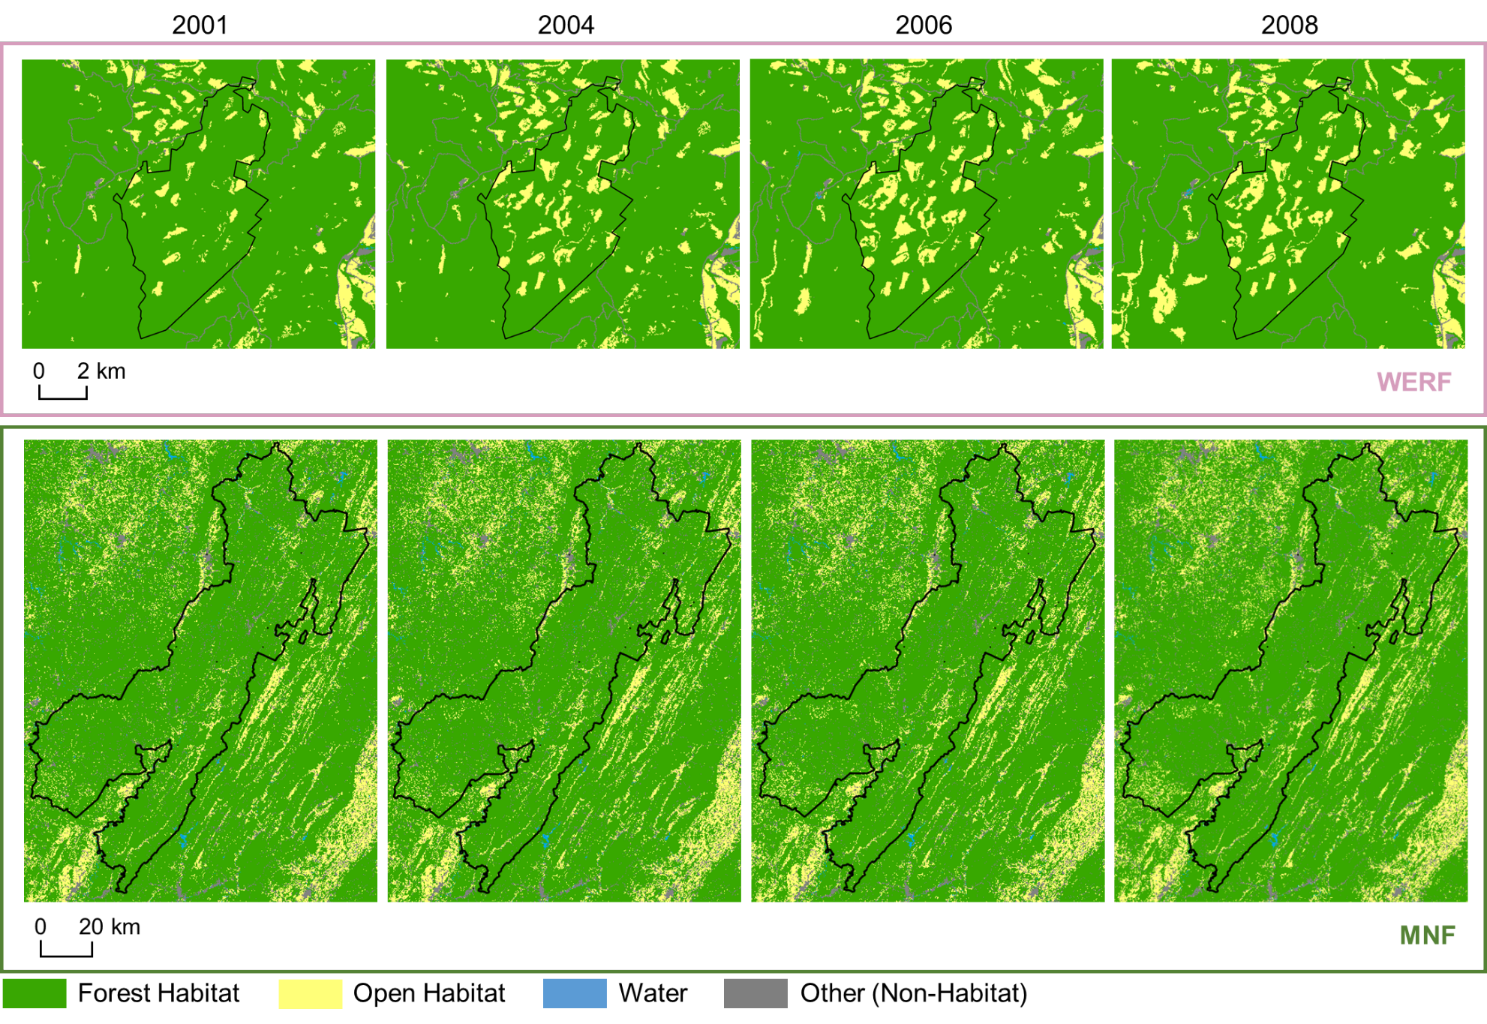

Figure 5. Land cover change in the MeadWestvaco Wildlife and Ecosystem Research Forest (WERF) and the Monongahela National Forest (MNF) from 2001 to 2009, based on 2001 / 2004 / 2006 / 2008 National Land Cover Database (NLCD) data. In these maps, NLCD land cover classifications were aggregated into 4 cover types: mature forest (comprising deciduous, mixed, and coniferous forest), open habitat (representing early-successional habitat and comprising shrubs, grasslands, and hay / pasture), water, and other non-habitat cover (comprising developed land, barren land, and cropland).

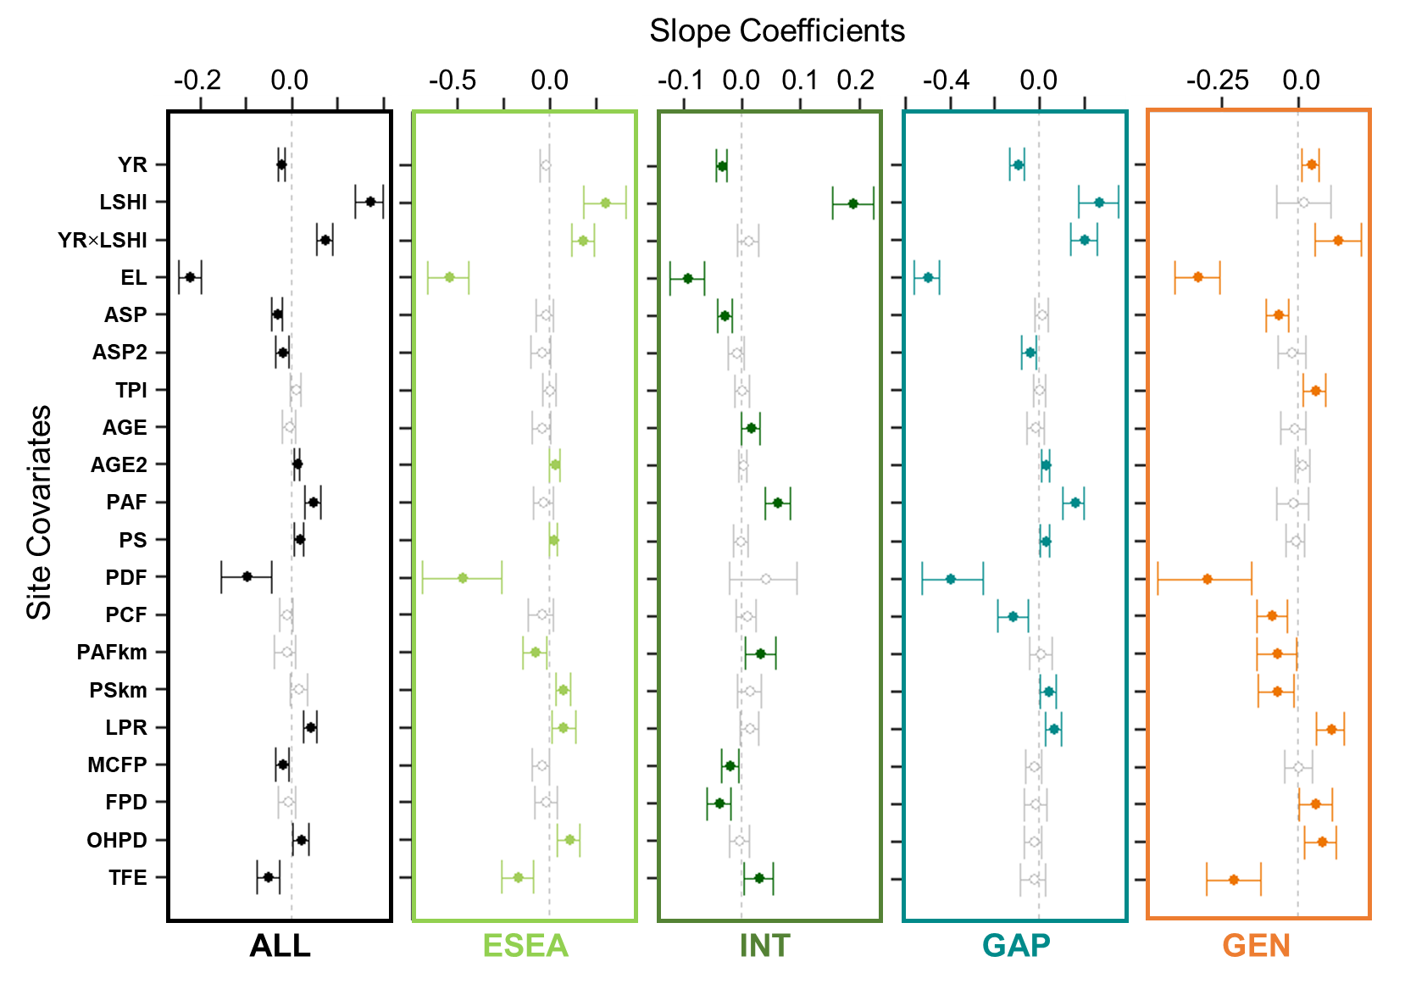

Figure 6. Whisker plots for overall species richness (ALL) and guild (early-successional / edge-associated [ESEA], forest-interior [INT], forest-gap [GAP], and forest generalist [GEN]) richness (see Appendix C1 for guild designations and associated forest songbird species), displaying the slope coefficients of the predictor variables (i.e., site covariates; year [YR], landscape-scale harvest intensity [LSHI], their interaction [YR×LSHI], elevation [EL], aspect [ASP] squared [ASP2], topographic position index [TPI], stand age [AGE] squared [AGE2], proportion of all forest [PAF] / shrub cover [PS] / deciduous forest [PDF] / conifer forest [PCF] within 50 m, proportion of all forest [PAFkm] / shrub cover [PSkm] within 1 km, and landscape patch richness [LPR] / mean core forest patches [MCFP] / forest patch density [FPD] / open habitat patch density [OHPD] / total forest edge [TFE] within 1 km). Points are located at the mean values for the posterior distributions and the corresponding whiskers encompass the 95% credible intervals. Solid colored points with closed circles and non-gray whiskers indicate statistical significance (i.e., credible intervals do not overlap 0).

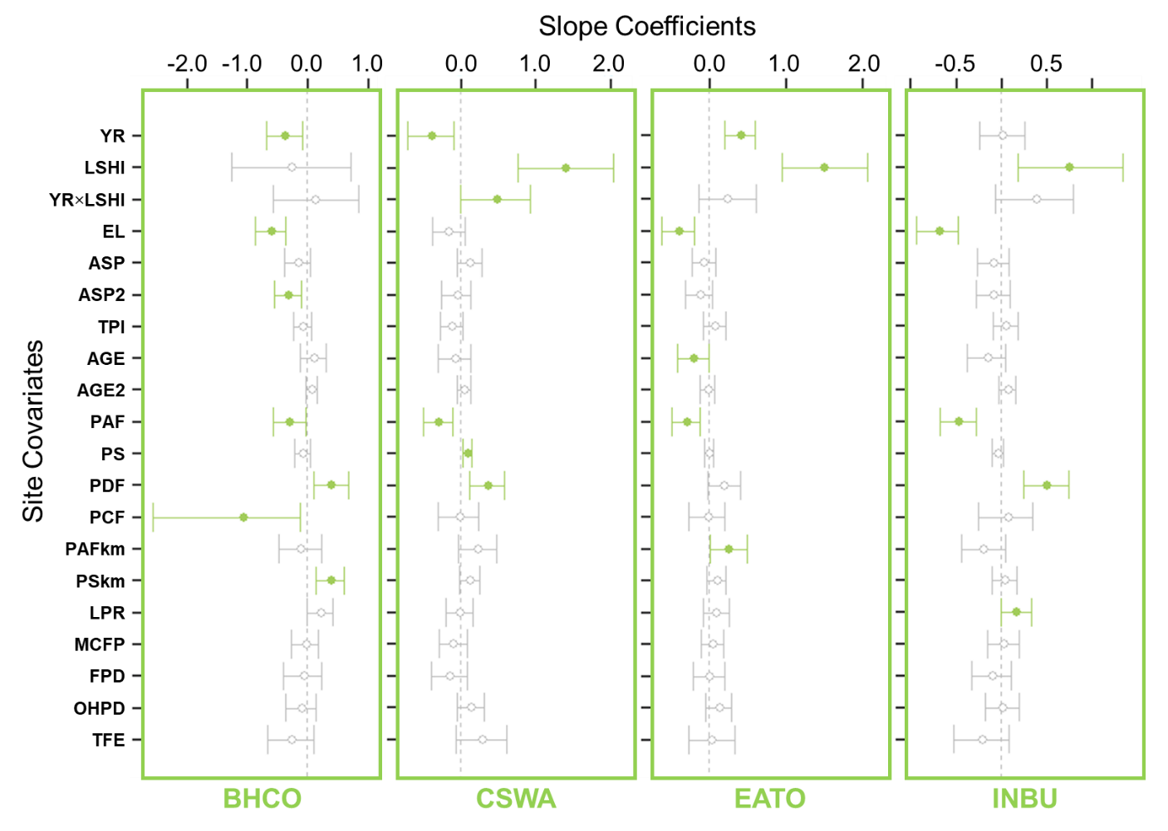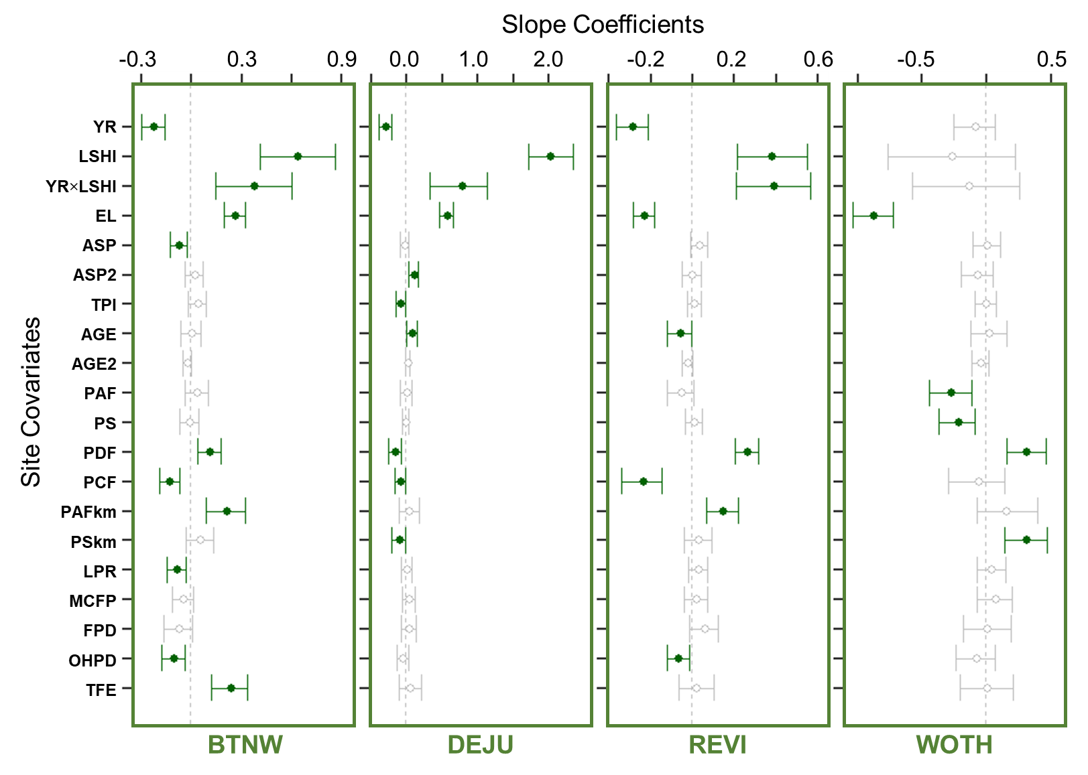

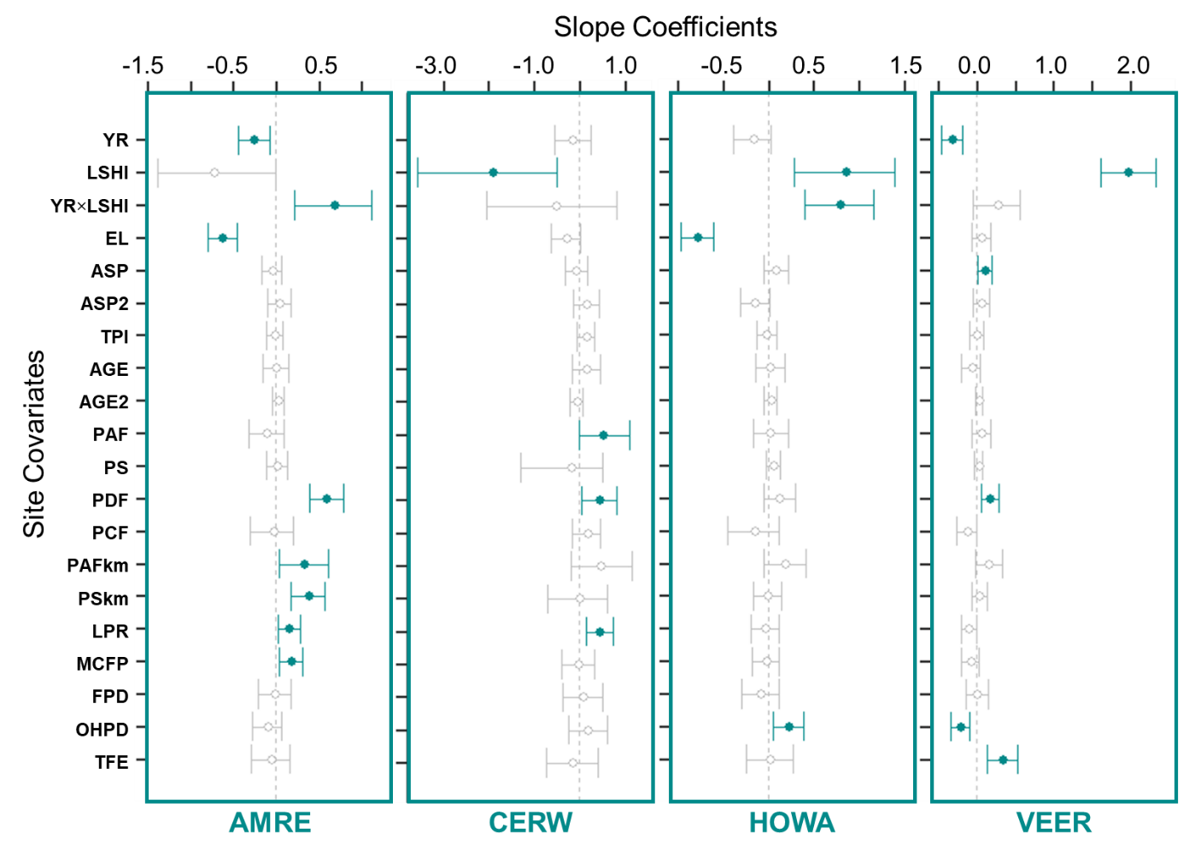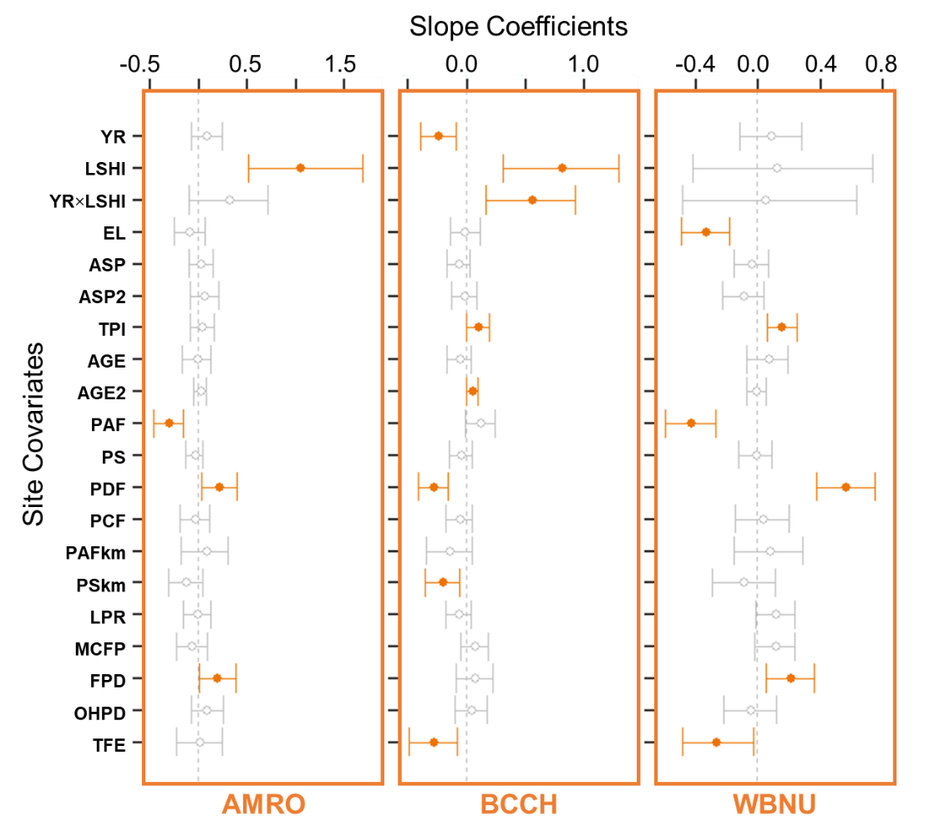

Figure 7. Whisker plots for each focal species in the abundance analyses (see Table 1 for species codes), displaying the slope coefficients of the predictor variables (i.e., site covariates; year [YR], landscape-scale harvest intensity [LSHI], their interaction [YR×LSHI], elevation [EL], aspect [ASP] squared [ASP2], topographic position index [TPI], stand age [AGE] squared [AGE2], proportion of all forest [PAF] / shrub cover [PS] / deciduous forest [PDF] / conifer forest [PCF] within 50 m, proportion of all forest [PAFkm] / shrub cover [PSkm] within 1 km, and landscape patch richness [LPR] / mean core forest patches [MCFP] / forest patch density [FPD] / open habitat patch density [OHPD] / total forest edge [TFE] within 1 km). Points are located at the mean values for the posterior distributions and the corresponding whiskers encompass the 95% credible intervals. Solid colored points with closed circles and non-gray whiskers indicate statistical significance (i.e., credible intervals do not overlap 0). Color of the 4-letter species code and plot elements indicates the species’ guild designation (light green = early-successional / edge-associated guild, dark green = forest-interior guild, teal = forest-gap guild, orange = forest generalist guild).

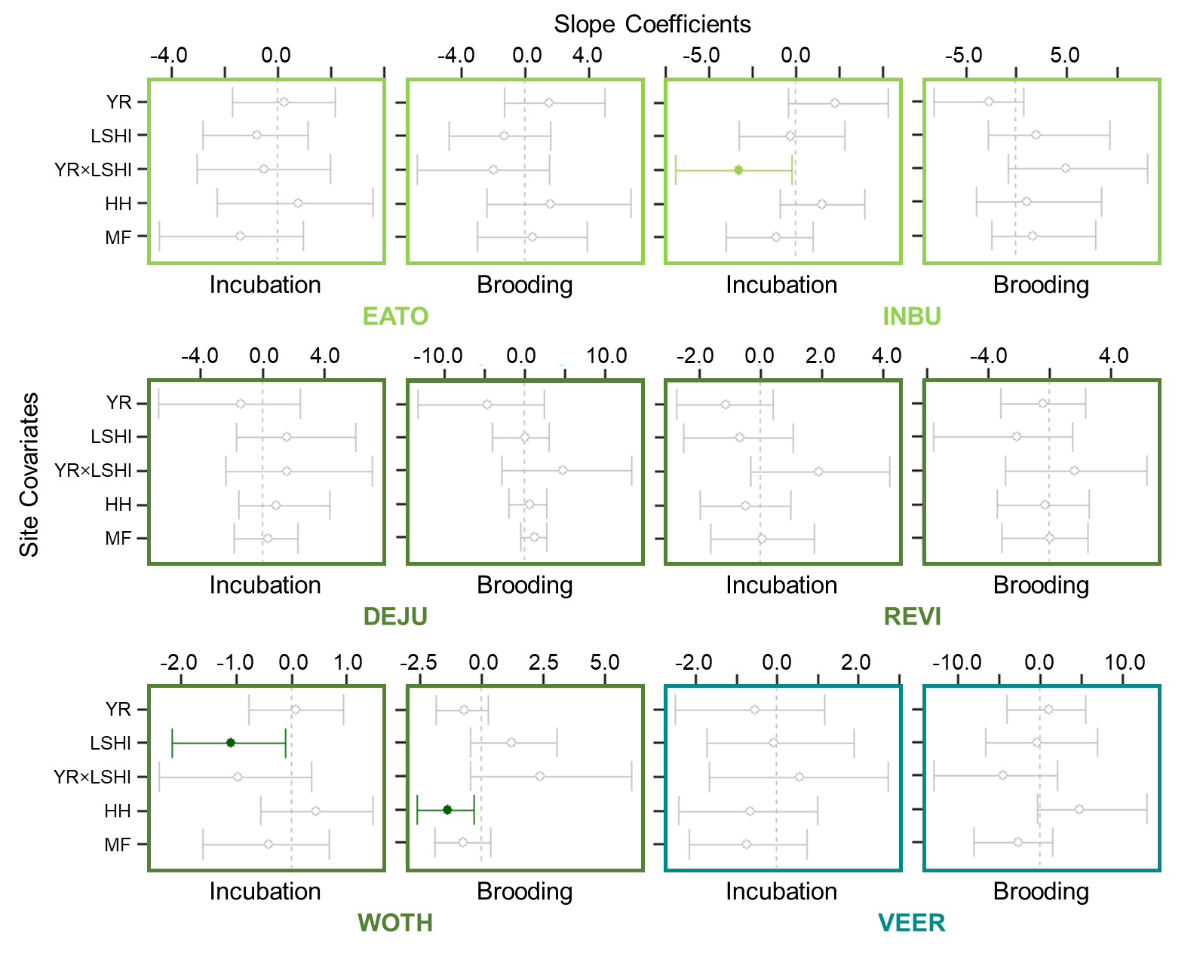

Figure 8. Whisker plots for each focal species in the nest success analyses (see Table 1 for species codes), displaying the slope coefficients of the predictor variables (i.e., site covariates; year [YR], landscape-scale harvest intensity [LSHI], interaction [YR×LSHI] between year and landscape-scale harvest intensity, harvest history [HH] of nest search plot, and nest search plot located in mature forest [MF]) for nest success during the incubation and brooding periods, respectively. Points are located at the mean values for the posterior distributions and the corresponding whiskers encompass the 95% credible intervals. Solid colored points with closed circles and non-gray whiskers indicate statistical significance (i.e., credible intervals do not overlap 0). Color of the 4-letter species code and plot elements indicates the species’ guild designation (light green = early-successional / edge-associated guild, dark green = forest-interior guild, teal = forest-gap guild).

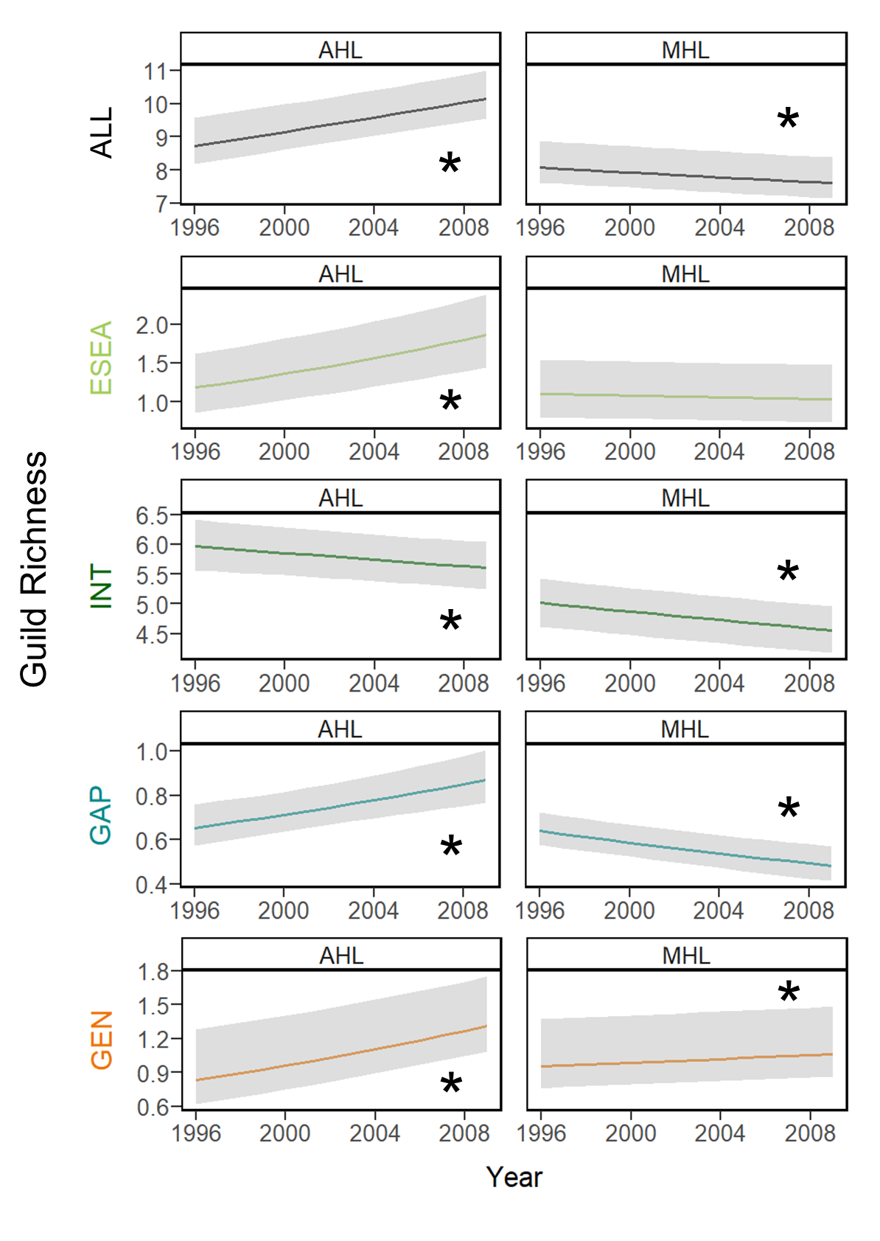

Figure . Plots of the change over time in overall species richness (ALL) and guild (early-successional / edge-associated [ESEA], forest-interior [INT], forest-gap [GAP], and forest generalist [GEN]) richness (see Appendix C1 for guild designations and associated forest songbird species) within an actively harvested landscape (AHL) and minimally harvested landscape (MHL). An asterisk indicates a significant trend, where the 95% credible interval of the effective slope coefficient for year does not overlap 0.

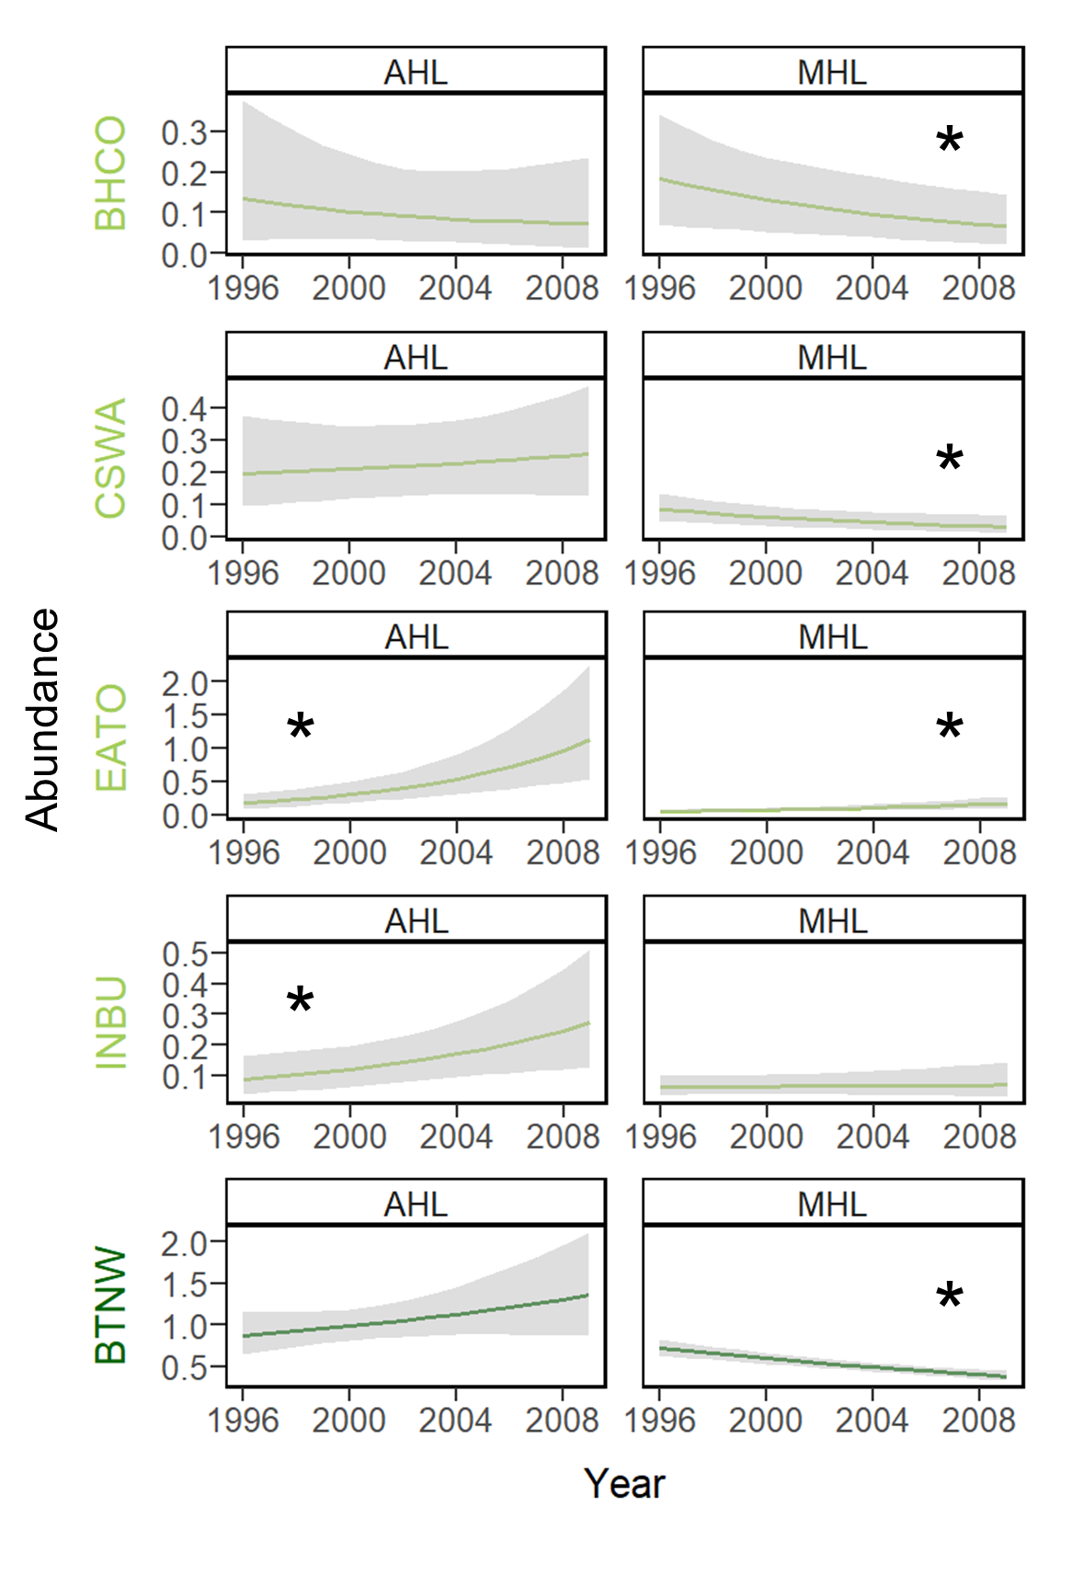

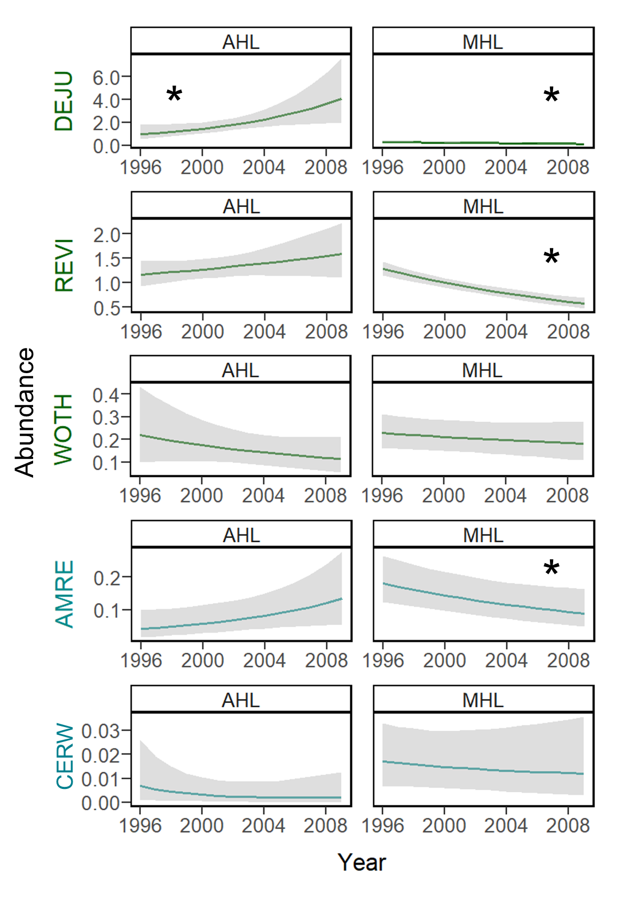

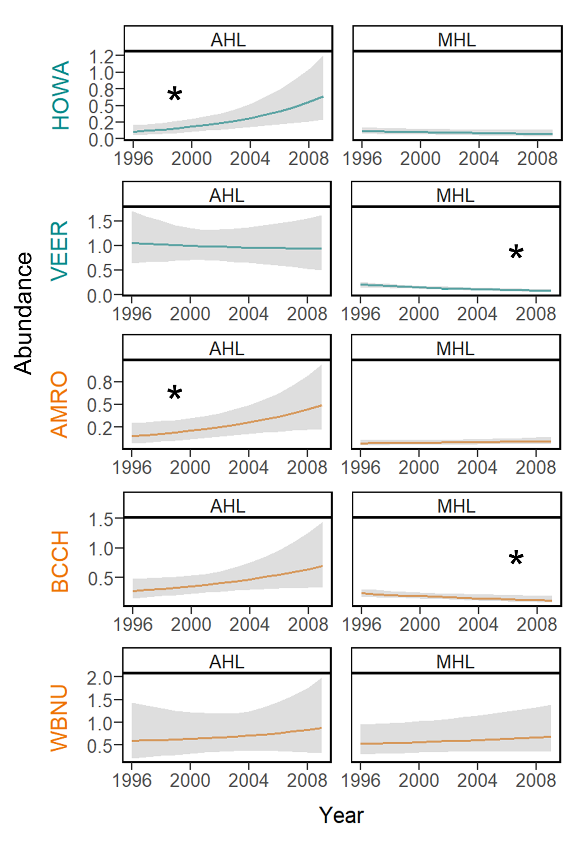

Figure 10. Plots of the change over time in focal songbird species abundance (see Table 1 for species codes) within an actively harvested landscape (AHL) and minimally harvested landscape (MHL). Color of the 4-letter species code and plot elements indicates the species’ guild designation (light green = early-successional / edge-associated guild, dark green = forest-interior guild, teal = forest-gap guild, orange = forest generalist guild). An asterisk indicates a significant trend, where the 95% credible interval of the effective slope coefficient for year does not overlap 0.

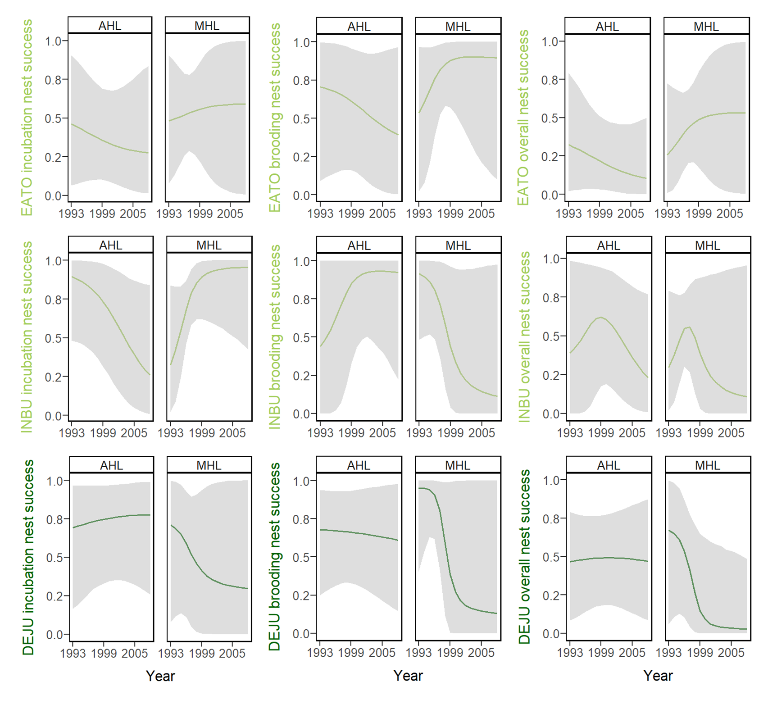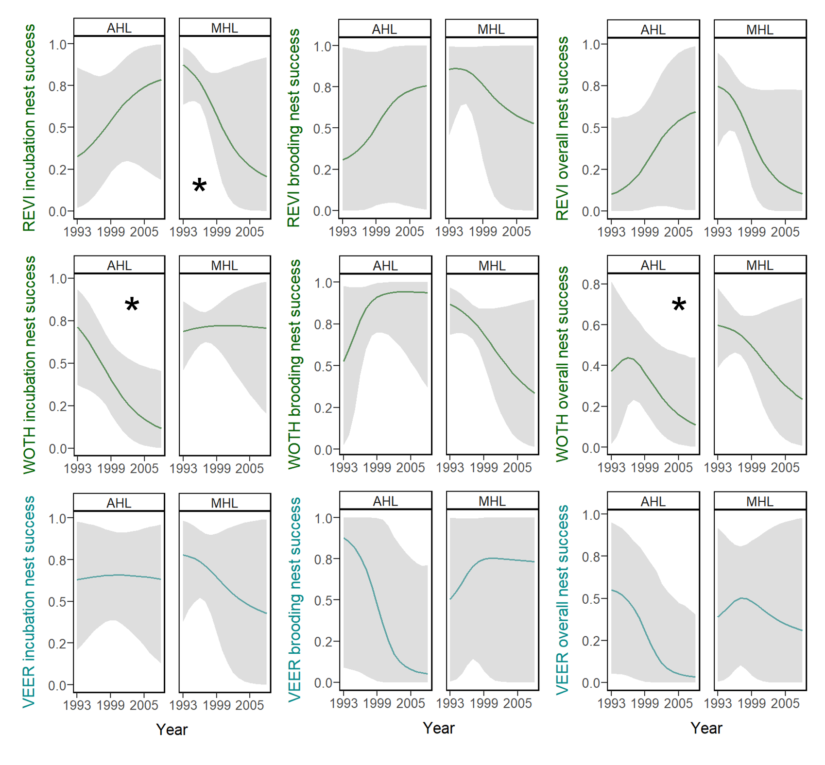

Figure 11. Plots of the change over time in focal songbird species nest success (see Table 1 for species codes) during the incubation period, brooding period, and overall nesting period within an actively harvested landscape (AHL) and minimally harvested landscape (MHL). Color of the 4-letter species code and plot elements indicates the species’ guild designation (light green = early-successional / edge-associated guild, dark green = forest-interior guild, teal = forest-gap guild). An asterisk indicates a significant trend, where the 95% credible interval of the effective slope coefficient for year does not overlap 0.

# CHAPTER 4

**Multi-species avian occupancy of wildlife openings in a heavily forested landscape**

## Introduction

### Wildlife use of forest openings

In forested landscapes and extensive forest stands within the eastern United States, openings (i.e., open patches of generally low vegetation that do not contain mature forest) can serve as habitat and provide food resources for disturbance-dependent, early-successional forest-associated wildlife species. Insects and herbaceous vegetation (i.e., grasses and forbs which are generally more nutritious and digestible than woody plants) can be more abundant in openings than beneath a forest canopy (Blake and Hoppes 1986, Martin and Karr 1986, Shure and Phillips 1991). Although forest openings do occur naturally (Askins 2001), wildlife openings (i.e., open or early-successional forest habitat created incidentally or purposefully for target wildlife species) tend to be specifically created and maintained by land managers through timber harvest, grazing, or other active forest management strategies. New wildlife openings are often created along or from log decks, log roads, and utility rights-of-way. To encourage and maintain the herbaceous community, managers use a variety of management actions, including mowing, liming, fertilizing, planting, and burning. In most cases, the purpose of these wildlife openings is to provide habitat specifically for game species (Overcash et al. 1989), including 3 popular game birds --- wild turkeys (*Meleagris gallopavo*), ruffed grouse (*Bonasa umbellus*), and American woodcocks (*Scolopax minor*).

Wild turkeys, ruffed grouse, and American woodcocks vary slightly in their forested habitat preferences, but all 3 species are known to use herbaceous wildlife openings for mating displays, nesting, brood-rearing, or feeding. Wild turkeys tend to reside in open deciduous or mixed forests with interspersed clearings. Wildlife openings are commonly maintained to improve forest habitat for wild turkeys (Healy and Nenno 1983), as openings can be important to nest site selection and poult feeding activity (Healy 1985, Byrne and Chamberlain 2013). Ruffed grouse and American woodcocks are both associated with early-successional, shrubby deciduous forests (Dessecker and McAuley 2001, Endrulat et al. 2005). Ruffed grouse tend to rely on young stands of trees for both cover and food, with wildlife openings providing brood cover and food for their chicks (Bump et al. 1947, Sharp 1963). American woodcocks use forest openings for mating displays in the spring and roosting in the summer (Roboski and Causey 1981). They also use wildlife openings and other open areas as nocturnal habitat (Straw et al. 1994, Krementz et al. 1995). It is widely believed that the loss of early-successional forest habitat is a primary reason for declines in American woodcock recruitment and in overall population status (Kelley et al. 2008).

Despite plenty of evidence that wild turkeys, ruffed grouse, and American woodcocks use wildlife openings, there is a general lack of published studies for each species that explicitly focus on their responses to a combination of local habitat attributes, size, management, or landscape context of wildlife openings (e.g., Shartell 2016). Results from the few existing studies suggest that local habitat attributes and management may have the greatest influence on species-specific use, but opening size was also mentioned frequently. For instance, wild turkey broods generally benefit from active management (e.g., mowing) that enhances the abundance of herbaceous vegetation in openings that were <0.5 ha in size (Healy and Nenno 1983). Similarly, ruffed grouse select for brood habitat with high amounts of herbaceous groundcover, which can be achieved by specific management actions (Jones et al. 2008). In the Cherokee National Forest in Tennessee, management of logging roads converted to linear wildlife openings resulted in greater arthropod availability to ruffed grouse chicks than logging roads not managed for wildlife (Hollifield and Dimmick 1995). In the same study, the abundance of herbaceous vegetation was more important in determining arthropod availability than the successional age of clearcuts. However, forest succession played a role in the amount of herbaceous vegetation and ruffed grouse brood use in 0.1–0.4 ha openings in Pennsylvania (Sharp 1963). Maintenance of permanent openings that are 0.1–0.8 ha in size is recommended for food production for ruffed grouse in Manistee National Forest in Michigan (Berner and Gysel 1969), but in central hardwood forests, Thompson and Dessecker (1997) suggested that ruffed grouse would benefit most from 2–16 ha patches of regenerating forest, with interspersion of habitats. For American woodcocks, habitat structure is important in the selection of display sites; opening size and distance to the nearest opening may also have influence (Gutzwiller et al. 1983). Regular disturbance (e.g., cutting trees) is likely important to maintain that structure and appears to increase American woodcock use of clearcut aspen areas (Hale and Gregg 1976). To best benefit American woodcocks, McAuley et al. (1996) and Masse et al. (2014) recommend actively maintaining >25% of the landscape as early-successional habitat, with approximately eight >0.2-ha wildlife openings per 40 ha.

In addition to game birds, wildlife openings potentially benefit songbird species associated with grasslands, shrub-scrub habitats, and disturbed areas in forested habitats, a habitat guild that has experienced widespread population declines in eastern North America (Hunter et al. 2001, DeGraaf and Yamasaki 2003). However, several attributes of wildlife openings, including size, time since disturbance, and treatment regime, may affect their suitability as early-successional bird habitat. Bird species that breed in early-successional habitat are often restricted by the area of wildlife openings (Roberts and King 2017, Margenau et al. 2022). In a study of the effects of group-selection opening size on breeding bird habitat use in a bottomland forest, species richness in 0.06-, 0.13-, 0.26-, and 0.5-ha openings increased as opening size increased, due to the increased use of larger openings by early-successional and edge-associated species (Moorman and Guynn, Jr. 2015). Shrubland bird density may also be related to patch size (Lehnen and Rodewald 2009). To best manage for early-successional forest and shrubland birds, DeGraaf and Yamasaki (2003) recommend that group selection and patch cuts should be at least 0.8 ha, while Chandler et al. (2009) suggest a minimum size of 1.2 ha and Shake et al. (2012) propose >5.5 ha. Opening size may also determine the magnitude of corresponding effects on forest-interior songbirds. One study reported that openings of 0.02–0.04 ha had a minor effect on the forest bird community (Robinson and Robinson 1999), while another found that 0.4-ha clearcut openings resulted in the movement of several forest-interior species away from openings and subsequently decreased abundance in and adjacent to openings (Germaine et al. 1997). Within forest-dominated landscapes in West Virginia, the width of rights-of-ways and wildlife openings had a negative influence on forest-interior bird species (Margenau et al. 2022). However, McDermott et al. (2011) documented an increase in late-successional bird diversity with size of stands that ranged in age from 15–40 years, such that the highest species diversity was found in the largest stands within their study. In addition to opening size, time since disturbance likely influences breeding songbird abundance and community composition in wildlife openings (George et al. 2019); if not regularly maintained, then an opening created by timber harvest may cease to provide suitable habitat for early successional breeding specialists after a certain period of time (McDermott et al. 2011). For example, Robinson and Robinson (1999) found that populations of gap-dependent species reached a peak 2–3 years after the creation of 0.02–0.04 ha openings but declined to population levels comparable to those in uncut forest after 5–10 years. Different successional stages are generally associated with distinct vegetation characteristics and thus local habitat attributes, such as vegetation structure and shrub density, which has been shown to be a primary factor affecting abundance of early-successional bird species (Bulluck and Buehler 2006, Askins et al. 2007, King et al. 2009, McDermott et al. 2011). Management regime (e.g., burning, mowing) may also affect shrubland bird abundance (Chandler et al. 2009), with an optimum post-treatment time of 10–15 years suggested by Schlossberg and King (2009) for shrubland birds in the eastern United States. Although very few studies have addressed the effect of landscape context on use of wildlife openings by early-successional bird species, landscape-level variables such as distance to the nearest opening and land cover composition within 1 km have been found to influence shrubland generalists more than shrubland specialists (Askins et al. 2007) or to have little influence (Shake et al. 2012). In addition, prairie warblers (*Setophaga discolor*) may be more likely to occur in forest openings that are closer to large patches of open habitat (Roberts and King 2017). Despite the paucity of studies and corresponding evidence, it is likely that landscape-level factors affect avian use of wildlife openings, as they have been found to explain mature forest songbird occupancy and abundance (Villard et al. 1999, Graham and Blake 2001, Lee et al. 2002), grassland bird species richness (Hamer et al. 2006), saltmarsh bird species diversity (Shriver et al. 2004), and waterbird species richness and occurrence (Guadagnin and Maltchik 2006). Based on the documented effects of landscape characteristics on these other avian species and guilds, as well as management recommendations for early-successional and shrubland birds (DeGraaf and Yamasaki 2003), I would expect spatially isolated wildlife openings in extensively forested landscapes to have lower occupancy and numbers of early-successional bird species.

Use of wildlife openings may not be restricted to early-successional and shrubland birds. Certain songbirds that breed in mature forest shift their habitat use to early-successional areas after nesting but before migration (i.e., during the post-breeding period). Rappole and Ballard (1987) were perhaps the first to report both post-breeding adult and juvenile forest birds moving into early-successional habitats. Since then, a number of mist-netting studies have found that forest-interior songbird species are frequently captured in regenerating clearcuts during the post-breeding season (e.g., Pagen et al. 2000, Marshall et al. 2003, Vitz and Rodewald 2006, McDermott and Wood 2010, Streby et al. 2011, Chandler et al. 2012, Major and Desrochers 2012, Stoleson 2013). Radio-tagging of ovenbirds (*Seiurus aurocapilla*), wood thrushes (*Hylocichla mustelina*), and scarlet tanagers (*Piranga olivacea*) have also shown that fledglings and adults of these species tend to move into edge and early-successional habitats after breeding in mature forest (Anders et al. 1998, Vega Rivera et al. 1998, 2003, King et al. 2006, Dellinger 2007). Contrary to formerly prevailing assumptions, a subset of forest-interior birds are present in significantly higher densities in early-successional habitats than in surrounding mature forest during the post-breeding season (Pagen et al. 2000, Bowen et al. 2007, Chandler et al. 2012). Thus, early-successional habitat within forested landscapes, such as wildlife openings, may benefit post-breeding forest-interior species in addition to early-successional and edge-associated species (Anders et al. 1998, Pagen et al. 2000, Vitz and Rodewald 2006, Chandler et al. 2012). Supporting this recommendation, forest-interior birds captured in regenerating clearcuts were more advanced in molt and in better condition than those captured in forests (Stoleson 2013). In addition, evidence suggests that food availability is equivalent or greater in early-successional habitats than in mature forest (Keller et al. 2003, Vitz and Rodewald 2006), and vertical structure may provide protection from predators (Vitz and Rodewald 2007). Specifically, post-breeding forest-interior songbirds achieve the highest densities in early-successional habitats with tall, complex vegetation structure (Chandler et al. 2012). However, the shape and size of wildlife openings may also affect use by post-breeding songbirds. One study found that post-breeding individuals avoid the edges and appear to prefer smaller regenerating clearcuts (4–9 ha) over large clearcuts (13–18 ha) (Vitz and Rodewald 2006). Furthermore, post-breeding early-successional, edge-associated, and forest-interior species may exhibit habitat guild-specific responses to wildlife openings created with timber harvest, based on size, amount of edge, and retained basal area (McDermott and Wood 2011). Overall, these handful of studies on the post-breeding songbird use of forest and wildlife openings emphasize the importance of size and vegetation structure, but they fail to address the potential effects of management or landscape context, despite the value of examining both patch- and landscape-level characteristics (Mazerolle and Villard 1999).

### Knowledge gap

Although wildlife openings are primarily meant to provide habitat and food resources for disturbance-dependent, early-successional game species, they may also benefit a myriad of forest-associated avifauna, including species of high regional conservation concern (Chandler et al. 2009). Yet those benefits are likely dependent upon certain wildlife opening attributes and likely vary among species and guilds. A research question that has been frequently addressed is the size of an opening needed to provide habitat for early-successional birds (Askins et al. 2007). However, there is a clear knowledge gap concerning which other wildlife opening attributes are important considerations for holistic management for entire avian communities. Most studies consider a limited number of local-scale characteristics of openings created incidentally by timber harvest operations and their corresponding effects on species-specific and, to a lesser extent, community-level responses of breeding songbirds. Only a handful of additional studies focus on the use of openings by game birds (e.g., Sharp 1963, Healy and Nenno 1983, Shartell 2016) or post-breeding songbirds (e.g., Chandler et al. 2012) but never both simultaneously and rarely in conjunction with breeding songbirds. Instead of approaching the question of management piecemeal by season, species, guild, taxon group, or opening characteristic, we need to comprehensively investigate how to optimize wildlife openings to attract a full spectrum of avian species throughout spring and summer, maximize richness across guilds and taxa groups, and minimize negative effects to the forest-interior breeding bird community. Understanding the sympatric use of wildlife openings by game birds, breeding songbirds, and post-breeding songbirds in response to site-level and landscape-level wildlife opening attributes is critical for land managers to design and maintain wildlife openings that simultaneously support game bird populations and promote a diverse suite of songbirds.

### Purpose, objectives, and hypotheses

The purpose of this research was to identify the characteristics of wildlife openings that support target game birds and a diversity of breeding and post-breeding songbirds. My objectives were to quantify how a suite of site-level and landscape-level wildlife opening attributes (Table 1) relate to multi-species occupancy of 3 game birds (wild turkey, ruffed grouse, and American woodcock) during the game bird courtship season and songbird guild richness during the breeding and post-breeding seasons.

In this study, I first tested competing hypotheses to determine whether local habitat attributes, opening size, management, landscape context, or a combination of site-level and landscape-level factors best explained game bird species occupancy in wildlife openings (Table 2). After identifying which wildlife opening attributes were important for the 3 target game bird species, I then evaluated the effects of those variables on breeding and post-breeding songbird communities within the wildlife openings and on breeding songbird communities in mature forest habitat adjacent to the wildlife openings. To holistically assess impacts on songbird diversity, I considered 4 habitat guilds (Appendix D1): early-successional / edge-associated species, forest-interior species, forest-gap species, and forest generalist species.

## Methods

### Study area

Sampling sites for this study were located throughout the Monongahela National Forest (MNF), which encompasses portions of 9 counties (Preston, Tucker, Grant, Randolph, Pendleton, Pocahontas, Webster, Nicholas, and Greenbrier) in eastern West Virginia (Figure 1). This area was placed under federal protection in 1920 and encompasses nearly 688,000 ha, of which 54% (371,906 ha) is owned and overseen by the USDA Forest Service. The MNF stretches across a latitudinal range of nearly 200 km and lies within 2 physiographic provinces, the Central Appalachians (Allegheny Mountains) and the Ridge and Valley. The eastern section of the Monongahela National Forest, which overlaps the Ridge and Valley physiographic province, lies in the rain shadow of the Allegheny Mountains, so it receives significantly less precipitation (~75 cm/year) compared to the rest of the forest, which experiences 115–150 cm/year (Clarkson 1966). Elevation within the MNF ranges from 275–1,480 m.

The MNF is comprised primarily of 70–100 years-old stands with high regional tree diversity and 4 major forest zones (mixed mesophytic, northern hardwoods, red spruce, and dry oaks) (McCay et al. 1997, DeMeo 1999). Mixed mesophytic forests are present at low elevations (<900 m), with northern red oak (*Quercus rubra*), hickory (*Carya* spp.), and yellow-poplar (*Liriodendron tulipifera*) as the dominant species (Madarish et al. 2002). At increasing elevations, there is a transition in stand dominance to northern hardwoods, including American beech (*Fagus grandifolia*), sugar maple (*Acer saccharum*), and black cherry (*Prunus serotina*) (Stephenson 1993). At the highest elevations (>1,150 m), remnant boreal forest ecosystems are dominated by red spruce (*Picea rubens*). In the eastern MNF, dry oaks are common in the Ridge and Valley area, consisting of white (*Quercus alba*), chestnut (*Q. prinus*), scarlet (*Q. coccinea*), and black (*Q. velutina*) oaks, as well as pines (*Pinus* spp.).

### Sampling design

There is a GIS dataset with manual records of ~2,200 individual openings within the MNF (Figure 2), ranging in size from 0.01 ha former log landings to 113 ha former mine lands and ranging in shape from linear cuts to sprawling grazing allotments (USDA Forest Service 2006). A subset of these openings, generally 0.02–22 ha (mean = 2.0 ha), were created or managed to benefit target wildlife species. Within the past several decades, many of the wildlife openings were constructed either opportunistically or systematically following timber harvest, gas well activity, or other human disturbances, and then subsequently managed or maintained by MNF or West Virginia Division of Natural Resources staff. The purpose of the wildlife openings is generally to provide habitat to regionally important game species associated with early-successional or open habitat, including white-tailed deer (*Odocoileus virginianus*), wild turkey, and American woodcock. The majority (>96%) of these wildlife openings are ≤5 ha in size, and approximately 80% of the openings are actively maintained or have a history of maintenance. Active management of wildlife openings consists primarily of mowing, although applying herbicides, liming, fertilizing, planting, and grazing are also implemented in select wildlife openings. The density of wildlife openings within the landscape varies, but many wildlife openings are located <1 km from the nearest neighboring opening.

For this study, I used stratified random sampling based on size and maintenance status to select a total of 335 wildlife openings as sampling sites (Figure 2). They ranged in size from 0.04 ha to 21.53 ha (mean = 1.56 ha), with 236 small (<1 ha) wildlife openings, 71 mid-sized (1–5 ha) wildlife openings, and 28 large (>5 ha) wildlife openings. Of those, 76 of the small wildlife openings, 28 of the mid-sized wildlife openings, and 18 of the large wildlife openings were not maintained or had no history of maintenance.

### Focal game bird species and songbird guild designations

Taking land manager goals into consideration, my research primarily focused on the 3 regionally important upland game bird species in the Central Appalachian region: wild turkey, ruffed grouse, and American woodcock. To assess additional impacts on songbird diversity, I considered a subset of passerine and near-passerine species. Although a total of 116 avian species were detected across all surveys, I limited the richness analyses to 66 species (see Appendix D1 for full list) with breeding ranges that encompassed the study area and that had ≥5 detections. I also excluded wetland-associated songbirds (e.g., red-winged blackbirds [*Agelaius phoeniceus*]) because they were incidental to the focal habitat types, as well as corvids (family Corvidae) and waterthrushes (*Parkesia* spp.) because they are not well-sampled with breeding songbird point count surveys.

Habitat-related guild designations for the 66 songbird species were assigned based on breeding habitat and comprised 4 categories (Appendix D1): (1) early-successional / edge-associated (i.e., primarily breed or found in grasslands, shrub/scrub, or young forest; or along forest edges, such as the interface of early-successional and mature forest); (2) forest-interior (i.e., generally breed or found in the core area of mature forest); (3) forest-gap (i.e., generally breed or found in or near small forest gaps within the core area of mature forest); and (4) forest generalist (i.e., associated with forest but no preference for early-successional vs. mature forest). For early-successional / edge-associated species, the presence of a wildlife opening is required, and for forest-gap species, the presence of gaps in the forest canopy is required.

### Field data collection

***In-person sampling methods for game bird species***

I conducted in-person game bird surveys at 64 wildlife openings in 2019 and 251 wildlife openings in 2021, for a total of 315 wildlife openings (Table 3); sampling occurred between 15 April and 10 May to overlap with the peak courtship / breeding period for the 3 game bird species (Schumacher 2002, US Fish and Wildlife Service 2011). For the in-person game bird surveys, I randomly generated a single sampling point within each wildlife opening that was >80 m from the forest edge (if possible); for the smallest wildlife openings (<1 ha), the point was located in the approximate center of the opening (Figure 3).

Wild turkeys and ruffed grouse were sampled simultaneously at 315 wildlife openings with repeated 10-minute morning modified drumming (Hansen et al. 2011) / gobbling surveys (Table 3). Each wildlife opening was surveyed twice during the game bird courtship period within a single sampling year (2019 or 2021). Surveys commenced at sunrise and were concluded within 4 hours after sunrise. The 10-minute survey was split into 2 equal time intervals: 0–5 minutes and >5–10 minutes. For each wild turkey or ruffed grouse that was seen or heard during the survey, the observer noted the species, time interval(s) during which it was detected, and location (within the opening, along the edge, or in the adjacent forest). Observers also recorded the survey date, start time, temperature, maximum wind speed, maximum ambient noise level (dB), precipitation status, and sky code. Maximum wind speed was measured with a Kestrel 1000 anemometer, and maximum ambient noise was measured with a sound level meter for 1 minute. Sky codes ranged from 0 to 4 and were adapted from the U.S. Weather Bureau and Breeding Bird Survey protocols (U.S. Geological Survey 1998) to measure general sky conditions. No surveys were conducted during mornings with moderate to heavy precipitation or consistent high wind speed (>5.8 m/s).

American woodcocks were sampled at 211 wildlife openings with a single 6-minute evening modified singing-ground survey (Table 3), following the U.S. Fish & Wildlife Service American Woodcock Singing Ground Survey protocols (Bergh and Andersen 2019). Surveys began 22 minutes after sunset when the sky had <75% cloud cover and 15 minutes after sunset when the sky was overcast (≥75% cloud cover). All surveys were completed by 38 minutes after the start time. The 6-minute survey was split into 3 equal time intervals: 0–2 minutes, >2–4 minutes, and >4–6 minutes. For each American woodcock that was seen or heard during the survey, the observer noted the time interval(s) during which it was detected and location (within the opening, along the edge, or in the adjacent forest). Observers also recorded the survey date, start time, temperature, maximum wind speed, maximum ambient noise level (dB), precipitation status, and sky condition (percent cloud cover). No surveys were conducted during evenings with precipitation, consistent high wind speed is high (>5.8 m/s), or temperatures below 4° C.

***Remote sampling methods for game bird species***

To increase overall detection probabilities of the 3 game bird species, I deployed game cameras and acoustic recording units (ARUs) for up to 11 days during the game bird courtship period in a total of 145 wildlife openings (Table 3). Together, game cameras and ARUs can collect large amounts of comparable data to in-person surveys in a cost‐effective, efficient, and standardized manner (Digby et al. 2013, Darras et al. 2018). At each wild opening, a single game camera (Bushnell Trophy Cam HD or Reconyx Hyperfire) and a single ARU (Wildlife Acoustics SongMeter SM2+, Wildlife Acoustics SongMeter SM3+, or Wildlife Acoustics SongMeter SM4+) were set up together within 50 m of the in-person game bird survey point (Figure 3). The ARUs were attached at a height of ~1.5 m to a tree or shrub and pointed in a direction that faced the in-person game bird survey point, minimized auditory obstruction, and maximized potential auditory detections (Darras et al. 2018). Game cameras were secured to the same tree or shrub at ~40 cm above the ground. They were oriented parallel with the ground and pointed in a direction that faced the in-person game bird survey point, minimized visual obstruction, and maximized potential visual detections. For every game camera and ARU pair, I noted the type of game camera and ARU, and I measured the distance (m) to the central game bird survey point.

All game cameras were equipped with an infrared flash; with highly sensitive and quick trigger times, the game cameras were able to record animals passing in front of them without the need for baiting. Each game camera was set on maximum trigger sensitivity and recorded multiple photographs per trigger, re‐triggering immediately if the animal was still in view. The ARUs were programmed to record from 3 hours before sunset to 1 hour after sunset and from 1 hour before sunrise to 6 hours after sunrise, which encompasses the time that >90% of all wild turkey gobbles occur (Colbert et al. 2015) and overlapped the in-person game bird survey time period.

***Communitywide avian point count surveys for breeding songbird species***

I conducted breeding songbird surveys between 16 May and 10 July at 63 wildlife openings in 2019, 134 wildlife openings in 2020, and 112 wildlife openings in 2021, for a total of 309 wildlife openings (Table 3). Breeding songbirds were sampled with 10-minute unlimited radius stationary point count surveys at 2 sampling points associated with each wildlife opening — a central point at the same location as the game bird sampling point and an adjacent forest point that was randomly generated between 150 m and 300 m from the perimeter of the wildlife opening, >100 m from any other edges or significant canopy disturbance (to avoid possible edge effects; Germaine et al. 1997, Hobson and Bayne 2000*b*), and at least 200 m from the central point (Figure 3).

Each sampling point was visited once. Surveys began within 15 minutes of sunrise and continued until approximately 4 hours after sunrise. The 10-minute survey was split into 2 equal time intervals: 0–5 minutes and >5–10 minutes. For each individual, the observer noted the species, time interval(s) during which it was detected, and distance band (≤50 m or >50 m). Observers also recorded the survey date, start time, temperature, maximum wind speed, maximum ambient noise level (dB), precipitation status, and sky code. No surveys were conducted on mornings with rain, heavy fog, or consistent high wind speed, following the guidelines of Ralph et al. (1993).

***Communitywide avian transect surveys for post-breeding songbird species***

I conducted post-breeding songbird surveys at a subset of 82 wildlife openings between 14 July and 5 August (Table 3); this sampling period was intended to minimize overlap with the breeding season (McDermott and Wood 2011, McDermott et al. 2011) and fall migration. Post-breeding songbirds were sampled twice with transect surveys. Because transect surveys were time-intensive and the sampling period was limited, I constrained sampling to wildlife openings where at least 1 game bird species had been detected during the game bird season. Post-breeding songbirds were surveyed along 4–8 transect segments per wildlife opening (Figure 3), based on opening size (e.g., 4 for small [<1 ha] openings, 6 for mid-sized [1–5 ha] openings, and 8 for large [>5 ha] openings). To maximize spatial representation, I randomly selected locations for the start points of each transect within the wildlife opening, while ensuring a minimum distance of 15–50 m between points, based on opening size (15 m for small openings, 30 m for mid-sized openings, and 50 m for large openings).

Transect surveys started 30 minutes after sunrise and continued until ~4 hours after sunrise. A single observer walked along the segments connecting the transect start points and recorded all birds detected visually or auditorily within or along the edge of the wildlife opening, excluding individuals recorded during a previous segment to avoid double-counting birds and excluding individuals that were in the adjacent forest surrounding the wildlife opening. For each transect survey, observers also recorded the total time elapsed. Transect surveys were not conducted in inclement weather (e.g., moderate or heavy precipitation, fog) or other conditions that would limit visual and auditory observation of birds.

***Vegetation surveys***

At every sampling point, I conducted a tree plot survey and a sight tube vegetation survey. During the tree plot survey, I collected data pertaining to canopy height, basal area, canopy position, and canopy cover. To measure canopy height, I used a clinometer to find the angle to the apex and base of a codominant tree and then measured the horizontal distance (m) to the base with a rangefinder. Trees were sampled with the variable radius plot method. Using a Jim-Gem Cruz-All with a basal area factor of 10, I identified all tree stems that qualified for the tree plot survey and recorded the species, diameter at breast height (DBH; measured with a Biltmore stick), and canopy position for each tree. For canopy position, I used a categorical classification that separates trees into 5 distinct classes: suppressed, intermediate, codominant, dominant, and open growth (for trees in non-forested sites, such as wildlife openings) (Jennings et al. 1999). Forest overstory density (i.e., percent canopy cover) was measured from the 4 cardinal directions using a spherical densiometer. To measure vegetative cover and structure at the sampling points, I used the sight tube method. For these surveys, a sight tube was used to determine the presence of 4 vegetation classes (herb, shrub, sapling, tree) at 5 points located 10 m apart in each cardinal direction, resulting in systematic estimates of vegetative cover at 20 points within a 50-m radius plot. For each of the 20 points for the sight tube survey, observers recorded whether it was located within the wildlife opening or not.

### Data compilation and processing

***Processing images from game cameras and sound files from ARUs***

Images from the game cameras were processed using eMammal software, which groups photos into sequences based on the time elapsed between photos, such that a sequence comprises multiple photos that are taken within 1 minute of each other. For each wildlife opening, trained data processing assistants recorded the species detected within each photo sequence. Sound files from the ARUs were processed using RavenPro 1.6 software. I semi-automated the initial screening process and used a Band-Limited Energy Detector with specific frequency and duration parameters to produce a selection of candidate vocalizations of wild turkey and American woodcock for trained data processing assistants to confirm. For each verified detection of wild turkey or American woodcock vocalizations, data processing assistants recorded the species, wildlife opening ID, and date detected.

***Predictor data – Local habitat***

Local habitat data associated with each wildlife opening consisted of percent cover of 4 vegetation classes (herb, shrub, sapling, tree), percent canopy cover, canopy height, number of trees, relative basal area, and 3 topographical variables (elevation, aspect, topographical position index [TPI]) (Table 1). From the sight tube vegetation surveys, I calculated percent herb / shrub / sapling / tree cover as the total number of points at which herbs / shrubs / saplings / trees were present divided by the total number of points located within the opening. Because mature forest surrounding small wildlife openings was often within 50 m of the central sampling point, I also calculated percent tree cover outside of the wildlife opening, for which I divided the total number of points outside of the opening at which trees were present by the total number of points in the survey (N = 20). Percent canopy cover, canopy height, number of trees, and basal area were derived from field data collected during the tree plot surveys. Percent canopy cover was calculated as the average of the 4 densiometer values. Canopy height was calculated using trigonometry for a right triangle, given horizontal distance and angle from the base to the apex. Number of trees corresponded to the total number of live trees and dead snags within the tree plot that had a diameter >10 cm. Relative basal area was calculated as the sum of the individual basal area (DBH2 × 0.005454) of all the trees within the tree plot. Mean elevation, mode aspect, and mode TPI within the boundaries of each wildlife opening were calculated or derived using Shuttle Radar Topography Mission digital elevation data, which had a resolution of ~20–25 m. Mode aspect was then converted to a dummy variable where 0 = mode aspect was towards the south or west (i.e., between 135 and 315 degrees) and 1 = mode aspect was towards the north or east (i.e., <135 or >315 degrees), reflecting differences in forest productivity (Desta et al. 2004).

I also calculated habitat data associated with each adjacent forest sampling point, which included percent shrub cover, percent any tree cover, percent canopy cover, basal area, elevation, and aspect. From the sight tube vegetation surveys, I calculated percent shrub cover and percent any tree cover as the total number of points at which shrubs and either saplings or trees were present divided by the total number of points (N = 20). Percent canopy cover and basal area were calculated in the same way as for the wildlife openings. Mean elevation and mode aspect within 50 m of each adjacent forest sampling point were calculated using Shuttle Radar Topography Mission digital elevation data. Mode aspect was then converted to a dummy variable following the same procedure as for the wildlife openings.

***Predictor data – Size and shape***

Size and shape data were derived from a GIS dataset of MNF wildlife openings (Table 1). In addition to the area of each wildlife opening, I calculated the edge-to-area ratio (i.e., perimeter divided by area) and the Polsby-Popper score (*PP*), which is a shape metric that indicates roundness and uses the following equation:

*PP* = 4π × *A* / *m*2

where *A* = area and *m* = perimeter.

***Predictor data – Management***

Management-related data were derived from both the GIS dataset of MNF wildlife openings and field observations, and included opening type, past maintenance status, recent disturbance, mowing frequency, human activity level, and proximity to roads (Table 1). Opening type was a designation by MNF and West Virginia Division of Natural Resources managers that I converted to a dummy variable, where 1 = opening type of “1” (N = 170 wildlife openings) and 0 = all other opening types (N = 155 wildlife openings). An opening type of “1” corresponded to standard maintained wildlife openings, which were intentionally created by managers and characterized as a group by their small sizes, their relatively round (i.e., non-linear) shapes, and being actively maintained or mowed frequently (every 1–2 years). Other opening types included maintained linear openings along Forest Service roads, utility rights-of-way maintained by utility or gas companies, gas well sites, reclaimed strip mines, orchards, hayfields, current or former grazing allotments, savannahs, and beaver meadows. Past maintenance status and recent disturbance were dummy variables indicating whether the wildlife openings had a record of past maintenance by managers and whether there had been a recent disturbance (e.g., exposed bare soil, tilling, mowing). Mowing frequency was how many years elapsed between mowing by managers, ranging from 1–5 years. Human activity level and proximity to roads were 2 more dummy variables, where 0 = no or low levels of human activity or recreation (e.g., wildlife openings that were not easily or readily accessible) and not within 50 m of a public, maintained road, and 1 = moderate to high levels of human activity or recreation (e.g., wildlife openings that were located in areas with designated camping, tourist attractions, hiking trails) and within 50 m of a public, maintained road.

***Predictor data – Landscape context***

Data pertaining to the landscape context of each wildlife opening were derived from multiple GIS datasets and calculated within 1 km (Askins et al. 2007, Shake et al. 2012). Landscape-scale variables included distance to the nearest neighboring wildlife opening, numbers of small / mid-size / large wildlife openings within 1 km, proportion of land with wildlife habitat priority status within 1 km, proportions of regenerating / immature sawtimber / mature sawtimber stands within 1 km, proportions of stands managed with individual tree selection / two-age harvest within 1 km, mode stand age within 1 km, proportions of all forest / dry-oak forest / red spruce forest within 1 km, proportion of agricultural land (comprising hay / pasture and cultivated crops) within 1 km, and proportion of open habitat within 1 km (Table 1). Using the GIS dataset of MNF wildlife openings, distance to the nearest neighboring wildlife opening was measured as the Euclidean distance from the edge of the focal wildlife opening to the edge of its nearest neighbor and ranged from <1 m to ~2,720 m. For the number of small / mid-size / large wildlife openings within 1 km, I counted all wildlife openings that overlapped with a 1-km buffer around the edge of the focal wildlife opening and tallied them by size category. To calculate the proportion of land with wildlife habitat priority status within 1 km, I used a GIS dataset from the MNF that mapped forest management prescriptions. For proportions of different stand types (e.g., regenerating [<10 years old], immature sawtimber [25–50 years old], and mature sawtimber [>50 years]) and different harvest types (e.g., individual tree selection and two-age) within 1 km and for mode stand age within 1 km, I used a GIS dataset from the MNF that mapped forest stands and provided stand-scale attribute information. Finally, I calculated the proportions of different forest types and land cover classes using a 2016 statewide spectral land cover classification for West Virginia with 5 m resolution (Maxwell et al. 2019). This raster map was created using geographic object-based image analysis, random forest machine learning, and National Agriculture Imagery Program orthophotography; it had an overall accuracy of 96.7%, and forest cover was mapped with user’s and producer’s accuracies of 98.0% and 99.4%, respectively (Maxwell et al. 2019). For all forest, I added the proportions of land cover classes 10–18 (other, red spruce, northern hardwood, mixed mesophytic, dry-mesic oak, dry oak / pine, pine oak rock, dry calcareous, and montane red oak forests), and for dry-oak forest, I combined the latter 5 land cover classes (14–18). Agricultural land included land cover classes 20 (hay / pasture) and 21 (cultivated crops), whereas open habitat included land cover classes 19 (low vegetation), 20 (hay / pasture), and 22 (mine grass).

I also calculated landscape-scale data associated with each adjacent forest sampling point, which included distance to the corresponding wildlife opening and proportions of dry-oak, northern hardwoods, and red spruce forest within 50 m. Euclidean distance to the wildlife opening was calculated using the GIS dataset of MNF wildlife openings, and proportions of different forest types were derived from WV land cover map (Maxwell et al. 2019).

### Data analysis

***Modeling occupancy of focal game bird species***

To quantify and compare how wildlife opening attributes influenced game bird species in wildlife openings, I estimated the probability of occurrence for wild turkey, ruffed grouse, and American woodcock in multi-species occupancy models (Rota et al. 2016) (see Appendix D2 for JAGS code). A multi-species occupancy modelling framework incorporates a hierarchical structure that accounts for imperfect detection and increasingly higher-order species interactions (Rota et al. 2016). For example, first-order linear models affect the probability of each species occurring when all others are absent, and second-order linear models affect the probability of 2 species occurring together.

Within the multi-species occupancy model, I modeled the latent occupancy state of species *sp* at site *s* as a multivariate Bernoulli random variable:

***Z****s* ~ MVB(*Ψs*)

where ***Z****s* = {*z.witus*, *z.rugrs*, *z.amwos*} was a 3-dimensional vector of 1’s and 0’s denoting the latent occupancy state of the 3 game bird species and *Ψs* was an 8-dimensional vector denoting the probability of all possible sequences of 1’s and 0’s that ***Z****s* could attain, such that the sum of all *Ψs* together was 1. The natural parameters *f.witu*, *f.rugr*, *f.amwo*, *f.witu.rugr*, *f.witu.amwo*, and *f.rugr.amwo* were defined as: $$f.witu = log \frac{Ψ_{100}}{Ψ_{000}}$$

$$f.rugr = log \frac{Ψ_{010}}{Ψ_{000}}$$

$$f.amwo = log \frac{Ψ_{001}}{Ψ_{000}}$$

$$f.witu.rugr = log \frac{Ψ_{110}Ψ_{000}}{Ψ_{100}Ψ_{010}}$$

$$f.witu.amwo = log \frac{Ψ_{101}Ψ_{000}}{Ψ_{100}Ψ_{001}}$$

$$f.rugr.amwo = log \frac{Ψ_{011}Ψ_{000}}{Ψ_{010}Ψ_{001}}$$

I further modeled the conditional occurrence of each game bird species (*f.witu*, *f.rugr*, and *f.amwo*; i.e., the log odds that species *sp* is present when the other 2 species are absent) as a function of 3–16 predictor variables (Tables 1–2). All continuous predictor variables were centered and scaled prior to analysis. Including quadratic relationships for certain variables, the total number of slope coefficients ranged 4–17, depending on the candidate model (Table 2). In addition, because my data included stacked observations across multiple years, I incorporated a random year effect for each species. For the second-order natural parameters (*f.witu.rugr*, *f.witu.amwo*, and *f.rugr.amwo*), I assumed constant interspecific interactions. When modeling the latent occupancy state of the 3 game bird species, I was also able to incorporate known detections of wild turkey, ruffed grouse, and American woodcock in the wildlife openings outside of survey periods (e.g., an incidental sighting of a wild turkey in the wildlife opening during deployment of the game cameras and ARUs).

Due to multiple types of surveys and sources of data for each game bird species (Table 3), I included 3 detection models for wild turkey, 1 detection model for ruffed grouse, and 2 detection models for American woodcock within the multi-species occupancy model, such that:

*y.witu.pcss,r | z.witus* ~ *Bernoulli*(*p.witu.pcss,r* × *z.witus*)  
*y.witu.gcs,r | z.witus* ~ *Bernoulli*(*p.witu.gcs,r* × *z.witus*)  
*y.witu.arus,r | z.witus* ~ *Bernoulli*(*p.witu.arus,r* × *z.witus*)  
*y.rugr.pcss,r* *| z.rugrs* ~ *Bernoulli*(*p.rugr.pcss,r* × *z.rugrs*)  
*y.amwo.pcss,r | z.amwos* ~ *Bernoulli*(*p.amwo.pcss,r* × *z.amwos*)  
*y.amwo.arus,r | z.amwos* ~ *Bernoulli*(*p.amwo.arus,r* × *z.amwos*)

where the observed data *y* indicate detection (1) and non-detection (0) of wild turkeys during in-person surveys (*y.witu.pcss,r*), game camera surveys (*y.witu.gcs,r*), or ARU surveys (*y.witu.arus,r*), ruffed grouse during in-person surveys (*y.rugr.pcss,r*), or American woodcocks during in-person surveys (*y.amwo.pcss,r*) or ARU surveys (*y.amwo.arus,r*) at site *s* during survey replicate *r*, and *p.witu.pcss,r*, *p.witu.gcs,r*, *p.witu.arus,r*, *p.rugr.pcss,r*, *p.amwo.pcss,r*, and *p.amwo.arus,r* are the corresponding detection probabilities for the *r*th replicate survey at site *s* corresponding to each species and data source, conditional on the presence of each game bird species at site *s* (e.g., *z.witus* = 1, *z.rugrs* = 1, *z.amwos* = 1). In the analyses, I included detections of game birds that were from the adjacent forest rather than solely within or along the edge of the wildlife openings because there were no wild turkeys detected in the wildlife openings during the in-person surveys and ARU detections could not be confirmed to be from individuals in the wildlife openings. Replicates for the in-person morning surveys for wild turkey and ruffed grouse included 2 within-survey replicates (i.e., two 5-minute time intervals during the 10-minute surveys) across the 2 visits per wildlife opening. For the in-person evening surveys for American woodcock, there were 3 replicates corresponding to the three 2-minute time intervals during the 6-minute surveys. For the game camera and ARU surveys, the number of survey replicates corresponded to the number of days that they were deployed and functioning in the wildlife opening (e.g., a game camera that was deployed for 10 days and was operational that entire time would result in 10 survey replicates).

I used a logit link to model relationships between detection probability for each game bird species / data source and up to 6 detection covariates (Table 4). All continuous detection covariates were centered and scaled prior to analysis. For in-person game bird surveys, I also included a species-specific random observer effect, and for the ARU surveys, I incorporated a random ARU type effect to account for possible differences in detection probability among the 3 ARU devices (i.e., Wildlife Acoustics SongMeter SM2+ vs. SM3+ vs. SM4+).

The multi-species occupancy models were constructed in a Bayesian framework and implemented with Markov chain Monte Carlo methods. For all model parameters, I used prior distributions which were meant to provide little information (Appendix D2). I fit the models in JAGS (Plummer 2003) using the “jagsUI” package (Kellner and Meredith 2021) in Program R (R Core Team 2022). I used the “autojags” function to run 3 chains for each model with a burn-in of 10,000 iterations, thinning rate of 5 iterations, and iteration increment of 5,000; models iteratively ran until reasonable convergence (R̂ ≤ 1.1) was achieved (Gelman et al. 2014), resulting in 3,000–9,000 posterior draws (Appendix D3).

***Model comparison to assess competing hypotheses***

To test competing hypotheses and determine whether local habitat attributes, opening size, management, landscape context, or a combination of site-level and landscape-level factors best explained game bird species occupancy of wildlife openings, I ran a total of 8 candidate models (Table 2). The first 7 models pertained to local habitat attributes (with 12 vegetation and topographical variables), opening size (with 3 size and shape variables), management (with 6 management-related variables), landscape context (with 16 landscape-scale variables), location (with 16 variables dealing with where the wildlife opening is located within the landscape), construction (with 7 variables dealing with how wildlife openings are constructed within the landscape), and condition (with 14 variables dealing with the status of the wildlife opening itself with no regard to the surrounding landscape). The final model combined the consistently important site-level and landscape-level variables from the first 7 models. To compare the 8 models representing the competing hypotheses, I ranked the models based on their deviance information criterion (DIC) values (Spiegelhalter et al. 2002). DIC is a penalized likelihood method based on the posterior distribution of the deviance statistic. Models with lower DIC values indicate a better fit to the data compared to models with higher DIC values.

***Determining importance and assessing effects of predictor variables on game bird species***

To identify predictor variables that had significant influence on at least 1 of the 3 game bird species, I assessed variable importance by looking at whether the 95% credible intervals of the slope coefficient values overlapped 0; if the 95% credible intervals did not overlap 0, the variable was considered important. I further evaluated the marginal effects of important site covariates on the 3 game bird species by plotting the estimated probability of marginal species occurrence for wild turkey, ruffed grouse, and American woodcock across the full range of the variable, while holding the other variables constant.

***Determining overall species and guild richness from hierarchical community models***

To calculate overall species richness and guild richness within each wildlife opening during the breeding and post-breeding seasons and in the adjacent forest during the breeding season, respectively, I estimated individual songbird species occupancy simultaneously in 3 hierarchical community models (see Appendix D2 for JAGS code) corresponding to the sampling season and survey location (Table 5), and then derived the corresponding sums for all species and each guild designation (Zipkin et al. 2010). I included 65 songbird species in the hierarchical community models for breeding and post-breeding songbirds within the wildlife opening and 44 songbird species in the hierarchical community model for breeding songbirds within 50 m of the adjacent forest sampling point (Appendix D1).

Hierarchical community models facilitate a multi-species approach to estimating individual species occurrence probabilities (Dorazio and Royle 2005, Dorazio et al. 2006). Following the modeling framework of Zipkin et al. (2010), species-specific occurrence and detection processes within each of the hierarchical community models were related to one another through a community-level hierarchical component, which assumed that each of the species parameters were random effects, governed by “hyper-parameters” (i.e., drawn from a community-level distribution). Linking individual species occurrence probabilities through this community-level hierarchical component leads to improved precision of species-specific estimates (Kéry and Royle 2008, Zipkin et al. 2009).

In each hierarchical community model, occurrence *Zs,sp* was defined as a binary variable in which *Zs,sp* = 1 if species *sp* occurs at site *s*. The occurrence state was assumed to be the outcome of a Bernoulli random variable, denoted by:

*Zs,sp* ~ *Bernoulli*(*Ψs,sp*)

where *Ψs,sp*is the probability that species *sp* occurs at site *s*. I further used a logit link to model linear relationships between occurrence probability (*Ψs,sp*) and 7–15 biologically relevant site covariates (Table 5). All continuous site covariates were centered and scaled prior to analysis. In addition, because my data included stacked observations across multiple years, each of the hierarchical community models also incorporated a random year effect.

Given the observed data *Ys,r,sp*, where *r* is a survey replicate, I defined the detection model for species *sp* at site *s* during replicate *r* as:

*Ys,r,sp* ~ *Bernoulli*(*ps,r,sp* × *Zs,sp*)

where *ps,r,sp* is the detection probability of species *sp* for the *r*th replicate at site *s*, given that species *sp* is present at site *s*. I further used a logit link to model linear relationships between detection probability (*ps,r,sp*) and 1–7 detection covariates (Table 5). I also incorporated a species-specific random observer effect in the hierarchical community models for breeding songbirds within the wildlife opening and in the adjacent forest.

Each hierarchical community model yielded species-specific estimates of latent occupancy (*Zs,sp*) for species *sp* at each site *s* based on observed data from replicate surveys. I then derived the overall species richness for each site by summing the occupancy of all the songbird species under consideration, as in the following equation:

$$\sum_{sp=1}^{N}{Z_{s,sp}}$$

where *N* = 65 or *N* = 44, depending on the sampling season and survey location (Table 5). Similarly, I derived guild-specific richness by summing the occupancy of the subset of songbird species that belonged to each guild designation.

All hierarchical community models were constructed in a Bayesian framework and implemented with Markov chain Monte Carlo methods. For all community-level and species-specific parameters, I used prior distributions which were meant to provide little information; all gamma prior distributions had a shape parameter of 0.1 and rate parameter of 0.1, and all Gaussian prior distributions had a mean of 0 and precision of 0.1 (Appendix D2). I fit the models in JAGS (Plummer 2003) using the “jagsUI” package (Kellner and Meredith 2021) in Program R (R Core Team 2022). I used the “autojags” function to run 3 chains for each hierarchical community model with a burn-in of 10,000 iterations, thinning rate of 5 iterations, and iteration increment of 5,000. The models iteratively ran until reasonable convergence (R̂ ≤ 1.1) was achieved (Gelman et al. 2014), resulting in 3,000–9,000 posterior draws (Appendix D3).

***Determining relationships between overall species and guild richness and important predictor variables for game bird species***

After I derived detection-corrected overall species and guild richness within each wildlife opening during the breeding and post-breeding seasons and in the adjacent forest during the breeding season from the corresponding hierarchical community model, I incorporated those estimates into generalized linear mixed effects models, with overall species richness or guild richness as the response variable. To propagate uncertainty from the original hierarchical community model results, I ran 3,000–9,000 iterations (corresponding to the total number of posterior draws; Appendix D3) of the generalized linear mixed effects models for overall species richness and for each guild designation, cycling through the values from each of the posterior draws. The models yielded a posterior distribution of 3,000–9,000 values for each slope coefficient, from which I derived the mean and 95% credible intervals. Thus, the estimated effects on overall species and guild richness were calculated as derived quantities (Kery and Royle 2016).

For each generalized linear mixed effects model, I assumed the number of species within each wildlife opening or within 50 m of each adjacent forest sampling point (i.e., overall species richness or guild richness) to be a Poisson random variable and used a log link to model relationships with up to 19 predictor variables that were important for game bird species (Table 6). All continuous predictor variables were centered and scaled prior to analysis. The total number of slope coefficients was 21 for breeding songbird guild richness within the wildlife opening and in the adjacent forest (resulting in a ratio of ~11–15 sites to 1 slope coefficient; Bolker et al. 2009) and 9 for post-breeding songbird guild richness within the wildlife opening (resulting in a ratio of 9 sites to 1 slope coefficient). The full set of site covariates (N = 19) comprised all of the predictor variables that were determined to be important for at least 1 of the 3 game bird species in at least 1 of the candidate models, including: area (quadratic), elevation (quadratic), opening type, proximity to road, percent sapling cover, percent tree cover outside of the wildlife opening, canopy height, number of trees, number of small openings within 1 km, number of mid-size openings within 1 km, number of large openings within 1 km, proportion of land with wildlife habitat priority status within 1 km, proportion of mature sawtimber stands within 1 km, proportion of immature sawtimber stands within 1 km, proportion of individual tree selection stands within 1 km, proportion of all mature forest within 1 km, proportion of dry-oak forest within 1 km, proportion of agricultural land within 1 km, and mode stand age within 1 km (Table 6). The subset of site covariates (N = 7) used for modeling post-breeding songbird guild richness consisted of the predictor variables that were determined to be important for ≥2 game bird species or in ≥2 candidate multi-species game bird species occupancy models, including: area (quadratic), elevation (quadratic), opening type, proportion of land with wildlife habitat priority status within 1 km, proportion of mature sawtimber stands within 1 km, proportion of all mature forest within 1 km, and proportion of agricultural land within 1 km (Table 6). Because my data included stacked observations across multiple years, all of the generalized linear mixed effects models also incorporated a random year effect for log expected richness. I fit all generalized linear mixed effects models using the “glmer” function from the “lme4” package (Bates et al. 2015) in Program R (R Core Team 2022).

***Determining importance and assessing effects of predictor variables on guild richness***

To identify predictor variables that had significant influence on overall species and guild richness within the wildlife opening during the breeding and post-breeding seasons and in the adjacent forest during the breeding season, I assessed variable importance by looking at whether the 95% credible intervals of the slope coefficient values overlapped 0; if the 95% credible intervals did not overlap 0, the variable was considered important. I further evaluated the marginal effects of important site covariates on overall species and guild richness within and adjacent to the wildlife openings by plotting the estimated number of species across the full range of the variable, while holding the other variables constant.

## Results

### Detection of game bird species during surveys

All 3 game bird species were detected in or adjacent to wildlife openings from the in-person game bird surveys from 15 April to 10 May. During the morning surveys for wild turkey and ruffed grouse at 315 wildlife openings, observers recorded 67 wild turkey detections for 44 wildlife openings and 76 ruffed grouse detections for 44 wildlife openings (Table 3). During the evening surveys for American woodcock at 211 wildlife openings, observers recorded 150 detections of American woodcock for 59 wildlife openings. Only wild turkeys were reliably detected by the game camera surveys. From 142 game camera surveys, there were 50 wild turkey detections at 36 wildlife openings. Both wild turkey and American woodcock were detected by the ARU surveys. From 123 ARU surveys, there were 206 wild turkey detections for 74 wildlife openings and 175 American woodcock detections for 33 wildlife openings. Due to ARU equipment failures and sound file corruption, the total sample size was lower than that of the game camera surveys.

### Comparison of multi-species game bird occupancy models

The 8 candidate models for multispecies game bird occupancy corresponded to competing hypotheses about whether local habitat attributes, opening size, management, landscape context, or a combination of site-level and landscape-level factors best explained game bird species occupancy in wildlife openings. Based on the DIC values (Table 2), the top model was the MANAGEMENT model with 6 predictor variables relating to management of the wildlife openings. The remaining of the top 4 models included HABITAT, CONDITION, and SIZE. The model with the largest DIC value (i.e., the worst of the 8 candidate models) was the LOCATION model with 16 predictor variables describing where the wildlife opening is located within the landscape.

### Effects of important predictor variables and co-occurrence on game bird occupancy

Looking at the top candidate model for multi-species game bird occupancy, 2 of the 6 management-related predictor variables had significant influence on at least 1 of the 3 game bird species (Table 7). When the opening type was “1” (i.e., standard maintained openings that tended to be small, round, and actively managed), the probability of marginal ruffed grouse occurrence was higher, and the probability of marginal American woodcock occurrence was lower (Figure 4). In addition, when wildlife openings were within 50 m of a public, maintained road, the probability of marginal wild turkey occurrence decreased (Figure 4). In this model, both wild turkeys and ruffed grouse had positive associations with American woodcock presence (Table 7).

The other 3 top candidate models also contained predictor variables that had significant influence on wild turkey, ruffed grouse, and/or American woodcock occupancy. The HABITAT model had 5 significant predictor variables, and ruffed grouse and American woodcock had positive associations with wild turkey presence (Table 7). The probability of marginal wild turkey occurrence peaked at a moderate number of trees in wildlife openings, although the credible intervals were wide at lower and higher numbers of trees; in contrast, ruffed grouse appeared to respond positively to increasing numbers of trees in wildlife openings (Figure 5). The probabilities of both marginal wild turkey occurrence and marginal ruffed grouse occurrence generally increased with elevation, whereas there was a clear peak in probability for American woodcock in wildlife openings at mid-elevations (Figure 5). The probability of marginal American woodcock occurrence further declined with increasing amounts of percent sapling cover within the wildlife opening and percent tree cover outside of the wildlife opening (Figure 5). In the CONDITION model, only 2 predictor variables were significant, and wild turkey and American woodcock had positive co-occurrence (Table 7). Just as in the MANAGEMENT model, the probability of marginal ruffed grouse occurrence was higher when the opening type was “1” (Figure 5). In addition, wild turkeys responded positively to increasing canopy height (Figure 5). Finally, in the SIZE model, area was a significant predictor variable for ruffed grouse (Table 7), with the highest probability of marginal ruffed grouse occurrence in the largest (12–22 ha) wildlife openings (Figure 5), and both wild turkeys and ruffed grouse had positive associations with American woodcock presence.

An additional 10 landscape-level predictor variables from the remaining 4 candidate models had significant relationships with at least 1 of the 3 game bird species (Table 8). Although not presented here, their effects were considered in conjunction with the guild richness results (Table 9).

### Detection of breeding and post-breeding songbird species during surveys

A total of 104 species were detected during the breeding bird point count surveys that were conducted within the wildlife openings and in the adjacent forest from 16 May to 10 July. Of those, 66 total species were considered in the guild richness analyses, with 65 species included in the hierarchical community model for breeding songbirds within the wildlife opening and 44 species included in the hierarchical community model for breeding songbirds in the adjacent forest. During the surveys for breeding songbirds at the central sampling points, observers recorded 2,229 detections of the 65 species at 294 of 309 wildlife openings, and during the surveys for breeding songbirds at the adjacent forest sampling points, observers recorded 1,216 detections of the 44 species for 211 of 241 wildlife openings (Table 3). A total of 90 species were detected during the post-breeding bird transect surveys that were conducted along transects within the wildlife openings from 14 July to 5 August. Of those, 65 species were included in the hierarchical community model for post-breeding songbirds. During the transect surveys, observers recorded 1,267 detections of the 65 species at 81 of 82 wildlife openings.

### Effects of important predictor variables on breeding and post-breeding songbird guild richness

A subset of the predictor variables that had significant influence on game bird species occupancy were also important for breeding songbirds in the wildlife openings. Of the 19 predictor variables, 9 had significant relationships with overall species richness, 13 had significant relationships with early-successional / edge-associated guild richness, 7 had significant relationships with forest-interior guild richness, 4 had significant relationships with forest-gap guild richness, and 6 had significant relationships with forest generalist guild richness (Table 10). Mean expected overall species richness and breeding songbird guild richness were lower in certain wildlife opening types and tended to respond negatively to percent tree cover outside the wildlife opening, elevation, proportion of both mature and immature sawtimber within 1 km, and proportion of agricultural land within 1 km, but tended to respond positively to road proximity and percent sapling cover (Table 10). In addition, 3 of the 4 guilds had a quadratic relationship with area; mean expected overall species richness and early-successional / edge-associated guild richness peaked within the largest (13–22 ha) wildlife openings, while mean expected forest-interior guild richness and forest generalist guild richness peaked within moderately large wildlife openings that were 9–14 ha in size (Figures 6–7).

Breeding songbirds in the adjacent forest were significantly influenced by certain predictor variables that were important for game bird species occupancy, but there were fewer overall significant relationships compared to breeding songbirds in the wildlife openings. Of the 19 predictor variables, 5 had significant relationships with overall species richness, 6 had significant relationships with forest-interior guild richness, 4 had significant relationships with forest-gap guild richness, and 4 had significant relationships with forest generalist guild richness (Table 10). Notably, mean expected overall species richness and forest-interior guild richness at adjacent forest sampling points had quadratic relationships with wildlife opening size (Figure 6), such that the peak represented the maximum mean expected number of species and corresponded to large wildlife openings that were 5–11 ha in size (Figure 7), but they responded negatively to the number of large openings within 1 km of the focal wildlife opening (Table 10).

For post-breeding songbirds in wildlife openings, only 3 of the 7 predictor variables included in the post-breeding guild richness models were significant for at least 1 guild (Table 10). For overall species and most guilds, mean expected richness decreased with elevation, but exhibited quadratic relationships with area, such that the peak represented the maximum mean expected number of species and corresponded to large wildlife openings that were 10–16 ha in size (Figures 6–7). In addition, mean expected overall species richness and forest generalist guild richness declined with increasing proportions of mature forest within 1 km.

## Discussion

In this study, I demonstrated that management actions primarily aimed toward creating and promoting habitat for target game birds can also benefit a diverse community of breeding and post-breeding songbirds within the Central Appalachians. Specifically, I quantified the effects of site-level and landscape-level wildlife opening attributes on multi-species avian occupancy and identified individual characteristics of wildlife openings that support both game birds and songbird diversity. My results supported the hypothesis that management and local habitat attributes best explain game bird species occupancy in wildlife openings. Site-level variables were better able to explain variation in multi-species game bird occupancy than landscape-level variables, based on model comparisons using DIC values. However, a holistic assessment of additional impacts on songbird diversity in wildlife openings highlighted the importance of landscape context. To promote game bird species occurrence in wildlife openings, land managers should primarily focus on management actions and habitat, but to also maximize overall songbird species richness and songbird guild richness during the breeding and post-breeding seasons, it is important to consider regional elevational gradients, size of the wildlife opening, and proportions of different land cover types in the surrounding landscape.

My results suggested that wild turkey, ruffed grouse, and American woodcock are responding more strongly to site-level factors than to landscape context. This is largely consistent with and builds upon the previous literature focused on game bird species in forest openings. Other studies have also documented game birds using open-canopy, managed areas (Hale and Gregg 1976, Healy and Nenno 1983, Akresh et al. 2022) and highlighted the importance of management and local habitat attributes (Healy and Nenno 1983, Healy 1985, Hollifield and Dimmick 1995, Jones et al. 2008). However, I did expect for percent vegetative cover to be more important than my results indicated, since previous studies often identify habitat structure as influential on the use of wildlife openings by game bird species. For example, Healy and Nenno (1983) emphasized that the essential feature of wild turkey brood habitat is herbaceous vegetation in wildlife openings, and recommendations for creating and managing ruffed grouse habitat include promoting the growth of young mixed stands with high horizontal and vertical cover provided by high small-stem density (Giroux et al. 2007). Interestingly, I found that wild turkeys were less likely to occur in wildlife openings close to public roads, perhaps due to their wariness of hunters or vehicular traffic (McDougal et al. 1990), whereas ruffed grouse are often observed near roads (Healy and Nenno 1983, Harper et al. 2006, Tirpak et al. 2010), although that relationship was not significant in my study.

My study results regarding wildlife opening size were also mostly congruent with prevailing game bird habitat management recommendations, which often involve creating midsize to large openings in the landscape (Thompson and Dessecker 1997). The mean probability of wild turkey occurrence was >0.50 for wildlife openings of any size and >0.75 for wildlife openings that were >7.7 ha in size, and the mean probability of American woodcock occurrence was >0.50 for wildlife openings that were >11.1 ha in size (Figure 5). However, the 95% credible intervals for both species were wide and thus the relationships were not statistically significant. Notably, there was a potential discrepancy in wildlife opening size effects on ruffed grouse between my study and others. Based on management recommendations for ruffed grouse in the Central Appalachians (Harper et al. 2006), they are thought to favor small (<0.5 ha) wildlife openings, but my results indicated that mean probability of ruffed grouse occurrence was higher (>0.50) for larger (>10.7 ha) wildlife openings (Figure 5). This is likely because my analyses were not restricted to only game birds detected within wildlife openings (i.e., I included game bird species occurrence within wildlife openings, along the edge of wildlife openings, or in the adjacent forest), since the location of individuals detected by the ARUs could not be determined.

Although land managers often focus on game bird species, promoting general biodiversity in wildlife openings is often a secondary goal. My study specifically identified the effects of site-level and landscape-level factors that were important for wild turkey, ruffed grouse, and American woodcock, and then explored their effects on breeding and post-breeding songbird species within and adjacent to the wildlife openings. One interesting trend was the consistency in importance and effects of opening size on breeding and post-breeding songbirds within the wildlife openings. Overall species richness and guild richness either had significant positive linear or quadratic relationships, with the maximum mean expected number of species repeatedly occurring between 9 ha and 18 ha across guilds and sampling seasons (Figure 7). Correspondingly, the minimum mean expected number of breeding and post-breeding songbird species within the wildlife openings occurred in small openings (<1 ha). When comparing the 4 habitat guilds, it was also notable that the highest magnitude effects of opening size were on early-successional / edge-associated guild richness. This is consistent with previous studies that correlate early-successional and shrubland guild richness and species abundance with patch size (Chandler et al. 2009, Lehnen and Rodewald 2009, Moorman and Guynn, Jr. 2015).

### Management recommendations for individual game bird species and breeding songbird guilds within wildlife openings

Based on the results of this study (Table 9) and of other research cited herein, land managers should consider creating or managing for the following conditions in order to promote individual game bird species and breeding / post-breeding songbird diversity in wildlife openings within the Central Appalachians:

***Wild turkeys:***The probability of wild turkey occurrence was statistically significantly higher in wildlife openings that met these conditions: >50 m from a public, maintained road; mid to high (>700 m) elevation; ≥1 neighboring large opening within 1 km; low (<0.20) proportions of mature sawtimber within 1 km; very low (<0.02) proportions of individual tree selection harvest within 1 km; and relatively low (<0.40) proportions of dry-oak forest within 1 km. Wild turkeys may also benefit from having a moderate amount of tall (>15 m) trees within the wildlife opening, reduced (<50%) percent sapling cover, higher numbers (5–15) of neighboring small (<1 ha) openings within 1 km, and higher (>0.40) proportions of immature sawtimber within 1 km. Healy and Nenno (1983) also provide recommendations for managing wildlife openings for wild turkeys in the Central Appalachians, with an emphasis on maintaining smaller (<0.5 ha) openings, promoting high percent herb cover, and mowing every 1–2 years.

***Ruffed grouse:***The probability of ruffed grouse occurrence was statistically significantly higher in wildlife openings that met these conditions: intentionally created by managers and generally small (<1 ha) in size, relatively round (i.e., non-linear) in shape, and actively maintained or mowed frequently (every 1–2 years); contained trees; and <1 ha or >10 ha in size. Note that ruffed grouse may be found within, along the edges, or adjacent to smaller (<1 ha) wildlife openings (Harper et al. 2006) but could be less likely to be found within the larger (>10 ha) wildlife openings, for which the edges or adjacent forest would serve as primary habitat. However, the interior of larger openings can be made more attractive to ruffed grouse by using hedgerows of soft mast producing trees to break up the opening (Harper et al. 2006). Ruffed grouse may also be more likely to occur in wildlife openings at mid- to high (>750 m) elevations and with reduced (<50%) percent sapling cover, shorter (<15 m) trees, higher numbers (5–15) of neighboring small (<1 ha) openings within 1 km (also endorsed by Harper et al. [2006]), lower (<0.30) proportions of mature sawtimber within 1 km, higher (>0.5) proportions of immature sawtimber within 1 km, and moderate (0.60–0.85) proportions of forest within 1 km. Maintaining young forest (<20 years old) cover in the landscape is also advocated by Tirpak et al. (2010).

***American woodcock:***The probability of American woodcock occurrence was statistically significantly higher in wildlife openings that met these conditions: mid (800–1200 m) elevation; <1 ha or >7 ha in size; <25% sapling cover; <50 years-old stands within 1 km; moderate (0.60–0.80) proportions of forest within 1 km; 5–15 neighboring small (<1 ha) openings and <2 neighboring midsize (1–5 ha) openings within 1 km; low (<0.25) proportions of dry-oak forest within 1 km; and very low (<0.02) proportions of agricultural land within 1 km. American woodcock may also be more likely to occur in wildlife openings that are >50 m from a public, maintained road. Recommendations for American woodcock conservation in the Appalachian Mountains from other sources (Sepik et al. 1981, Kelley et al. 2008) agree with these conditions and include creating multiple openings that are >0.2 ha for singing grounds and >1.2 ha for roosting grounds, as well as maintaining little to no sapling or tree cover within them, but also emphasize the importance of earthworms.

***Early-successional / edge-associated songbird species:***During the breeding season, mean expected richness of the early-successional / edge-associated guild was statistically significantly higher in wildlife openings that met these conditions: contain few to no trees (a characteristic also supported by the findings of Smetzer et al. [2014]); low (500–900 m) elevation; 13–22 ha in size; 5–8 neighboring midsize (1–5 ha) openings within 1 km (similar to the clustering of early-successional patches recommended by DeGraaf and Yamasaki [2003] and Dettmers [2003]); low (<0.50) proportions of immature sawtimber within 1 km; moderate (0.60–0.80) proportions of forest within 1 km; low (<0.40) proportions of dry-oak forest within 1 km; and low (<0.10) proportions of agricultural land within 1 km. Mean expected early-successional / edge-associated guild richness during the post-breeding season was also higher in wildlife openings that were at low (500–900 m) elevations and 12–20 ha in size.

***All songbird species:***During the breeding season, mean expected overall species richness was statistically significantly higher in wildlife openings that met these conditions: >50% sapling cover; low (500–900 m) elevation; 12–22 ha in size; low (<0.30) proportions of mature sawtimber within 1 km; low (<0.50) proportions of immature sawtimber within 1 km; and low (<0.10) proportions of agricultural land within 1 km. Mean expected overall species richness during the post-breeding season was also higher in wildlife openings that were at low (500–900 m) elevations and 10–18 ha in size.

### Management recommendations for holistic avian communities within wildlife openings

Ultimately, based on my results, land managers may be able to maximize both game bird occurrence and breeding / post-breeding songbird diversity in wildlife openings within the Central Appalachians by establishing relatively large (9–22 ha), actively managed (1–2 years) wildlife openings in mid-elevation (800–1200 m) areas away (>50 m) from roads. Within the wildlife openings, it would be best to have trees present but reduce percent sapling cover and canopy height. Considering the surrounding landscape, it might be beneficial to have small and large openings within 1 km but to avoid landscapes with high proportions of mature sawtimber, mature forest, dry-oak forest, and agricultural land. Such landscapes would likely have high habitat heterogeneity and forest age diversity, which is a common management recommendation for many of the focal species in this study (e.g., Hagan et al. 1997, DeGraaf and Yamasaki 2003, McDermott and Wood 2009, Warburton et al. 2011, Greenberg et al. 2023). For perspective on the current management of wildlife openings in the Monongahela National Forest, only 2 the 335 total wildlife openings in my study meet all of those recommendations; the vast majority of documented wildlife openings are smaller than recommended and located in landscapes with high proportions of mature forest.

### Additional considerations for breeding songbirds in the adjacent forest

It is important to consider potential negative effects on the breeding bird community in mature forest adjacent to the wildlife openings, which exhibited peaks in guild richness when openings were 5–11 ha in size and responded negatively to the number of large openings within 1 km of the focal wildlife opening. Therefore, to avoid negatively impacting the breeding bird community in adjacent forest, it would be prudent to limit the maximum size of wildlife openings to ≤16 ha (a size at which breeding and post-breeding songbird guild richness within the wildlife openings were still near or at their peak) and increase the spacing between large wildlife openings created in the landscape. Previous studies have found that larger openings can have more negative effects on forest-interior songbirds (Germaine et al. 1997, Moorman and Guynn, Jr. 2015). It is also important to note that my study did not consider responses in survival or nest success to wildlife opening characteristics. Forest-interior species generally avoid edge conditions for nesting (Kroodsma 1984), and several studies have demonstrated higher predation and parasitism rates of nests located along or near forest edges (e.g., Brittingham and Temple 1983, Wilcove 1985, Andren and Angelstam 1988, Yahner and Scott 1988).

### Future research directions

It should also be noted that this study did not encompass all of the potential factors that could influence game bird and breeding / post-breeding presence in wildlife openings of the Central Appalachians. Future studies could incorporate sampling sites that are located within private and state-owned forests and encompass more expansive management activities (e.g., prescribed fire, plantings). Additional wildlife opening attributes to explore include origin (naturally occurring vs. created by management activities), vegetation composition (e.g., native vs. nonnative, natural vs. plantings, cool-season grasses vs. warm-season grasses), time since creation / establishment, time since disturbance, and seasonal timing of disturbance. For instance, although I did not investigate the effects of the timing of mowing or other management actions, other studies and management guides recommend mowing late in the growing season every 1–2 years to maintain grass / forb cover (Sepik et al. 1981, Healy and Nenno 1983). Harper et al. (2006) assert that mowing should be avoided during the nesting / brooding season (May –August) and rather be delayed until late winter. I would highly recommend that any future studies on similar topics solicit substantial input from land managers throughout the scientific process, from project development to data collection and analyses to interpretation of results.

### Conclusions

Here, I establish that game bird species occupancy in wildlife openings in heavily forested landscape may be best explained by management actions and local habitat attributes. The results of this study are valuable for understanding how to best manage wildlife openings and their surrounding forest matrices for target game bird species and a diversity of songbird species in both the breeding and post-breeding seasons. My findings indicate that it may be feasible to manage wildlife openings for the mutual benefit of these different species groups. I further present a set of management recommendations to maximize occurrence of wild turkey, ruffed grouse, and American woodcock in concurrence with breeding and post-breeding songbird occurrence within wildlife openings, with considerations for minimizing negative impacts to breeding songbirds in adjacent forests. These actions be applied by private landowners, non-governmental organizations, and government agencies to simultaneously meet management goals and promote diverse forest ecosystems.

## Acknowledgments

This research was supported by the National Science Foundation Graduate Research Fellowship under Grant No. DGE-1102689, as well as funding from the West Virginia Cooperative Fish and Wildlife Research Unit, West Virginia University (WVU) through McIntire-Stennis Project WVA00818, and the following research grants: Explorers Club Washington Group Exploration and Field Research Grant, WVU Stitzel Graduate Student Support Fund Award, American Wildlife Conservation Foundation Research Grant, Association for Environmental Health and Sciences Foundation’s Dr. David F. Ludwig Memorial Student Travel Scholarship, American Ornithological Society Research Award, and WVU Farm Credit of the Virginias Student Value-Added Opportunity Fund Award. I thank Spencer Crawford, Marco Messina, Davey Walters, Kyle Klotz, Larissa Babicz, Emie McGee, Isabella Plummer, and Jeremy Castle for their hard work collecting, entering, and processing data as field technicians; Cassidy Attanasio, Mark McKnight, and Jacob Lam for assisting with field data collection; Blayne Ott, Cassidy Rausch, and Aly Scheibe for assisting with data entry and data proofing; Marleigh Kuhn, Daniel Rubianto, Domonique Ennis, Seth Blackwell, Annie Simpson, Jacob Lam, Larissa Babicz, Aly Scheibe, Kayley Toothman, Audrey Longenecker, Megan Tenney, Connor Tracey, and Maria Tallman for assisting with game camera and/or ARU data processing; Dr. Jim Anderson, Donna Hartman, and Gregory Brooks for providing and conferring field equipment; and Dr. Cathy Johnson, Kyle Crafts, Gregory Brooks, Andy Moore, Dr. Melissa Thomas-Van Gundy, Jon Morgan, Jack Tribble, Shane Jones, Joe Foster, Keith Krantz, Jeremy Rowan, Rich Rogers, Danny Bennett, and Brian Kain for providing data on wildlife openings, facilitating access to sampling sites, and providing field housing.

## Literature Cited

Akresh, M. E., E. D. Meeker, and D. I. King. 2022. Observations of snakes and game birds in a managed pine barren in Massachusetts. Northeastern Naturalist 29:11–27.

Anders, A. D., J. Faaborg, and F. R. Thompson. 1998. Postfledging dispersal, habitat use, and home-range size of juvenile Wood Thrushes. The Auk 115:349–358.

Andren, H., and P. Angelstam. 1988. Elevated predation rates as an edge effect in habitat islands: Experimental evidence. Ecology 69:544–547.

Askins, R. A. 2001. Sustaining biological diversity in early successional communities: The challenge of managing unpopular habitats. Wildlife Society Bulletin 29:407–412.

Askins, R. A., B. Zuckerberg, and L. Novak. 2007. Do the size and landscape context of forest openings influence the abundance and breeding success of shrubland songbirds in southern New England? Forest Ecology and Management 250:137–147.

Bates, D., M. Mächler, B. M. Bolker, and S. C. Walker. 2015. Fitting linear mixed-effects models using lme4. Journal of Statistical Software 67:1–48.

Bergh, S. M., and D. E. Andersen. 2019. Detection probability and occupancy of American Woodcock during singing-ground surveys. American Woodcock Symposium 11:200–208.

Berner, A., and L. W. Gysel. 1969. Habitat analysis and management considerations for ruffed grouse for a multiple use area in Michigan. The Journal of Wildlife Management 33:769–778.

Blake, J. G., and W. G. Hoppes. 1986. Influence of resource abundance on use of tree-fall gaps by birds in an isolated woodlot. The Auk 103:328–340.

Bolker, B. M., M. E. Brooks, C. J. Clark, S. W. Geange, J. R. Poulsen, M. H. H. Stevens, and J. S. S. White. 2009. Generalized linear mixed models: A practical guide for ecology and evolution. Trends in Ecology and Evolution 24:127–135.

Bowen, L. T., C. E. Moorman, and J. C. Kilgo. 2007. Seasonal bird use of canopy gaps in a bottomland forest. The Wilson Journal of Ornithology 119:77–88.

Brittingham, M. C., and S. A. Temple. 1983. Have cowbirds caused forest songbirds to decline? BioScience 33:31–35.

Bulluck, L. P., and D. A. Buehler. 2006. Avian use of early successional habitats: Are regenerating forests, utility right-of-ways and reclaimed surface mines the same? Forest Ecology and Management 236:76–84.

Byrne, M. E., and M. J. Chamberlain. 2013. Nesting ecology of wild turkeys in a bottomland hardwood forest. The American Midland Naturalist 170:95–110.

Chandler, C. C., D. I. King, and R. B. Chandler. 2012. Do mature forest birds prefer early-successional habitat during the post-fledging period? Forest Ecology and Management 264:1–9.

Chandler, R. B., D. I. King, and C. C. Chandler. 2009. Effects of management regime on the abundance and nest survival of shrubland birds in wildlife openings in northern New England, USA. Forest Ecology and Management 258:1669–1676.

Clarkson, R. B. 1966. The vascular Flora of the Monongahela National Forest, West Virginia. Castanea 31:1–119.

Colbert, D. S., J. A. Ruttinger, M. Streich, M. Chamberlain, L. M. Conner, and R. J. Warren. 2015. Application of autonomous recording units to monitor gobbling activity by wild turkey. Wildlife Society Bulletin 39:757–763.

Darras, K., P. Batáry, B. Furnas, A. Celis-Murillo, S. L. Van Wilgenburg, Y. A. Mulyani, and T. Tscharntke. 2018. Comparing the sampling performance of sound recorders versus point counts in bird surveys: A meta-analysis. Journal of Applied Ecology 55:2575–2586.

DeGraaf, R. M., and M. Yamasaki. 2003. Options for managing early-successional forest and shrubland bird habitats in the northeastern United States. Forest Ecology and Management 185:179–191.

Dellinger, T. A. 2007. Post-fledging ecology and survival of Neotropical migratory songbirds on a managed Appalachian forest. M.S. Thesis, West Virginia University, Morgantown, West Virginia, USA.

DeMeo, T. E. 1999. Forest songbird abundance and viability at multiple scales on the Monongahela National Forest, West Virginia. Ph.D. dissertation, West Virginia University, Morgantown, West Virginia, USA.

Dessecker, D. R., and D. G. McAuley. 2001. Importance of early successional habitat to ruffed grouse and American woodcock. Wildlife Society Bulletin 29:456–465.

Desta, F., J. J. Colbert, J. S. Rentch, and K. W. Gottschalk. 2004. Aspect induced differences in vegetation, soil, and microclimatic characteristics of an Appalachian watershed. Castanea 69:92–108.

Dettmers, R. 2003. Status and conservation of shrubland birds in the northeastern US. Forest Ecology and Management 185:81–93.

Digby, A., M. Towsey, B. D. Bell, and P. D. Teal. 2013. A practical comparison of manual and autonomous methods for acoustic monitoring. Methods in Ecology and Evolution 4:675–683.

Dorazio, R. M., and J. A. Royle. 2005. Estimating size and composition of biological communities by modeling the occurrence of species. Journal of the American Statistical Association 100:389–398.

Dorazio, R. M., J. A. Royle, B. Söderström, and A. Glimskär. 2006. Estimating species richness and accumulation by modeling species occurrence and detectability. Ecology 9658:12–15.

Endrulat, E. G., S. R. McWilliams, and B. C. Tefft. 2005. Habitat selection and home range size of ruffed grouse in Rhode Island. Northeastern Naturalist 12:411–424.

Gelman, A., J. B. Carlin, H. S. Stern, and D. B. Rubin. 2014. Bayesian data analysis. Third edition. CRC Press, Boca Raton, Florida, USA.

George, A. D., P. A. Porneluzi, J. M. Haslerig, and J. Faaborg. 2019. Response of shrubland birds to regenerating clearcut area and shape. The Journal of Wildlife Management 83:1508–1514.

Germaine, S. S., S. H. Vessey, and D. E. Capen. 1997. Effects of small forest openings on the breeding bird community in a Vermont hardwood forest. Condor 99:708–718.

Giroux, W., P. Blanchette, J.-C. Bourgeois, and G. Cabana. 2007. Ruffed grouse brood habitat use in mixed softwood–hardwood nordic–temperate forests, Quebec, Canada. Journal of Wildlife Management 71:87–95.

Graham, C. H., and J. G. Blake. 2001. Influence of patch- and landscape-level factors on bird assemblages in a fragmented tropical landscape. Ecological Applications 11:1709–1721.

Greenberg, C. H., C. E. Moorman, K. J. Elliott, K. Martin, M. Hopey, and P. V. Caldwell. 2023. Breeding bird abundance and species diversity greatest in high-severity wildfire patches in central hardwood forests. Forest Ecology and Management 529:120715.

Guadagnin, D. L., and L. Maltchik. 2006. Habitat and landscape factors associated with neotropical waterbird occurrence and richness in wetland fragments. Pages 405–418 in Vertebrate Conservation and Biodiversity. Springer Netherlands, Dordrecht, Netherlands.

Gutzwiller, K. J., K. R. Kinsley, G. L. Storm, W. M. Tzilkowski, and J. S. Wakeley. 1983. Relative value of vegetation structure and species composition for identifying American woodcock breeding habitat. Journal of Wildlife Management 47:535–540.

Hagan, J. M., P. S. McKinley, A. L. Meehan, and S. L. Grove. 1997. Diversity and abundance of landbirds in a northeastern industrial forest. The Journal of Wildlife Management 61:718–735.

Hale, J. B., and L. E. Gregg. 1976. Woodcock use of clearcut aspen areas in Wisconsin. Wildlife Society Bulletin 4:111–115.

Hamer, T. L., C. H. Flather, and B. R. Noon. 2006. Factors associated with grassland bird species richness: The relative roles of grassland area, landscape structure, and prey. Landscape Ecology 21:569–583.

Hansen, C. P., J. J. Millspaugh, and M. A. Rumble. 2011. Occupancy modeling of ruffed grouse in the Black Hills National Forest. The Journal of Wildlife Management 75:71–77.

Harper, C. A., B. C. Jones, D. M. Whitaker, and G. W. Norman. 2006. Managing habitats for ruffed grouse in the central and southern Appalachians. West Virginia University Press, Morgantown, West Virginia, USA.

Healy, W. M. 1985. Turkey poult feeding activity, invertebrate abundance, and vegetation structure. The Journal of Wildlife Management 49:466–472.

Healy, W. M., and E. S. Nenno. 1983. Minimum maintenance versus intensive management of clearings for wild turkeys. Wildlife Society Bulletin 11:113–120.

Hobson, K. A., and E. Bayne. 2000. Effects of forest fragmentation by agriculture on avian communities in the southern boreal mixedwoods of western Canada. Wilson Bulletin 112:373–387.

Hollifield, B. K., and R. W. Dimmick. 1995. Arthropod abundance relative to forest management practices benefiting ruffed grouse in the southern Appalachians. Wildlife Society Bulletin 23:756–764.

Hunter, W. C., D. A. Buehler, R. A. Canterbury, J. L. Confer, and P. B. Hamel. 2001. Conservation of disturbance-dependent birds in eastern North America. Wildlife Society Bulletin 29:440–455.

Jennings, S., N. Brown, and D. Sheil. 1999. Assessing forest canopies and understory illumination: Canopy closure, canopy cover and other measures. Forestry 72:59–74.

Jones, B. C., J. L. Kleitch, C. A. Harper, and D. A. Buehler. 2008. Ruffed grouse brood habitat use in a mixed hardwood forest: Implications for forest management in the Appalachians. Forest Ecology and Management 255:3580–3588.

Keller, J. K., M. E. Richmond, and C. R. Smith. 2003. An explanation of patterns of breeding bird species richness and density following clearcutting in northeastern USA forests. Forest Ecology and Management 174:541–564.

Kelley, J., S. Williamson, and T. R. Cooper. 2008. American woodcock conservation plan: A summary of and recommendations for woodcock conservation in North America. U.S. Fish and Wildlife Publications Paper 430.

Kellner, K., and M. Meredith. 2021. Package “jagsUI.” <http://mcmc-jags.sourceforge.net>.

Kéry, M., and J. A. Royle. 2008. Hierarchical Bayes estimation of species richness and occupancy in spatially replicated surveys. Journal of Applied Ecology 45:589–598.

Kéry, M., and J. A. Royle. 2016. Applied hierarchical modeling in ecology. Academic Press, Boston, Massachusetts, USA.

King, D. I., R. B. Chandler, S. Schlossberg, and C. C. Chandler. 2009. Habitat use and nest success of scrub-shrub birds in wildlife and silvicultural openings in western Massachusetts, USA. Forest Ecology and Management 257:421–426.

King, D. I., R. M. Degraaf, M. L. Smith, and J. P. Buonaccorsi. 2006. Habitat selection and habitat-specific survival of fledgling ovenbirds (*Seiurus aurocapilla*). Journal of Zoology 269:414–421.

Krementz, D. G., J. T. Seginak, and G. W. Pendleton. 1995. Habitat use at night by wintering American Woodcock in coastal Georgia and Virginia. The Wilson Bulletin 107:686–697.

Kroodsma, R. L. 1984. Effect of edge on breeding forest bird species. The Wilson Bulletin 96:426–436.

La Sorte, F. A., K. G. Horton, C. Nilsson, and A. M. Dokter. 2019. Projected changes in wind assistance under climate change for nocturnally migrating bird populations. Global Change Biology 25:589–601.

Lee, M., L. Fahrig, K. Freemark, and D. J. Currie. 2002. Importance of patch scale vs landscape scale on selected forest birds. Oikos 96:110–118.

Lehnen, S. E., and A. D. Rodewald. 2009. Investigating area-sensitivity in shrubland birds: Responses to patch size in a forested landscape. Forest Ecology and Management 257:2308–2316.

Madarish, D. M., Rodrigue, J. L., and M. B. Adams. 2002. Vascular flora and macroscopic fauna on the Fernow Experimental Forest. General Technical Report NE-291. USDA Forest Service Northeast Research Station, Newtown Square, Pennsylvania, USA.

Major, M., and A. Desrochers. 2012. Avian use of early-successional boreal forests in the postbreeding period. The Auk 129:419–426.

Margenau, E. L., P. B. Wood, and C. T. Rota. 2022. Habitat management for stopover and breeding songbird communities along rights-of-way in forest-dominated landscapes. Ecological Applications 32:e2540.

Marshall, M. R., J. A. DeCecco, A. B. Williams, G. A. Gale, and R. J. Cooper. 2003. Use of regenerating clearcuts by late-successional bird species and their young during the post-fledging period. Forest Ecology and Management 183:127–135.

Martin, T. E., and J. R. Karr. 1986. Patch utilization by migrating birds: Resource oriented? Ornis Scandinavica 17:165–174.

Masse, R. J., B. C. Tefft, and S. R. McWilliams. 2014. Multiscale habitat selection by a forest-dwelling shorebird, the American woodcock: Implications for forest management in southern New England, USA. Forest Ecology and Management 325:37–48.

Maxwell, A. E., M. P. Strager, T. A. Warner, C. A. Ramezan, A. N. Morgan, and C. E. Pauley. 2019. Large-area, high spatial resolution land cover mapping using random forests, GEOBIA, and NAIP orthophotography: Findings and recommendations. Remote Sensing 11:1409.

Mazerolle, M. J., and M.-A. Villard. 1999. Patch characteristics and landscape context as predictors of species presence and abundance: A review 1. Écoscience 6:117–124.

McAuley, D. G., J. R. Longcore, G. F. Sepik, and G. W. Pendleton. 1996. Habitat characteristics of American woodcock nest sites on a managed area in Maine. Journal of Wildlife Management 60:138–148.

McCay, D. H., M. D. Abrams, and T. E. DeMeo. 1997. Gradient analysis of secondary forests of eastern West Virginia. Journal of the Torrey Botanical Society 124:160–173.

McDermott, M. E., and P. B. Wood. 2009. Short- and long-term implications of clearcut and two-age silviculture for conservation of breeding forest birds in the central Appalachians, USA. Biological Conservation 142:212–220.

McDermott, M. E., and P. B. Wood. 2010. Influence of cover and food resource variation on post-breeding bird use of timber harvests with residual canopy trees. The Wilson Journal of Ornithology 122:545–555.

McDermott, M. E., and P. B. Wood. 2011. Post-breeding bird responses to canopy tree retention, stand size, and edge in regenerating Appalachian hardwood stands. Forest Ecology and Management 262:547–554.

McDermott, M. E., P. B. Wood, G. W. Miller, and B. T. Simpson. 2011. Predicting breeding bird occurrence by stand- and microhabitat-scale features in even-aged stands in the Central Appalachians. Forest Ecology and Management 261:373–380.

McDougal, L. A., M. R. Vaughan, and P. T. Bromley. 1990. Wild turkey and road relationships on a Virginia national forest. Proceedings of the National Wild Turkey Symposium 6:96–106.

Moorman, C. E., and D. C. Guynn, Jr. 2015. Effects of group-selection opening size on breeding bird habitat use in bottomland forest. Ecological Applications 11:1680–1691.

Overcash, J. L., J. L. Roseberry, and W. D. Klimstra. 1989. Wildlife openings in the Shawnee National Forest and their contribution to habitat change. Transactions of the Illinois Academy of Science 82:137–142.

Pagen, R. W., F. R. Thompson III, and D. E. Burhans. 2000. Breeding and post-breeding habitat use by forest migrant songbirds in the Missouri Ozarks. The Condor 102:738–747.

Plummer, M. 2003. JAGS: A program for analysis of Bayesian graphical models using Gibbs sampling. In K. Hornik, F. Leisch, and A. Zeileis (eds.). Proceedings of the 3rd International Workshop on Distributed Statistical Computing. Vienna, Austria.

R Core Team. 2022. R: A language and environment for statistical computing. R Foundation for Statistical Computing, Vienna, Austria. https://www.R-project.org/.

Ralph, C. J., S. Droege, J. R. Sauer. 1993. Managing and monitoring birds using point counts: Standards and applications. General Technical Report PSW-GTR-149. USDA Forest Service, Albany, California, USA.

Rappole, J. H., and K. Ballard. 1987. Postbreeding movements of selected species of birds in Athens. The Wilson Bulletin 99:475–480.

Roberts, H. P., and D. I. King. 2017. Area requirements and landscape-level factors influencing shrubland birds. The Journal of Wildlife Management 81:1298–1307.

Robinson, W. D., and S. K. Robinson. 1999. Effects of selective logging on forest bird populations in a fragmented landscape. Conservation Biology 13:58–66.

Roboski, J. C., and M. K. Causey. 1981. Incidence, habitat use, and chronology of woodcock nesting in Alabama. Journal of Wildlife Management 45:793–797.

Rota, C. T., M. A. R. Ferreira, R. W. Kays, T. D. Forrester, E. L. Kalies, W. J. McShea, A. W. Parsons, and J. J. Millspaugh. 2016. A multispecies occupancy model for two or more interacting species. Methods in Ecology and Evolution 7:1164–1173.

Schlossberg, S., and D. I. King. 2009. Postlogging succession and habitat usage of shrubland birds. Journal of Wildlife Management 73:226–231.

Schumacher, C. L. 2002. Ruffed Grouse habitat use in western North Carolina. M.S. thesis, University of Tennessee, Knoxville, Tennessee, USA.

Sepik, G. F., R. B. Owen, Jr., M. W. Coulter, and H. L. Mendall. 1981. A landowner’s guild to woodcock management in the Northeast. US Fish & Wildlife Publications 371.

Shake, C. S., C. E. Moorman, J. D. Riddle, and M. R. Burchell II. 2012. Influence of patch size and shape on occupancy by shrubland birds. The Condor 114:268–278.

Sharp, W. M. 1963. The effects of habitat manipulation and forest succession on ruffed grouse. Journal of Wildlife Management 27:664–671.

Shartell, L. 2016. Use of managed forest openings by American woodcock. <https://files.dnr.state.mn.us/wildlife/research/summaries/forest/2016_woodcock.pdf>.

Shriver, W. G., T. P. Hodgman, J. P. Gibbs, and P. D. Vickery. 2004. Landscape context influences salt marsh bird diversity and area requirements in New England. Biological Conservation 119:545–553.

Shure, D. J., and D. L. Phillips. 1991. Patch size of forest openings and arthropod populations. Oecologia 86:325–334.

Smetzer, J. R., D. I. King, and S. Schlossberg. 2014. Management regime influences shrubland birds and habitat conditions in the Northern Appalachians, USA. The Journal of Wildlife Management 78:314–324.

Spiegelhalter, D. J., N. G. Best, B. P. Carlin, and A. Van Der Linde. 2002. Bayesian measures of model complexity and fit. Journal of the Royal Statistical Society B: Statistical Methodology 64:583–616.

Stephenson, S. L. 1993. Upland forests of West Virginia. McClain Printing Co, Parsons, West Virginia, USA.

Stoleson, S. H. 2013. Condition varies with habitat choice in postbreeding forest birds. The Auk 130:417–428.

Streby, H. M., S. M. Peterson, T. L. McAllister, and D. E. Andersen. 2011. Use of early-successional managed northern forest by mature-forest species during the post-fledging period. The Condor 113:817–824.

Thompson III, F. R., and D. R. Dessecker. 1997. Management of early-successional Communities in central hardwood forests with special emphasis on the ecology and management of oaks, ruffed grouse, and forest songbirds. General Technical Report NC-195, USDA Forest Service, St. Paul, Minnesota, USA.

U.S. Fish & Wildlife Service. 2011. American Woodcock singing-ground survey: background and instructions. Division of Migratory Bird Management, Arlington, Virginia, USA.

U.S. Geological Survey. 1998. Instructions for conducting the North American Breeding Bird Survey. Patuxent Wildlife Research Center, Laurel, Maryland, USA.

USDA Forest Service. 2006. Monongahela National Forest: Land and Resource Management Plan.

Vega Rivera, J. H., J. H. Rappole, W. J. McShea, and C. A. Haas. 1998. Wood thrush postfledging movements and habitat use in northern Virginia. The Condor 100:69–78.

Vega Rivera, J. H., W. J. McShea, and J. H. Rappole. 2003. Comparison of breeding and postbreeding movements and habitat requirements for the scarlet tanager (*Piranga olivacea*) in Virginia. The Auk 120:632–644.

Villard, M. A., M. K. Trzcinski, and G. Merriam. 1999. Fragmentation effects on forest birds: Relative influence of woodland cover and configuration on landscape occupancy. Conservation Biology 13:774–783.

Vitz, A. C., and A. D. Rodewald. 2006. Can regenerating clearcuts benefit mature-forest songbirds? An examination of post-breeding ecology. Biological Conservation 127:477–486.

Vitz, A. C., and A. D. Rodewald. 2007. Vegetative and fruit resources as determinants of habitat use by mature-forest birds during the postbreeding period. The Auk 124:494–507.

Warburton, G. S., C. A. Harper, and K. Weeks. 2011. Conservation of early successional habitats in the Appalachian Mountains: A manager’s perspective. Pages 225–251 in Sustainable Young Forest Communities. Springer, Dordrecht, Netherlands.

Wilcove, D. S. 1985. Nest predation in forest tracks and the decline of migratory songbirds. Ecology 66:1211–1214.

Yahner, R. H., and D. P. Scott. 1988. Effects of forest fragmentation on depredation of artificial nests. The Journal of Wildlife Management 52:158–161.

Zipkin, E. F., A. Dewan, and J. A. Royle. 2009. Impacts of forest fragmentation on species richness: A hierarchical approach to community modelling. Journal of Applied Ecology 46:815–822.

Zipkin, E. F., J. A. Royle, D. K. Dawson, and S. Bates. 2010. Multi-species occurrence models to evaluate the effects of conservation and management actions. Biological Conservation 143:479–484.

## Tables

Table 1. List of site covariates corresponding to the wildlife openings, organized by category.

|  |  |  |  |
| --- | --- | --- | --- |
| **Category** | **Site Covariate** | **Description** | **Data Source** |
| Local Habitat | Percent Herb | Percentage reflecting the total number of vegetation survey points at which herbs / shrubs / saplings / trees were present divided by the total number of points located within the wildlife opening | Sight tube vegetation surveys |
| Percent Shrub |
| Percent Sapling |
| Percent Tree |
| Percent Tree Outside Opening | Percentage reflecting the total number of vegetation survey points outside of the wildlife opening at which trees were present divided by the total number of points in the survey (N = 20) |
| Canopy Cover | Percentage reflecting the average of 4 densiometer measurements of forest overstory density | Tree plot surveys |
| Canopy Height | Height (m) of an average intermediate tree within the wildlife opening |
| Number Trees | Total number of live trees and dead snags with >10 cm diameter located within the tree plot; index of relative tree density |
| Basal Area | Sum of the individual basal areas of all the trees within the tree plot; index of relative basal area |
| Elevation | Mean elevation within boundaries of wildlife opening | Shuttle Radar Topography Mission digital elevation data |
| Aspect | Mode aspect within boundaries of wildlife opening |
| TPI | Mode topographical position index (TPI) value within boundaries of wildlife opening |
| Size | Area | Area (ha) of wildlife opening | GIS dataset of MNF wildlife openings |
| Edge:Area Ratio | Ratio of total edge distance (m) to area (ha) of wildlife opening |
| Roundness | Shape metric; also known as the Polsby-Popper score |

Table 1. Continued.

|  |  |  |  |
| --- | --- | --- | --- |
| **Category** | **Site Covariate** | **Description** | **Data Source** |
| Management | Opening Type | Dummy variable where 1 = opening type of “1” (i.e., standard maintained wildlife openings that were intentionally created by managers and tended to be small, round, and actively managed) and 0 = all other opening types (e.g., reclaimed strip mines, grazing allotments, gas well sites) | GIS dataset of MNF wildlife openings (supplemented by field observations) |
| Past Maintenance | Dummy variable where 1 = record of past maintenance by managers and 0 = no record |
| Recent Disturbance | Dummy variable where 1 = disturbance involving exposing bare soil, tilling, or mowing within past 5 years and 0 = no disturbance |
| Mowing Frequency | Number of elapsed years between mowing by managers |
| Human Activity | Dummy variable where 1 = moderate to high levels of human activity or recreation and 0 = no or low levels of human activity or recreation |
| Road Proximity | Dummy variable where 1 = within 50 m of a public, maintained road and 0 = not within 50 m of a public, maintained road |
| Landscape Context | Distance to Nearest Opening | Distance (m) from the edge of the focal wildlife opening to the edge of its nearest neighbor | GIS dataset of MNF wildlife openings |
|  | Number Small Openings | Number of small (<1 ha) / midsize (1–5 ha) / large (>5 ha) wildlife openings that intersected a 1-km buffer around the edge of the focal wildlife opening |
|  | Number Midsize Openings |
|  | Number Large Openings |
|  | Proportion Wildlife Priority | Proportion of land designated as having “wildlife habitat priority” status within 1 km of the edge of the wildlife opening | GIS dataset of MNF forest management prescriptions |

Table 1. Continued.

|  |  |  |  |
| --- | --- | --- | --- |
| **Category** | **Site Covariate** | **Description** | **Data Source** |
| Landscape Context | Proportion Regenerating Stand | Proportion of different stand types (regenerating (<10 years old) / immature sawtimber (25–50 years old) / mature sawtimber (>50 years old)) within 1 km of the edge of the wildlife opening | GIS dataset of MNF forest stands |
| Proportion Immature Sawtimber |
| Proportion Mature Sawtimber |
| Proportion Individual Tree Selection | Proportion of different harvest types (individual tree selection / two-age harvest) within 1 km of the edge of the wildlife opening |
| Proportion Two-Age Harvest |
| Stand Age | Mode stand age within 1 km of the edge of the wildlife opening |
| Proportion Forest | Proportion of all mature forest within 1 km of the edge of the wildlife opening | WV land cover map |
| Proportion Oaks | Proportion of dry-oak forest within 1 km of the edge of the wildlife opening |
| Proportion Red Spruce | Proportion of red spruce forest within 1 km of the edge of the wildlife opening |
| Proportion Agriculture | Proportion of agriculture (including hay / pasture and cultivated crops) within 1 km of the edge of the wildlife opening |
| Proportion Open | Proportion of open habitat (including low vegetation, hay / pasture, and mine grass) within 1 km of the edge of the wildlife opening |

Table 2. List of 8 candidate models (representing competing hypotheses that seek to explain game bird species occupancy of wildlife openings) with corresponding list of predictor variables (and total number of slope coefficients), and deviance information criterion (DIC) value, in order from lowest to highest DIC value.

|  |  |  |  |
| --- | --- | --- | --- |
| **Candidate Model** | **Predictor Variables (N Coefficients)** | **DIC** | **ΔDIC** |
| MANAGEMENT | Opening Type + Past Maintenance + Recent Disturbance + Mowing Frequency + Human Activity + Road Proximity (6) | 2800 | --- |
| HABITAT | Percent Herb + Percent Shrub + Percent Sapling + (Percent Tree)2 + Percent Tree Outside Opening + (Canopy Cover)2 + Canopy Height + (Number Trees)2 + Basal Area + (Elevation)2 + Aspect + TPI (16) | 2832 | 32 |
| CONDITION | Opening Type + Past Maintenance + Recent Disturbance + Mowing Frequency + Human Activity + Percent Herb + Percent Shrub + Percent Sapling + (Percent Tree)2 + Percent Tree Outside Opening + (Canopy Cover)2 + Canopy Height + (Number Trees)2 + Basal Area (17) | 2839 | 39 |
| SIZE | (Area)2 + Edge:Area Ratio + Roundness (4) | 2862 | 62 |
| LANDSCAPE | Distance to Nearest Opening + Number Small Openings + Number Midsize Openings + Number Large Openings + Proportion Wildlife Priority + Proportion Regenerating Stand + Proportion Immature Sawtimber + Proportion Mature Sawtimber + Proportion Individual Tree Selection + Proportion Two-Age Harvest + (Stand Age)2 + Proportion Forest + Proportion Oaks + Proportion Red Spruce + Proportion Agriculture + Proportion Open (17) | 2952 | 152 |
| COMBINED | Opening Type + (Elevation)2 + (Area)2 + Number Total Openings + Proportion Wildlife Priority + Proportion Mature Sawtimber + Proportion Forest + Proportion Agriculture (10) | 2961 | 161 |
| CONSTRUCTION | Distance to Nearest Opening + Number Small Openings + Number Midsize Openings + Number Large Openings + (Area)2 + Edge:Area Ratio + Roundness (8) | 2992 | 192 |
| LOCATION | Road Proximity + (Elevation)2 + Aspect + TPI + Proportion Wildlife Priority + Proportion Regenerating Stand + Proportion Immature Sawtimber + Proportion Mature Sawtimber + Proportion Individual Tree Selection + Proportion Two-Age Harvest + (Stand Age)2 + Proportion Forest + Proportion Oaks + Proportion Red Spruce + Proportion Agriculture + Proportion Open (18) | 3032 | 232 |

Table 3. List of the various data sources for game bird and breeding / post-breeding songbird occurrence, with survey type, target species, sampling period, total sample size (number of wildlife openings or adjacent forest sampling points), number of between-survey replicates (i.e., visits), number of within-survey replicates (i.e., time intervals within total survey period), maximum number of total sampling replicates, total number of replicates with detections of the target species from the corresponding survey type, and number of wildlife openings where the target species was detected during the corresponding survey type.

|  |  |  |  |  |  |  |  |  |
| --- | --- | --- | --- | --- | --- | --- | --- | --- |
| **Survey Type** | **Species** | **Sampling Period** | **Sample Size** | **Visits** | **Time Intervals** | **Replicates** | **Detections** | **Openings with Detections** |
| Morning game bird survey | WITU / RUGR | 15 April – 10 May | 315 | 2 | 2 | 4 | WITU = 67  RUGR = 76 | WITU = 44  RUGR = 44 |
| Evening game bird survey | AMWO | 15 April – 10 May | 211 | 1 | 3 | 3 | 150 | 59 |
| Game camera survey | WITU | 15 April – 10 May | 142 | 1 | 1–11 (mean: 7.6 days) | 11 | 50 | 36 |
| ARU survey | WITU / AMWO | 15 April – 10 May | 123 | 1 | 1–11 (mean: 6.6 days) | 11 | WITU = 206 AMWO = 175 | WITU = 74 AMWO = 33 |
| Point count survey (in wildlife opening) | Breeding songbirds (N = 65) | 16 May – 10 July | 309 | 1 | 2 | 2 | 2,229 | 294 |
| Point count survey (in adjacent forest) | Breeding songbirds (N = 44) | 16 May – 10 July | 241 | 1 | 2 | 2 | 1,216 | 211 |
| Transect survey | Post-breeding songbirds | 14 July – 5 August | 82 | 2 | N/A | 2 | 1,267 | 81 |

Table 4. List of detection covariates corresponding to each survey type.

|  |  |  |
| --- | --- | --- |
| **Survey Type** | **Detection Covariate** | **Description** |
| Morning / evening game bird survey | Day | Numeric day of year (where 1 = 1 January) |
| Time Since Sunrise / Sunset | Number of elapsed hours since local sunrise or sunset time |
| Wind | Dummy variable where 1 = wind codes exceeding “1” and 0 = wind codes of either “0” or “1” |
| Precipitation | Dummy variable where 1 = light precipitation and 0 = no precipitation |
| Temperature | Dummy variable where 1 = temperatures ≤7.2 or ≥18.3 °C and 0 = temperatures between 7.2 and 18.3 °C |
| Noise | Maximum noise level (dB) during survey |
| Observer | Numeric designation for each unique observer; used for random effects |
| Game camera / ARU survey | Day | Numeric day of year (where 1 = 1 January) |
| Distance to Center | Distance (m) to the central survey point |
| Game Camera Type | Type of game camera (0 = Bushnell Trophy Cam HD, 1 = Reconyx Hyperfire) |
| ARU Type | Numeric designation for each type of ARU (1 = Wildlife Acoustics SongMeter SM2+, 2 = SM3+, 3 = SM4+); used for random effects |
| Point count survey (in wildlife opening or adjacent forest) | Day | Numeric day of year (where 1 = 1 January) |
| Time Since Sunrise | Number of elapsed hours since local sunrise time |
| Wind Speed | Maximum wind speed (m/s) during survey |
| Sky | Dummy variable where 1 = sky codes exceeding “1” and 0 = sky codes of either “0” or “1” |
| Precipitation | Dummy variable where 1 = light precipitation and 0 = no precipitation |
| Temperature | Dummy variable where 1 = temperatures ≤7.2 or ≥21.7 °C and 0 = temperatures between 7.2 and 21.7 °C |
| Noise | Maximum noise level (dB) during survey |
| Observer | Numeric designation for each unique observer; used for random effects |
| Transect survey | Total Survey Time | Number of elapsed hours from start time to end time of survey |

Table 5. List of the 3 hierarchical community models organized by sampling season and sampling point location, along with their corresponding number of species (N) and site / detection covariates (with corresponding total number of slope coefficients).

|  |  |  |  |  |
| --- | --- | --- | --- | --- |
| **Sampling Season** | **Location** | **N** | **Site Covariates**  **(N Coefficients)** | **Detection Covariates**  **(N Coefficients)** |
| Breeding season (16 May – 10 July) | Wildlife opening | 65 | Percent Herb +  (Percent Shrub)2 +  (Percent Tree)2 +  Recent Distribution +  Basal Area + Elevation + Aspect + Area +  Edge:Area Ratio + Proportion Forest + Proportion Oaks + Proportion Red Spruce + Proportion Open (15) | Day +  (Time Since Sunrise)2 + Wind Speed + Sky + Precipitation + Temperature + Noise (8) |
| Breeding season (16 May – 10 July) | Adjacent forest | 44 | Distance to Wildlife Opening + (Percent Shrub)2 + (Percent Any Tree)2 + (Canopy Cover)2 + Basal Area + Elevation + Aspect + Proportion Oaks + Proportion Northern Hardwoods + Proportion Red Spruce (13) | Day +  (Time Since Sunrise)2 + Precipitation + Noise (5) |
| Post-breeding season (14 July –  5 August) | Wildlife opening | 65 | Percent Shrub + Percent Tree + Recent Disturbance + Elevation + Area + Edge:Area Ratio + Proportion Forest (7) | Total Survey Time (1) |

Table 6. List of the 3 sets of guild richness models, organized by sampling season and sampling point location, along with the corresponding number of guilds (N) and site covariates (with corresponding total number of slope coefficients). All breeding season guild richness models had the same set of site covariates.

|  |  |  |  |
| --- | --- | --- | --- |
| **Sampling Period** | **Location** | **N** | **Site Covariates (N Coefficients)** |
| Breeding season (16 May – 10 July) | Wildlife opening | 4 | Opening Type + Road Proximity + Percent Sapling + Percent Tree Outside Opening + Canopy Height + Number Trees + (Elevation)2 + (Area)2 + Number Small Openings + Number Midsize Openings + Number Large Openings + Proportion Wildlife Priority + Proportion Immature Sawtimber + Proportion Mature Sawtimber + Proportion Individual Tree Selection + Stand Age + Proportion Forest + Proportion Oaks + Proportion Agriculture (21) |
| Breeding season (16 May – 10 July) | Adjacent forest | 3 |
| Post-breeding season (14 July –  5 August) | Wildlife opening | 4 | Opening Type + (Elevation)2 + (Area)2 + Proportion Wildlife Priority + Proportion Mature Sawtimber + Proportion Forest + Proportion Agriculture (9) |

Table 7. Slope coefficient values and significance (bold type) associated with the full set of predictor variables from the top 4 candidate multi-species game bird occupancy models (MANAGEMENT, HABITAT, CONDITION, SIZE) for wild turkey (WITU), ruffed grouse (RUGR), and American woodcock (AMWO). Predictor variables are organized by category (management, local habitat, and size).

|  |  |  |  |  |  |  |  |  |  |  |  |  |
| --- | --- | --- | --- | --- | --- | --- | --- | --- | --- | --- | --- | --- |
| **Predictor Variable** | **MANAGEMENT** | | | **HABITAT** | | | **CONDITION** | | | **SIZE** | | |
| *WITU* | *RUGR* | *AMWO* | *WITU* | *RUGR* | *AMWO* | *WITU* | *RUGR* | *AMWO* | *WITU* | *RUGR* | *AMWO* |
| Opening Type | -0.473 | **1.745** | **-0.820** | --- | --- | --- | 0.091 | **1.961** | -0.780 | --- | --- | --- |
| Past Maintenance | -0.329 | 0.513 | 0.683 | --- | --- | --- | 0.683 | 0.587 | 0.532 | --- | --- | --- |
| Recent Disturbance | 0.687 | 0.240 | 0.553 | --- | --- | --- | 0.549 | 0.265 | 0.455 | --- | --- | --- |
| Mowing Frequency | 0.151 | -0.486 | 0.091 | --- | --- | --- | 0.377 | -0.504 | 0.212 | --- | --- | --- |
| Human Activity | 1.219 | 0.847 | 0.360 | --- | --- | --- | 1.156 | 0.894 | 0.331 | --- | --- | --- |
| Road Proximity | **-1.483** | -0.314 | -0.135 | --- | --- | --- | --- | --- | --- | --- | --- | --- |
| Percent Herb | --- | --- | --- | -0.974 | 0.292 | 0.140 | -0.485 | 0.268 | 0.280 | --- | --- | --- |
| Percent Shrub | --- | --- | --- | 0.290 | 0.286 | 0.403 | 0.875 | 0.245 | 0.298 | --- | --- | --- |
| Percent Sapling | --- | --- | --- | -0.079 | -0.489 | **-0.666** | 0.423 | -0.457 | -0.510 | --- | --- | --- |
| Percent Tree | --- | --- | --- | 0.603 | -0.088 | 0.046 | -0.128 | -0.109 | -0.107 | --- | --- | --- |
| Percent Tree Squared | --- | --- | --- | 0.945 | -0.131 | -0.018 | 1.032 | -0.162 | -0.015 | --- | --- | --- |
| Percent Tree Outside Opening | --- | --- | --- | 1.102 | 0.394 | **-0.611** | 0.872 | 0.291 | -0.319 | --- | --- | --- |
| Canopy Cover | --- | --- | --- | -0.446 | 0.137 | -0.623 | 0.662 | -0.110 | -0.182 | --- | --- | --- |
| Canopy Cover Squared | --- | --- | --- | 0.832 | -0.097 | 0.247 | 0.908 | 0.004 | 0.032 | --- | --- | --- |
| Canopy Height | --- | --- | --- | 1.282 | -0.128 | -0.147 | **1.711** | -0.311 | -0.332 | --- | --- | --- |
| Number Trees | --- | --- | --- | **2.548** | 0.469 | 0.124 | 2.217 | 0.577 | -0.176 | --- | --- | --- |
| Number Trees Squared | --- | --- | --- | 0.543 | 0.167 | 0.010 | 0.361 | 0.143 | 0.005 | --- | --- | --- |
| Basal Area | --- | --- | --- | 0.496 | -0.094 | -0.048 | 0.882 | -0.201 | 0.223 | --- | --- | --- |
| Elevation | --- | --- | --- | **1.129** | **0.691** | **0.601** | --- | --- | --- | --- | --- | --- |
| Elevation Squared | --- | --- | --- | -0.216 | -0.389 | **-1.358** | --- | --- | --- | --- | --- | --- |
| Aspect | --- | --- | --- | -0.219 | 0.080 | -0.006 | --- | --- | --- | --- | --- | --- |
| TPI | --- | --- | --- | -1.197 | -0.548 | -0.169 | --- | --- | --- | --- | --- | --- |

Table 7. Continued.

|  |  |  |  |  |  |  |  |  |  |  |  |  |
| --- | --- | --- | --- | --- | --- | --- | --- | --- | --- | --- | --- | --- |
| **Predictor Variable** | **MANAGEMENT** | | | **HABITAT** | | | **CONDITION** | | | **SIZE** | | |
| *WITU* | *RUGR* | *AMWO* | *WITU* | *RUGR* | *AMWO* | *WITU* | *RUGR* | *AMWO* | *WITU* | *RUGR* | *AMWO* |
| Area | --- | --- | --- | --- | --- | --- | --- | --- | --- | -0.833 | **-2.347** | 0.464 |
| Area Squared | --- | --- | --- | --- | --- | --- | --- | --- | --- | 0.644 | **0.918** | -0.037 |
| Edge:Area Ratio | --- | --- | --- | --- | --- | --- | --- | --- | --- | 0.118 | -0.389 | -0.074 |
| Roundness | --- | --- | --- | --- | --- | --- | --- | --- | --- | -0.008 | -0.268 | 0.260 |
| WITU × RUGR | -1.388 | | | **-2.470** | | | -1.032 | | | -1.122 | | |
| WITU × AMWO | **2.344** | | | **1.785** | | | **2.816** | | | **2.060** | | |
| RUGR × AMWO | **1.092** | | | 0.652 | | | 1.004 | | | **0.986** | | |

Table 8. Slope coefficient values and significance (bold type) associated with the full set of predictor variables from the bottom 4 candidate multi-species game bird occupancy models (LANDSCAPE, COMBINED, CONSTRUCTION, LOCATION) for wild turkey (WITU), ruffed grouse (RUGR), and American woodcock (AMWO). Predictor variables are organized by category (landscape context, management, local habitat, and size).

|  |  |  |  |  |  |  |  |  |  |  |  |  |
| --- | --- | --- | --- | --- | --- | --- | --- | --- | --- | --- | --- | --- |
| **Predictor Variable** | **LANDSCAPE** | | | **COMBINED** | | | **CONSTRUCTION** | | | **LOCATION** | | |
| *WITU* | *RUGR* | *AMWO* | *WITU* | *RUGR* | *AMWO* | *WITU* | *RUGR* | *AMWO* | *WITU* | *RUGR* | *AMWO* |
| Distance to Nearest Opening | 1.324 | 0.243 | -0.333 | --- | --- | --- | 0.605 | -0.090 | -0.312 | --- | --- | --- |
| Number Small Openings | 1.529 | **0.683** | 0.236 | --- | --- | --- | 0.124 | 0.120 | 0.346 | --- | --- | --- |
| Number Midsize Openings | 0.763 | -0.088 | 0.042 | --- | --- | --- | 1.098 | 0.186 | **-0.679** | --- | --- | --- |
| Number Large Openings | 1.495 | -0.074 | -0.350 | --- | --- | --- | **2.034** | 0.115 | -0.228 | --- | --- | --- |
| Number Total Openings | --- | --- | --- | 0.124 | 0.021 | -0.008 | --- | --- | --- | --- | --- | --- |
| Proportion Wildlife Priority | -0.062 | 0.730 | **0.777** | 0.172 | 0.539 | 0.225 | --- | --- | --- | -0.464 | 0.652 | 0.295 |
| Proportion Regenerating Stand | -0.684 | -0.333 | -0.213 | --- | --- | --- | --- | --- | --- | -0.677 | -0.192 | -0.294 |
| Proportion Immature Sawtimber | 1.453 | **0.728** | -0.125 | --- | --- | --- | --- | --- | --- | 0.435 | 0.406 | -0.377 |
| Proportion Mature Sawtimber | **-1.839** | -0.498 | 0.263 | --- | --- | --- | --- | --- | --- | **-2.460** | -0.407 | 0.232 |
| Proportion Individual Tree Selection | **-1.614** | -0.271 | 0.232 | **-1.781** | -0.396 | 0.314 | --- | --- | --- | -0.979 | 0.247 | 0.201 |
| Proportion Two-Age Harvest | -0.058 | 0.188 | 0.295 | --- | --- | --- | --- | --- | --- | 0.743 | 0.143 | -0.021 |
| Stand Age | -0.074 | -0.381 | **-1.026** | --- | --- | --- | --- | --- | --- | -0.220 | -0.284 | -1.012 |
| Stand Age Squared | 1.002 | -0.504 | 0.183 | --- | --- | --- | --- | --- | --- | 0.735 | -0.570 | 0.125 |
| Proportion Forest | 0.073 | -0.470 | **-1.002** | -0.799 | -0.735 | **-0.648** | --- | --- | --- | -0.286 | -0.577 | **-0.796** |
| Proportion Oaks | **-2.519** | -0.660 | -0.389 | --- | --- | --- | --- | --- | --- | -1.408 | 0.197 | -0.158 |
| Proportion Red Spruce | -0.455 | -0.303 | 0.425 | --- | --- | --- | --- | --- | --- | -1.795 | -0.594 | 0.184 |
| Proportion Agriculture | -0.336 | 0.623 | **-1.546** | 1.173 | 0.791 | -0.690 | --- | --- | --- | 0.685 | 1.092 | **-1.209** |
| Proportion Open | 1.071 | -0.038 | -0.137 | --- | --- | --- | --- | --- | --- | -0.571 | -0.237 | -0.264 |

Table 8. Continued.

|  |  |  |  |  |  |  |  |  |  |  |  |  |
| --- | --- | --- | --- | --- | --- | --- | --- | --- | --- | --- | --- | --- |
| **Predictor Variable** | **LANDSCAPE** | | | **COMBINED** | | | **CONSTRUCTION** | | | **LOCATION** | | |
| *WITU* | *RUGR* | *AMWO* | *WITU* | *RUGR* | *AMWO* | *WITU* | *RUGR* | *AMWO* | *WITU* | *RUGR* | *AMWO* |
| Opening Type | --- | --- | --- | -0.930 | **2.218** | -0.666 | --- | --- | --- | --- | --- | --- |
| Road Proximity | --- | --- | --- | --- | --- | --- | --- | --- | --- | -1.339 | -0.245 | 0.518 |
| Elevation | --- | --- | --- | **2.093** | **1.312** | 0.246 | --- | --- | --- | **2.318** | **1.438** | 0.685 |
| Elevation Squared | --- | --- | --- | -1.277 | -0.069 | **-1.249** | --- | --- | --- | -0.787 | -0.219 | **-1.253** |
| Aspect | --- | --- | --- | --- | --- | --- | --- | --- | --- | 1.015 | 0.659 | -0.003 |
| TPI | --- | --- | --- | --- | --- | --- | --- | --- | --- | -0.764 | -0.352 | -0.265 |
| Area | --- | --- | --- | -0.420 | -0.591 | 0.597 | -2.000 | **-2.294** | 0.399 | --- | --- | --- |
| Area Squared | --- | --- | --- | 0.286 | 0.478 | 0.020 | **1.301** | **0.941** | -0.008 | --- | --- | --- |
| Edge:Area Ratio | --- | --- | --- | --- | --- | --- | -0.005 | -0.379 | -0.303 | --- | --- | --- |
| Roundness | --- | --- | --- | --- | --- | --- | 0.253 | -0.178 | 0.195 | --- | --- | --- |
| WITU × RUGR | **-2.187** | | | -1.144 | | | -1.464 | | | -0.398 | | |
| WITU × AMWO | **2.140** | | | 2.798 | | | **2.455** | | | 2.109 | | |
| RUGR × AMWO | 0.897 | | | 0.875 | | | **1.171** | | | 0.704 | | |

Table 9. Overall summary of the significance, direction, and magnitude of effects of predictor variables on game bird occupancy (1 = wild turkey, 2 = ruffed grouse, 3 = American woodcock) and songbird guild richness (ALL = all species, ESEA = early-successional / edge-associated, INT = forest-interior, GAP = forest-gap, GEN = forest generalist) during the breeding and post-breeding seasons. Cell colors indicate a non-significant (gray) or significant negative (blue) / positive (yellow) / quadratic (green) relationship resulting in a change of ≥0.10 in probability of marginal occurrence for game bird species or of ≥1 species for songbird guild richness.

|  |  |  |  |  |  |  |  |  |  |  |  |  |  |  |  |  |  |  |  |  |
| --- | --- | --- | --- | --- | --- | --- | --- | --- | --- | --- | --- | --- | --- | --- | --- | --- | --- | --- | --- | --- |
| **Predictor Variable** | **Game Birds** | | | **Breeding Birds (Opening)** | | | | | | **Breeding Birds (Forest)** | | | | | **Post-breeding Birds** | | | | | |
| *1* | *2* | *3* | *ALL* | *ESEA* | *INT* | *GAP* | *GEN* | *ALL* | | *INT* | *GAP* | *GEN* | *ALL* | | *ESEA* | *INT* | *GAP* | *GEN* |
| Opening Type |  |  |  |  |  |  |  |  |  | |  |  |  |  | |  |  |  |  |
| Road Proximity |  |  |  |  |  |  |  |  |  | |  |  |  | --- | | --- | --- | --- | --- |
| Percent Sapling |  |  |  |  |  |  |  |  |  | |  |  |  | --- | | --- | --- | --- | --- |
| Percent Tree Outside Opening |  |  |  |  |  |  |  |  |  | |  |  |  | --- | | --- | --- | --- | --- |
| Canopy Height |  |  |  |  |  |  |  |  |  | |  |  |  | --- | | --- | --- | --- | --- |
| Number Trees |  |  |  |  |  |  |  |  |  | |  |  |  | --- | | --- | --- | --- | --- |
| Elevation |  |  |  |  |  |  |  |  |  | |  |  |  |  | |  |  |  |  |
| Area |  |  |  |  |  |  |  |  |  | |  |  |  |  | |  |  |  |  |
| Number Small Openings |  |  |  |  |  |  |  |  |  | |  |  |  | --- | | --- | --- | --- | --- |
| Number Midsize Openings |  |  |  |  |  |  |  |  |  | |  |  |  | --- | | --- | --- | --- | --- |
| Number Large Openings |  |  |  |  |  |  |  |  |  | |  |  |  | --- | | --- | --- | --- | --- |
| Proportion Wildlife Priority |  |  |  |  |  |  |  |  |  | |  |  |  |  | |  |  |  |  |
| Proportion Mature Sawtimber |  |  |  |  |  |  |  |  |  | |  |  |  |  | |  |  |  |  |
| Proportion Immature Sawtimber |  |  |  |  |  |  |  |  |  | |  |  |  | --- | | --- | --- | --- | --- |
| Proportion Individual Tree Selection |  |  |  |  |  |  |  |  |  | |  |  |  | --- | | --- | --- | --- | --- |
| Stand Age |  |  |  |  |  |  |  |  |  | |  |  |  | --- | | --- | --- | --- | --- |
| Proportion Forest |  |  |  |  |  |  |  |  |  | |  |  |  |  | |  |  |  |  |
| Proportion Oaks |  |  |  |  |  |  |  |  |  | |  |  |  | --- | | --- | --- | --- | --- |
| Proportion Agriculture |  |  |  |  |  |  |  |  |  | |  |  |  |  | |  |  |  |  |

Table 10. Slope coefficient values and significance (bold type) associated with the full set of predictor variables from the 14 guild richness models. Predictor variables are organized by category (management, local habitat, size, and landscape context).

|  |  |  |  |  |  |  |  |  |  |  |  |  |  |  |
| --- | --- | --- | --- | --- | --- | --- | --- | --- | --- | --- | --- | --- | --- | --- |
| **Predictor Variable** | **Breeding Birds (Opening)** | | | | | **Breeding Birds (Forest)** | | | | **Post-breeding Birds** | | | | |
| *ALL* | *ESEA* | *INT* | *GAP* | *GEN* | *ALL* | *INT* | *GAP* | *GEN* | *ALL* | *ESEA* | *INT* | *GAP* | *GEN* |
| Opening Type | **-0.076** | -0.057 | -0.061 | 0.091 | **-0.266** | -0.053 | -0.015 | -0.098 | -0.136 | 0.000 | 0.027 | -0.024 | 0.003 | 0.048 |
| Road Proximity | 0.055 | **0.097** | -0.066 | **0.383** | 0.036 | 0.005 | 0.021 | -0.033 | -0.082 | --- | --- | --- | --- | --- |
| Percent Sapling | **0.032** | **0.030** | 0.032 | 0.007 | 0.054 | 0.024 | -0.014 | 0.038 | **0.118** | --- | --- | --- | --- | --- |
| Percent Tree Outside Opening | **-0.116** | **-0.166** | -0.043 | 0.036 | -0.048 | 0.046 | 0.034 | **0.177** | -0.107 | --- | --- | --- | --- | --- |
| Canopy Height | **-0.036** | 0.013 | **-0.136** | **0.199** | -0.033 | -0.040 | -0.042 | 0.005 | **-0.135** | --- | --- | --- | --- | --- |
| Number Trees | 0.005 | **-0.076** | **0.102** | -0.045 | 0.021 | **-0.082** | **-0.110** | -0.145 | 0.051 | --- | --- | --- | --- | --- |
| Elevation | **-0.149** | **-0.262** | 0.003 | **-0.313** | -0.083 | -0.061 | 0.027 | **-0.645** | -0.190 | **-0.130** | **-0.254** | 0.067 | **-0.629** | **-0.300** |
| Elevation Squared | -0.026 | **-0.092** | **0.067** | -0.090 | -0.022 | **0.055** | **0.053** | 0.043 | 0.032 | 0.012 | -0.025 | 0.022 | -0.093 | -0.011 |
| Area | **0.221** | **0.277** | **0.198** | 0.014 | **0.285** | **0.175** | **0.193** | 0.253 | 0.014 | **0.248** | **0.337** | **0.189** | **0.294** | **0.279** |
| Area Squared | **-0.020** | **-0.024** | **-0.024** | 0.013 | **-0.042** | **-0.031** | **-0.038** | -0.023 | -0.007 | **-0.042** | **-0.047** | **-0.039** | -0.061 | **-0.051** |
| Number Small Openings | 0.011 | 0.005 | -0.018 | 0.080 | **0.094** | 0.016 | -0.009 | **0.205** | 0.023 | --- | --- | --- | --- | --- |
| Number Midsize Openings | -0.008 | **0.053** | -0.043 | -0.058 | **-0.114** | 0.002 | -0.025 | 0.026 | 0.038 | --- | --- | --- | --- | --- |
| Number Large Openings | 0.018 | -0.001 | 0.031 | -0.077 | **0.111** | **-0.118** | **-0.117** | -0.157 | -0.114 | --- | --- | --- | --- | --- |
| Proportion Wildlife Priority | 0.034 | 0.028 | 0.008 | 0.049 | 0.035 | 0.016 | 0.009 | -0.095 | 0.101 | 0.009 | -0.006 | -0.019 | 0.059 | 0.062 |
| Proportion Mature Sawtimber | **-0.077** | -0.013 | **-0.170** | **0.116** | **-0.252** | -0.029 | -0.013 | 0.091 | **-0.161** | -0.019 | -0.033 | -0.011 | -0.034 | 0.001 |
| Proportion Immature Sawtimber | **-0.067** | **-0.072** | **-0.082** | -0.046 | -0.016 | 0.005 | -0.009 | 0.048 | 0.048 | --- | --- | --- | --- | --- |
| Proportion Individual Tree Selection | 0.020 | **0.055** | -0.023 | 0.081 | -0.069 | -0.013 | 0.018 | -0.105 | **-0.177** | --- | --- | --- | --- | --- |
| Stand Age | 0.007 | **-0.039** | **0.110** | -0.006 | -0.019 | 0.023 | 0.023 | 0.027 | 0.071 | --- | --- | --- | --- | --- |
| Proportion Forest | -0.015 | **-0.049** | 0.056 | 0.058 | -0.072 | **-0.047** | **-0.060** | 0.015 | -0.016 | **-0.042** | -0.041 | -0.018 | -0.053 | **-0.103** |
| Proportion Oaks | -0.047 | **-0.108** | -0.067 | 0.159 | 0.120 | -0.022 | 0.009 | **-0.383** | 0.004 | --- | --- | --- | --- | --- |
| Proportion Agriculture | **-0.045** | **-0.057** | -0.073 | -0.039 | -0.019 | -0.030 | **-0.053** | 0.017 | 0.042 | 0.012 | 0.040 | 0.006 | -0.027 | 0.004 |

## Figures

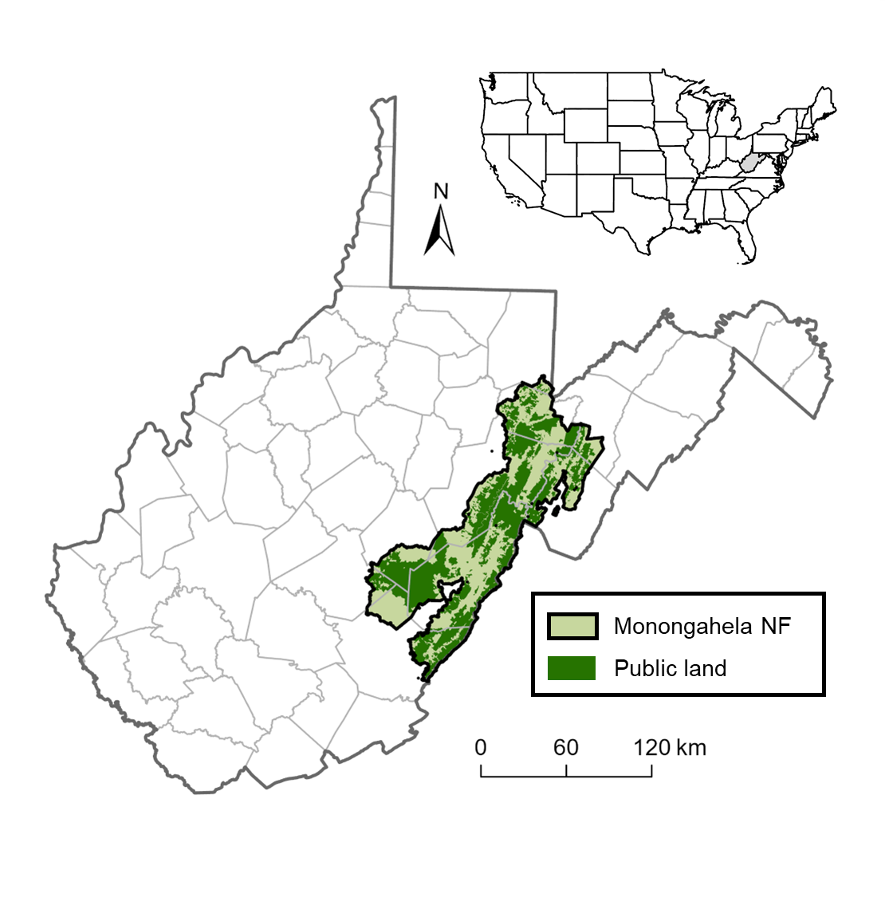

Figure 1. Sampling sites for this study were located throughout the Monongahela National Forest (NF), which encompasses portions of 9 counties (delineated by gray lines) in eastern West Virginia. The National Forest encompasses nearly 688,000 ha, of which 54% (371,906 ha) is public land (dark green).

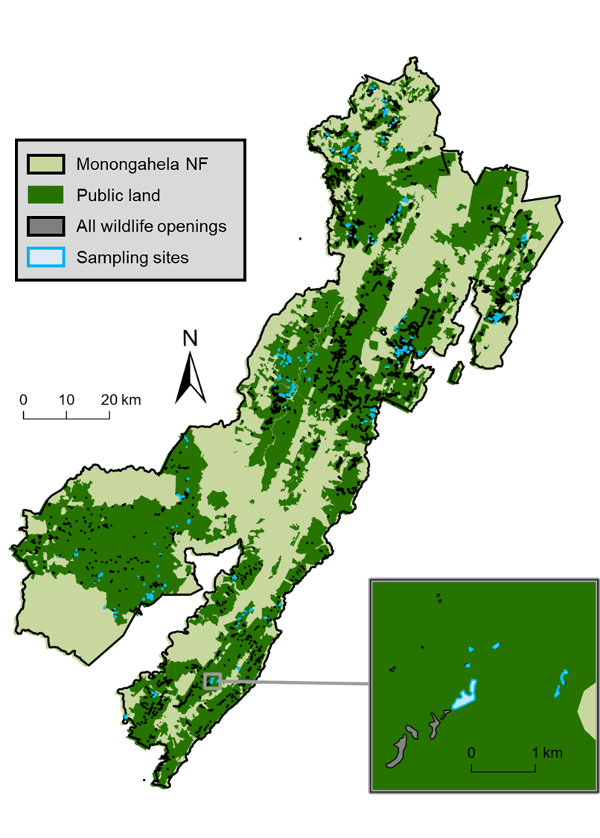

Figure 2. Locations of all recorded wildlife openings (N = ~2,200) and the study sampling sites (N = 335) within the Monongahela National Forest (NF), West Virginia.

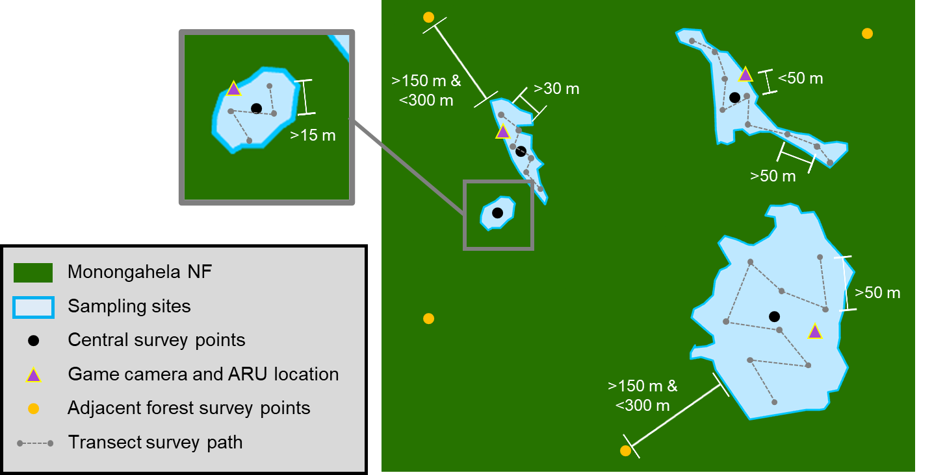

Figure 3. Diagram of a small (<1 ha) wildlife opening (inset), a midsize (1–5 ha) wildlife opening (top left), and 2 large (>5 ha) wildlife openings (right) within the Monongahela National Forest (NF), with their central survey points (black circles), game camera and acoustic recording unit (ARU) survey points (purple triangle), adjacent forest survey points (gold circles), and transect survey points (gray circles) and segments (dashed gray lines). White line segments and labels indicate minimum or maximum distances, such that: game camera and ARU survey points are located within 50 m of the central survey point; adjacent forest survey points are located between 150 and 300 m from the edge of their corresponding wildlife opening; transect segments in small openings are >15 m, transect segments in midsize openings are >30 m, and transect segments in large wildlife openings are >50 m.

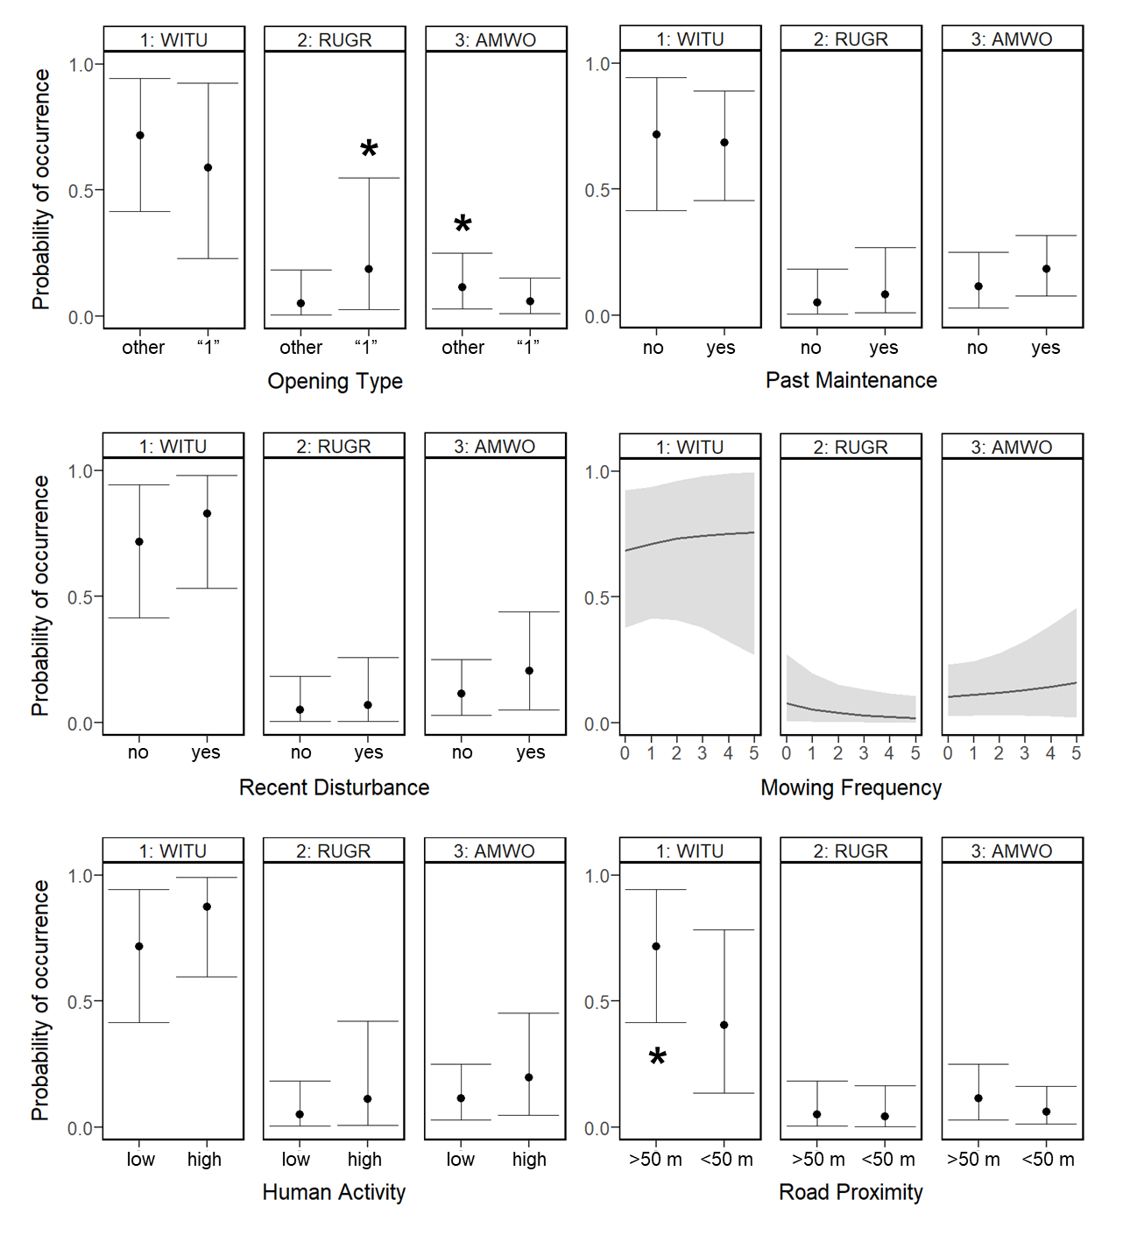

Figure 4. Effects of the 6 predictor variables (Tables 1–2) in the MANAGEMENT candidate model of multi-species game bird occupancy. Bold asterisks indicate significant relationships between the predictor variable and the probability of marginal occurrence of wild turkey (1: WITU), ruffed grouse (2: RUGR), or American woodcock (3: AMWO), with the asterisk aligned with the condition resulting in higher probability of marginal occurrence.

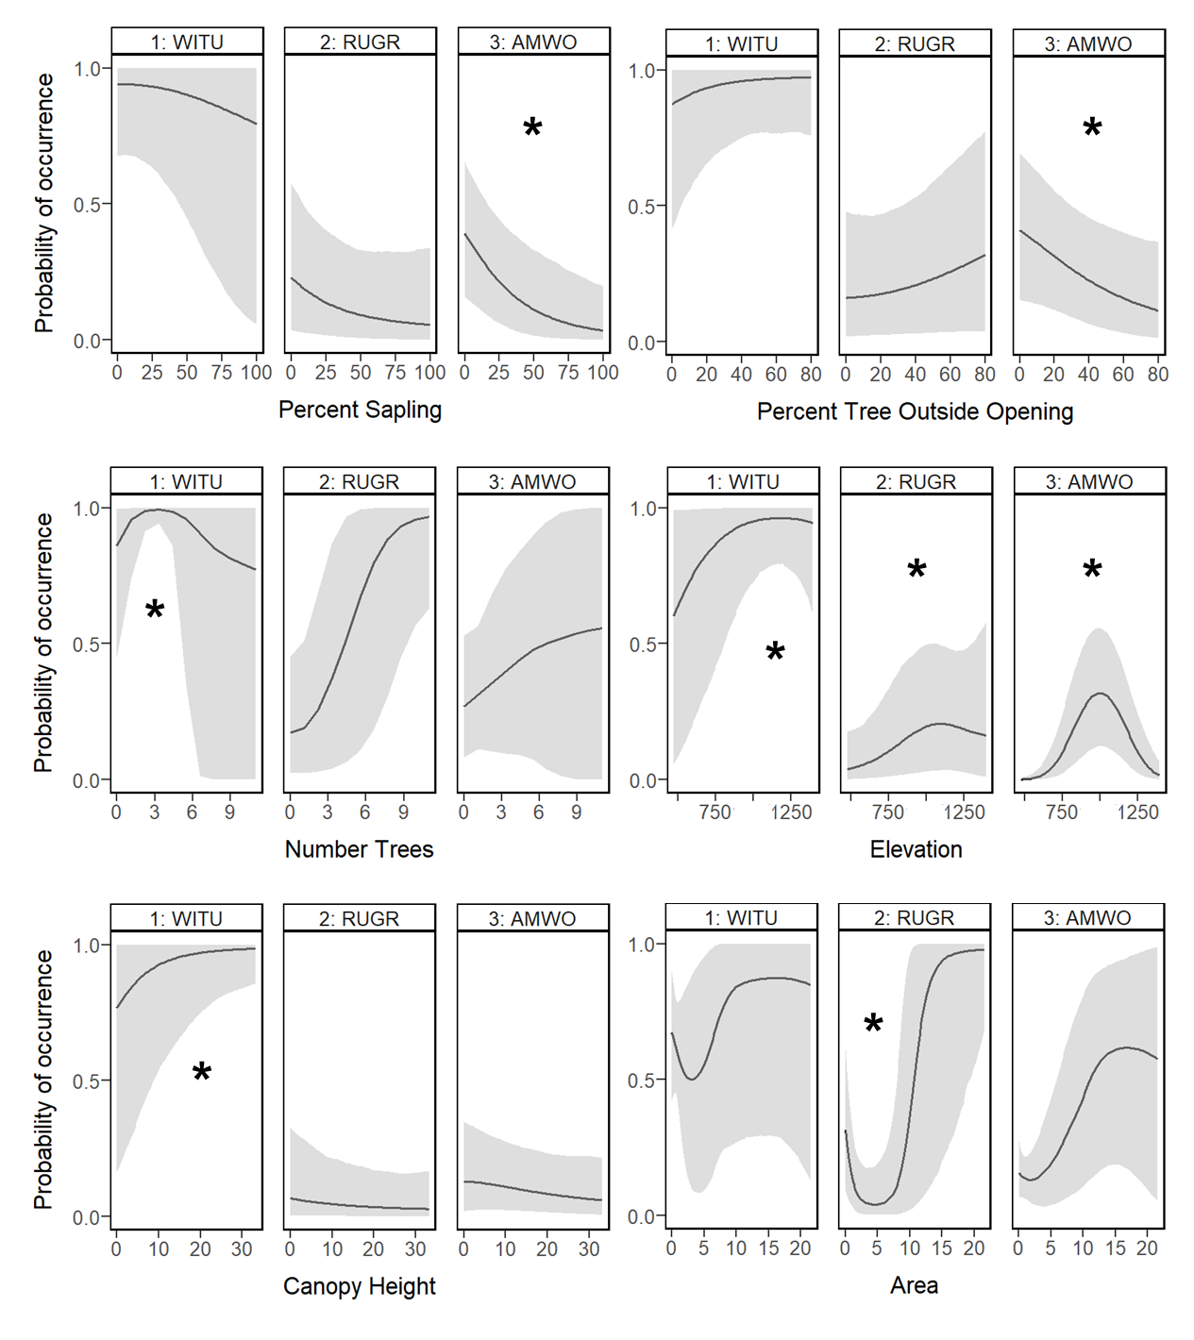

Figure 5. Effects of the significant predictor variables (Tables 1–2, 7) in the HABITAT, CONDITION, and SIZE candidate models of multi-species game bird occupancy. Bold asterisks indicate significant relationships between the predictor variable and the probability of marginal occurrence of wild turkey (1: WITU), ruffed grouse (2: RUGR), or American woodcock (3: AMWO).

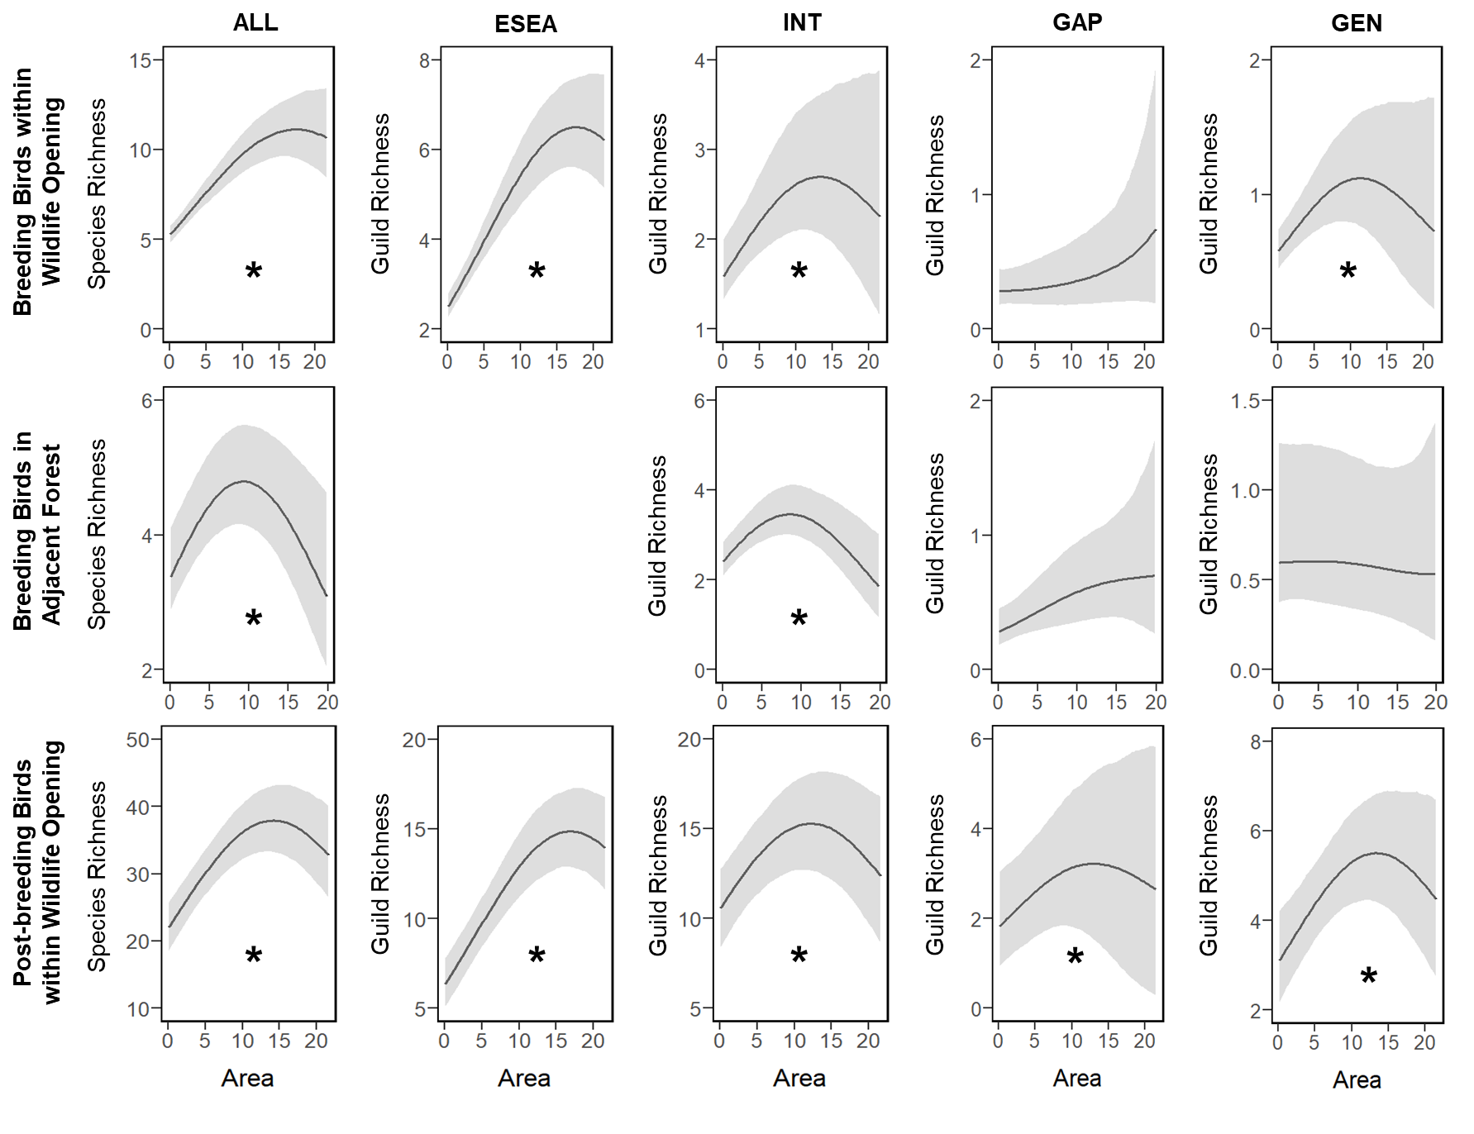

Figure 6. Effects of wildlife opening size (i.e., area in ha) on mean expected overall (ALL) species richness (first column), early-successional / edge-associated (ESEA) guild richness (second column), forest-interior (INT) guild richness (third column), forest-gap (GAP) guild richness (fourth column), and forest generalist (GEN) guild richness (fifth column) during the breeding season within the wildlife opening (first row) and in the adjacent forest (second row), as well as during the post-breeding season within the wildlife opening (third row). Bold asterisks indicate significant relationships between area and the mean expected number of species.

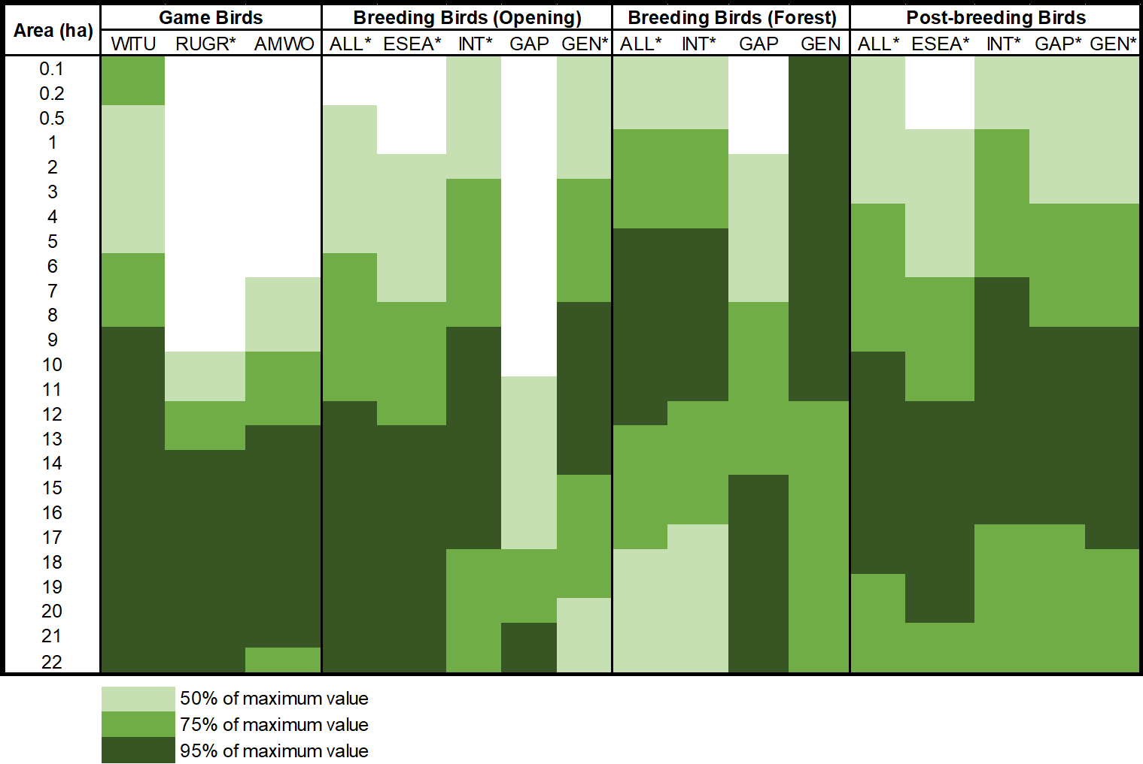

Figure . Optimal wildlife opening sizes (ha) for game bird occupancy (WITU = wild turkey, RUGR = ruffed grouse, AMWO = American woodcock) and songbird guild richness (ALL = all species, ESEA = early-successional / edge-associated, INT = forest-interior, GAP = forest-gap, GEN = forest generalist) during the breeding and post-breeding seasons. Light green, middle green, and dark green colors represent 50%, 75%, and 95%, respectively, of the maximum values of predicted probability of game bird occurrence and expected mean richness. An asterisk indicates a significant relationship.

APPENDIX A

**Effects of climate and land cover change on forest songbirds of the   
Appalachian Mountains: A literature review and case study**

## Appendix A1: JAGS model code

**JAGS model code for the negative binomial model with spatial dependence**

model{

### PRIORS

r ~ dgamma(0.01,0.01)

tau ~ dgamma(0.01,0.01)

s2 <- 1/tau

phi ~ dunif(0,1)

b0 ~ dnorm(0,0.01)

for (b in 1:C) {

beta[b] ~ dnorm(0,0.01)

}

#NOTES: Loop over C (number of coefficients)

for (a in 1:S){

mu[a] <- b0

for (b in 1:S){

# Covariance matrix:

Sigma[a, b] <- s2*exp(log(phi)*dist[a,b])

}

}

# NOTES: Loop over S (number of unique BBS routes)

site[1:S] ~ dmnorm.vcov(mu[1:S],Sigma[1:S,1:S])

### LIKELIHOOD

for(i in 1:N){

y[i] ~ dnegbin(p[i],r)

log(lambda[i]) <- inprod(beta[1:C],x[i,1:C])+site[id[i]]

p[i] <- r/(r+lambda[i])

# FOR MODEL FIT - Squared Pearson residual: (obs-lambda)^2/(r(1-p)/p^2)

p.resid[i] <- pow((y[i]-lambda[i]), 2)/((r*(1-p[i]))/(pow(p[i],2)))

y.new[i] ~ dnegbin(p[i],r)

p.resid.new[i] <- pow((y.new[i]-lambda[i]),2)/((r*(1-p[i]))/(pow(p[i],2)))

}

# NOTES: Loop over N (number of sites)

### MODEL FIT AND CHECKING

overall.fit <- sum(p.resid[])

overall.fit.new <- sum(p.resid.new[])

overall.p.val <- step(overall.fit.new - overall.fit)

}

**JAGS model code for the negative binomial model without spatial dependence**

model {

### PRIORS

beta0 ~ dnorm(0,0.01)

tau_l ~ dgamma(0.01,0.01)

mu_logr ~ dnorm(0,0.01)

tau_logr ~ dgamma(0.01,0.01)

for (s in 1:S){

# Site-level random effect for the expected count

site_l[s] ~ dnorm(0,tau_l)

# Site-level random effect for the dispersion parameter

site_r[s] ~ dnorm(mu_logr,tau_logr)

log(r[s]) <- site_r[s]

}

# NOTES: Loop over S (number of unique BBS routes)

for (b in 1:C) {

beta[b] ~ dnorm(0,0.01)

}

# NOTES: Loop over C (number of coefficients)

### LIKELIHOOD

for (i in 1:N){

y[i] ~ dnegbin(p[i],r[id[i]])

log(lambda[i]) <- beta0+inprod(beta[1:C],x[i,1:C])+site_l[id[i]]

p[i] <- r[id[i]]/(r[id[i]]+lambda[i])

# FOR MODEL FIT - Squared Pearson residual: (obs-lambda)^2/(r(1-p)/p^2)

p.resid[i] <- pow((y[i]-lambda[i]),2)/((r[id[i]]*(1-p[i]))/pow(p[i],2))

y.new[i] ~ dnegbin(p[i],r[id[i]])

p.resid.new[i] <- pow((y.new[i]-lambda[i]),2)/((r[id[i]]*(1-p[i]))/

pow(p[i],2))

}

# NOTES: Loop over N (number of sites

### MODEL FIT AND CHECKING

overall.fit <- sum(p.resid[])

overall.fit.new <- sum(p.resid.new[])

overall.p.val <- step(overall.fit.new - overall.fit)

}

APPENDIX B

**Effects of climate and temporal trends in forest songbird communities and abundance**

**along latitudinal and elevational gradients in the Appalachian Mountains**

## Appendix B1: Table of forest songbird species

**Table of the 40 forest songbird species considered in the guild richness analyses**

Table B1. List of the common name, scientific name, 4-letter species code, relative frequency, taxonomic family, and guild designation of all 40 forest songbird species considered for the guild richness analyses. Relative frequency is the number of detections across all point count surveys from all 3 study regions. The guild designation indicates the extent of the species’ range within the Appalachian Mountains, such that: species in the north guild are only found in the Northern or Central Appalachians; species in the south guild are only found in the Southern or Central Appalachians; species in the trailing guild have trailing-edge populations that are found throughout the Appalachian Mountains but are limited to higher elevations in the Southern Appalachians; and species in the general guild are found throughout the Appalachian Mountains.

|  |  |  |  |  |  |
| --- | --- | --- | --- | --- | --- |
| **Common Name**  **(*Scientific Name*)** | **Species Code** | **Relative Frequency** | **Taxonomic Family** | **Guild Designation** | **Focal Species** |
| Blackpoll warbler  (*Setophaga striata*) | BLPW | 2,220 | Parulidae | north | 1 |
| Swainson's thrush  (*Catharus ustulatus*) | SWTH | 4,465 | Turdidae | north | 1 |
| Yellow-bellied flycatcher  (*Empidonax flaviventris*) | YBFL | 1,360 | Tyrannidae | north | 1 |
| Evening grosbeak  (*Coccothraustes vespertinus*) | EVGR | 64 | Fringillidae | north | 0 |
| Hermit thrush  (*Catharus guttatus*) | HETH | 2,880 | Turdidae | north | 0 |
| Northern waterthrush  (*Parkesia noveboracensis*) | NOWA | 42 | Parulidae | north | 0 |
| Pine siskin  (*Spinus pinus*) | PISI | 125 | Fringillidae | north | 0 |
| Purple finch  (*Haemorhous purpureus*) | PUFI | 554 | Fringillidae | north | 0 |
| Ruby-crowned kinglet  (*Corthylio calendula*) | RCKI | 39 | Regulidae | north | 0 |
| Yellow-rumped warbler  (*Setophaga coronata*) | YRWA | 5,132 | Parulidae | north | 0 |
| Acadian flycatcher  (*Empidonax virescens*) | ACFL | 1,154 | Tyrannidae | south | 1 |
| Hooded warbler  (*Setophaga citrina*) | HOWA | 1,677 | Parulidae | south | 1 |

Table B1. Continued.

|  |  |  |  |  |  |
| --- | --- | --- | --- | --- | --- |
| **Common Name**  **(*Scientific Name*)** | **Species Code** | **Relative Frequency** | **Taxonomic Family** | **Guild Designation** | **Focal Species** |
| Worm-eating warbler  (*Helmitheros vermivorum*) | WEWA | 750 | Parulidae | south | 1 |
| Cerulean warbler  (*Setophaga cerulea*) | CERW | 127 | Parulidae | south | 0 |
| Kentucky warbler  (*Geothlypis formosa*) | KEWA | 42 | Parulidae | south | 0 |
| Swainson's warbler  (*Limnothlypis swainsonii*) | SWWA | 56 | Parulidae | south | 0 |
| Yellow-throated warbler  (*Setophaga dominica*) | YTWA | 93 | Parulidae | south | 0 |
| Blackburnian warbler  (*Setophaga fusca*) | BLBW | 15,776 | Parulidae | trailing | 1 |
| Black-throated blue warbler  (*Setophaga caerulescens*) | BTBW | 21,244 | Parulidae | trailing | 1 |
| Black-throated green warbler  (*Setophaga virens*) | BTNW | 21,055 | Parulidae | trailing | 1 |
| Canada warbler  (*Cardellina canadensis*) | CAWA | 1,807 | Parulidae | trailing | 1 |
| Least flycatcher  (*Empidonax minimus*) | LEFL | 288 | Tyrannidae | trailing | 1 |
| Veery  (*Catharus fuscescens*) | VEER | 1,830 | Turdidae | trailing | 1 |
| Blue-headed vireo  (*Vireo solitarius*) | BHVI | 5,691 | Vireonidae | trailing | 0 |
| Brown creeper  (*Certhia americana*) | BRCR | 2,780 | Certhiidae | trailing | 0 |
| Dark-eyed junco  (*Junco hyemalis*) | DEJU | 4,787 | Passerellidae | trailing | 0 |
| Golden-crowned kinglet  (*Regulus satrapa*) | GCKI | 4,980 | Regulidae | trailing | 0 |
| Red-breasted nuthatch  (*Sitta canadensis*) | RBNU | 2,225 | Sittidae | trailing | 0 |
| Red crossbill  (*Loxia curvirostra*) | RECR | 74 | Fringillidae | trailing | 0 |
| Winter wren  (*Troglodytes hiemalis*) | WIWR | 4,397 | Troglodytidae | trailing | 0 |
| American redstart  (*Setophaga ruticilla*) | AMRE | 1,631 | Parulidae | general | 1 |
| Northern parula  (*Setophaga americana*) | NOPA | 779 | Parulidae | general | 1 |
| Ovenbird  (*Seiurus aurocapilla*) | OVEN | 18,707 | Parulidae | general | 1 |
| Wood thrush  (*Hylocichla mustelina*) | WOTH | 1,095 | Turdidae | general | 1 |

Table B1. Continued.

|  |  |  |  |  |  |
| --- | --- | --- | --- | --- | --- |
| **Common Name**  **(*Scientific Name*)** | **Species Code** | **Relative Frequency** | **Taxonomic Family** | **Guild Designation** | **Focal Species** |
| Black-and-white warbler  (*Mniotilta varia*) | BAWW | 2,201 | Parulidae | general | 0 |
| Louisiana waterthrush  (*Parkesia motacilla*) | LOWA | 171 | Parulidae | general | 0 |
| Pine warbler  (*Setophaga pinus*) | PIWA | 249 | Parulidae | general | 0 |
| Red-eyed vireo  (*Vireo olivaceus*) | REVI | 20,618 | Vireonidae | general | 0 |
| Scarlet tanager  (*Piranga olivacea*) | SCTA | 2,798 | Cardinalidae | general | 0 |
| White-breasted nuthatch  (*Sitta carolinensis*) | WBNU | 1,194 | Sittidae | general | 0 |

## Appendix B2: JAGS model code

**JAGS model code for the guild richness analyses**

model {

### PRIORS

# COMMUNITY-LEVEL MODEL PARAMETERS (JUST FOR OCCUPANCY)

community.occupancy.a ~ dlogis(0,1) #this assumes a logistic prior

community.occupancy.tau ~ dgamma(1,1)

# COMMUNITY-LEVEL PARAMETERS FOR SITE COVARIATE SLOPE COEFFICIENTS

for (sitecov in 1:n.sitecovs) {

mu.alpha[sitecov] ~ dnorm(0, 0.1)

tau.alpha[sitecov] ~ dgamma(1,1)

}

# COMMUNITY-LEVEL PARAMETERS FOR DETECTION COVARIATE SLOPE COEFFICIENTS

for (detcov in 1:n.detcovs) {

mu.beta[detcov] ~ dnorm(0, 0.1)

tau.beta[detcov] ~ dgamma(1,1)

}

# SPECIES-SPECIFIC PRIORS FROM THE COMMUNITY-LEVEL PRIOR DISTRIBUTIONS

for (species in 1:n.species) {

# INTERCEPTS

alpha0[species] ~ dnorm(community.occupancy.a, community.occupancy.tau)

beta0[species] ~ dnorm(0, 0.1)

# SLOPE COEFFICIENTS FOR SITE COVARIATES

for (sitecov in 1:n.sitecovs) {

alpha[species, sitecov] ~ dnorm(mu.alpha[sitecov], tau.alpha[sitecov])

}

# SLOPE COEFFICIENTS FOR DETECTION COVARIATES

for (detcov in 1:n.detcovs) {

beta[species, detcov] ~ dnorm(mu.beta[detcov], tau.beta[detcov])

}

}

# NOTES: Loop over all species

# PARAMETERS FOR IMPUTATION OF DETECTION COVARIATES

for (region in 1:n.regions) {

# TIME

time.mu[region] ~ dnorm(0, 1) #NOTE: Normal distribution

time.tau[region] ~ dgamma(1, 1)

# WIND CODE

wind.prob[region] ~ dbeta(1, 1)

# SKY CODE

sky.prob[region] ~ dbeta(1, 1)

}

# NOTES: Loop over each study region

### LIKELIHOOD

# IMPUTATION OF DETECTION COVARIATES

for (site in 1:n.sites){

for (year in 1:n.years[site]) {

for (replicate in 1:n.replicates[site, year]) {

time[site, year, replicate] ~ dnorm(time.mu[region[site]],

time.tau[region[site]])

wind[site, year, replicate] ~ dbern(wind.prob[region[site]])

sky[site, year, replicate] ~ dbern(sky.prob[region[site]])

}

}

}

# NOTES: Loop over sites, years, and replicates

for (species in 1:n.species) {

# Loop to estimate the Z matrix (true site occurrence) for each species at

# each site

for (site in 1:n.sites){

for (year in 1:n.years[site]) {

# OCCUPANCY MODEL

logit(psi[site, year, species]) <- alpha0[species] +

inprod(alpha[species, 1:n.sitecovs],

sitecov.array[site, year, 1:n.sitecovs])

# ESTIMATING OCCUPANCY

Z[site, year, species] ~ dbern(psi[site, year, species])

# Loop to estimate detection each species at each site during each

# sampling replicate

for (replicate in 1:n.replicates[site, year]) {

# DETECTION MODEL

logit(p[site, year, replicate, species]) <- beta0[species] +

beta[species, 1] * day[site, year, replicate] +

beta[species, 2] * time[site, year, replicate] +

beta[species, 3] * wind[site, year, replicate] +

beta[species, 4] * sky[site, year, replicate]

# MODEL PROBABILITY OF DETECTION FOR 1 MINUTE

p.adjusted[site, year, replicate, species] <- 1 - (1 –

p[site, year, replicate, species]) ^ exponent.array[site,

year, replicate]

# ESTIMATING PROBABILITY OF DETECTION

mu.p[site, year, replicate, species] <- p.adjusted[site, year,

replicate, species] * Z[site, year, species]

Y[site, year, replicate, species] ~ dbern(mu.p[site, year,

replicate, species])

}

# NOTES: Loop over each replicate for each site (variable number of

# replicates depending on site and year)

} #end year loop

} #end site loop

} #end species loop

### DERIVED QUANTITIES

# Loop to determine site-level richness estimates for the whole community and # for subsets or assemblages of interest per year

for (site in 1:n.sites) {

for (year in 1:n.years[site]) {

site.species.richness[site, year] <- sum(Z[site, year, 1:n.species])

north.guild.richness[site, year] <- inprod(Z[site, year, 1:n.species],

north.guild[1:n.species])

south.guild.richness[site, year] <- inprod(Z[site, year, 1:n.species],

south.guild[1:n.species])

trailing.guild.richness[site, year] <- inprod(Z[site, year,

1:n.species], trailing.guild[1:n.species])

general.guild.richness[site, year] <- inprod(Z[site, year,

1:n.species], general.guild[1:n.species])

}

}

}

**JAGS model code for the focal species analyses**

model {

### PRIORS

for (species in 1:n.species) {

# INTERCEPTS

alpha0[species] ~ dnorm(0, 0.01) #intercept for abundance model

beta0[species] ~ dnorm(0, 0.01) #intercept for detection model

# RANDOM SITE EFFECT

tau.rse[species] ~ dgamma(0.01, 0.01) #for random site effects

for (site in 1:n.sites){

random.site.effect[species, site] ~ dnorm(alpha0[species],

tau.rse[species]) #for random site effects

}

# NOTES: Loop over the number of unique sites

# SLOPE COEFFICIENTS FOR SITE COVARIATES

for (alpha.index in 1:n.alphas) {

alpha[species, alpha.index] ~ dnorm(0, 0.01)

#create a slope coefficient for each site covariate

}

# SLOPE COEFFICIENTS FOR DETECTION COVARIATES

for (detcov in 1:n.detcovs) {

beta[species, detcov] ~ dnorm(0, 0.01)

#create a slope coefficient for each detection covariate

}

}

# NOTES: Loop over each focal species

# PARAMETERS FOR IMPUTATION OF DETECTION COVARIATES

for (region in 1:n.regions) {

# TIME

time.mu[region] ~ dnorm(0, 0.01)

time.tau[region] ~ dgamma(0.1, 0.1)

# NOTE: Normal distribution.

# WIND CODE

wind.prob[region] ~ dbeta(1, 1)

# SKY CODE

sky.prob[region] ~ dbeta(1, 1)

}

# NOTES: Loop over each study region

### LIKELIHOOD

# IMPUTATION OF DETECTION COVARIATES

for (site in 1:n.sites){

for (year in 1:n.years[site]) {

for (visit in 1:n.visits[site,year]) {

time[site, year, visit] ~ dnorm(time.mu[region[site]],

time.tau[region[site]])

wind[site, year, visit] ~ dbern(wind.prob[region[site]])

sky[site, year, visit] ~ dbern(sky.prob[region[site]])

}

}

}

# NOTES: Loop over sites, years, and visits

# ESTIMATE ABUNDANCE AND DETECTION PROBABILITY

for (species in 1:n.species) {

# Loop to estimate N (true abundance) for each species at each site

for (site in 1:n.sites) {

for (year in 1:n.years[site]) {

# ABUNDANCE MODEL

log(lambda[site, year, species]) <- alpha[species, 1] *

sitecov.array[site, year, 1] + #year

alpha[species, 2] * sitecov.array[site, year, 2] + #elevation

alpha[species, 3] * sitecov.array[site, year, 3] + #aspect

alpha[species, 4] * sitecov.array[site, year, 4] + #TPI

alpha[species, 5] * sitecov.array[site, year, 5] +

#dominant forest type == Deciduous

alpha[species, 6] * sitecov.array[site, year, 6] +

#proportion of forest within 1 km

alpha[species, 7] * sitecov.array[site, year, 7] +

#mean current temperature

alpha[species, 8] * sitecov.array[site, year, 8] +

#SD temperature

alpha[species, 9] * sitecov.array[site, year, 9] +

#total current precip

alpha[species, 10] * sitecov.array[site, year, 10] +

#total previous precip

alpha[species, 11] * sitecov.array[site, year, 2] *

sitecov.array[site, year, 1] + #elevation x year

alpha[species, 12] * sitecov.array[site, year, 2] *

sitecov.array[site, year, 7] +

#elevation x mean current temperature

alpha[species, 13] * sitecov.array[site, year, 2] *

sitecov.array[site, year, 8] + #elevation x SD temperature

alpha[species, 14] * sitecov.array[site, year, 2] *

sitecov.array[site, year, 9] +

#elevation x total current precip

alpha[species, 15] * sitecov.array[site, year, 2] *

sitecov.array[site, year, 10] +

#elevation x total previous precip

alpha[species, 16] * sitecov.array[site, year, 7] *

sitecov.array[site, year, 1] +

#mean current temperature x year

alpha[species, 17] * sitecov.array[site, year, 7] *

sitecov.array[site, year, 8] +

#mean current temperature x SD temperature

alpha[species, 18] * sitecov.array[site, year, 7] *

sitecov.array[site, year, 9] +

#mean current temperature x total current precip

alpha[species, 19] * sitecov.array[site, year, 7] *

sitecov.array[site, year, 10] +

#mean current temperature x total previous precip

alpha[species, 20] * sitecov.array[site, year, 2] *

sitecov.array[site, year, 7] * sitecov.array[site, year, 1] + #elevation x mean current temperature x year

alpha[species, 21] * sitecov.array[site, year, 2] *

sitecov.array[site, year, 7] * sitecov.array[site, year, 8] + #elevation x mean current temperature x SD temperature

alpha[species, 22] * sitecov.array[site, year, 2] *

sitecov.array[site, year, 7] * sitecov.array[site, year, 9] + #elevation x mean current temperature x total current precip

alpha[species, 23] * sitecov.array[site, year, 2] *

sitecov.array[site, year, 7] * sitecov.array[site, year, 10] + #elevation x mean current temperature x total previous precip

random.site.effect[species, site] #random site effect

# ESTIMATING ABUNDANCE

N[site, year, species] ~ dpois(lambda[site, year, species])

for (visit in 1:n.visits[site,year]) {

# OBSERVATION PROBABILITY

Y[site, year, visit, 1, species] ~ dbin(p.adjusted[site, year,

visit, 1, species], N[site, year, species])

z[site, year, visit, 1, species] <- N[site, year, species] –

Y[site, year, visit, 1, species]

for (i in 2:3) {

Y[site, year, visit, i, species] ~ dbin(p.adjusted[site, year,

visit, i, species], z[site, year, visit, i-1, species])

z[site, year, visit, i, species] <- N[site, year, species] –

sum(Y[site, year, visit, 1:i, species])

}

# Loop to estimate detection each species at each site during

# each sampling replicate

for (replicate in 1:3) {

# DETECTION MODEL

logit(p[site, year, visit, replicate, species]) <-

beta0[species] + beta[species, 1] * day[site, year, visit] + beta[species, 2] * time[site, year, visit] +

beta[species, 3] * wind[site, year, visit] +

beta[species, 4] * sky[site, year, visit]

# MODEL PROBABILITY OF DETECTION FOR 1 MINUTE

p.adjusted[site, year, visit, replicate, species] <- 1 - (1 –

p[site, year, visit, replicate, species]) ^ exponent.array[site, year, visit, replicate]

}

# NOTES: Loop over each replicate for each site (variable number

# of replicates depending on site and year)

} # end visit loop

} #end year loop

} # end site loop

} # end site loop

}

## Appendix B3: Model information

**Table of model information for overall species richness, the 4 guild designations, and the 16 focal forest songbird species considered in the guild richness and focal species analyses**

Table B2. List of the 4 guild designations and 16 focal forest songbird species (sorted by guild and family), with corresponding Bayesian model information that includes the number of chains (Chains), total iterations (Total), burn-in (Burn), thinning rate (Thin), and resulting posterior iterations (Posterior).

|  |  |  |  |  |  |  |  |
| --- | --- | --- | --- | --- | --- | --- | --- |
| **Guild** | **Family** | **Species** | **Chains** | **Total** | **Burn-In** | **Thin** | **Posterior** |
| ALL |  |  | 3 | 3,500 | 2,500 | 1 | 3,000 |
| NORTH | |  | 3 | 3,500 | 2,500 | 1 | 3,000 |
|  | Parulidae | BLPW | 3 | 153,000 | 123,000 | 3 | 30,000 |
|  | Turdidae | SWTH | 3 | 51,000 | 39,000 | 3 | 12,000 |
|  | Tyrannidae | YBFL | 3 | 167,000 | 137,000 | 3 | 30,000 |
| SOUTH | |  | 3 | 3,500 | 2,500 | 1 | 3,000 |
|  | Parulidae | HOWA | 3 | 56,000 | 50,000 | 3 | 6,000 |
|  | Parulidae | WEWA | 3 | 67000 | 49000 | 3 | 18000 |
|  | Tyrannidae | ACFL | 3 | 54,000 | 45,000 | 3 | 9,000 |
| TRAILING | |  | 3 | 3,500 | 2,500 | 1 | 3,000 |
|  | Parulidae | BLBW | 3 | 11,000 | 2,000 | 3 | 9,000 |
|  | Parulidae | BTNW | 3 | 11,000 | 2,000 | 3 | 9,000 |
|  | Parulidae | BTBW | 3 | 11,000 | 2,000 | 3 | 9,000 |
|  | Parulidae | CAWA | 3 | 26,000 | 20,000 | 3 | 6,000 |
|  | Turdidae | VEER | 3 | 19,000 | 10,000 | 3 | 9,000 |
|  | Tyrannidae | LEFL | 3 | 29,000 | 20,000 | 3 | 9,000 |
| GENERAL | |  | 3 | 3,500 | 2,500 | 1 | 3,000 |
|  | Parulidae | AMRE | 3 | 29,000 | 20,000 | 3 | 9,000 |
|  | Parulidae | NOPA | 3 | 73,000 | 64,000 | 3 | 9,000 |
|  | Parulidae | OVEN | 3 | 11,000 | 2,000 | 3 | 9,000 |
|  | Turdidae | WOTH | 3 | 36,000 | 30,000 | 3 | 6,000 |

APPENDIX C

**Comparison of avian guild richness, species abundance, and nest success in   
actively harvested and minimally harvested forested landscapes**

## Appendix C1: Table of forest songbird species

**Table of the 62 passerine and near-passerine species considered in the guild richness analyses**

Table C1. List of the common name, scientific name, 4-letter species code, relative frequency, taxonomic family, habitat-related guild designation, and focal species status of all 62 passerine and near-passerine species considered for the guild richness analyses. Relative frequency is the number of detections across all breeding bird point count surveys from all sampling points in the study. The habitat-related guild designation indicates the primary breeding habitat of the species, such that: species in the early-successional / edge-associated (ESEA) guild breed in open habitat, shrub/scrub, or young forest, or along forest edges, such as the interface of early-successional and mature forest; species in the forest-interior (INT) guild breed in the core area of mature forest; species in the forest-gap (GAP) guild breed in or near small forest gaps within the core area of mature forest; and species in the forest generalist (GEN) guild are associated with forest but have no preference for early-successional vs. mature forest.

|  |  |  |  |  |  |
| --- | --- | --- | --- | --- | --- |
| **Common Name**  **(*Scientific Name*)** | **Species Code** | **Relative Frequency** | **Taxonomic Family** | **Guild** | **Focal Species** |
| Brown-headed Cowbird  (*Molothrus ater*) | BHCO | 163 | Icteridae | ESEA | 1 |
| Chestnut-sided Warbler  (*Setophaga pensylvanica*) | CSWA | 600 | Parulidae | ESEA | 1 |
| Eastern Towhee  (*Pipilo erythrophthalmus*) | EATO | 718 | Passerellidae | ESEA | 1 |
| Indigo Bunting  (*Passerina cyanea*) | INBU | 589 | Cardinalidae | ESEA | 1 |
| American Goldfinch  (*Spinus tristis*) | AMGO | 89 | Fringillidae | ESEA | 0 |
| Blue-winged Warbler  (*Vermivora cyanoptera*) | BWWA | 110 | Parulidae | ESEA | 0 |
| Carolina Wren  (*Thryothorus ludovicianus*) | CARW | 14 | Troglodytidae | ESEA | 0 |
| Cedar Waxwing  (*Bombycilla cedrorum*) | CEDW | 216 | Bombycillidae | ESEA | 0 |
| Chipping Sparrow  (*Spizella passerina*) | CHSP | 40 | Passerellidae | ESEA | 0 |

Table C1. Continued.

|  |  |  |  |  |  |
| --- | --- | --- | --- | --- | --- |
| **Common Name**  **(*Scientific Name*)** | **Species Code** | **Relative Frequency** | **Taxonomic Family** | **Guild** | **Focal Species** |
| Common Yellowthroat  (*Geothlypis trichas*) | COYE | 60 | Parulidae | ESEA | 0 |
| Eastern Phoebe  (*Sayornis phoebe*) | EAPH | 16 | Tyrannidae | ESEA | 0 |
| Field Sparrow  (*Spizella pusilla*) | FISP | 34 | Passerellidae | ESEA | 0 |
| Gray Catbird  (*Dumetella carolinensis*) | GRCA | 132 | Mimidae | ESEA | 0 |
| Mourning Dove  (*Zenaida macroura*) | MODO | 17 | Columbidae | ESEA | 0 |
| Mourning Warbler  (*Geothlypis philadelphia*) | MOWA | 42 | Parulidae | ESEA | 0 |
| Northern Cardinal  (*Cardinalis cardinalis*) | NOCA | 24 | Cardinalidae | ESEA | 0 |
| Song Sparrow  (*Melospiza melodia*) | SOSP | 75 | Passerellidae | ESEA | 0 |
| Yellow-billed Cuckoo  (*Coccyzus americanus*) | YBCU | 64 | Cuculidae | ESEA | 0 |
| Black-throated Green Warbler  (*Setophaga virens*) | BTNW | 2458 | Parulidae | INT | 1 |
| Dark-eyed Junco  (*Junco hyemalis*) | DEJU | 1719 | Passerellidae | INT | 1 |
| Red-eyed Vireo  (*Vireo olivaceus*) | REVI | 3135 | Vireonidae | INT | 1 |
| Wood Thrush  (*Hylocichla mustelina*) | WOTH | 610 | Turdidae | INT | 1 |
| Acadian Flycatcher  (*Empidonax virescens*) | ACFL | 708 | Tyrannidae | INT | 0 |
| Black-and-white Warbler  (*Mniotilta varia*) | BAWW | 641 | Parulidae | INT | 0 |
| Blackburnian Warbler  (*Setophaga fusca*) | BLBW | 608 | Parulidae | INT | 0 |
| Black-throated Blue Warbler  (*Setophaga caerulescens*) | BTBW | 1162 | Parulidae | INT | 0 |
| Blue-headed Vireo  (*Vireo solitarius*) | BHVI | 1636 | Vireonidae | INT | 0 |
| Brown Creeper  (*Certhia americana*) | BRCR | 150 | Certhiidae | INT | 0 |
| Canada Warbler  (*Cardellina canadensis*) | CAWA | 558 | Parulidae | INT | 0 |
| Golden-crowned Kinglet  (*Regulus satrapa*) | GCKI | 437 | Regulidae | INT | 0 |

Table C1. Continued.

|  |  |  |  |  |  |
| --- | --- | --- | --- | --- | --- |
| **Common Name**  **(*Scientific Name*)** | **Species Code** | **Relative Frequency** | **Taxonomic Family** | **Guild** | **Focal Species** |
| Hairy Woodpecker  (*Leuconotopicus villosus*) | HAWO | 318 | Picidae | INT | 0 |
| Hermit Thrush  (*Catharus guttatus*) | HETH | 384 | Turdidae | INT | 0 |
| Least Flycatcher  (*Empidonax minimus*) | LEFL | 71 | Tyrannidae | INT | 0 |
| Magnolia Warbler  (*Setophaga magnolia*) | MAWA | 1153 | Parulidae | INT | 0 |
| Ovenbird  (*Seiurus aurocapilla*) | OVEN | 788 | Parulidae | INT | 0 |
| Pileated Woodpecker  (*Dryocopus pileatus*) | PIWO | 168 | Picidae | INT | 0 |
| Pine Warbler  (*Setophaga pinus*) | PIWA | 79 | Parulidae | INT | 0 |
| Purple Finch  (*Haemorhous purpureus*) | PUFI | 35 | Fringillidae | INT | 0 |
| Red-breasted Nuthatch  (*Sitta canadensis*) | RBNU | 198 | Sittidae | INT | 0 |
| Rose-breasted Grosbeak  (*Pheucticus ludovicianus*) | RBGR | 443 | Cardinalidae | INT | 0 |
| Scarlet Tanager  (*Piranga olivacea*) | SCTA | 1084 | Cardinalidae | INT | 0 |
| Swainson's Thrush  (*Catharus ustulatus*) | SWTH | 126 | Turdidae | INT | 0 |
| Winter Wren  (*Troglodytes hiemalis*) | WIWR | 541 | Troglodytidae | INT | 0 |
| Worm-eating Warbler  (*Helmitheros vermivorum*) | WEWA | 237 | Parulidae | INT | 0 |
| Yellow-rumped Warbler  (*Setophaga coronata*) | YRWA | 83 | Parulidae | INT | 0 |
| American Redstart  (*Setophaga ruticilla*) | AMRE | 568 | Parulidae | GAP | 1 |
| Cerulean Warbler  (*Setophaga cerulea*) | CERW | 125 | Parulidae | GAP | 1 |
| Hooded Warbler  (*Setophaga citrina*) | HOWA | 580 | Parulidae | GAP | 1 |
| Veery  (*Catharus fuscescens*) | VEER | 1070 | Turdidae | GAP | 1 |
| Eastern Wood-Pewee  (*Contopus virens*) | EAWP | 314 | Tyrannidae | GAP | 0 |
| Great-crested Flycatcher  (*Myiarchus crinitus*) | GCFL | 90 | Tyrannidae | GAP | 0 |

Table C1. Continued.

|  |  |  |  |  |  |
| --- | --- | --- | --- | --- | --- |
| **Common Name**  **(*Scientific Name*)** | **Species Code** | **Relative Frequency** | **Taxonomic Family** | **Guild** | **Focal Species** |
| Northern Parula  (*Setophaga americana*) | NOPA | 113 | Parulidae | GAP | 0 |
| Yellow-throated Vireo  (*Vireo flavifrons*) | YTVI | 44 | Vireonidae | GAP | 0 |
| American Robin  (*Turdus migratorius*) | AMRO | 533 | Turdidae | GEN | 1 |
| Black-capped Chickadee  (*Poecile atricapillus*) | BCCH | 702 | Paridae | GEN | 1 |
| White-breasted Nuthatch  (*Sitta carolinensis*) | WBNU | 449 | Sittidae | GEN | 1 |
| Blue-gray Gnatcatcher  (*Polioptila caerulea*) | BGGN | 147 | Polioptilidae | GEN | 0 |
| Downy Woodpecker  (*Picoides pubescens*) | DOWO | 206 | Picidae | GEN | 0 |
| Northern Flicker  (*Colaptes auratus*) | NOFL | 134 | Picidae | GEN | 0 |
| Red-bellied Woodpecker  (*Melanerpes carolinus*) | RBWO | 51 | Picidae | GEN | 0 |
| Tufted Titmouse  (*Baeolophus bicolor*) | TUTI | 195 | Paridae | GEN | 0 |
| Yellow-bellied Sapsucker  (*Sphyrapicus varius*) | YBSA | 24 | Picidae | GEN | 0 |

## Appendix C2: JAGS model code

**JAGS model code for the guild richness analyses**

model {

### PRIORS

# COMMUNITY-LEVEL MODEL PARAMETERS (OCCUPANCY)

community.occupancy.a ~ dlogis(0,1) #this assumes a logistic prior

community.occupancy.tau ~ dgamma(0.1, 0.1)

# COMMUNITY-LEVEL PARAMETERS FOR SITE COVARIATE SLOPE COEFFICIENTS

for (sitecov in 1:n.sitecovs) {

mu.alpha[sitecov] ~ dnorm(0, 0.1)

tau.alpha[sitecov] ~ dgamma(0.1, 0.1)

}

# COMMUNITY-LEVEL PARAMETERS FOR DETECTION COVARIATE SLOPE COEFFICIENTS

for (detcov in 1:n.detcovs) {

mu.beta[detcov] ~ dnorm(0, 0.1)

tau.beta[detcov] ~ dgamma(0.1, 0.1)

}

# SPECIES-SPECIFIC PRIORS FROM THE COMMUNITY-LEVEL PRIOR DISTRIBUTIONS

for (spp in 1:n.species) {

# INTERCEPTS

alpha0[spp] ~ dnorm(community.occupancy.a, community.occupancy.tau)

beta0[spp] ~ dnorm(0, 0.1)

# SLOPE COEFFICIENTS FOR SITE COVARIATES

for (sitecov in 1:n.sitecovs) {

alpha[spp, sitecov] ~ dnorm(mu.alpha[sitecov], tau.alpha[sitecov])

}

# RANDOM SITE EFFECT

tau.rse[spp] ~ dgamma(0.1, 0.1)

for (site in 1:n.sites) {

random.site.effect[spp, site] ~ dnorm(alpha0[spp], tau.rse[spp])

}

# SLOPE COEFFICIENTS FOR DETECTION COVARIATES

for (detcov in 1:n.detcovs) {

beta[spp, detcov] ~ dnorm(mu.beta[detcov], tau.beta[detcov])

}

} # NOTES: Loop over all species

# PARAMETERS FOR IMPUTATION OF DETECTION COVARIATES (WIND CODE AND SKY CODE)

wind.prob ~ dbeta(1, 1)

sky.prob ~ dbeta(1, 1)

### LIKELIHOOD

# IMPUTATION OF DETECTION COVARIATES

for (site in 1:n.sites){

for (year in 1:n.years[site]) {

for (replicate in 1:n.replicates[site, year]) {

time.array[site, year, replicate] ~ dnorm(0, 1)

wind.array[site, year, replicate] ~ dbern(wind.prob)

sky.array[site, year, replicate] ~ dbern(sky.prob)

}

}

}

# NOTES: Loop over sites, years, and replicates

# Loop to estimate the Z matrix (true occurrence) for each species at each

# site

for (spp in 1:n.species) {

for (site in 1:n.sites){

for (year in 1:n.years[site]) {

# OCCUPANCY MODEL

logit(psi[site, year, spp]) <- inprod(alpha[spp, 1:n.sitecovs],

sitecov.array[site, year, 1:n.sitecovs]) +

random.site.effect[spp, site]

# ESTIMATING OCCUPANCY

Z[site, year, spp] ~ dbern(psi[site, year, spp])

# Loop to estimate detection of each species at each site during

# each sampling replicate

for (replicate in 1:n.replicates[site, year]) {

# DETECTION MODEL

logit(p[site, year, replicate, spp]) <- beta0[species] +

beta[spp, 1] * day.array[site, year, replicate] +

beta[spp, 2] * time.array[site, year, replicate] +

beta[spp, 3] * time.array[site, year, replicate] *

time.array[site, year, replicate] +

beta[spp, 4] * wind.array[site, year, replicate] +

beta[spp, 5] * sky.array[site, year, replicate]

# ESTIMATING PROBABILITY OF DETECTION

mu.p[site, year, replicate, spp] <- p[site, year, replicate, spp]

* Z[site, year, spp]

Y[site, year, replicate, species] ~ dbern(mu.p[site, year,

replicate, species])

} # end replicate loop

} #end year loop

} #end site loop

} #end species loop

### DERIVED QUANTITIES

# Loop to determine site-level richness estimates for the whole community

# and for subsets or assemblages of interest

for (site in 1:n.sites) {

for (year in 1:n.years[site]) {

overall.species.richness[site, year] <- sum(Z[site, year, 1:n.species])

ESEA.guild.richness[site, year] <- inprod(Z[site, year, 1:n.species],

es.ea.guild[1:n.species])

INT.guild.richness[site, year] <- inprod(Z[site, year, 1:n.species],

forest.interior.guild[1:n.species])

GAP.guild.richness[site, year] <- inprod(Z[site, year, 1:n.species],

forest.gap.guild[1:n.species])

GEN.guild.richness[site, year] <- inprod(Z[site, year, 1:n.species],

forest.generalist.guild[1:n.species])

}

} #end site loop

}

**JAGS model code for the focal species abundance analyses**

model {

### PRIORS

for (spp in 1:n.species) {

# INTERCEPTS

alpha0[spp] ~ dnorm(0, 0.1) #intercept for abundance model

beta0[spp] ~ dnorm(0, 0.1) #intercept for detection model

# SLOPE COEFFICIENTS FOR SITE COVARIATES

for (alpha.index in 1:n.alphas) {

alpha[spp, alpha.index] ~ dnorm(0, 0.1)

}

# RANDOM SITE EFFECT

tau.rse[spp] ~ dgamma(0.1, 0.1) #for random site effects

for (site in 1:n.sites){

random.site.effect[spp, site] ~ dnorm(alpha0[spp], tau.rse[spp])

}

# NOTES: Loop over the number of unique sites

# SLOPE COEFFICIENTS FOR DETECTION COVARIATES

for (detcov in 1:n.detcovs) {

beta[species, detcov] ~ dnorm(0, 0.1)

}

# RANDOM OBSERVER EFFECT

tau.roe[spp] ~ dgamma(0.1, 0.1)

for (observer in 1:n.observers) {

random.observer.effect[spp, observer] ~ dnorm(beta0[spp], tau.roe[spp])

}

}

# NOTES: Loop over each focal species

# PARAMETERS FOR IMPUTATION OF DETECTION COVARIATES (WIND CODE AND SKY CODE)

wind.prob ~ dbeta(1, 1)

sky.prob ~ dbeta(1, 1)

### LIKELIHOOD

# IMPUTATION OF DETECTION COVARIATES

for (site in 1:n.sites){

for (year in 1:n.years[site]) {

for (visit in 1:n.visits[site, year]) {

time.array[site, year, visit] ~ dnorm(0, 1)

wind.array[site, year, visit] ~ dbern(wind.prob)

sky.array[site, year, visit] ~ dbern(sky.prob)

}

}

}

# NOTES: Loop over sites, years, and visits.

# ESTIMATE ABUNDANCE AND DETECTION PROBABILITY

for (spp in 1:n.species) {

# Loop to estimate N (true abundance) for each species at each site

for (site in 1:n.sites) {

for (year in 1:n.years[site]) {

# ABUNDANCE MODEL

log(lambda[site, year, spp]) <- inprod(alpha[spp, 1:n.sitecovs],

sitecov.array[site, year, 1:n.sitecovs]) +

random.site.effect[spp, site]

# ESTIMATING ABUNDANCE

N[site, year, spp] ~ dpois(lambda[site, year, spp])

for (visit in 1:n.visits[site, year]) {

# OBSERVATION PROBABILITY

Y[site, year, visit, 1, spp] ~ dbin(p[site, year, visit, 1, spp],

N[site, year, spp])

z[site, year, visit, 1, spp] <- N[site, year, spp] –

Y[site, year, visit, 1, spp]

for (i in 2:n.replicates) {

Y[site, year, visit, i, spp] ~ dbin(p[site, year, visit, i, spp],

z[site, year, visit, i-1, spp])

z[site, year, visit, i, spp] <- N[site, year, spp] –

sum(Y[site, year, visit, 1:i, spp])

}

# Loop to estimate detection each species at each site

for (replicate in 1:n.replicates) {

# DETECTION MODEL

logit(p[site, year, visit, replicate, spp]) <-

beta[spp, 1] * day.array[site, year, visit] +

beta[spp, 2] * time.array[site, year, visit] +

beta[spp, 3] * time.array[site, year, visit] *

time.array[site, year, visit] +

beta[spp, 4] * wind.array[site, year, visit] +

beta[spp, 5] * sky.array[site, year, visit] +

random.observer.effect[spp,

observer.id.array[site, year, visit]]

}

# NOTES: Loop over each replicate for each site.

} # end visit loop

} # end year loop

} # end site loop

} # end species loop

}

**JAGS model code for the focal species nest success analyses**

model {

### PRIORS

# INTERCEPTS

ISM.alpha0 ~ dnorm(0, 0.01) #intercept for incubation success model (ISM)

BSM.alpha0 ~ dnorm(0, 0.01) #intercept for brooding success model (BSM)

# SLOPE COEFFICIENTS FOR SITE COVARIATES

for (alpha.index in 1:n.alphas) {

ISM.alpha[alpha.index] ~ dnorm(0, 0.01) #for incubation success model

BSM.alpha[alpha.index] ~ dnorm(0, 0.01) #for brooding success model

}

# RANDOM PLOT EFFECT

ISM.tau.rpe ~ dgamma(0.01, 0.01) #for incubation success model

BSM.tau.rpe ~ dgamma(0.01, 0.01) #for brooding success model

for (nest.plot in 1:n.nest.plots){

ISM.random.plot.effect[nest.plot] ~ dnorm(ISM.alpha0, ISM.tau.rpe)

BSM.random.plot.effect[nest.plot] ~ dnorm(BSM.alpha0, BSM.tau.rpe)

}

# NOTES: Loop over the number of nest search plots

### LIKELIHOOD

for (nest in 1:n.nests){

Y[nest, 1] ~ dbern(p.incubation[nest])

Y[nest, 2] ~ dbern(p.brooding[nest] * Y[nest, 1])

# NOTE: probability of nest success during brooding period is conditional

# on nest success during incubation period

logit(p.incubation[nest]) <- ISM.alpha[1] * sitecov.matrix[nest, 1] +

ISM.alpha[2] * sitecov.matrix[nest, 2] +

ISM.alpha[3] * sitecov.matrix[nest, 3] +

ISM.alpha[4] * sitecov.matrix[nest, 4] +

ISM.alpha[5] * sitecov.matrix[nest, 1] * sitecov.matrix[nest, 2] +

ISM.random.plot.effect[nest.plot.index[nest]]

# sitecov.matrix: 1 = study area, 2 = year, 3 = nest search plot with

# harvest history, 4 = nest search plot in mature forest

logit(p.brooding[nest]) <- BSM.alpha[1] * sitecov.matrix[nest, 1] +

BSM.alpha[2] * sitecov.matrix[nest, 2] +

BSM.alpha[3] * sitecov.matrix[nest, 3] +

BSM.alpha[4] * sitecov.matrix[nest, 4] +

BSM.alpha[5] * sitecov.matrix[nest, 1] *

sitecov.matrix[nest, 2] +

BSM.random.plot.effect[nest.plot.index[nest]]

# sitecov.matrix: 1 = study area, 2 = year, 3 = nest search plot with

# harvest history, 4 = nest search plot in mature forest

p.overall[nest] <- p.incubation[nest] * p.brooding[nest]

} # end nest loop

}

## Appendix C3: Model information

**Table of model information for overall species richness, the 4 habitat-related guild designations considered in the guild richness analyses, the 15 focal songbird species considered in the abundance analyses, and the 6 focal songbird species considered in the nest success analyses**

Table C2. List of the 4 habitat-related guild designations and 15 focal songbird species (see Table 1 for species codes), with corresponding information for the hierarchical community model (HCM), focal species abundance (FSA) models, and focal species nest success (FSNS) models that includes the number of chains (Chains), total iterations (Total), burn-in (Burn), thinning rate (Thin), and resulting posterior iterations (Posterior). The habitat-related guild designation indicates the primary breeding habitat of the species (see Appendix C1 for precise definitions) and includes 4 categories: early-successional / edge-associated (ESEA), forest-interior (INT), forest-gap (GAP), and forest generalist (GEN).

|  |  |  |  |  |  |  |  |
| --- | --- | --- | --- | --- | --- | --- | --- |
| **Guild** | **Species** | **Model** | **Chains** | **Total** | **Burn-In** | **Thin** | **Posterior** |
| ALL |  | HCM | 3 | 18,000 | 15,000 | 1 | 9,000 |
| ESEA | | HCM | 3 | 18,000 | 15,000 | 1 | 9,000 |
|  | BHCO | FSA | 3 | 63,000 | 54,000 | 3 | 9,000 |
|  | CSWA | FSA | 3 | 24,000 | 15,000 | 3 | 9,000 |
|  | EATO | FSA | 3 | 38,000 | 29,000 | 3 | 9,000 |
|  |  | FSNS | 3 | 12,000 | 6,000 | 3 | 6,000 |
|  | INBU | FSA | 3 | 19,000 | 10,000 | 3 | 9,000 |
|  |  | FSNS | 3 | 30,000 | 21,000 | 3 | 9,000 |
| INT | | HCM | 3 | 18,000 | 15,000 | 1 | 9,000 |
|  | BTNW | FSA | 3 | 12,000 | 9,000 | 3 | 3,000 |
|  | DEJU | FSA | 3 | 12,000 | 9,000 | 3 | 3,000 |
|  |  | FSNS | 3 | 15,000 | 6,000 | 3 | 9,000 |
|  | REVI | FSA | 3 | 12,000 | 9,000 | 3 | 3,000 |
|  |  | FSNS | 3 | 12,000 | 6,000 | 3 | 6,000 |
|  | WOTH | FSA | 3 | 24,000 | 15,000 | 3 | 9,000 |
|  |  | FSNS | 3 | 9,000 | 3,000 | 3 | 6,000 |
| GAP | | HCM | 3 | 18,000 | 15,000 | 1 | 9,000 |
|  | AMRE | FSA | 3 | 19,000 | 10,000 | 3 | 9,000 |
|  | CERW | FSA | 3 | 63,000 | 54,000 | 3 | 9,000 |
|  | HOWA | FSA | 3 | 19,000 | 10,000 | 3 | 9,000 |
|  | VEER | FSA | 3 | 12,000 | 9,000 | 3 | 3,000 |
|  |  | FSNS | 3 | 12,000 | 6,000 | 3 | 6,000 |
| GEN | | HCM | 3 | 18,000 | 15,000 | 1 | 9,000 |
|  | AMRO | FSA | 3 | 36,000 | 30,000 | 3 | 6,000 |
|  | BCCH | FSA | 3 | 38,000 | 29,000 | 3 | 9,000 |
|  | WBNU | FSA | 3 | 36,000 | 30,000 | 3 | 6,000 |

APPENDIX D

**Multi-species avian occupancy of wildlife openings in a heavily forested landscape**

## Appendix D1: Table of forest songbird species

**Table of the 66 forest songbird species considered in the guild richness analyses**

Table D1. List of the common name, scientific name, 4-letter species code, relative frequency, taxonomic family, guild designation, and corresponding hierarchical community model (1 = breeding songbirds within the wildlife opening, 2 = breeding songbirds in the adjacent forest, 3 = post-breeding songbirds within the wildlife opening) of all 66 forest songbird species considered for the guild richness analyses. Relative frequency is the number of detections across all breeding bird point count surveys from all sampling points (within the wildlife opening and in the adjacent forest) and all post-breeding bird transect surveys. The guild designation indicates the primary breeding habitat of the species, such that: species in the early-successional / edge-associated (ESEA) guild breed in open habitat, shrub/scrub, or young forest, or along forest edges, such as the interface of early-successional and mature forest; species in the forest-interior (INT) guild breed in the core area of mature forest; species in the forest-gap (GAP) guild breed in or near small forest gaps within the core area of mature forest; and species in the forest generalist (GEN) guild are associated with forest but have no preference for early-successional vs. mature forest.

|  |  |  |  |  |  |
| --- | --- | --- | --- | --- | --- |
| **Common Name**  **(*Scientific Name*)** | **Species Code** | **Relative Frequency** | **Taxonomic Family** | **Guild** | **Model** |
| American Goldfinch  (*Spinus tristis*) | AMGO | 192 | Fringillidae | ESEA | 1+3 |
| Brown Thrasher  (*Toxostoma rufum*) | BRTH | 11 | Mimidae | ESEA | 1+3 |
| Brown-headed Cowbird  (*Molothrus ater*) | BHCO | 42 | Icteridae | ESEA | 1+3 |
| Carolina Wren  (*Thryothorus ludovicianus*) | CARW | 148 | Troglodytidae | ESEA | 1+3 |
| Cedar Waxwing  (*Bombycilla cedrorum*) | CEDW | 513 | Bombycillidae | ESEA | 1+3 |
| Chestnut-sided Warbler  (*Setophaga pensylvanica*) | CSWA | 184 | Parulidae | ESEA | 1+3 |
| Chipping Sparrow  (*Spizella passerina*) | CHSP | 212 | Passerellidae | ESEA | 1+3 |
| Common Yellowthroat  (*Geothlypis trichas*) | COYE | 355 | Parulidae | ESEA | 1+3 |

Table D1. Continued.

|  |  |  |  |  |  |
| --- | --- | --- | --- | --- | --- |
| **Common Name**  **(*Scientific Name*)** | **Species Code** | **Relative Frequency** | **Taxonomic Family** | **Guild** | **Model** |
| Eastern Bluebird  (*Sialia sialis*) | EABL | 5 | Turdidae | ESEA | 3 |
| Eastern Phoebe  (*Sayornis phoebe*) | EAPH | 28 | Tyrannidae | ESEA | 1+3 |
| Eastern Towhee  (*Pipilo erythrophthalmus*) | EATO | 487 | Passerellidae | ESEA | 1+3 |
| Field Sparrow  (*Spizella pusilla*) | FISP | 229 | Passerellidae | ESEA | 1+3 |
| Gray Catbird  (*Dumetella carolinensis*) | GRCA | 148 | Mimidae | ESEA | 1+3 |
| House Wren  (*Troglodytes aedon*) | HOWR | 49 | Troglodytidae | ESEA | 1+3 |
| Indigo Bunting  (*Passerina cyanea*) | INBU | 553 | Cardinalidae | ESEA | 1+3 |
| Mourning Dove  (*Zenaida macroura*) | MODO | 45 | Columbidae | ESEA | 1+3 |
| Mourning Warbler  (*Geothlypis philadelphia*) | MOWA | 26 | Parulidae | ESEA | 1+3 |
| Northern Cardinal  (*Cardinalis cardinalis*) | NOCA | 67 | Cardinalidae | ESEA | 1+3 |
| Song Sparrow  (*Melospiza melodia*) | SOSP | 107 | Passerellidae | ESEA | 1+3 |
| Yellow Warbler  (*Setophaga petechia*) | YEWA | 5 | Parulidae | ESEA | 1+3 |
| Yellow-billed Cuckoo  (*Coccyzus americanus*) | YBCU | 42 | Cuculidae | ESEA | 1+3 |
| Acadian Flycatcher  (*Empidonax virescens*) | ACFL | 79 | Tyrannidae | INT | 1+2+3 |
| Black-and-white Warbler  (*Mniotilta varia*) | BAWW | 166 | Parulidae | INT | 1+2+3 |
| Blackburnian Warbler  (*Setophaga fusca*) | BLBW | 130 | Parulidae | INT | 1+2+3 |
| Black-throated Blue Warbler  (*Setophaga caerulescens*) | BTBW | 210 | Parulidae | INT | 1+2+3 |
| Black-throated Green Warbler  (*Setophaga virens*) | BTNW | 838 | Parulidae | INT | 1+2+3 |
| Blue-headed Vireo  (*Vireo solitarius*) | BHVI | 423 | Vireonidae | INT | 1+2+3 |
| Brown Creeper  (*Certhia americana*) | BRCR | 18 | Certhiidae | INT | 1+2+3 |
| Canada Warbler  (*Cardellina canadensis*) | CAWA | 39 | Parulidae | INT | 1+2+3 |

Table D1. Continued.

|  |  |  |  |  |  |
| --- | --- | --- | --- | --- | --- |
| **Common Name**  **(*Scientific Name*)** | **Species Code** | **Relative Frequency** | **Taxonomic Family** | **Guild** | **Model** |
| Dark-eyed Junco  (*Junco hyemalis*) | DEJU | 430 | Passerellidae | INT | 1+2+3 |
| Golden-crowned Kinglet  (*Regulus satrapa*) | GCKI | 184 | Regulidae | INT | 1+2+3 |
| Hairy Woodpecker  (*Leuconotopicus villosus*) | HAWO | 65 | Picidae | INT | 1+2+3 |
| Hermit Thrush  (*Catharus guttatus*) | HETH | 234 | Turdidae | INT | 1+2+3 |
| Least Flycatcher  (*Empidonax minimus*) | LEFL | 78 | Tyrannidae | INT | 1+2+3 |
| Magnolia Warbler  (*Setophaga magnolia*) | MAWA | 226 | Parulidae | INT | 1+2+3 |
| Ovenbird  (*Seiurus aurocapilla*) | OVEN | 410 | Parulidae | INT | 1+2+3 |
| Pileated Woodpecker  (*Dryocopus pileatus*) | PIWO | 116 | Picidae | INT | 1+2+3 |
| Pine Warbler  (*Setophaga pinus*) | PIWA | 7 | Parulidae | INT | 1+2+3 |
| Purple Finch  (*Haemorhous purpureus*) | PUFI | 10 | Fringillidae | INT | 1+2+3 |
| Red Crossbill  (*Loxia curvirostra*) | RECR | 93 | Fringillidae | INT | 1+2+3 |
| Red-breasted Nuthatch  (*Sitta canadensis*) | RBNU | 156 | Sittidae | INT | 1+2+3 |
| Red-eyed Vireo  (*Vireo olivaceus*) | REVI | 895 | Vireonidae | INT | 1+2+3 |
| Rose-breasted Grosbeak  (*Pheucticus ludovicianus*) | RBGR | 49 | Cardinalidae | INT | 1+2+3 |
| Scarlet Tanager  (*Piranga olivacea*) | SCTA | 219 | Cardinalidae | INT | 1+2+3 |
| Swainson's Thrush  (*Catharus ustulatus*) | SWTH | 41 | Turdidae | INT | 1+2+3 |
| Winter Wren  (*Troglodytes hiemalis*) | WIWR | 109 | Troglodytidae | INT | 1+2+3 |
| Wood Thrush  (*Hylocichla mustelina*) | WOTH | 182 | Turdidae | INT | 1+2+3 |
| Worm-eating Warbler  (*Helmitheros vermivorum*) | WEWA | 23 | Parulidae | INT | 1+2+3 |
| Yellow-rumped Warbler  (*Setophaga coronata*) | YRWA | 35 | Parulidae | INT | 1+2+3 |
| American Redstart  (*Setophaga ruticilla*) | AMRE | 128 | Parulidae | GAP | 1+2+3 |

Table D1. Continued.

|  |  |  |  |  |  |
| --- | --- | --- | --- | --- | --- |
| **Common Name**  **(*Scientific Name*)** | **Species Code** | **Relative Frequency** | **Taxonomic Family** | **Guild** | **Model** |
| Black-billed Cuckoo  (*Coccyzus erythropthalmus*) | BBCU | 6 | Cuculidae | GAP | 1+3 |
| Eastern Wood-Pewee  (*Contopus virens*) | EAWP | 201 | Tyrannidae | GAP | 1+2+3 |
| Great-crested Flycatcher  (*Myiarchus crinitus*) | GCFL | 12 | Tyrannidae | GAP | 1+2+3 |
| Hooded Warbler  (*Setophaga citrina*) | HOWA | 145 | Parulidae | GAP | 1+2+3 |
| Northern Parula  (*Setophaga americana*) | NOPA | 38 | Parulidae | GAP | 1+2+3 |
| Veery  (*Catharus fuscescens*) | VEER | 266 | Turdidae | GAP | 1+2+3 |
| Yellow-throated Vireo  (*Vireo flavifrons*) | YTVI | 16 | Vireonidae | GAP | 1+2 |
| American Robin  (*Turdus migratorius*) | AMRO | 343 | Turdidae | GEN | 1+2+3 |
| Black-capped Chickadee  (*Poecile atricapillus*) | BCCH | 482 | Paridae | GEN | 1+2+3 |
| Blue-gray Gnatcatcher  (*Polioptila caerulea*) | BGGN | 33 | Polioptilidae | GEN | 1+2+3 |
| Downy Woodpecker  (*Picoides pubescens*) | DOWO | 80 | Picidae | GEN | 1+2+3 |
| Northern Flicker  (*Colaptes auratus*) | NOFL | 66 | Picidae | GEN | 1+2+3 |
| Red-bellied Woodpecker  (*Melanerpes carolinus*) | RBWO | 100 | Picidae | GEN | 1+2+3 |
| Tufted Titmouse  (*Baeolophus bicolor*) | TUTI | 170 | Paridae | GEN | 1+2+3 |
| White-breasted Nuthatch  (*Sitta carolinensis*) | WBNU | 89 | Sittidae | GEN | 1+2+3 |
| Yellow-bellied Sapsucker  (*Sphyrapicus varius*) | YBSA | 90 | Picidae | GEN | 1+2+3 |

## Appendix D2: JAGS model code

**JAGS model code for the multi-species game bird occupancy analyses**

model{

### PRIORS

# SITE COVARIATES - INTERCEPT (alpha0)

alpha0.witu ~ dunif(-10, 10) #WITU

alpha0.rugr ~ dunif(-10, 10) #RUGR

alpha0.amwo ~ dunif(-10, 10) #AMWO

# SITE COVARIATES - SLOPE COEFFICIENTS (alpha)

for(sitecov in 1:n.sitecovs){

alpha.witu[sitecov] ~ dlogis(0, 1) #WITU

alpha.rugr[sitecov] ~ dlogis(0, 1) #RUGR

alpha.amwo[sitecov] ~ dlogis(0, 1) #AMWO

}

# RANDOM YEAR EFFECT (rye) - for modeling natural parameters

tau.rye.witu ~ dgamma(0.1, 0.1) #WITU

tau.rye.rugr ~ dgamma(0.1, 0.1) #RUGR

tau.rye.amwo ~ dgamma(0.1, 0.1) #AMWO

for (year in 1:n.years) {

rye.witu[year] ~ dnorm(alpha0.witu, tau.rye.witu)

rye.rugr[year] ~ dnorm(alpha0.rugr, tau.rye.rugr)

rye.amwo[year] ~ dnorm(alpha0.amwo, tau.rye.amwo)

}

# CO-OCCURENCE - for each two-way combination of game bird species

alpha.witu.rugr ~ dlogis(0, 1) #WITU+RUGR

alpha.witu.amwo ~ dlogis(0, 1) #WITU+AMWO

alpha.rugr.amwo ~ dlogis(0, 1) #RUGR+AMWO

# DETECTION COVARIATES - INTERCEPT (beta0)

beta0.witu.pcs ~ dunif(-10, 10) #WITU in-person point count survey

beta0.rugr.pcs ~ dunif(-10, 10) #RUGR in-person point count survey

beta0.amwo.pcs ~ dunif(-10, 10) #AMWO in-person point count survey

beta0.witu.gc ~ dunif(-10, 10) #WITU game camera survey

beta0.witu.aru ~ dunif(-10, 10) #WITU acoustic recording unit survey

beta0.amwo.aru ~ dunif(-10, 10) #AMWO acoustic recording unit survey

# DETECTION COVARIATES - SLOPE COEFFICIENTS (beta)

for(detcov in 1:n.detcovs.witu.rugr.pcs){

beta.witu.pcs[detcov] ~ dlogis(0, 1) #WITU in-person point count survey

beta.rugr.pcs[detcov] ~ dlogis(0, 1) #RUGR in-person point count survey

}

for(detcov in 1:n.detcovs.amwo.pcs){

beta.amwo.pcs[detcov] ~ dlogis(0, 1) #AMWO in-person point count survey

}

for(detcov in 1:n.detcovs.gc){

beta.witu.gc[detcov] ~ dlogis(0, 1) #WITU game camera survey

}

for(detcov in 1:n.detcovs.aru){

beta.witu.aru[detcov] ~ dlogis(0, 1) #WITU ARU survey

beta.amwo.aru[detcov] ~ dlogis(0, 1) #AMWO ARU survey

}

# RANDOM OBSERVER EFFECT (roe)

tau.roe.witu ~ dgamma(0.1, 0.1) #WITU

tau.roe.rugr ~ dgamma(0.1, 0.1) #RUGR

tau.roe.amwo ~ dgamma(0.1, 0.1) #AMWO

for (observer in 1:n.observers.witu.rugr) {

roe.witu[observer] ~ dnorm(beta0.witu.pcs, tau.roe.witu)

roe.rugr[observer] ~ dnorm(beta0.rugr.pcs, tau.roe.rugr)

}

for (observer in 1:n.observers.amwo) {

roe.amwo[observer] ~ dnorm(beta0.amwo.pcs, tau.roe.amwo)

}

# RANDOM ARU TYPE EFFECT (rate)

tau.rate.witu ~ dgamma(0.1, 0.1) #WITU

tau.rate.amwo ~ dgamma(0.1, 0.1) #AMWO

for (aru.type in 1:n.aru.types) {

rate.witu[aru.type] ~ dnorm(beta0.witu.aru, tau.rate.witu)

rate.amwo[aru.type] ~ dnorm(beta0.amwo.aru, tau.rate.amwo)

}

### LIKELIHOOD

for(site in 1:n.sites){

# NATURAL PARAMETERS

f.witu[site] <- inprod(alpha.witu[1:n.sitecovs],

sitecov.matrix[site, 1:n.sitecovs]) + rye.witu[year.id[site]]

f.rugr[site] <- inprod(alpha.rugr[1:n.sitecovs],

sitecov.matrix[site, 1:n.sitecovs]) + rye.rugr[year.id[site]]

f.amwo[site] <- inprod(alpha.amwo[1:n.sitecovs],

sitecov.matrix[site, 1:n.sitecovs]) + rye.amwo[year.id[site]]

f.witu.rugr[site] <- alpha.witu.rugr

f.witu.amwo[site] <- alpha.witu.amwo

f.rugr.amwo[site] <- alpha.rugr.amwo

# PROBABILITY OF EACH COMBINATION OF 1 AND 0

Psi[site, 1] <- exp(f.witu[site] + f.rugr[site] + f.amwo[site] +

f.witu.rugr[site] + f.witu.amwo[site] + f.rugr.amwo[site]) * no.extra.detections.vector[site]

Psi[site, 2] <- exp(f.witu[site] + f.rugr[site] + f.witu.rugr[site]) *

no.extra.detections.vector[site]

Psi[site, 3] <- exp(f.witu[site] + f.amwo[site] + f.witu.amwo[site]) *

no.extra.detections.vector[site]

Psi[site, 4] <- exp(f.witu[site]) * no.extra.detections.vector[site]

Psi[site, 5] <- exp(f.rugr[site] + f.amwo[site] + f.rugr.amwo[site]) *

no.extra.detections.vector[site]

Psi[site, 6] <- exp(f.rugr[site]) * no.extra.detections.vector[site]

Psi[site, 7] <- exp(f.amwo[site]) * no.extra.detections.vector[site]

Psi[site, 8] <- 1 * no.extra.detections.vector[site]

Psi.WITU[site, 1] <- exp(f.witu[site] + f.rugr[site] + f.amwo[site] +

f.witu.rugr[site] + f.witu.amwo[site] + f.rugr.amwo[site]) * known.witu.vector[site]

Psi.WITU[site, 2] <- exp(f.witu[site] + f.rugr[site] + f.witu.rugr[site])

* known.witu.vector[site]

Psi.WITU[site, 3] <- exp(f.witu[site] + f.amwo[site] + f.witu.amwo[site])

* known.witu.vector[site]

Psi.WITU[site, 4] <- exp(f.witu[site]) * known.witu.vector[site]

Psi.WITU[site, 5] <- 0

Psi.WITU[site, 6] <- 0

Psi.WITU[site, 7] <- 0

Psi.WITU[site, 8] <- 0

Psi.RUGR[site, 1] <- exp(f.witu[site] + f.rugr[site] + f.amwo[site] +

f.witu.rugr[site] + f.witu.amwo[site] + f.rugr.amwo[site]) * known.rugr.vector[site]

Psi.RUGR[site, 2] <- exp(f.witu[site] + f.rugr[site] + f.witu.rugr[site])

* known.rugr.vector[site]

Psi.RUGR[site, 3] <- 0

Psi.RUGR[site, 4] <- 0

Psi.RUGR[site, 5] <- exp(f.rugr[site] + f.amwo[site] + f.rugr.amwo[site])

* known.rugr.vector[site]

Psi.RUGR[site, 6] <- exp(f.rugr[site]) * known.rugr.vector[site]

Psi.RUGR[site, 7] <- 0

Psi.RUGR[site, 8] <- 0

Psi.AMWO[site, 1] <- exp(f.witu[site] + f.rugr[site] + f.amwo[site] +

f.witu.rugr[site] + f.witu.amwo[site] + f.rugr.amwo[site]) * known.amwo.vector[site

Psi.AMWO[site, 2] <- 0

Psi.AMWO[site, 3] <- exp(f.witu[site] + f.amwo[site] + f.witu.amwo[site])

* known.amwo.vector[site

Psi.AMWO[site, 4] <- 0

Psi.AMWO[site, 5] <- exp(f.rugr[site] + f.amwo[site] + f.rugr.amwo[site])

* known.amwo.vector[site]

Psi.AMWO[site, 6] <- 0

Psi.AMWO[site, 7] <- exp(f.amwo[site]) * known.amwo.vector[site]

Psi.AMWO[site, 8] <- 0

Psi.WITU.RUGR[site, 1] <- exp(f.witu[site] + f.rugr[site] + f.amwo[site]

+ f.witu.rugr[site] + f.witu.amwo[site] + f.rugr.amwo[site]) * known.witu.rugr.vector[site]

Psi.WITU.RUGR[site, 2] <- exp(f.witu[site] + f.rugr[site] +

f.witu.rugr[site]) * known.witu.rugr.vector[site]

Psi.WITU.RUGR[site, 3] <- 0

Psi.WITU.RUGR[site, 4] <- 0

Psi.WITU.RUGR[site, 5] <- 0

Psi.WITU.RUGR[site, 6] <- 0

Psi.WITU.RUGR[site, 7] <- 0

Psi.WITU.RUGR[site, 8] <- 0

Psi.TOTAL[site,1] <- Psi[site,1] + Psi.WITU[site,1] + Psi.RUGR[site,1] +

Psi.AMWO[site,1] + Psi.WITU.RUGR[site,1]

Psi.TOTAL[site,2] <- Psi[site,2] + Psi.WITU[site,2] + Psi.RUGR[site,2] +

Psi.AMWO[site,2] + Psi.WITU.RUGR[site,2]

Psi.TOTAL[site,3] <- Psi[site,3] + Psi.WITU[site,3] + Psi.RUGR[site,3] +

Psi.AMWO[site,3] + Psi.WITU.RUGR[site,3]

Psi.TOTAL[site,4] <- Psi[site,4] + Psi.WITU[site,4] + Psi.RUGR[site,4] +

Psi.AMWO[site,4] + Psi.WITU.RUGR[site,4]

Psi.TOTAL[site,5] <- Psi[site,5] + Psi.WITU[site,5] + Psi.RUGR[site,5] +

Psi.AMWO[site,5] + Psi.WITU.RUGR[site,5]

Psi.TOTAL[site,6] <- Psi[site,6] + Psi.WITU[site,6] + Psi.RUGR[site,6] +

Psi.AMWO[site,6] + Psi.WITU.RUGR[site,6]

Psi.TOTAL[site,7] <- Psi[site,7] + Psi.WITU[site,7] + Psi.RUGR[site,7] +

Psi.AMWO[site,7] + Psi.WITU.RUGR[site,7]

Psi.TOTAL[site,8] <- Psi[site,8] + Psi.WITU[site,8] + Psi.RUGR[site,8] +

Psi.AMWO[site,8] + Psi.WITU.RUGR[site,8]

# LATENT OCCUPANCY STATE

Z[site] ~ dcat(Psi.TOTAL[site, 1:8])

z.witu[site] <- (Z[site] == 1) + (Z[site] == 2) + (Z[site] == 3) +

(Z[site] == 4)

z.rugr[site] <- (Z[site] == 1) + (Z[site] == 2) + (Z[site] == 5) +

(Z[site] == 6)

z.amwo[site] <- (Z[site] == 1) + (Z[site] == 3) + (Z[site] == 5) +

(Z[site] == 7)

# DETECTION PROCESS FOR WITU AND RUGR POINT COUNT SURVEYS (pcs)

for(replicate in 1:n.replicates.witu.rugr.pcs[site]){

# CONDITIONAL DETECTION PROBABILITY

logit(p.witu.pcs[site, replicate]) <-

inprod(beta.witu.pcs[1:n.detcovs.witu.rugr.pcs],

detcov.array.witu.rugr.pcs[site, replicate, 1:n.detcovs.witu.rugr.pcs]) + roe.witu[observer.id.witu.rugr[site, replicate]]

logit(p.rugr.pcs[site, replicate]) <-

inprod(beta.rugr.pcs[1:n.detcovs.witu.rugr.pcs], detcov.array.witu.rugr.pcs[site, replicate, 1:n.detcovs.witu.rugr.pcs]) + roe.rugr[observer.id.witu.rugr[site, replicate]]

# DETECTION MODEL

y.witu.pcs[site, replicate] ~ dbern(z.witu[site] * p.witu.pcs[site,

replicate])

y.rugr.pcs[site, replicate] ~ dbern(z.rugr[site] * p.rugr.pcs[site,

replicate])

} # END REPLICATE LOOP FOR WITU AND RUGR POINT COUNT SURVEYS (pcs)

# DETECTION PROCESS FOR AMWO POINT COUNT SURVEYS (pcs)

for(replicate in 1:n.replicates.amwo.pcs[site]){

# CONDITIONAL DETECTION PROBABILITY

logit(p.amwo.pcs[site, replicate]) <-

inprod(beta.amwo.pcs[1:n.detcovs.amwo.pcs], detcov.matrix.amwo.pcs[site, 1:n.detcovs.amwo.pcs]) + roe.amwo[observer.id.amwo[site]]

# DETECTION MODEL

y.amwo.pcs[site, replicate] ~ dbern(z.amwo[site] * p.amwo.pcs[site,

replicate])

} # END REPLICATE LOOP FOR AMWO POINT COUNT SURVEYS (pcs)

# DETECTION PROCESS FOR GAME CAMERA SURVEYS (gc)

for(replicate in 1:n.replicates.gc[site]){

# CONDITIONAL DETECTION PROBABILITY

logit(p.witu.gc[site, replicate]) <- beta0.witu.gc +

inprod(beta.witu.gc[1:n.detcovs.gc], detcov.matrix.gc[site, 1:n.detcovs.gc])

# DETECTION MODEL

y.witu.gc[site, replicate] ~ dbern(z.witu[site] * p.witu.gc[site,

replicate])

} # END REPLICATE LOOP FOR GAME CAMERA SURVEYS (gc)

# DETECTION PROCESS FOR ACOUSTIC RECORDING UNIT SURVEYS (aru)

for(replicate in 1:n.replicates.aru[site]){

# CONDITIONAL DETECTION PROBABILITY

logit(p.witu.aru[site, replicate]) <-

inprod(beta.witu.aru[1:n.detcovs.aru], detcov.matrix.aru[site, 1:n.detcovs.aru]) + rate.witu[aru.type.id[site]]

logit(p.amwo.aru[site, replicate]) <-

inprod(beta.amwo.aru[1:n.detcovs.aru], detcov.matrix.aru[site, 1:n.detcovs.aru]) + rate.amwo[aru.type.id[site]]

# DETECTION MODEL

y.witu.aru[site, replicate] ~ dbern(z.witu[site] * p.witu.aru[site,

replicate])

y.amwo.aru[site, replicate] ~ dbern(z.amwo[site] * p.amwo.aru[site,

replicate])

} # END REPLICATE LOOP FOR ACOUSTIC RECORDING UNIT SURVEYS (aru)

} # END SITE LOOP

}

**JAGS model code for the guild richness analyses**

model {

### PRIORS

# COMMUNITY-LEVEL MODEL PARAMETERS (OCCUPANCY)

community.occupancy.a ~ dlogis(0,1) #this assumes a logistic prior

community.occupancy.tau ~ dgamma(0.1, 0.1)

# COMMUNITY-LEVEL MODEL PARAMETERS (DETECTION)

community.detection.b ~ dlogis(0,1) #this assumes a logistic prior

community.detection.tau ~ dgamma(0.1, 0.1)

# COMMUNITY-LEVEL PARAMETERS FOR SITE COVARIATE SLOPE COEFFICIENTS

for (sitecov in 1:n.sitecovs) {

mu.alpha[sitecov] ~ dnorm(0, 0.01)

tau.alpha[sitecov] ~ dgamma(0.1, 0.1)

}

# COMMUNITY-LEVEL PARAMETERS FOR DETECTION COVARIATE SLOPE COEFFICIENTS

for (detcov in 1:n.detcovs) {

mu.beta[detcov] ~ dnorm(0, 0.01)

tau.beta[detcov] ~ dgamma(0.1, 0.1)

}

# SPECIES-SPECIFIC PRIORS FROM THE COMMUNITY-LEVEL PRIOR DISTRIBUTIONS

for (species in 1:n.species) {

# INTERCEPTS

alpha0[species] ~ dnorm(community.occupancy.a, community.occupancy.tau)

beta0[species] ~ dnorm(community.detection.b, community.detection.tau)

# SLOPE COEFFICIENTS FOR SITE COVARIATES

for (sitecov in 1:n.sitecovs) {

alpha[species, sitecov] ~ dnorm(mu.alpha[sitecov],

tau.alpha[sitecov])

}

# RANDOM YEAR EFFECT

tau.rye[species] ~ dgamma(0.1, 0.1)

for (year in 1:n.years) {

random.year.effect[species, year] ~ dnorm(alpha0[species],

tau.rye[species])

}

# SLOPE COEFFICIENTS FOR DETECTION COVARIATES

for (detcov in 1:n.detcovs) {

beta[species, detcov] ~ dnorm(mu.beta[detcov], tau.beta[detcov])

}

# RANDOM OBSERVER EFFECT

tau.roe[species] ~ dgamma(0.1, 0.1)

for (observer in 1:n.observers) {

random.observer.effect[species, observer] ~ dnorm(beta0[species],

tau.roe[species])

}

}

# NOTES: Loop over all species

### LIKELIHOOD

for (species in 1:n.species) {

# Loop to estimate Z matrix (true occurrence) for species at each site

for (site in 1:n.sites){

# OCCUPANCY MODEL

logit(psi[site, species]) <- inprod(alpha[species, 1:n.sitecovs],

sitecov.matrix[site, 1:n.sitecovs]) +

random.year.effect[species, year.id[site]]

# ESTIMATING OCCUPANCY

Z[site, species] ~ dbern(psi[site, species])

# Loop to estimate detection

for (replicate in 1:n.replicates) {

# DETECTION MODEL

logit(p[site, replicate, species]) <-

inprod(beta[species, 1:n.detcovs],

detcov.array[site, replicate, 1:n.detcovs]) +

random.observer.effect[species, observer.id[site]]

# ESTIMATING PROBABILITY OF DETECTION

mu.p[site, replicate, species] <- p[site, replicate, species] *

Z[site, species]

Y[site, replicate, species] ~ dbern(mu.p[site, replicate,

species])

} # end replicate loop

} #end site loop

} #end species loop

### DERIVED QUANTITIES

# Loop to determine site-level richness estimates

for (site in 1:n.sites) {

site.species.richness[site] <- sum(Z[site, 1:n.species])

es.ea.guild.richness[site] <- inprod(Z[site, 1:n.species],

es.ea.guild[1:n.species])

forest.interior.guild.richness[site] <- inprod(Z[site, 1:n.species],

forest.interior.guild[1:n.species])

forest.gap.guild.richness[site] <- inprod(Z[site, 1:n.species],

forest.gap.guild[1:n.species])

generalist.guild.richness[site] <- inprod(Z[site, 1:n.species],

generalist.guild[1:n.species])

} #end site loop

}

## Appendix D3: Model information

**Table of model information associated with the multi-species game bird occupancy candidate models and hierarchical community models**

Table D2. List of the 8 multi-species game bird occupancy candidate models (HABITAT, SIZE, MANAGEMENT, LANDSCAPE, LOCATION, CONSTRUCTION, CONDITION, COMBINED) and 3 hierarchical community models (HCM 1 = breeding songbirds within wildlife openings, HCM 2 = breeding songbirds in the adjacent forest, HCM 3 = post-breeding songbirds within wildlife openings), with corresponding model information that includes the number of chains (Chains), total iterations (Total), burn-in (Burn), thinning rate (Thin), and resulting posterior iterations (Posterior).

|  |  |  |  |  |  |  |
| --- | --- | --- | --- | --- | --- | --- |
| **Model** | **Chains** | **Total** | **Burn-In** | **Thin** | **Posterior** | |
| HABITAT | 3 | 20,000 | 10,000 | 5 | 6,000 |
| SIZE | 3 | 25,000 | 10,000 | 5 | 9,000 |
| MANAGEMENT | 3 | 20,000 | 10,000 | 5 | 6,000 |
| LANDSCAPE | 3 | 25,000 | 10,000 | 5 | 9,000 |
| LOCATION | 3 | 20,000 | 10,000 | 5 | 6,000 |
| CONSTRUCTION | 3 | 20,000 | 10,000 | 5 | 6,000 |
| CONDITION | 3 | 25,000 | 10,000 | 5 | 9,000 |
| COMBINED | 3 | 25,000 | 10,000 | 5 | 9,000 |
| HCM 1 | 3 | 15,000 | 10,000 | 5 | 3,000 |
| HCM 2 | 3 | 25,000 | 10,000 | 5 | 9,000 |
| HCM 3 | 3 | 15,000 | 10,000 | 5 | 3,000 |